The Status of Dover Sole (*Microstomus pacificus*)

along the U.S. West Coast in 2011

**Allan C Hicks**

**Chantell Wetzel**

National Marine Fisheries Service

Northwest Fisheries Science Center

2725 Montlake Blvd. E.

Seattle WA, 98112

206-302-2435 (phone)

206-860-6792 (fax)

[Allan.Hicks@noaa.gov](mailto:Allan.Hicks@noaa.gov)

[Chantell.Wetzel@noaa.gov](mailto:Chantell.Wetzel@noaa.gov)

SAFE Document

October 13, 2011

**Table of Contents**

Executive Summary 4

Stock 4

Landings 4

Data and Assessment 5

Stock Biomass 6

Recruitment 7

Exploitation status 8

Reference points 11

Management performance 12

Unresolved problems and major uncertainties 12

Forecasts 13

Decision Table 14

Research and data needs 16

1 Introduction 19

1.1 Distribution and Stock Structure 19

1.2 Life-History and Ecosystem Interactions 19

1.3 Historical and Current Fishery 20

1.4 Management History and Performance 20

1.5 Fisheries in Canada and Alaska 21

2 Data 21

2.1 Fishery-Independent Data 21

2.1.1 AFSC slope survey 21

2.1.2 Triennial Bottom Trawl Survey 22

2.1.3 NWFSC Bottom Trawl Survey 22

2.2 Biological Data 24

2.2.1 Weight-Length Relationship 24

2.2.2 Maturity schedule 25

2.2.3 Fecundity 25

2.2.4 Natural Mortality 25

2.2.5 Length-at-age 25

2.2.6 Sex ratios 26

2.2.7 Ageing Bias and Imprecision 26

2.3 Fishery dependent data 27

2.3.1 Historical commercial catch reconstruction 27

2.3.2 Recent commercial landings (1981–2010) 28

2.3.3 Fishery-Catch-Per-Unit-Effort 28

2.3.4 Fishery Biological Data 29

2.3.5 Discards 29

3 History of Modeling Approaches 30

3.1 Previous Assessment 30

3.2 Pre-Assessment Workshop, GAP, and GMT Input 31

3.3 Response to STAR Panel Recommendations in 2005 31

4 Model Description 33

4.1 New modeling approaches 33

4.2 General model specifications and assumptions 33

4.2.1 Summary of Fleets 33

4.2.2 Other specifications 34

4.2.3 Priors 35

4.2.4 Sample Weights 35

4.2.5 Estimated and Fixed Parameters 36

4.3 Link from the 2005 to the 2011 Assessment Models 36

4.4 Model selection and evaluation 37

4.4.1 Key Assumptions and Structural Choices 37

4.4.2 Alternate Models Explored 37

4.4.3 Convergence Status 38

4.5 Response to STAR panel recommendations 38

4.6 Base-Case Model Results 38

4.6.1 Parameter estimates 38

4.6.2 Fits to the data 39

4.6.3 Population trajectory 41

4.7 Uncertainty and Sensitivity Analysis 41

4.7.1 Parameter uncertainty 41

4.7.2 Sensitivity Analysis 42

4.7.3 Retrospective Analysis 42

4.7.4 Likelihood Profiles 42

5 Reference points 43

6 Harvest projections and decision tables 44

7 Research needs 44

8 Acknowledgements 45

9 Literature cited 46

10 Tables 48

11 Figures 76

Appendix A. Fits to length and age composition data 169

Appendix B. Predicted numbers at age by sex 198

Appendix C. SS Data File 204

Appendix D. SS Control File 314

Appendix E. SS Starter File 320

Appendix F. SS Forecast File 321

Executive Summary

Stock

This is an assessment of Dover sole (*Microstomus pacificus*) that reside in the waters off California, Oregon and Washington from the U.S./Canadian border in the north to the U.S./Mexico border in the south. Dover sole are also harvested from the waters off British Columbia and in the Gulf of Alaska, and although those catches were not included in this assessment, it is not certain if those populations contribute to the biomass of Dover sole off of the U.S. West Coast.

Landings

Dover sole were first landed in California in the early part of the 20th century and the fishery began increasing landings in Oregon and Washington in the 1940’s. Landings remained relatively constant throughout the 1950’s and 1960’s before increasing rapidly into the early 1990’s. Subsequently, the landings declined (mostly in California) until 2007 when harvest guidelines increased the allowable catch. Groundfish trawl fisheries land the majority of Dover sole while fixed gears, shrimp trawls, and recreational fisheries make up a very small amount of fishing mortality. Some discarding of Dover sole occurs in the fisheries, and appears to have different patterns based on location. These discards were estimated in the model and total catches are reported, as opposed to landings.

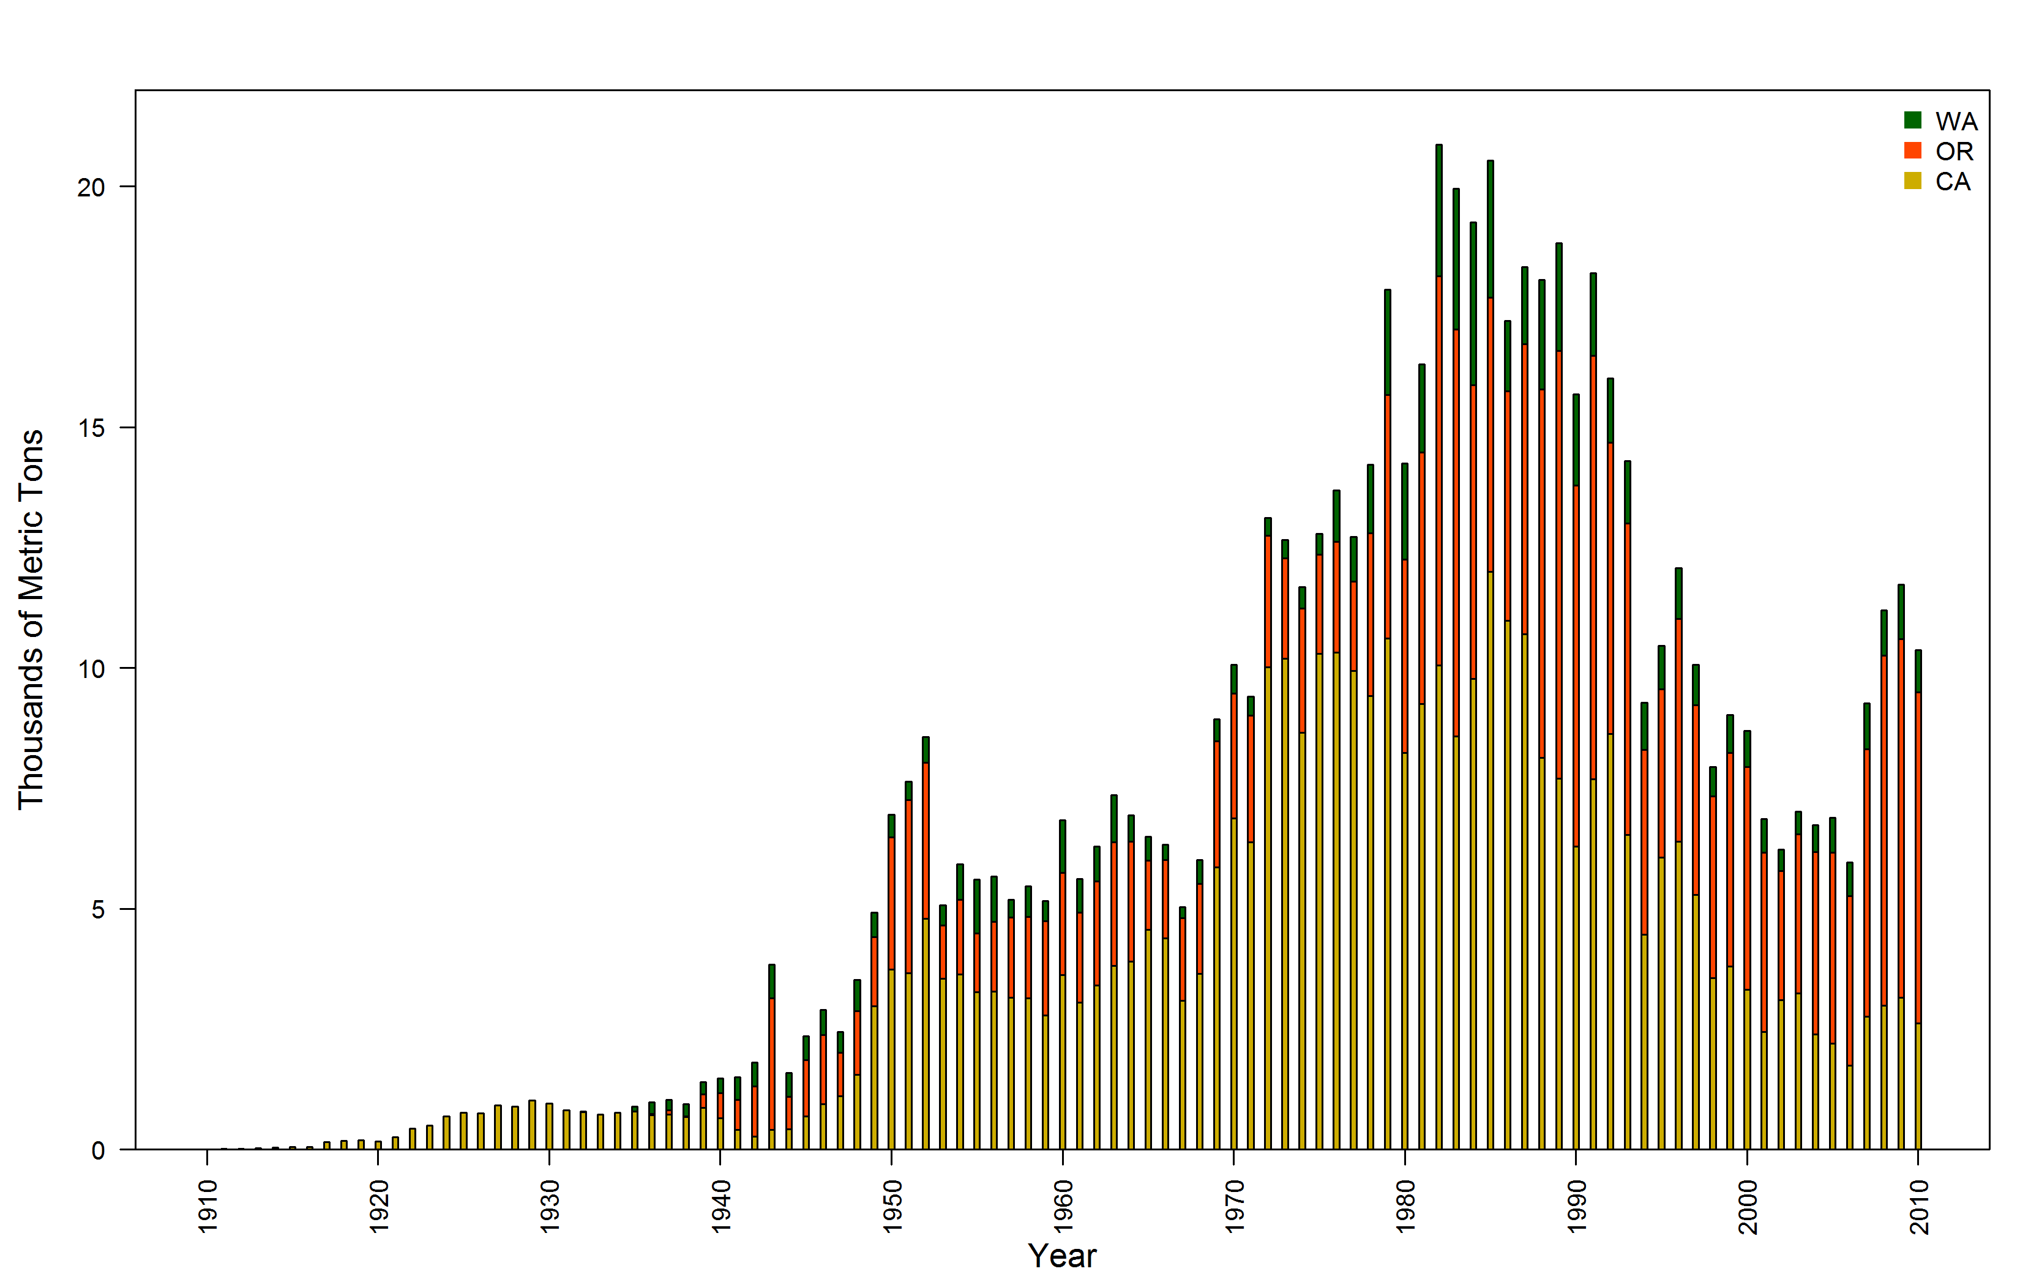

Figure a. Total Dover sole landings used in this assessment, by state from 1910-2010.

Table a. Recent commercial fishery landings (mt).

|  |  |  |  |  |
| --- | --- | --- | --- | --- |
| Year | CA | OR | WA | TOTAL |
| 2001 | 2,446 | 3,715 | 704 | 6,865 |
| 2002 | 3,100 | 2,690 | 444 | 6,234 |
| 2003 | 3,239 | 3,313 | 465 | 7,017 |
| 2004 | 2,384 | 3,799 | 550 | 6,733 |
| 2005 | 2,202 | 3,969 | 721 | 6,892 |
| 2006 | 1,740 | 3,523 | 694 | 5,957 |
| 2007 | 2,759 | 5,550 | 955 | 9,264 |
| 2008 | 2,992 | 7,260 | 952 | 11,204 |
| 2009 | 3,154 | 7,452 | 1,125 | 11,731 |
| 2010 | 2,614 | 6,879 | 882 | 10,375 |

Data and Assessment

Dover sole off the west coast of the U.S. was assessed here using the length- and age-structured model Stock Synthesis (version 3.12f). The last assessment was done in 2005 and showed the stock to be increasing with a 2005 depletion level at 63.2% of virgin spawning biomass. This new assessment treats the commercial fleets differently than the 2005 assessment by separating them by states. In addition, new types of selectivity curves were used that allowed increased flexibility in shape, and natural mortality was estimated for males and females separately.

Population parameters were estimated using fishery landings, length data, and age data from state-specific fishing fleets, abundance indices and length data from the National Marine Fisheries Service (NMFS) triennial survey and the Alaska Fishery Science Center (AFSC) slope survey, and abundance indices, length data, and age data from the Northwest Fisheries Science Center (NWFSC) slope and shelf/slope surveys. The Triennial survey was split into two series (1980–1992 and 1995–2004) based on changes in survey timing. The extension of the NWFSC shelf/slope survey was new to this assessment and added a considerable amount of information, including age data which were fit in the model as conditional age-at-length vectors. Additionally, recent data on discarding collected by the West Coast Groundfish Observer Program (WCGOP), including length data, were used to determine retention curves and selectivity for the commercial fleets.

The base case model estimated parameters for male and female selectivity and retention curves based on length for all of the state-specific fishing fleets, gender-specific selectivity curves for the four surveys, length-at-age relationships for males and females, natural mortality for males and females, and recruitment deviations starting in 1910. A steepness parameter was fixed at 0.8 and not estimated.

Uncertainty for the parameter estimates and derived quantities was determined in two ways. First, approximate asymptotic 95% confidence intervals based on maximum likelihood theory were calculated using the base model. Second, fixed values of natural mortality were varied above and below the values assumed in the base model to define a range for the states of nature.

Although there is a plethora of data available for Dover sole, which were used in this assessment, there is little information about natural mortality, steepness, and historical recruitment. Estimates of steepness are uncertain partly because the stock has not been fished to low levels. Uncertainty in natural mortality appears to be related to some inconsistencies between length data and age data. These data indicate that larger fish tend to be caught deeper, at least in the summer, but there was no trend of age with depth. There was, however, a trend in sex ratio with depth (as seen in the data collected from the NWFSC shelf/slope survey). The data also showed differences in the overall sex ratios, with age data typically showing a higher proportion of females than the length data. This could be related to sampling and age data being more variable because fewer are sampled, but there also appears to be some behavioral aspects which may contribute to sampled data showing skewed sex ratios. Nevertheless, the uncertainty in M translates to a considerable amount of uncertainty in the estimates of spawning biomass. Finally, there is little information about the levels of historical recruitment mostly due to a lack of historical length or age data. This uncertainty was included in the predictions from this assessment.

Stock Biomass

The estimated spawning biomass has shown a slight decline over the entire time series with two periods of more significant decline (the early 1960’s and the 1980’s). Even though catches continued to increase in the 1970’s, the spawning biomass also increased because of larger than average recruitment in the early 1960’s. A period of smaller than average recruitments in the late 1970’s and early 1980’s along with the highest catches on record caused a decline in spawning biomass throughout the 1980’s. More recently, spawning biomass has been increasing, although a recent increase in catch and low estimated recruitment in the early 2000’s seem to be resulting in a slight downturn in spawning biomass. The level of depletion is well above the target of 25% of unfished spawning biomass.

Approximate confidence intervals based on the asymptotic variance estimates show that the uncertainty in the estimated spawning biomass is high. Sensitivities showed that this uncertainty can be largely attributed to uncertainty in natural mortality. The estimates of spawning biomass from the 2005 assessment are contained within the intervals estimated from this assessment, but the average spawning biomass from this assessment is approximately 40% larger.

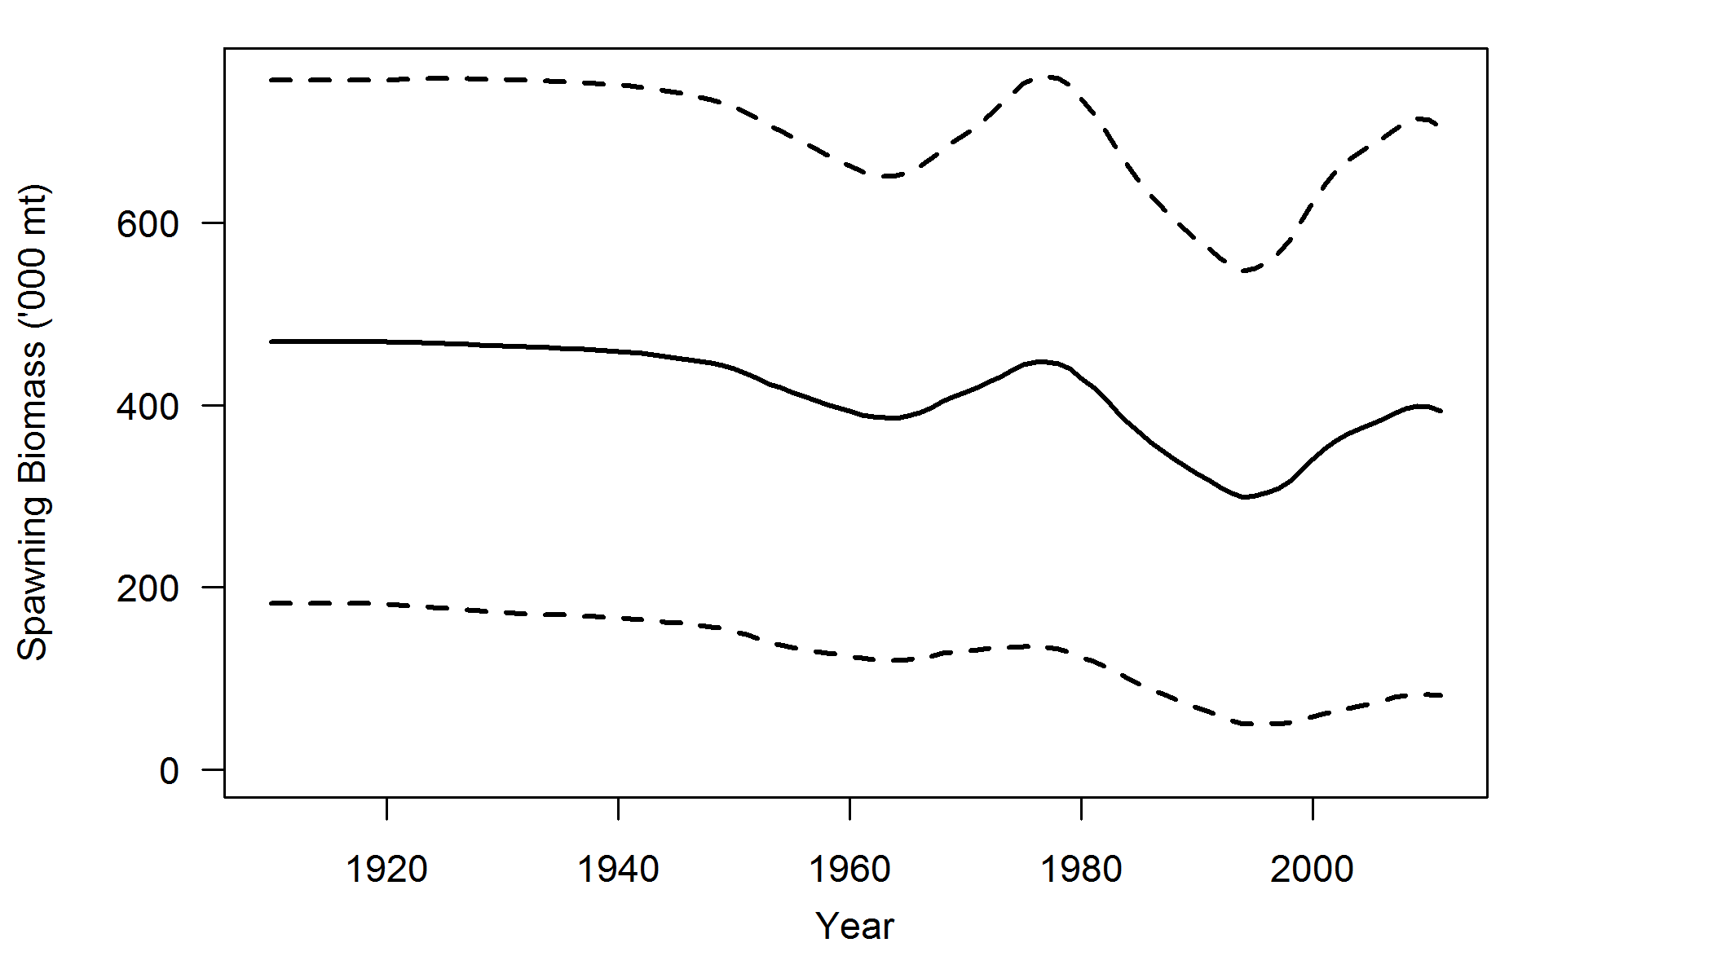

Figure b. Estimated female spawning biomass time-series from the base model (solid line) with an approximate asymptotic 95% confidence interval (thick dashed lines).

Table b. Recent trend in estimated female spawning biomass and relative depletion of the spawning biomass.

|  |  |  |  |  |  |
| --- | --- | --- | --- | --- | --- |
| Year | Spawning Biomass | ~ 95% Confidence Interval |  | Depletion % | ~ 95% Confidence Interval |
| 2002 | 361,507 | 64,665–658,349 |  | 76.9% | 60–94% |
| 2003 | 368,402 | 67,455–669,349 |  | 78.4% | 61–96% |
| 2004 | 373,512 | 69,622–677,402 |  | 79.5% | 63–97% |
| 2005 | 379,112 | 72,546–685,678 |  | 80.7% | 64–98% |
| 2006 | 384,556 | 75,519–693,593 |  | 81.8% | 65–99% |
| 2007 | 390,893 | 79,241–702,545 |  | 83.2% | 67–100% |
| 2008 | 396,088 | 81,659–710,517 |  | 84.3% | 68–101% |
| 2009 | 398,921 | 82,761–715,081 |  | 84.9% | 68–101% |
| 2010 | 397,836 | 82,407–713,265 |  | 84.7% | 68–101% |
| 2011 | 393,507 | 81,481–705,533 |  | 83.7% | 67–100% |

Recruitment

Recruitment deviations were estimated for the entire time series modeled. There is little information regarding recruitment prior to 1960, and the uncertainty in these estimates is expressed in the model. Estimates of recruitment appear to oscillate between periods of low recruitment and periods of high recruitment. The five largest recruitments were predicted in the years 2000, 1992, 1988, 1965, and 1991. The five smallest recruitments were predicted in 2003, 2002, 2004, 2006, and 1974.

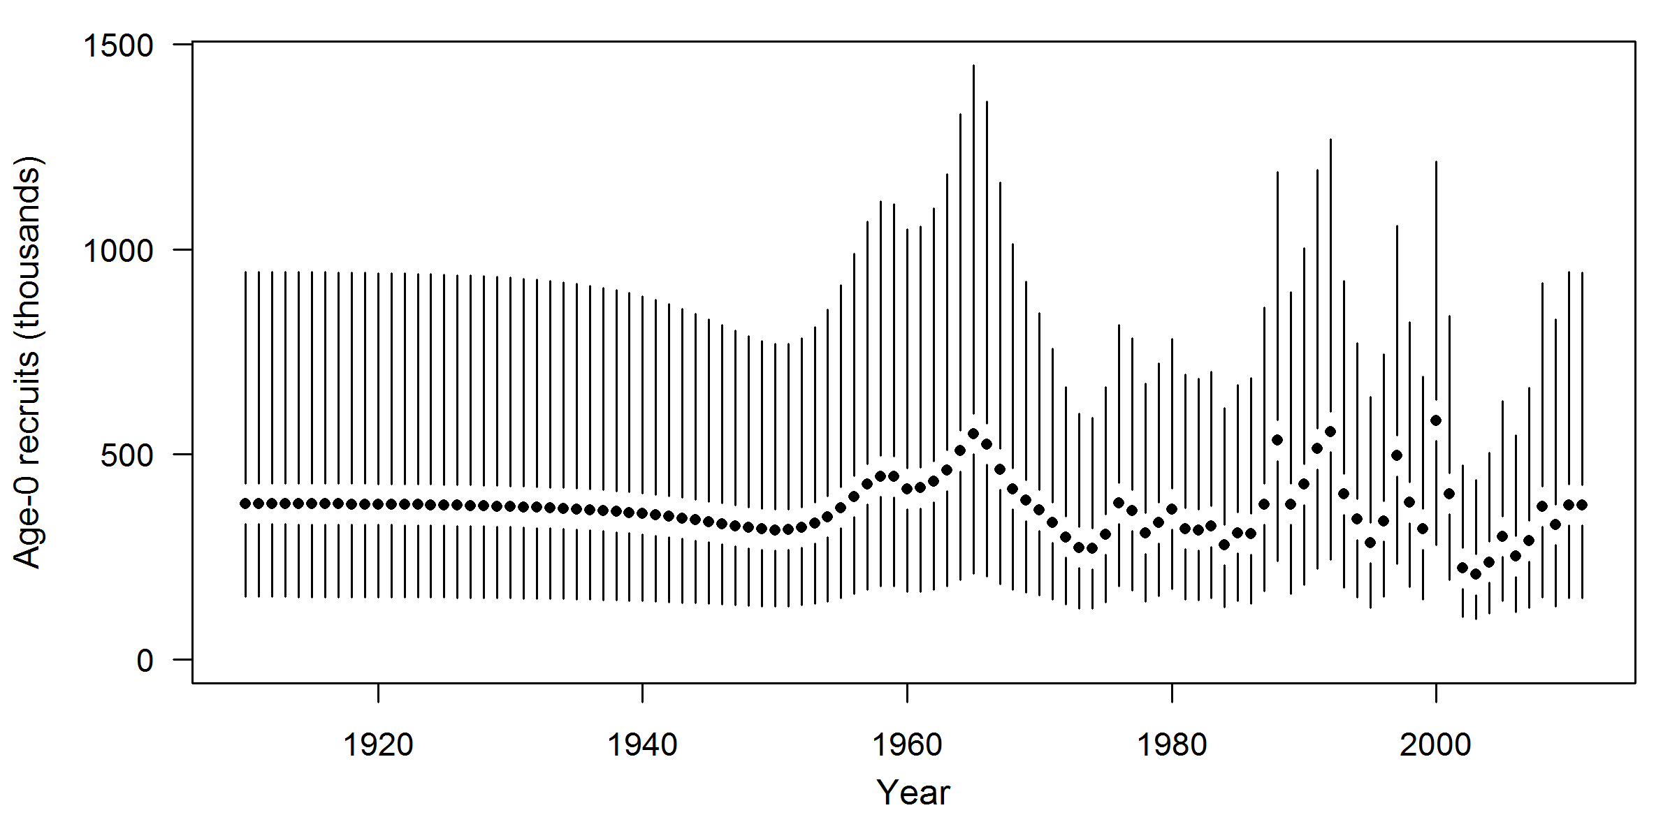

Figure c. Time-series of estimated recruitments for the base case model (round points) with approximate asymptotic 95% confidence interval (vertical bars).

Table c. Recent estimated trend in Dover sole recruitment with approximate 95% confidence intervals determined from the base model.

|  |  |  |
| --- | --- | --- |
| Year | Recruits | ~ 95% confidence interval |
| 2001 | 403,700 | 194,708–837,017 |
| 2002 | 222,419 | 104,697–472,508 |
| 2003 | 207,409 | 98,173–438,189 |
| 2004 | 237,284 | 111,899–503,167 |
| 2005 | 299,746 | 142,559–630,248 |
| 2006 | 251,610 | 115,888–546,282 |
| 2007 | 288,809 | 126,046–661,746 |
| 2008 | 372,962 | 151,584–917,645 |
| 2009 | 328,391 | 130,124–828,751 |
| 2010 | 376,517 | 150,161–944,086 |

Exploitation status

The spawning biomass of Dover sole reached a low in the mid 1990’s before beginning to increase throughout the last decade. The estimated depletion has remained above the 25% of unfished spawning biomass target and it is unlikely that the stock has ever fallen below this threshold. Throughout the 1970’s, 1980’s, and 1990’s the exploitation rate and *SPR* generally increased, but never exceeded current estimates of the harvest rate limit (*SPR30%*). Recent exploitation rates on Dover sole have been small, even after management increased catch levels in 2007.

Table d. Recent trend in spawning potential ratio (entered as 1-SPR) and summary exploitation rate (catch divided by biomass of age-5 and older fish)

|  |  |  |  |  |  |
| --- | --- | --- | --- | --- | --- |
| Year | Estimated 1-SPR (%) | ~95% confidence interval |  | Harvest rate (proportion) | ~95% confidence interval |
|
| 2001 | 12.8% | 3–22% |  | 1.3% | 0.4–2.3 |
| 2002 | 11.6% | 3–20% |  | 1.2% | 0.3–2.0 |
| 2003 | 12.7% | 4–22% |  | 1.3% | 0.3–2.2 |
| 2004 | 10.8% | 3–19% |  | 1.1% | 0.3–1.9 |
| 2005 | 10.9% | 3–19% |  | 1.1% | 0.3–1.9 |
| 2006 | 9.3% | 3–16% |  | 0.9% | 0.3–1.6 |
| 2007 | 13.8% | 4–23% |  | 1.4% | 0.4–2.4 |
| 2008 | 16.2% | 5–27% |  | 1.8% | 0.5–2.9 |
| 2009 | 17.0% | 6–28% |  | 1.9% | 0.5–3.1 |
| 2010 | 15.5% | 5–26% |  | 1.7% | 0.5–2.8 |

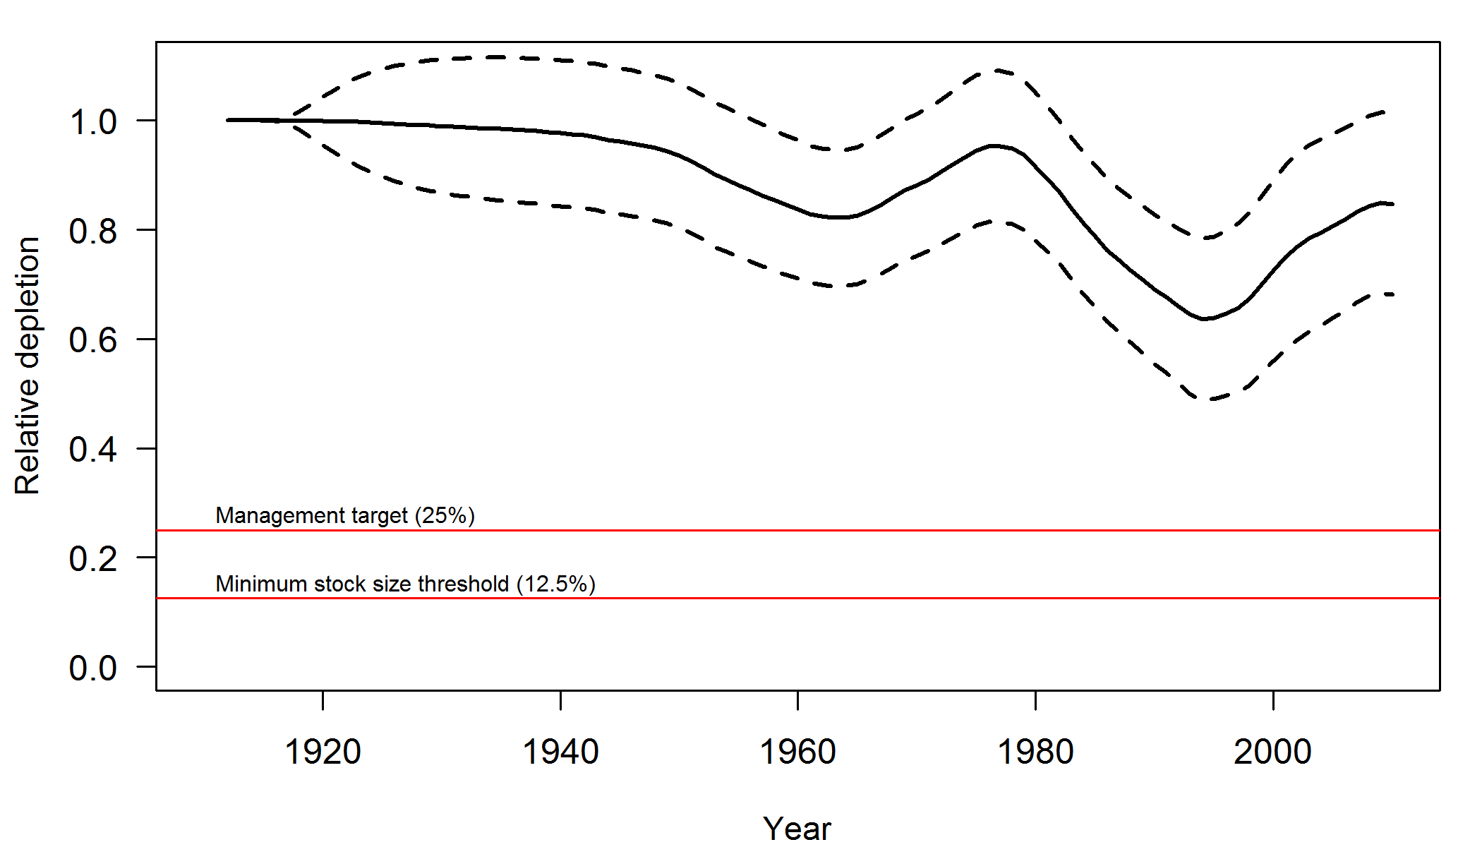

Figure d. Estimated relative depletion with approximate 95% asymptotic confidence intervals (dashed lines) for the base case assessment model.

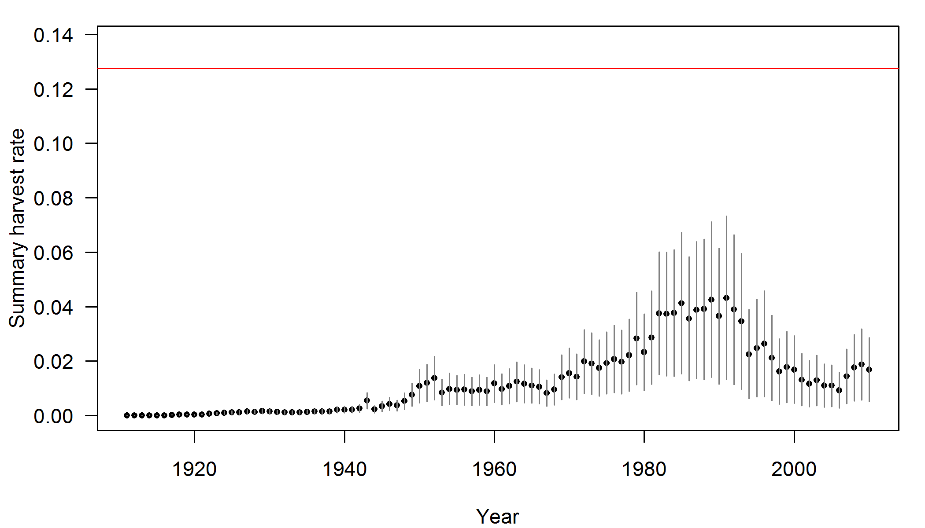

Figure e. Time-series of estimated summary harvest rate (total catch divided by age-5 and older biomass) for the base case model (round points) with approximate 95% asymptotic confidence intervals (grey lines). The red line is the harvest rate at the overfishing proxy using SPR30%.

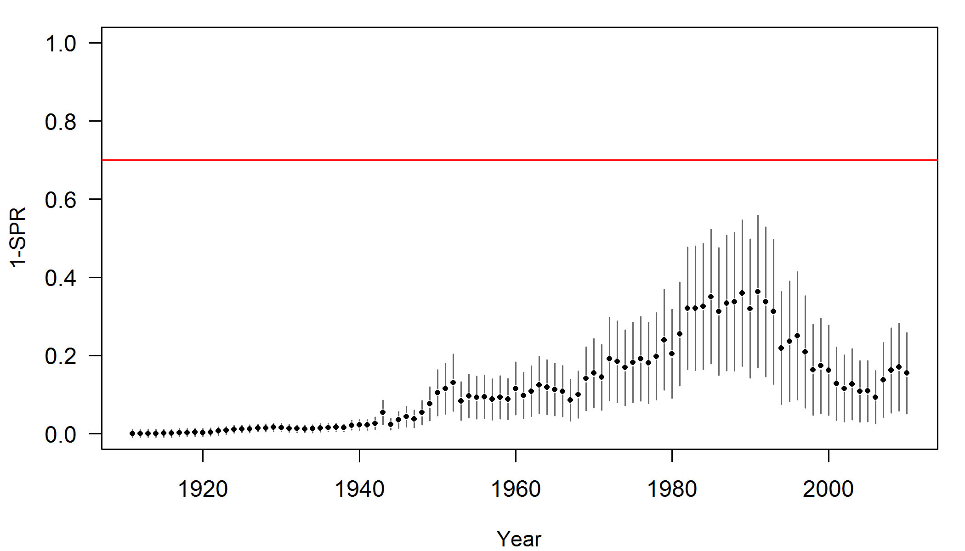

Figure f. Estimated spawning potential ratio (SPR) for the base case model with approximate 95% asymptotic confidence intervals. One minus SPR is plotted so that higher exploitation rates occur on the upper portion of the y-axis. The management target is plotted as red horizontal line and values above this reflect harvests in excess of the overfishing proxy based on the SPR30%.

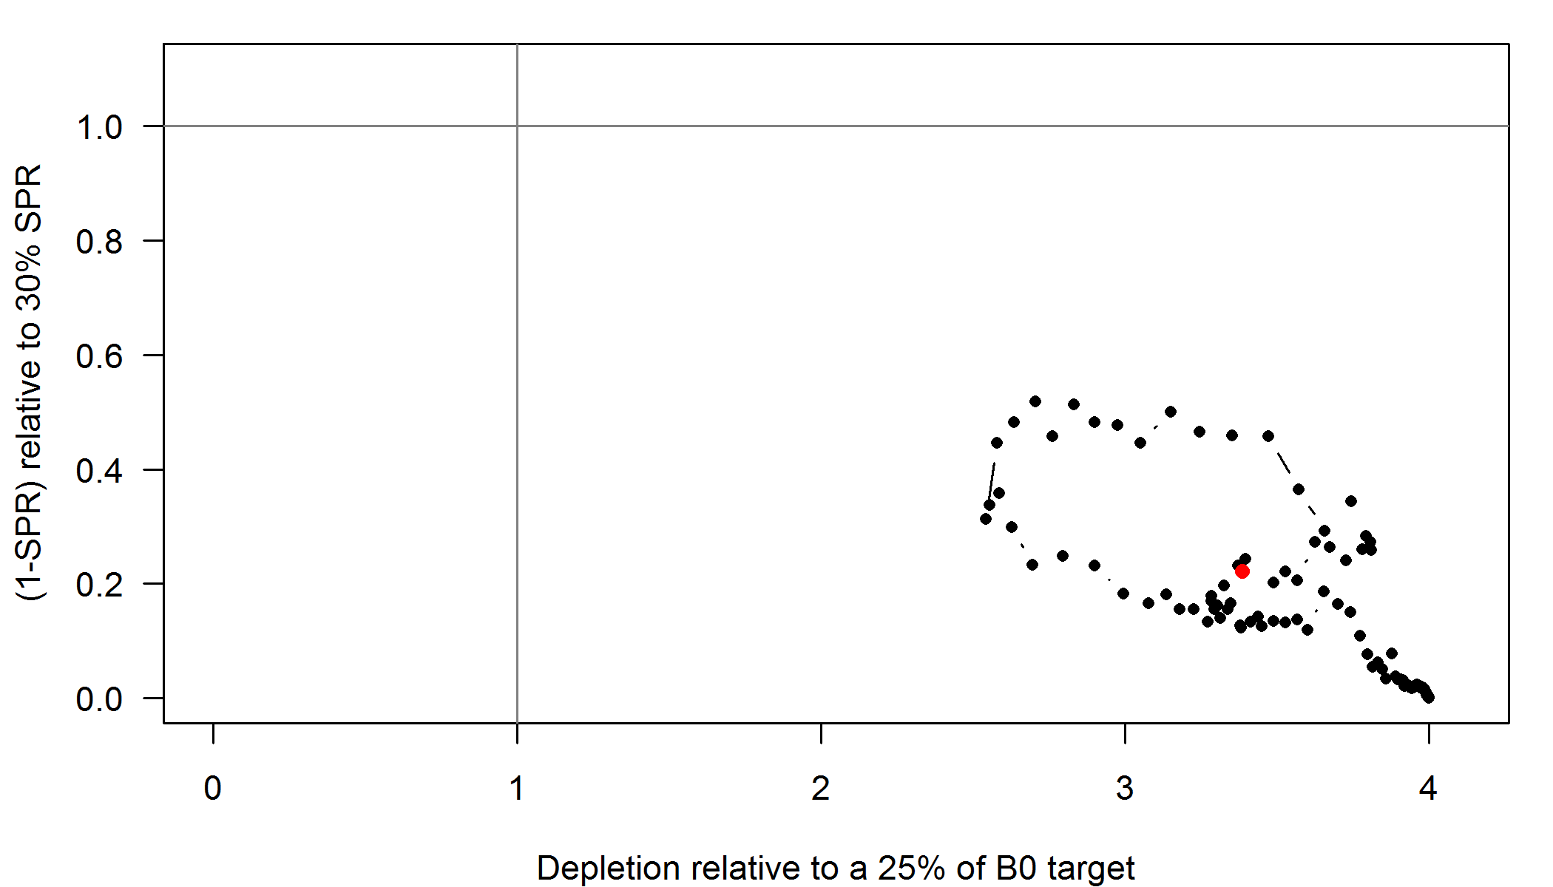

Figure g. Phase plot of estimated relative (1-SPR) vs. relative spawning biomass for the base case model. The relative (1-SPR) is (1-SPR) divided by 0.3 (the SPR target). Relative depletion is the annual spawning biomass divided by the spawning biomass corresponding to 25% of the unfished spawning biomass. The red point indicates the year 2010.

Reference points

Reference points were calculated using the estimated selectivities and a fleet distribution based on the last three years of landings (2008–2010). Sustainable total yields (landings plus discards) were 34,743 mt when using an *SPR30%* reference harvest rate and ranged from 15,402 to 54,082 mt based on estimates of uncertainty. The value for 25% of the unfished spawning output (analogous to B25%) was 117,467 metric tons. The recent catches (landings plus discards) have been slightly less than the lower confidence bound of potential long-term yields calculated using an *SPR30%* reference point. As a result, the spawning biomass of the stock has been increasing over the last decade except in the last three years which is partly due to recent low estimated recruitment levels.

Table e. Summary of Dover sole reference points for the base case model. Values are calculated using a fishery distribution based on the average of the landings from 2008 through 2010.

|  |  |  |
| --- | --- | --- |
| **Quantity** | **Estimate** | **~95% Confidence Interval** |
|
| Unfished Spawning biomass (mt) | 469,866 | 182,741–756,991 |
| Unfished age 5+ biomass (mt) | 821,271 | 391,404–1,251,138 |
| Unfished recruitment (R0) | 380,777 | 123,519–638,034 |
| Depletion (2011) | 83.7% | 67.4–100.1% |
| ***Reference points based on SB25%*** |  |  |
| Proxy spawning biomass (*B25%*) | 117,467 | 45,684–189,249 |
| SPR resulting in *B25%* (*SPR30%*) | 0.297 |  |
| Exploitation rate resulting in *B25%* | 0.129 | 0.120–0.138 |
| Yield with *SPR30%* at *B25%* (mt) | 34,751 | 15,403–54,098 |
| ***Reference points based on SPR proxy for MSY*** |  |  |
| Spawning biomass | 119,033 | 46,293–191,772 |
| *SPRproxy* | 0.30 |  |
| Exploitation rate corresponding to *SPRproxy* | 0.128 | 0.119–0.136 |
| Yield with *SPRproxy* at *SBSPR* (mt) | 34,743 | 15,402–54,082 |
| ***Reference points based on estimated MSY values*** |  |  |
| Spawning biomass at *MSY* (*SBMSY*) | 114,398 | 45,640–183,155 |
| *SPRMSY* | 0.291 | 0.286–0.296 |
| Exploitation rate corresponding to *SPRMSY* | 0.131 | 0.122–0.141 |
| *MSY* (mt) | 34,757 | 15,400–54,114 |

Management performance

Exploitation rates on Dover sole have never exceeded the *MSY* proxy level and the base case model did not predict that the stock has ever fallen below the target biomass defined as 25% of unfished spawning biomass. In 2007, the exploitation rates have slightly increased due to increases in the allowable catch, but are still below target thresholds. A considerable increase in the OFL was put in place in 2011 due to the results of the 2005 stock assessment. A 4% reduction in the 2011 OFL due to scientific uncertainty (the P* approach) resulted in an ABC of 42,436 metric tons, and although the ACL could be set equal to the ABC for a stock above the target biomass, the ACL was set to 25,000 mt, which is higher than the maximum historical catch. Overall, Dover sole have been lightly exploited and the spawning biomass has remained well above target levels. Recent low recruitment coupled with a slight increase in catch has caused the trend in spawning biomass to level.

Table f. Recent trend in total catch and commercial landings (mt) relative to the management guidelines. The OFL (overfishing limit) was formerly known as the ABC, and the ACL (annual catch limit) is similar to what was formerly known as the OY. Estimated total catch reflect the commercial landings plus the model estimated discarded biomass.

|  |  |  |  |  |
| --- | --- | --- | --- | --- |
| Year | OFL (mt) | ACL (mt) | Commercial Landings (mt) | Estimated1 Total Catch (mt) |
| 2001 | 8,510 | 7,440 | 6,865 | 8,422 |
| 2002 | 8,510 | 7,440 | 6,234 | 7,697 |
| 2003 | 8,510 | 7,440 | 7,017 | 8,651 |
| 2004 | 8,510 | 7,440 | 6,733 | 7,429 |
| 2005 | 8,522 | 7,476 | 6,892 | 7,592 |
| 2006 | 8,589 | 7,564 | 5,957 | 6,548 |
| 2007 | 28,522 | 16,500 | 9,264 | 10,171 |
| 2008 | 28,442 | 16,500 | 11,204 | 12,245 |
| 2009 | 29,453 | 16,500 | 11,731 | 12,820 |
| 2010 | 28,582 | 16,500 | 10,375 | 11,313 |
| 2011 | 44,400 | 25,000 | –– | –– |

Unresolved problems and major uncertainties

The base case model was developed with the goal of balancing parsimony with realism and fitting the data. There were, however, some pieces of data that were fit poorly. Specifically, the commercial length and age data for the Washington and Oregon fleets showed some unsatisfactory patterns. It is uncertain if these patterns are related to a lack of fit due to retention curves, selectivity curves, or growth. It is possible that Dover sole exhibit different life-history patterns in the north and the model is unable to capture these differences without introducing additional complexity.

Natural mortality was estimated in this assessment for the first time in the history of U.S. West Coast Dover sole assessments. A prior was developed for gender-specific natural mortality, which had a median larger than values assumed in previous assessments. Additionally, the estimates from the base case model were larger than previous assumed values and natural mortality for males was uncertain. However, the 95% joint confidence interval from the joint likelihood profile over female and male natural mortality parameters did not encompass the 0.09 values assumed for female and male M in the 2005 assessment. It would be useful to investigate the life-history of Dover sole as well as the length and age data to determine if the larger values of *M* are reasonable.

Recruitment was estimated over the entire time series and although was uncertain, it showed an interesting pattern in the early years by dipping down below average recruitment before the era in which recruitment deviates could be somewhat estimated. These patterns may indicate model misspecification, but it may also be an indication that the stock may have been below unfished equilibrium biomass when fishing mortality really began to increase. This may be caused by greater than assumed historical fishing levels, or a period of low recruitment preceding the start of the fishery. Given that estimated recruitment from more recent periods shows periods of low and high recruitments, it may be that a period of low recruitment occurred prior to 1960.

Discards are problematic for many stocks because there is little quantitative information on historical discarding practices. This holds true for Dover sole and is further complicated by differences in discarding due to location as well as changes in discarding over time. Many assumptions were made regarding discarding behavior and although discards have been small for Dover sole, some lack of fit may be due to misspecification of retention curves. A better understanding of discard behavior and how it has changed over time would help to make better assumptions in the model.

Dover sole life-history parameters exhibit strong relationships with depth that indicate the stock is more complex than the model assumes. Small fish are found in shallow water, while mid-sized and larger fish are found in middle and deeper depths. There is not a trend of larger fish being found deeper, but there is a trend of fewer smaller fish found deeper. In addition, there is a pattern of sex ratio by depth with more males found in middle depths and more females found in shallow and deeper depths. These patterns are apparent in the summer fisheries and surveys, and there is some evidence that the patterns change in the winter during the spawning season. It is uncertain how the patterns affect the data (they may be a cause of the bimodal length distributions seen in the slope surveys) and if these patterns can be effectively modeled to produce better fits to the data and better predictions of biomass.

Forecasts

Forecasts and projections of the Dover sole population up to the year 2022 were constructed assuming that the next two years of landings (2011 and 2012) would be an average of the last three years of fleet-specific landings, and from 2013 onward, catches would reach the calculated OFL. This forecast table shows that even with these high catches from 2013 onward, the predicted spawning biomass does not drop below the target spawning biomass before 2023. However, it does show that even with catches less than the ACL in 2011 and 2012, the spawning biomass is predicted to decline slightly. This is due to recent predictions of poor recruitment.

Table g. Projection of potential OFL, landings, and catch, summary biomass (age-5 and older), spawning biomass, and depletion for the base case model projected with status quo catches in 2011 and 2012, and catches at the OFL from 2013 onward. The 2011 and 2012 OFL’s are values specified by the PFMC and not predicted by this assessment. The OFL in years later than 2012 is the calculated total catch determined by *FSPR*.

|  |  |  |  |  |  |  |
| --- | --- | --- | --- | --- | --- | --- |
| Year | Predicted OFL (mt) | Total Catch (mt) | Landings (mt) | Age 5+ biomass (mt) | Spawning Biomass | Depletion (%) |
|
| 2011 |  | 12,116 | 11,100 | 657,004 | 393,507 | 83.75% |
| 2012 |  | 12,120 | 11,100 | 643,291 | 386,143 | 82.18% |
| 2013 | 90,411 | 90,411 | 82,730 | 635,535 | 377,601 | 80.36% |
| 2014 | 75,517 | 75,517 | 68,984 | 552,801 | 329,856 | 70.20% |
| 2015 | 64,885 | 64,885 | 59,152 | 493,279 | 289,873 | 61.69% |
| 2016 | 57,488 | 57,488 | 52,302 | 449,642 | 257,379 | 54.78% |
| 2017 | 52,453 | 52,453 | 47,635 | 417,705 | 231,515 | 49.27% |
| 2018 | 49,065 | 49,065 | 44,495 | 394,207 | 211,283 | 44.97% |
| 2019 | 46,768 | 46,768 | 42,367 | 376,487 | 195,619 | 41.63% |
| 2020 | 45,158 | 45,158 | 40,880 | 362,731 | 183,484 | 39.05% |
| 2021 | 43,964 | 43,964 | 39,780 | 351,687 | 173,995 | 37.03% |
| 2022 | 43,017 | 43,017 | 38,910 | 342,526 | 166,455 | 35.43% |

Decision Table

The axis of uncertainty chosen for this assessment was based on the joint profile of natural mortality for females and males. A one-dimensional decision table is given, but is quantified over female and male natural mortalities by finding the most likely combinations of joint *M* (based on the joint likelihood profile) that correspond to the 12.5% and 87.5% quantiles of 2011 spawning biomass in log space (251,000 and 616,000 mt, respectively). This satisfies the criteria specified in the terms of reference and the geometric mean is approximately equal to the base case estimate of current spawning biomass.

The average catch from the last three years was used for 2011 and 2012 catches with allocation and selectivities based on 2010. Three catch levels were chosen for the years 2013 and beyond in the decision table. First, it was assumed that the entire OFL would be caught in these years. Second, it was assumed that the current ACL of 25,000 mt would be taken every year from 2013 to 2022. And, lastly, it was assumed that status quo catches would be taken based on the average catch over the last three years.

Table h. Summary table of 12-year projections beginning in 2013 for alternate states of nature based on an axis uncertainty calculated using the joint likelihood profile on female and male natural mortality. Columns range over different combinations of natural mortality giving a low, mid, and high state of nature, and rows range over different assumptions of catch levels based on the predicted OFL’s, the current ACL’s, and status quo catches based on the average of catches from the last three years including estimated discards.

|  |  |  |  |  |  |  |  |  |
| --- | --- | --- | --- | --- | --- | --- | --- | --- |
|  |  |  | **State of nature** | | | | | |
|  |  |  | Low | | Base case | | High | |
|  |  |  | *Mf* = 0.110 | | *Mf* = 0.117 | | *Mf* = 0.120 | |
|  |  |  | *Mm* = 0.125 | | *Mm* = 0.142 | | *Mm* = 0.159 | |
| **Relative probability of ln(SB_2011)** | | | 0.25 | | 0.5 | | 0.25 | |
| **Management decision** | Year | Catch (mt) | Spawning biomass (mt) | Depletion | Spawning biomass (mt) | Depletion | Spawning biomass (mt) | Depletion |
| OFL | 2013 | 90,411 | 240,029 | 70.2% | 377,601 | 80.4% | 677,186 | 89.0% |
| 2014 | 75,517 | 195,784 | 57.2% | 329,856 | 70.2% | 621,798 | 81.7% |
| 2015 | 64,885 | 158,399 | 46.3% | 289,873 | 61.7% | 575,533 | 75.6% |
| 2016 | 57,488 | 127,579 | 37.3% | 257,379 | 54.8% | 538,415 | 70.8% |
| 2017 | 52,453 | 102,664 | 30.0% | 231,515 | 49.3% | 509,530 | 67.0% |
| 2018 | 49,065 | 82,887 | 24.2% | 211,283 | 45.0% | 487,689 | 64.1% |
| 2019 | 46,768 | 67,323 | 19.7% | 195,619 | 41.6% | 471,579 | 62.0% |
| 2020 | 45,158 | 54,995 | 16.1% | 183,484 | 39.1% | 459,894 | 60.4% |
| 2021 | 43,964 | 45,020 | 13.2% | 173,995 | 37.0% | 451,511 | 59.3% |
| 2022 | 43,017 | 36,676 | 10.7% | 166,455 | 35.4% | 445,553 | 58.6% |
| Current ACL | 2013 | 25,000 | 240,029 | 70.2% | 377,601 | 80.4% | 677,186 | 89.0% |
| 2014 | 25,000 | 228,381 | 66.8% | 362,668 | 77.2% | 655,006 | 86.1% |
| 2015 | 25,000 | 217,371 | 63.6% | 348,791 | 74.2% | 634,698 | 83.4% |
| 2016 | 25,000 | 207,555 | 60.7% | 336,770 | 71.7% | 617,600 | 81.2% |
| 2017 | 25,000 | 199,131 | 58.2% | 326,838 | 69.6% | 604,064 | 79.4% |
| 2018 | 25,000 | 192,128 | 56.2% | 318,967 | 67.9% | 593,964 | 78.1% |
| 2019 | 25,000 | 186,405 | 54.5% | 312,909 | 66.6% | 586,836 | 77.1% |
| 2020 | 25,000 | 181,701 | 53.1% | 308,280 | 65.6% | 582,020 | 76.5% |
| 2021 | 25,000 | 177,758 | 52.0% | 304,702 | 64.8% | 578,872 | 76.1% |
| 2022 | 25,000 | 174,364 | 51.0% | 301,870 | 64.2% | 576,880 | 75.8% |
| Status quo  catches | 2013 | 12,127 | 240,029 | 70.2% | 377,601 | 80.4% | 677,186 | 89.0% |
| 2014 | 12,135 | 234,602 | 68.6% | 368,952 | 78.5% | 661,398 | 86.9% |
| 2015 | 12,143 | 229,771 | 67.2% | 361,268 | 76.9% | 647,350 | 85.1% |
| 2016 | 12,149 | 226,014 | 66.1% | 355,274 | 75.6% | 636,310 | 83.6% |
| 2017 | 12,154 | 223,476 | 65.3% | 351,155 | 74.7% | 628,583 | 82.6% |
| 2018 | 12,157 | 222,149 | 65.0% | 348,848 | 74.2% | 624,015 | 82.0% |
| 2019 | 12,158 | 221,870 | 64.9% | 348,089 | 74.1% | 622,126 | 81.8% |
| 2020 | 12,158 | 222,375 | 65.0% | 348,485 | 74.2% | 622,248 | 81.8% |
| 2021 | 12,158 | 223,398 | 65.3% | 349,654 | 74.4% | 623,736 | 82.0% |
| 2022 | 12,157 | 224,732 | 65.7% | 351,296 | 74.8% | 626,082 | 82.3% |

Research and data needs

There are 5 topics for which additional research would greatly improve the assessment of Dover sole.

1. **Age reading error:** Estimates of ageing error were simplified because minimal data and cross-validation were available. There are many within-lab rereads from the Cooperative Ageing Project laboratory in Newport, OR, and some from the California ageing lab, but there is little organized data on cross-lab reads. A workshop in 2004 resulted in some cross-lab reads, but there is little data that can be used to characterize the differences between labs. Furthermore, a bomb calibration study of Dover sole ototliths from Alaska was done by the AFSC, and they concluded that there was little bias in ageing for easy to read otoliths. However, they state that the majority of Dover sole otoliths are difficult to read and result in uncertain ages through double-reads. A ground-truthing study on the U.S. West Coast would be useful to characterize potential bias in ageing Dover sole ototliths. Further research into quantifying the uncertainty of Dover sole ageing may help clear up some of the conflicts between the age and length data and may even give insight into the estimates of natural mortality.
2. **Patterns with depth:** As discussed above, there are patterns of length and sex ratios with depth which may indicate that the stock is more complex than currently modeled. Further research into the causes of these patterns as well as differences between seasons would help with understanding the stock characteristics such that a more realistic model could be built. This may also provide further insight into migration and help determine if there are localized populations.
3. **Recruitment patterns:** Even though recruitment variability is low compared to other West Coast groundfish, this assessment model predicted periods of low and high recruitment that affect the trend in biomass. These periods may correlate with the environment and would help predict future biomass levels. It would be useful to investigate these patterns in recruitment but to also further investigate the life-history of Dover sole to determine if that can also explain the estimated patterns.
4. **Stock boundaries:** A common question in stock assessments is whether or not the entire stock is being accounted for. Dover sole live deeper than the range of the fisheries and surveys. The assessment model attempts to account for out of area biomass through catchability coefficients and selectivity curves, but that portion of the stock is unknown and can only be guessed at. Research into abundance in deep areas would be useful to verify that the assessment adequately predicts the entire spawning stock of Dover sole.
5. **Variability of sex ratios in length and age data:**  There were differences in predicted sex ratios from the length data and the age data which should be further explored. It is uncertain if this is simply an artifact of sampling or if there is a selection bias in age and/or length observations. This phenomenon may contribute to the conflict between age and length data.

Table i. Summary table of the results for the Dover sole assessment.

|  |  |  |  |  |  |  |  |  |  |  |  |
| --- | --- | --- | --- | --- | --- | --- | --- | --- | --- | --- | --- |
|  | 2001 | 2002 | 2003 | 2004 | 2005 | 2006 | 2007 | 2008 | 2009 | 2010 | 2011 |
| Commercial landings (mt) | 6,865 | 6,234 | 7,017 | 6,733 | 6,892 | 5,957 | 9,264 | 11,204 | 11,731 | 10,375 | NA |
| Estimated Total catch (mt) | 8,422 | 7,697 | 8,651 | 7,429 | 7,592 | 6,548 | 10,171 | 12,245 | 12,820 | 11,313 | NA |
| OFL (mt) | 8,510 | 8,510 | 8,510 | 8,510 | 8,522 | 8,589 | 28,522 | 28,442 | 29,453 | 28,582 | 44,400 |
| ACL (mt) | 7440 | 7440 | 7440 | 7440 | 7476 | 7564 | 16500 | 16500 | 16500 | 16500 | 25000 |
| 1-SPR | 12.75% | 11.57% | 12.66% | 10.84% | 10.89% | 9.34% | 13.77% | 16.17% | 16.99% | 15.49% | NA |
| Exploitation rate (catch/ age 5+ biomass) | 0.013 | 0.012 | 0.013 | 0.011 | 0.011 | 0.009 | 0.014 | 0.018 | 0.019 | 0.017 | NA |
| Age 5+ biomass (mt) | 657,004 | 643,291 | 635,535 | 552,798 | 493,274 | 449,636 | 417,699 | 394,200 | 376,478 | 362,720 | 351,675 |
| Spawning Biomass | 352,007 | 361,507 | 368,402 | 373,512 | 379,112 | 384,556 | 390,893 | 396,088 | 398,921 | 397,836 | 393,507 |
| ~95% Confidence Interval | 61,454–642,559 | 64,665–658,349 | 67,455–669,349 | 69,622–677,402 | 72,546–685,678 | 75,519–693,593 | 79,241–702,545 | 81,659–710,517 | 82,761–715,081 | 82,407–713,265 | 81,481–705,533 |
| Recruitment | 403,700 | 222,419 | 207,409 | 237,284 | 299,746 | 251,610 | 288,809 | 372,962 | 328,391 | 376,517 | 376,215 |
| ~95% Confidence Interval | 194,708–837,017 | 104,697–472,508 | 98,173–438,189 | 111,899–503,167 | 142,559–630,248 | 115,888–546,282 | 126,046–661,746 | 151,584–917,645 | 130,124–828,751 | 150,161–944,086 | 150,036–943,357 |
| Depletion (%) | 74.9% | 76.9% | 78.4% | 79.5% | 80.7% | 81.8% | 83.2% | 84.3% | 84.9% | 84.7% | 83.7% |
| ~95% Confidence Interval | 58–92% | 60–94% | 61–96% | 63–97% | 64–98% | 65–99% | 67–100% | 68–101% | 68–101% | 68–101% | 67–100% |

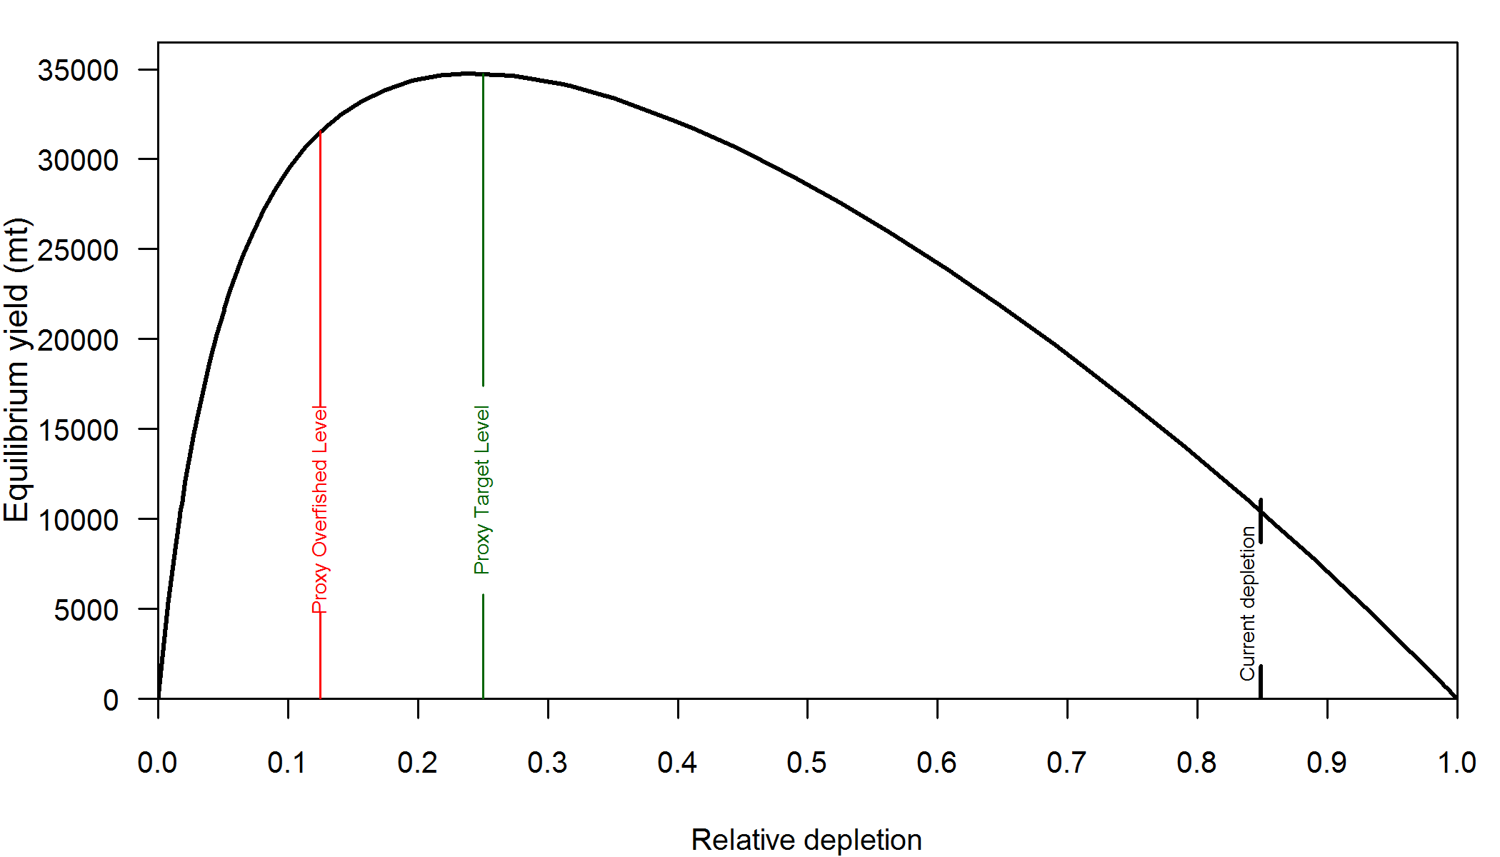

Figure h. Equilibrium yield curve (derived from reference point values reported in Table i) for the base case model. Values are based on 2010 fishery selectivity and distribution with steepness fixed at 0.8. The depletion is relative to unfished spawning biomass.

# Introduction

The Dover sole, *Microstomus pacificus* (Lockington) is a flatfish belonging to the family Pleuronectidae and is called a sole although it is a flounder. Dover sole has also been known by several different common names including slippery sole, lemon sole, smear dab, rubber sole, short finned sole, slime sole, and tongue sole. Although there was little interest in Dover sole when the U.S. West Coast trawl fishery first began, the species is now commonly landed.

This is an assessment of the Dover sole population off of the U.S. West, including coastal waters of California, Oregon, and Washington from the U.S./Mexico border to the U.S./Canadian border. It does not include Canadian or Alaskan populations and assumes that these northern populations do not contribute to the stock being assessed here.

## Distribution and Stock Structure

Dover sole range from Baja California to the Bering Sea and eastern Aleutian Islands (Kramer et al. 1995). Stock structure is not well understood and Westerheim et al (1992) reports that conventional stock-recruitment assessments of Dover sole are unlikely to be successful due to nonintermingling adult stocks, but larvae probably intermingle during their long pelagic life. Stepien (1999) used sequences of mitochondrial DNA extracted from Dover sole sampled at six sites ranging from southern California to the Gulf of Alaska and found phylogeographical structure in west coast Dover sole with spatial clustering of genetically similar individuals. However, there were several unusual clusters of specimens having apparently similar genetic make-up although they were geographically separated (e.g., fish from Alaska with similar genetics as fish from San Diego).

Results from tagging studies taking place between 1948-79 indicated seasonal movements of Dover sole onto the shelf in the summer and off the shelf in the winter, but little evidence of north-south movement or appreciable mixing between Pacific Marine Fisheries Commission (PMFC) statistical areas (Westrheim et al. 1992). A few tagged fish moved long distances, however. For example, Westrheim and Morgan (1963) reported that a fish caught and tagged in the Willapa Deep area off Washington was subsequently recaptured off Humboldt Bay, CA, 360 nautical miles south. Barss and Demory (1988) reported having records for 13 tagged fish that were recaptured after 10 or more years at liberty. The longest time a fish was at liberty was 22 years and was recaptured within 1 nautical mile of its original release location.

## Life-History and Ecosystem Interactions

Dover sole are generally found on mud or mud-sand bottom deeper than 20 fathoms (37 m) and out to deeper than 1500 m (Jacobson & Hunter 1993). They feed on polychaete worms, pink shrimp, brittle stars, gammarid amphipods, and small bivalves (Pearcy and Hancock 1978, Gabriel and Pearcy 1981). Living to a maximum age greater than 50 years, female Dover sole attain a maximum length of 55 to 60 cm, about 5 to 10 cm longer than the males.

Based on samples from the commercial fishery in northern California Hagerman (1952) concluded that the spawning period for Dover sole is during November to March or April with heavy spawning during December to February. Spawning occurs in relatively deep water (Hagerman 1952) and prior to 1954 few Dover sole were caught during winter months because the fish are generally unavailable on the shelf during winter. Dover sole eggs and larvae are buoyant (Hagerman 1952) and this species has an extended larval phase lasting at least one year (Pearcy et al. 1977, Markle et al. 1992, Butler et al. 1996). Markle et al 1992 postulate that Dover sole larvae may extend settlement by delaying metamorphosis to avoid unfavorable oceanographic conditions.

Based on research survey tows, Jacobson and Hunter (1993) found that the catches of Dover sole in a given area and depth zone were not randomly distributed by sex, with males and females tending to occur in separate patches. Furthermore, Dover sole appear to undergo ontogenetic shifts in their distribution with fish gradually moving to deeper water as they grow (Jacobson et al 2001).

## Historical and Current Fishery

Trawl fishing with boats powered by sail began in California waters in 1876 and caught many flatfishes, including Dover sole (Hagerman 1952). Even though there are reports of Dover sole being sold in summer markets in San Francisco as early as 1878 (Lockington 1880 as referenced by Hagerman 1952), it wasn’t until the early part of the 20th century that landings of Dover sole were recorded. Fisheries for Dover sole didn’t begin in Oregon and Washington until the 1930’s.

Dover sole was considered a “repulsive” fish by some (Smith 1936) and was likely discarded as bycatch when pursuing other more desirable species such as petrale sole (*Eopseta jordani*) and English sole (*Parophrys vetulus)*. However, markets were eventually developed and landings began steadily increasing in the 1940’s (Figure 1). Landings remained relatively constant throughout the 1950’s and 1960’s before increasing rapidly into the early 1990’s. Subsequently, the landings declined (mostly in California) until 2007 when harvest guidelines increased the allowable catch.

Groundfish trawl fisheries land the majority of Dover sole while fixed gears, shrimp trawls, and recreational fisheries make up a very small amount of fishing mortality (Table 1). Shrimp trawls have been using excluders which have reduced bycatch of many species including Dover sole. The trawl fisheries typically catch Dover sole while targeting the depwater complex (DTS) consisting of Dover sole, sablefish (*Anoplopoma fimbria*), shortspine thornyhead (*Sebastolobus alascanus*), and longspine thornyhead (*Sebastolobus altivelis*). Discarding occurs in these fisheries due to small size, but also possibly due to trip limits or less desirable large Dover sole in a “jellied” or soft state (Sampson 2005).

## Management History and Performance

Management restrictions for Dover sole came largely into place in the early 1980’s with the implementation of trip limits and quotas on DTS species, which mostly limited catches of Dover sole because of more restrictive trip limits on the higher priced sablefish and thornyheads. Management actions important to Dover sole fisheries since 1989 are summarized in Table 2. More recently, the annual allowable catch level (ACL, but formerly known as the optimal yield or OY) has increased from just under 8,000 metric tons to 16,500 metric tons (Table 3), and catch levels have been substantially lower than the ACL since 2007. A considerable increase in the OFL was put in place in 2011 due to the results of the 2005 stock assessment done by Sampson (2005). A 4% reduction in the 2011 OFL due to scientific uncertainty (the P* approach) resulted in an ABC of 42,436 metric tons, and although the ACL could be set equal to the ABC for a stock above the target biomass, the ACL was set to 25,000 mt, which is higher than the maximum historical catch (July 2011 Pink Pages from the PFMC website, www.pcouncil.org).

Overall, Dover catches rarely exceeded the fishing limits. Since 2007, the annual landings have been much less than the ACL (Table 3).

## Fisheries in Canada and Alaska

Dover sole in Canadian waters are treated as two distinct stocks; a northern stock and a southern stock. The fishery in the north began in the 1970’s while the fishery off of the West Coast of Vancouver Island started in the late 1980’s. Area quotas were used to manage the two stocks until the introduction of individual based quotas in 1996. A 1998 assessment reported that the stocks were being exploited at levels near the maximum sustainable yield (DFO 1999). For the two areas combined, MSY is estimated to be between 2000 and 2700 mt.

In the Gulf of Alaska the flatfish fishery has caught substantial quantities of Dover sole, with the peak of 9,740 mt in 1991, diminishing to 682 mt in 2004 (Turnock and A'mar 2004). Triennial bottom trawl survey estimates of biomass for Dover sole in the Gulf of Alaska (GOA) declined from 96,600 mt in 1990 to 63,800 mt in 1999, but rose to 99,300 mt in 2003. Bottom trawl surveys have indicated that Dover sole are a small component of the flatfish biomass in the Aleutian Islands and are negligible in the Bering Sea (Wilderbuer et al 1999). The GOA stock of Dover sole was recently assessed with an age-based model (Stockhausen et al 2009), which estimated that biomass had increased from 72,000 mt in 2007 to about 76,000 mt in 2009. The projected F40% yield for 2010 was 6,007 mt.

# Data

## Fishery-Independent Data

Data from three surveys were used in this assessment. The surveys covered different areas of the Dover sole habitat, and are described below.

Strata were defined by latitude and depth to analyze the catch-rates, length compositions, and age compositions using stratified random sampling theory. The latitude and depth breaks were chosen based on the design of the survey as well as by looking at biological patterns with latitude and depth. In addition, the strata were chosen such that at least 3 positive catch rates were available for each year in each stratum, which resulted in collapsing some deeper strata over a wider range of latitude.

Indices of abundance for all of the surveys were derived using a generalized linear mixed model (GLMM) following the methods of Helser et al. (2004). The surveys were stratified by latitude and depth, and vessel-specific differences in catchability (via inclusion of random effects for the NWFSC surveys and fixed effects for the AFSC and Triennial survey) were estimated for each survey time series. The Delta-GLMM approach explicitly models both the zero and non-zero catches and allows for skewness in the distribution of catch rates through the use of a gamma error structure. Initial investigations with many different species showed that gamma errors performed best for these analyses (pers comm, John Wallace, NWFSC , NOAA). This assessment’s GLMM indexes were generated using the same basic method, but reprogrammed by John Wallace (personal com.) utilizing a R package which uses OpenBUGS (<http://www.openbugs.info/>).

### AFSC slope survey

The AFSC slope survey operated during autumn (October-November) aboard the R/V *Miller Freeman*. Partial survey coverage of the U.S. west coast occurred during 1988–96 and complete coverage (north of 34° 30’ S) during 1997, 1999, 2000, and 2001. Only the four years of consistent and complete surveys were used in this assessment. ‘The number of tows ranged from 182 in 1997 to 208 in 2000 (Table 5). The number of tows with length and ages of Dover sole are also shown in Table 5.

The indices for this survey were developed using a GLMM with the stratification shown in Table 7. Figure 3 and Table 6 shows how the index increases over the entire time series. Length frequencies for each year were expanded using the same stratification as the GLMM (Table 7) and are shown in Figure 4. Smaller males were less prevalent in the later years, but some smaller females were appearing in 2001. The proportion of females in the length data were between 0.35 and 0.43. Some age data were available for the AFSC slope survey and the proportion of females in these expanded data were between 0.52 and 0.64, much higher than the length data. Due to concerns about non-random sampling and potential biases due to incomplete coverage of the depth range of Dover sole, these data were not used in the assessment.

### Triennial Bottom Trawl Survey

The triennial shelf trawl survey conducted by NMFS starting in 1977 is the second source of fishery-independent data regarding the abundance of Dover sole (Dark and Wilkins 1994). The sampling methods used in the survey over the 24-year period are most recently described in Weinberg et al. (2002). The basic design was a series of equally spaced transects from which searches for tows in a specific depth range were initiated (Figure 5). The survey design has changed slightly over the period of time (Table 8, Figure 6). In general, all of the surveys were conducted in the mid-summer through early fall: the survey in 1977 was conducted from early July through late September; the surveys from 1980 through 1989 ran from mid-July to late September; the survey in 1992 spanned from mid-July through early October; the survey in 1995 was conducted from early June to late August; the 1998 survey ran from early June through early August; and the 2001, 2004 surveys were conducted in May-July (Figure 6). Haul depths ranged from 91–457 m during the 1977 survey with no hauls shallower than 91 m. The surveys in 1980, 1983, and 1986 covered the West Coast south to 36.8°N latitude and a depth range of 55–366 meters. The surveys in 1989 and 1992 covered the same depth range but extended the southern range to 34.5°N (near Point Conception). From 1995–2004, the surveys covered the depth range 55–500 meters and surveyed south to 34.5°N. In the final year of the triennial series (2004), the Fishery Resource and Monitoring division (FRAM) at the NWFSC undertook the survey from the AFSC and followed very similar protocols as the AFSC.

Given the different depths surveyed during 1977 the results from the 1977 survey were not included in this assessment. Water hauls (Zimmermann et al. 2003) and tows located in Canadian waters were excluded from the analysis of this survey. The survey was analyzed as an early series (1980–1992) and a late series (1995–2004).

The indices for the early and late series of this survey were developed using a GLMM with the stratifications shown in Table 9. Figure 3 and Table 6 provide the two indices. The late series increases more than threefold from 1995 to 2004. Length frequencies for each year were expanded using the same stratification as the GLMM (Figure 7). Female lengths showed a slight decline over the series, and a widening of the distribution in 2004. The male lengths showed a slight decline in lengths, then an increase over the last few surveys. There were no age data from this survey.

### NWFSC Bottom Trawl Survey

The NWFSC fishery-independent bottom trawl survey produces three sources of information: an index of relative abundance, length-frequency distributions, and age-frequency distributions. The survey was split into two series, one for the years 1998-2002 representing the slope survey, and a second for 2003–2010 representing the shelf and slope regions. These surveys are discussed in more detail below.

**NWFSC slope survey**

The NWFSC slope survey covered waters throughout the summer from 183 m to 1280 m north of 34° 30’ S, which is near Point Conception. The survey strata used to expand the data for this assessment are shown in Table 10. The number of tows per year for this survey has increased over the years, but was typically less than the Triennial survey (Table 5). Most tows caught Dover sole and sampled lengths, but about half of those tows had at least one age sampled (Table 5).

The indices for this survey are more constant than the Triennial and AFSC slope surveys during the same period (Figure 3 and Table 6). The length frequencies show an increasing trend in lengths from 1998 to 2002, with a switch from smaller fish in 2000 to larger fish in 2001 (Figure 19). The age frequencies are much more variable, but show the presence of some old fish greater than 20 years in 2001 for both males and females (Figure 20). The proportion of females in the expanded length data ranged from 38 to 41% and the expanded age data were similar.

Figure 21 shows the estimated length frequencies for all depths of the slope survey compared to length frequencies for depths between 182 m and 548 m, and depths greater than 548 m. The length frequencies in these depth ranges are quite difference and seem to give rise to a somewhat bimodal shape of the overall length frequencies, especially for females.

**NWFSC shelf/slope survey**

The NWFSC shelf/slope survey is based on a random-grid design; covering the coastal waters from a depth of 55 m to 1,280 m (Keller et al. 2007). This design uses four industry chartered vessels per year, assigned to a roughly equal number of randomly selected grid cells and is divided into two ‘passes’ of the coast which are executed from north to south. Two vessels fish during each pass, which have been conducted from late-May to early-October each year. This design therefore incorporates both vessel-to-vessel differences in catchability as well as variance associated with selecting a relatively small number (~700) of possible cells from a very large population of possible cells spread from the Mexican to the Canadian border. Much effort has been expended on appropriate analysis methods for this type of data, culminating in the West Coast trawl survey workshop held in Seattle in November 2006 (see background materials).

Dover sole are commonly caught in the shelf/slope survey with high catch rates occurring north of Point Conception (Figure 8). South of Point Conception, survey observations show lower densities (Figure 9). There is some variability in length off the coast of South and Central California. Small fish are common near Point Conception and tend to get larger at points farther south (Figure 10). In fact, only Dover sole greater than 35 cm have been observed around 32 degrees latitude. Moving north of Point Conception, fish tend to get larger until near San Francisco Bay, where only small fish have been observed by the survey. This may be due to unsurveyable grounds near there, though. North of about 40 degrees latitude, the length distribution appears constant (Figure 10). Age at latitude shows a similar pattern with young fish just south of Point Conception, very old fish at the southern-most point of the survey, young fish near San Francisco Bay, and constant ages north of about 40 degrees latitude (Figure 11).

As mentioned earlier, Dover sole undergo ontogenetic migration as well as seasonal migrations, moving onto the shelf in the summer. The shelf/slope survey data show a trend of larger fish in deeper water, but it appears that it is more a function of fewer small fish in deeper water (Figure 12). Some of the largest fish were observed at depths of about 100 meters, where some of the smallest fish were also observed. This pattern was apparent for both females and males, although larger females seemed to occur in shallow depths (Figure 13). Increasing age was apparent at deeper depths, but the oldest fish were found deeper and young fish were also found in deep water (Figure 14 and Figure 15). It seems that length has a stronger pattern with depth although ageing error may blur these results.

Figure 16 and Figure 17 confirm these observations and attempt to look at the interactions between depth and latitude. They show that Dover sole in shallow water are small at southern latitudes and more variable at higher latitudes with more large and older fish present. In the depth range of 549 to 900 meters, the lengths were larger than the shallower depths, but ages did not seem to be much older. The two deepest depth strata showed similar distribution at different latitudes, unlike the two shallower strata, which show increasing length and age with increasing latitude.

Survey indices for the NWFSC shelf/slope survey have been stable over the last eight years (Figure 3). Separating the indices by the shelf and slope components showed a slightly increasing biomass on the slope and a stable of slightly decreasing biomass on the shelf (Figure 18).

Expanded length frequencies from this survey show a trend of higher proportions of larger fish in recent years (Figure 19) and the expanded age frequencies show a similar pattern (Figure 20). The expanded age frequencies are shown for convenience and the conditional ages-at-length were fit in the model. Figure 22 shows the estimated length frequencies for all depths of the shelf/slope survey compared to length frequencies for depths less than 182 m, depths between 182 m and 548 m, and depths greater than 548 m. The length frequencies in the deepest depths were quite difference and the lengths from the middle depths seemed most similar to the overall length frequencies.

Sex ratios from the raw age data showed a higher percentage of females than from the length data (Figure 23) and it is uncertain if this an artifact of sampling or some other process. However, sex ratios from the expanded data (Figure 23) appeared to be closer indicating that tows may mostly consist of one gender. This is difficult to verify from the survey data because very few dover sole are sampled from each tow, although there does appear to be some spatial separation of sexes over depth.

## Biological Data

### Weight-Length Relationship

Weight-at-length data collected by the NWFSC fishery-independent shelf and slope trawl survey was used to estimate weight-length relationship for both sexes of Dover sole. Weight-at-length was generally similar between females and males (Figure 25). Males were estimated to weigh more at the larger lengths (>40cm) compared to females. However, the majority of observations of fish greater than 50cm are predominated by female fish because males generally do not tend to grow as large in comparison. The following pooled estimate of the weight-at-length relationship was used by sex in this assessment:

Females

Males

where weight is measured in grams and length in cm.

### Maturity schedule

Estimates of maturity at length and age have been variable between studies. Hagerman (1952) reported that 50% of 35 cm female Dover sole were mature with all mature at a length of 45 cm. Yoklovich and Pikitch (1989) reported a smaller size at 50% mature. Hunter et al 1992 reported that different collection times and methods of analysis resulted in different estimates of maturity at length and suggest that differences reported between Hagerman (1952) and Yoklavich and Pikitch (1989) may have been due these differences rather than changes in maturity. Brodziak and Mikus (2000) found significant north-south differences in maturity curves derived for INPFC areas, with fish maturing at smaller sizes in the north. Their estimate of length at 50% mature was less than 35 cm, as reported by Hagerman (1952).

The 2005 assessment of Dover sole (Sampson 2005) assumed that maturity declined linearly from values for 50% mature of 36.5cm prior to 1957 to 33.4 cm from 1984 onward. Due to uncertainty in maturity schedules, we used a constant maturity curve for all years equal to the Hagerman (1952) estimates (Figure 26).

### Fecundity

Fecundity is related to size with a 40 cm female producing about 40,000 oocytes and a 55 cm female producing about 160,000 oocytes (Yoklavich and Pikitch 1989). It is sometimes reasonable to model spawning output instead of spawning biomass, but the relationship of fecundity to weight is nearly linear when translated from length, and Yoklavich and Pikitch (1989) actually report fecundity as a linear function of weight.

### Natural Mortality

Natural mortality is a parameter that is often highly uncertain in fish stocks. There are no current published estimates of natural mortality, aside from what has been used in previous assessments which were based upon maximum ages. Recent assessments of Dover sole off the West Coast have fixed this parameter at 0.09yr-1 for both males and females (Brodziak et al. 1997, Sampson 2005). The values were selected such that it resulted in 0.1% of Dover sole surviving to age 48 years in an unexploited stock, which was considered consistent with observed older ages.

In this assessment, natural mortality was estimated for both sexes. A lognormal prior based upon multiple life-history correlates (Table 15) were developed for each sex (pers comm, Owen Hamel, NWFSC, NOAA). The median of the prior was 0.101 for females and 0.103 for males) and the sigma was 0.337. Figure 29 shows that these prior distributions are wide and not highly informative.

### Length-at-age

A number of ages were available from the NWFSC shelf/slope survey (Table 5) and are plotted in Figure 27. Females grow larger than males and appear to have an average maximum length around 45 cm. The average maximum size for males appears to be closer to 40 cm.

Brodziak & Mikus (2000) reported differences in growth curves between some INPFC areas using data collected on the continental slope (183–1280m). Using data collected during the NWFSC shelf/slope survey (55–1280m) we investigated length-at-age for four different regions along the coast: south of Point Conception, Point Conception to the 40°10' management line near Point Arena, the 40°10' management line to 47°, and north of 47°. Figure 28 shows that there was no difference between male growth curves in each of these areas. However, larger fish were present in areas north of 40°10', although the asymptote of the growth curve was nearly the same for all areas (north of 47° was influenced greatly by one large and old fish). It seems that variability in size may be greater in northern areas.

### Sex ratios

The percentage of females showed interesting patterns with depth. First, because males grow to a smaller size, the proportion of females at intermediate lengths is less than 50%, and is 100% at larger lengths (Figure 24). This interplays with the pattern of larger fish in deeper water and results in fewer females at intermediate depths (250-750 m) and nearly all females in the deepest depths (Figure 23). Sex ratio was slightly variable over latitude but showed no specific pattern (Figure 23).

### Ageing Bias and Imprecision

Uncertainty surrounding the ageing error process for Dover sole was incorporated by estimating ageing error by age. The most common and current method applied for age reads for Dover sole is break-and-burn (BB). All age composition data used in the model were from BB reads, except for a small select subset of early age data (1966-1984) from Oregon, which were produced by scale reads. Otoliths collected from commercial catches were aged by each state’s ageing error laboratory. Samples from the NWFSC survey were also used in this assessment and were aged by the Cooperative Ageing Project (CAP) in Newport, Oregon.

Age validation has been done by bomb radiocarbon methods for Dover sole otoliths collected in Alaskan waters by the AFSC (Kastelle et al. 2008) which concluded there was little ageing error for easy to read otoliths by BB method for a wide range of ages (8 to 47 years). However, the author’s state that the majority of Dover sole otoliths are difficult to read and the few otoliths of this type included in the study resulted in varying estimates of age by double-reads. Ideally to estimate bias and ageing error within-lab rereads along with cross-lab rereads would be used which would allow for estimates of bias and precision by lab and relative to each other. Currently for Dover sole only data from a 2004 workshop resulted in some cross-lab reads, however the number was relatively small and insufficient to estimate ageing error. Due to the lack of cross-lab reads, each lab where within-lab double-reads were available was used to estimate ageing error separately.

BB double readings of 3,764 Dover sole otoliths were performed by CAP (unpublished data). An ageing error estimate was made based on these double reads using a computational tool specifically developed for estimating ageing error (Punt et al. 2008), which produces a standard deviation in estimated age as a function of true age. A non-linear standard error was estimated by age where there is more variability in the estimated age of older fish (Table 16, Figure 30). California provided 195 BB double reads that were used to estimate ageing error for otoliths aged by that lab. A linear standard error by age was estimated based upon this data set (Table 16, Figure 31). The third and final data set of double-reads was provided by the state of Oregon which included comparisons between scale read and BB reads. Scale reads were typically low relative to the corresponding BB reads at older ages indicating a potential negative bias in reads of older aged fish by scale reads and a hockey-stick ageing error was applied (Table 16, Figure 32). In the absence of double-reads for an ageing lab (i.e., Washington), the estimated ageing error from CAP, the largest data source, was used.

## Fishery dependent data

Dover sole have been targeted by fisheries since the early part of the 20th century, even though a 1936 biological report from the State of Washington Department of Fisheries stated that Dover sole “is very slimy and is repulsive to handle” and “[i]t has no value as a commercial fish.” (Smith 1936). It was not long after 1936 that Dover sole were being landed in significant quantities up and down the U.S. coast. Discarding practices in the early 1900’s are uncertain, but catches of Dover sole on the outer coast are likely small during this time.

Landings from the Pacific Fishery Information Network (PacFIN, Pacific States Marine Fisheries Commission) show that the majority of landings of Dover sole have occurred in the trawl fishery, but a very small proportion has been seen in the hook and line, net, and recreational fisheries. A slightly larger amount of Dover sole have been landed from the shrimp trawl fishery, but at most was 1.1% of the annual coastwide landings. Table 1 shows the percentage of Dover sole landings retrieved from the PacFIN database (Pacific Fisheries Information Network (PacFIN) retrieval dated March 9, 2001, Pacific States Marine Fisheries Commission, Portland, Oregon; www.psmfc.org) reported for various gear types.

### Historical commercial catch reconstruction

PacFIN serves as a clearinghouse for commercial landings data since the early 1980’s, and before that, landings for each state were reconstructed using the assumptions described below.

#### Washington

Historical commercial landings of non-shrimp trawl gear were reconstructed for Dover sole landed in Washington. Shrimp trawl, fixed gear, and recreational landings constitute a negligible amount of the total mortality. Historical landings of Dover sole landed in the state of Washington were determined as follows for the periods shown.

**Pre-1935**

As stated by Smith 1936 (also see above) Dover sole was “never retained in the commercial catch.” The report also states, “[i]t is not abundant at any place in the fishery… few are taken in the extraterritorial fishery off the Washington Coast.” Therefore, catch before 1935 was assumed to be zero in Washington.

**1935–1950**

Total sole landings were obtained from State of Washington Department of Fisheries Annual Reports and were first partitioned into Dover landings, then partitioned into outer coast landings, and lastly partitioned into landings caught in US waters. The proportions used for the partitioning were calculated using 1951–1954 data from a Washington marine fish ticket database supplied to me by Greg Lippert (pers comm., WDFW). Of the sole landings, 14.5% were considered to be Dover sole. Of the Dover sole landings, 1.5% were caught in Puget Sound, and of the outer coast Dover sole catch, 80.8% were taken in US waters.

**1951–1969**

Landings of Dover sole were obtained from the State of Washington Department of Fisheries Annual Reports and Yearly Fisheries Statistics. Puget Sound catches from an internal report at the Washington Department of Fish & Wildlife called the “Yellow Book” (Greg Lippert, pers comm, WDFW) were removed from these Dover sole landings. And the annual proportions of US catch (ranging from 40% to 87%) were calculated from the Washington Marine Fish Ticket database supplied by WDFW (Greg Lippert, pers comm, WDFW).

**1970–1980**

The 1981 Fisheries Statistical Report from the Washington Department of Fisheries published total landings of Dover sole, Puget Sound landings of Dover sole, and Pacific Ocean landings of Dover sole. The Total landings landings minus the Puget Sound landings were used for the outer coast landings of Dover sole. It was assumed that the proportion of Dover sole caught in the U.S. linearly increased from 1970 (assumed to be the average of the US proportion from 1967–1969, or 60.3%) to 100% in 1978 (entirely US catches).

#### Oregon

Historically reconstructed landings from Oregon for the years 1927–1980 were obtained from Vladlena Gertseva (NWFSC, NOAA). A description of the methods can be found in Gertseva et al (2010). These reconstructed landings matched closely with the landings used in the 2005 assessment, except in 1955 where the reconstructed landings were slightly less (Figure 33). Further comparison was not possible because the 2005 assessment reported landings by INPFC area.

#### California

Historical commercial fishery landings of Dover sole were obtained from the California Cooperative Groundfish Survey, also known as CALCOM (<http://128.114.3.187/>) for the years 1948–1980. Prior to that, the landings used in the 2005 assessment (Sampson 2005) were used. It was assumed that these landings were all trawl landings, and other gears extracted from the CALCOM database for 1969 and onward showed very little Dover sole landed. For the period of years which the 2005 assessment reported statewide landings (1948–1955), the historical reconstructed landings used in this assessment were slightly smaller than the landings used in 2005 (on average about 13% except for 1948 which was 52% less). A comparison after 1955 cannot be made because the landings in the 2005 assessment are reported by INPFC area and not state.

### Recent commercial landings (1981–2010)

Recent landings for California, Oregon, and Washington were retrieved from PacFIN (Pacific Fisheries Information Network (PacFIN) retrieval dated March 9, 2011, Pacific States Marine Fisheries Commission, Portland, Oregon; [www.psmfc.org](http://www.psmfc.org)). Puget Sound catches were removed and only non-shrimp trawl gear was used. Coastwide, the landings match relatively well with the landings used in the 2005 assessment (Figure 35).

### Fishery-Catch-Per-Unit-Effort

For the 1997 assessment, Brodziak et al. (1997) included fishery catch-per-unit-effort (CPUE) as a tuning index derived by applying a general linear model (GLM) to trawl logbook data from California, Oregon, and Washington. Sampson (2005) included this index in the 2005 assessment with a fixed asymptotic selectivity curve. These data were not used in this assessment because standardized trawl surveys are available for a similar time period, much new data was available for recent years from the NWFSC shelf/slope survey, it is uncertain if CPUE data adequately index abundance, and it is uncertain what the selectivity is that should be applied when determining the fit. However, fits to the index are shown in the modeling results section.

A new standardized CPUE series was not developed because recent management changes make linking years difficult, even with proper standardization techniques. And, as mentioned above, data are available from surveys statistically design to provide an index for many groundfish species, and are particularly suited for indexing flatfish species since the area covered by the surveys are flatfish habitats. It is important to investigate catch-rates from the fishery, but one must use caution when using them to index abundance (Hilborn and Walters, 1992).

### Fishery Biological Data

Expanded lengths and ages from the commercial fishery were used in this assessment. The numbers of trips sampled for the length compositions are shown in Table 11 and for age data in Table 12. Plots of sex-specific length compositions and age compositions for the three states are shown in

### Discards

The West Coast Groundfish Observer Program (WCGOP) has been collecting at-sea data since 2002 to mainly record discard information. Their data are current through 2009 and are summarized here. A proportion of the fleet for various gear types has been observed in each year and the data collected are used to estimate the total mortality to various species. In 2011, under trawl rationalization, 100% observer coverage is required for some sectors, which will result in a large increase in data and ability to determine discard behavior. However, given the change in management, it is likely that there will be a change in behavior.

Table 17 shows discard ratios (total weight discarded divided by the sum of total discard weight plus total retained weight) for each state and year since the WCGOP has been collecting data. Figure 36 shows the discard ratios by area and depth. Discard rates were around 15-20% in 2002 and 2003, and dropped to around 6-14% afterwards. The Oregon fleet typically had the lowest discard rate while California had the highest. All of the states typically showed the lowest discard rates in depths between 150 and 300 m (Table 18 and Figure 36). Discard rates were generally higher in the 300+ m depths and average weights were greater, indicating that larger fish are being discarded (Table 19, Figure 37, and Figure 38). It is uncertain if those larger fish are purposefully discarded because they are unmarketable, or if trip limits are being reached. Weighted length frequencies of discards by area and depth strata show that discards in shallow depths consist of smaller fish in California, but some larger fish in Oregon and Washington (Figure 39 to Figure 42).

These discards were estimated in the model and estimated total catches, as opposed to landings, are reported where necessary.

# History of Modeling Approaches

## Previous Assessment

The previous assessment of Dover sole was done in 2005 by David Sampson and concluded that the biomass of Dover sole off of the U.S. West Coast was well above the target biomass, which was 40% at that time. The following is a summary of some of the assumptions in that model, but Sampson (2005) provides more detail.

* The modeled period was from 1910-2004, with the assumption that the stock initially was in equilibrium with a zero level of catch, but recruitment deviates were estimated starting in 1930.
* There were two fisheries (south - Eureka to Conception; north – U.S. Vancouver to Columbia), with sex-specific, domed selection curves based on length.
* Growth curves were derived by Synthesis based (in part) on average length-at-age data collected during the coastwide NMFS slope surveys, 1997-2004. None of the growth curve parameters were pre-specified, except for the coefficients of variation in length-at-age.
* The natural mortality coefficient (M) was assumed to be 0.09 yr -1 for both sexes.
* Sigma(R) was set to 0.35; steepness was fixed at 0.8.
* There were length-based discards based on logistic retention curves fixed during two periods, 1956-80, 1986-2004 with linear transitions in the curve parameters during 1981–85.
* The AFSC and NWFSC slope surveys were treated as entirely independent tuning indices.
* The AFSC coastwide biomass estimates (1992, 1996, 1997, 1999, 2000, and 2001) were coupled with coastwide length composition data for 1997, 1999, 2000, and 2001.
* The NWFSC coastwide annual biomass estimates (1998-2004, slope portion only) were coupled with coastwide length and age composition data (1998-2004).
* The NMFS triennial shelf survey biomass estimates (excluding "water hauls") for 1980, 1983, 1986, 1989, 1992, and 1995, and 1998 were used as a tuning index, coupled with length frequency data for 1986, 1989, 1992, and 1995, 1998, and 2001.
* Brodziak's index of relative abundance from commercial trawl fishery logbooks, 1978-94, was used as a tuning index, matched with an asymptotic size-selection curve having a fixed L50 of 33.8 cm and a slope coefficient of 0.55 cm-1.
* The length-at-age and age composition data were down-weighted.
* In the fishery selection curves the ascending slope parameters were fixed at 0.1.
* In the survey selection curves the parameters for the female length at the peak were fixed: AFSC = 30, NWFSC = 32, Shelf = 30.
* In the slope survey selection curves the parameters for the female ascending slope were fixed at 0.1; the parameters for the male length-at-transition were fixed at 32; and the selection values at Lmax were forced to zero.
* The growth parameters were estimated, but were time-invariant.
* The parameter value for the length at 50% maturity varied in three stages. During 1910-1954 it was fixed at a value of 36.5, during 1984-2004 it was fixed at a value of 33.4, and during 1955-83 it changed incrementally to conform with a linear trend between the end-point values.
* There were year-to-year deviations in the female ascending inflection point parameters for both fisheries.

## Pre-Assessment Workshop, GAP, and GMT Input

A pre-assessment workshop took place in April 2011 in Newport, OR and was attended by NWFS employees, ODFW employees, industry representatives, and a Makah tribal representative. Unfortunately, attendance was low for the Dover sole portion of the workshop as a meeting for the NWFSC shelf/slope trawl survey was concurrently taking place. However, Brad Pettinger, Craig Goode (ODFW), and John Devore (PFMC) provided insight into some of the issues that this assessment would have to address. Some of the more important anecdotal points coming from that workshop were:

* There are bigger fish on the shelf.
* Fish in the southern portion of the coast do not firm up as well in comparison to the quality of the meat up north.
* The change in mesh size in the 1980’s was a good change for the fishery because it reduced sorting time and retained marketable fish.
* The 1990’s saw lower catch rates and some areas were not fished, giving them a rest.
* Discards were not as substantial in the 1990’s, but during the 2000’s, when the population appeared to be coming back, discarding behaviors changed.
* In 2002 and 2003 the fishery was experiencing nice sized tows of Dover sole.
* The spring is when the best fishing occurs because the fish are a similar size. During the winter months, there is more diversity in the sizes.
* In the last few years, small fish are caught less frequently and few fish go overboard due to size sorting.
* In shallow water, boats are using a bigger mesh size to maximize the size of the fish and to reduce sorting.
* There is little bycatch in the shrimp fisheries, but tows that occur at night may catch larger Dover sole. However, these fish would be retained and landed.
* Fish excluders became mandatory for shrimp trawls in 2003, but most boats were using them in 2002.
* The price of Dover sole increased in 2011 to 42 cents/lb compared to 30 cents/lb in 2010.
* After the ACL increased, there was a lot of effort to develop the market. There are likely many recent market driven changes in the fishery that may affect the assessment.
* Dover sole move from winter deep water spawning areas onto the shelf.
* When Dover sole are transitionally moving in the late Spring, they are difficult to catch.
* In the 1990s, Dover sole seemed to be associated with a hard-bottom area. More recently, “you just drive by and look at the net and they jump in.” It is postulated that the rocky areas may have been refuge, and/or Dover sole may be in rocky areas during certain times of the year.

## Response to STAR Panel Recommendations in 2005

The STAR panel report from the 2005 review identified a number of recommendations for future assessments. Although all these recommendations could not be addressed for 2011 progress on each is summarized below:

1. *Investigate model structure to diagnose and solve convergence problems. Some of the following recommendations are considered elements of this investigation.*

Complex age-structured stock assessment models are prone to convergence problems that every stock assessment scientist should be aware of. This assessment did show some difficulty in convergence, but not anything more than has been seen in other stock assessments. Some things that were done to aid in convergence were: starting values were determined *a priori* based on first principles and prior knowledge of the stock, the assessment model was restructured to use state-specific fleets, numerous years of data were added from the NWFC shelf/slope survey, and natural mortality was estimated for each gender. The biggest convergence problem was apparent with the estimates of natural mortality. When the model began estimating male natural mortality, it would occasionally wander into a likelihood space of high M and very high biomasses from which it could not come back from (to more reasonable and expected values). Some experimentation showed that better likelihoods were obtained with these more reasonable values. Male natural mortality was estimated in the very last phase, after female natural mortality, to try and alleviate this problem. Tight bounds were not implemented on male natural mortality so that the model would not be restricted, especially when estimating uncertainty.

1. *Develop a model for this population to overcome limitations with handling size/sex related patterns either by having SS2 modified or use some other approach.*

Many improvements have been made to the modeling software called Stock Synthesis since the 2005 Dover sole assessment, some of which deal with the size/sex issues experienced then. An attempt was made to deal with these issues while also trying to maintain a parsimonious model. However, many of the size and sex related issues are also related to location of fishing (in particular relationships with depth). This would require collected depth specific data from fisheries and partitioning those fisheries not only by latitude, but by depth, for which there is little data and the data that are available are uncertain and typically summarized over a number of tows. Instead, alternative selectivity parameterizations were used, such as cubic splines and offsets to the proportion of females caught, which seemed to explain some of the inconsistencies seen in the 2005 assessment.

1. *Collect more information on length composition (by sex if possible) of discards, especially in the southern area.*

The West Coast Groundfish Observer Program has been collecting length data since 2006, although they do not determine gender. In 2011, with the start of trawl rationalization, some sectors of fishing fleets will have 100% observer coverage and much more data will be available. This may also result in a change in fishing practice such that discarding behavior is changed. However, historical discards remain uncertain.

1. *Determine factors underlying discard patterns in north and southern fishery. Factors such as change in acceptable size to markets, targeting by depth, problems with jellied condition of the larger fish in the south and changes in regulations (e.g., varying trip limits) were all suggested as having an influence.*

Discussions at a pre-assessment workshop (April 2011, Newport, OR) with industry representatives and stakeholders suggested that discards were not a major problem in the 1990’s when the stock size appeared lower. In the 2000’s, however, Dover seemed easier to catch and discards became more prevalent. Fortunately, the WCGOP began sampling then and those data were investigated for differences in discards in relation to latitude and depth. Interviews with various industry representatives are still ongoing and will be discussed at the STAR panel.

1. *Explore having the CV of length-at-age interpolated being a function of age instead of length.*

This option is implemented in the Stock Synthesis version 3 along with many other options. For the 2011 assessment, a lognormal distribution of length-at-age was used where the standard deviation in log space was a function of age. This distribution was chosen based on fit to the data.

1. *The commercial CPUE is only used up to 1995 because of problems with changes in regulations after this time. Extensions of this series should be investigated by determining how this index could be used as a biomass index accounting for problems with trip limits, bycatch limits, etc.*

The 2011 stock assessment of petrale sole investigated the use of CPUE as an index of abundance, attempting to account for seasonal differences, management changes, and fleet dynamics. This ended up being a lengthy undertaking for a small gain. A 2011 STAR panel determined that although petrale CPUE may show trends in abundance, it may not be linearly related to abundance. In addition, the NWFSC annual shelf/slope survey is designed to provide statistically designed abundance indices and is particularly suitable for flatfish. Therefore, due to time spent investigating petrale CPUE, the management changes that have taken place in the last few decades as well as the current restructuring of the fishery, and the availability of a coastwide survey, CPUE for Dover sole was not investigated.

# Model Description

An age-structured stock assessment model was used to predict the biomass trajectory of Dover sole with an approach of balancing parsimony with complexity. This allowed for the determination of general trends in the biomass over time and not trying to format data into partitions that explain little additional variation.

Stock Synthesis v3.21f was used to estimate the parameters in the model. R4SS, revision 1.16, along with R version 2.13 were used to investigate and plot model fits. A summary of the data sources used in the mdoel (discussed above) is shown in Figure 43.

## New modeling approaches

The modeling approach used in this assessment is similar to recent assessments done at the NWFSC, but included some new concepts, mainly new features of Stock Synthesis. First, a lognormal distribution was used to characterize the variability of length-at-age with the standard deviation in log space (similar to the coefficient of variation or CV) a function of age. Second, selectivity curves for the slope surveys were modeled using cubic splines which allows for a greater possibility of shapes. Lastly, the female selectivity curves were not forced to asymptote at one, allowing for the possibility of differential sex selection. All of these approaches appeared to improve the modeling capabilities.

## General model specifications and assumptions

Stock Synthesis has many options when setting up a model and the assessment model for Dover sole was set up in the following manner.

### Summary of Fleets

Dover sole are found along the entire West Coast of the U.S. and it was decided to define the fleets by state landed due to data availability (historical reconstructions by state) and ease of summarizing commercial data such as lengths and ages. Only trawl landings were considered because they are typically more than 99% on the total coastwide landings (Table 1). And, in recent years at least, bycatch in other gears, including shrimp trawls, was a negligible proportion of the total catch.

The main Dover sole fishery appears to occur in the north and could possibly be more similar to Oregon fisheries than Southern and Central California fisheries. However, format of the historical data made it difficult to easily combine Northern California with Oregon. It is uncertain how much affect this has on the model results.

### Other specifications

The specifications of the assessment are listed in Table 13. In summary, the model is a two-sex, age-structured model starting in 1910 with ages pooled at 60 years. Growth and natural mortality were estimated for each gender separately. The lengths in the population were tracked by 1 cm intervals, but the data were binned into 2cm intervals. Ageing imprecision was also introduced separately for CA observations and OR/WA observations.

The Triennial survey was split into an early and a late series, based mostly on timing of the survey (Figure 6), by estimating different catchability parameters for each period. The selectivity curves for each period were the same. Only years in which the AFSC slope survey surveyed its entire range were used (1997–2001). The NWFSC survey was split at 2003 with 1998–2002 representing just the slope area and 2003–2010 representing the shelf and slope areas. Age data were not available for the Triennial survey and were not used from the AFSC slope survey due to the possibility of non-random sampling. Age compositions were fit to the NWFSC slope survey because there is the possibility that larger fish live deeper, but the relationship is not as strong for age. Age-at-length data were derived from the NWFSC shelf/slope survey because that survey was more comprehensive in coverage and better represented the overall population length-at-age structure. Length-frequencies were calculated for each survey.

The specification of when to estimate recruitment deviations is an assumption that likely affects model uncertainty. It was decided to estimate the full set of recruitment deviations (1910–2010) to appropriately quantify uncertainty. Even though the earliest length-composition data occur in 1966, the most informed years for estimating recruitment deviations seemed to be in the mid-1960’ to the mid-2000’s. Therefore, the period from 1910–1959 was fit using an early series with no bias adjustment, the main period of recruitment deviates occurred from 1960–2009 with a ramping of bias adjustment (Figure 44) and 2010 onward was fit using forecast recruitment deviates with no bias adjustment. Methot and Taylor (2011) summarize the reasoning behind varying levels of bias adjustment based on the information available to estimate the deviates. Recruitment deviation was assumed to be 0.35, following the recommendations from the 2005 assessment (Sampson 2005), but the bias adjustment did not reach its maximum (Figure 44).

The recommended selectivity type in Stock Synthesis is the double normal and was used in this assessment for the fleets and surveys that covered the shelf (Triennial and NWFSC shelf/slope) with separate selectivity-at-length relationships for females and males. Offsets of the female to male selectivity at age 50 and selectivity at a defined peak were estimated to allow for a slightly different shape of the female selectivity curve as well as the maximum selectivity being less than zero.

The slope surveys showed a bimodal length composition, which may be due to stock distribution during the survey months, thus a cubic spline (a smooth piece-wise polynomial function) was used for selectivity curves to allow more flexibility in the shape of curve. Cubic splines work by specifying nodes or knots, where the curve passes through, and estimating the value at these nodes as well as the slope at the ends. Five nodes starting at 20 cm and ending at 56 cm were used. Offsets of the male to female selectivity at age 50 and selectivity at a defined peak were estimated to allow for a slightly different shape of the female selectivity curve. Having the offset of male to female for these selectivity curves seemed to behave better and allow for the maximum selectivity of females to be less than zero.

Female maturity at length has been modeled various ways over the past assessments. The 1999 assessment used a length at 50% maturity of 33.8. The 2005 assessment assumed that the length at 50% maturity changed from 36.5 to 33.4 between 1955 and 1983. Hunter et al. (1992) showed that estimates of the length at 50% mature are highly variable depending on when the samples were taken and how the samples were analyzed. They also dismissed a statistically significant difference seen between samples taken in 1940 and samples taken in the 1980’s due to this. We chose to use the length at maturity reported by Hagerman 1952 with the length at 50% mature equal to 35.0 cm and a slope that leads to 100% at age 45.

Time blocks on selectivity and retention parameters were used to allow for shifts in these curves. The time blocks for the peak of the selectivity parameter were 1910–1980, 1981–1995, and 1996–2010. These blocks were based on what seemed to be large scale management changes to the DTS fishery, but were also influenced by the 2005 assessment (Sampson 2005). The time blocks for the fishery retention in Oregon were 1910–1988, 1989–2003, and 2004–2010. Washington and California did not have as much historical discard data, thus the time blocks on retention for those fleets was 1910–2003 and 2004–2010. The blocks for retention were decided on because management seemed to become more restrictive in 1989 and again in 2003 (Table 2). There also appeared to be changes in discard ratios in 2004 (Table 17).

### Priors

Prior distributions were developed for the gender-specific natural mortality parameters from an analysis on maximum age, *L∞*, *k*, *W∞*, and average temperature (Table 15). The analysis was performed by Owen Hamel (pers comm, NWFSC, NOAA). It uses a combination of methods to provide a lognormal distribution of natural mortality. The medians of the lognormal prior for females and males were 0.101 and 0.103, respectively. The standard deviations in log space were 2.289 and 2.276 for females and males, respectively. These prior distributions are plotted in Figure 29.

When the steepness parameter was estimated (as a sensitivity), a prior developed from Myers et al (1999) was used. This prior was normal with a mean of 0.8 and a standard deviation of 0.09.

### Sample Weights

The base case assessment model was iteratively reweighted so that the various data sources were mostly consistent with each other. For the fishery fleets and the NWFSC slope survey, age compositions were fit along with length compositions. To avoid double weighting of observations from the same fish, the lambdas were set to 0.5 for each dataset. The age compositions were not down-weighted from the other data, unlike the 2005 assessment. Length and age data started with a sample size of number of trips for port sampling from fleets and number of tows for survey samples. It is not often that these sample sizes are upweighted because catches from a tow tend be similar in size. However, this assessment model suggested that the fishery length and age compositions be up-weighted. This may be due to multiple tows making up a single trip. However, survey length comps were also up-weighted. The NWFSC survey historically lengthed more than 10 Dover sole from each tow, but recently has reduced that number to 5 per tow. The numbers of tows for the survey age comps were down-weighted by factors of 0.3 and 0.1 for the NWFSC slope and NWFSC shelf/slope surveys, respectively. One extra variability parameter was estimated for each survey index series. The variability supplied with the discard fractions and mean weight of discards was not changed.

### Estimated and Fixed Parameters

There were 204 estimated parameters in the base case model. These included one parameter for *R0*, 10 parameters for growth, two parameters for natural mortality, four parameters for extra variability on the survey indices, two parameters for the catchability of the two series of the Triennial survey (the catchability for other surveys was calculated analytically), 42 parameters for selectivity, retention, and time blocking of the fleets, 30 parameters for survey selectivity, 101 recruitment deviations for model years, and 12 forecast recruitment deviations.

Fixed parameters in the model were as follows. Steepness was fixed at 0.8, which is the value used in the last assessment as well as the mean from Myers (Myers et al. 1999) meta-analysis. A sensitivity analysis and a likelihood profile were done for steepness, but it was assumed that there is insufficient contrast in the data to adequately estimate the parameter. The standard deviation of recruitment deviates was fixed at 0.35, also used in the last assessment, and although the model results indicated that it should be less, it was kept at 0.35 following the same logic as Sampson (2005) that it is implausible that recruitment be nearly constant. However, the bias correction on recruitment deviates was not fully implemented which implies that the recruitment deviates were never fully and adequately estimated. As discussed above, though, the life history of Dover sole may indicate that they are less susceptible to variation in annual ocean conditions, and thus they may have a smaller variation in recruitment. Maturity at length was fixed with a length at 50% mature at 35.0 and 100% maturity occurring at 45.0 (Figure 26). Length-weight parameters were fixed at estimates from the NWFSC shelf/slope survey data (Figure 25 and Table 14). Finally, asymptotic male selectivity at length was assumed for the fleets, but female selectivity was allowed to possibly have a dome shape.

## Link from the 2005 to the 2011 Assessment Models

This assessment began by recreating the 2005 assessment in SSv3.21 and slowly added as many of the new assumptions as possible to see what differences they made. Figure 45 compares the 2005 assessment spawning biomass with the spawning biomass estimated by SSv3.21. Simply putting in the estimated parameters resulted in a trajectory that was higher than the 2005 assessment, but lowering *R0* brought the two assessments pretty close into line. When SSv3.21 was allowed to estimate the parameters with the same assumptions as the 2005 assessment, the spawning biomass trajectory started at approximately the same place, but did not decline as quickly throughout the 1980’s and 1990’s, resulting in a higher final spawning biomass. It is uncertain if this is due to a change in the way SSv3.21 models the population or if it is a slight difference in how the model was set up in SSv3.21. Nevertheless, SSv3.21 produced similar results as the 2005 assessment done in SSv2.

The model was slowly built up from the 2005 reproduction in SSv3.21 to see how new assumptions and new data affect the estimates of spawning biomass (Figure 46). First, the CPUE data were removed, which resulted in a slight shift upward in spawning biomass and less decrease in the 1980’s. Next, the NWFSC shelf/slope survey estimates for 2003 and 2004 were omitted because they are now part of the NWFSC shelf/slope survey and the new estimates of the NWFSC slope survey were input with the same CV’s that were in the 2005 assessment, and the 1992 and 1996 AFSC slope survey estimates were omitted because they did not survey the same area as the later years of the AFSC slope survey. This run increased the estimates of spawning biomass considerably. The model was then extended to 2010 by adding catches for the North and South approximated by OR/WA and CA, respectively. And finally, the new landings were input, approximating OR/WA as the Northern area and CA as the Southern area, and input the NWSC slope survey and NWFSC shelf/slope survey indices, as well as the length frequencies for these surveys, although assumed the selectivity was the same for the surveys. These final two runs did not show much further difference from the run that modified the slope surveys. It appears that the CPUE indices and the 2005 assessment assumptions about the slope surveys have a decreasing effect on the estimates of spawning biomass.

## Model selection and evaluation

The base case assessment model for Dover sole was developed to balance parsimony and realism, and the goal was to estimate a biomass trajectory for the population of Dover sole on the outer west coast of the United States and provide quality predictions of the future biomass under various catch assumptions. The model contains many assumptions to achieve parsimony and uses many different sources of data to estimate reality. A series of investigative model runs were done to achieve the final base case model.

### Key Assumptions and Structural Choices

The key assumptions in the model were that the assessed population is a single stock, maturity at length has remained constant over the period modeled, weight-at-length has remained constant over the period modeled, the standard deviation in recruitment deviation is 0.35, and steepness is 0.8. These are simplifying assumptions that unfortunately cannot be verified or disproven. Sensitivities were done for most of these assumptions to determine their effect on the results.

Structurally, the model assumed that each state was a separate fleet, but within that state selectivity and retention were constant. The model also treated the Triennial survey as two series with the same selectivity curve but different catchability coefficients. The AFSC slope, NWFSC slope, and NWFSC shelf/slope surveys were each a constant series linearly indexing abundance. In the model, a plus group at 60 years was used and length was tracked by 1 cm bins between 5 cm and 65 cm. The model started at equilibrium in 1910 and fishing mortality before then was assumed negligible.

### Alternate Models Explored

The exploration of models began with the reproduction of the 2005 assessment in SSv3.21, working through many runs to the current base model. *M* was fixed initially to hone in on the general behavior of the model. With M estimated, explorations of selectivity types and age or length based selectivities were done. Age based selectivity did not to explain the data better than length based selectivities. Length based selectivity with a declining age based selectivity was also explored and did not improve the fits to the data. In addition, the use of cubic spline selectivities were explored and it was decided that these are able to explain the bimodal distribution seen from the slope surveys (the slope surveys do not cover the entire range of Dover sole and may be encountering a large population of fish and a smaller population of fish).

Selectivities were a major source of investigation and time blocking was also used to explain residual patterns in the data. However, instead of basing the blocks on residual patterns, we made some *a priori* decisions of the blocks based on management history. And, in the spirit of parsimony, we used as few blocks as possible, and added new blocks when we felt they were justified by changes in management and they improved the fit to the data.

Natural mortality was also a major topic of investigation. It appeared that female natural mortality was somewhat defined, but male natural mortality was quite variable to the assumptions being made. In other assessments, it has been seen that the offset of male to female *M* is well defined in the data, thus fixed offset was attempted, but failed to produce desirable results. This will be discussed more when presenting likelihood profiles. After changes to the error distribution of length-at-age, removing the AFSC slope survey age data, dialing in the selectivity assumptions (in particular the cubic spline parameterizations), and tuning the data, the male estimate of *M* seemed to behave better, although is still quite uncertain.

In addition, and presented as a sensitivity, a simple production type model was fit to the data. This model assumed fixed recruitment, growth, and natural mortality, and used only length data. This model was not chosen as a base case model because assumptions were made which could be relaxed with a more complicated model, and poor residual patterns were explained much better with a slightly more complicated model.

### Convergence Status

Proper convergence was determined by starting the minimization process from dispersed values of the maximum likelihood estimates to determine if the model found a better minimum. This was repeated 100 times and a better minimum was not found. The model did experience some convergence issues, but through the jittering done as explained above and likelihood profiles, it is likely that the base case as presented represents the best fit to the data given the assumptions made. There were no difficulties in inverting the Hessian, although much of the early model investigation was done without attempting to estimate a Hessian.

## Response to STAR panel recommendations

The STAR panel thoroughly reviewed the data and the model presented in this assessment of Dover sole and concluded that given the data available, the model sufficiently balanced parsimony and realism. It seems that Dover sole have unique characteristics of migration, growth, and other life-history patterns which often lead to interesting observations in the data. Unfortunately, it is difficult to accurately investigate these patterns further without additional data collection. The STAR panel noted concern with long-term forecasts of the model and estimates of equilibrium reference points due to the lack of model complexity as well a large amount of uncertainty in the estimates, but the model is useful for more short-term . We agree with the STAR panel that the model is the best available science and additional data collection along with more detailed studies Dover sole would benefit the assessment and allow for a better understanding of the stock. Additionally, we agree with the STAR panel that it is difficult to estimate equilibrium reference points and other assessment model parameters when the stock has been lightly fished.

## Base-Case Model Results

The base case model parameter estimates along with approximate asymptotic standard errors are shown in Table 21 and the likelihood components are shown in Table 20. Estimates of key derived parameters and approximate 95% asymptotic confidence intervals are shown in Table 22.

### Parameter estimates

Many of the parameter estimates seem reasonable but there were some that should be noted. The cubic spline selectivity curves showed a bimodal shape, which helped to explain the bimodal length frequencies. It may be that the slope survey is selecting two segments of the population that have differing size distributions, and the survey is not gaining a complete picture of the entire population since it did not survey the shelf area. Also with the selectivity, the female selectivity curves reached a maximum value less than one, indicating that males are preferentially selected.

The estimates of natural mortality were higher than have been assumed in past assessments, and were higher than suggested by the median of the prior distribution. Estimating *M* is difficult in stock assessments, and the parameters may represent model misspecification instead of the actual life-history trait. However, when investigating models leading up to the base case model, the estimates of M were rarely less than 0.10, and cases when that happened was when some restrictions, such as equal natural mortality for males and females, were imposed.

Selectivity curves were estimated for commercial and survey fleets. The estimated selectivity, retention, and keep (the product of selectivity and retention) curves for the commercial fleets are shown in Figure 47, Figure 48, and Figure 49, respectively. The selectivity curves showed a shift to smaller fish in the 1981–1995 period. The retention curves showed a shift to retaining smaller fish in recent years (since 2003), and the resulting curves for actual kept fish (keep curves) showed that smaller fish are being landed more recently.

Additional survey variability (process error added directly to each year’s input variability) was estimated in the model and resulted in a large addition to the Triennial survey (0.23), moderate additions to the AFSC slope and NWFSC slope surveys (0.06 and 0.04, respectively), and virtually no addition to the NWFSC shelf/slope survey. It is not surprising that the slope and Triennial surveys require extra variability since they do not survey the entire stock. The NWFSC shelf/slope survey covers much more range of the stock and the GLMM is used to obtain reasonable estimates of variance.

The estimates of maximum size for both females and males were slightly less than anticipated when looking at the survey data alone. This is not uncommon, especially when using a lognormal distribution for length-at-age. The skewed lognormal distribution is able to explain those larger fish.

### Fits to the data

There are four types of data for which the fits are discussed: survey abundance indices, discard biomass and discard average weight estimates, length composition data, and conditional age-at-length observations.

Fits to the three series of survey abundances are shown in Figure 51. The increasing trend in the late Triennial series is not fit well, but the general trend of the two slope surveys and the NWFSC slope/shelf survey are captured.

The total discard ratios (discard divided by total catch) were fit quite well with the time blocks used in the base case model (Figure 52). The Washington fleet showed the most variable annual discard fraction and the time block in 2004 did not have much effect. The 1986 data for the Oregon trawl fleet predicted a much higher discard ratio. The input standard errors on the discard ratios were high, and given the good fits could possibly be reduced. However, it was felt that the variances should not be reduced from the bootstrapped estimates of variance for the 2002 to 2009 data and the earlier data should have a higher variance than the recent data.

Fits to the mean weight of discards were relatively good for the Oregon and Washington fisheries (Figure 53). The fits to the mean weight of discards from California were good for the years 2002 and 2003, but after the time block in 2004, the mean weights were consistently overestimated. With the discard ratios fit well, it may be that larger fish are discarded less frequently in recent years, but the model was unable to capture that.

Fits to the length-composition data are displayed in two different ways: the Pearson residuals-at-length are shown for each year for all types of length compositions, and the fits to aggregates of all years are shown for the female and male retained and well as the combined sexes discards. These fits are shown in Figure 54 to Figure 67. More detailed plots of fitted lines drawn over the plotted proportions at length are shown in Appendix A.

The fits to the California length frequencies were overall good. Some patterns were discernible, but the residuals were generally small. The aggregate fit to the discard data showed that smaller fish were predicted, which was also seen in the mean weight data. The fits to the Oregon length composition data were worse than for California. Some patterns were seen in the residuals and the size of the residuals were slightly larger. Males before 1980 were mostly over-predicted throughout the entire length range, and larger males were often predicted but not observed. There was additional discard data for the Oregon fleets other than the more recent WCGOP data. Even though blocks were used in the model to fit these data, the model was unable to fit them well. The Pikitch data (1986–1987) showed almost no fish being discarded larger than 30cm. This seems unlikely for the Dover sole fishery. The WCGOP length composition data for the Oregon fleet was fit well given the noise in the observed data. The fits to the Washington length frequency data were problematic in that the model commonly predicted more small females than the observations indicated, although the residuals were small. Poor fits were as not as common for the male fish. Given the noisy discard length frequencies, they were fit reasonably well.

The fits to the survey length frequencies were overall good. The bimodal shape was fit for females in the slope surveys while maintaining the smaller males, the triennial survey showed a slight pattern where later in time the smaller fish were underfit, but residuals were generally small. The NWFSC shelf/slope survey was fit very well, but there was some lack of fit in the 2010 with larger fish being under-predicted.

Age data showed inconsistent fits for each of the fleets. The fit to the age data for the California fleet was quite good with small residuals (Figure 76) and show good correspondence with the aggregated age compositions (Figure 77). The residuals of the fits to the Oregon fleet age compositions were typically larger than those from the California fleet (Figure 78) and showed an over-prediction of the ages younger than 10 and an under-prediction of the ages between 10 and 15, as can also be seen in the plots of aggregated age compositions (Figure 79). The fits to the age compositions from the Washington fleet were troublesome. The model often over-predicted the proportion of older age fish in the 15-30 year range and under-predicted the younger ages (Figure 78 and Figure 79). Introducing a declining selectivity at older ages in the model did not reduce this pattern.

The fits to the NWFSC slope survey age compositions did not show any troublesome patterns, except for the occasional large residual which was likely caused by sampling variability and expanding a small sample to a large tow (Figure 82 and Figure 83). Although conditional age-at-length distributions were fit to from the NWFSC shelf/slope survey, the implied fits to the age compositions are shown (Figure 84). There are a few large residuals, again likely due to small sample sizes, and no worrisome pattern can be seen except that in 2010 the small females were under-predicted and the small males were over-predicted. The fits to the conditional age-at-length data from the NWFSC shelf/slope survey are shown in Figure 85. The residuals for these data are quite small in 2010, and show some larger residuals in 2003. The fits to the female data appeared to have larger residuals.

### Population trajectory

The predicted spawning biomass (in metric tons) is given in Table 23 and plotted in Figure 86. The trajectory shows a decline starting in the late 1940’s with an increase occurring throughout late 1960’s and 1970’s. A larger decline occurred in the 1980’s and early 1990’s before increasing quickly during the first decade of the 21st century. The spawning biomass trajectory was predicted to have leveled out in 2009 and has since shown a very slight decrease. The trajectory of the age 5+ biomass shows a very similar pattern, except with more decline recently (Figure 87). Estimated depletion never dips below the management target of 25% of unfished biomass (Figure 88).

Estimated recruits showed the strongest cohorts in 2000, 1992, 1988, 1965, and 1991, respectively, and the weakest in 2003, 2002, 2004, 2006, and 1974 (Table 23, Figure 89). The estimates of recruitment were uncertain which contributed to the uncertainty in spawning biomass. The recruitment estimates showed an oscillating pattern of a group of years of good recruitment and a group of years of poor recruitment. It may be worthwhile to investigate this further to see if it is an artifact of the data or a result of environment.

## Uncertainty and Sensitivity Analysis

Two types of uncertainty are presented for the assessment of Dover sole. First, uncertainty in the parameter estimates was determined using approximate asymptotic estimates of the standard error. These estimates were based on the likelihood theory that the inverse of the Hessian matrix (the second derivative of the parameter vector) approaches the true uncertainty of the parameter estimates as the sample size approaches infinity. This approach takes into account the uncertainty in the data and supplies correlation estimates between parameters, but does not capture possible skewness in the error distribution of the parameters and may not accurately estimate the standard error in some cases.

The second type of uncertainty that is presented is related to modeling error. This uncertainty cannot be captured in the base case model as it is related to errors in the assumptions used in the base case model. Therefore, sensitivity analyses were done where assumptions were modified to determine the effect they have on the model results.

### Parameter uncertainty

Parameter estimates are shown in Table 21 along with approximate asymptotic standard errors. Some selectivity parameters showed large uncertainty, indicating that they were poorly estimated. Most correlations between parameters were below an absolute value of 0.9, although the correlation between the natural log of *R0* and male *M* was 0.97. Estimates of key derived parameters are given in Table 22 along with approximate 95% asymptotic confidence intervals. There is a considerable amount of uncertainty in the estimates of biomass and the coefficient of variation (CV) on the 2011 estimate of depletion was 10.2%. The confidence interval on current depletion is entirely above the management target of 25% of the unfished spawning biomass.

### Sensitivity Analysis

Sensitivity analysis was performed to determine the model behavior under different assumptions than those of the base case model. Six sensitivities were conducted to explore the potential differences in model structure and assumptions and included

1. Fixing natural mortality (M) at 0.09 for males and females.
2. Fixing M for males to be equal to females, but estimating female M.
3. Estimating steepness.
4. Downweight age data by a factor of 5.
5. Downweight length data by a factor of 5.
6. Force male and female selectivity to reach a maximum of 1 while still allowing for dome shaped selectivity in the surveys.

Likelihood values and estimates of key parameters are shown in Table 24, predicted population trajectories are shown in Figure 90, and recruitment estimates are shown in Figure 91.

The current status of the stock in the sensitivity runs ranged from 0.467 to 0.841, all above the current management target. Excluding the downweighting sensitivities, the best fit to the length data was seen when estimating steepness, but it was insignificant, and the best fit to the age data was with the base case model. The fits to the survey indices improved slightly when downweighting the length data and when forcing selectivity maximum to one. When downweighting the age data, estimates of M were smaller and maximum size at age was smaller. Estimates of M were similar to the base case when downweighting the length data, but maximum size at age was slightly larger. Estimates of biomass related quantities decreased with smaller M and increased when more weight was given to the age data.

### Retrospective Analysis

A 5-year retrospective analysis was conducted by running the model using data only through 2005, 2006, 2007, 2008, and 2009 (Table 25 and Figure 93). There was little to no retrospective pattern in the estimate of spawning biomass as the terminal year of data was removed. Over the last two decades, the spawning biomass trajectories were relatively similar when subsequent years of data were removed (Figure 93). The retrospective where the most data were removed (2006) resulted in scaling the spawning biomass estimate higher throughout the time-series, however the resulting depletion in the final year with data did not differ greatly from the other estimates (Figure 94). The estimated recruitment over time showed comparable patterns, although the estimates of the 2000 year class were inflated for the 2006 retrospective run relative to the other model runs (Figure 95).

The current model produced estimates of spawning biomass that were greater than the previous two assessments (Figure 96). This is mostly due to an higher value of natural mortality in the current assessment, but is also partly due to the addition of the NWFSC shelf/slope survey, as was seen in Figure 46.

### Likelihood Profiles

Likelihood profiles were done for steepness (even though it was not estimated in the base case) and jointly over female and male natural mortality. These likelihood profiles were done without priors on the parameters being profiled, thus the MLE estimates from the base case may be different than the MLE in the likelihood profile. For steepness, the negative log-likelihood was minimized near 1, but the 95% confidence interval extends down to near 0.5 (Figure 97). Likelihoods components by data source for various values of steepness are shown in Table 26 and Figure 98 show that the index and length data have little influence on the estimate of steepness, although they typically prefer high values. The age data show more influence on the estimate of steepness with CA and OR commercial data supporting high values and other age data supporting low values. The NWFSC shelf/slope survey strongly supports low values of steepness, which is contradictory to most other data sources.

For natural mortality, the joint likelihood profile showed that small values were likely for females and large values for males (Figure 99). The difference between the two genders was not well defined. Estimates of spawning biomass did not change greatly with changes in female *M*, but did increase greatly with increase in male *M* (Figure 99). The joint 95% confidence interval for natural mortality ranged between about 0.12 and 0.17 for males, and 0.10 and 0.13 for females (Figure 99). Likelihood components by data source (Table 27 and Figure 100) showed that index data had little influence on the estimates of male natural mortality, and length data supported values from 0.12 to 0.16. Age data from the commercial fisheries supported male natural mortality estimates from 0.11 to 0.13, and the NWFSC shelf/slope survey was very influential with high support of large values from male *M*. Changing the value of male natural mortality did not have much effect on the estimated male selectivity, but did affect the right portion of the estimated female selectivity (Figure 101 and Figure 102). This is mostly an artifact of the model setup and the linking between male and female selectivity through offsets. Unlinking the gender-specific selectivities and estimating them independently of one another would likely improve the model behavior.

# Reference points

Reference points were calculated using the estimated selectivities and a fleet distribution based on the last year with catch observations (2010) and are shown in Table 22. Sustainable total yields (landings plus discards) were 34,743 mt when using an *SPR30%* reference harvest rate and ranged from 15,402 to 54,082 mt based on estimates of uncertainty. The value for 25% of the unfished spawning output (analogous to B25%) was 117,467 metric tons. The recent catches (landings plus discards) have been slightly less than the lower confidence bound of potential long-term yields calculated using an *SPR30%* reference point. As a result, the spawning biomass of the stock has been increasing over the last decade except in the last three years which is partly due to recent low recruitment levels.

The spawning biomass of Dover sole reached a low in the mid 1990’s before beginning to increase throughout the last decade (Figure 86). The estimated depletion has remained above the 25% of unfished spawning biomass target and it is unlikely that the stock has ever fallen below this threshold (Figure 88). Throughout the 1970’s, 1980’s, and 1990’s the exploitation rate and *SPR* have generally increased and never exceeded current estimates of the harvest rate limit (*SPR30%*), as seen in Figure 103. Recent exploitation rates on Dover sole have been small, even after management increased catch levels in 2007 (Figure 104). Overall, the stock has remained in the safe area of higher than the target biomass and exploitation rates less than the target (Figure 105).

The equilibrium yield plot is shown in Figure 106, but steepness was fixed at 0.8, thus this curve may not represent the best curve fit to the available data.

# Harvest projections and decision tables

Forecasts and projections of the Dover sole population up to the year 2022 were constructed assuming that the next two years of catch (2011 and 2012) would be an average of the last three years of fleet-specific catch, and from 2013 onward, catches would reach the calculated OFL. This forecast table (Table 28) shows that even with these high catches from 2013 onward, the predicted spawning biomass does not drop below the target spawning biomass before 2023. However, it does show that even with catches less than the ACL in 2011 and 2012, the spawning biomass is predicted to decline slightly. This is due to recent predictions of poor recruitment.

The axis of uncertainty chosen for this assessment was based on the joint profile of natural mortality for females and males. A one-dimensional decision table is given (Table 29), but is quantified over female and male natural mortalities by finding the most likely combinations of joint M (based on the joint likelihood profile) that correspond to the 12.5% and 87.5% quantiles of 2011 spawning biomass in log space (251,000 and 616,000 mt, respectively). This satisfies the criteria specified in the terms of reference and the geometric mean is approximately equal to the base case estimate of current spawning biomass.

The average catch from the last three years was used for 2011 and 2012 catches with allocation and selectivities based on 2010. Three catch levels were chosen for the years 2013 and beyond in the decision table. First, it was assumed that the entire OFL would be caught in these years. Second, it was assumed that the current ACL of 25,000 mt would be taken every year from 2013 to 2022. And, lastly, it was assumed that status quo catches would be taken based on the average catch over the last three years.

# Research needs

There are 5 topics for which additional research would greatly improve the assessment of Dover sole.

1. **Age reading error:** Estimates of ageing error were simplified because minimal data and cross-validation were available. There are many within-lab rereads from the Cooperative Ageing Project laboratory in Newport, OR, and some from the California ageing lab, but there is little organized data on cross-lab reads. A workshop in 2004 resulted in some cross-lab reads, but there is little data that can be used to characterize the differences between labs. Furthermore, a bomb calibration study of Dover sole ototliths from Alaska was done by the AFSC, and they concluded that there was little bias in ageing for easy to read otoliths. However, they state that the majority of Dover sole otoliths are difficult to read and result in varying ages through double-reads. A ground-truthing study on the U.S. West Coast would be useful to characterize potential bias in ageing Dover sole ototliths. Further research into quantifying the uncertainty of Dover sole ageing may help clear up some of the conflicts between the age and length data and may even give insight into the values of natural mortality.
2. **Patterns with depth:** As discussed above, there are patterns of length and sex ratios with depth which may indicate that the stock is more complex than currently modeled. Further research into the causes of these patterns as well as differences between seasons would help with understanding the stock characteristics such that a more realistic model could be built. This may also provide further insight into migration and help determine if there are localized populations.
3. **Recruitment patterns:** Even though recruitment variability is low compared to other West Coast groundfish, this assessment model predicted periods of low and high recruitment that affect the trend in biomass. These periods may correlate with the environment and would help predict future biomass levels. It would be useful to investigate these patterns in recruitment but to also further investigate the life-history of Dover sole to determine if that can also explain the estimated patterns.
4. **Stock boundaries:** A common question in stock assessments is whether or not the entire stock is being accounted for. Dover sole live deeper than the range of the fisheries and surveys. The assessment model attempts to account for out of area biomass through catchability coefficients and selectivity curves, but that portion of the stock is unknown and can only be guessed at. Research into abundance in deep areas would be useful to verify that the assessment adequately predicts the entire spawning stock of Dover sole.
5. **Variability of sex ratios in length and age data:**  There were differences in predicted sex ratios from the length data and the age data which should be further explored. It is uncertain if this is simply an artifact of sampling or if there is a selection bias in age and/or length observations. This phenomenon may contribute to the conflict between age and length data.

# Acknowledgements

Many people were instrumental in the successful completion of this assessment and their contribution is greatly appreciated. Countless interruptions to Ian Stewart’s work for questions regarding data and the Stock Synthesis framework, as well as discussions of model behavior were a great help. Ian Taylor contributed with further discussions and by updating the R4SS code when needed. David Sampson provided files from the 2005 assessment. Mark Karnowski and Troy Buell (ODFW) supplied advice and data from Oregon and went above and beyond to look at archived otoliths to determine if they were read with the break and burn method. Theresa Tsou, Greg Lippert, and Debbra Bacon (WDFW) put in countless hours of effort compiling data and references from Washington fisheries. Joanna Grebel and Brenda Irwin (CDFG) were very prompt and thorough in their descriptions of Dover sole data.

We are very grateful to Patrick McDonald and Niki Atkins for their hard work reading numerous otoliths and availability to answer questions when needed. Beth Horness was always eager to help, quick to supply survey extractions, and answered numerous questions we had. Jason Jannot patiently supplied data from the WCGOP and entertained our many requests. And, Jim Hastie supplied advice on the assessment and greatly improved an early draft.

Many industry representatives, including Brad Pettinger, Gerry Richter, and Pete Leipzig, were a great help in understanding the Dover sole fisheries. Craig Goode (ODFW) attended the pre-assessment workshop and provided very useful insight into the fishery as well as the collection of data.

The reviewers of the STAR panel (Kevin Stokes, Sven Kupschus, and David Sampson), the STAR panel chair (Vidar Westepad), the GMT representative (Joanna Grebel), and the GAP representative (Gerry Richter) are greatly appreciated for their patience, advice, focus, understanding, and comments before, during, and after the STAR panel meeting. John Devore was an indispensible resource of past, current, and future management as well as a great organizer and representative of the Pacific Fishery Management Council. And, finally, none of this would have happened without the editing, organizational and coordinating skills of Stacey Miller.

# Literature cited

Barss, W.H., Demory, R.L., and Ten Eyck, N. 1977. Marine resource surveys on the continental shelf and upper slope off Washington, 1975-76. Oregon Dept. of Fish and Wildlife. Unpublished project completion report to NMFS.

Brodziak, J., Jacobson, L., Lauth, R., and Wilkins, M. 1997. Assessment of the Dover sole stock for 1997. Appendix to status of the Pacific Coast groundfish fishery through 1997 and recommended acceptable biological catches for 1998. Pacific Fishery Management Council, Portland, OR.

Butler, J.L., Dahlin, K.A., Moser, H.G. 1996. Growth and duration of the planktonic phase and a stage based population matrix of Dover sole, *Microstomus pacificus*. Bull. Mar. Sci. 58: 29-43.

Dark, T. A., and Wilkins, M. E. 1994. Distribution, abundance and biological characteristics of groundfish off the coast of Washington, Oregon and California, 1977-1986. NOAA Technical Report NMFS 117:1-73.

DFO. 1999. Dover sole west coast Vancouver Island (Areas 3C, D) to Queen Charlotte Islands (Areas 5A-E). DFO Science Stock Status Report A6-04 (1999).

Fargo, J.J. 1999. Flatfish stock assessments for the west coast of Canada for 1998 and recommended yield options for 1999. Can. Stock Assess. Sec. Res. Doc. 99/17. 51p.

Gabriel, W.L., and Pearcy. W.G. 1981 Feeding selectivity of Dover sole, *Microstomus pacificus*, off Oregon. Fish. Bull. 79: 749-763.

Gertseva, V., Karnowski, M., and Stephens, A. 2010. Historical Reconstruction of Oregon Commercial Groundfish Landings. NOAA NWFSC.

Hagerman, F.B. 1952. The biology of Dover sole, *Microstomus pacificus* (Lockington). State of California Department of Fish and Game Bureau of Marine Fisheries Fish Bulletin No. 85.

Hilborn, R., and Walters C.J. 1992. Quantitative fisheries stock assessment: choice, dynamics and uncertainty. Chapman and Hall, New York. 570p.

Hunter, J.R., Macewicz, B.J., Lo, N.C., and Kimbrell, C.A. 1992. Fecundity, spawning and maturity of female Dover sole, *Microstomus pacificus*, with an evaluation of assumptions and precision. Fish. Bull. 93: 101-128.

Jacobson, L.D., and Hunter, J.R. 1993. Bathymetric demography and management of Dover sole. N. Amer. J. Fish. Manage. 13: 405-420.

Jacobson, L.D., Brodziak, J., and Rogers, J. 2001. Depth distributions and time-varying bottom trawl selectivities for Dover sole (*Microstomus pacificus*) sablefish (*Anoplopoma fimbria*), and thornyheads (*Sebastolobus alascanus and S. altivelis*) in a commercial fishery. Fish. Bull. 99: 309-327.

Kastelle, C.R, Anderl, D.M., Kimura, D.K., and Johnston, C.G. 2008. Age validation of Dover sole (*Micorstomus pacificus*) by means of bomb radiocarbon. Fish. Bull. 106: 375-385.

Keller, A.A., Simon, V.H., Horness, B.H., Wallace, J.R., Tuttle, V.J., Fruh, E.L., Bosley, K.L.,. Kamikawa, D.J, and Buchanan, J.C. 2007. The 2003 U.S. west coast bottom trawl survey of groundfish resources off Washington, Oregon, and California: Estimates of distribution, abundance, and length composition. U.S. Dept. Commer., NOAA Tech. Memo. NMFS-NWFSC-86, 130p.

Kramer, D.E., Barss, W.H, Paust, B.C., and Bracken, B.E. 1995 Guide to northeast Pacific flatfishes: families Bothidae, Cynoglossidae, and Pleuronectidae. Alaska Sea Grant College Program, Fairbanks, AK and Alaska Fisheries Development Foundation, Anchorage, AK. Marine Advisory Bull. 47. 104p.

Lockington, W.N. 1880. Report on the food fish of San Francisco. Calif. Comm. Of Fish., Rept., 1878-1879. P. 17-58.

Markle, D.F., Harris, P. and Toole, C. 1992 Metamorphosis and an overview of early-life-history stages in Dover sole *Microstomus pacificus*. Fish. Bull. 90:285-301.

Methot, R.D. and Taylor, I.G. 2011. Adjusting for Bias due to Variability of Estimated Recruitments in Fishery Assessment Models. Can. J. Fish. Aquat. Sci. In press.

Myers, R.A., Dowen, K.G., and Barrowman, N.J. 1999. Maximum reproductive rate of fish at low population sizes. Can. J. Fish. Aquat. Sci. 56: 2404-2419.

Pearcy, W.G., Hosie, M.J., and Richardson, S.L. 1977. Distribution and duration of pelagic life of larvae of Dover sole, *Microstomus pacificus*; rex sole, *Glyptocephalus zachirus*; and petrale sole *Eopsetta jordani* in waters off Oregon. Fish. Bull. 75: 173-183.

Pearcy, W.G., and Hancock, D. 1978. Feeding habits of Dover sole, *Microstomus pacificus*; rex sole, *Glyptocephalus zachirus*; slender sole,  *Lyopsetta exilis*; and Pacific sanddab, *Citharichthys sordidus,*  in a region of diverse sediments and bathymetry off Oregon. Fish. Bull. 76: 641-651.

Punt, A.E, Smith, D.C., KrusicGolub, K., and Roberston, S. 2008. Quantifying age-reading error for use in fisheries stock assessments, with application to species in Australia’s southern and eastern scalefish and shark fishery. Can. J. Aquat. Sci. 65: 1991-2005.

Sampson, D.B. 2005. The status of Dover sole off the U.S. West Coast in 2005. Pacific Fishery Management Council, Portland, OR.

Smith RT. 1936. Report on the Puget Sound Otter trawl investigations. State of Washington Division of Scientific Research Department of Fisheries Biological Report No. 36B.

Stepien, C. 1999. Phylogeographical structure of Dover sole *Microstomus pacificus*: the larval retention hypothesis and genetic divergence along the deep continental slope of the northeastern Pacific Ocean. Molecular Ecology 8: 923-939.

Stewart, I.J. 2007. Status of the U.S. canary resource in 2007. In: Pacific Coast Groundfish Fishery Stock Assessment and Fishery Evaluation, Volume 1. Pacific Fishery Management Council, Portland, OR. March 2008.

Stockhausen WT, Wilkins ME, Martin MH. 2009. Assessment of the deepwater flatfish stock in the Gulf of Alaska. http://www.afsc.noaa.gov/REFM/docs/2009/GOAdeepflat.pdf.

Tagart , J.V., and Kimura, D.K.. 1982. Review of Washington’s coastal trawl rockfish fishery. State of Washington Department of Fisheries Technical Report No. 68. 66p.

Turnock, B.J., and A’mar, Z.T. 2004. Gulf of Alaska Dover sole. In Stock assessment and fishery evaluation report for the groundfish resources of the Gulf of Alaska. North Pacific Fishery Management Council, Anchorage, AK.

Weinberg, J. R., P. J. Rago, W. W. Wakefield, and C. Keith. 2002. Estimation of tow distance and spatial heterogeneity using data from inclinometer sensors: an example using a clam survey dredge. Fisheries Research 55:49-61.

Westrheim, S.J., and Morgan, A.R. 1963 Results from tagging a spawning stock of Dover sole, *Microstomus pacificus*. Pac. Mar. Fish. Comm. Bull. 6: 14-21.

Westrheim, S.J., Barss, W.H., Pikitch, E.K., and Quirollo, L.F. 1992. Stock delineation of Dover sole in the California-British Columbia region, based on tagging studies conducted during 1948-1979. N. Amer. J. Fish. Manage. 12: 172-181.

Yoklavich, M.M., and Pikitch, E.K. 1989. Reproductive status of Dover sole, *Microstomus pacificus*, off northern Oregon. Fish. Bull. 87: 988-995.

Zimmermann, M., Wilkins, M.E., Weinberg, K.L., Lauth, R.R., and Shaw, R.R. 2003. Influence of improved performance monitoring on the consistency of a bottom trawl survey. ICES J. Mar. Sci. 60:818-826.

# Tables

Table . Percentage of landings by various gear types from 1981–2010 as retrieved from the PacFIN database.

|  |  |  |  |  |  |  |
| --- | --- | --- | --- | --- | --- | --- |
| Year | HKL | NET | POT | TWL | TWS | Other |
| 1981 | 0 | 0 | 0.06 | 99.37 | 0.58 | 0 |
| 1982 | 0 | 0 | 0 | 99.52 | 0.47 | 0 |
| 1983 | 0 | 0 | 0 | 99.66 | 0.33 | 0 |
| 1984 | 0 | 0 | 0 | 99.91 | 0.08 | 0 |
| 1985 | 0.08 | 0 | 0 | 99.76 | 0.16 | 0 |
| 1986 | 0.03 | 0.07 | 0.23 | 99.14 | 0.47 | 0.07 |
| 1987 | 0.05 | 0.14 | 0.06 | 99.27 | 0.48 | 0 |
| 1988 | 0.02 | 0.1 | 0.21 | 99.42 | 0.25 | 0 |
| 1989 | 0.01 | 0.02 | 0.05 | 99.76 | 0.16 | 0.01 |
| 1990 | 0.01 | 0.1 | 0 | 99.63 | 0.26 | 0 |
| 1991 | 0.01 | 0.17 | 0.01 | 99.68 | 0.13 | 0 |
| 1992 | 0.01 | 0.06 | 0.01 | 99.74 | 0.18 | 0 |
| 1993 | 0.01 | 0.05 | 0.01 | 99.58 | 0.33 | 0.01 |
| 1994 | 0.03 | 0 | 0.01 | 98.87 | 1.08 | 0 |
| 1995 | 0.06 | 0 | 0 | 98.84 | 1.1 | 0 |
| 1996 | 0.05 | 0 | 0 | 99.12 | 0.81 | 0.02 |
| 1997 | 0.05 | 0 | 0.01 | 99.44 | 0.51 | 0 |
| 1998 | 0.03 | 0 | 0 | 99.39 | 0.56 | 0.01 |
| 1999 | 0.05 | 0 | 0 | 98.76 | 1.15 | 0.05 |
| 2000 | 0.03 | 0 | 0.01 | 99.43 | 0.52 | 0 |
| 2001 | 0.05 | 0 | 0.01 | 99.55 | 0.32 | 0.07 |
| 2002 | 0.03 | 0.08 | 0.01 | 99.72 | 0.16 | 0 |
| 2003 | 0.02 | 0 | 0.02 | 99.95 | 0.01 | 0 |
| 2004 | 0.04 | 0 | 0.01 | 99.9 | 0.01 | 0.04 |
| 2005 | 0.02 | 0 | 0.02 | 99.95 | 0 | 0 |
| 2006 | 0.03 | 0 | 0.01 | 99.96 | 0 | 0 |
| 2007 | 0.02 | 0 | 0.01 | 99.97 | 0 | 0 |
| 2008 | 0.02 | 0 | 0.01 | 99.97 | 0 | 0 |
| 2009 | 0.04 | 0 | 0.01 | 99.92 | 0 | 0.03 |
| 2010 | 0.04 | 0 | 0 | 99.96 | 0 | 0 |

Table . Management regulation for the fishery for Dover sole, 1989-2011

|  |  |
| --- | --- |
| Effective  Date | Management action taken |
| 01/01/89 | Established a coastwide trawl trip of 1,000 pounds or 45% of the deepwater complex (consisting of sablefish, Dover sole, arrowtooth flounder and thornyheads), whichever is greater. |
| 04/26/89 | Established coastwide weekly trip limit on the deepwater complex (consisting of sablefish, Dover sole, arrowtooth flounder and thornyheads) of only 1 landing above 4,000 pounds per week, not to exceed 30,000 pounds. No limit on the number of landings of deepwater complex less than 4,000 pounds. For each landing of the deepwater complex, no more than 1,000 pounds or 25% of the deepwater complex, whichever is greater, may be sablefish. If fishing under the 25% limit, no more than 5,000 pounds may be sablefish under 22 inches (total length). |
| 01/31/90 | Continued in effect the coastwide trawl trip of 1,000 pounds or 25% of the deepwater complex (consisting of sablefish, Dover sole, arrowtooth flounder and thornyheads), whichever is greater. |
| 10/03/90 | In order to reduce trawl sablefish landings so the trawl quota would not be exceeded, established a 15,000-pound trip limit on the deepwater complex (sablefish, Dover sole and thornyheads); allowed only one landing per week of the deepwater complex above 1,000 pounds; and maintained the current sablefish trip limit of 1,000 pounds or 25% of the deepwater complex, whichever is greater. Biweekly and twice weekly landing options are provided. |
| 01/01/91 | Established a coastwide weekly trawl trip for the deepwater complex (sablefish, Dover sole and thornyheads) of 27,500 pounds (including no more sablefish than 1,000 pounds or 25% of the deepwater complex, whichever is greater, and no more than 7,500 pounds of thornyheads). Only one landing above 4,000 pounds of deepwater complex per week. Biweekly and twice weekly options available. |
| 01/01/92 | For the deepwater complex (sablefish, Dover sole, and thornyheads), established a cumulative landing limit per specified 2-week period of 55,000 pounds of which no more than 25,000 pounds may be thornyheads. In any landing, no more than 25% of the deepwater complex may be sablefish, unless less than 1,000 pounds of sablefish are landed, in which case the percentage does not apply. |
| 01/01/93 | For the deepwater complex (sablefish, Dover sole and thornyheads), established a cumulative landing limit per specified 2-week period of 45,000 pounds of which no more than 20,000 pounds may be thornyheads. In any landing, no more than 25% of the deepwater complex may be sablefish, unless less than 1,000 pounds of sablefish are landed, in which case the percentage does not apply. In any landing, no more than 5,000 pounds of sablefish may be smaller than 22 inches (TL). |
| 12/01/93 | Reduced the cumulative trip limits for the Dover sole/thornyhead/trawl-caught sablefish (DTS) complex. The previous limit was 60,000 pounds per 4-week period, of which no more than 35,000 pounds could be thornyheads and, in any trip, the limit for trawl-caught sablefish was the greater of 1,000 pounds or 25% of the complex up to 3,000 pounds. The new limit allows no more than 5,000 pounds of species in the DTS complex to be taken, retained, possessed or landed per vessel per trip, of which no more than 1,000 pounds may be sablefish. Only one landing of fish in the DTS complex may be made in any 1-week period. |
| 01/01/94 | For the DTS complex established a cumulative limit of 50,000 pounds per month of which no more than 30,000 pounds may be thornyheads and no more than 12,000 pounds may be trawl-caught sablefish. The sablefish trip limit is 1,000 pounds or 25% of the DTS complex, whichever is greater, and applies to each trip. |
| 07/01/94 | Reduced the trip limits for the DTS complex to 30,000 pounds of the DTS complex per vessel per calendar month of which no more than 8,000 pounds may be thornyheads and no more than 6,000 pounds may be trawl-caught sablefish. |
| 12/01/94 | Reduced the monthly cumulative trip limit for Dover sole to 6,000 pounds north of 36°N latitude. Prohibited all commercial sablefish fishing north of 36°N latitude. Reduced the thornyhead monthly cumulative trip limit to 1,500 pounds north of 36°N latitude. |
| 01/01/95 | Established a cumulative DTS limit of 35,000 pounds per month north of Cape Mendocino and 50,000 pounds per month south of Cape Mendocino. Within the DTS complex limit not more than 20,000 pounds may be thornyheads, of which not more than 4,000 pounds per month may be shortspine thornyhead. For trawl-caught sablefish the cumulative limit is 6,000 pounds per month including a trip limit of 1,000 pounds or 25% of the DTS complex, whichever is greater, per trip. |

Table 2 (cont). Management regulation for the fishery for Dover sole, 1985-2011

|  |  |
| --- | --- |
| 04/01/95 | Reduced the cumulative monthly limit of the two thornyhead species to 15,000 pounds, not more than 3,000 pounds of which may be shortspine thornyhead. |
| 05/01/95 | The cumulative monthly limit for trawl-caught sablefish increased from 6,000 to 7,000 pounds. |
| 07/01/95 | Dover sole, thornyheads, and trawl-caught sablefish (DTS) complex cumulative limit of 35,000 pounds per month north of Cape Mendocino, California and 50,000 pounds per month south of Cape Mendocino; within the DTS complex limit, not more than 20,000 pounds may be thornyheads, of which not more than 4,000 pounds per month may be shortspine thornyhead. For trawl-caught sablefish, the cumulative limit is 6,000 pounds per month including a trip limit of 1,000 pounds or 25% of the DTS complex, whichever is greater, per trip. In any landing, no more than 500 pounds of sablefish may be smaller than 22 inches. |
| 07/14/95 | Removed the trip limit that required trawl-caught sablefish to comprise no more than 1,000 pounds or one third of the Dover sole and thornyheads. |
| 09/01/95 | Reduced the thornyhead portion of the DTS complex cumulative monthly limit from 15,000 pounds, no more than 3,000 pounds of which may be shortspine thornyhead, to 8,000 pounds, no more than 1,500 pounds of which may be shortspine thornyhead. |
| 09/08/95 | The trawl minimum mesh size now applies throughout the net. Removed the legal distinction between bottom and roller trawls and the requirement for continuous riblines. Clarified the distinction between bottom and pelagic (midwater) trawls. Modified chafing gear requirements. Changed the term “doubleply mesh” to “double-bar mesh.” |
| 11/30/95 | Prohibited further landings of thornyheads and trawl-caught sablefish for the remainder of the year and reduce the cumulative monthly limit of Dover sole to 3,000 pounds per vessel. |
| 01/01/96 | Established cumulative vessel limits for specified 2-month periods rather than 1-month periods, with the target harvest level per month being 50% of the 2-month limit. However, vessels could land as much as 60% of the 2-month limit in either of the two months, so long as the total did not exceed the specified limit. |
| 01/01/96 | Established a cumulative DTS limit of 70,000 pounds per two month period north of Cape Mendocino and 100,000 pounds per month south of Cape Mendocino. Within the DTS complex not more than 20,000 pounds may be thornyheads, of which not more than 4,000 pounds per two months may be shortspine thornyhead. For trawl-caught sablefish the cumulative limit is 12,000 pounds per 2-months. |
| 07/01/96 | Reduced the cumulative 2-month limit for Dover sole north of Cape Mendocino to be 38,000 pounds. |
| 01/01/97 | Established a cumulative DTS limit of 70,000 pounds per two months period north of Cape Mendocino and 100,000 pounds per month south of Cape Mendocino. Within the DTS complex not more than 20,000 pounds may be thornyheads, of which not more than 4,000 pounds per two months may be shortspine thornyhead. For trawl-caught sablefish the cumulative limit is 12,000 pounds per 2-months. For Dover sole north of Cape Mendocino the cumulative limit is 38,000 pounds per two months. |
| 05/01/97 | Reduced the DTS complex cumulative 2-month limit for Dover sole north of Cape Mendocino to 30,000 pounds. Reduced the overall limit of thornyheads to 15,000 pounds and reduced the two-month cumulative limit on shortspines to 3,000 pounds. The cumulative limit for DTS complex was reduced to 57,000 pounds per two months north of Cape Mendocino. |
| 09/01/97 | Changed from two month cumulative limits to one month cumulative limits for Dover sole, thornyheads, and trawl-caught sablefish. |
| 10/01/97 | Reduced the monthly limit of DTS complex to 11,000 pounds north of Cape Mendocino and 38,500 pounds south of Cape Mendocino. Within these limits, no more than 1,500 pounds could be Dover sole north of Cape Mendocino, and 30,000 pounds south of Cape Mendocino; no more than 2,000 pounds coast wide could be trawl-caught sablefish; and no more than 7,500 pounds coast wide could be thornyheads. No more than 1,500 pounds of the thornyheads could be shortspine thornyheads. |
| 01/01/98 | Established coast wide cumulative limit of 40,000 pounds of Dover sole in the January-February period and 18,000 pounds per two-month period thereafter; not more than 5,000 pounds of sablefish, not more than 10,000 pounds of longspine thornyheads, and not more than 4,000 pounds of shortspine thornyhead. |

Table 2 (cont). Management regulation for the fishery for Dover sole, 1985-2011

|  |  |
| --- | --- |
| 05/01/98 | Increased the 2-month cumulative limit for Dover sole to 22,000 pounds, for longspine thornyheads to 12,000 pounds, for shortspine thornyheads to 5,000 pounds, and for trawl-caught sablefish to 6,000 pounds. The overall DTS complex cumulative limit was removed. |
| 09/01/98 | All limited entry cumulative limits became monthly limits |
| 10/01/98 | The Dover sole monthly cumulative limit increased to 18,000 pounds. |
| 12/01/98 | The Dover sole monthly limit increased to 36,000 pounds. |
| 01/01/99 | A new three-phase cumulative limit period system was introduced. Phase 1 is a single cumulative limit period that is three months long, from January 1- March 31. Phase 2 has three separate 2-month cumulative limit periods of April 1- May 31, June 1-July 31, and August 1- September 30. Phase 3 has three separate 1-month cumulative limit periods of October 1-31, November 1-30, and December 1-31. For all species except POP and bocaccio, there was no monthly limit within the cumulative landing limit periods. An option was available to apply cumulative trip limits lagged by 2 weeks (from the 16th to the 15th) to limited entry trawl vessels when their permits were renewed for 1999. Vessels authorized to operate in this “B” platoon could take and retain, but not land, groundfish during January 1-15, 1999. Dover sole coast wide landings limits were 70,000 pounds per period for Phase 1, 20,000 pounds per period for Phase 2; and 22,000 pounds per period for Phase 3. |
| 05/01/99 | (05/16/99 for “B” platoon vessels) Dover sole 2-month cumulative limit for the period April 1- May 31 increased from 20,000 pounds to 25,000 pounds. Beginning June 1, the 2-month cumulative limits for Dover sole reverted to 20,000 pounds. |
| 01/01/00 | New cumulative trip limit periods were defined as follows: A cumulative trip limit is the maximum amount that may be taken and retained, possessed, or landed per vessel in a specified period of time without a limit on the number of landings or trips, unless otherwise specified. The limits for Dover sole were 55,000 pounds per 2-month period for January-April, 20,000 pounds per 2-month period for May-October, and 20,000 pounds per month for each of November-December. |
| 01/01/01 | DTS complex. For 2001, differential trip limits are introduced for the DTS complex (Dover sole, shortspine thornyhead, longspine thornyhead, sablefish) north and south of the management line at 40°10 N. lat. Vessels operating in the limited entry trawl fishery are subject to crossover provisions when making landings that include any one of the four species in the DTS complex. [Example: The January-February cumulative limit for Dover sole north of 40°10 N. lat. is 65,000 lb (29,484 kg) and the cumulative limit for sablefish in that same period and area is 5,000 lb (2,268 kg), while the cumulative limits south of 40°10 N. lat. are 35,000 lb (15,876 kg) for Dover sole and 8,000 lb (3,629 kg) for sablefish. Under the crossover provisions, a vessel may not take and retain Dover sole north of 40°10 N. lat. and then travel south of 40°10 N. lat. in that same 2-month period to take and retain the higher sablefish limit in the south.] |
| 2001 final | Differential cumulative trip limits north and south of the management line at 40 deg.10' N. lat were introduced for landings of Dover sole, thornyheads, sablefish. In the northern area the limits for Dover sole were 65,000 pounds bimonthly for January-April, 20,000 pounds bimonthly for May-June, 15,000 pounds bimonthly for July-August, and 7,500 pounds for September. The fishery was closed during October-November and there was a 1,000-pound limit per trip during December. In the southern area the limits for Dover sole were 35,000 pounds bimonthly for January-June, 30,000 pounds bimonthly July-August, and 15,000 pounds for September. The fishery was closed during October-November and there was a 1,000-pound per trip limit during December. |
| 2002 final | Differential limits were introduced this year in the northern area for large versus small footrope trawls. In the northern area the limits for Dover sole were 30,000 pounds bimonthly for January-February, 28,000 pounds bimonthly for March-April, 14,000 pounds bimonthly for May-August, and 20,000 pounds bimonthly for September-October in times and areas that were not closed. During November-December the limit was 22,000 pounds bimonthly if only large-footrope gear was used during the entire period and 12,000 pounds bimonthly if small-footrope gear was used at any time in any area (North or South). In the southern area the limits were 22,000 pounds bimonthly for the entire year. |

Table 2 (cont). Management regulation for the fishery for Dover sole, 1985-2011

|  |  |
| --- | --- |
| 2003 final | In the northern area the limits for Dover sole during January-April were 26,000 pounds bimonthly. For Dover sole taken during May-October the limits were 31,000 pounds bimonthly during May-June and 34,000 pounds bimonthly for July-October if only large-footrope gear was used during the entire period. The limits during May-October were 12,500 pounds bimonthly if small-footrope gear was used at all during the period in any area (North or South). During November-December the Dover sole limits were 30,000 pounds bimonthly. In the southern area the limits for Dover sole were 26,000 pounds bimonthly for January-April, 31,000 pounds bimonthly for May-June, 34,000 pounds bimonthly for July-October, and 30,000 pounds bimonthly for November-December. |
| 2004 final | In the northern area the limits for Dover sole taken with large-footrope trawls were 67,500 pounds bimonthly for January-April, 32,000 pounds bimonthly for May-June, 31,000 pounds bimonthly for July-August, and 40,000 pounds bimonthly for September-December. The limits for Dover sole taken with small-footrope trawls were 10,000 pounds bimonthly for January-April, 27,000 pounds bimonthly for May-August, and 40,000 pounds bimonthly for September-December. In the southern area the limits for Dover sole were 39,000 pounds bimonthly for January-April, 49,000 pounds bimonthly for May-June, and 48,000 pounds bimonthly for July-December. |
| 04/08/05 | Lower trawl trip limits for petrale sole, Dover sole, Other Flatfish, and arrowtooth flounder to avoid early attainment of petrale sole and Dover sole. |
| 09/23/05 | Increase the trawl RCA to 0-250 fm north of 36° N lat. and 50-250 fm south of 36° N lat. with changes in Dover sole, thornyhead, and sablefish limited entry trawl trip limits to respond to conservation concerns for petrale sole and canary rockfish. |
| 2005 final | Regulations required selective flatfish gear shoreward of the RCA north of 40° 10’ N latitude. In the northern area the limits for Dover sole taken with gear other than selective flatfish gear were 69,000 pounds bimonthly for January-April, 30,000 pounds bimonthly for May-August, 35,000 pounds bimonthly for September-October, and 20,000 pounds bimonthly for November-December. The limits for Dover sole taken with selective flatfish gear were 20,000 pounds bimonthly for January-February, 35,000 pounds bimonthly for March-October, and 20,000 pounds bimonthly for November-December. In the southern area the limits for Dover sole were 50,000 pounds bimonthly for January-April, 40,000 pounds bimonthly for May-October, and 30,000 pounds bimonthly for November-December. |
| 2006 final | In the northern area the limits for Dover sole taken with gear other than selective flatfish gear were 25,000 pounds monthly for January-February, 50,000 pounds bimonthly for March-April, and 35,000 pounds bimonthly for September-December. The limits for Dover sole taken with selective flatfish gear were 10,000 pounds monthly for January-February, 28,000 pounds bimonthly for March-October, and 20,000 pounds bimonthly for November-December. In the southern area the limits for Dover sole were 25,000 pounds monthly for January-February, 50,000 pounds bimonthly for March-April, and 35,000 pounds bimonthly for June-December. |
| 2007 final | In the northern area the limits for Dover sole taken with gear other than selective flatfish gear were 80,000 pounds bimonthly for January-April, 60,000 pounds bimonthly for May-August, and 95,000 pounds bimonthly for September-December. The limits for Dover sole taken with selective flatfish gear were 40,000 pounds bimonthly for January-April, 38,000 pounds bimonthly for May-October, and 25,000 pounds bimonthly for November-December. In the southern area the limits for Dover sole were 70,000 pounds bimonthly for January-June, 80,000 pounds bimonthly for July-August, and 95,000 pounds bimonthly for September-December. |
| 2008 final | The limits for Dover sole taken with gear other than selective flatfish gear were 80,000 pounds bimonthly for January-October and 90,000 pounds bimonthly for November-December. The limits for Dover sole taken with selective flatfish gear were 40,000 pounds bimonthly for January-February, 50,000 pounds bimonthly for March-April, 40,000 pounds bimonthly for May-June, and 50,000 pounds bimonthly for July-December. In the southern area the limits for Dover sole were 80,000 pounds bimonthly for January-October and 90,000 pounds bimonthly for period November-December. |

Table 2 (cont). Management regulation for the fishery for Dover sole, 1985-2011

|  |  |
| --- | --- |
| 2009 final | The limits for Dover sole taken with gear other than selective flatfish gear were 110,000 pounds bimonthly for January-December. The limits for Dover sole taken with selective flatfish gear were 40,000 pounds bimonthly for January-February, 45,000 pounds bimonthly for March-October, and 40,000 pounds bimonthly for November-December. In the southern area the limits for Dover sole were 110,000 pounds bimonthly for January-December. |
| 2010 final | The limits for Dover sole taken with gear other than selective flatfish gear were 110,000 pounds bimonthly for January-December. The limits for Dover sole taken with selective flatfish gear were 65,000 pounds bimonthly for January-December. In the southern area the limits for Dover sole were 110,000 pounds bimonthly for January-December. |

Table . Catch limits and commercial landings from 1995 to 2011. OFL is the overfishing limit and was formerly known as the Allowable Biological Catch (ABC). The ACL is the Annual Catch Limit, which take into account scientific uncertainty and harvest control rules. The ACL was formerly known as the OY, or Optimum Yield.

|  |  |  |  |
| --- | --- | --- | --- |
| Year | OFL (mt) | ACL (mt) | Commercial Landings (mt) |
| 1995 | 14,300 | –– | 10,461 |
| 1996 | 11,855 | –– | 12,069 |
| 1997 | 11,859 | –– | 10,063 |
| 1998 | 9,426 | –– | 7,951 |
| 1999 | 9,426 | –– | 9,024 |
| 2000 | 9,426 | –– | 8,690 |
| 2001 | 8,510 | 7,440 | 6,864 |
| 2002 | 8,510 | 7,440 | 6,234 |
| 2003 | 8,510 | 7,440 | 7,017 |
| 2004 | 8,510 | 7,440 | 6,733 |
| 2005 | 8,522 | 7,476 | 6,892 |
| 2006 | 8,589 | 7,564 | 5,957 |
| 2007 | 28,522 | 16,500 | 9,264 |
| 2008 | 28,442 | 16,500 | 11,204 |
| 2009 | 29,453 | 16,500 | 11,732 |
| 2010 | 28,582 | 16,500 | 10,375 |
| 2011 | 44,400 | 25,000 | –– |

Table . Dover sole landings (mt) by state for 1910–2010.

|  |  |  |  |  |  |  |  |  |  |  |
| --- | --- | --- | --- | --- | --- | --- | --- | --- | --- | --- |
| Year | California | Oregon | Washington | Total |  | Year | California | Oregon | Washington | Total |
| 1910 | 0.0 | 0.0 | 0.0 | 0.0 |  |  |  |  |  |  |
| 1911 | 10.0 | 0.0 | 0.0 | 10.0 |  | 1961 | 3046.4 | 1867.6 | 708.5 | 5622.5 |
| 1912 | 20.0 | 0.0 | 0.0 | 20.0 |  | 1962 | 3406.5 | 2160.3 | 731.6 | 6298.4 |
| 1913 | 30.0 | 0.0 | 0.0 | 30.0 |  | 1963 | 3808.6 | 2578.8 | 969.2 | 7356.6 |
| 1914 | 40.0 | 0.0 | 0.0 | 40.0 |  | 1964 | 3898.0 | 2501.4 | 546.4 | 6945.8 |
| 1915 | 50.0 | 0.0 | 0.0 | 50.0 |  | 1965 | 4563.8 | 1439.3 | 497.4 | 6500.5 |
| 1916 | 55.8 | 0.0 | 0.0 | 55.8 |  | 1966 | 4383.1 | 1629.2 | 313.5 | 6325.8 |
| 1917 | 152.1 | 0.0 | 0.0 | 152.1 |  | 1967 | 3091.0 | 1718.8 | 226.9 | 5036.7 |
| 1918 | 183.7 | 0.0 | 0.0 | 183.7 |  | 1968 | 3647.1 | 1873.7 | 491.7 | 6012.5 |
| 1919 | 192.7 | 0.0 | 0.0 | 192.7 |  | 1969 | 5860.0 | 2621.0 | 460.9 | 8941.9 |
| 1920 | 166.5 | 0.0 | 0.0 | 166.5 |  | 1970 | 6876.9 | 2590.1 | 597.2 | 10064.2 |
| 1921 | 254.6 | 0.0 | 0.0 | 254.6 |  | 1971 | 6383.4 | 2632.7 | 394.4 | 9410.5 |
| 1922 | 429.6 | 0.0 | 0.0 | 429.6 |  | 1972 | 10016.1 | 2728.0 | 369.8 | 13113.9 |
| 1923 | 493.9 | 0.0 | 0.0 | 493.9 |  | 1973 | 10199.3 | 2075.5 | 383.5 | 12658.3 |
| 1924 | 692.8 | 0.0 | 0.0 | 692.8 |  | 1974 | 8657.9 | 2578.3 | 441.0 | 11677.2 |
| 1925 | 763.5 | 0.0 | 0.0 | 763.5 |  | 1975 | 10291.3 | 2068.3 | 428.5 | 12788.1 |
| 1926 | 753.7 | 0.0 | 0.0 | 753.7 |  | 1976 | 10322.3 | 2295.0 | 1072.7 | 13690.0 |
| 1927 | 913.1 | 0.0 | 0.0 | 913.1 |  | 1977 | 9944.5 | 1854.4 | 928.4 | 12727.3 |
| 1928 | 895.9 | 0.0 | 0.0 | 895.9 |  | 1978 | 9421.1 | 3383.8 | 1422.2 | 14227.1 |
| 1929 | 1020.0 | 0.0 | 0.0 | 1020.0 |  | 1979 | 10611.5 | 5064.9 | 2186.5 | 17862.9 |
| 1930 | 951.8 | 0.0 | 0.0 | 951.8 |  | 1980 | 8231.9 | 4024.7 | 1990.0 | 14246.6 |
| 1931 | 820.2 | 0.0 | 0.0 | 820.2 |  | 1981 | 9250.7 | 5228.1 | 1834.2 | 16313.0 |
| 1932 | 774.7 | 9.4 | 0.0 | 784.1 |  | 1982 | 10050.4 | 8083.4 | 2738.2 | 20872.0 |
| 1933 | 724.2 | 4.4 | 0.0 | 728.6 |  | 1983 | 8578.1 | 8449.4 | 2922.8 | 19950.3 |
| 1934 | 767.7 | 1.6 | 0.0 | 769.3 |  | 1984 | 9779.0 | 6099.4 | 3376.4 | 19254.8 |
| 1935 | 785.2 | 4.7 | 95.0 | 884.9 |  | 1985 | 12001.8 | 5695.2 | 2846.2 | 20543.2 |
| 1936 | 719.3 | 18.3 | 244.0 | 981.6 |  | 1986 | 10981.9 | 4771.9 | 1451.0 | 17204.8 |
| 1937 | 726.1 | 92.7 | 210.9 | 1029.7 |  | 1987 | 10708.3 | 6016.8 | 1606.3 | 18331.4 |
| 1938 | 680.0 | 1.9 | 260.3 | 942.2 |  | 1988 | 8138.0 | 7647.4 | 2270.2 | 18055.6 |
| 1939 | 861.5 | 288.6 | 245.6 | 1395.7 |  | 1989 | 7706.4 | 8886.0 | 2235.5 | 18827.9 |
| 1940 | 655.5 | 518.5 | 296.9 | 1470.9 |  | 1990 | 6297.3 | 7489.6 | 1897.1 | 15684.0 |
| 1941 | 412.2 | 618.9 | 467.9 | 1499.0 |  | 1991 | 7686.1 | 8793.9 | 1716.6 | 18196.6 |
| 1942 | 273.9 | 1031.6 | 500.6 | 1806.1 |  | 1992 | 8630.5 | 6055.0 | 1334.8 | 16020.3 |
| 1943 | 408.8 | 2732.1 | 696.9 | 3837.8 |  | 1993 | 6534.0 | 6462.7 | 1308.8 | 14305.5 |
| 1944 | 417.7 | 676.5 | 498.8 | 1593.0 |  | 1994 | 4457.6 | 3842.9 | 979.8 | 9280.3 |
| 1945 | 683.3 | 1170.7 | 500.9 | 2354.9 |  | 1995 | 6060.9 | 3503.1 | 897.3 | 10461.3 |
| 1946 | 944.7 | 1427.2 | 526.7 | 2898.6 |  | 1996 | 6391.0 | 4629.4 | 1048.6 | 12069.0 |
| 1947 | 1104.0 | 905.4 | 434.5 | 2443.9 |  | 1997 | 5292.0 | 3937.7 | 833.6 | 10063.3 |
| 1948 | 1554.9 | 1321.9 | 639.0 | 3515.8 |  | 1998 | 3561.9 | 3769.3 | 619.7 | 7950.9 |
| 1949 | 2977.6 | 1431.9 | 512.9 | 4922.4 |  | 1999 | 3804.8 | 4430.6 | 788.3 | 9023.7 |
| 1950 | 3731.9 | 2750.3 | 471.7 | 6953.9 |  | 2000 | 3323.4 | 4625.1 | 741.9 | 8690.4 |
| 1951 | 3662.3 | 3601.8 | 379.0 | 7643.1 |  | 2001 | 2446.3 | 3714.5 | 703.6 | 6864.4 |
| 1952 | 4796.8 | 3234.0 | 532.0 | 8562.8 |  | 2002 | 3099.7 | 2689.5 | 444.3 | 6233.5 |
| 1953 | 3545.5 | 1111.0 | 420.6 | 5077.1 |  | 2003 | 3239.0 | 3312.9 | 464.7 | 7016.6 |
| 1954 | 3638.1 | 1543.7 | 736.9 | 5918.7 |  | 2004 | 2384.4 | 3798.6 | 550.1 | 6733.1 |
| 1955 | 3267.7 | 1214.3 | 1130.0 | 5612.0 |  | 2005 | 2202.4 | 3968.7 | 721.2 | 6892.3 |
| 1956 | 3286.1 | 1447.2 | 932.5 | 5665.8 |  | 2006 | 1739.7 | 3523.4 | 694.0 | 5957.1 |
| 1957 | 3159.1 | 1656.1 | 365.3 | 5180.5 |  | 2007 | 2758.7 | 5550.2 | 955.2 | 9264.1 |
| 1958 | 3136.0 | 1690.7 | 642.3 | 5469.0 |  | 2008 | 2992.1 | 7259.6 | 951.9 | 11203.6 |
| 1959 | 2784.0 | 1952.8 | 423.7 | 5160.5 |  | 2009 | 3154.3 | 7452.4 | 1124.8 | 11731.5 |
| 1960 | 3619.7 | 2127.3 | 1091.7 | 6838.7 |  | 2010 | 2613.6 | 6878.9 | 882.1 | 10374.6 |

Table . Number of tows in each year for each survey. The NWFSC survey consists of the slope survey (1998–2002) and the shelf/slope survey (2003–2010).

|  |  |  |  |  |  |  |  |  |  |  |  |
| --- | --- | --- | --- | --- | --- | --- | --- | --- | --- | --- | --- |
|  | Number of tows | | |  | Number of tows with lengths | | |  | Number of tows with ages | | |
| Year | AFSC slope | Triennial | NWFSC |  | AFSC slope | Triennial | NWFSC |  | AFSC slope | Triennial | NWFSC |
| 1980 |  | 301 |  |  |  | 28 |  |  |  |  |  |
| 1981 |  |  |  |  |  |  |  |  |  |  |  |
| 1982 |  |  |  |  |  |  |  |  |  |  |  |
| 1983 |  | 479 |  |  |  | 35 |  |  |  |  |  |
| 1984 |  |  |  |  |  |  |  |  |  |  |  |
| 1985 |  |  |  |  |  |  |  |  |  |  |  |
| 1986 |  | 483 |  |  |  | 125 |  |  |  |  |  |
| 1987 |  |  |  |  |  |  |  |  |  |  |  |
| 1988 |  |  |  |  |  |  |  |  |  |  |  |
| 1989 |  | 440 |  |  |  | 323 |  |  |  |  |  |
| 1990 |  |  |  |  |  |  |  |  |  |  |  |
| 1991 |  |  |  |  |  |  |  |  |  |  |  |
| 1992 |  | 421 |  |  |  | 243 |  |  |  |  |  |
| 1993 |  |  |  |  |  |  |  |  |  |  |  |
| 1994 |  |  |  |  |  |  |  |  |  |  |  |
| 1995 |  | 441 |  |  |  | 296 |  |  |  |  |  |
| 1996 |  |  |  |  |  |  |  |  |  |  |  |
| 1997 | 182 |  |  |  | 162 |  |  |  |  |  |  |
| 1998 |  | 468 | 301 |  |  | 374 | 272 |  |  |  | 139 |
| 1999 | 199 |  | 324 |  | 166 |  | 282 |  |  |  | 131 |
| 2000 | 208 |  | 329 |  | 176 |  | 291 |  |  |  | 126 |
| 2001 | 207 | 466 | 334 |  | 179 | 454 | 292 |  |  |  | 132 |
| 2002 |  |  | 426 |  |  |  | 367 |  |  |  | 140 |
| 2003 |  |  | 540 |  |  |  | 438 |  |  |  | 381 |
| 2004 |  | 383 | 471 |  |  | 371 | 402 |  |  |  | 207 |
| 2005 |  |  | 635 |  |  |  | 544 |  |  |  | 518 |
| 2006 |  |  | 642 |  |  |  | 529 |  |  |  | 505 |
| 2007 |  |  | 686 |  |  |  | 577 |  |  |  | 550 |
| 2008 |  |  | 679 |  |  |  | 553 |  |  |  | 541 |
| 2009 |  |  | 682 |  |  |  | 543 |  |  |  | 536 |
| 2010 |  |  | 712 |  |  |  | 597 |  |  |  | 573 |

Table : Survey indices of abundance used in the base case model.

|  |  |  |  |  |  |  |  |  |
| --- | --- | --- | --- | --- | --- | --- | --- | --- |
|  |  | Triennial |  |  | AFSC |  |  | NWFSC |
| Year | Estimate (B) | SE(logB) |  | Estimate (B) | SE(logB) |  | Estimate (B) | SE(logB) |
| 1980 | 17,880 | 0.0730 |  |  |  |  |  |  |
| 1981 |  |  |  |  |  |  |  |  |
| 1982 |  |  |  |  |  |  |  |  |
| 1983 | 23,399 | 0.0650 |  |  |  |  |  |  |
| 1984 |  |  |  |  |  |  |  |  |
| 1985 |  |  |  |  |  |  |  |  |
| 1986 | 26,576 | 0.0733 |  |  |  |  |  |  |
| 1987 |  |  |  |  |  |  |  |  |
| 1988 |  |  |  |  |  |  |  |  |
| 1989 | 18,716 | 0.0599 |  |  |  |  |  |  |
| 1990 |  |  |  |  |  |  |  |  |
| 1991 |  |  |  |  |  |  |  |  |
| 1992 | 15,545 | 0.0863 |  |  |  |  |  |  |
| 1993 |  |  |  |  |  |  |  |  |
| 1994 |  |  |  |  |  |  |  |  |
| 1995 | 35,860 | 0.0654 |  |  |  |  |  |  |
| 1996 |  |  |  |  |  |  |  |  |
| 1997 |  |  |  | 115,287 | 0.091 |  |  |  |
| 1998 | 45,344 | 0.0581 |  |  |  |  | 131,311 | 0.063 |
| 1999 |  |  |  | 116,305 | 0.096 |  | 148,025 | 0.074 |
| 2000 |  |  |  | 133,776 | 0.091 |  | 137,962 | 0.068 |
| 2001 | 67,085 | 0.0544 |  | 181,507 | 0.093 |  | 124,823 | 0.066 |
| 2002 |  |  |  |  |  |  | 172,914 | 0.063 |
| 2003 |  |  |  |  |  |  | 293,435 | 0.077 |
| 2004 | 113,327 | 0.0590 |  |  |  |  | 255,789 | 0.060 |
| 2005 |  |  |  |  |  |  | 253,880 | 0.057 |
| 2006 |  |  |  |  |  |  | 267,902 | 0.054 |
| 2007 |  |  |  |  |  |  | 299,383 | 0.049 |
| 2008 |  |  |  |  |  |  | 278,503 | 0.052 |
| 2009 |  |  |  |  |  |  | 252,248 | 0.053 |
| 2010 |  |  |  |  |  |  | 266,348 | 0.057 |

Table . Strata defined for the AFSC slope survey.

|  |  |  |  |  |  |
| --- | --- | --- | --- | --- | --- |
| Strata | Area | Depth1 | Depth2 | Latitude1 | Latitude2 |
| A | 5828.867 | 183 | 549 | 49 | 45 |
| B | 4023.608 | 549 | 900 | 49 | 45 |
| C | 9258.571 | 900 | 1280 | 49 | 40.5 |
| D | 6210.903 | 183 | 549 | 45 | 40.5 |
| E | 5264.062 | 549 | 900 | 45 | 40.5 |
| F | 6951.654 | 183 | 549 | 40.5 | 34.5 |
| G | 7801.3 | 549 | 900 | 40.5 | 34.5 |
| H | 8058.58 | 900 | 1280 | 40.5 | 34.5 |

Table : Depth ranges and limits of the southern latitude in the Triennial survey for the different years.

|  |  |  |
| --- | --- | --- |
| **Years** | **Depth range (m)** | **Southern latitude** |
| 1977 | 91–457 | 34.05 |
| 1980–1986 | 55–366 | 36.8 |
| 1989–1992 | 55–366 | 34.5 |
| 1995–2004 | 55–500 | 34.5 |

Table . Stratifications used for the early and late series of the Triennial survey

|  |  |  |  |  |  |
| --- | --- | --- | --- | --- | --- |
| **1980-1992** | | | | | |
| Strata | Area | Depth1 | Depth2 | Latitude1 | Latitude2 |
| A | 11787.265 | 55 | 183 | 45 | 49 |
| B | 3800.6086 | 183 | 400 | 45 | 49 |
| C | 11255.125 | 55 | 183 | 40.5 | 45 |
| D | 3867.1965 | 183 | 400 | 40.5 | 45 |
| E | 8905.6568 | 55 | 183 | 36.5 | 40.5 |
| F | 1843.7036 | 183 | 400 | 36.5 | 40.5 |
|  |  |  |  |  |  |
| **1995-2004** | | | | | |
| Strata | Area (km2) | Depth1 | Depth2 | Latitude1 | Latitude2 |
| A | 11787.265 | 55 | 183 | 49 | 45 |
| B | 5356.7258 | 183 | 500 | 49 | 45 |
| C | 11255.125 | 55 | 183 | 45 | 40.5 |
| D | 5427.2737 | 183 | 500 | 45 | 40.5 |
| E | 10687.856 | 55 | 183 | 40.5 | 34.5 |
| F | 5708.5405 | 183 | 500 | 40.5 | 34.5 |

Table . Strata used for the NWFSC slope and NWFSC shelf/slope surveys

|  |  |  |  |  |  |
| --- | --- | --- | --- | --- | --- |
| **NWFSC slope (1998-2002)** | | | | | |
| Strata | Area | Depth1 | Depth2 | Latitude1 | Latitude2 |
| A |  | 183 | 549 | 45 | 49 |
| B |  | 549 | 900 | 45 | 49 |
| C |  | 900 | 1280 | 40.5 | 49 |
| D |  | 183 | 549 | 40.5 | 45 |
| E |  | 549 | 900 | 40.5 | 45 |
| F |  | 183 | 549 | 34.5 | 40.5 |
| G |  | 549 | 900 | 34.5 | 40.5 |
| H |  | 900 | 1280 | 34.5 | 40.5 |
|  |  |  |  |  |  |
| **NWFSC shelf/slope (2003-2010)** | | | | | |
| Strata | Area | Depth1 | Depth2 | Latitude1 | Latitude2 |
| A |  | 55 | 183 | 49 | 45 |
| B |  | 183 | 549 | 49 | 45 |
| C |  | 549 | 900 | 49 | 45 |
| D |  | 900 | 1280 | 49 | 40.5 |
| E |  | 55 | 183 | 45 | 40.5 |
| F |  | 183 | 549 | 45 | 40.5 |
| G |  | 549 | 900 | 45 | 40.5 |
| H |  | 55 | 183 | 40.5 | 34.5 |
| I |  | 183 | 549 | 40.5 | 34.5 |
| J |  | 549 | 900 | 40.5 | 34.5 |
| K |  | 900 | 1280 | 40.5 | 34.5 |
| L |  | 55 | 183 | 34.5 | 30 |
| M |  | 183 | 549 | 34.5 | 30 |
| N |  | 549 | 900 | 34.5 | 30 |
| O |  | 900 | 1280 | 34.5 | 30 |

Table . Number of trips sampled in the expanded commercial fishery length data by fleet. Numbers in italics indicate that the composition was unsexed. Blank cells indicate there were no data.

|  |  |  |  |  |  |  |  |  |
| --- | --- | --- | --- | --- | --- | --- | --- | --- |
| **Year** | **CA** | **OR** | **WA** |  | **Year** | **CA** | **OR** | **WA** |
| 1965 |  |  | *1* |  | 1988 | 94 | 52 | 22 |
| 1966 |  | 34 | 1 |  | 1989 | 127 | 64 | 20 |
| 1967 |  | 26 | *4* |  | 1990 | 101 | 65 | 16 |
| 1968 |  | 27 | 7 |  | 1991 | 133 | 91 | 18 |
| 1969 |  | 28 | *4* |  | 1992 | 130 | 88 | 17 |
| 1970 |  | 27 | *32* |  | 1993 | 85 | 33 | 17 |
| 1971 |  | 4 | *9* |  | 1994 | 70 | 36 | 17 |
| 1972 |  | 20 | *7* |  | 1995 | 97 | 31 | 21 |
| 1973 |  | 24 | 3 |  | 1996 | 94 | 26 | 20 |
| 1974 |  | 22 | 2 |  | 1997 | 88 | 37 | 20 |
| 1975 |  | 16 | 3 |  | 1998 | 90 | 49 | 19 |
| 1976 |  | 11 | 6 |  | 1999 | 83 | 46 | 24 |
| 1977 |  | 12 | 2 |  | 2000 | 74 | 46 | 23 |
| 1978 | 64 | 5 |  |  | 2001 | 80 | 42 | 19 |
| 1979 | 38 | 21 |  |  | 2002 | 119 | 49 | 18 |
| 1980 | 115 | 26 |  |  | 2003 | 114 | 65 | 23 |
| 1981 | 80 | 37 |  |  | 2004 | 76 | 63 | 19 |
| 1982 | 68 | 35 |  |  | 2005 | 97 | 68 | 17 |
| 1983 | 106 | 30 | 1 |  | 2006 | 83 | 86 | *12* |
| 1984 | 88 | 38 |  |  | 2007 | 85 | 100 | 22 |
| 1985 | 121 | 50 | 11 |  | 2008 | 91 | 134 | 23 |
| 1986 | 100 | 36 | 11 |  | 2009 | 71 | 106 | 10 |
| 1987 | 98 | 39 | 18 |  | 2010 |  | 30 | 12 |
|  |  |  |  |  |  |  |  |  |

Table . Number of trips sampled in the expanded commercial fishery age data by fleet. Numbers in italics indicate that the data were scale reads and were not used. Blank cells indicate there were no data.

|  |  |  |  |  |  |  |  |  |
| --- | --- | --- | --- | --- | --- | --- | --- | --- |
| Year | CA | OR | WA |  | Year | CA | OR | WA |
| 1966 |  | *34* |  |  | 1988 | 71 | 50 | 17 |
| 1967 |  | *26* |  |  | 1989 | 105 | 62 | 12 |
| 1968 |  | *27* |  |  | 1990 | 26 | 63 | 12 |
| 1969 |  | *28* |  |  | 1991 | 26 | 91 | 9 |
| 1970 |  | *27* |  |  | 1992 | 43 | 87 | 17 |
| 1971 |  | *16* |  |  | 1993 | 29 | 33 | 15 |
| 1972 |  | *20* |  |  | 1994 | 25 | 36 | 17 |
| 1973 |  | *24* |  |  | 1995 | 35 | 30 | 21 |
| 1974 |  | *22* |  |  | 1996 | 40 | 26 | 20 |
| 1975 |  | *16* |  |  | 1997 | 42 | 34 | 8 |
| 1976 |  | *11* |  |  | 1998 | 48 | 40 | 18 |
| 1977 |  | *12* |  |  | 1999 | 42 | 41 | 24 |
| 1978 |  | *5* |  |  | 2000 | 65 | 39 | 23 |
| 1979 |  | *21* |  |  | 2001 | 61 | 40 | 12 |
| 1980 | *56* | *25* |  |  | 2002 | 67 | 33 | 18 |
| 1981 | 48 | *36* |  |  | 2003 | 65 | 52 | 21 |
| 1982 | 28 | *35* |  |  | 2004 | 8 | 53 | 19 |
| 1983 | 38 | *30* |  |  | 2005 |  | 28 | 7 |
| 1984 | 54 | *37* |  |  | 2006 | 10 | 52 | 12 |
| 1985 | 80 | 36 | 6 |  | 2007 | 22 | 59 | 22 |
| 1986 | 75 | 23 | 7 |  | 2008 | 6 | 52 |  |
| 1987 | 72 | 39 | 13 |  | 2009 |  | 76 |  |

Table : Specification of the assessment model.

|  |  |
| --- | --- |
| Starting year | 1910 |
|  |  |
| *Population characteristics* |  |
| Maximum age | 60 |
| Genders | 2 |
| Population lengths | 5-65 cm by 1 cm bins |
| Summary biomass (mt) | Age 5+ |
|  |  |
| *Data characteristics* |  |
| Data lengths | 8-60 cm by 2 cm bins |
| Data ages | 1-60 |
| Minimum age for growth calcs | 1 |
| Maximum age for growth calcs | 50 |
| First mature age | 2 |
| Starting year of estimated recruitment | 1910 |
|  |  |
| *Fishery characteristics* |  |
| Fishery timing | 0.5 |
| AFSC slope survey timing | 0.825 |
| Triennial survey timing | 0.55 |
| NWFSC slope survey timing | 0.65 |
| NWFSC combo survey timing | 0.65 |
| Fishing mortality method | Hybrid method |
| Maximum F | 3.5 |
| Catchability | Estimated and analytic |
| Fishery Selectivity | Double Normal |
| AFSC Survey Selectivity | Cubic Spline |
| Triennial Survey Selectivity | Double normal |
| NWFSC Slope Survey Selectivity | Cubic Spline |
| NWFSC Combo Survey Selectivity | Double Normal |

Table . Description of biological parameters in the base case assessment model. The lognormal (LN) prior distribution is specified with the median of the parameter and the standard deviation of the log of the parameter.

|  |  |  |  |  |
| --- | --- | --- | --- | --- |
|  | **Initial** | **Number** | **Bounds** | **Prior** |
| **Parameter** | **value** | **estimated** | **(low, high)** | **distribution** |
| *Biological* |  |  |  |  |
| Females: |  |  |  |  |
| Natural mortality (M, female) | 0.101 | 1 | (0.05-0.20) | LN(0.101, 0.337) |
| Length at age 1 | 15 | 1 | (3-25) |  |
| Length at age 45 | 47.5 | 1 | (35-60) |  |
| von Bertalanffy K | 0.096 | 1 | (0.03-0.2) |  |
| SD of length at age 1 | 0.13 | 1 | (0.01-1.0) |  |
| SD of length at age 45 | 0.05 | 1 | (0.01-1.0) |  |
| Maturity inflection | 35 | 0 |  |  |
| Maturity slope | -0.775 | 0 |  |  |
| Fecundity intercept | 1 | 0 |  |  |
| Fecundity slope | 0 | 0 |  |  |
| Length-weight intercept |  | 0 |  |  |
| Length-weight slope |  | 0 |  |  |
| Males: |  |  |  |  |
| Natural mortality (M, male) | 0.103 | 1 | (0.05-0.20) | LN(0.103, 0.337) |
| Length at age 1 | 15 | 1 | (3-25) |  |
| Length at age 45 | 43.7 | 1 | (35-60) |  |
| von Bertalanffy K | 0.097 | 1 | (0.03-0.20) |  |
| SD of length at age 1 | 0.13 | 1 | (0.01-1) |  |
| SD of length at age 45 | 0.05 | 1 | (0.01-1) |  |
| Length-weight intercept |  | 0 |  |  |
| Length-weight slope |  | 0 |  |  |

Table . Parameter values used for the analysis for the prior distribution on natural mortality. Length and weight parameters were estimated directly from the NWFSC shelf/slope survey data and differ from the estimates coming from the full Stock Synthesis model.

|  |  |  |
| --- | --- | --- |
|  | **Female** | **Male** |
| Max Age | 70 | 70 |
| *L∞* (cm) | 51.3 | 44 |
| *k* | 0.166 | 0.111 |
| *W∞* (g) | 1450 | 890 |
| Temperature | 6 | 6 |

Table : Ageing error used by data source in the base case model

|  |  |  |  |  |  |  |  |  |
| --- | --- | --- | --- | --- | --- | --- | --- | --- |
|  | **Standard Deviation** | |  |  |  | **Standard Deviation** | |  |
| **True Age** | **CAP** | **CA** | **Scale** |  | **True Age** | **CAP** | **CA** | **Scale** |
| **1** | 0.210 | 0.140 | 0.214 |  | **31** | 4.464 | 4.337 | 2.818 |
| **2** | 0.284 | 0.280 | 0.356 |  | **32** | 4.715 | 4.477 | 2.882 |
| **3** | 0.361 | 0.420 | 0.499 |  | **33** | 4.975 | 4.617 | 2.947 |
| **4** | 0.441 | 0.560 | 0.641 |  | **34** | 5.247 | 4.757 | 3.011 |
| **5** | 0.525 | 0.700 | 0.784 |  | **35** | 5.530 | 4.897 | 3.075 |
| **6** | 0.612 | 0.839 | 0.926 |  | **36** | 5.824 | 5.037 | 3.139 |
| **7** | 0.703 | 0.979 | 1.069 |  | **37** | 6.131 | 5.176 | 3.203 |
| **8** | 0.797 | 1.119 | 1.211 |  | **38** | 6.450 | 5.316 | 3.267 |
| **9** | 0.896 | 1.259 | 1.354 |  | **39** | 6.783 | 5.456 | 3.331 |
| **10** | 0.998 | 1.399 | 1.471 |  | **40** | 7.129 | 5.596 | 3.396 |
| **11** | 1.105 | 1.539 | 1.536 |  | **41** | 7.490 | 5.736 | 3.460 |
| **12** | 1.216 | 1.679 | 1.600 |  | **42** | 7.866 | 5.876 | 3.524 |
| **13** | 1.332 | 1.819 | 1.664 |  | **43** | 8.257 | 6.016 | 3.588 |
| **14** | 1.452 | 1.959 | 1.728 |  | **44** | 8.664 | 6.156 | 3.652 |
| **15** | 1.578 | 2.099 | 1.792 |  | **45** | 9.089 | 6.296 | 3.716 |
| **16** | 1.709 | 2.238 | 1.856 |  | **46** | 9.531 | 6.436 | 3.780 |
| **17** | 1.845 | 2.378 | 1.920 |  | **47** | 9.991 | 6.575 | 3.845 |
| **18** | 1.987 | 2.518 | 1.985 |  | **48** | 10.470 | 6.715 | 3.909 |
| **19** | 2.134 | 2.658 | 2.049 |  | **49** | 10.969 | 6.855 | 3.973 |
| **20** | 2.288 | 2.798 | 2.113 |  | **50** | 11.489 | 6.995 | 4.037 |
| **21** | 2.448 | 2.938 | 2.177 |  | **51** | 12.031 | 7.135 | 4.101 |
| **22** | 2.615 | 3.078 | 2.241 |  | **52** | 12.594 | 7.275 | 4.165 |
| **23** | 2.789 | 3.218 | 2.305 |  | **53** | 13.182 | 7.415 | 4.229 |
| **24** | 2.970 | 3.358 | 2.369 |  | **54** | 13.793 | 7.555 | 4.294 |
| **25** | 3.158 | 3.498 | 2.434 |  | **55** | 14.430 | 7.695 | 4.358 |
| **26** | 3.354 | 3.637 | 2.498 |  | **56** | 15.093 | 7.835 | 4.422 |
| **27** | 3.559 | 3.777 | 2.562 |  | **57** | 15.784 | 7.974 | 4.486 |
| **28** | 3.771 | 3.917 | 2.626 |  | **58** | 16.503 | 8.114 | 4.550 |
| **29** | 3.993 | 4.057 | 2.690 |  | **59** | 17.252 | 8.254 | 4.614 |
| **30** | 4.224 | 4.197 | 2.754 |  | **60** | 18.032 | 8.394 | 4.678 |

Table . Discard ratios (discards divided by total catch) for the three states and the years 2002 to 2009.

|  |  |  |  |
| --- | --- | --- | --- |
| Year | Fleet | Value | Error |
| 2002 | CA | 0.232 | 0.069 |
| 2002 | OR | 0.158 | 0.119 |
| 2002 | WA | 0.133 | 0.079 |
|  |  |  |  |
| 2003 | CA | 0.203 | 0.060 |
| 2003 | OR | 0.179 | 0.086 |
| 2003 | WA | 0.229 | 0.111 |
|  |  |  |  |
| 2004 | CA | 0.112 | 0.121 |
| 2004 | OR | 0.062 | 0.152 |
| 2004 | WA | 0.044 | 0.103 |
|  |  |  |  |
| 2005 | CA | 0.125 | 0.064 |
| 2005 | OR | 0.091 | 0.133 |
| 2005 | WA | 0.131 | 0.083 |
|  |  |  |  |
| 2006 | CA | 0.168 | 0.088 |
| 2006 | OR | 0.109 | 0.181 |
| 2006 | WA | 0.213 | 0.088 |
|  |  |  |  |
| 2007 | CA | 0.163 | 0.080 |
| 2007 | OR | 0.067 | 0.207 |
| 2007 | WA | 0.111 | 0.143 |
|  |  |  |  |
| 2008 | CA | 0.112 | 0.092 |
| 2008 | OR | 0.034 | 0.216 |
| 2008 | WA | 0.035 | 0.212 |
|  |  |  |  |
| 2009 | CA | 0.144 | 0.089 |
| 2009 | OR | 0.042 | 0.113 |
| 2009 | WA | 0.057 | 0.129 |

Table . Discard ratios for trawl gear by area and three depth ranges.

|  |  |  |  |  |  |  |  |  |  |  |  |  |  |  |  |
| --- | --- | --- | --- | --- | --- | --- | --- | --- | --- | --- | --- | --- | --- | --- | --- |
|  |  | S  CA |  |  |  | N CA |  |  |  | OR |  |  |  | WA |  |
| Year | 0-  150m | 150-300m | 300+m |  | 0-  150m | 150-300m | 300+m |  | 0-150m | 150-300m | 300+m |  | 0-150m | 150-300m | 300+m |
| 2002 | 0.96 | 0.04 | 0.25 |  | 0.14 | 0.04 | 0.39 |  | 0.17 | 0.09 | 0.24 |  | 0.14 | 0.03 | 0.38 |
| 2003 | 0.88 | 0.12 | 0.17 |  | 0.80 | 0.02 | 0.17 |  | 0.52 | 0.06 | 0.09 |  | 0.32 | 0.05 | 0.25 |
| 2004 | 0.62 | 0.08 | 0.13 |  | 0.11 | 0.03 | 0.13 |  | 0.21 | 0.02 | 0.09 |  | 0.07 | 0.01 | 0.03 |
| 2005 | 1.00 | 0.16 | 0.11 |  | 0.04 | 0.01 | 0.12 |  | 0.11 | 0.07 | 0.14 |  | 0.16 | 0.06 | 0.10 |
| 2006 | 0.69 | 0.20 | 0.29 |  | 0.00 | 0.02 | 0.32 |  | 0.16 | 0.08 | 0.14 |  | 0.30 | 0.05 | 0.14 |
| 2007 | 0.96 | 0.28 | 0.09 |  | 0.01 | 0.02 | 0.38 |  | 0.06 | 0.02 | 0.30 |  | 0.19 | 0.07 | 0.10 |
| 2008 | 0.59 | 0.10 | 0.12 |  | 0.04 | 0.00 | 0.23 |  | 0.08 | 0.01 | 0.09 |  | 0.03 | 0.03 | 0.06 |
| 2009 | 0.86 | 0.17 | 0.60 |  | 0.15 | 0.01 | 0.20 |  | 0.09 | 0.03 | 0.06 |  | 0.15 | 0.02 | 0.07 |

Table . Median of the average weight (lbs) of the discard by area and depth strata.

|  |  |  |  |  |  |  |  |  |  |  |  |  |  |  |  |
| --- | --- | --- | --- | --- | --- | --- | --- | --- | --- | --- | --- | --- | --- | --- | --- |
|  |  | S  CA |  |  |  | N CA |  |  |  | OR |  |  |  | WA |  |
| Year | 0-  150m | 150-300m | 300+m |  | 0-  150m | 150-300m | 300+m |  | 0-150m | 150-300m | 300+m |  | 0-150m | 150-300m | 300+m |
| 2002 | 0.30 | 0.81 | 1.44 |  | 0.48 | 0.71 | 1.70 |  | 0.52 | 0.67 | 1.50 |  | 0.52 | 0.75 | 1.41 |
| 2003 | 0.26 | 0.73 | 0.85 |  | 0.36 | 0.63 | 1.61 |  | 0.49 | 0.64 | 1.29 |  | 0.52 | 0.62 | 1.35 |
| 2004 | 0.40 | 0.59 | 1.18 |  | 0.44 | 0.53 | 1.64 |  | 0.45 | 0.53 | 1.15 |  | 0.45 | 0.72 | 0.78 |
| 2005 | 0.33 | 0.59 | 0.82 |  | 0.64 | 0.54 | 1.58 |  | 0.51 | 0.51 | 1.26 |  | 0.55 | 0.83 | 1.06 |
| 2006 | 0.36 | 0.54 | 1.50 |  | 0.30 | 0.50 | 1.46 |  | 0.50 | 0.55 | 1.19 |  | 0.51 | 0.66 | 1.03 |
| 2007 | 0.38 | 0.48 | 1.52 |  | 0.34 | 0.53 | 1.49 |  | 0.51 | 0.60 | 1.12 |  | 0.54 | 0.71 | 0.92 |
| 2008 | 0.44 | 0.57 | 1.49 |  | 0.41 | 0.55 | 1.57 |  | 0.40 | 0.59 | 1.13 |  | 0.57 | 0.71 | 0.88 |
| 2009 | 0.40 | 0.58 | 1.70 |  | 0.72 | 0.64 | 1.43 |  | 0.54 | 0.63 | 1.17 |  | 0.50 | 0.63 | 0.92 |

Table : Likelihood components and other quantities related to the minimization of the base case model.

|  |  |
| --- | --- |
| Description | Values |
| Nparameters | 216 |
| Gradient | 0.0000399 |
| *Negative log-likelihoods* |  |
| Total | 1892.27 |
| Indices | -39.49 |
| Length-frequency data | 885.55 |
| Age-frequency data | 1028.86 |
| Discard biomass | 86.82 |
| Discard mean weight | -50.40 |
| Recruitment | -19.66 |
| Priors | 0.54 |

Table . Parameter estimates and approximate asymptotic standard deviations for the base case model (from final year for commercial selectivity and retention).

|  |  |  |
| --- | --- | --- |
| **Parameter** | **Estimate** | **SD** |
| *Stock and recruitment* |  |  |
| Ln(R0) | 12.85 | 0.345 |
| *Catchability ln(q)* |  |  |
| AFSC | 0.719 |  |
| Early triennial | 0.090 |  |
| Late triennial | 0.235 |  |
| NWFSC Slope | 0.911 |  |
| NWFSC Combo | 0.696 |  |

*Selectivity ( sex specific)*

|  |  |  |  |  |  |  |  |  |
| --- | --- | --- | --- | --- | --- | --- | --- | --- |
|  | CA trawl | |  | OR trawl | |  | WA trawl | |
|  | Est | SD |  | Est | SD |  | Est | SD |
| Length at peak selectivity | 38.953 | 0.610 |  | 38.160 | 0.441 |  | 41.142 | 0.956 |
| Width of top | -1.483 | 77.064 |  | 0.387 | 59.81 |  | 0.532 | 90.015 |
| Ascending width | 3.967 | 0.122 |  | 3.907 | 0.092 |  | 4.594 | 0.111 |
| Female descending width offset | -0.764 | 0.116 |  | -0.833 | 0.114 |  | -0.881 | 0.133 |
| Female final offset | -2.259 | 0.602 |  | -1.867 | 0.580 |  | -1.257 | 0.661 |
| Retention inflection | 26.962 | 0.639 |  | 25.414 | 0.712 |  | 27.607 | 0.760 |
| Retention slope | 1.065 | 0.260 |  | 1.877 | 0.270 |  | 3.005 | 0.368 |
| Retention asymptote | 0.869 | 0.005 |  | 0.947 | 0.004 |  | 0.949 | 0.008 |
|  |  |  |  |  |  |  |  |  |
| Slope surveys: | AFSC slope | |  | NWFSC slope | |  |  |  |
|  | Est | SD |  | Est | SD |  |  |  |
| Gradient at the first node | 0.3969 | 0.0422 |  | 0.6194 | 0.1719 |  |  |  |
| Gradient at the last node | -0.2933 | 0.4430 |  | 0.0092 | 0.0289 |  |  |  |
| Value at Node 1 | -2.2101 | 0.1603 |  | -3.7000 | 0.4077 |  |  |  |
| Value at Node 2 | 0.1893 | 0.0940 |  | -0.0491 | 0.0910 |  |  |  |
| Value at Node 4 | 0.4777 | 0.1808 |  | 0.6202 | 0.1714 |  |  |  |
| Value at Node 5 | -1.2094 | 1.0897 |  | -0.7559 | 0.4670 |  |  |  |
| Male offset at dogleg | 1.2665 | 0.1529 |  | 1.3125 | 0.1491 |  |  |  |
| Male offset at max | -1.3427 | 4.2823 |  | -4.4868 | 5.0058 |  |  |  |
|  |  |  |  |  |  |  |  |  |
| Shelf surveys | Triennial | |  | NWFSC combo | |  |  |  |
|  | Est | SD |  | Est | SD |  |  |  |
| Length at peak selectivity | 30.527 | 0.410 |  | 33.120 | 0.457 |  |  |  |
| Width of top | -9.533 | 12.253 |  | 1.697 | 28.691 |  |  |  |
| Ascending width | 3.896 | 0.089 |  | 3.928 | 0.071 |  |  |  |
| Descending width | 3.613 | 0.240 |  | 0.665 | 246.436 |  |  |  |
| Final selectivity | -1.544 | 0.272 |  | 1.844 | 78.339 |  |  |  |
| Female descending width offset | -0.443 | 0.109 |  | -0.723 | 0.114 |  |  |  |
| Female final offset | 0.100 | 0.011 |  | -1.455 | 0.581 |  |  |  |
|  |  |  |  |  |  |  |  |  |
| *Biological* | Female | |  | Male | |  |  |  |
|  | Est | SD |  | Est | SD |  |  |  |
| Natural mortality (M) | 0.1165 | 0.0056 |  | 0.1417 | 0.0120 |  |  |  |
| Length at age 1 | 5.40 | 0.7243 |  | 9.04 | 0.6883 |  |  |  |
| Length at age 50 | 47.81 | 0.8287 |  | 39.91 | 0.3238 |  |  |  |
| Von Bertalanffy K | 0.1497 | 0.0078 |  | 0.1713 | 0.0073 |  |  |  |
| SD (log) at age 1 | 0.0945 | 0.0068 |  | 0.0741 | 0.0050 |  |  |  |
| SD (log) at age 50 | 0.1143 | 0.0132 |  | 0.1341 | 0.0114 |  |  |  |
|  |  |  |  |  |  |  |  |  |

Table . Estimates of key derived parameters and reference points with approximate 95% asymptotic confidence intervals.

|  |  |  |
| --- | --- | --- |
| **Quantity** | **Estimate** | **~95% Confidence Interval** |
|
| Unfished Spawning biomass (mt) | 469,866 | 182,741–756,991 |
| Unfished age 5+ biomass (mt) | 821,271 | 391,404–1,251,138 |
| Unfished recruitment (R0) | 380,777 | 123,519–638,034 |
| Depletion (2011) | 83.7% | 67.4–100.1% |
| ***Reference points based on SB25%*** |  |  |
| Proxy spawning biomass (*B25%*) | 117,467 | 45,684–189,249 |
| SPR resulting in *B25%* (*SPR30%*) | 0.297 |  |
| Exploitation rate resulting in *B25%* | 12.9% | 12.0–13.8% |
| Yield with *SPR30%* at *B25%* (mt) | 34,751 | 15,403–54,098 |
| ***Reference points based on SPR proxy for MSY*** |  |  |
| Spawning biomass | 119,033 | 46,293–191,772 |
| *SPRproxy* | 0.30 |  |
| Exploitation rate corresponding to *SPRproxy* | 12.8% | 11.9–13.6% |
| Yield with *SPRproxy* at *SBSPR* (mt) | 34,743 | 15,402–54,082 |
| ***Reference points based on estimated MSY values*** |  |  |
| Spawning biomass at *MSY* (*SBMSY*) | 114,398 | 45,640–183,155 |
| *SPRMSY* | 0.291 | 0.286–0.296 |
| Exploitation rate corresponding to *SPRMSY* | 13.1% | 12.2–14.1% |
| *MSY* (mt) | 34,757 | 15,400–54,114 |

Table . Time-series of population estimates from the base case model.

|  |  |  |  |  |  |  |  |  |
| --- | --- | --- | --- | --- | --- | --- | --- | --- |
| Year | Total biomass (mt) | Spawning Biomass | Total Biomass 5+ (mt) | Depletion | Age-0 recruits | Total catch (mt) | 1-SPR | Relative exploitation rate |
| 1910 | 853,954 | 469,866 | 821,271 | 100.0% | 379,820 | 0 | 0.000 | 0.000 |
| 1911 | 853,951 | 469,866 | 821,271 | 100.0% | 379,720 | 12 | 0.000 | 0.000 |
| 1912 | 853,930 | 469,860 | 821,260 | 100.0% | 379,609 | 25 | 0.000 | 0.000 |
| 1913 | 853,881 | 469,848 | 821,238 | 100.0% | 379,484 | 37 | 0.000 | 0.000 |
| 1914 | 853,801 | 469,830 | 821,206 | 100.0% | 379,346 | 50 | 0.001 | 0.000 |
| 1915 | 853,688 | 469,806 | 821,102 | 100.0% | 379,193 | 62 | 0.001 | 0.000 |
| 1916 | 853,541 | 469,776 | 820,965 | 100.0% | 379,023 | 69 | 0.001 | 0.000 |
| 1917 | 853,366 | 469,735 | 820,802 | 100.0% | 378,833 | 189 | 0.002 | 0.000 |
| 1918 | 853,062 | 469,619 | 820,511 | 99.9% | 378,617 | 228 | 0.003 | 0.000 |
| 1919 | 852,711 | 469,467 | 820,175 | 99.9% | 378,374 | 239 | 0.003 | 0.000 |
| 1920 | 852,344 | 469,297 | 819,823 | 99.9% | 378,103 | 207 | 0.003 | 0.000 |
| 1921 | 852,001 | 469,135 | 819,497 | 99.8% | 377,801 | 316 | 0.004 | 0.000 |
| 1922 | 851,548 | 468,911 | 819,065 | 99.8% | 377,463 | 533 | 0.007 | 0.001 |
| 1923 | 850,894 | 468,574 | 818,434 | 99.7% | 377,083 | 613 | 0.008 | 0.001 |
| 1924 | 850,177 | 468,200 | 817,741 | 99.6% | 376,659 | 860 | 0.011 | 0.001 |
| 1925 | 849,245 | 467,706 | 816,838 | 99.5% | 376,176 | 948 | 0.012 | 0.001 |
| 1926 | 848,257 | 467,179 | 815,881 | 99.4% | 375,649 | 935 | 0.012 | 0.001 |
| 1927 | 847,306 | 466,671 | 814,965 | 99.3% | 375,045 | 1,133 | 0.015 | 0.001 |
| 1928 | 846,192 | 466,077 | 813,891 | 99.2% | 374,368 | 1,112 | 0.014 | 0.001 |
| 1929 | 845,121 | 465,509 | 812,865 | 99.1% | 373,603 | 1,266 | 0.016 | 0.002 |
| 1930 | 843,923 | 464,878 | 811,717 | 98.9% | 372,751 | 1,181 | 0.015 | 0.001 |
| 1931 | 842,818 | 464,304 | 810,668 | 98.8% | 371,793 | 1,018 | 0.013 | 0.001 |
| 1932 | 841,861 | 463,823 | 809,774 | 98.7% | 370,718 | 972 | 0.013 | 0.001 |
| 1933 | 840,922 | 463,369 | 808,906 | 98.6% | 369,509 | 904 | 0.012 | 0.001 |
| 1934 | 840,005 | 462,947 | 808,068 | 98.5% | 368,144 | 955 | 0.013 | 0.001 |
| 1935 | 838,983 | 462,489 | 807,136 | 98.4% | 366,598 | 1,084 | 0.014 | 0.001 |
| 1936 | 837,781 | 461,944 | 806,035 | 98.3% | 364,848 | 1,180 | 0.016 | 0.001 |
| 1937 | 836,427 | 461,324 | 804,794 | 98.2% | 362,867 | 1,235 | 0.016 | 0.002 |
| 1938 | 834,935 | 460,657 | 803,429 | 98.0% | 360,624 | 1,131 | 0.015 | 0.001 |
| 1939 | 833,439 | 460,013 | 802,079 | 97.9% | 358,092 | 1,660 | 0.022 | 0.002 |
| 1940 | 831,331 | 459,069 | 800,135 | 97.7% | 355,221 | 1,717 | 0.022 | 0.002 |
| 1941 | 829,059 | 458,061 | 798,049 | 97.5% | 351,994 | 1,714 | 0.022 | 0.002 |
| 1942 | 826,665 | 457,005 | 795,864 | 97.3% | 348,395 | 2,038 | 0.026 | 0.003 |
| 1943 | 823,810 | 455,742 | 793,247 | 97.0% | 344,411 | 4,318 | 0.055 | 0.005 |
| 1944 | 818,718 | 453,279 | 788,422 | 96.5% | 340,032 | 1,818 | 0.024 | 0.002 |
| 1945 | 815,816 | 452,057 | 785,819 | 96.2% | 335,423 | 2,702 | 0.035 | 0.003 |
| 1946 | 811,838 | 450,320 | 782,172 | 95.8% | 330,632 | 3,340 | 0.044 | 0.004 |
| 1947 | 807,027 | 448,183 | 777,721 | 95.4% | 325,866 | 2,855 | 0.038 | 0.004 |
| 1948 | 802,399 | 446,209 | 773,481 | 95.0% | 321,448 | 4,103 | 0.054 | 0.005 |
| 1949 | 796,335 | 443,481 | 767,818 | 94.4% | 317,826 | 5,853 | 0.076 | 0.008 |
| 1950 | 788,409 | 439,762 | 760,294 | 93.6% | 315,783 | 8,215 | 0.105 | 0.011 |
| 1951 | 778,197 | 434,756 | 750,458 | 92.5% | 316,552 | 8,977 | 0.115 | 0.012 |
| 1952 | 767,343 | 429,309 | 739,918 | 91.4% | 321,748 | 10,142 | 0.131 | 0.014 |
| 1953 | 755,612 | 423,200 | 728,379 | 90.1% | 332,334 | 6,099 | 0.084 | 0.008 |
| 1954 | 747,961 | 419,132 | 720,710 | 89.2% | 348,113 | 7,042 | 0.096 | 0.010 |
| 1955 | 739,837 | 414,482 | 712,248 | 88.2% | 369,683 | 6,645 | 0.092 | 0.009 |
| 1956 | 732,857 | 409,953 | 704,513 | 87.2% | 397,479 | 6,712 | 0.094 | 0.010 |
| 1957 | 726,954 | 405,383 | 697,394 | 86.3% | 427,303 | 6,168 | 0.088 | 0.009 |
| 1958 | 723,167 | 401,180 | 691,939 | 85.4% | 446,773 | 6,481 | 0.093 | 0.009 |
| 1959 | 721,258 | 396,968 | 687,950 | 84.5% | 445,716 | 6,099 | 0.089 | 0.009 |
| 1960 | 722,245 | 393,362 | 686,697 | 83.7% | 416,076 | 8,065 | 0.116 | 0.012 |

Table 23 (Continued). Time-series of population estimates from the base case model.

|  |  |  |  |  |  |  |  |  |
| --- | --- | --- | --- | --- | --- | --- | --- | --- |
| Year | Total biomass (mt) | Spawning Biomass | Total Biomass 5+ (mt) | Depletion | Age-0 recruits | Total catch (mt) | SPR | Relative exploitation rate |
| 1961 | 724,129 | 389,373 | 686,778 | 82.9% | 418,345 | 6,647 | 0.098 | 0.010 |
| 1962 | 729,708 | 387,193 | 691,791 | 82.4% | 433,351 | 7,451 | 0.109 | 0.011 |
| 1963 | 736,366 | 386,012 | 699,194 | 82.2% | 461,059 | 8,685 | 0.125 | 0.012 |
| 1964 | 743,359 | 385,954 | 707,227 | 82.1% | 508,260 | 8,250 | 0.119 | 0.012 |
| 1965 | 752,084 | 388,093 | 715,020 | 82.6% | 549,865 | 7,838 | 0.113 | 0.011 |
| 1966 | 762,684 | 392,157 | 723,628 | 83.5% | 524,723 | 7,624 | 0.109 | 0.011 |
| 1967 | 775,321 | 397,437 | 733,417 | 84.6% | 463,273 | 6,020 | 0.086 | 0.008 |
| 1968 | 791,261 | 403,949 | 746,545 | 86.0% | 416,182 | 7,176 | 0.099 | 0.010 |
| 1969 | 807,218 | 409,958 | 762,035 | 87.2% | 387,378 | 10,735 | 0.141 | 0.014 |
| 1970 | 819,849 | 414,477 | 778,016 | 88.2% | 363,766 | 12,121 | 0.155 | 0.016 |
| 1971 | 830,034 | 419,193 | 792,641 | 89.2% | 333,517 | 11,335 | 0.144 | 0.014 |
| 1972 | 838,666 | 425,820 | 804,538 | 90.6% | 298,177 | 15,940 | 0.191 | 0.020 |
| 1973 | 839,898 | 431,550 | 808,134 | 91.8% | 272,644 | 15,446 | 0.184 | 0.019 |
| 1974 | 837,956 | 437,983 | 808,505 | 93.2% | 270,022 | 14,143 | 0.169 | 0.017 |
| 1975 | 833,196 | 444,120 | 806,310 | 94.5% | 304,907 | 15,579 | 0.182 | 0.019 |
| 1976 | 823,127 | 447,437 | 798,423 | 95.2% | 380,803 | 16,566 | 0.191 | 0.021 |
| 1977 | 808,957 | 447,599 | 784,965 | 95.3% | 362,965 | 15,435 | 0.181 | 0.020 |
| 1978 | 793,981 | 445,617 | 768,468 | 94.8% | 307,935 | 17,022 | 0.198 | 0.022 |
| 1979 | 777,027 | 440,070 | 748,217 | 93.7% | 333,361 | 21,200 | 0.240 | 0.028 |
| 1980 | 756,493 | 429,735 | 725,172 | 91.5% | 366,423 | 16,869 | 0.204 | 0.023 |
| 1981 | 740,759 | 419,622 | 711,390 | 89.3% | 318,750 | 20,345 | 0.255 | 0.029 |
| 1982 | 721,729 | 408,010 | 694,005 | 86.8% | 315,526 | 26,059 | 0.321 | 0.038 |
| 1983 | 698,276 | 393,918 | 669,057 | 83.8% | 324,923 | 24,961 | 0.321 | 0.037 |
| 1984 | 677,160 | 381,420 | 647,736 | 81.2% | 279,134 | 24,371 | 0.325 | 0.038 |
| 1985 | 657,787 | 370,120 | 630,616 | 78.8% | 308,811 | 26,029 | 0.351 | 0.041 |
| 1986 | 637,650 | 358,570 | 610,803 | 76.3% | 306,214 | 21,710 | 0.312 | 0.036 |
| 1987 | 622,586 | 349,662 | 596,113 | 74.4% | 378,285 | 23,094 | 0.334 | 0.039 |
| 1988 | 607,000 | 340,868 | 581,586 | 72.5% | 533,723 | 22,734 | 0.338 | 0.039 |
| 1989 | 593,081 | 332,854 | 565,397 | 70.8% | 378,467 | 24,087 | 0.359 | 0.043 |
| 1990 | 580,765 | 324,399 | 549,966 | 69.0% | 426,593 | 20,087 | 0.320 | 0.037 |
| 1991 | 575,790 | 317,819 | 539,103 | 67.6% | 513,563 | 23,299 | 0.363 | 0.043 |
| 1992 | 571,123 | 309,617 | 530,639 | 65.9% | 554,739 | 20,638 | 0.337 | 0.039 |
| 1993 | 572,856 | 302,904 | 537,307 | 64.5% | 402,621 | 18,609 | 0.312 | 0.035 |
| 1994 | 580,510 | 298,655 | 540,427 | 63.6% | 341,595 | 12,177 | 0.219 | 0.023 |
| 1995 | 597,202 | 300,146 | 553,851 | 63.9% | 284,405 | 13,704 | 0.236 | 0.025 |
| 1996 | 613,204 | 303,874 | 572,678 | 64.7% | 337,026 | 15,108 | 0.251 | 0.026 |
| 1997 | 627,012 | 308,715 | 595,397 | 65.7% | 496,785 | 12,613 | 0.209 | 0.021 |
| 1998 | 641,010 | 316,856 | 612,860 | 67.4% | 382,499 | 9,920 | 0.163 | 0.016 |
| 1999 | 655,742 | 328,510 | 627,436 | 69.9% | 318,032 | 11,202 | 0.174 | 0.018 |
| 2000 | 667,807 | 340,701 | 634,056 | 72.5% | 582,600 | 10,715 | 0.162 | 0.017 |
| 2001 | 678,618 | 352,007 | 640,768 | 74.9% | 403,700 | 8,422 | 0.128 | 0.013 |
| 2002 | 691,092 | 361,507 | 657,891 | 76.9% | 222,419 | 7,697 | 0.116 | 0.012 |
| 2003 | 703,918 | 368,402 | 669,079 | 78.4% | 207,409 | 8,651 | 0.127 | 0.013 |
| 2004 | 714,105 | 373,512 | 673,753 | 79.5% | 237,284 | 7,429 | 0.108 | 0.011 |
| 2005 | 722,134 | 379,112 | 694,786 | 80.7% | 299,746 | 7,592 | 0.109 | 0.011 |
| 2006 | 725,675 | 384,556 | 706,623 | 81.8% | 251,610 | 6,548 | 0.093 | 0.009 |
| 2007 | 726,096 | 390,893 | 706,360 | 83.2% | 288,809 | 10,171 | 0.138 | 0.014 |
| 2008 | 719,466 | 396,088 | 697,087 | 84.3% | 372,962 | 12,245 | 0.162 | 0.018 |
| 2009 | 708,295 | 398,921 | 683,759 | 84.9% | 328,391 | 12,820 | 0.170 | 0.019 |
| 2010 | 695,649 | 397,836 | 671,510 | 84.7% | 376,517 | 11,313 | 0.155 | 0.017 |
| 2011 | 684,685 | 393,507 | 657,004 | 83.7% | 376,215 | NA | NA | NA |

Table . Results from the sensitivity analyses compared to the base case model. See text for explanations.

|  |  |  |  |  |  |  |  |
| --- | --- | --- | --- | --- | --- | --- | --- |
| Description | Base Case | Fix M = 0.09, for both sexes | Estimate M, equal for sexes | Estimate steepness | Down weight age data by 5x | Down weight length data by 5x | Selectivty asymptote=1 for both sexes |
| Nparameters | 204 | 202 | 203 | 205 | 204 | 204 | 197 |
| **Negative log-likelihoods** |  |  |  |  |  |  |  |
| Total | 1892.27 | 1907.72 | 1902.21 | 1892.22 | 1041.58 | 1139.69 | 2007.38 |
| Indices | -39.49 | -39.34 | -39.63 | -39.50 | -39.88 | -39.29 | -39.01 |
| Length-frequency data | 885.55 | 886.21 | 885.84 | 885.50 | 842.25 | 214.78 | 945.23 |
| Age-frequency data | 1028.86 | 1042.32 | 1039.15 | 1028.90 | 223.56 | 957.11 | 1084.06 |
| Discard biomass | 86.82 | 86.19 | 86.98 | 86.82 | 85.98 | 81.61 | 86.59 |
| Discard mean weight | -50.40 | -50.47 | -50.42 | -50.40 | -50.16 | -52.15 | -50.14 |
| Recruitment | -19.66 | -17.26 | -19.78 | -19.71 | -20.35 | -23.13 | -20.03 |
| Priors | 0.54 | 0.00 | 0.02 | 0.58 | 0.12 | 0.72 | 0.62 |
| **Select parameters** |  |  |  |  |  |  |  |
| *Stock-recruit, productivity* |  |  |  |  |  |  |  |
| log(R*0)* | 12.85 | 11.67 | 12.06 | 12.84 | 12.31 | 13.02 | 12.92 |
| Steepness (*h*) | 0.800 | 0.800 | 0.800 | 0.826 | 0.800 | 0.800 | 0.800 |
| Female M | 0.117 | 0.090 | 0.108 | 0.116 | 0.106 | 0.117 | 0.141 |
| Male M | 0.142 | 0.090 | 0.000 | 0.142 | 0.120 | 0.150 | 0.124 |
| *Survey catchability* |  |  |  |  |  |  |  |
| AFSC | 0.719 | 1.945 | 1.481 | 0.721 | 1.141 | 0.702 | 0.368 |
| Early Triennial | 0.090 | 0.185 | 0.147 | 0.091 | 0.130 | 0.085 | 0.066 |
| Late Triennial | 0.235 | 0.620 | 0.449 | 0.235 | 0.338 | 0.232 | 0.174 |
| NWFSC slope | 0.911 | 2.449 | 1.862 | 0.913 | 1.421 | 0.904 | 0.427 |
| NWFSC combo | 0.696 | 1.639 | 1.218 | 0.696 | 0.899 | 0.693 | 0.455 |
| *Individual growth* |  |  |  |  |  |  |  |
| Female length at age min | 5.405 | 4.986 | 4.896 | 5.403 | 3.506 | 7.281 | 4.579 |
| Female length at age max | 47.806 | 46.596 | 46.534 | 47.800 | 44.956 | 49.055 | 47.738 |
| Female von Bertalanffy *K* | 0.150 | 0.160 | 0.161 | 0.150 | 0.184 | 0.132 | 0.151 |
| Female CV length-at-age min | 0.094 | 0.090 | 0.089 | 0.094 | 0.089 | 0.102 | 0.097 |
| Female CV length-at-age max | 0.114 | 0.126 | 0.125 | 0.114 | 0.150 | 0.074 | 0.106 |
| Male length at age min | 9.041 | 8.853 | 8.882 | 9.041 | 7.811 | 10.143 | 8.499 |
| Male length at age max | 39.911 | 39.617 | 39.580 | 39.910 | 39.441 | 40.778 | 38.610 |
| Male von Bertalanffy *K* | 0.171 | 0.177 | 0.177 | 0.171 | 0.191 | 0.154 | 0.198 |
| Male CV length-at-age min | 0.074 | 0.073 | 0.073 | 0.074 | 0.057 | 0.083 | 0.069 |
| Male CV length-at-age max | 0.134 | 0.137 | 0.140 | 0.134 | 0.171 | 0.097 | 0.158 |
|  |  |  |  |  |  |  |  |
| **Management quantities** |  |  |  |  |  |  |  |
| Unfished Spawning Biomass | 469,866 | 238,594 | 240,956 | 467,732 | 311,435 | 559,049 | 318,288 |
| 2011 Spawning Biomass | 393,507 | 111,498 | 142,333 | 392,768 | 233,467 | 470,118 | 259,000 |
| 2011 Depletion | 0.837 | 0.467 | 0.591 | 0.840 | 0.750 | 0.841 | 0.814 |
| 2010 1-*SPR* | 0.155 | 0.451 | 0.341 | 0.155 | 0.234 | 0.132 | 0.188 |
| 2010 exploitation rate | 0.017 | 0.051 | 0.039 | 0.017 | 0.026 | 0.015 | 0.018 |
| SSB at SPRproxy | 119,033 | 60,444 | 61,042 | 122,115 | 78,897 | 141,626 | 80,633 |
| MSY at SPRproxy | 34,743 | 15,522 | 19,095 | 35,777 | 24,168 | 39,419 | 33,657 |

Table . Results from retrospective runs, sequentially removing data over the last five years using the base case assumptions.

|  |  |  |  |  |  |  |  |
| --- | --- | --- | --- | --- | --- | --- | --- |
| **Year Assessed** | **Last year of data** | **Unfished Spawning Biomass** | **2006 Spawning Biomass** | **2006 Depletion** | **2011 Depletion** | **Female M** | **Male M** |
| 2011 | 2010 | 469,866 | 384,556 | 81.84% | 83.75% | 0.1165 | 0.1417 |
| 2010 | 2009 | 453,992 | 358,771 | 79.03% | 80.76% | 0.1172 | 0.1415 |
| 2009 | 2008 | 439,269 | 336,492 | 76.60% | 81.50% | 0.1196 | 0.1433 |
| 2008 | 2007 | 411,169 | 295,684 | 71.91% | 76.03% | 0.1207 | 0.1419 |
| 2007 | 2006 | 432,985 | 304,711 | 70.37% | 75.10% | 0.1219 | 0.1451 |
| 2006 | 2005 | 505,234 | 366,232 | 72.49% | 86.37% | 0.1279 | 0.1544 |

Table : Likelihood values, parameter estimates, and derived parameters from the joint likelihood profile on *h.*

|  |  |  |  |  |  |  |  |  |  |
| --- | --- | --- | --- | --- | --- | --- | --- | --- | --- |
| negloglike | 1898.94 | 1896.64 | 1894.95 | 1893.89 | 1893.18 | 1892.66 | 1892.27 | 1891.96 | 1891.77 |
| surveylike | -37.608 | -38.487 | -38.972 | -39.209 | -39.344 | -39.430 | -39.489 | -39.532 | -39.558 |
| discardlike | 86.908 | 86.865 | 86.843 | 86.833 | 86.827 | 86.824 | 86.821 | 86.819 | 86.818 |
| discardWtlike | -50.337 | -50.362 | -50.378 | -50.388 | -50.394 | -50.398 | -50.401 | -50.404 | -50.405 |
| lengthlike | 889.557 | 888.349 | 887.298 | 886.612 | 886.137 | 885.801 | 885.550 | 885.355 | 885.228 |
| agelike | 1025.740 | 1026.810 | 1027.630 | 1028.130 | 1028.470 | 1028.700 | 1028.860 | 1028.990 | 1029.070 |
|  |  |  |  |  |  |  |  |  |  |
| *h* | 0.22 | 0.3 | 0.4 | 0.5 | 0.6 | 0.7 | 0.8 | 0.9 | 0.98 |
| Female *M* | 0.1216 | 0.1201 | 0.1187 | 0.1179 | 0.1173 | 0.1168 | 0.1165 | 0.1162 | 0.1161 |
| Male *M* | 0.1583 | 0.1519 | 0.1477 | 0.1452 | 0.1436 | 0.1425 | 0.1417 | 0.1411 | 0.1407 |
| LatAminF | 5.74 | 5.58 | 5.50 | 5.45 | 5.43 | 5.42 | 5.40 | 5.40 | 5.39 |
| LatAmaxF | 48.53 | 48.23 | 48.04 | 47.94 | 47.88 | 47.84 | 47.81 | 47.78 | 47.77 |
| LkF | 0.14 | 0.15 | 0.15 | 0.15 | 0.15 | 0.15 | 0.15 | 0.15 | 0.15 |
| LatAminM | 9.08 | 9.05 | 9.04 | 9.04 | 9.04 | 9.04 | 9.04 | 9.04 | 9.04 |
| LatAmaxM | 39.98 | 39.96 | 39.94 | 39.93 | 39.92 | 39.91 | 39.91 | 39.91 | 39.91 |
| LkM | 0.17 | 0.17 | 0.17 | 0.17 | 0.17 | 0.17 | 0.17 | 0.17 | 0.17 |
| lnR0 | 13.37 | 13.18 | 13.04 | 12.96 | 12.91 | 12.88 | 12.85 | 12.83 | 12.82 |
|  |  |  |  |  |  |  |  |  |  |
| Depletion | 0.684 | 0.727 | 0.768 | 0.795 | 0.814 | 0.827 | 0.837 | 0.845 | 0.851 |
| Unfished spawning biomass | 731,953 | 616,681 | 549,874 | 515,114 | 493,893 | 479,842 | 469,867 | 462,427 | 457,726 |
| Bmsy | 360,416 | 281,161 | 226,084 | 190,300 | 162,571 | 138,295 | 114,399 | 86,953 | 52,664 |
| 2011 spawning biomass | 500,520 | 448,383 | 422,577 | 409,755 | 401,987 | 396,990 | 393,508 | 390,945 | 389,349 |

Table : Likelihood values, parameter estimates, and derived parameters from a slice of the joint likelihood profile on *M,* with female natural mortality fixed at 0.115 and male natural mortality ranging from 0.08 to 0.18.

|  |  |  |  |  |  |  |  |  |  |  |  |
| --- | --- | --- | --- | --- | --- | --- | --- | --- | --- | --- | --- |
| negloglike | 2129.86 | 2019.46 | 1945.51 | 1911.89 | 1897.37 | 1892.75 | 1891.81 | 1892.01 | 1891.92 | 1893.09 | 1895.68 |
| surveylike | -39.79 | -39.97 | -39.69 | -39.66 | -39.70 | -39.67 | -39.52 | -39.25 | -38.92 | -38.50 | -37.98 |
| discardlike | 97.49 | 92.64 | 89.05 | 87.59 | 86.93 | 86.75 | 86.79 | 86.90 | 86.99 | 87.04 | 87.05 |
| discardWtlike | -48.58 | -49.28 | -50.34 | -50.38 | -50.40 | -50.41 | -50.41 | -50.40 | -50.37 | -50.33 | -50.30 |
| lengthlike | 1013.48 | 945.68 | 900.90 | 889.99 | 884.88 | 884.43 | 885.64 | 887.08 | 887.46 | 888.73 | 890.39 |
| agelike | 1113.62 | 1081.47 | 1063.87 | 1043.93 | 1035.79 | 1031.69 | 1028.95 | 1026.80 | 1025.36 | 1024.22 | 1024.05 |
|  |  |  |  |  |  |  |  |  |  |  |  |
| Female *M* | 0.115 | 0.115 | 0.115 | 0.115 | 0.115 | 0.115 | 0.115 | 0.115 | 0.115 | 0.115 | 0.115 |
| **Male *M*** | **0.08** | **0.09** | **0.1** | **0.11** | **0.12** | **0.13** | **0.14** | **0.15** | **0.16** | **0.17** | **0.18** |
| LatAminF | 4.78 | 4.71 | 4.83 | 4.85 | 4.95 | 5.17 | 5.44 | 5.70 | 6.05 | 6.22 | 6.11 |
| LatAmaxF | 47.55 | 47.22 | 47.01 | 46.64 | 46.67 | 47.22 | 47.86 | 48.41 | 48.92 | 49.22 | 49.26 |
| LkF | 0.16 | 0.16 | 0.16 | 0.16 | 0.16 | 0.15 | 0.15 | 0.14 | 0.14 | 0.14 | 0.14 |
| LatAminM | 9.41 | 9.10 | 8.86 | 8.89 | 8.91 | 8.97 | 9.05 | 9.11 | 9.17 | 9.21 | 9.19 |
| LatAmaxM | 39.25 | 39.16 | 39.12 | 39.43 | 39.66 | 39.81 | 39.91 | 39.98 | 40.05 | 40.12 | 40.19 |
| LkM | 0.17 | 0.18 | 0.18 | 0.18 | 0.18 | 0.17 | 0.17 | 0.17 | 0.17 | 0.17 | 0.17 |
| lnR0 | 11.863 | 11.982 | 12.006 | 12.143 | 12.321 | 12.545 | 12.804 | 13.094 | 13.414 | 13.795 | 14.310 |
|  |  |  |  |  |  |  |  |  |  |  |  |
| Depletion | 0.394 | 0.461 | 0.539 | 0.599 | 0.676 | 0.757 | 0.830 | 0.890 | 0.937 | 0.977 | 1.013 |
| Unfished spawning biomass | 185,374 | 203,364 | 203,882 | 228,836 | 272,891 | 348,690 | 462,996 | 631,075 | 883,680 | 1,307,590 | 2,195,770 |
| Bmsy | 48,227 | 50,781 | 49,630 | 55,849 | 66,813 | 85,284 | 112,912 | 153,375 | 213,786 | 315,316 | 528,653 |
| 2011 spawning biomass | 73,019 | 93,762 | 109,885 | 137,136 | 184,563 | 263,887 | 384,086 | 561,624 | 827,729 | 1,277,000 | 2,223,860 |

Table . Projection of potential OFL, landings, and catch, summary biomass (age-5 and older), spawning biomass, and depletion for the base case model projected with status quo catches in 2011 and 2012, and catches at the OFL from 2013 onward. The 2011 and 2012 OFL’s are values specified by the PFMC and not predicted by this assessment. The OFL in years later than 2012 is the calculated total catch determined by *FSPR* and allocation for the three states based on an average of the last three years.

|  |  |  |  |  |  |  |
| --- | --- | --- | --- | --- | --- | --- |
| Year | OFL (mt) | Total Catch (mt) | Landings (mt) | Age 5+ biomass (mt) | Spawning Biomass | Depletion (%) |
|
| 2011 | 44,400 | 12,116 | 11,100 | 657,004 | 393,507 | 83.75% |
| 2012 | 44,826 | 12,120 | 11,100 | 643,291 | 386,143 | 82.18% |
| 2013 | 90,411 | 90,411 | 82,730 | 635,535 | 377,601 | 80.36% |
| 2014 | 75,517 | 75,517 | 68,984 | 552,801 | 329,856 | 70.20% |
| 2015 | 64,885 | 64,885 | 59,152 | 493,279 | 289,873 | 61.69% |
| 2016 | 57,488 | 57,488 | 52,302 | 449,642 | 257,379 | 54.78% |
| 2017 | 52,453 | 52,453 | 47,635 | 417,705 | 231,515 | 49.27% |
| 2018 | 49,065 | 49,065 | 44,495 | 394,207 | 211,283 | 44.97% |
| 2019 | 46,768 | 46,768 | 42,367 | 376,487 | 195,619 | 41.63% |
| 2020 | 45,158 | 45,158 | 40,880 | 362,731 | 183,484 | 39.05% |
| 2021 | 43,964 | 43,964 | 39,780 | 351,687 | 173,995 | 37.03% |
| 2022 | 43,017 | 43,017 | 38,910 | 342,526 | 166,455 | 35.43% |

Table . Summary table of 12-year projections beginning in 2013 for alternate states of nature based on an axis uncertainty calculated using the joint likelihood profile on female and male natural mortality. Columns range over different combinations of natural mortality giving a low, mid, and high state of nature, and rows range over different assumptions of catch levels based on the predicted OFL’s, the current ACL’s, and status quo catches based on the average of catches from the last three years.

|  |  |  |  |  |  |  |  |  |
| --- | --- | --- | --- | --- | --- | --- | --- | --- |
|  |  |  | **State of nature** | | | | | |
|  |  |  | Low | | Base case | | High | |
|  |  |  | *Mf* = 0.110 | | *Mf* = 0.117 | | *Mf* = 0.120 | |
|  |  |  | *Mm* = 0.125 | | *Mm* = 0.142 | | *Mm* = 0.159 | |
| **Relative probability of ln(SB_2011)** | | | 0.25 | | 0.5 | | 0.25 | |
| **Management decision** | Year | Catch (mt) | Spawning biomass (mt) | Depletion | Spawning biomass (mt) | Depletion | Spawning biomass (mt) | Depletion |
| OFL | 2013 | 90,411 | 240,029 | 70.2% | 377,601 | 80.4% | 677,186 | 89.0% |
| 2014 | 75,517 | 195,784 | 57.2% | 329,856 | 70.2% | 621,798 | 81.7% |
| 2015 | 64,885 | 158,399 | 46.3% | 289,873 | 61.7% | 575,533 | 75.6% |
| 2016 | 57,488 | 127,579 | 37.3% | 257,379 | 54.8% | 538,415 | 70.8% |
| 2017 | 52,453 | 102,664 | 30.0% | 231,515 | 49.3% | 509,530 | 67.0% |
| 2018 | 49,065 | 82,887 | 24.2% | 211,283 | 45.0% | 487,689 | 64.1% |
| 2019 | 46,768 | 67,323 | 19.7% | 195,619 | 41.6% | 471,579 | 62.0% |
| 2020 | 45,158 | 54,995 | 16.1% | 183,484 | 39.1% | 459,894 | 60.4% |
| 2021 | 43,964 | 45,020 | 13.2% | 173,995 | 37.0% | 451,511 | 59.3% |
| 2022 | 43,017 | 36,676 | 10.7% | 166,455 | 35.4% | 445,553 | 58.6% |
| Current ACL | 2013 | 25,000 | 240,029 | 70.2% | 377,601 | 80.4% | 677,186 | 89.0% |
| 2014 | 25,000 | 228,381 | 66.8% | 362,668 | 77.2% | 655,006 | 86.1% |
| 2015 | 25,000 | 217,371 | 63.6% | 348,791 | 74.2% | 634,698 | 83.4% |
| 2016 | 25,000 | 207,555 | 60.7% | 336,770 | 71.7% | 617,600 | 81.2% |
| 2017 | 25,000 | 199,131 | 58.2% | 326,838 | 69.6% | 604,064 | 79.4% |
| 2018 | 25,000 | 192,128 | 56.2% | 318,967 | 67.9% | 593,964 | 78.1% |
| 2019 | 25,000 | 186,405 | 54.5% | 312,909 | 66.6% | 586,836 | 77.1% |
| 2020 | 25,000 | 181,701 | 53.1% | 308,280 | 65.6% | 582,020 | 76.5% |
| 2021 | 25,000 | 177,758 | 52.0% | 304,702 | 64.8% | 578,872 | 76.1% |
| 2022 | 25,000 | 174,364 | 51.0% | 301,870 | 64.2% | 576,880 | 75.8% |
| Status quo  catches | 2013 | 12,127 | 240,029 | 70.2% | 377,601 | 80.4% | 677,186 | 89.0% |
| 2014 | 12,135 | 234,602 | 68.6% | 368,952 | 78.5% | 661,398 | 86.9% |
| 2015 | 12,143 | 229,771 | 67.2% | 361,268 | 76.9% | 647,350 | 85.1% |
| 2016 | 12,149 | 226,014 | 66.1% | 355,274 | 75.6% | 636,310 | 83.6% |
| 2017 | 12,154 | 223,476 | 65.3% | 351,155 | 74.7% | 628,583 | 82.6% |
| 2018 | 12,157 | 222,149 | 65.0% | 348,848 | 74.2% | 624,015 | 82.0% |
| 2019 | 12,158 | 221,870 | 64.9% | 348,089 | 74.1% | 622,126 | 81.8% |
| 2020 | 12,158 | 222,375 | 65.0% | 348,485 | 74.2% | 622,248 | 81.8% |
| 2021 | 12,158 | 223,398 | 65.3% | 349,654 | 74.4% | 623,736 | 82.0% |
| 2022 | 12,157 | 224,732 | 65.7% | 351,296 | 74.8% | 626,082 | 82.3% |

# Figures



Figure . Landings of Dover sole (mt) from 1910–2010 separated by the state where landed.

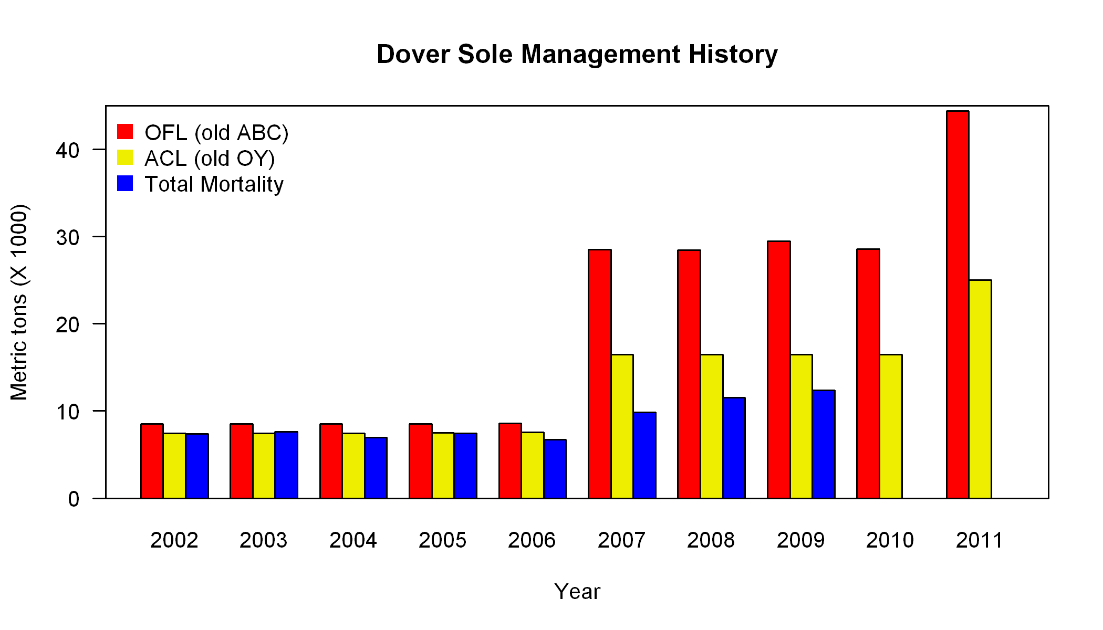

Figure . Recent management history and performance showing the OFL (formerly known as the ABC), the ACL (formerly known as the OY), and the estimated total mortality estimated from landings and discard data (pers. comm., WCGOP program, NWFSC, NMFS) in metric tons for the years 2002 to 2011.

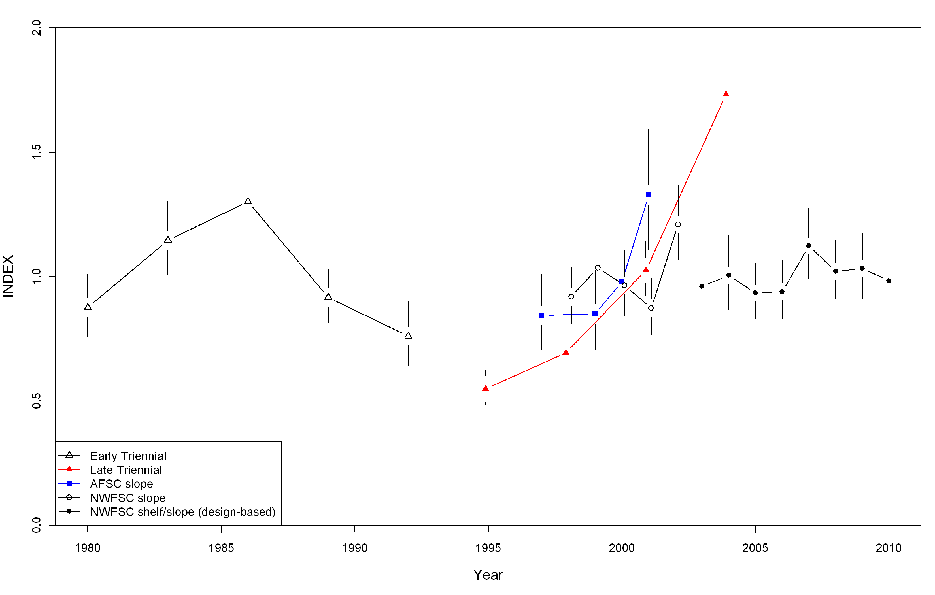

Figure . Survey indices for the four surveys, each centered around 1 for comparison.

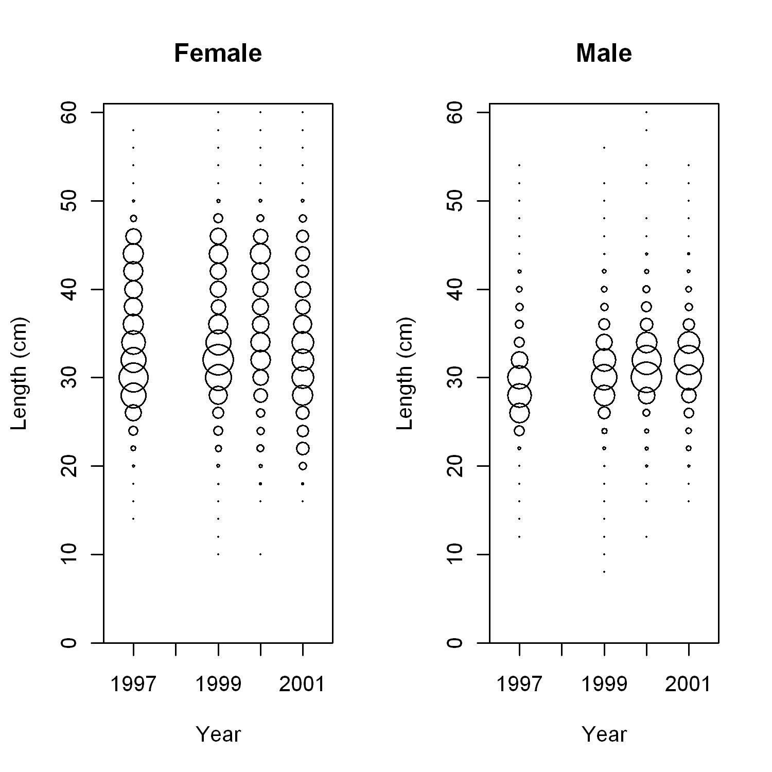

Figure . Expanded length frequencies by 2 cm bins for the AFSC slope survey.



Figure . Survey tow locations in 2004, showing the difference in station design for the NWFSC survey relative to the Triennial trawl survey (Figure from Stewart (2007)).



Figure . Distribution of dates of operation for the triennial survey (1980-2004). Solid bars show the mean date for each survey year, points represent individual hauls dates, but are jittered to allow better delineation of the distribution of individual points (Figure from Stewart (2007)).

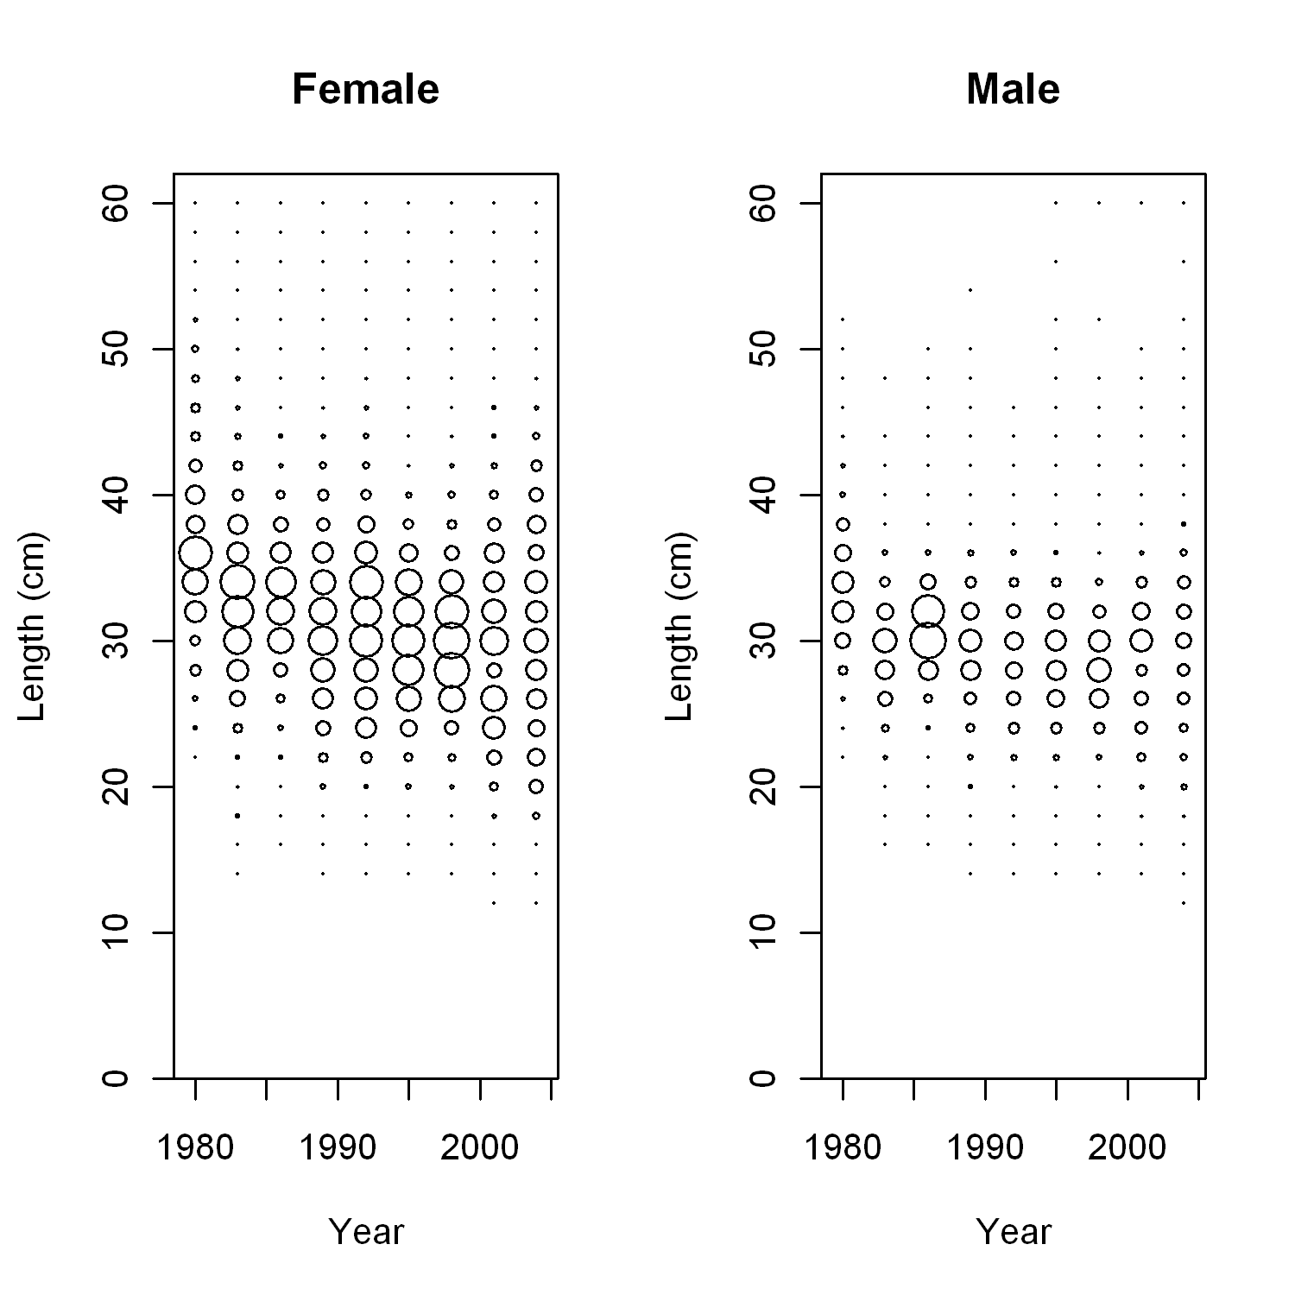

Figure . Expanded length frequencies from the Triennial survey.

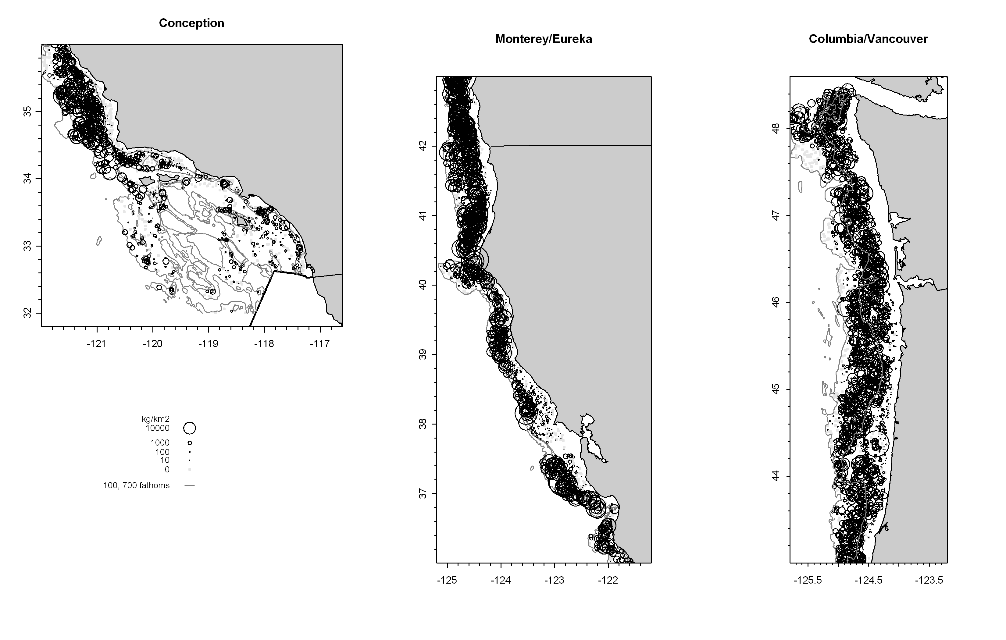

Figure . Catch rates plotted by location for the years 2003–2010 of the NWFSC shelf/slope trawl survey.

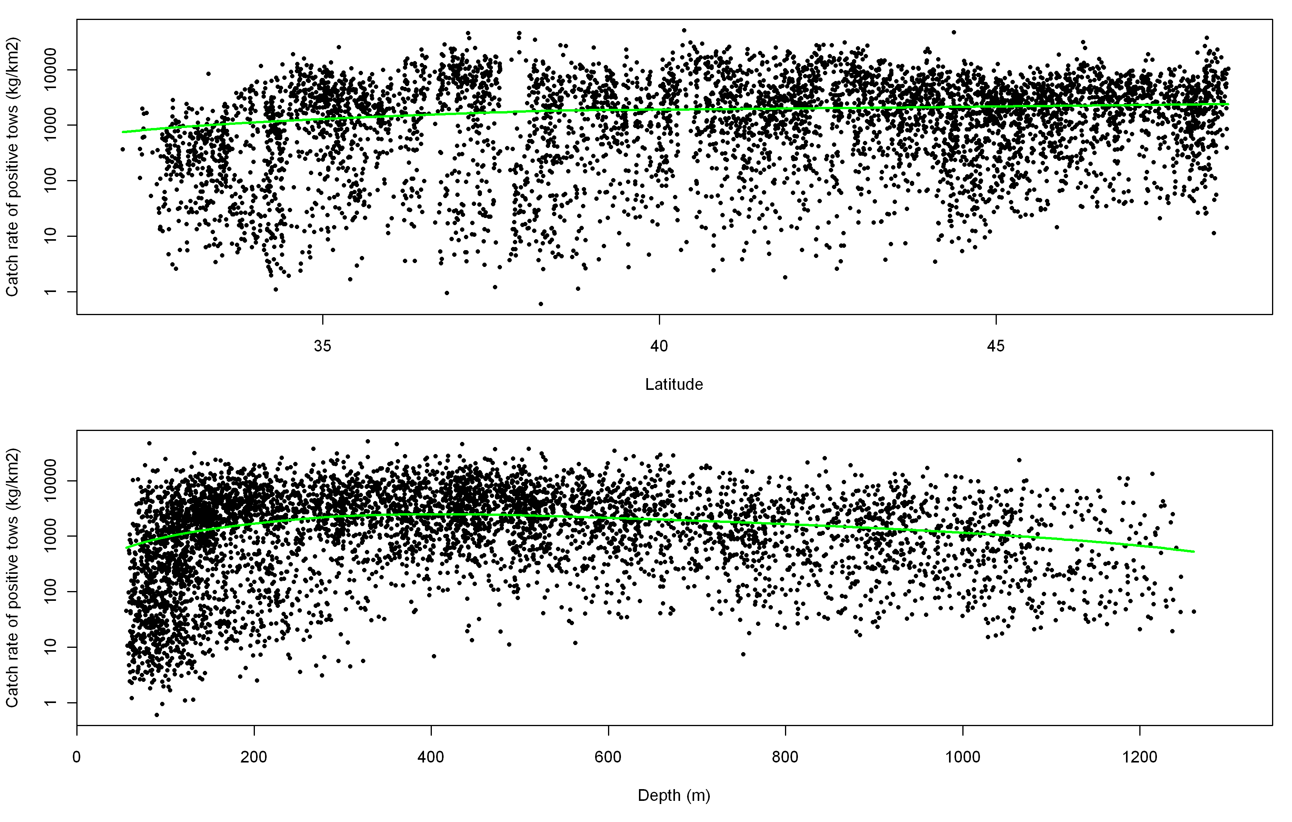

Figure . Catch rate (kg/km2) from the NWFSC shelf/slope survey (2003–2010) plotted over latitude (top) and depth (bottom). The green line is a smoothed line to help define the trends.

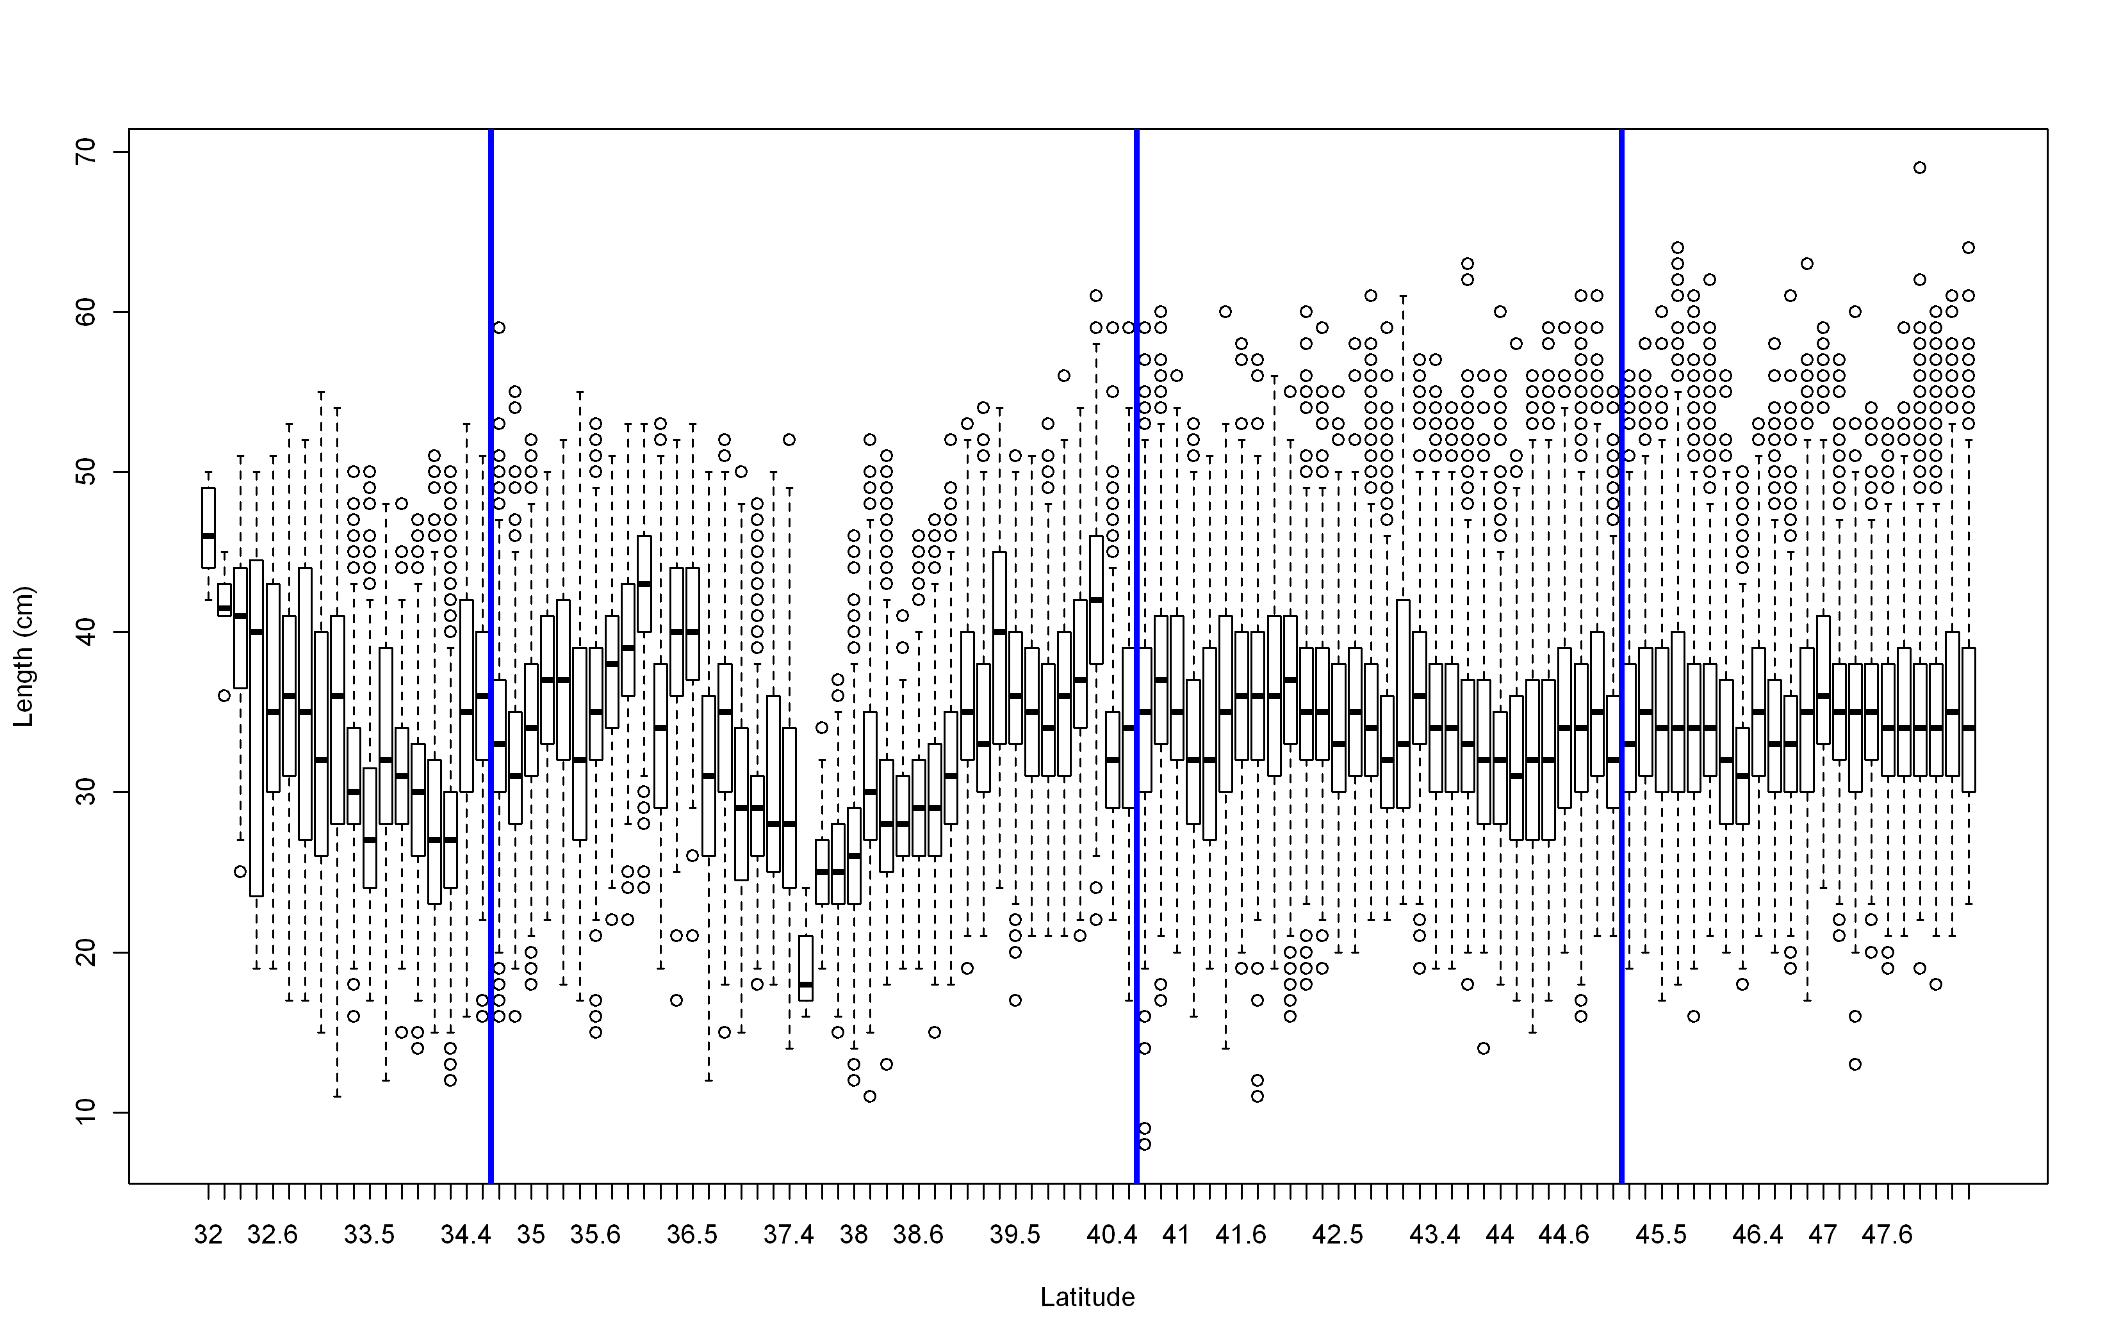

Figure . Boxplots of length from the NWFSC shelf/slope survey (2003–2010) binned by latitude. The vertical blue lines are the strata used in the analysis of these survey data. The most southern break occurs at Point Conception.

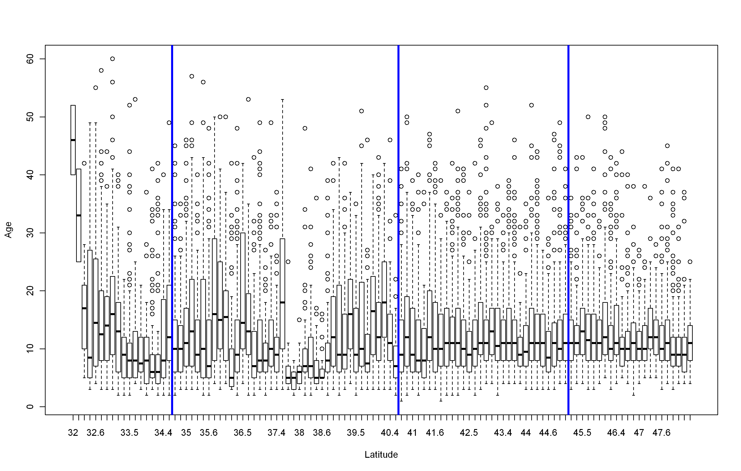

Figure . Boxplots of ages from the NWFSC shelf/slope survey (2003–2010) binned by latitude. The vertical blue lines are the strata used in the analysis of these survey data. The most southern break occurs at Point Conception.

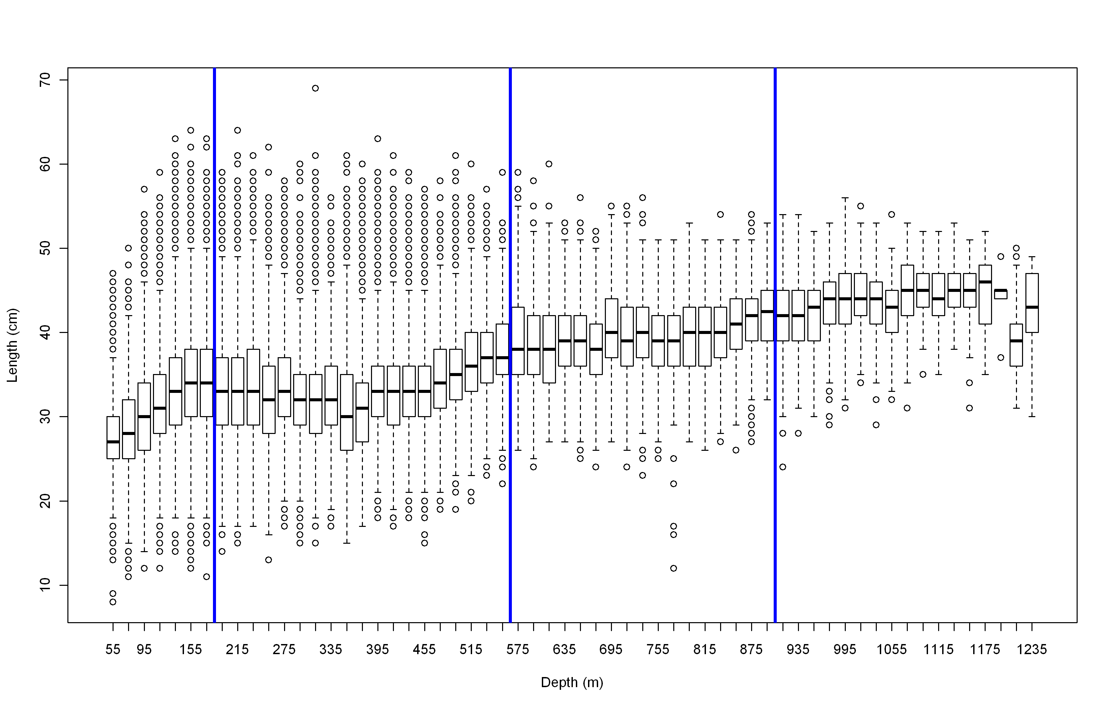

Figure . Boxplots of lengths from the NWFSC shelf/slope survey (2003–2010) by 20 m depth intervals. The vertical blue lines show the depth breaks in the stratification used in this assessment. The depth break at 183 m is considered the shelf/slope break.

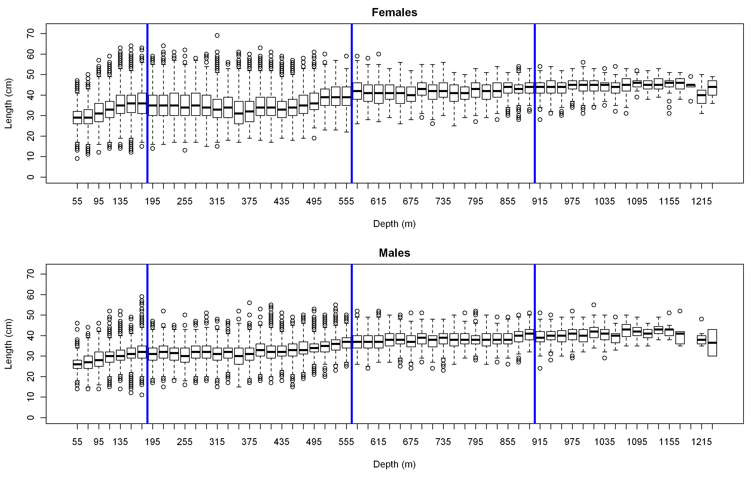

Figure . Lengths from the NWFSC shelf/slope survey (2003–2010) binned by 20 m depth intervals for females (top) and males (bottom). The vertical blue lines show the depth breaks in the stratification used in this assessment. The depth break at 183 m is considered the shelf/slope break.

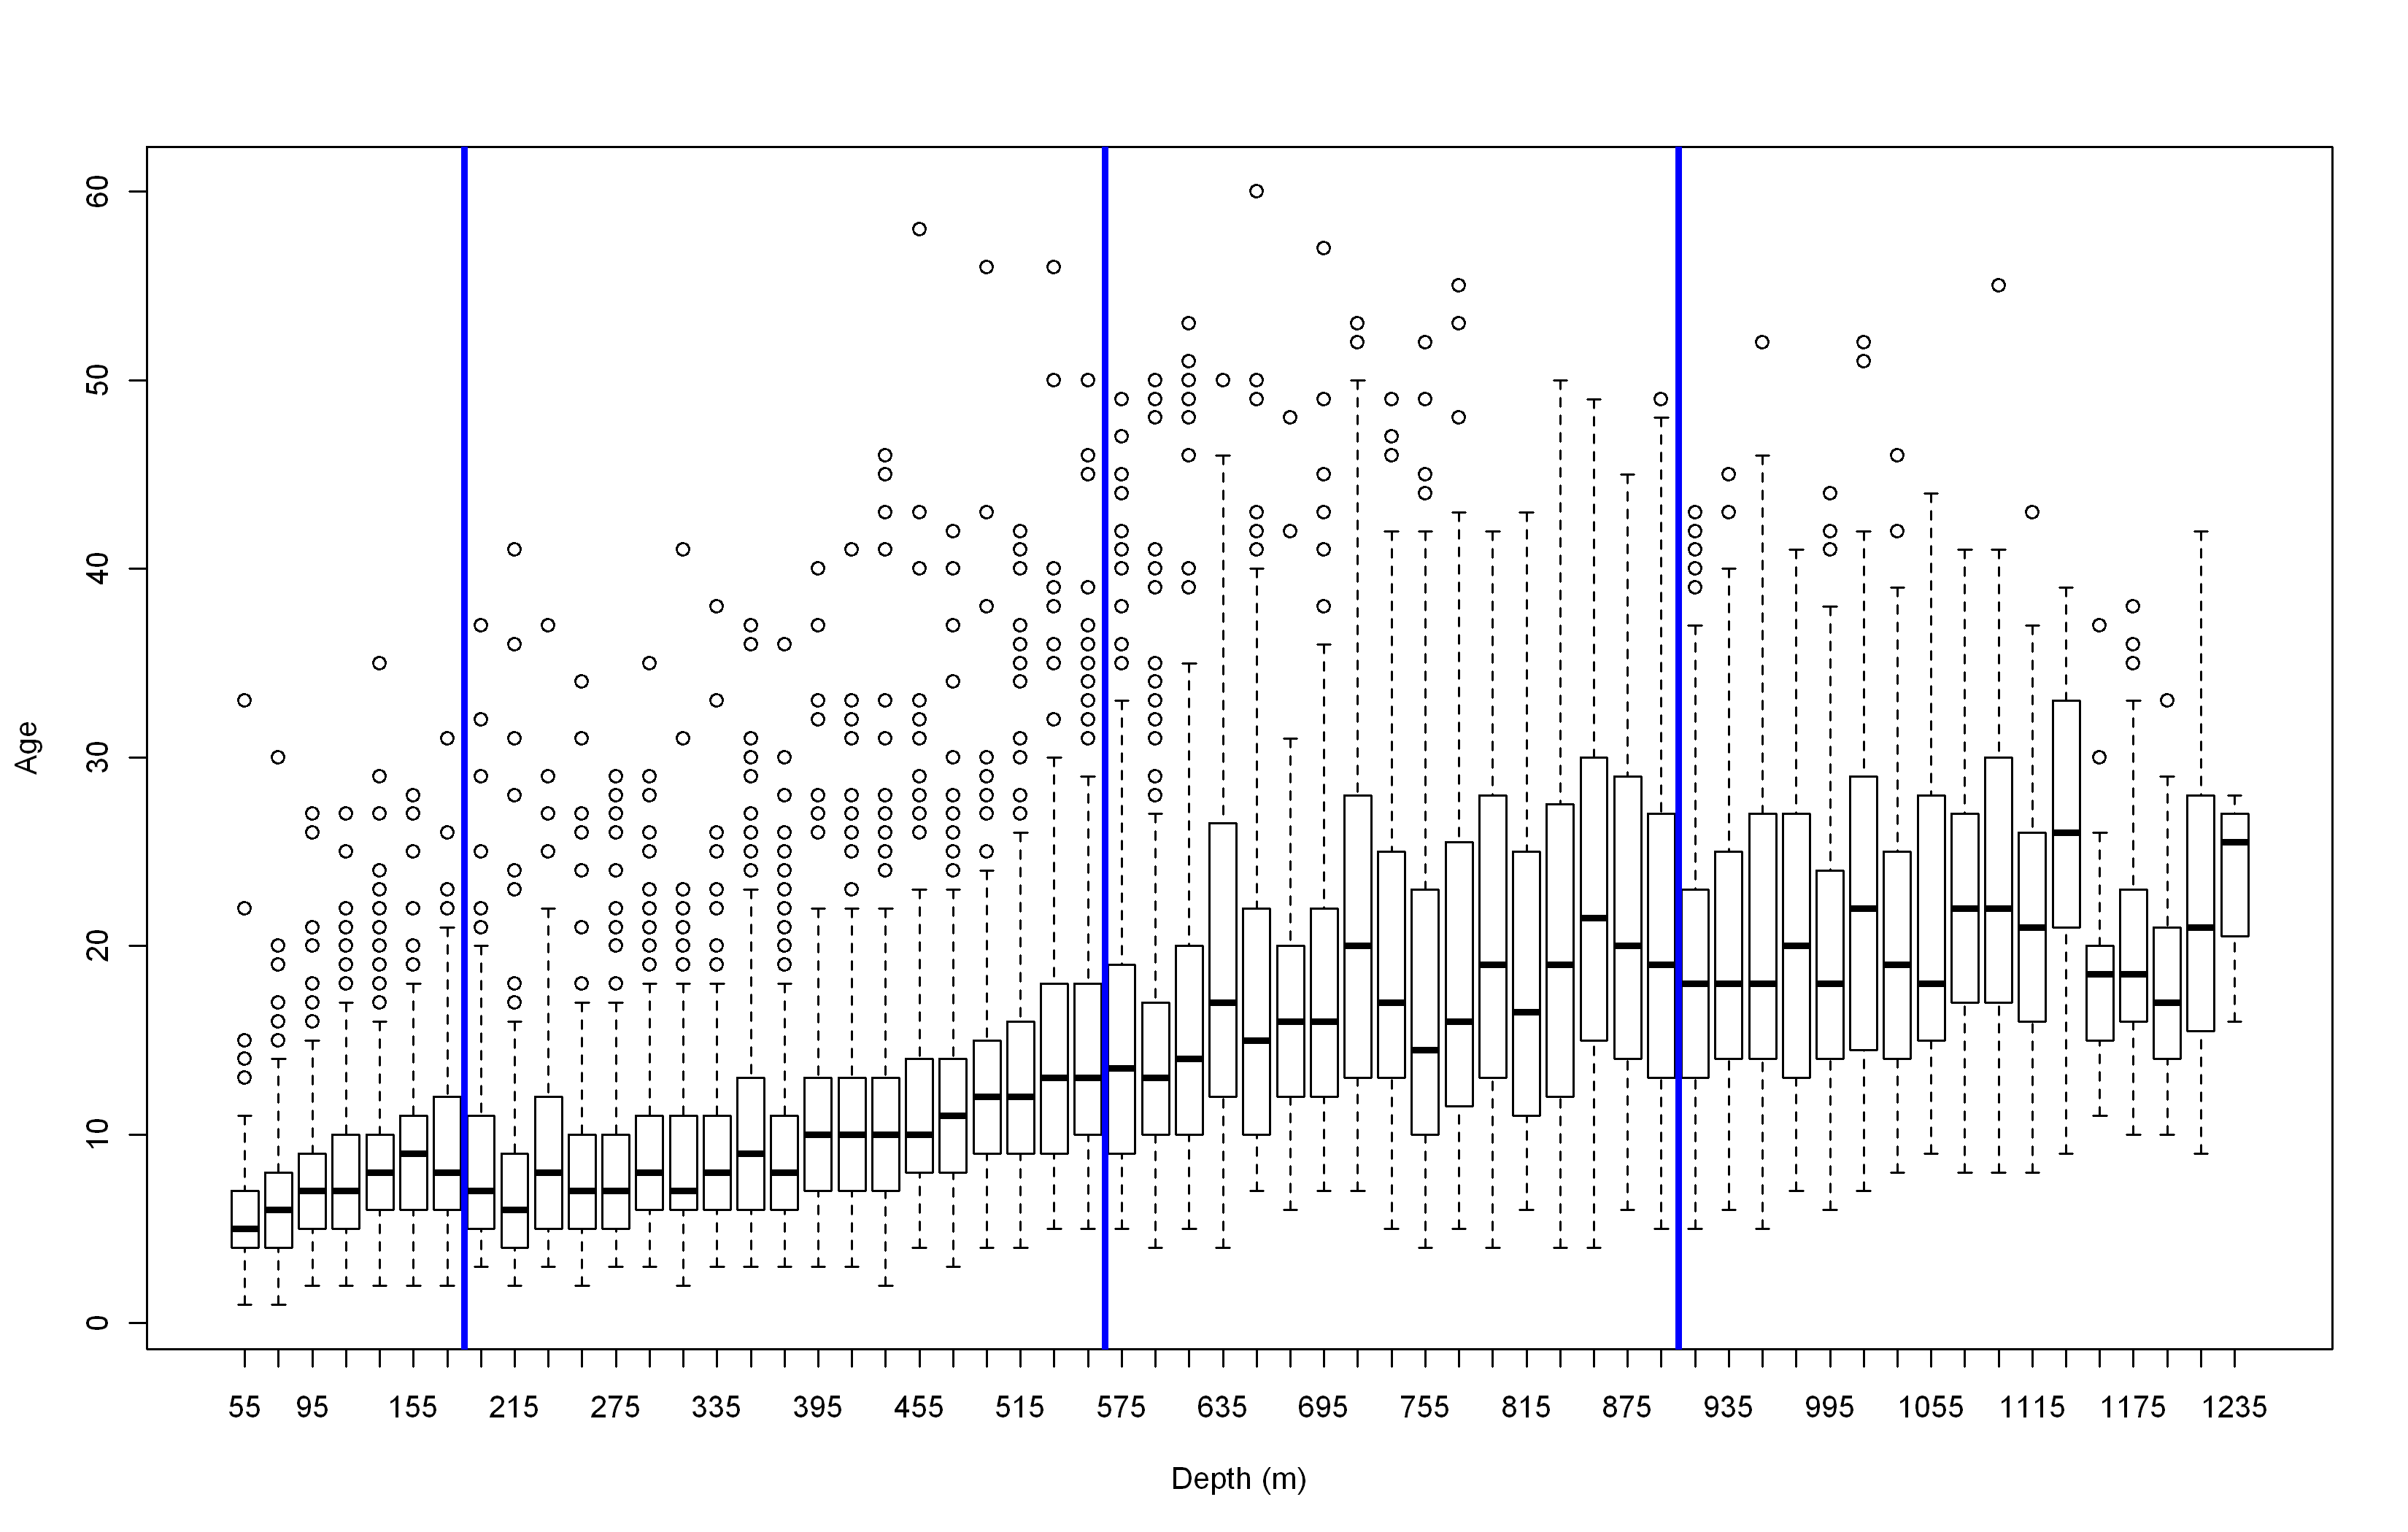

Figure . Boxplots of ages from the NWFSC shelf/slope survey (2003–2010) by 20 m depth intervals. The vertical blue lines show the depth breaks in the stratification used in this assessment. The depth break at 183 m is considered the shelf/slope break.

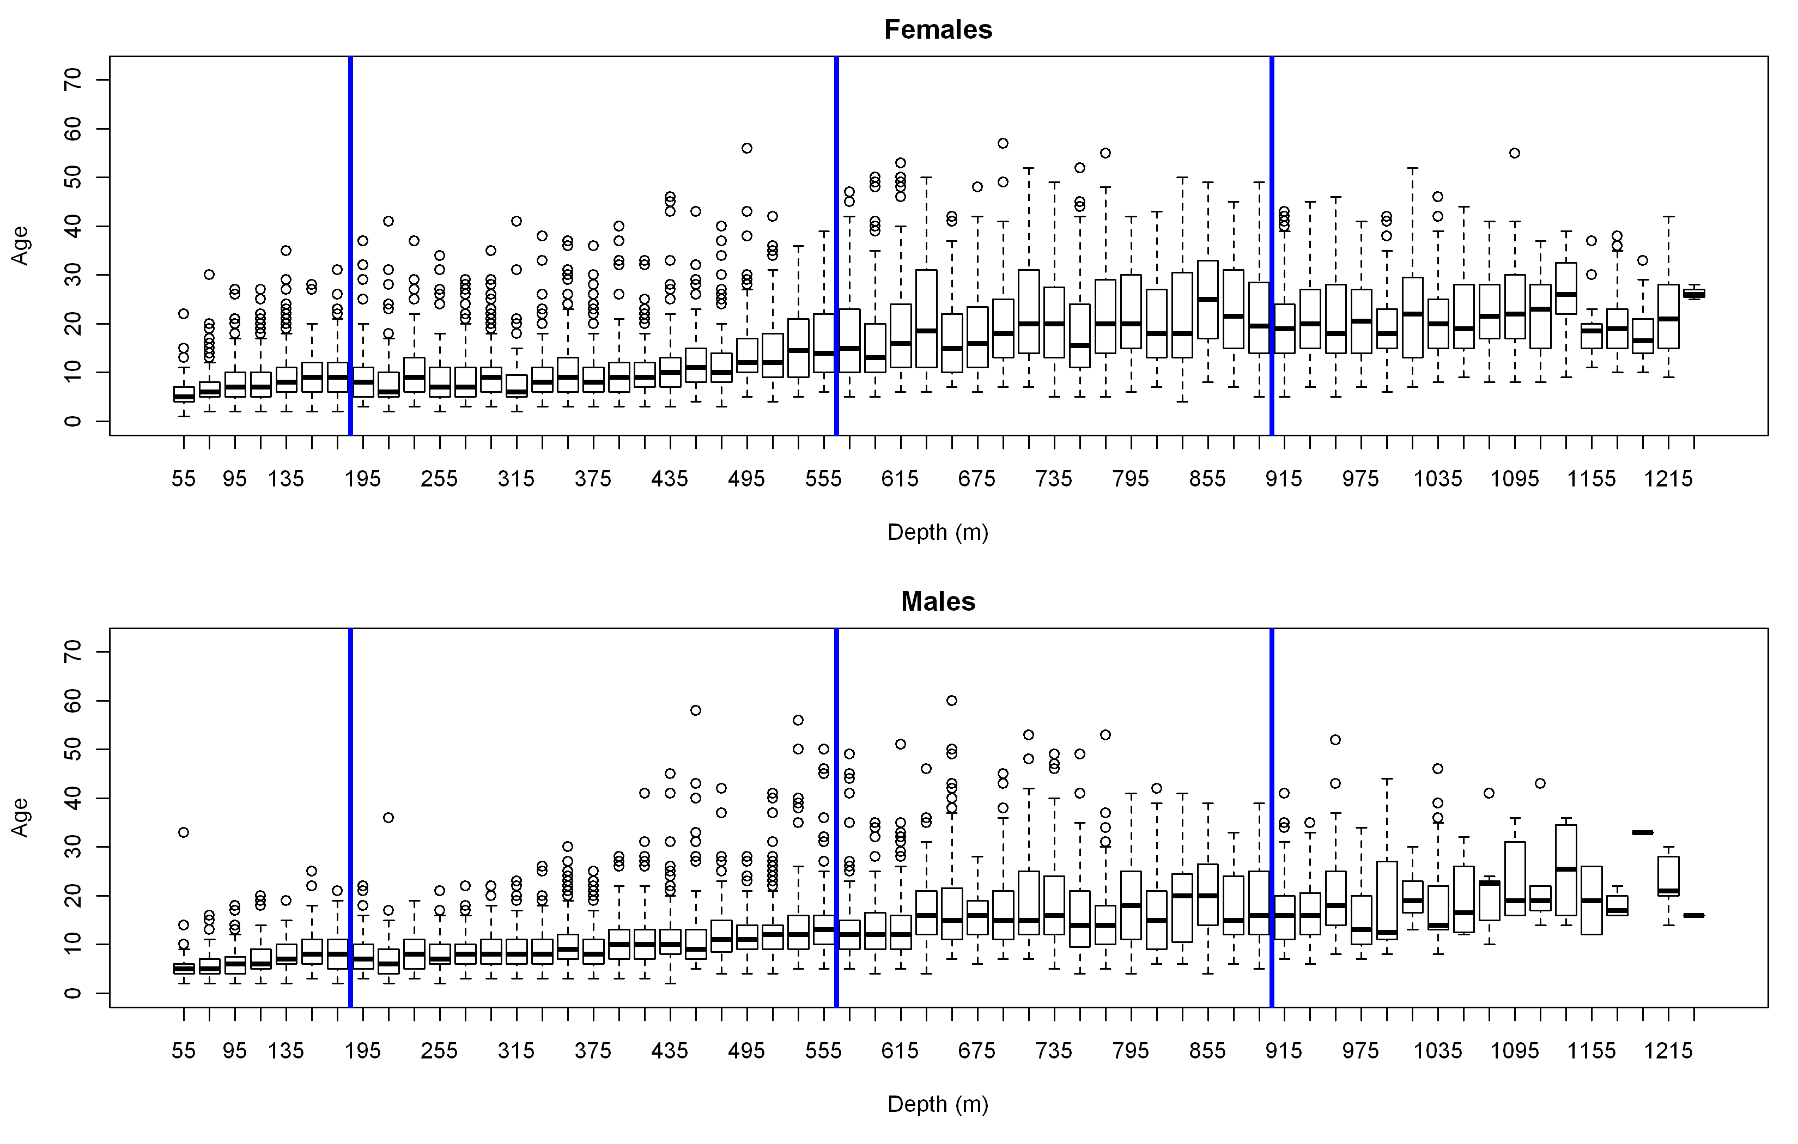

Figure . Ages from the NWFSC shelf/slope survey (2003–2010) binned by 20 m depth intervals for females (top) and males (bottom). The vertical blue lines show the depth breaks in the stratification used in this assessment. The depth break at 183 m is considered the shelf/slope break.

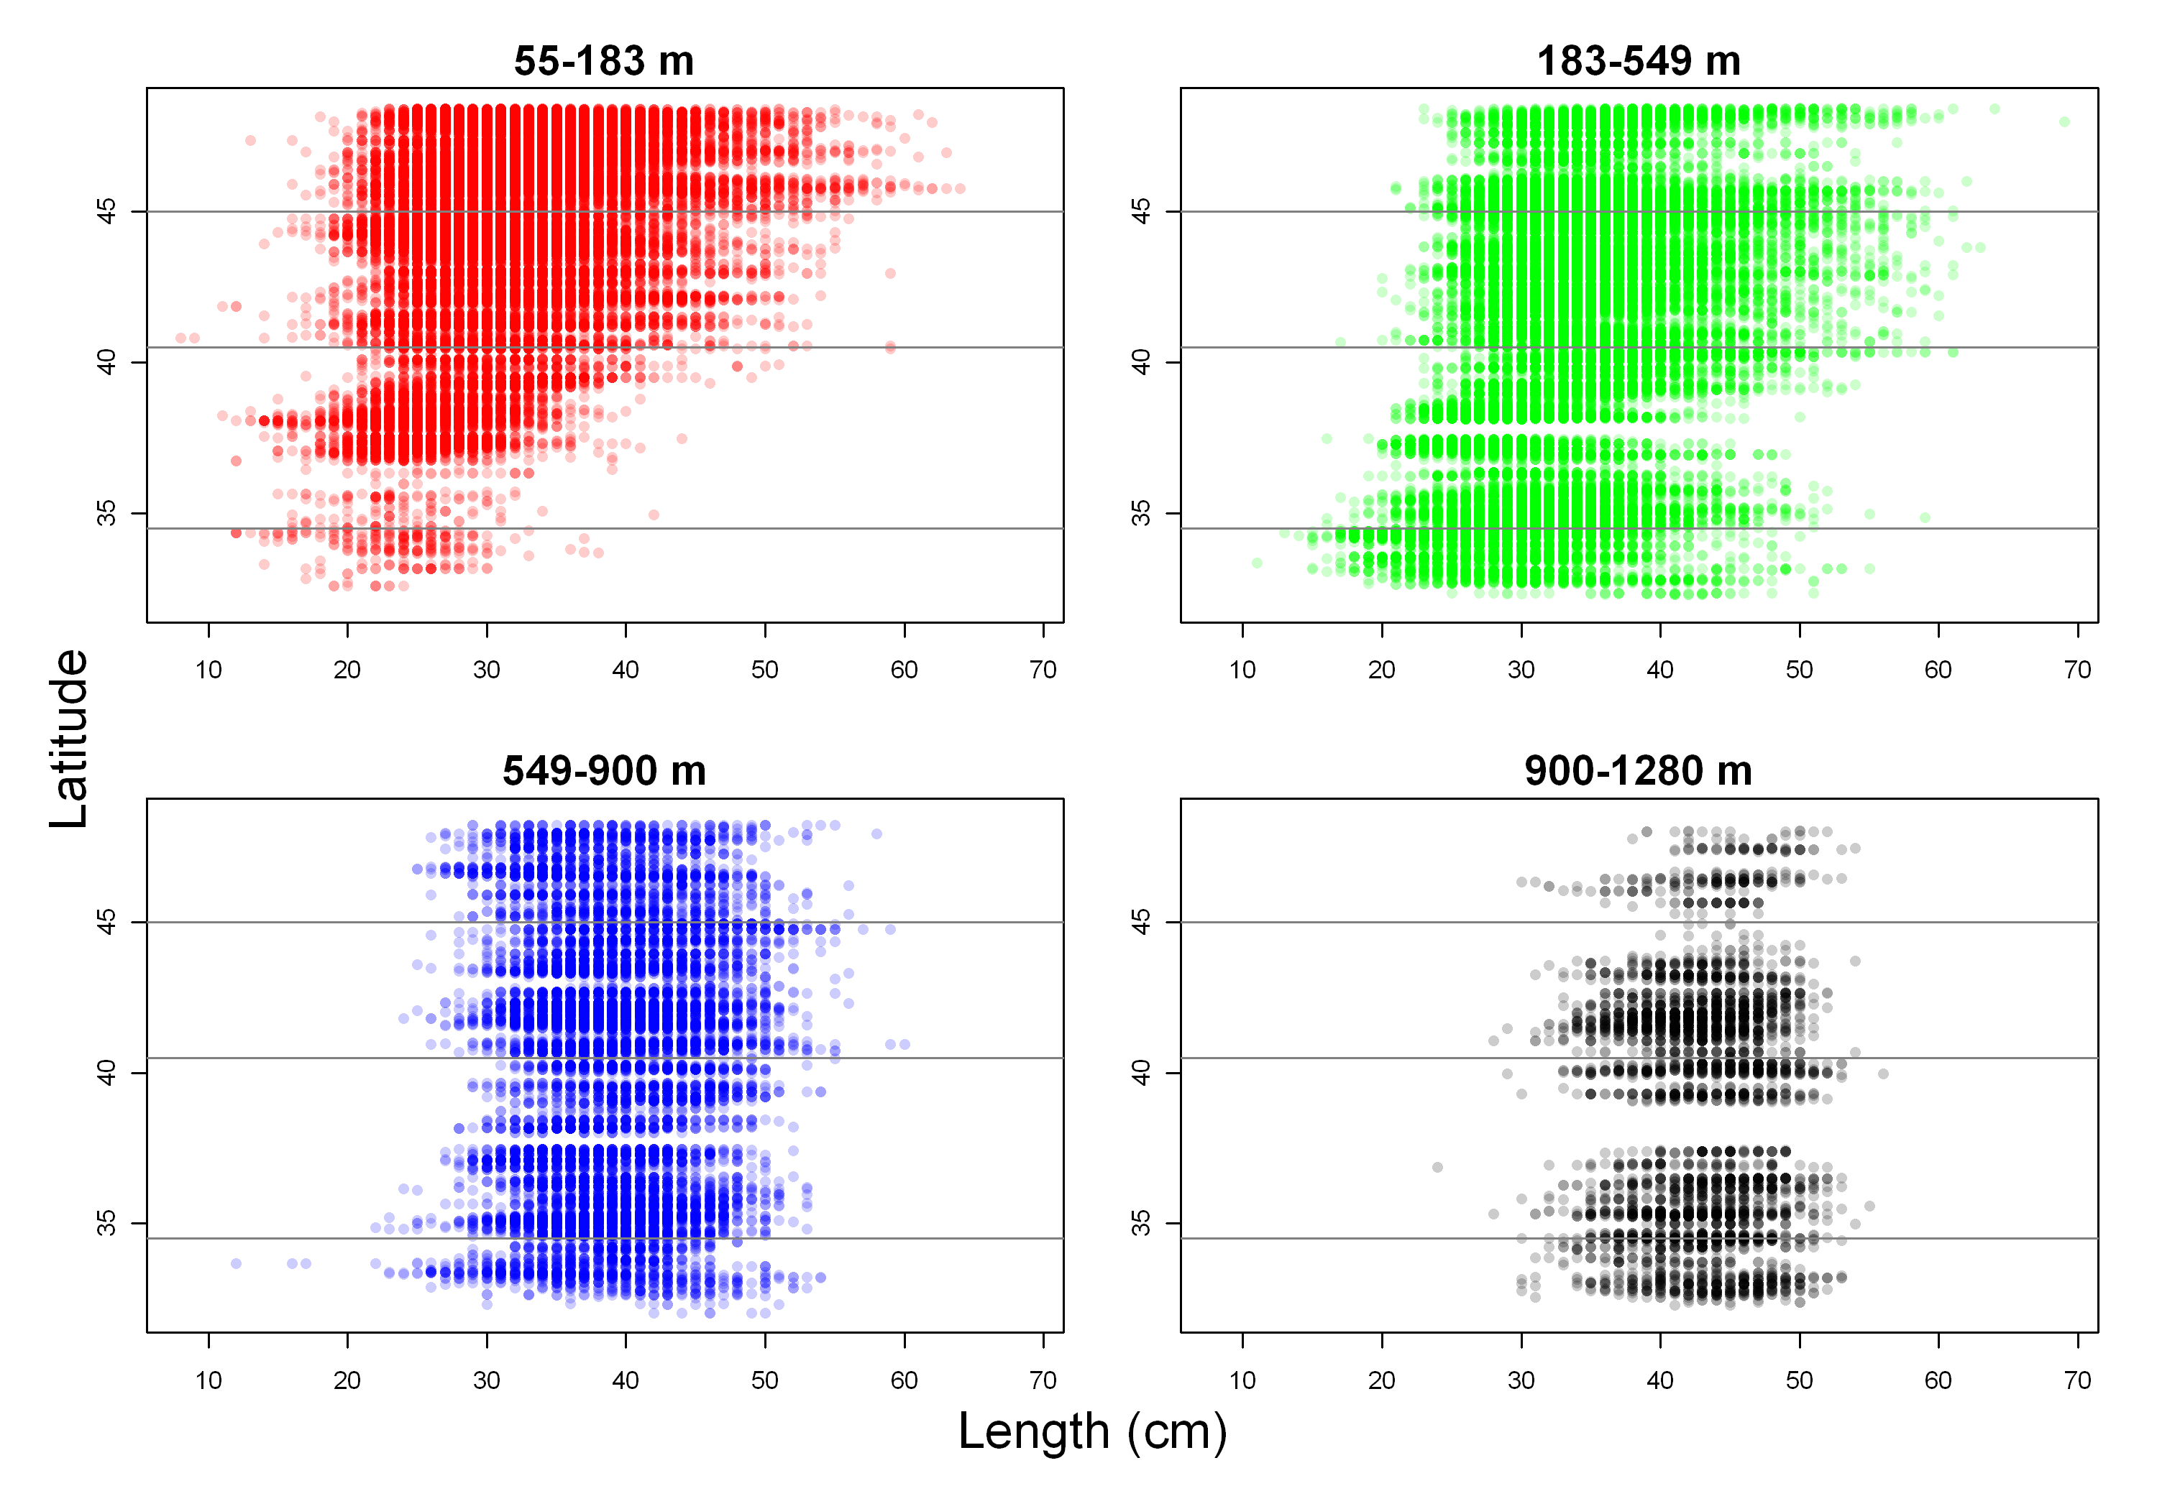

Figure . Length by depth strata (panels) and latitude (y-axis) from the NWFSC shelf/slope survey.

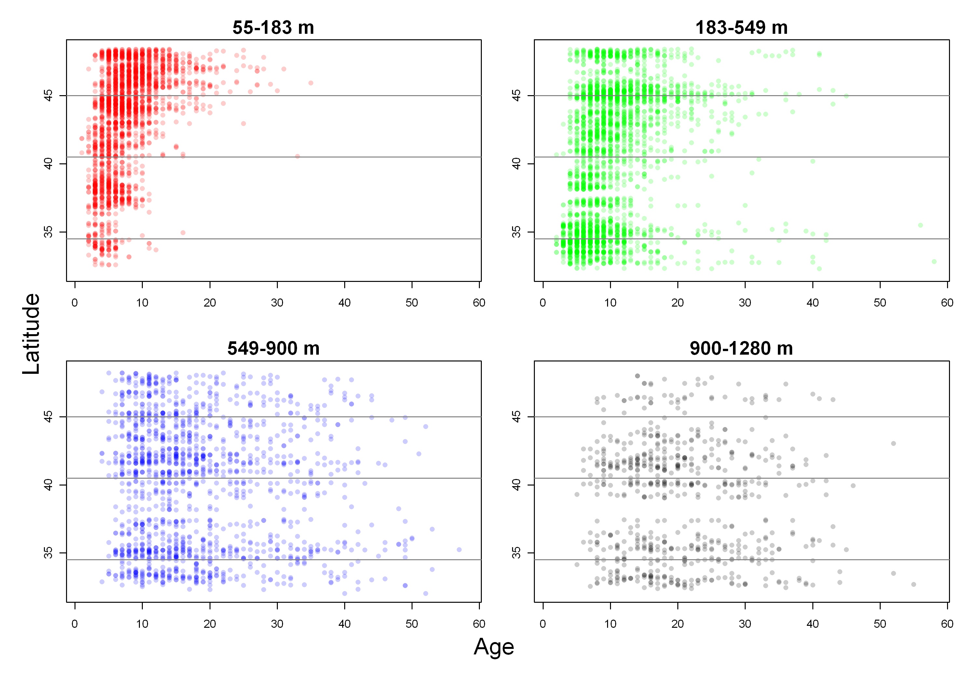

Figure . Age by depth strata (panels) and latitude (y-axis) from the NWFSC shelf/slope survey.



Figure : Area-swept biomass estimates for shelf and slope components of the NWFSC surveys.

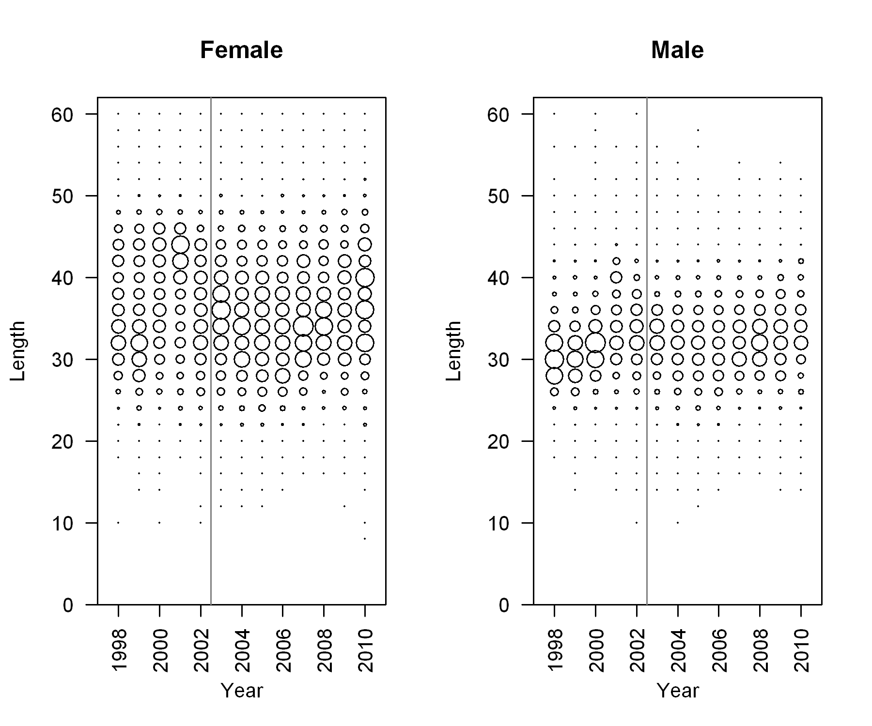

Figure . Length frequencies for the NWFSC surveys. The vertical line separates the slope and shelf/slope surveys.

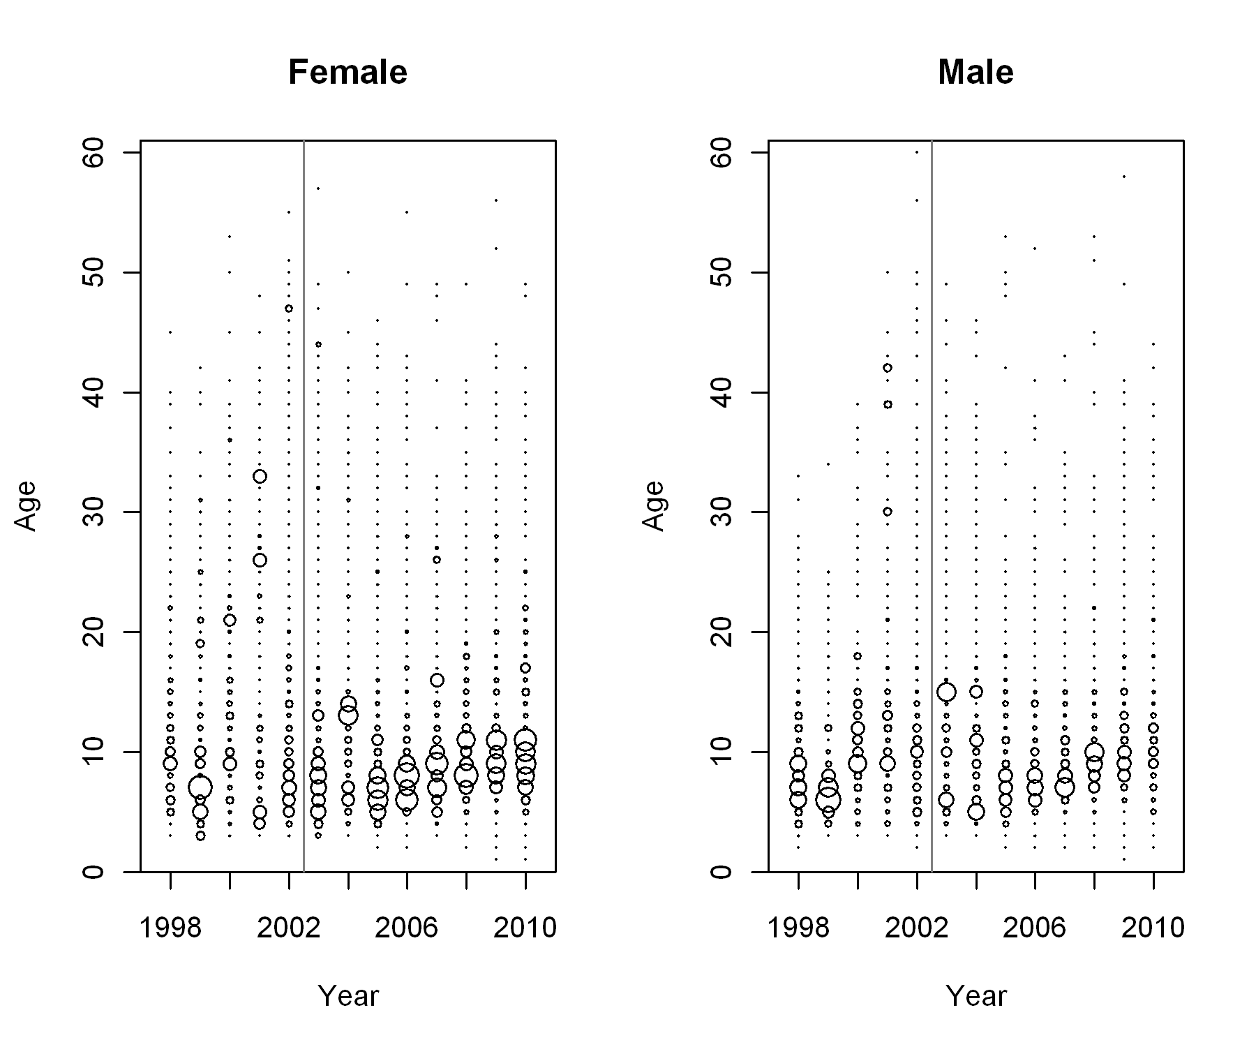

Figure . Expanded age frequencies from the NWFSC surveys. The gray vertical line separates the slope and shelf/slope surveys.



Figure : Length frequencies for the NWFSC slope survey over all depths between 182 m and 1280 m (black), depths between 182 m and 548 m, and depths greater than 548 m. Females are shown on the left and males are shown on the right.

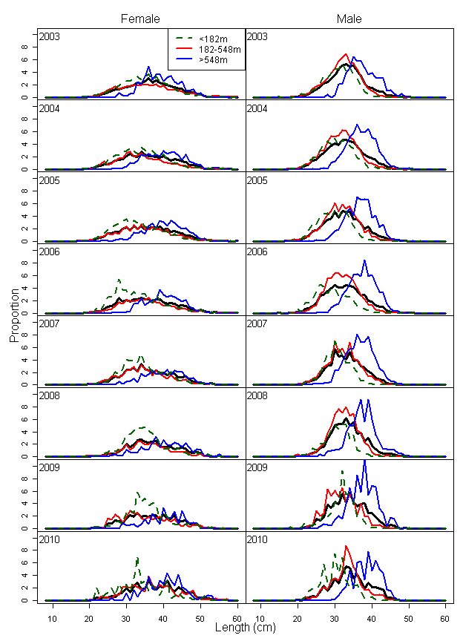

Figure : Length frequencies for the NWFSC shelf/slope survey over all depths between 55 m and 1280 m (black), depths between 55 m and 182 m (green broken line), depths between 182 m and 548 m, and depths greater than 548 m. Females are shown on the left and males are shown on the right

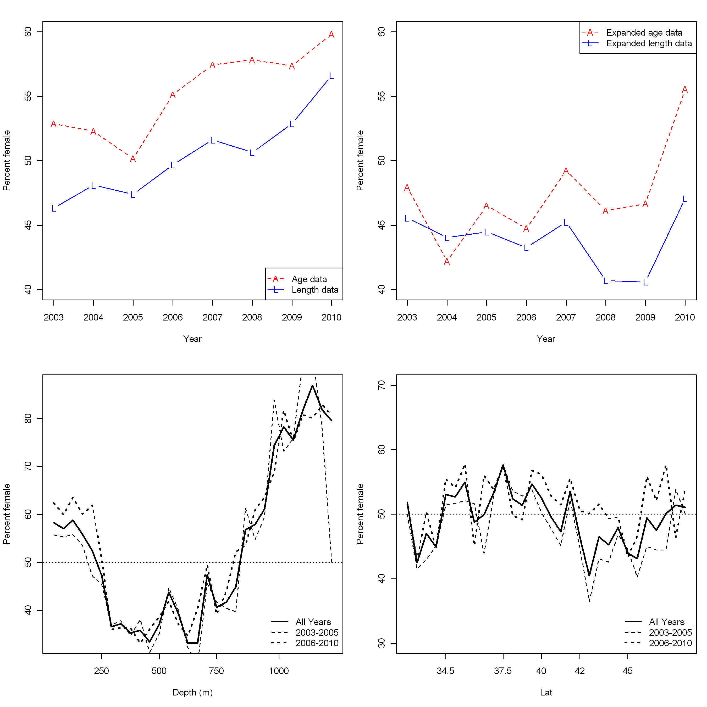

Figure . Sex ratio (as percent female) from the raw age data and length data from the NWFSC shelf/slope survey (top left panel) and the expanded age and length data from the NWFSC shelf/slope survey (top right panel). The bottom panels show the percent females by depth (left) and latitude (right) using the length data from the NWFSC shelf/slope survey. The dashed lines represent early and late periods in the survey series.

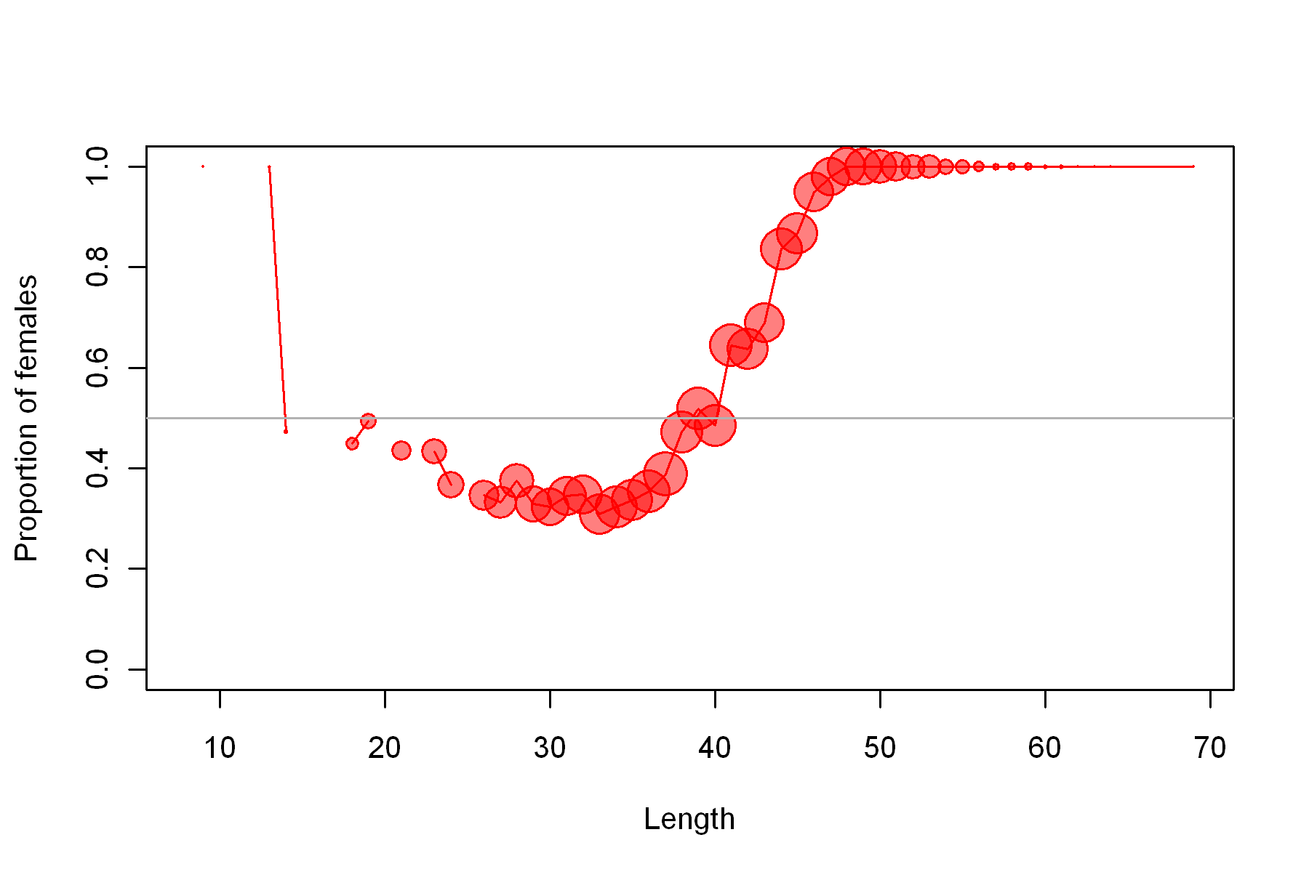

Figure . Sex ratio by length from the NWFSC shelf/slope survey. The line represents the median sex ratio for that length over all tows that recorded lengths of Dover sole. The circles indicate the number of observations at that length with bigger circles representing more samples.

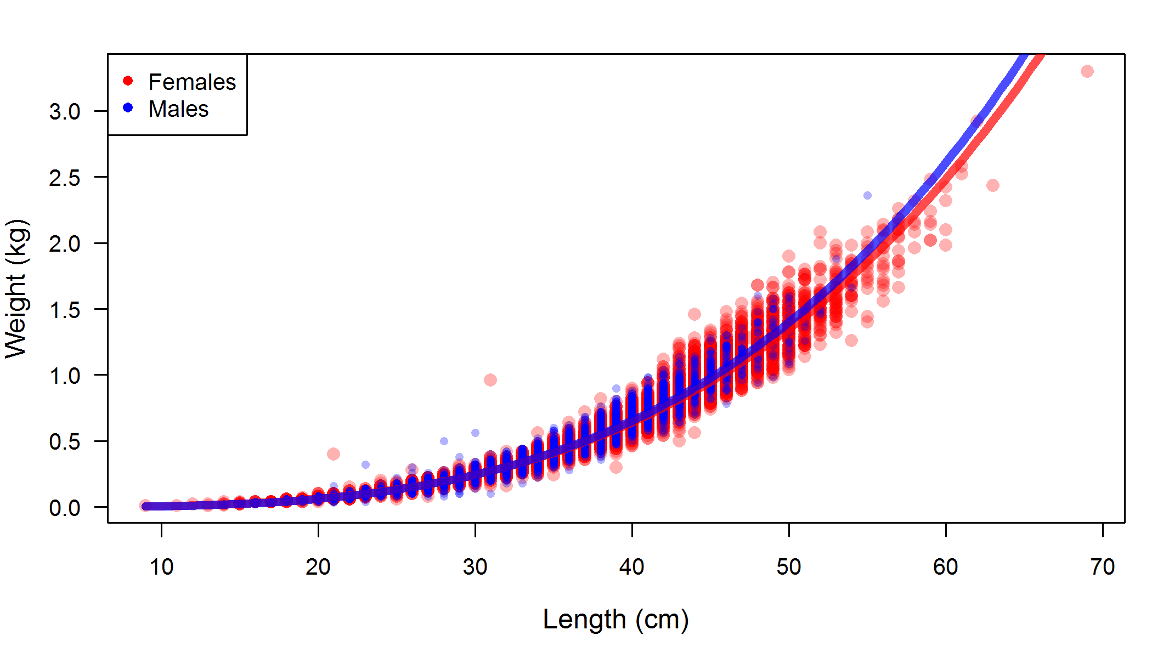

Figure . Weight-length relationship from NWFSC shelf/slope survey data.

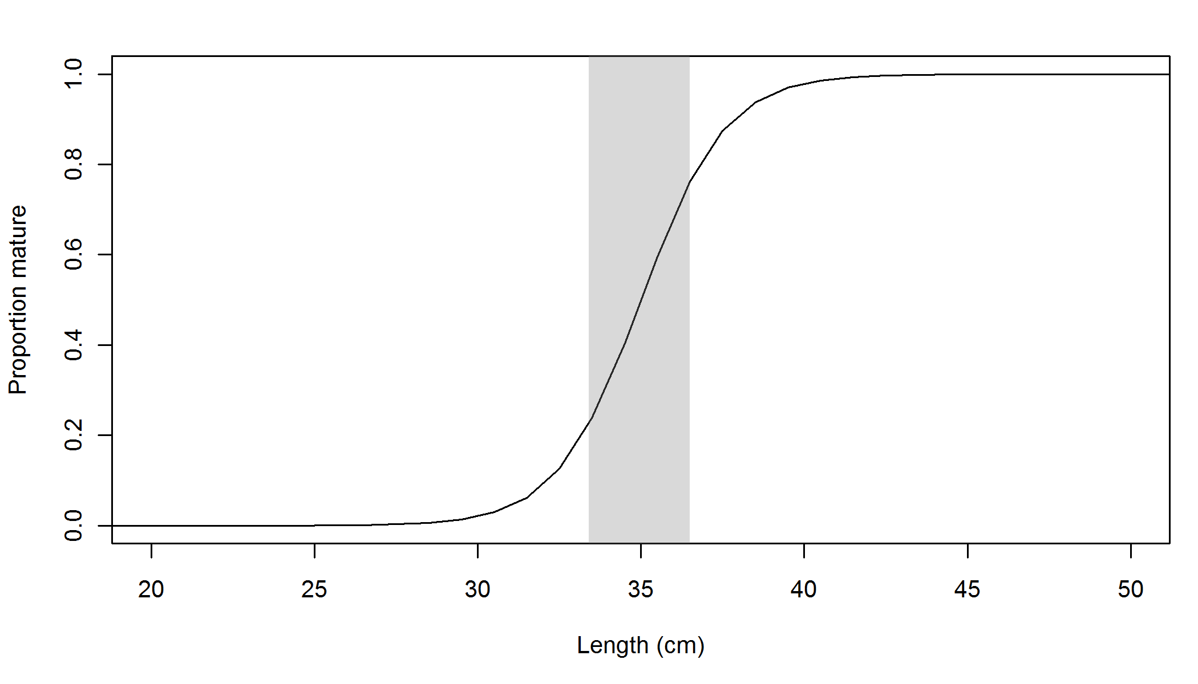

Figure . Maturity curve used in the 2011 base case assessment. The grey box shows the range of length at 50% mature used in the 2005 assessment.

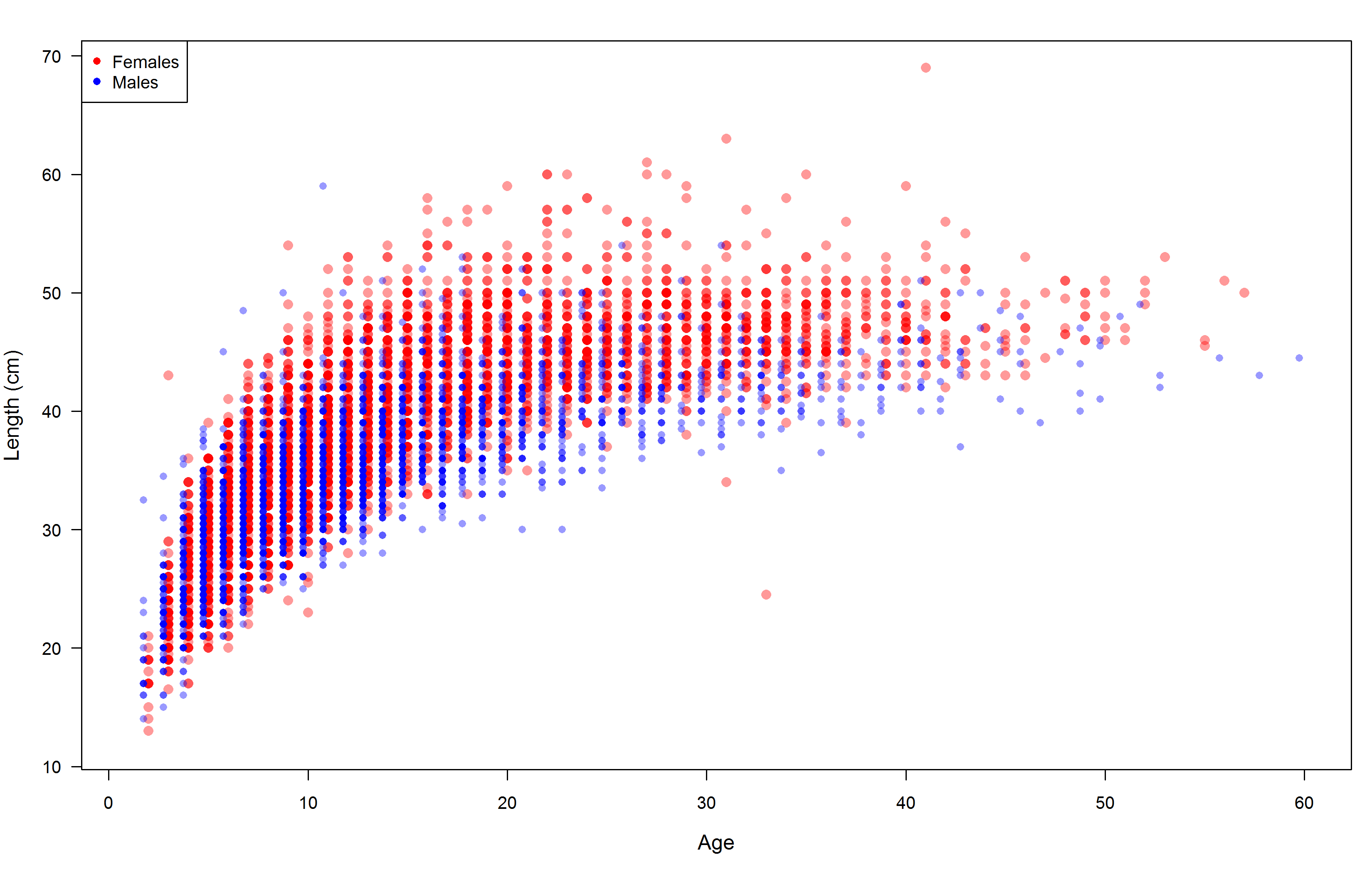

Figure . Length-at-age observations for the NWFSC shelf/slope survey (2003–2010).

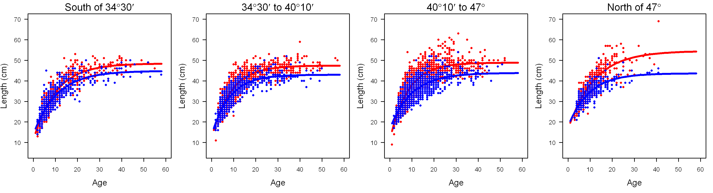

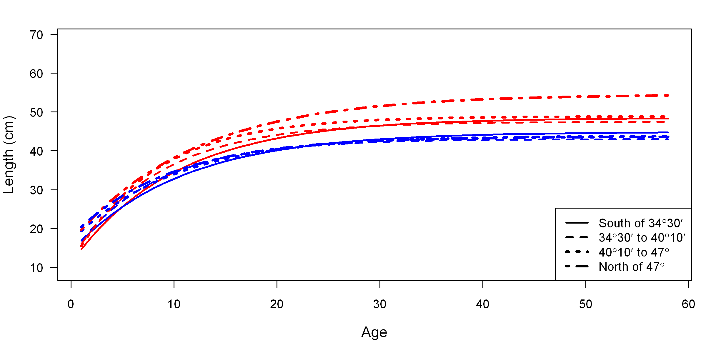

Figure . Length at age observations and fitted von Bertalanffy growth curves by latitudinal areas. Red lines and points indicate female observations and fits while blue lines and points indicate male observations and fits.

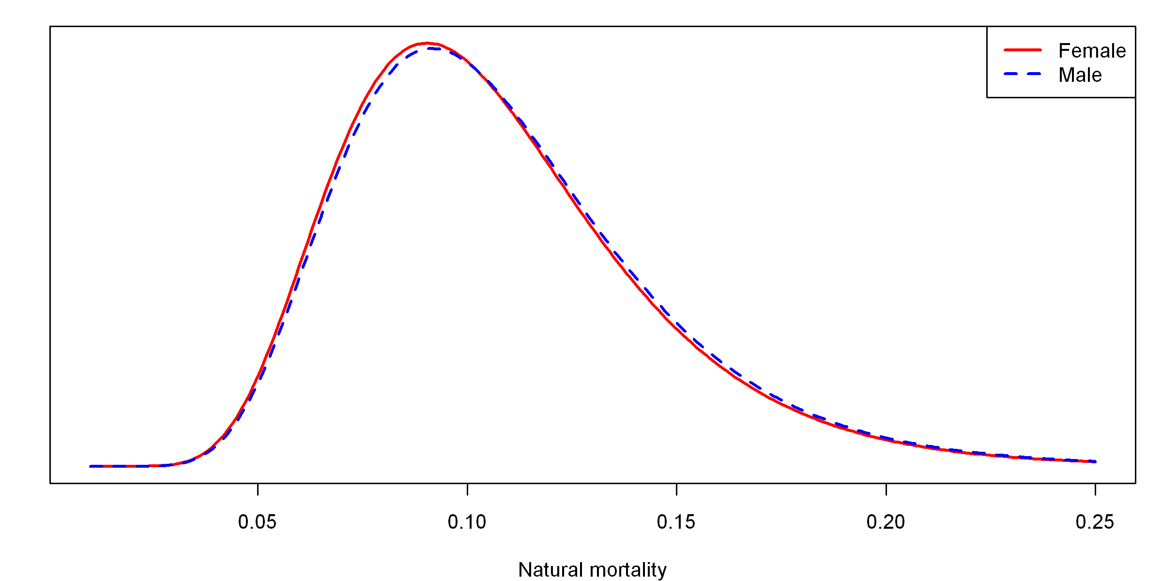

Figure . Prior distributions for female and male natural mortality parameters.

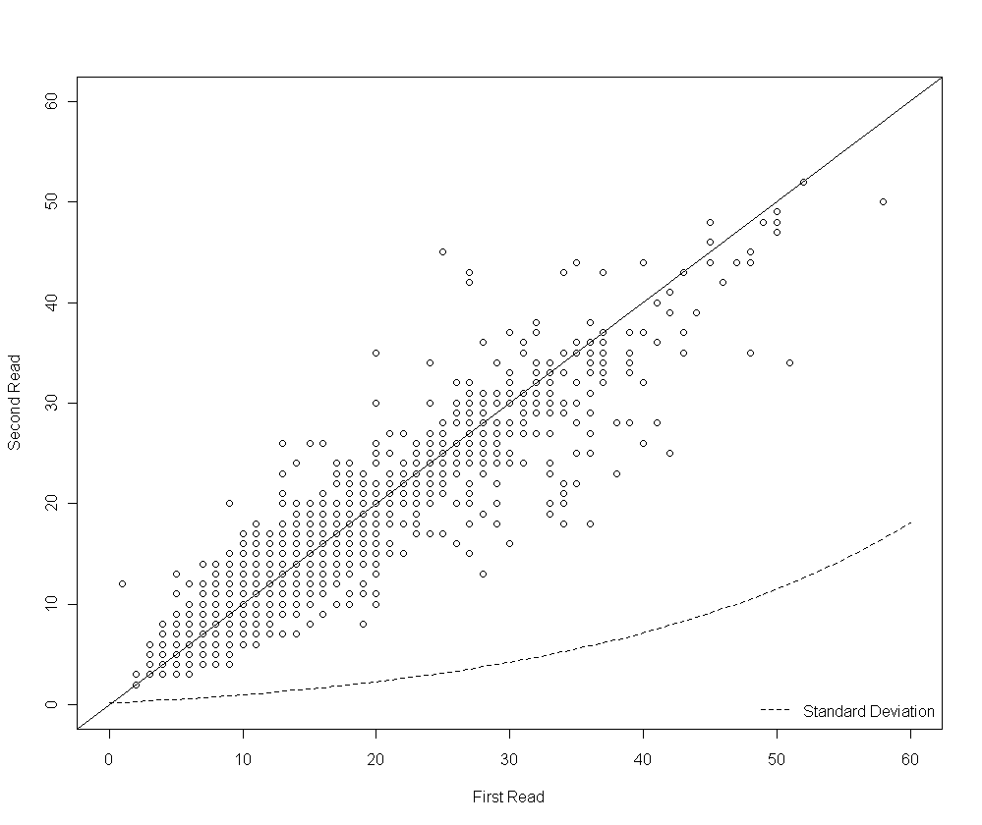

Figure . Ageing double-reads by break and burn by the Cooperative Ageing Project (CAP) laboratory with the estimated standard deviation by age (dashed line).

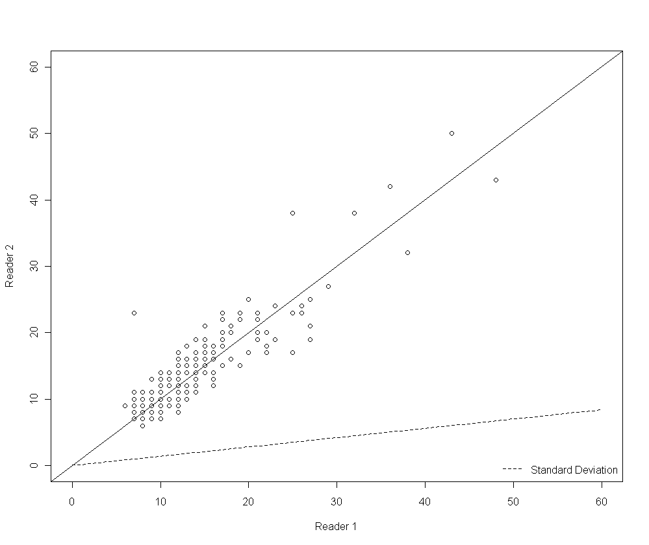

Figure . Ageing double-reads by break and burn by California with the estimated standard deviation by age (dashed line).

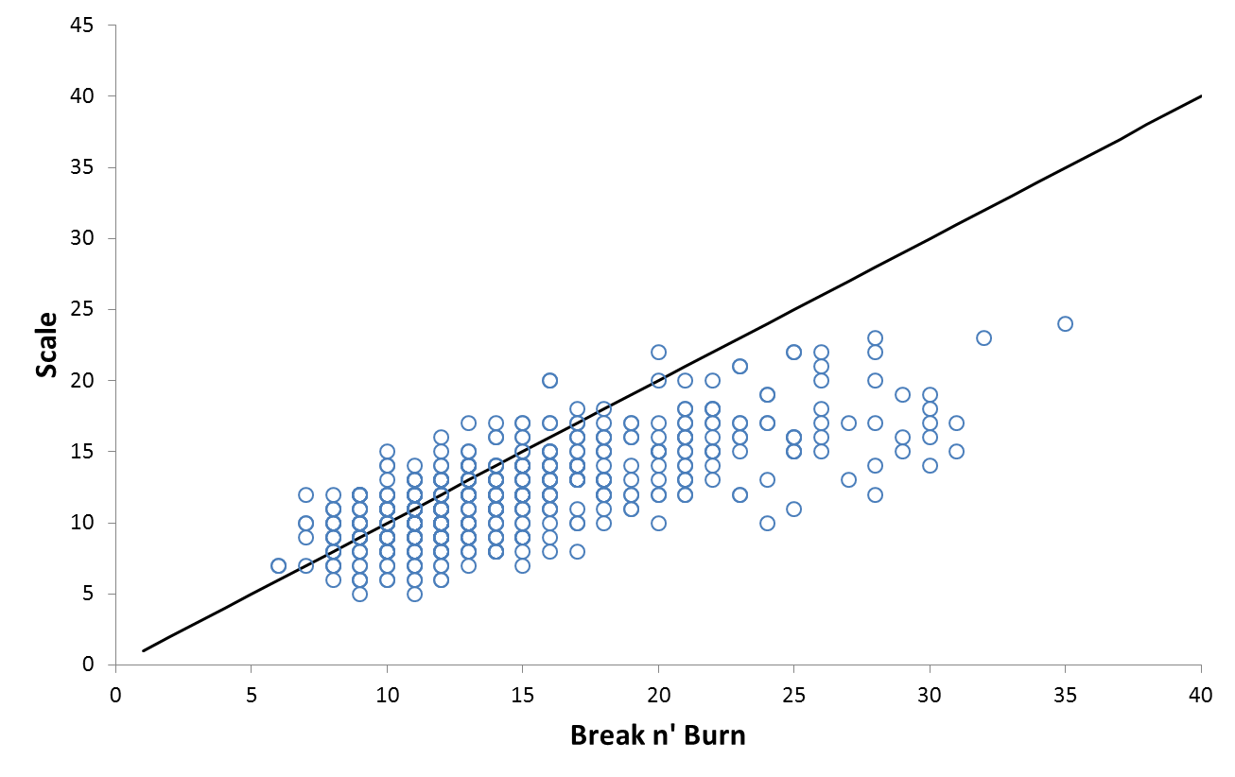

Figure . Ageing double-reads by break and burn and scale reads.

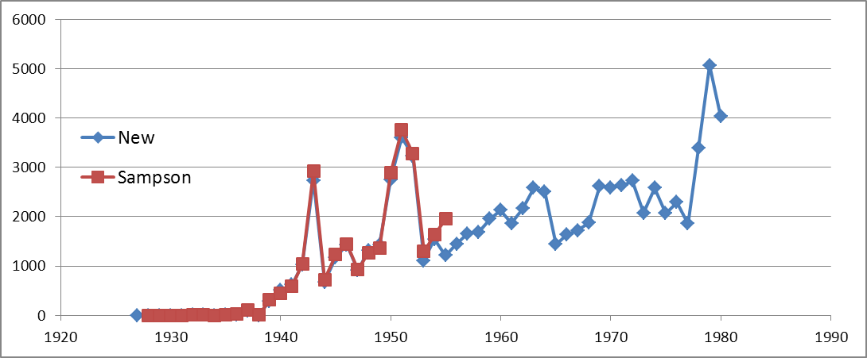

Figure . A comparison of the Oregon reconstructed landings with the landings used in the 2005 assessment (Sampson 2005).

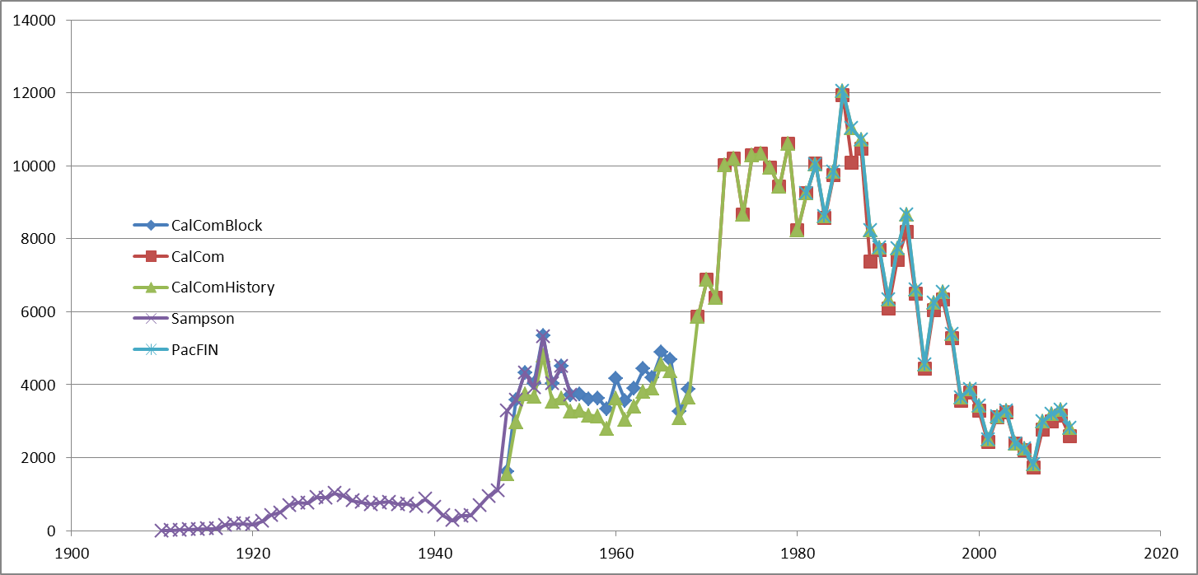

Figure . A comparison of California landings of Dover sole obtained from CALCOM, PacFIN, and the 2005 assessment (Sampson 2005).

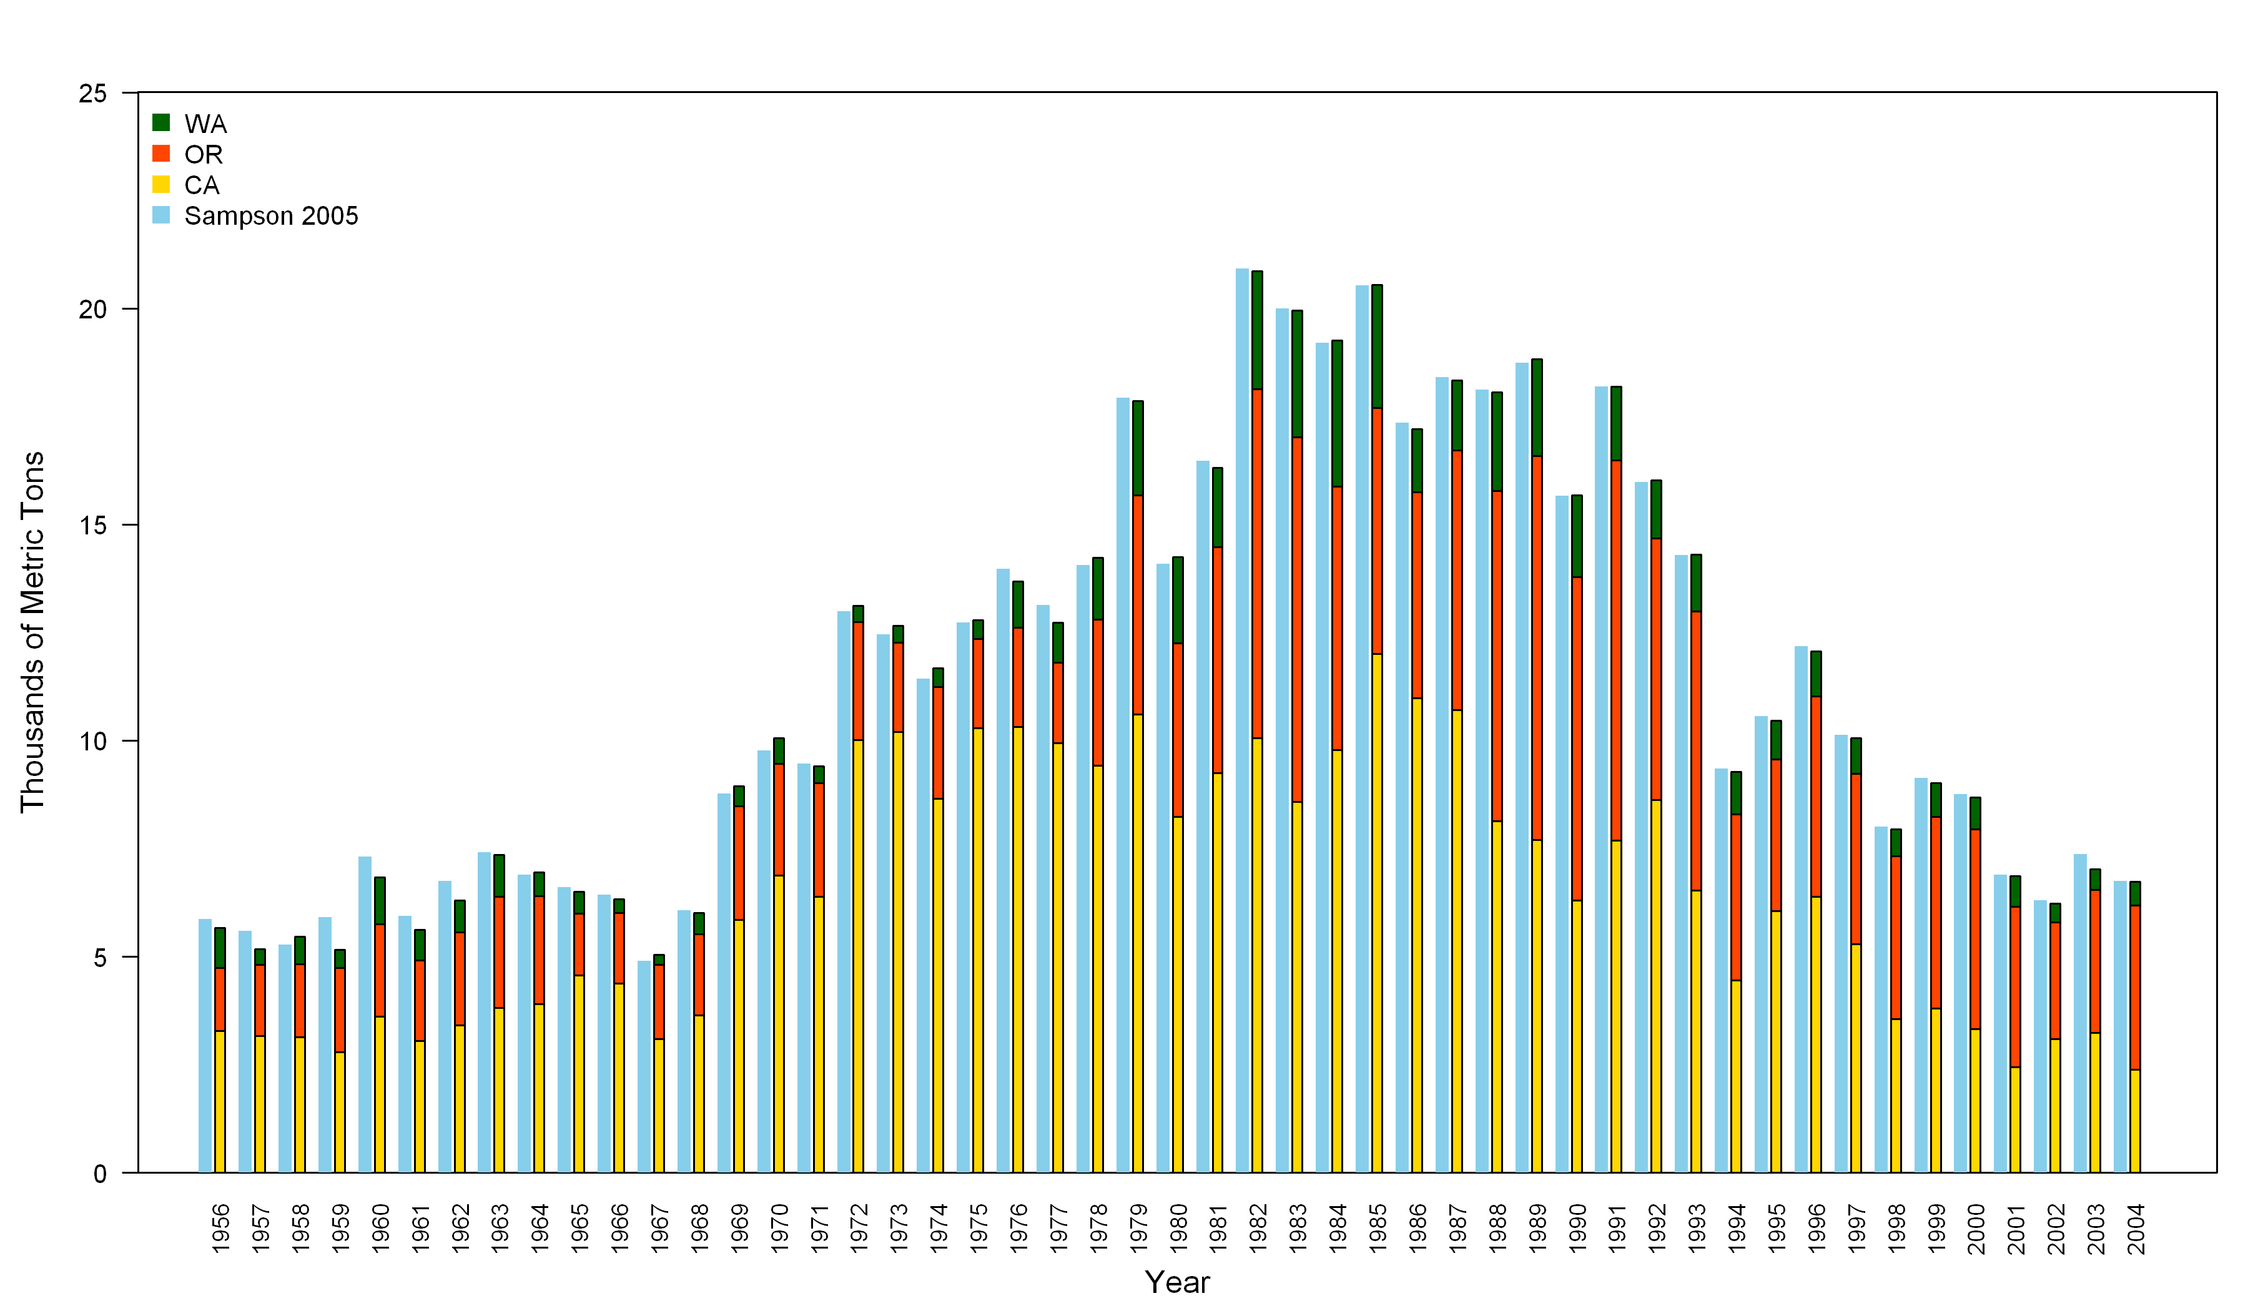

Figure . Coastwide landings used in this assessment from 1956 to 2004 compared to the landings used in the 2005 assessment (Sampson 2005) shown in light blue bars.



Figure . Ratio of discards to total catch by area for three different depths.



Figure . Catch weighted average weight of discards by area for three different depths



Figure : Catch weighted mean length of discards by area for three different depths.

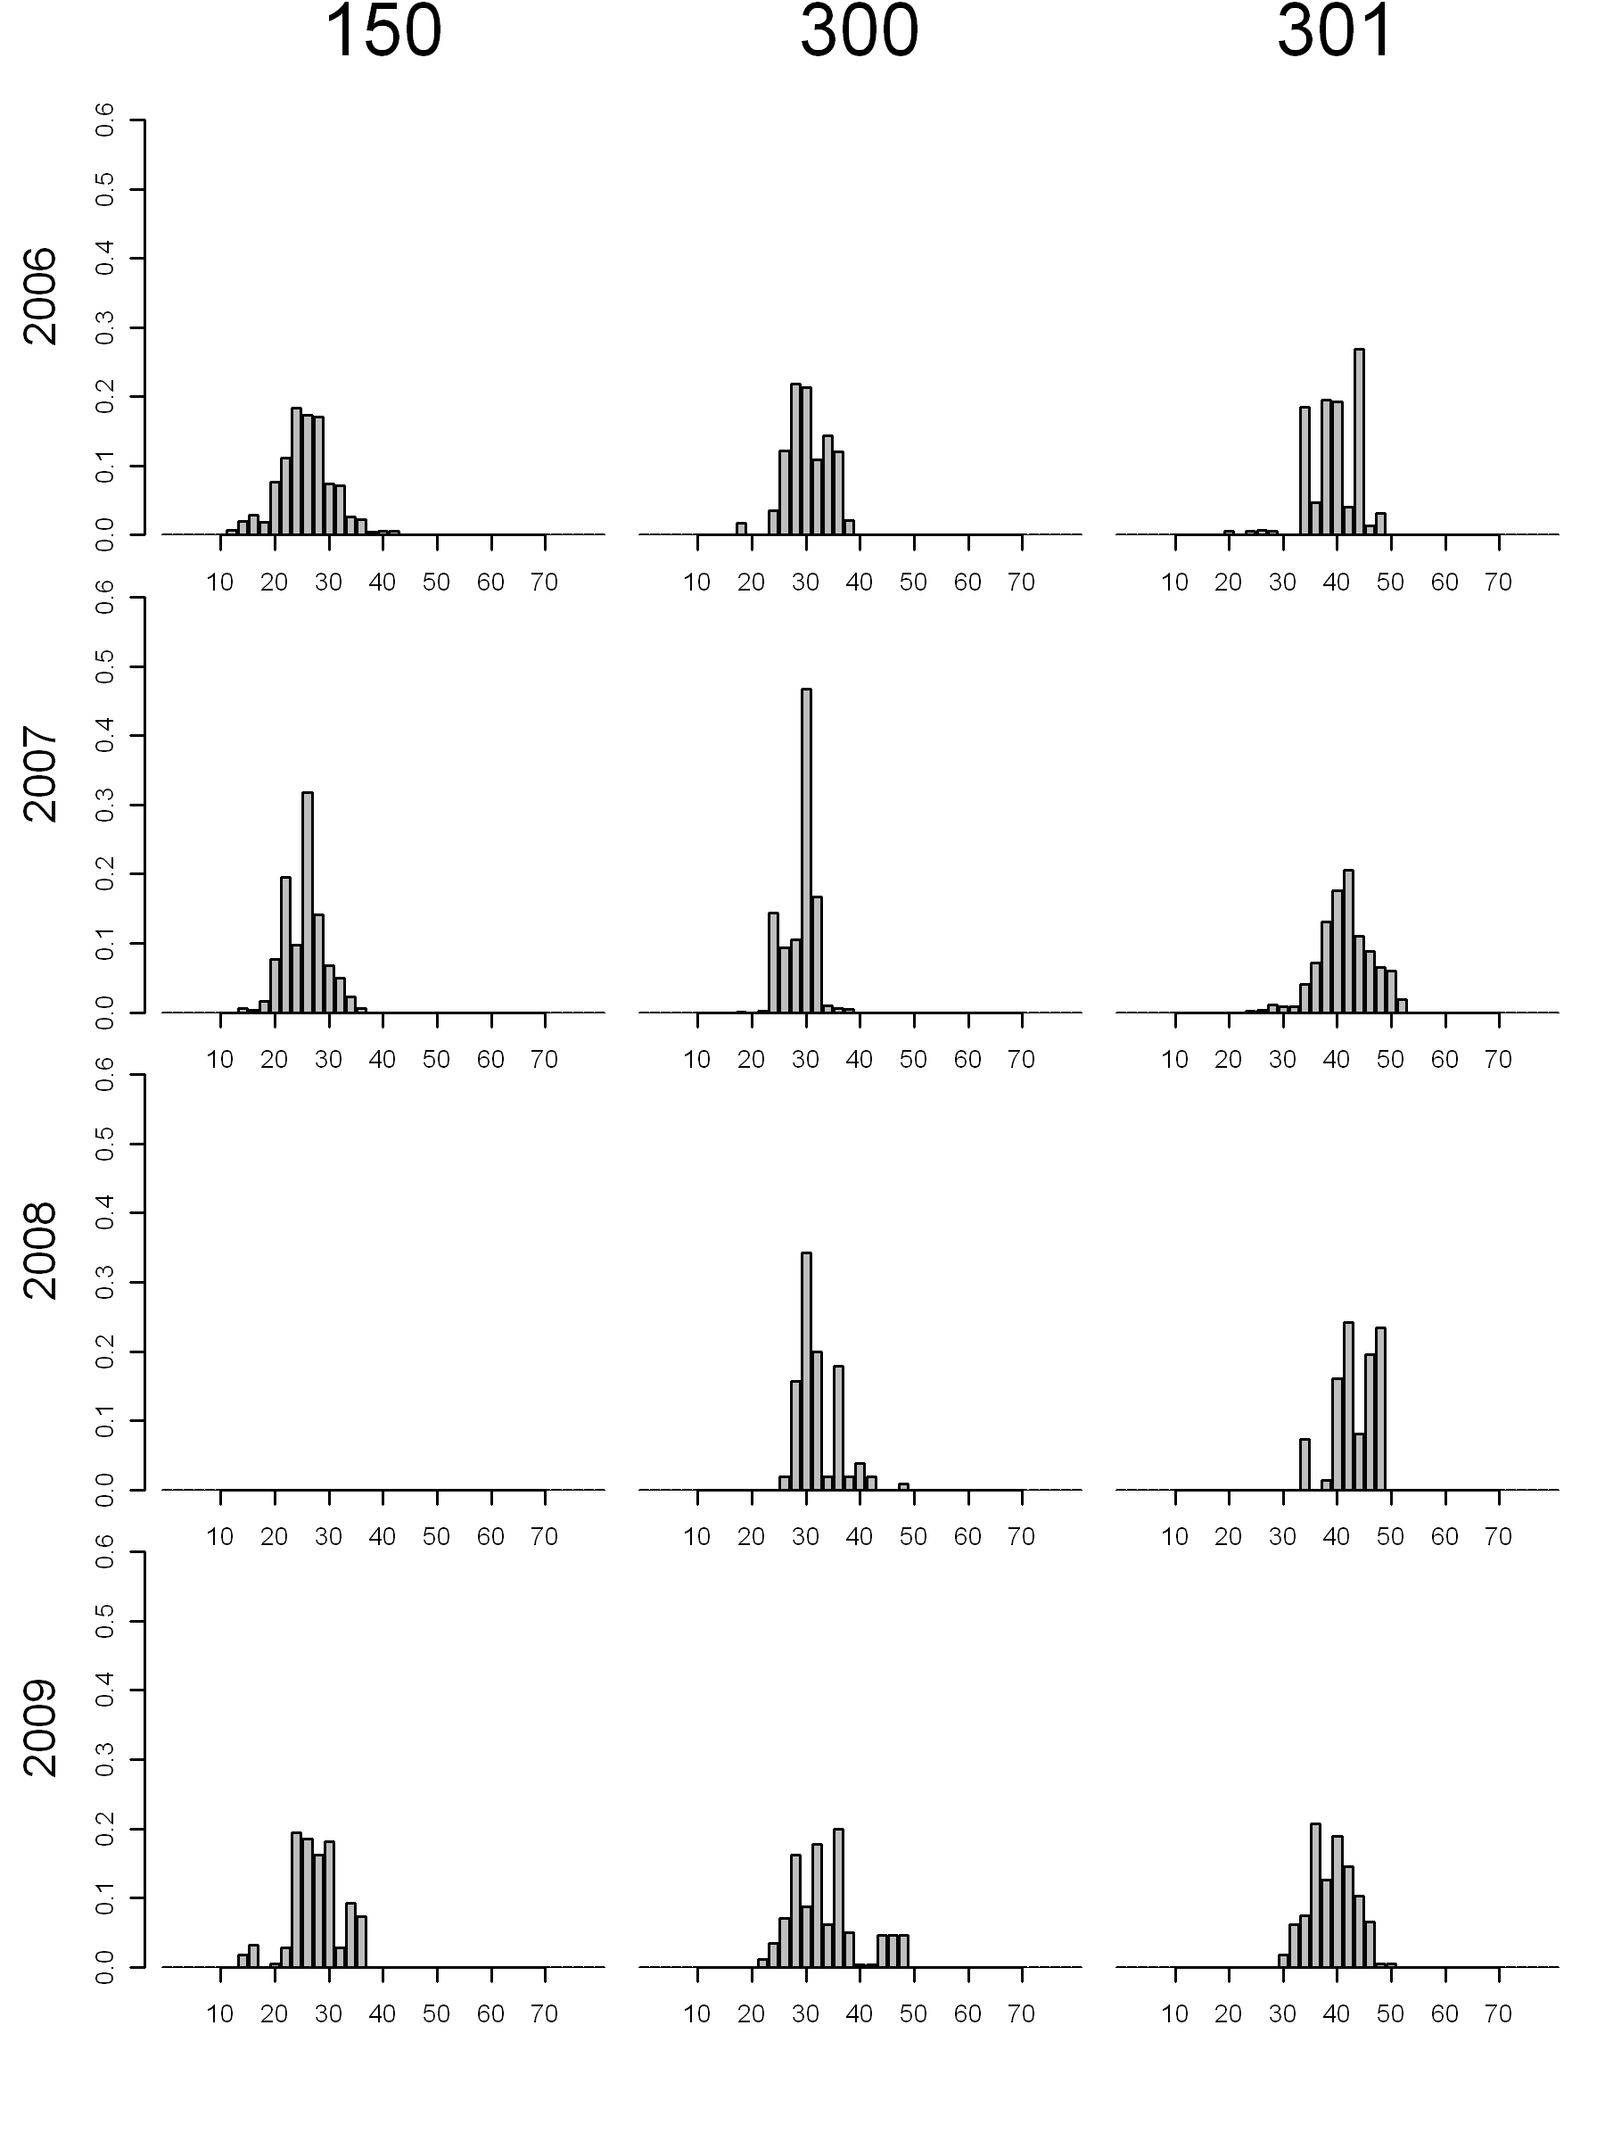

Figure . Weighted length frequencies of discards from Southern California by depth strata (columns) and years (rows).

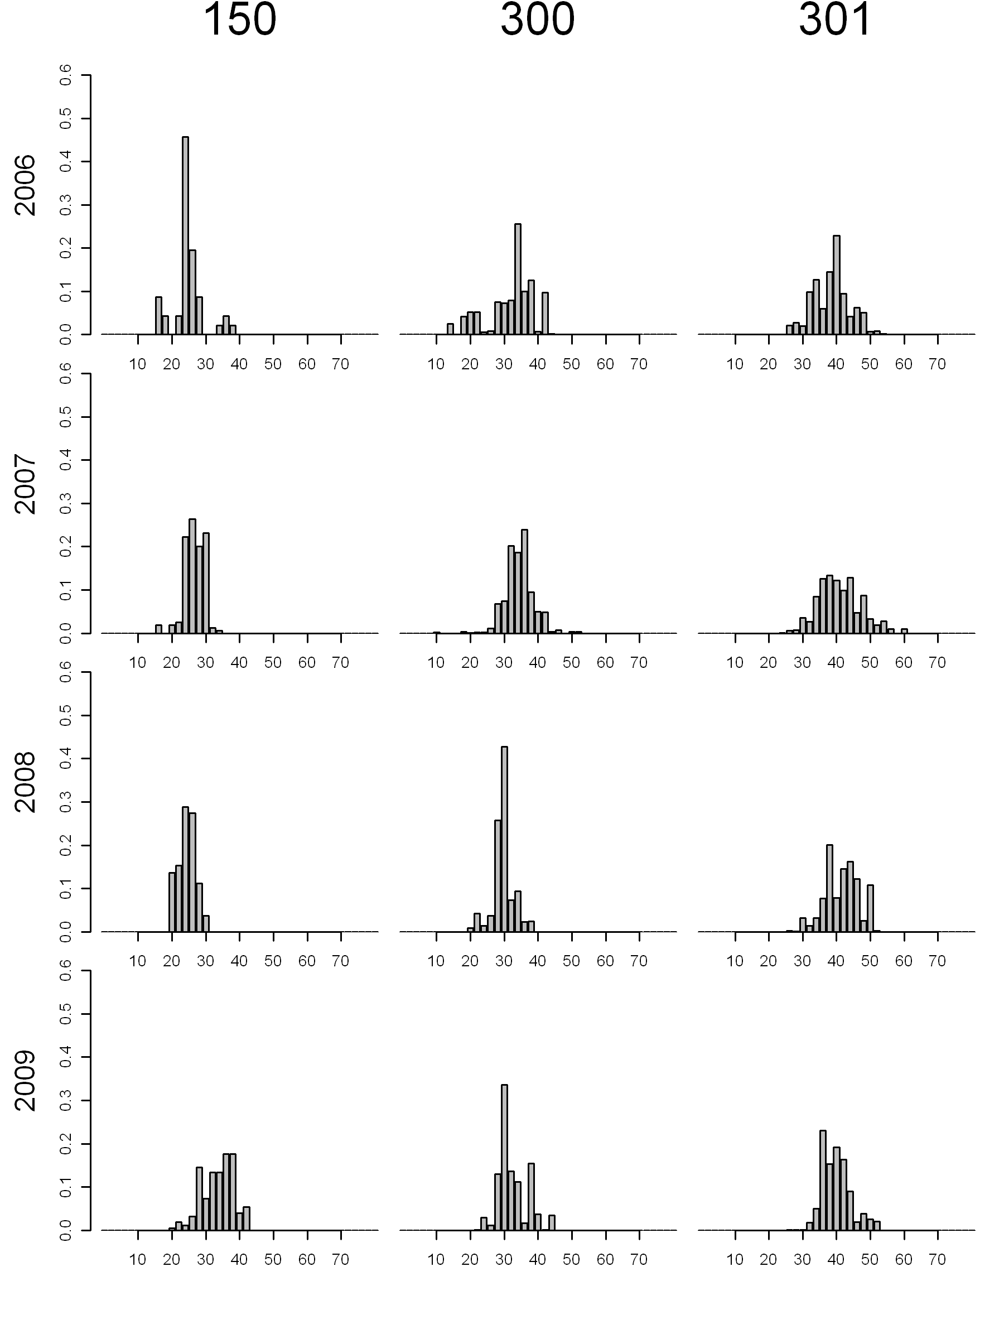

Figure . Weighted length frequencies of discards from Northern California by depth strata (columns) and years (rows).

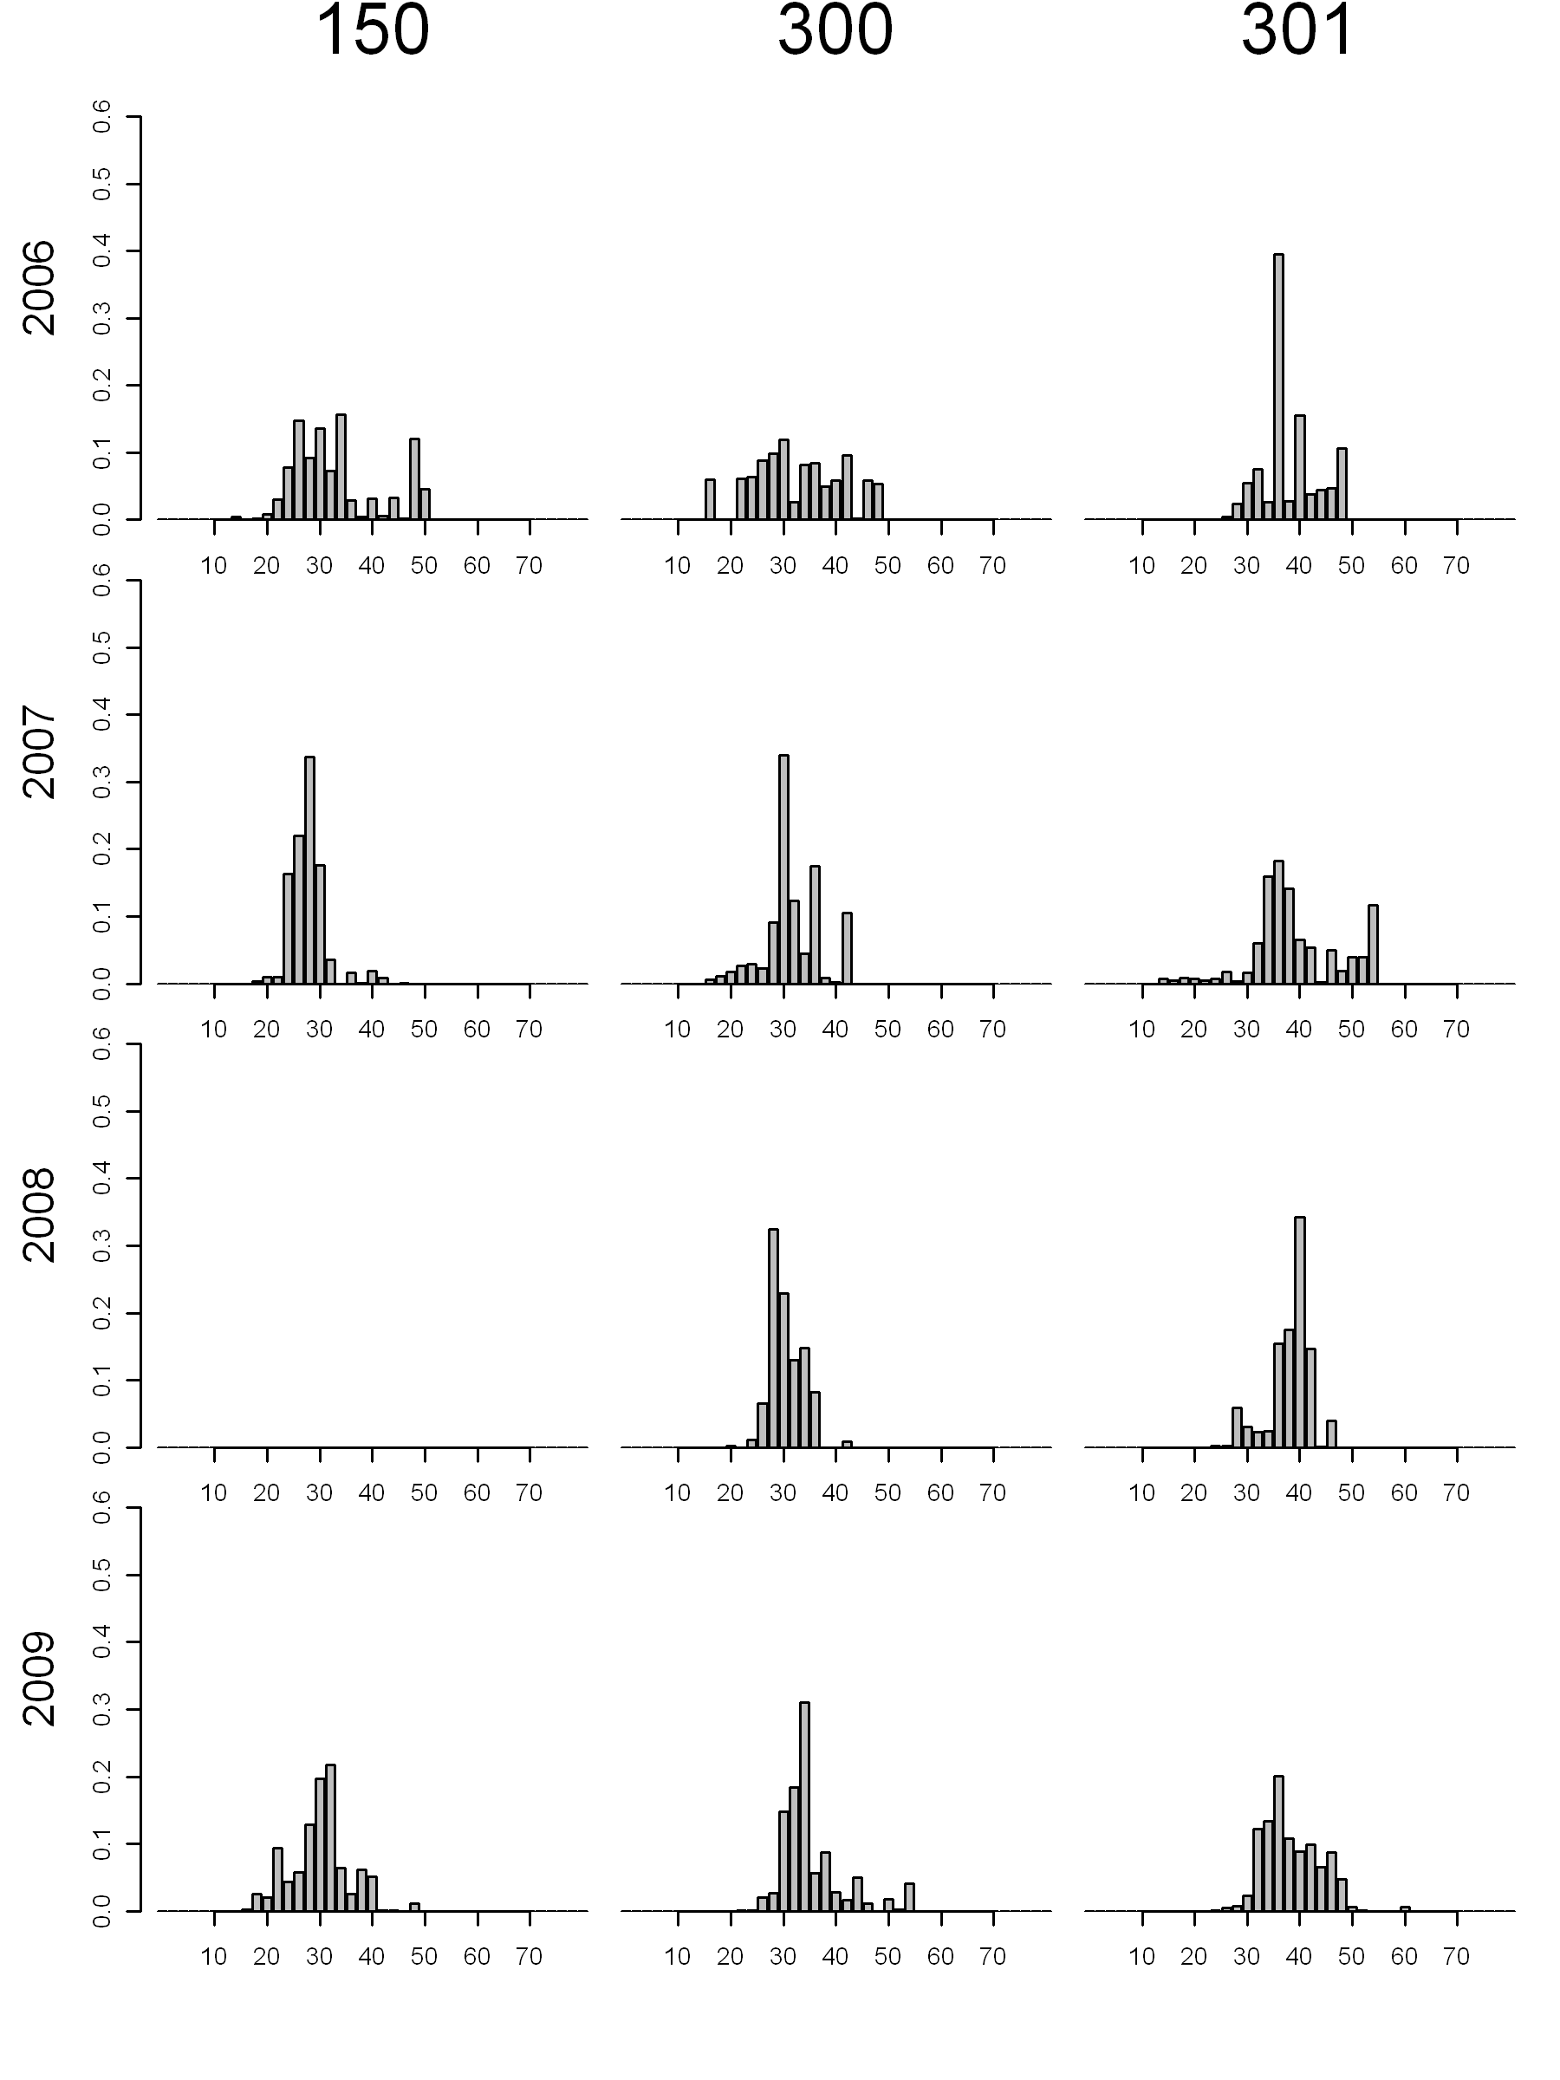

Figure . Weighted length frequencies of discards from Oregon by depth strata (columns) and years (rows).

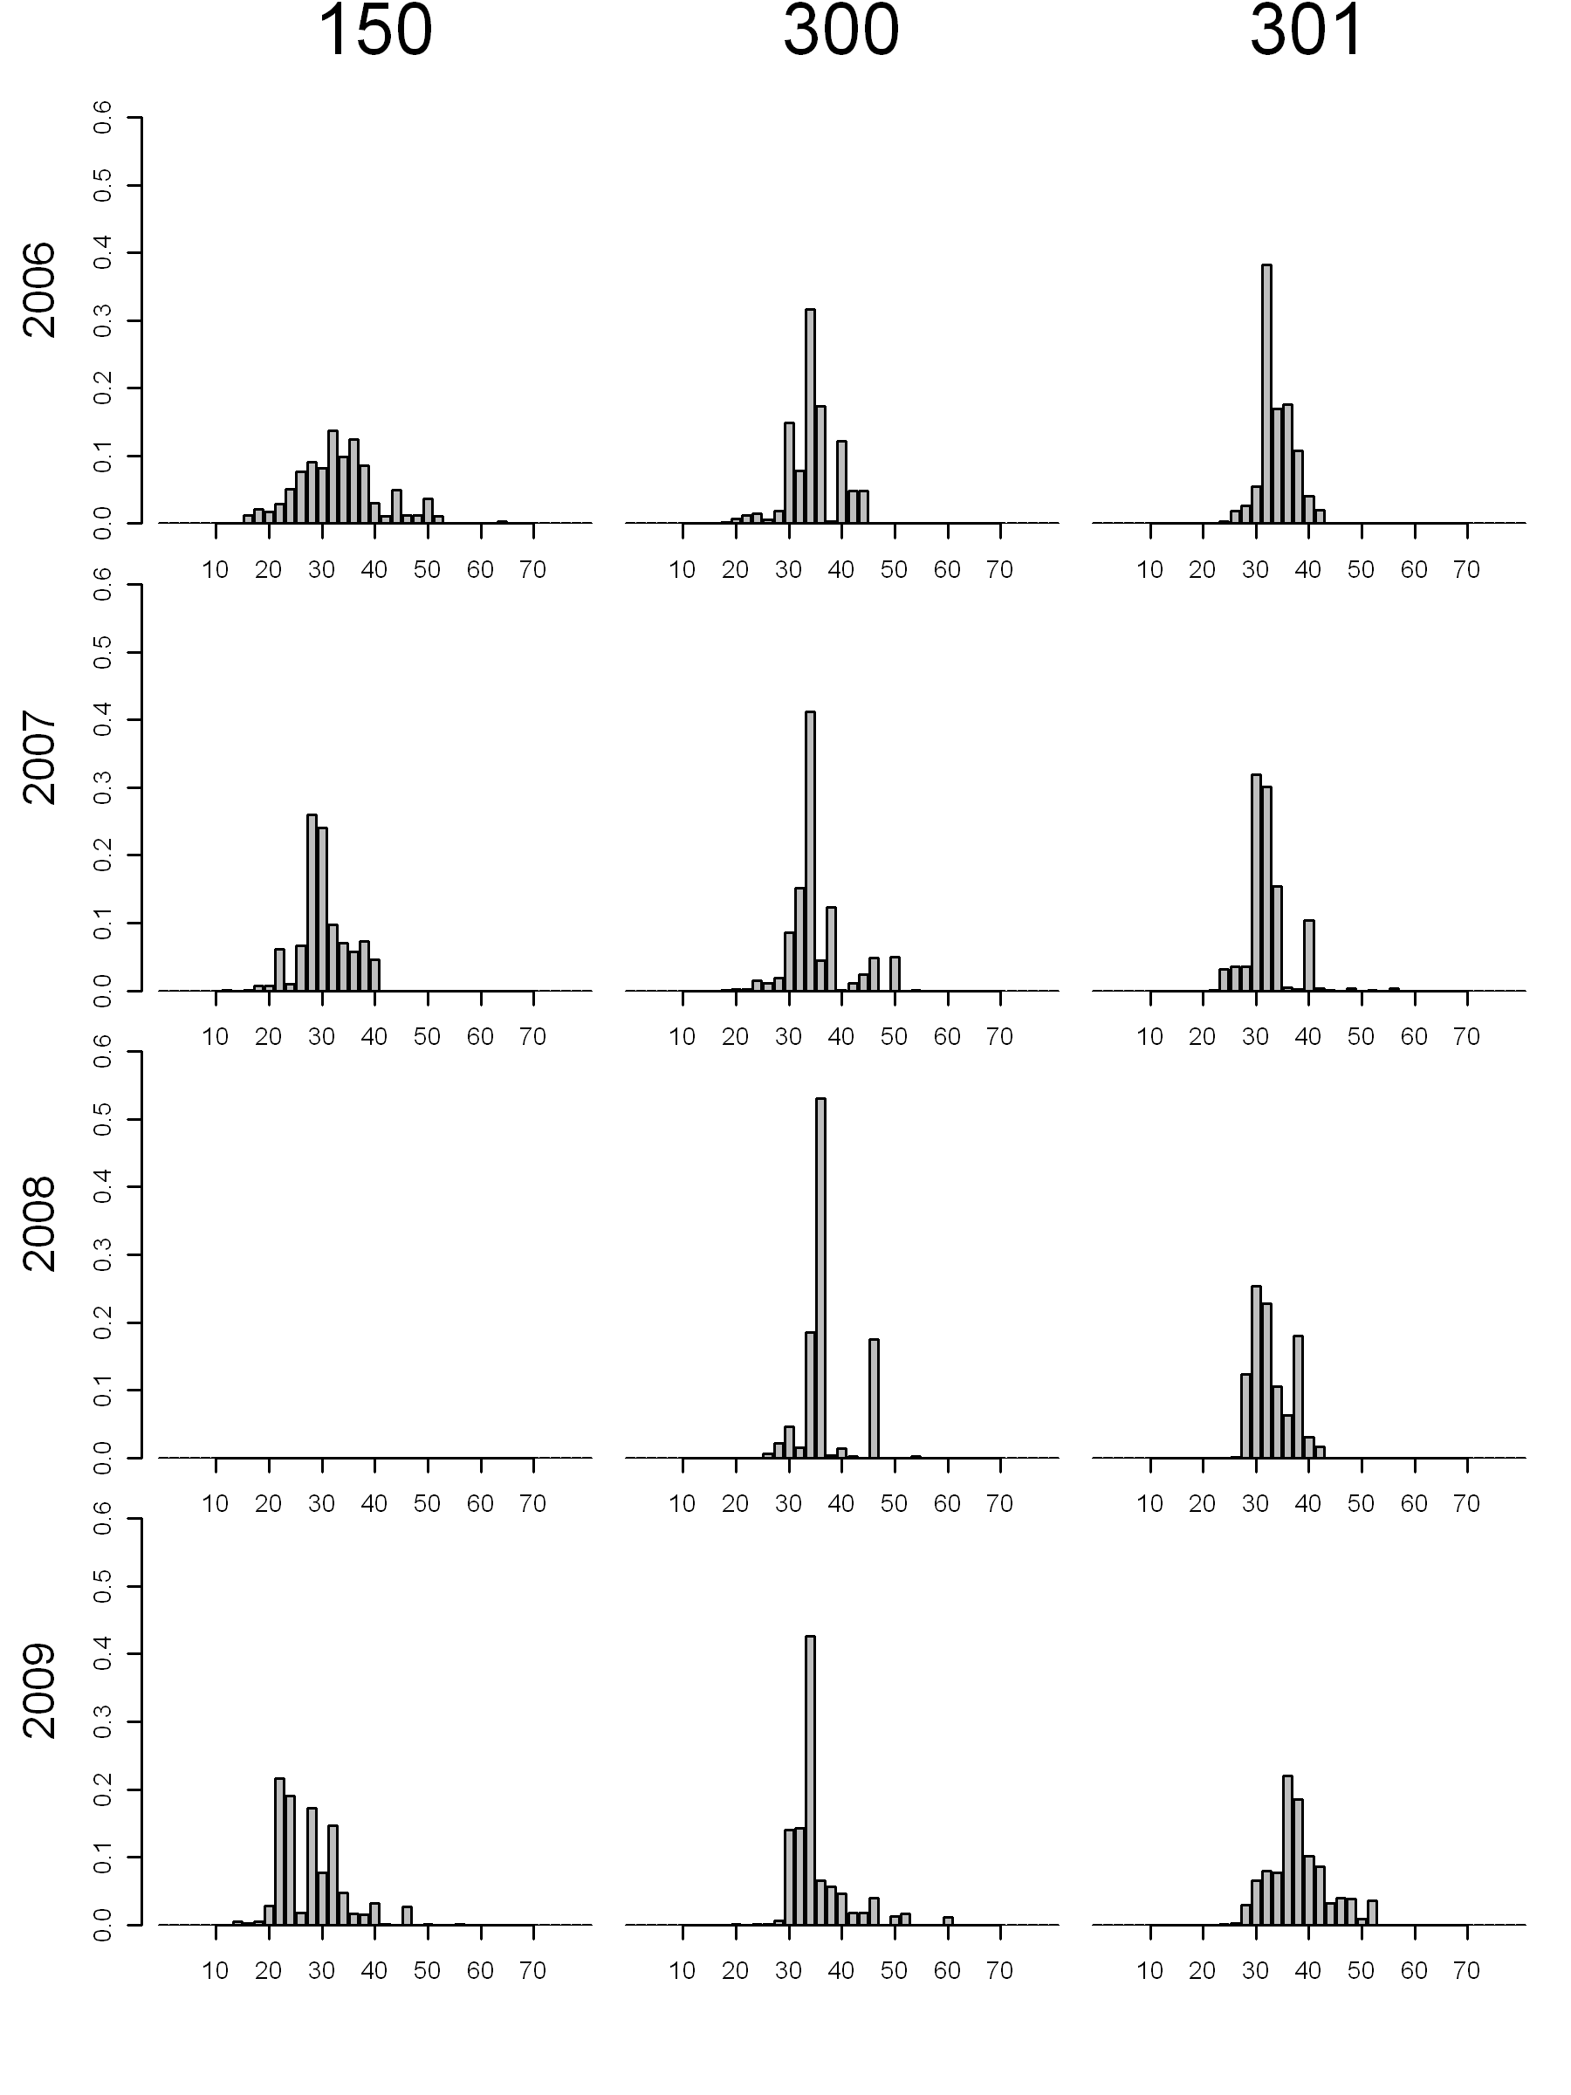

Figure . Weighted length frequencies of discards from Washington by depth strata (columns) and years (rows).

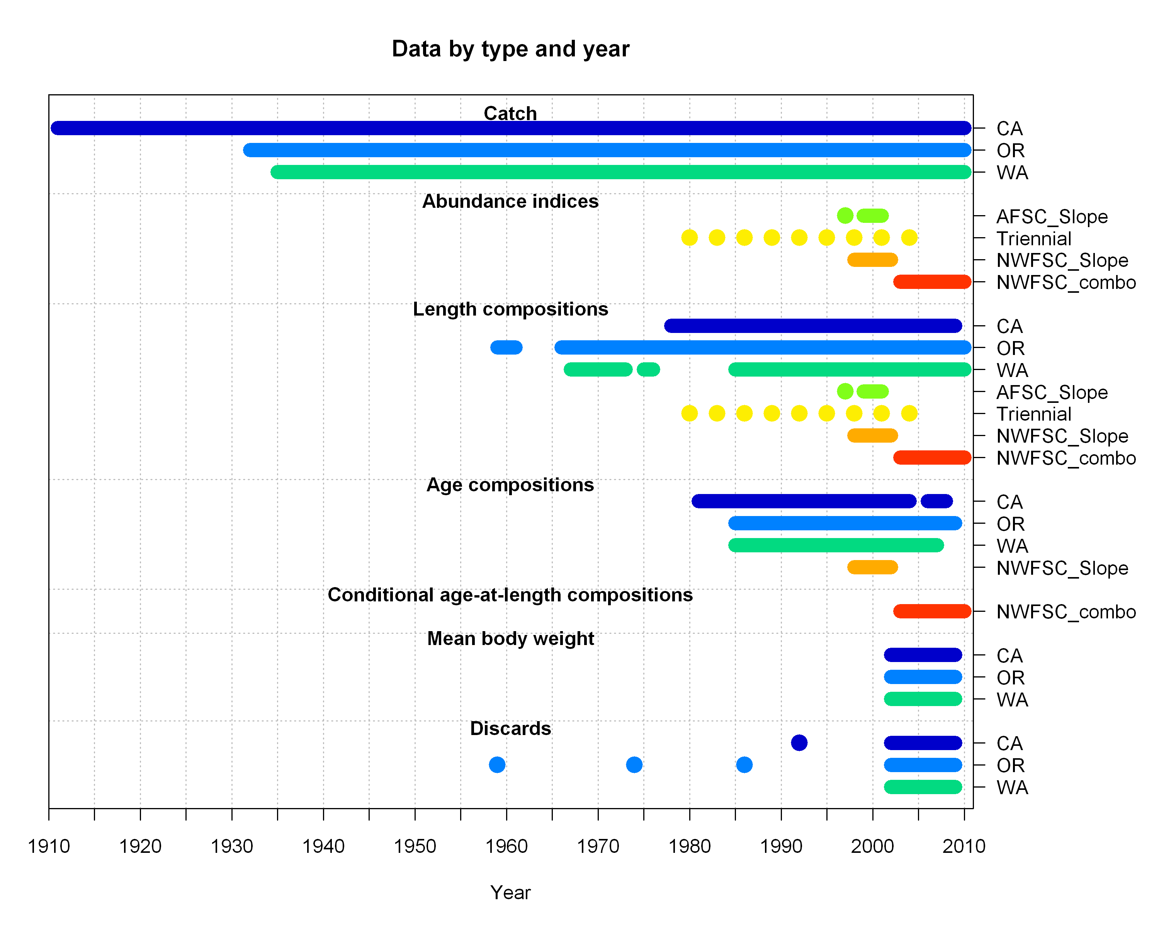

Figure . Summary of the years of catch data and the survey and fishery data fitted to in the model.

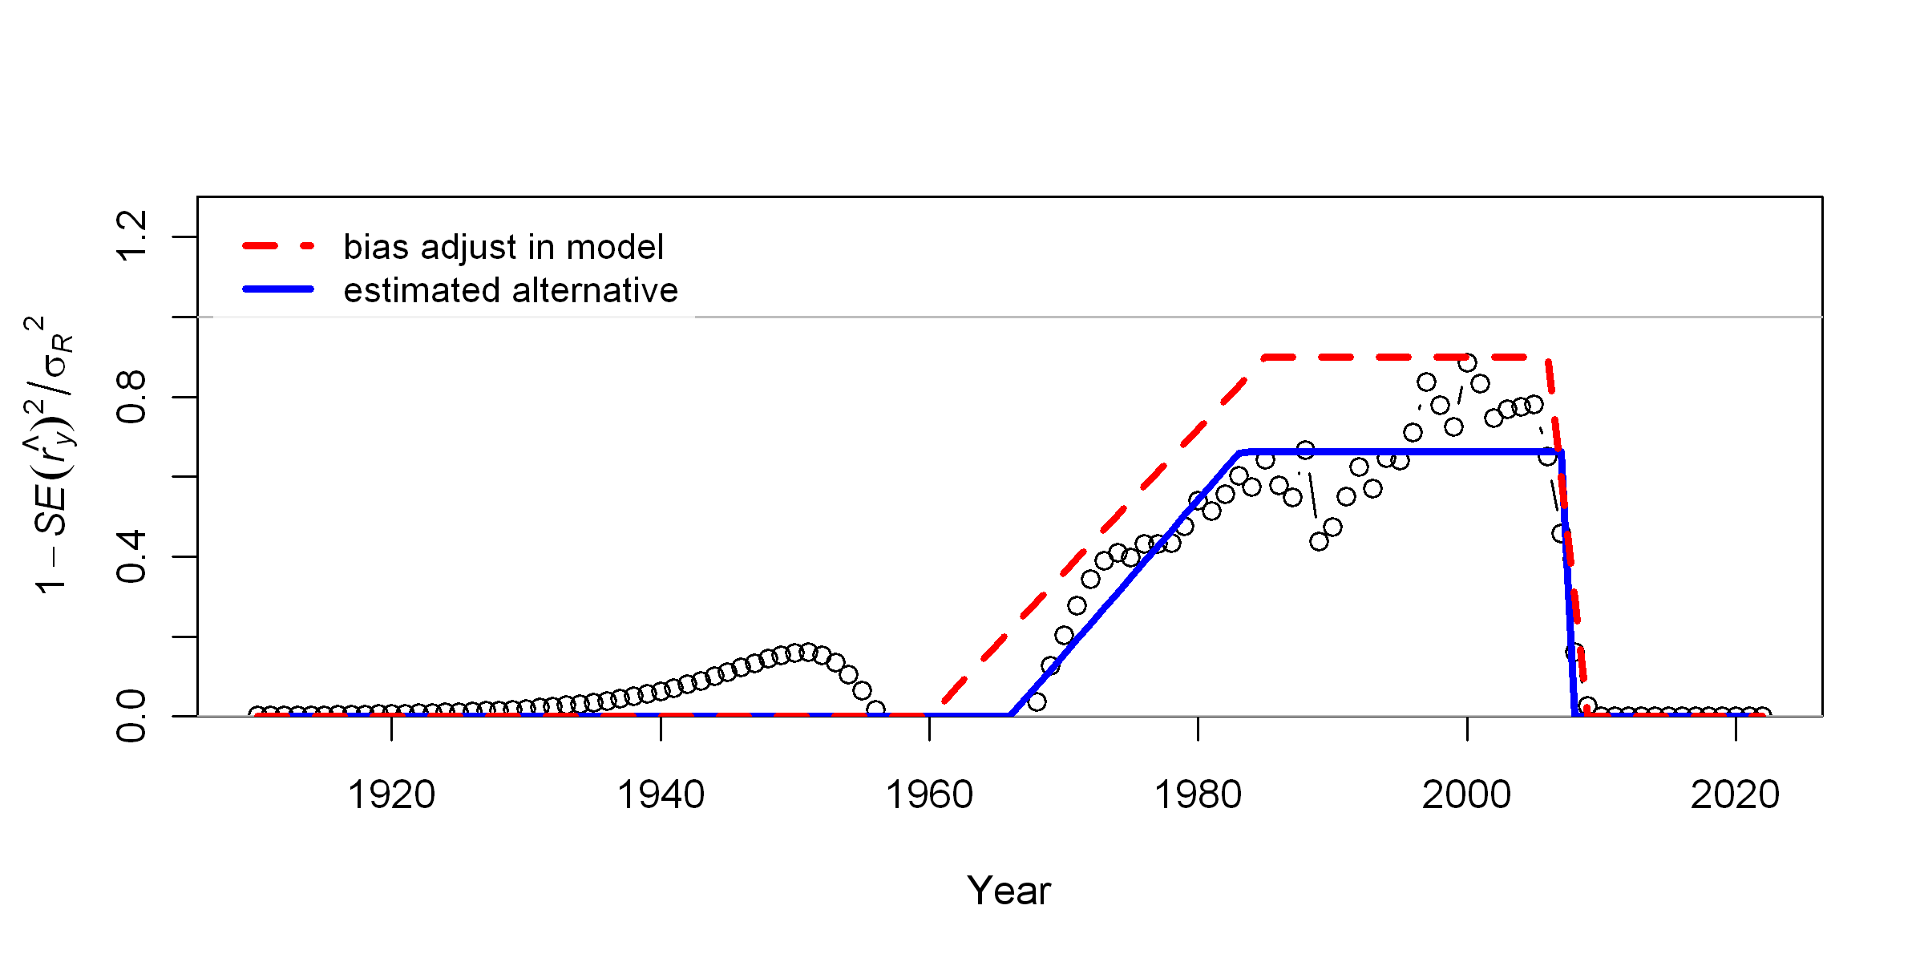

Figure . Bias adjustment ramping in the model for the recruitment deviate estimates.

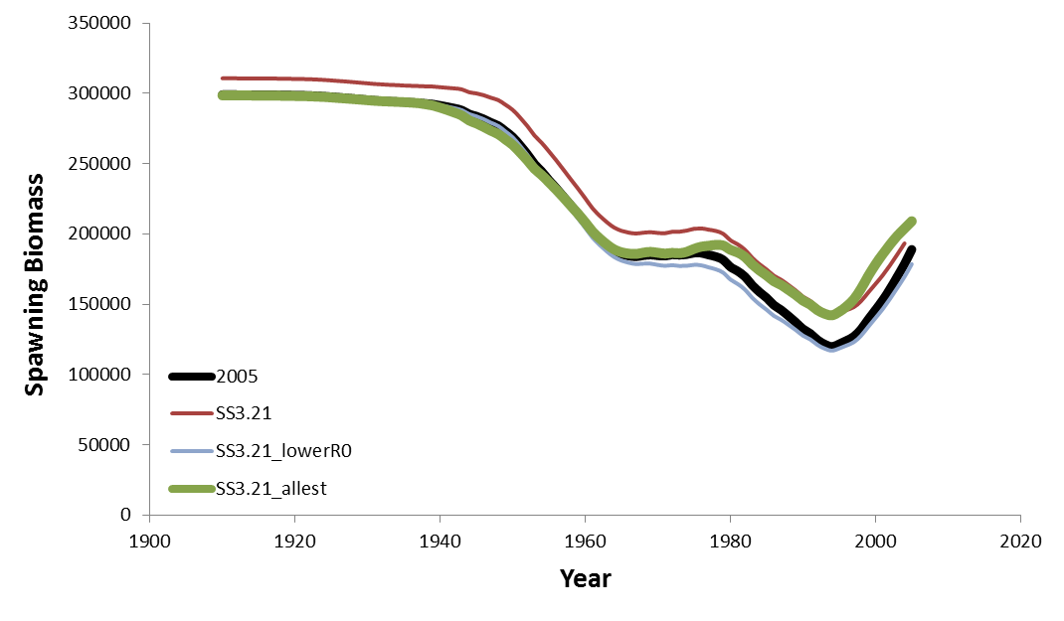

Figure . Estimates of spawning biomass from the 2005 assessment in black (*2005*), SSv3.21 with the same parameters as the 2005 assessment and kept fixed in red (*SS3.21*), SSv3.21 with a lower R0 to line up the start with the 2005 assessment in blue (*SS3.21_lowerR0*), and SS3.21a with the same parameters estimated that were estimated in the 2005 assessment in green (*SS3.21_allest*).

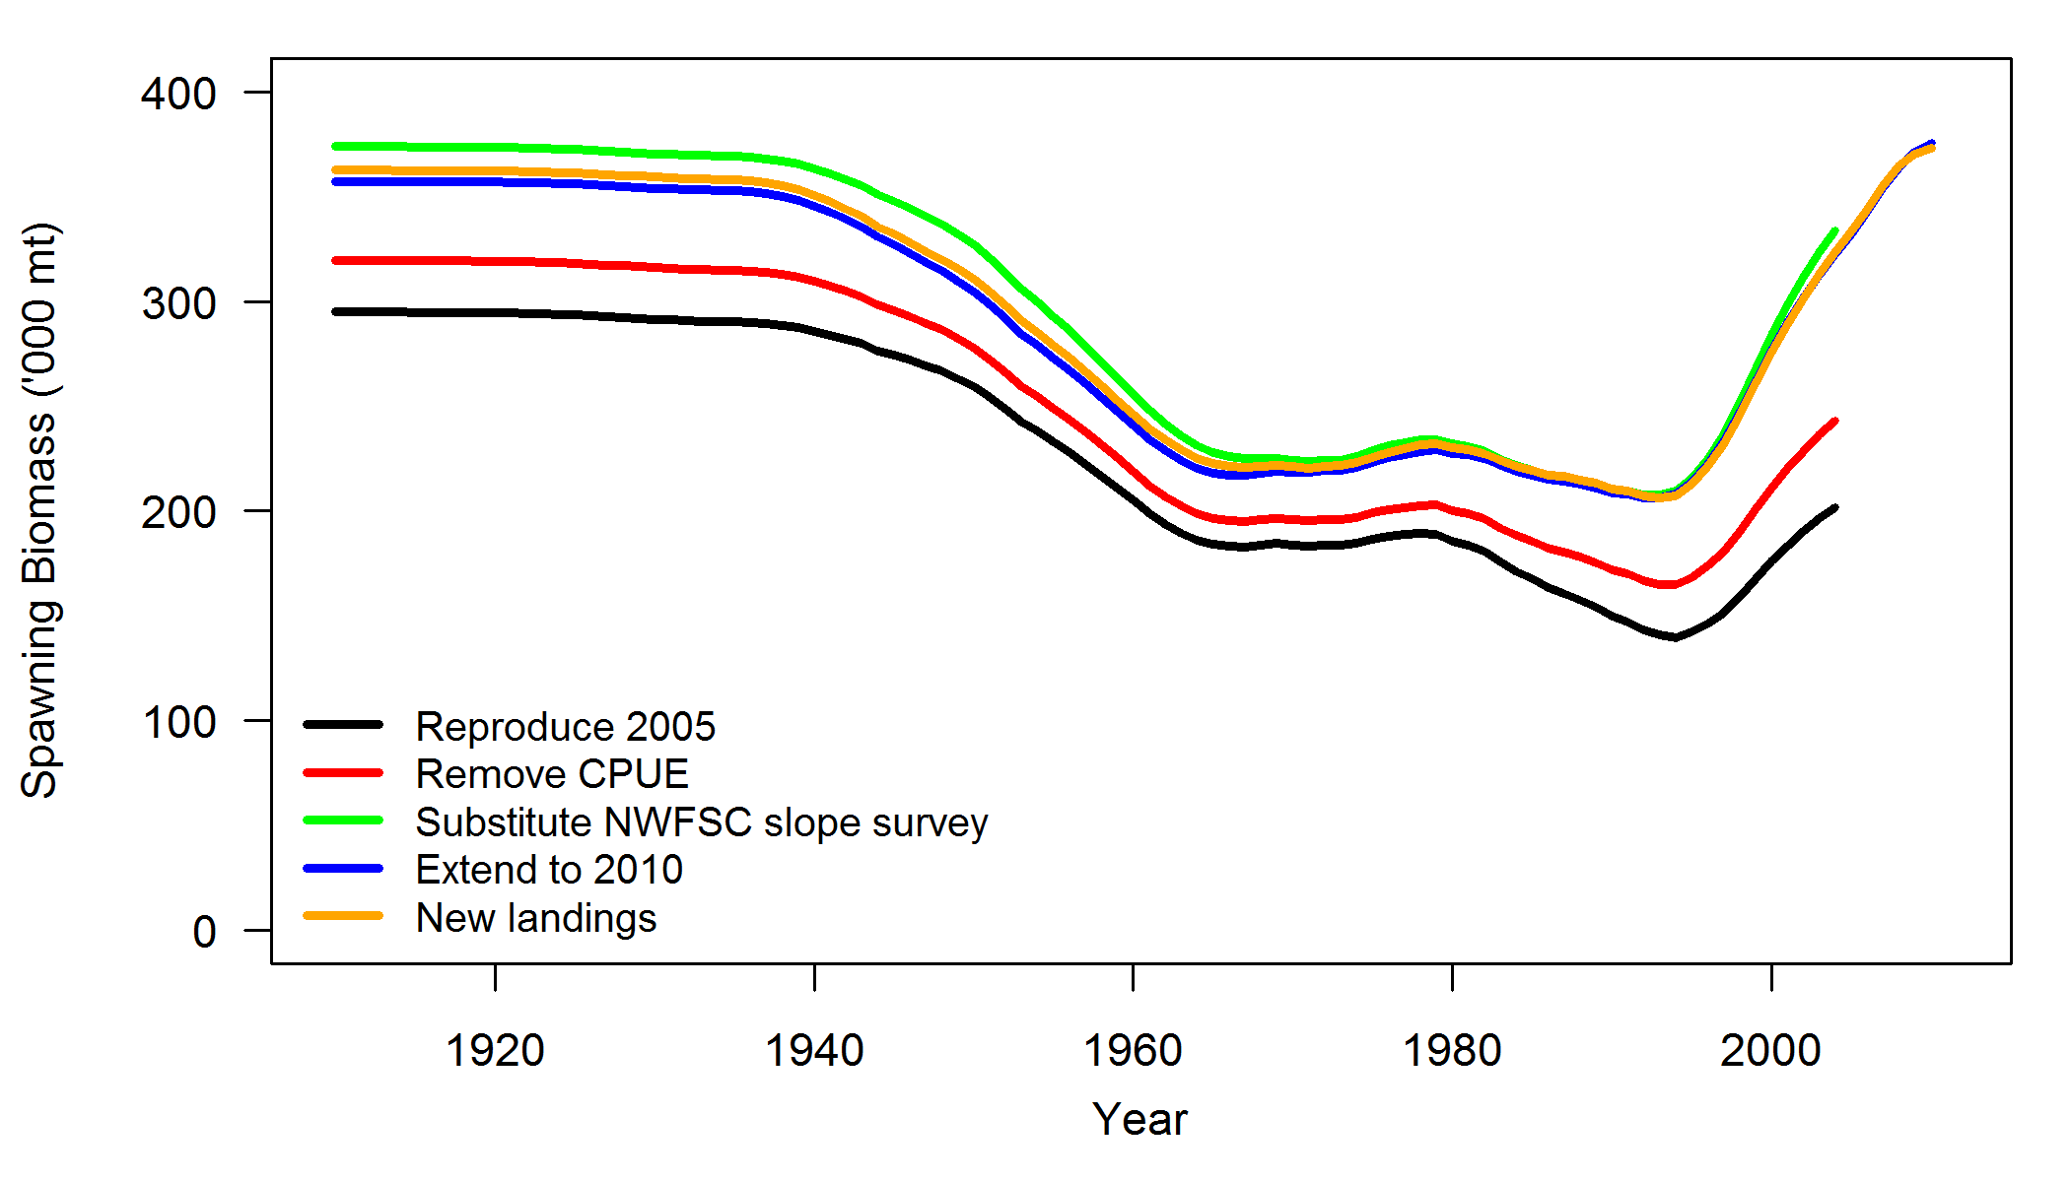

Figure . Estimated spawning biomass from models transitioning from the reproduced 2005 assessment in SSv3.21 (*Reproduce 2005*) to extending the model with new landings and adding recent survey data (*New landings*). The intermediate models build sequentially from the reproduced 2005 assessment by removing the CPUE series (*Remove CPUE*), adding in the NWFSC shelf/slope survey and removing the 1992 and 1996 AFSC survey values (*Substitue NWFSC slope survey*), and then extending the model to 2010 with recent catches, the entire NWFSC shelf/slope survey series, and length frequencies from the NWFSC shelf/slope survey (*Extend to 2010*). Note: the “New landings” contained a small error and were slightly different than the landings used in the base case model. However, the results should not be noticeably different.

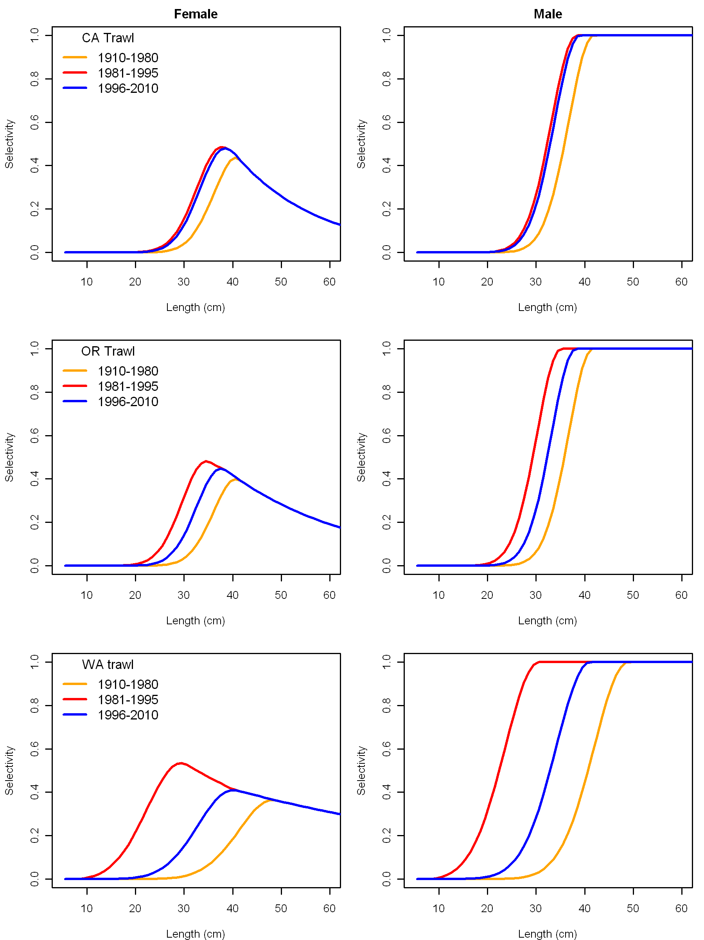

Figure . Estimated selectivity curves for the three fleets (CA at the top, OR in the middle, and WA at the bottom) with time blocks changes.

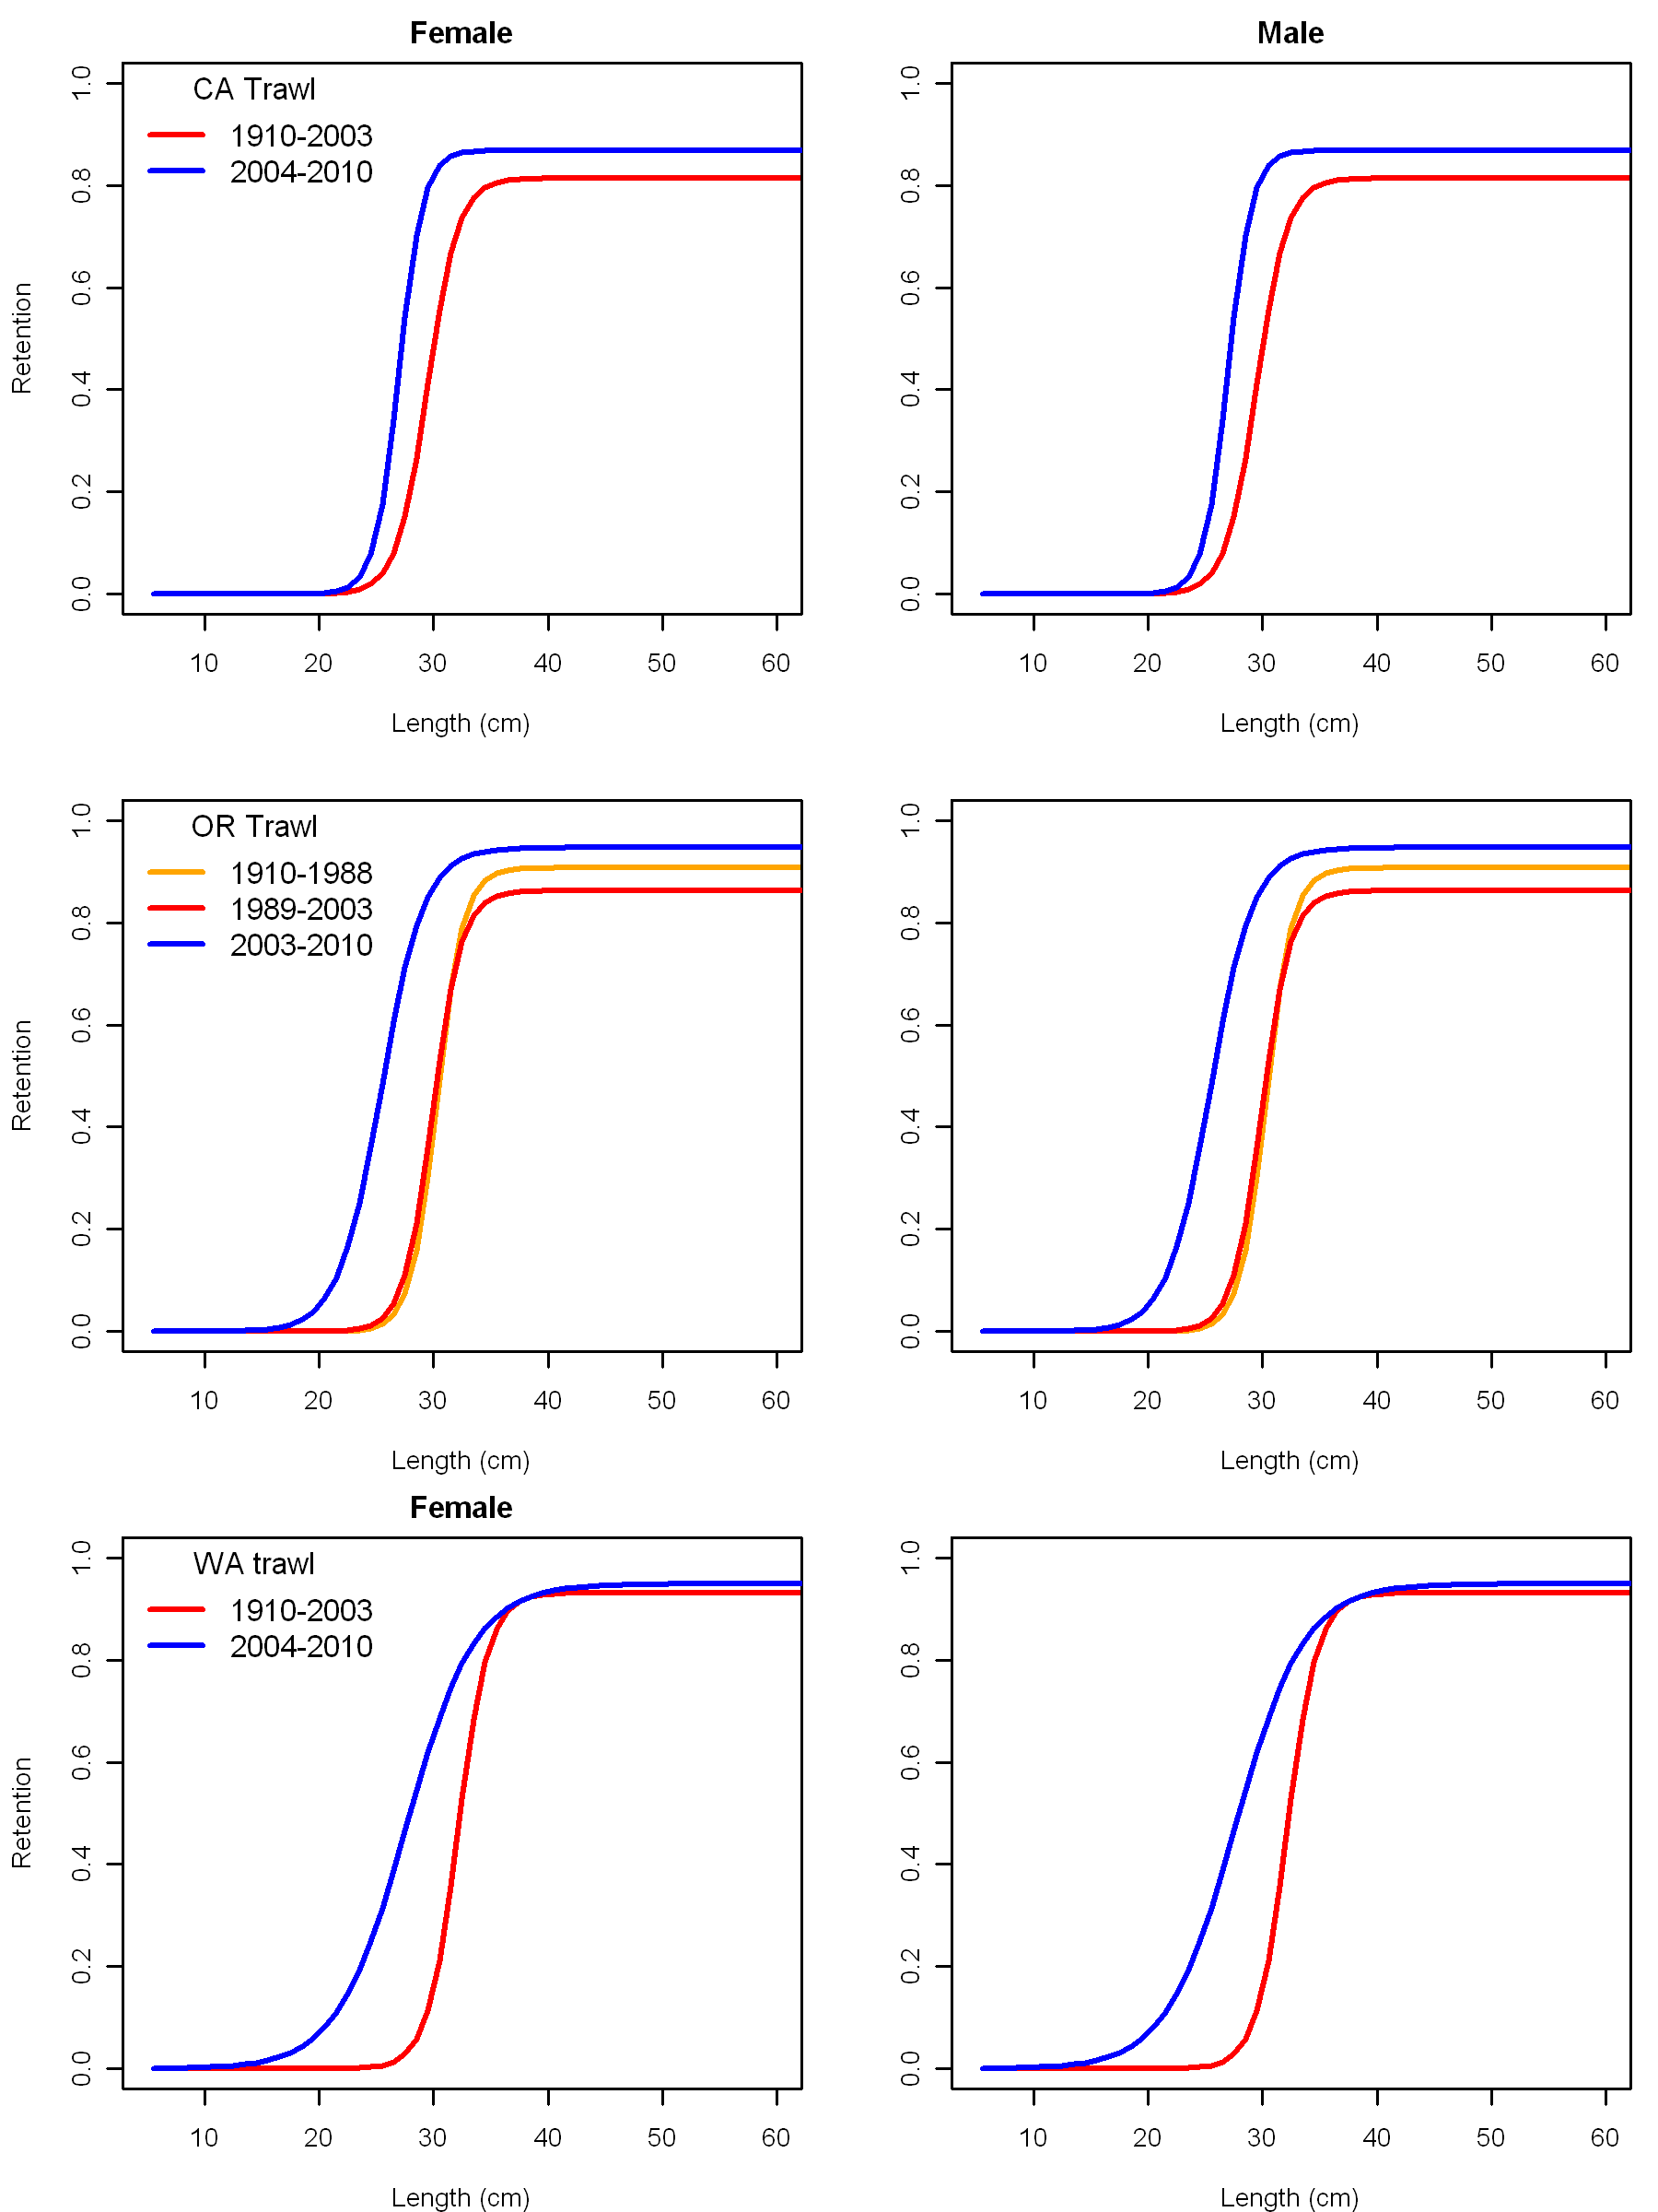

Figure . Estimated retention curves for the three fleets (CA at the top, OR in the middle, and WA at the bottom) with time blocks changes.

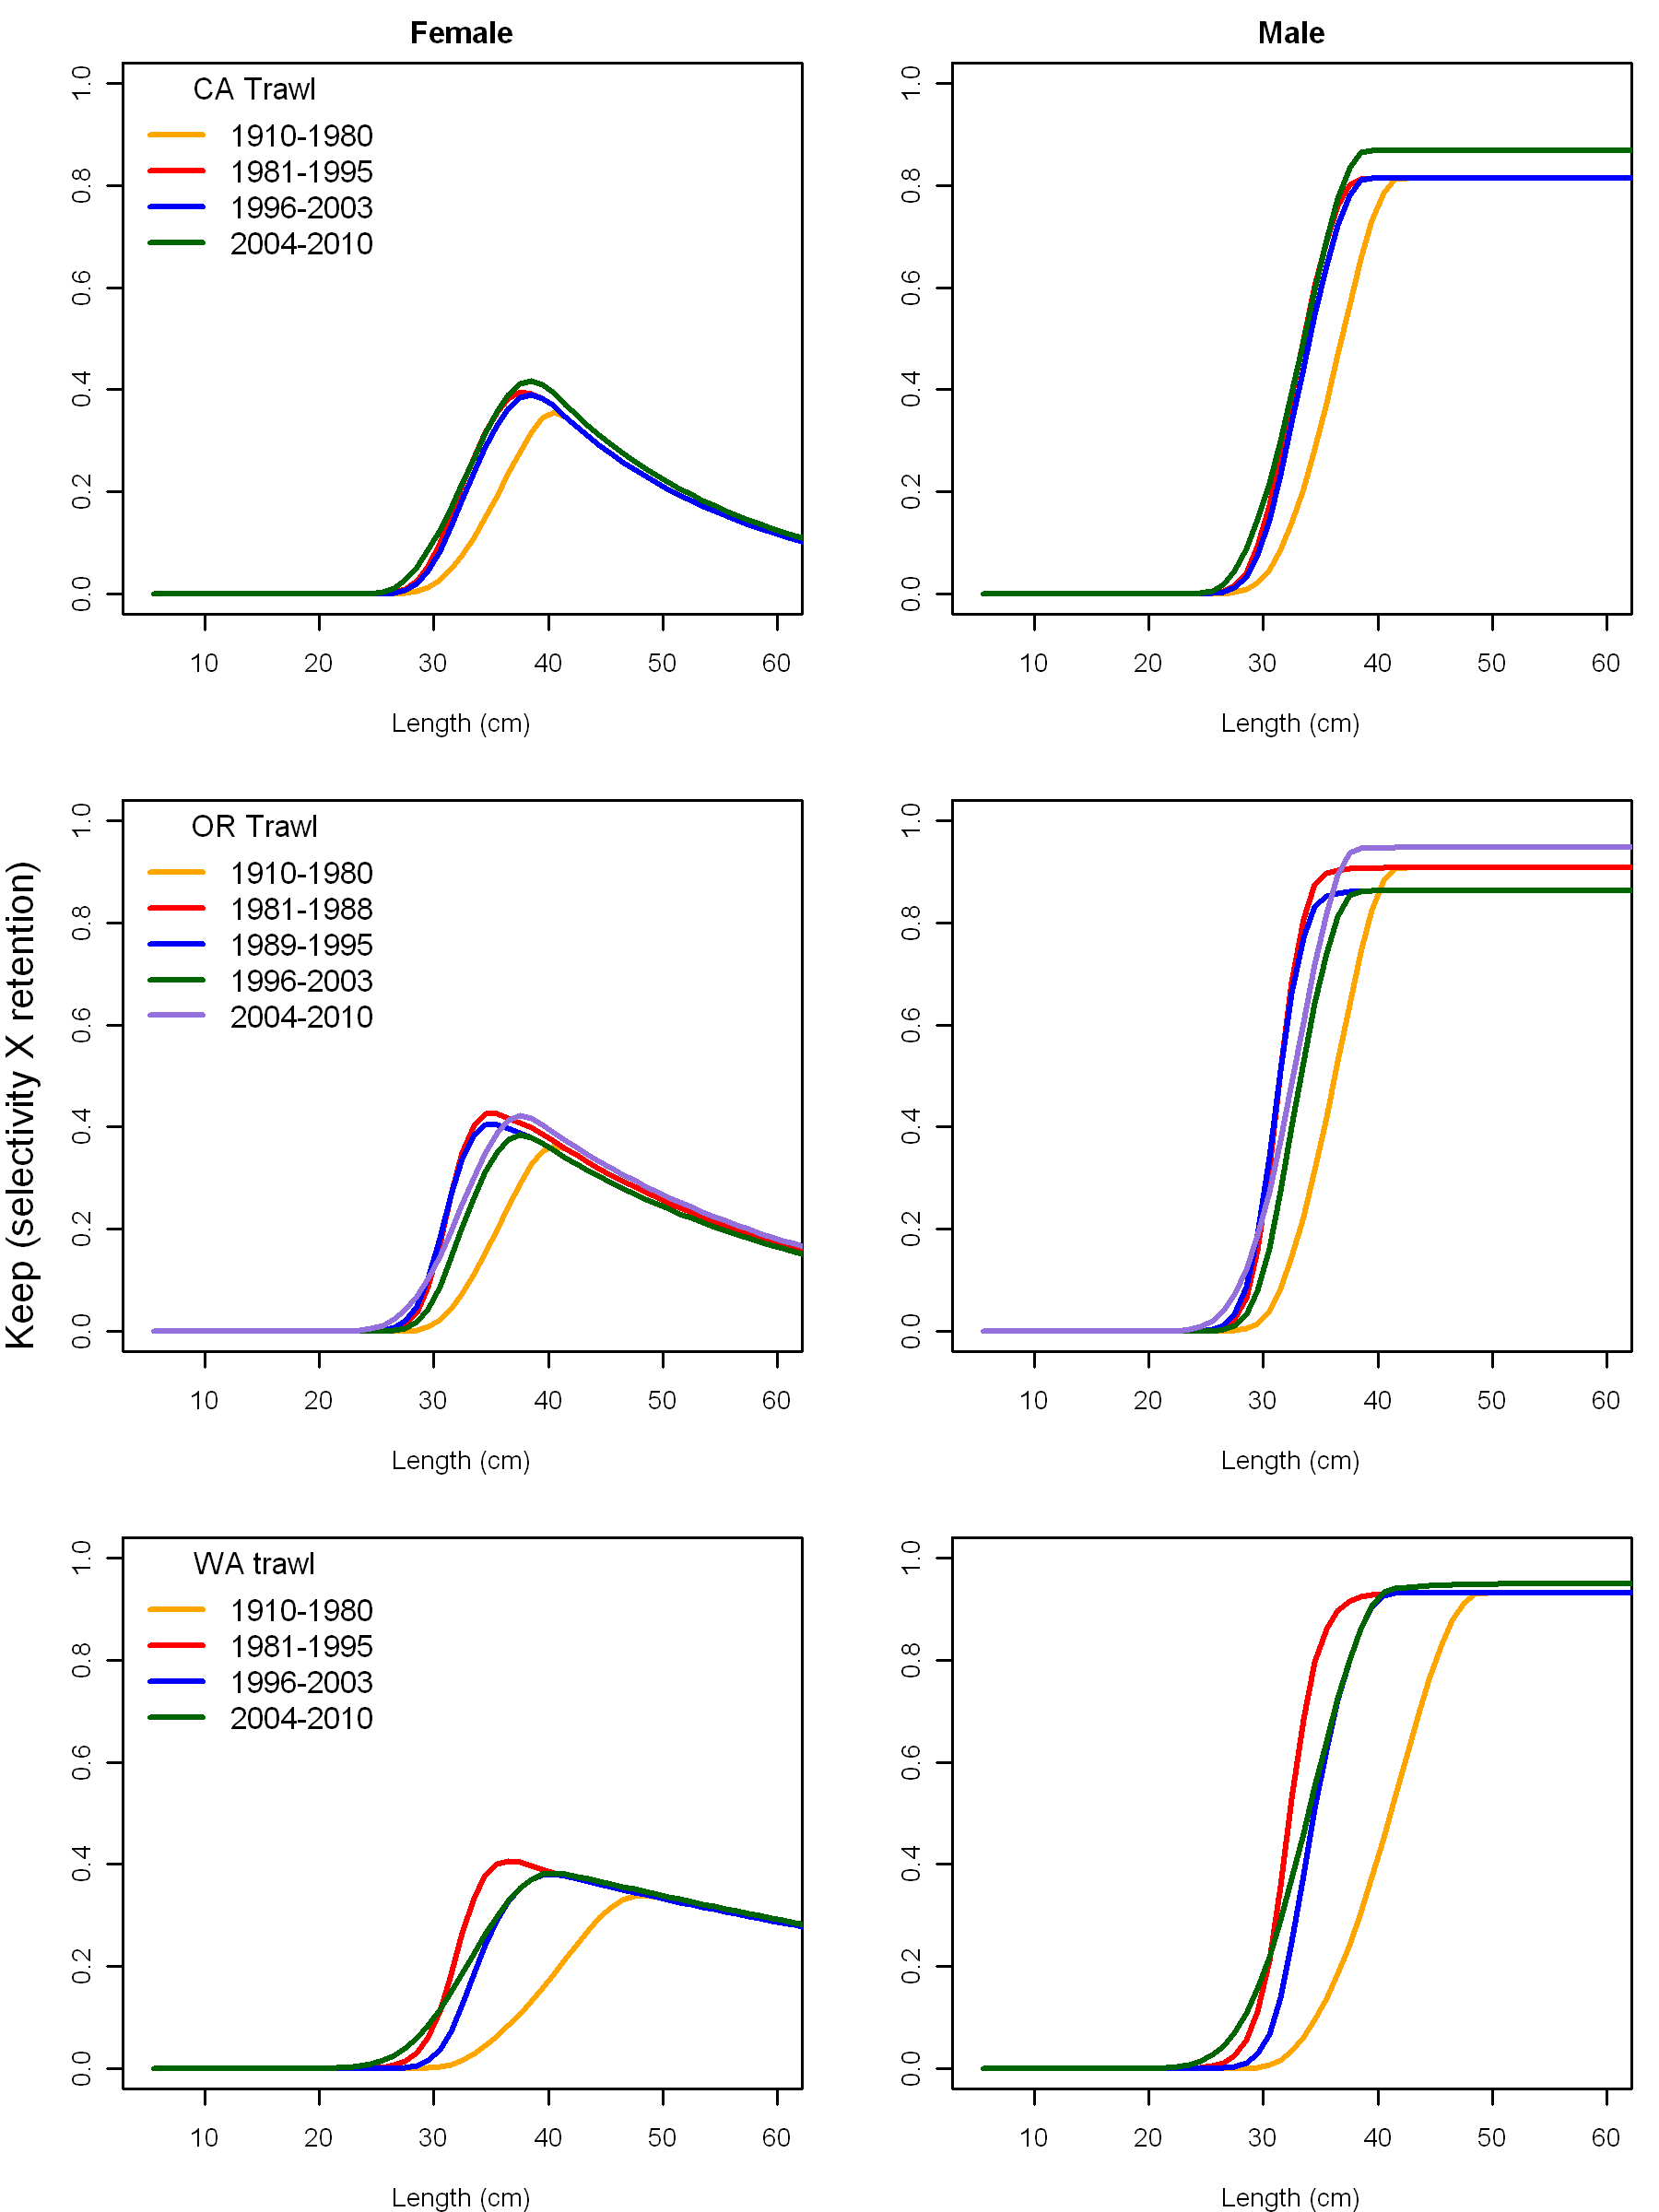

Figure . Estimated keep curves (the product of selectivity and retention) for the three fleets (CA at the top, OR in the middle, and WA at the bottom) with time blocks changes.

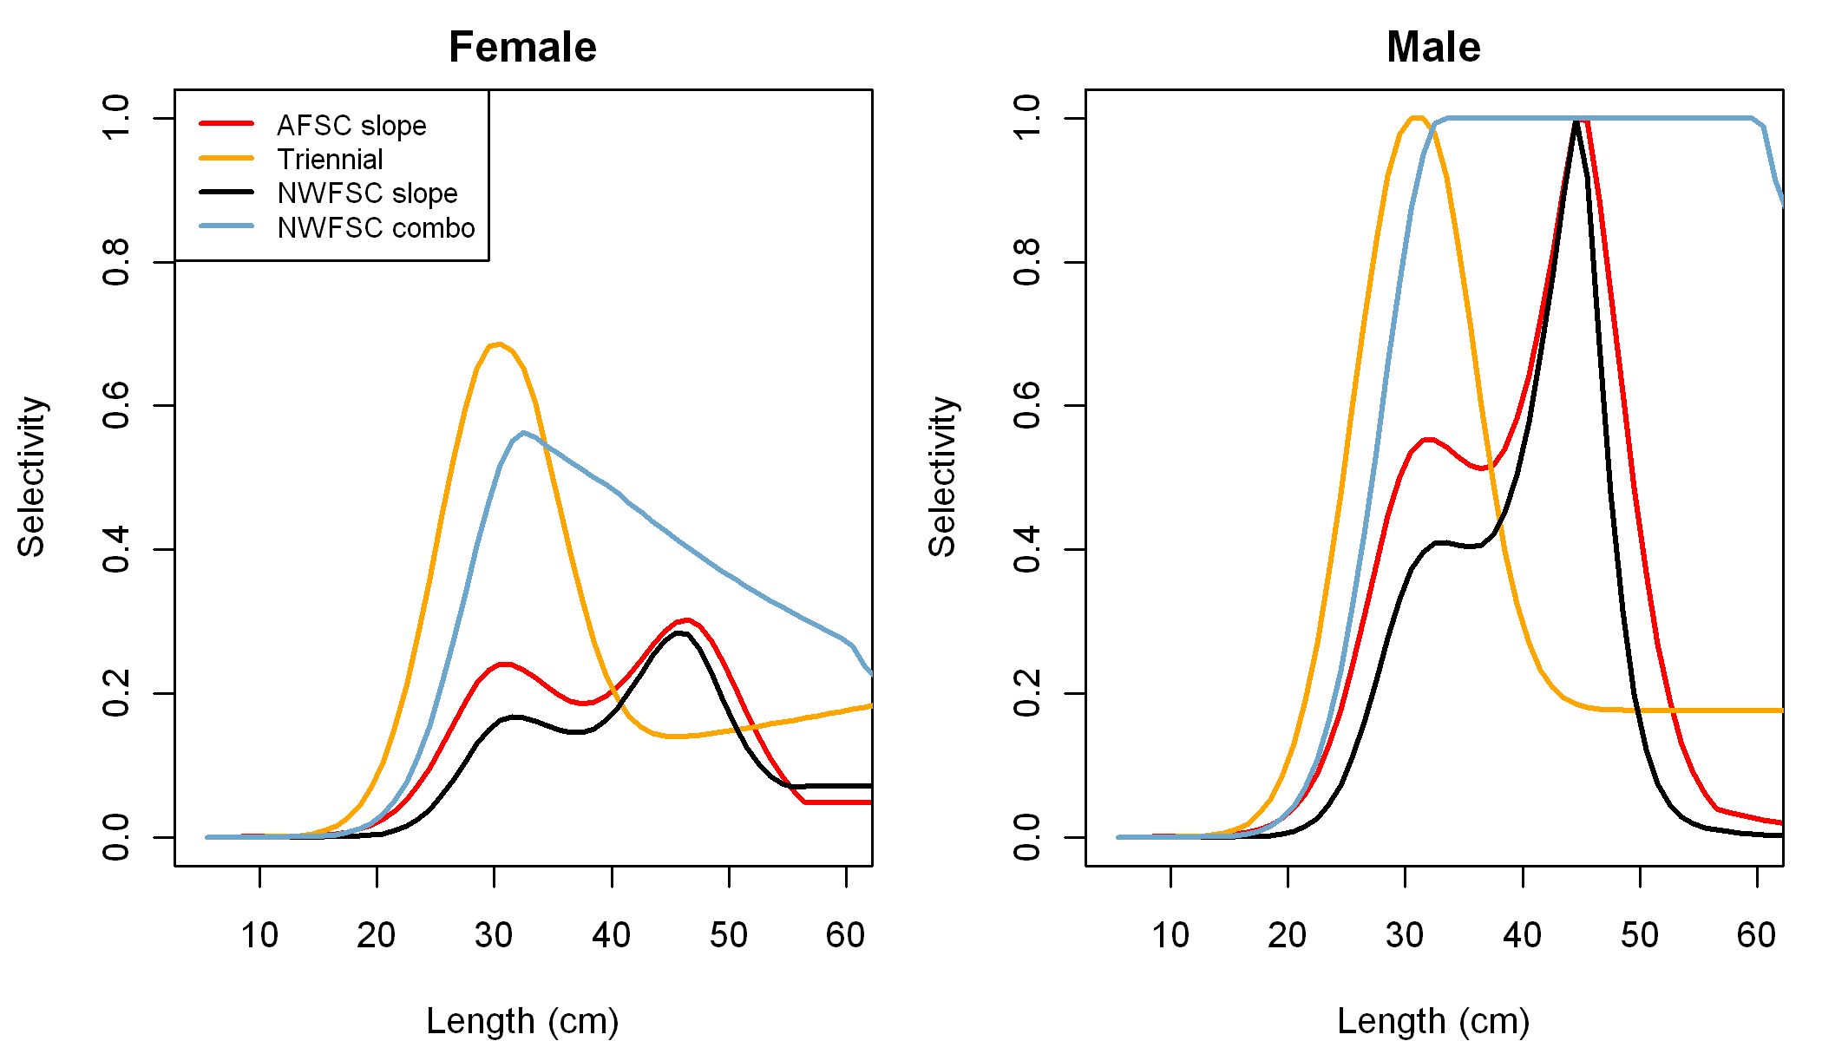

Figure . Estimated survey selectivity curves for females (left) and males (right).

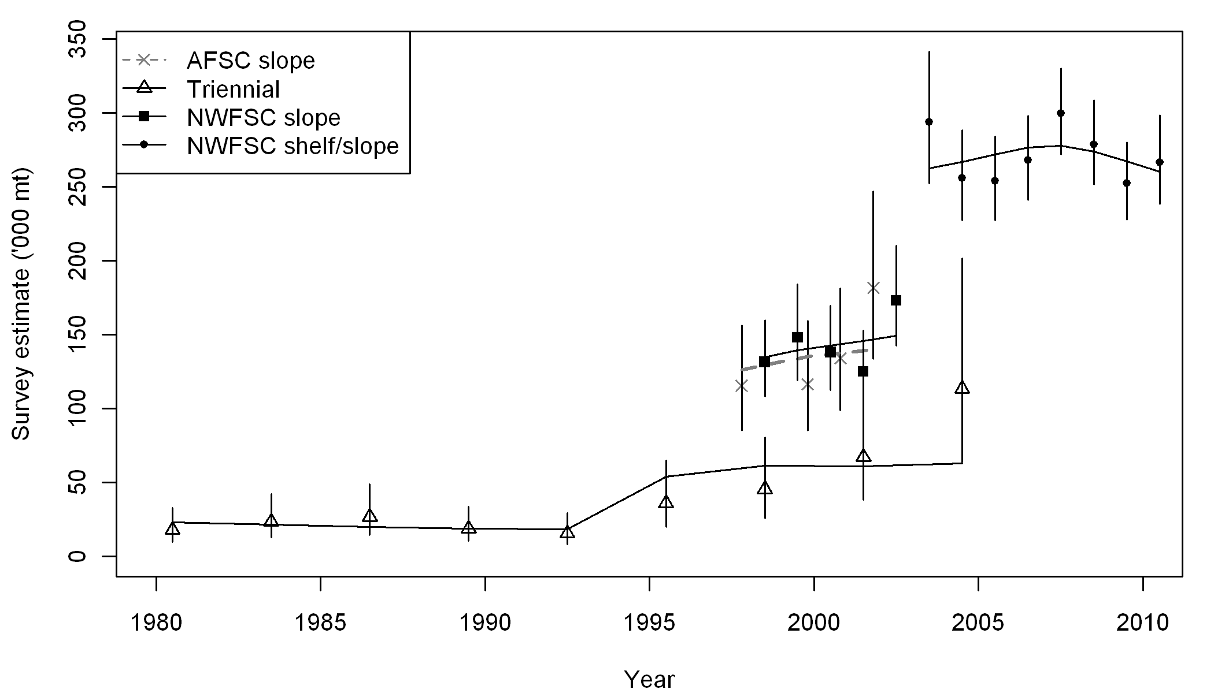

Figure . Fits to the survey abundance estimates for the base case model.

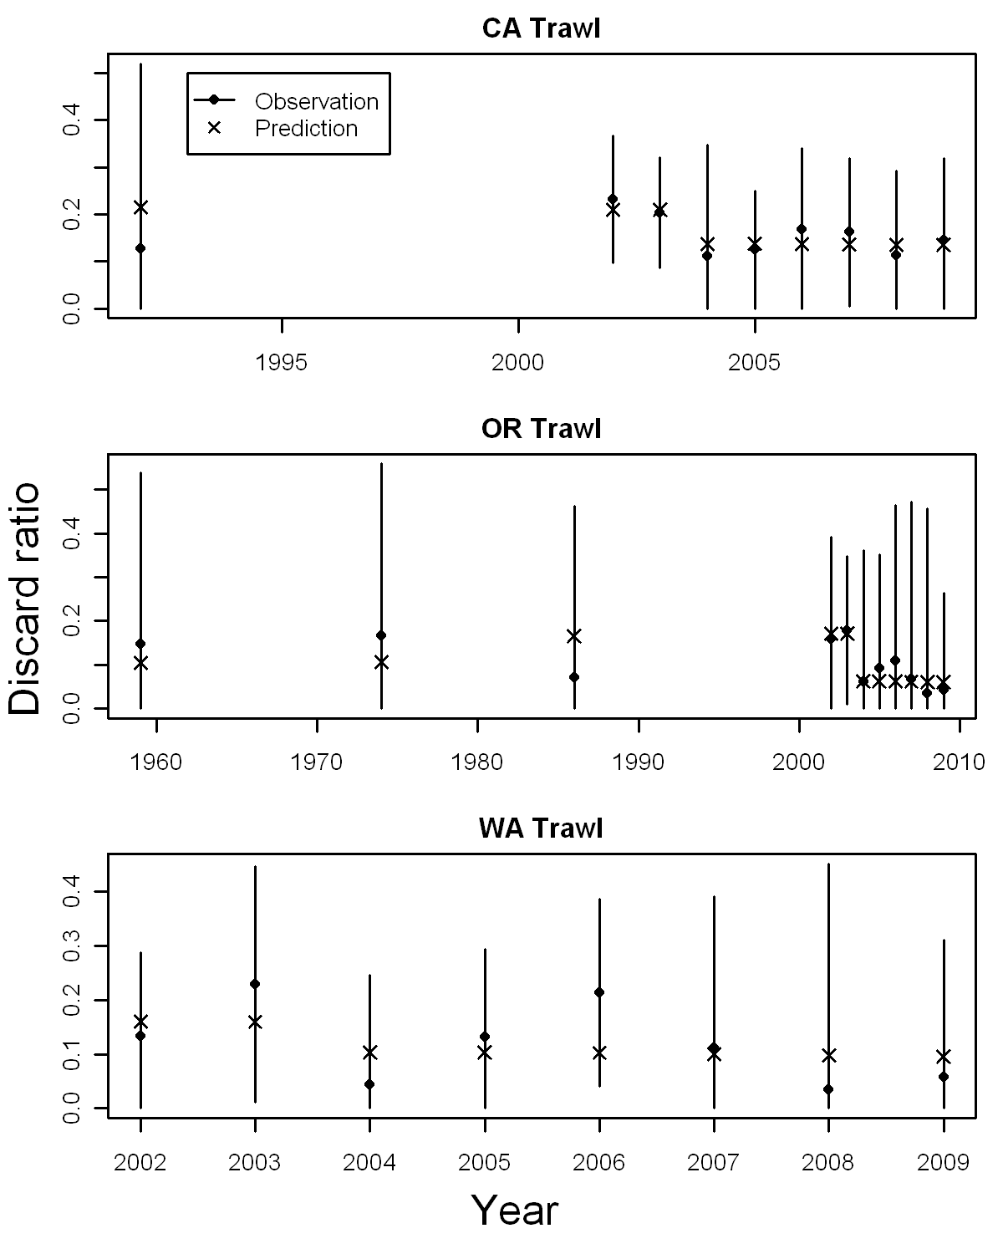

Figure . Predicted and observed discard ratios from the Dover sole base model. Note that the x-axis for each fleet is on a different scale due to different data sources.

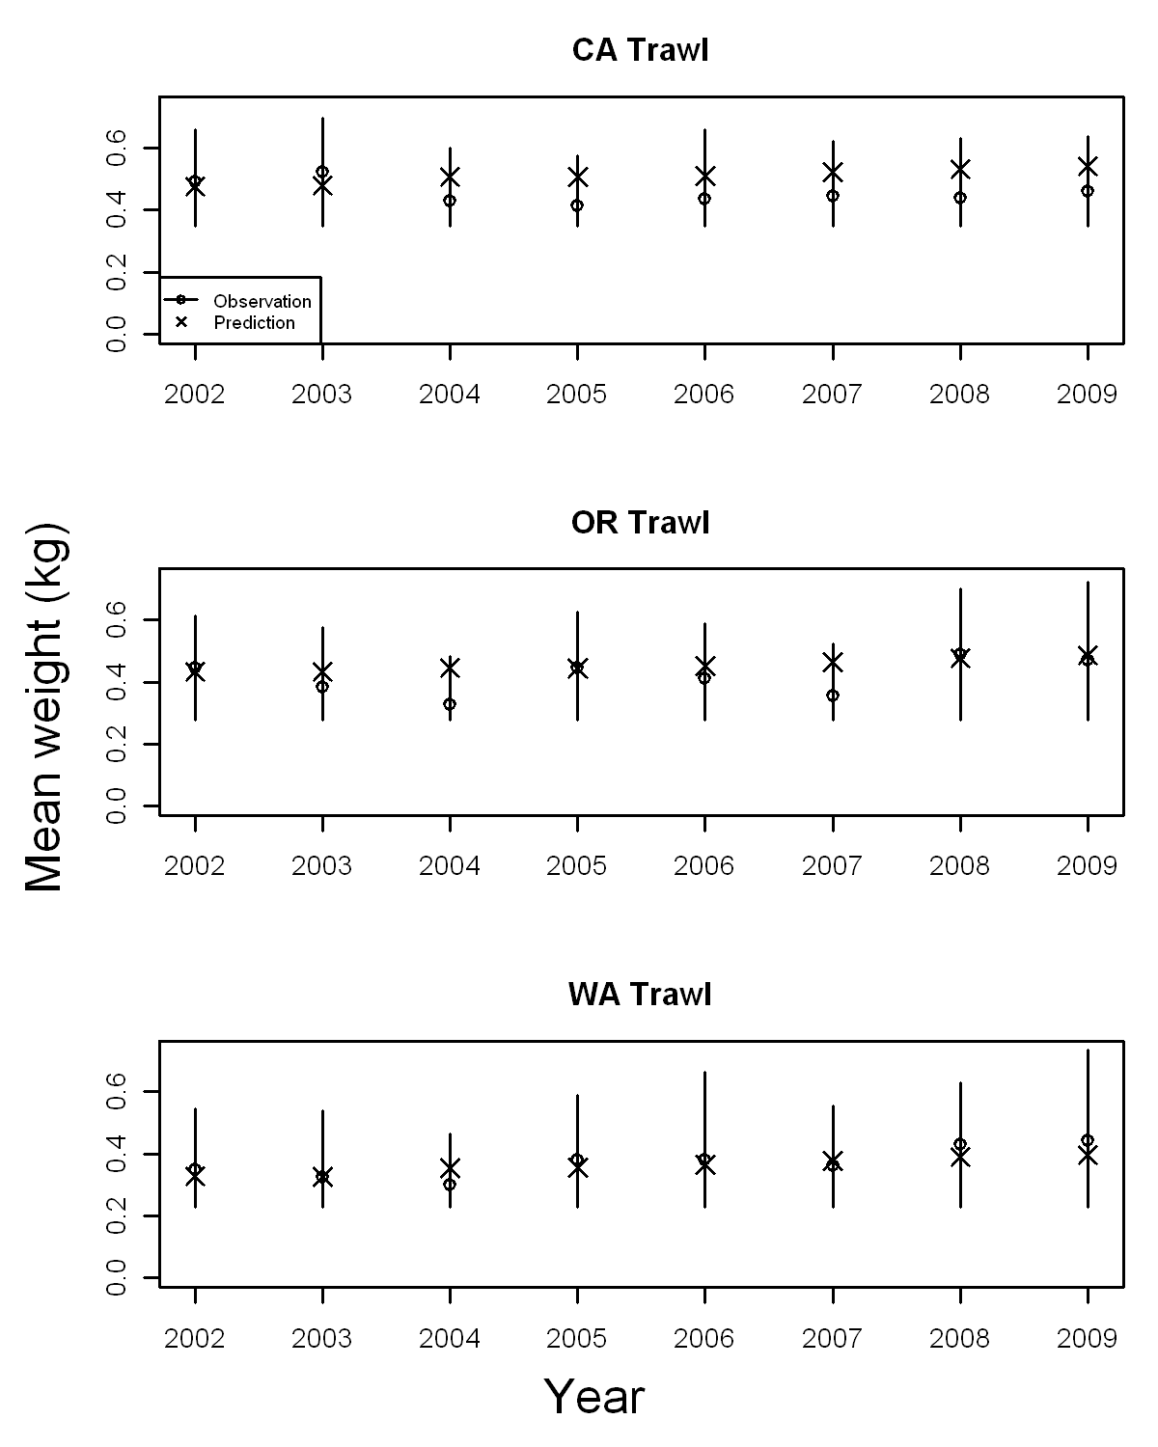

Figure . Fits to the mean weight of the discards for each fleet from the base case model.





Figure . Fits to the retained length composition data for the California fleet as shown with Person’s residuals. A filled circle indicates that the model underfit the observation. The maximum size of the circles are given in the title.

|  |  |
| --- | --- |
| **Females** | **Males** |
|  |  |

Figure . Fits to the retained length frequencies aggregated over all years for the CA fleet. The filled distribution represents the observations and the line represents the model predictions.



Figure . Fits to the discard length composition data for the California fleet as shown with Person’s residuals. A filled circle indicates that the model underfit the observation. The maximum size of the circles are given in the title.



Figure . Fits to the discard length frequencies aggregated over all years for the CA fleet. The filled distribution represents the observations and the line represents the model predictions.

 

Figure . Fits to the retained length composition data for the Oregon fleet as shown with Person’s residuals. A filled circle indicates that the model underfit the observation. The maximum size of the circles are given in the title.

|  |  |
| --- | --- |
| **Females** | **Males** |
|  |  |

Figure . Fits to the retained length frequencies aggregated over all years for the OR fleet. The filled distribution represents the observations and the line represents the model predictions.

|  |  |
| --- | --- |
| **Whole catch, combined sexes** | **Retained catch, combined sexes** |
|  |  |

Figure . Fits to the length composition data collected in 1959-1960 as part of the 1959–1961 study for the Oregon fleet as shown with Person’s residuals. A filled circle indicates that the model underfit the observation. The maximum size of the circles are given in the title.

|  |  |
| --- | --- |
| **Female** | **Male** |
|  |  |

Figure . Fits to the Pikitch discard length composition data for the Oregon fleet as shown with Person’s residuals. A filled circle indicates that the model underfit the observation. The maximum size of the circles are given in the title.



Figure . Fits to the discard length composition data collected by the WCGOP for the Oregon fleet as shown with Person’s residuals. A filled circle indicates that the model underfit the observation. The maximum size of the circles are given in the title.



Figure . Fits to the sex combined discard length frequencies collected by the WCGOP aggregated over all years (2006-2009) for the OR fleet. The filled distribution represents the observations and the line represents the model predictions.



Figure . Fits to the retained length composition data for the Washington fleet as shown with Person’s residuals. A filled circle indicates that the model underfit the observation. The maximum size of the circles are given in the title.

|  |  |
| --- | --- |
| **Females** | **Males** |
|  |  |
|  | |
| **Unsexed** | |
|  | |

Figure . Fits to the retained length frequencies aggregated over all years for the WA fleet. The filled distribution represents the observations and the line represents the model predictions.



Figure . Fits to the discard length composition data collected by the WCGOP for the Washington fleet as shown with Person’s residuals. A filled circle indicates that the model underfit the observation. The maximum size of the circles are given in the title.



Figure . Fits to the sex combined discard length frequencies collected by the WCGOP aggregated over all years (2006-2009) for the WA fleet. The filled distribution represents the observations and the line represents the model predictions.

 

Figure . Fits to the retained length composition data for the AFSC slope survey as shown with Person’s residuals. A filled circle indicates that the model underfit the observation. The maximum size of the circles are given in the title.

|  |  |
| --- | --- |
| **Females** | **Males** |
|  |  |

Figure . Fits to the retained length frequencies aggregated over all years for the AFSC slope. The filled distribution represents the observations and the line represents the model predictions.

 

Figure . Fits to the retained length composition data for the Triennial survey as shown with Person’s residuals. A filled circle indicates that the model underfit the observation. The maximum size of the circles are given in the title.

|  |  |
| --- | --- |
| **Females** | **Males** |
|  |  |

Figure . Fits to the retained length frequencies aggregated over all years for the Triennial survey. The filled distribution represents the observations and the line represents the model predictions.

 

Figure . Fits to the retained length composition data for the NWFSC slope survey as shown with Person’s residuals. A filled circle indicates that the model underfit the observation. The maximum size of the circles are given in the title.

|  |  |
| --- | --- |
| **Females** | **Males** |
|  |  |

Figure . Fits to the retained length frequencies aggregated over all years for the NWFSC slope survey. The filled distribution represents the observations and the line represents the model predictions.

 

Figure . Fits to the retained length composition data for the NWFSC shelf/slope survey as shown with Person’s residuals. A filled circle indicates that the model underfit the observation. The maximum size of the circles are given in the title.

|  |  |
| --- | --- |
| **Females** | **Males** |
|  |  |

Figure . Fits to the retained length frequencies aggregated over all years for the NWFSC shelf/slope survey. The filled distribution represents the observations and the line represents the model predictions.

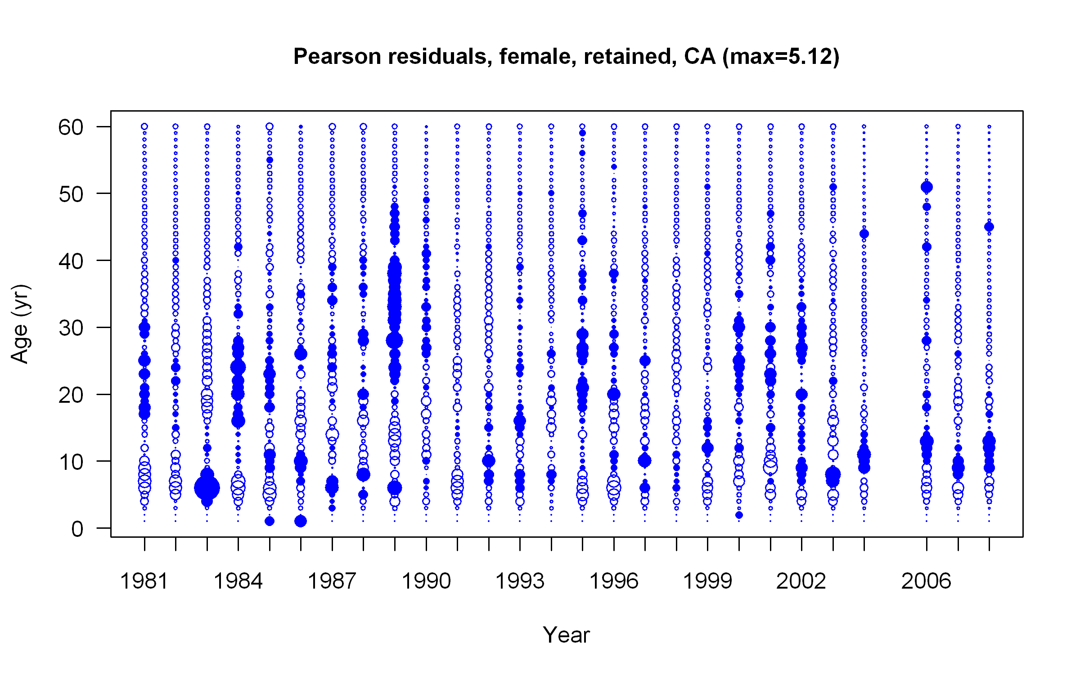 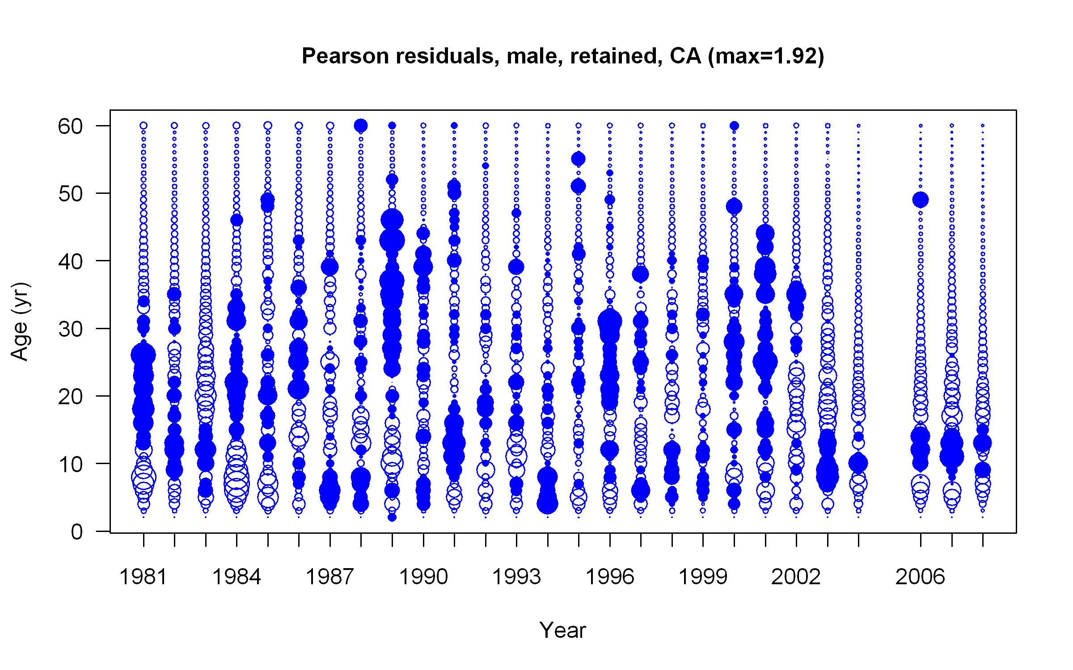

Figure . Fits to the retained age composition data for the California fleet as shown with Person’s residuals. A filled circle indicates that the model underfit the observation. The maximum size of the circles are given in the title.

|  |  |
| --- | --- |
| **Females** | **Males** |
|  |  |

Figure . Fits to the retained age frequencies aggregated over all years for the CA fleet. The filled distribution represents the observations and the line represents the model predictions.

 

Figure . Fits to the retained age composition data for the Oregon fleet as shown with Person’s residuals. A filled circle indicates that the model underfit the observation. The maximum size of the circles are given in the title.

|  |  |
| --- | --- |
| **Females** | **Males** |
|  |  |

Figure . Fits to the retained age frequencies aggregated over all years for the OR fleet. The filled distribution represents the observations and the line represents the model predictions.



Figure . Fits to the retained age composition data for the Washington fleet as shown with Person’s residuals. A filled circle indicates that the model underfit the observation. The maximum size of the circles are given in the title.

|  |  |
| --- | --- |
| **Females** | **Males** |
|  |  |

Figure . Fits to the retained age frequencies aggregated over all years for the WA fleet. The filled distribution represents the observations and the line represents the model predictions.

 

Figure . Fits to the retained age composition data for the NWFSC slope survey as shown with Person’s residuals. A filled circle indicates that the model underfit the observation. The maximum size of the circles are given in the title.

|  |  |
| --- | --- |
| **Females** | **Males** |
|  |  |

Figure . Fits to the retained age frequencies aggregated over all years for the NWFSC slope survey. The filled distribution represents the observations and the line represents the model predictions.



Figure . Implied fits to the retained age composition data for the NWFSC shelf/slope survey as shown with Person’s residuals. A filled circle indicates that the model underfit the observation. The maximum size of the circles are given in the title. These data were fit to via length-at-age vectors.

 

Figure . Fits to the conditional length-at-age frequencies for the NWFSC shelf/slope survey. A filled circle indicates that the model underfit the observation. The maximum size of the circles are given in the title.



Figure : Predicted spawning biomass (mt) from the Dover sole base case assessment. The solid line is the MLE estimate and the dashed lines are the approximate asymptotic 95% confidence intervals.

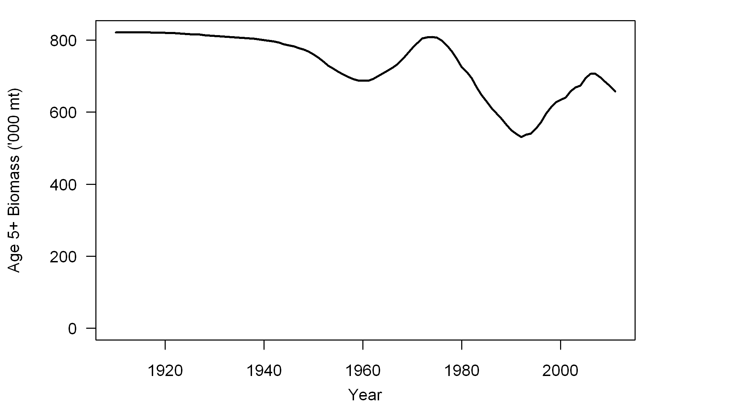

Figure : Predicted trajectory of the age 5+ biomass from the Dover sole base case assessment.



Figure . Predicted depletion relative to unfished biomass from the Dover sole base case assessment. The solid line is the MLE estimate and the dashed lines are the approximate asymptotic 95% confidence intervals. The red lines show the management target of 25% of unfished biomass and the minimum stock size threshold of 12.5% of unfished biomass.

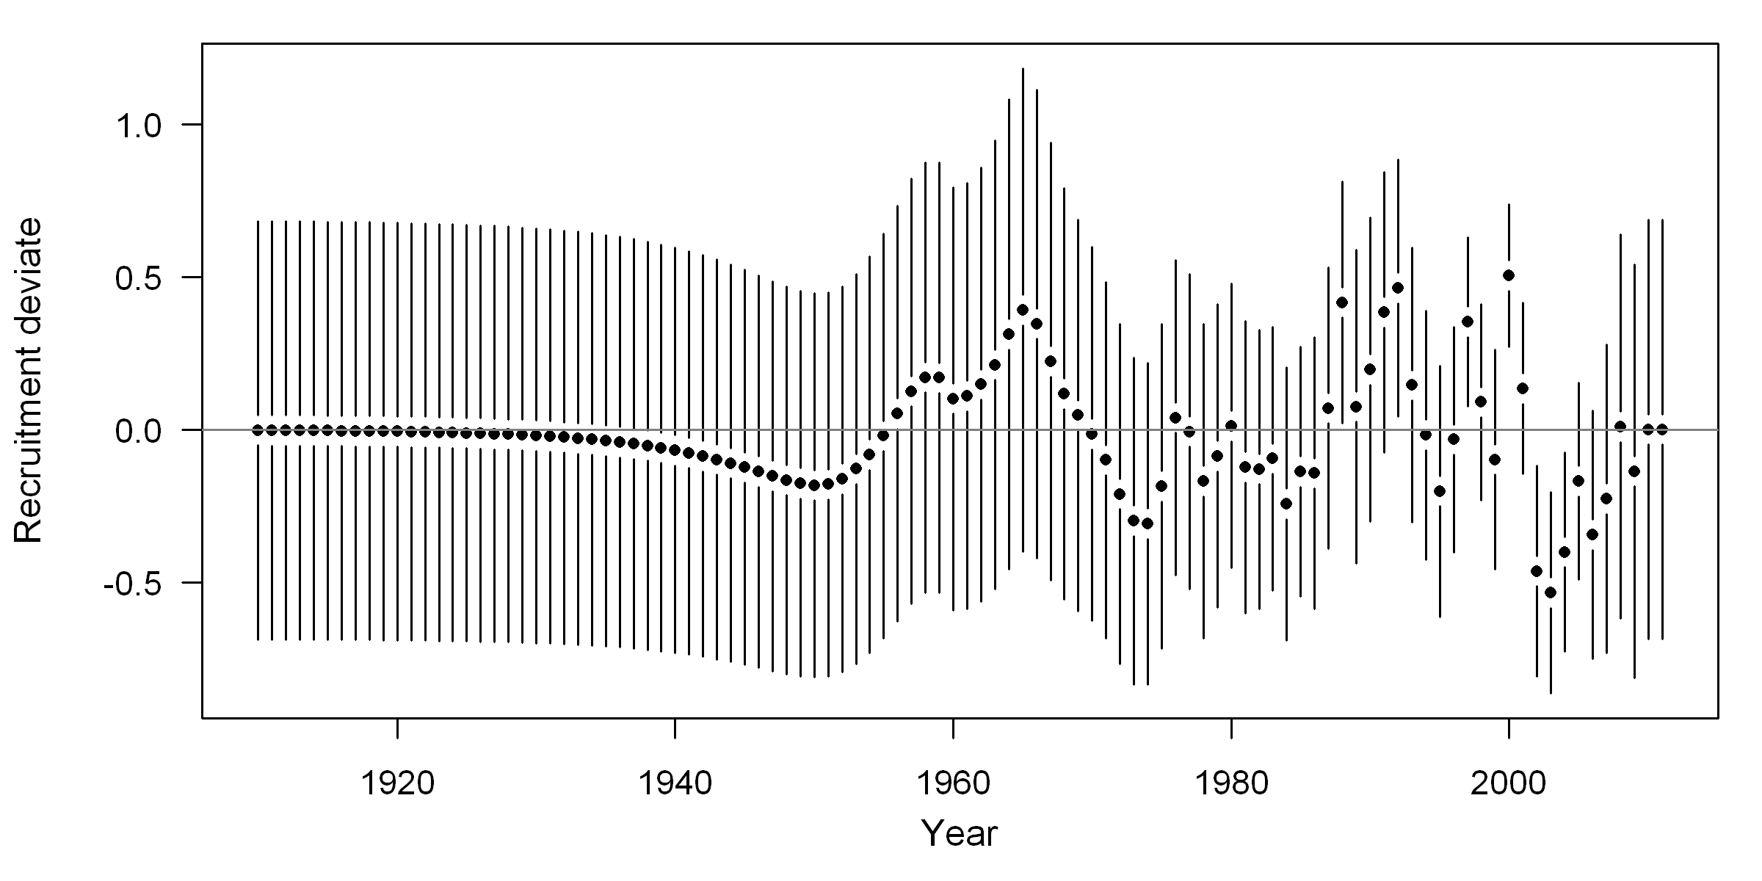

Figure : Estimates of recruitment (upper) and recruitment deviates (lower) with approximate asymptotic confidence intervals (lines) from the MLE estimates.



Figure . Spawning biomass and depletion trajectories from the base case model and sensitivity runs.



Figure . Estimates of recruitment from the base case model and the sensitivity runs.

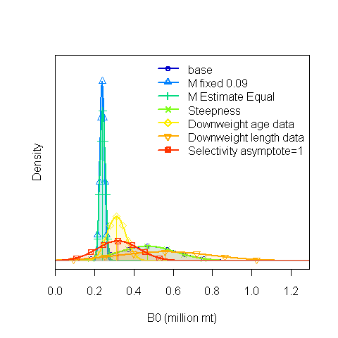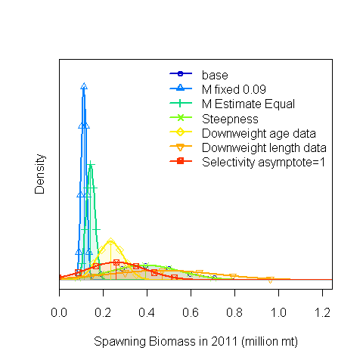

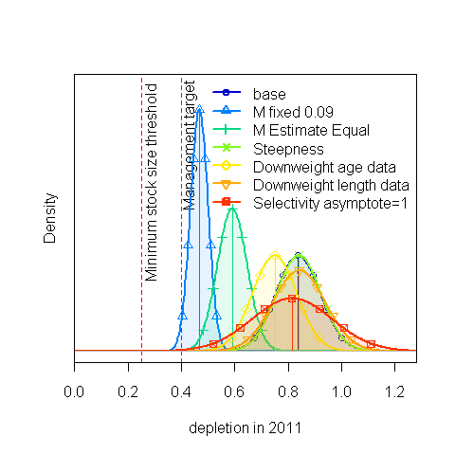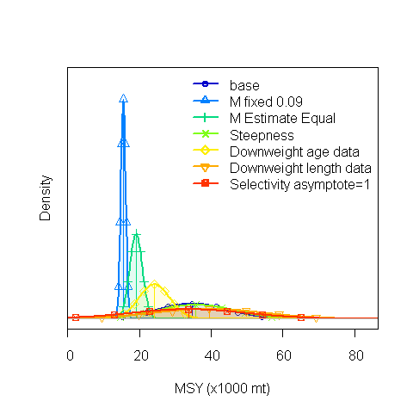

Figure : Approximate asymptotic normal density estimates of unfished spawning biomass (B0), spawning biomass in 2011, depletion in 2011, and MSY for the base case and sensitivities.



Figure . Spawning biomass estimates from the retrospective analysis sequentially removing data for the last five years. The bottom plot shows spawning biomass estimates over the last two decades.



Figure . Depletion estimates from the retrospective analysis sequentially removing data for the last five years.



Figure . Estimates of recruitment for the retrospective analysis.

Figure : Estimated spawning biomass trajectories from the 2001 assessment (red), 2005 assessment (green), and the current basecase assessment (blue) for Dover sole. 95% confidence intervals from the current assessment are shown as dotted blue lines.

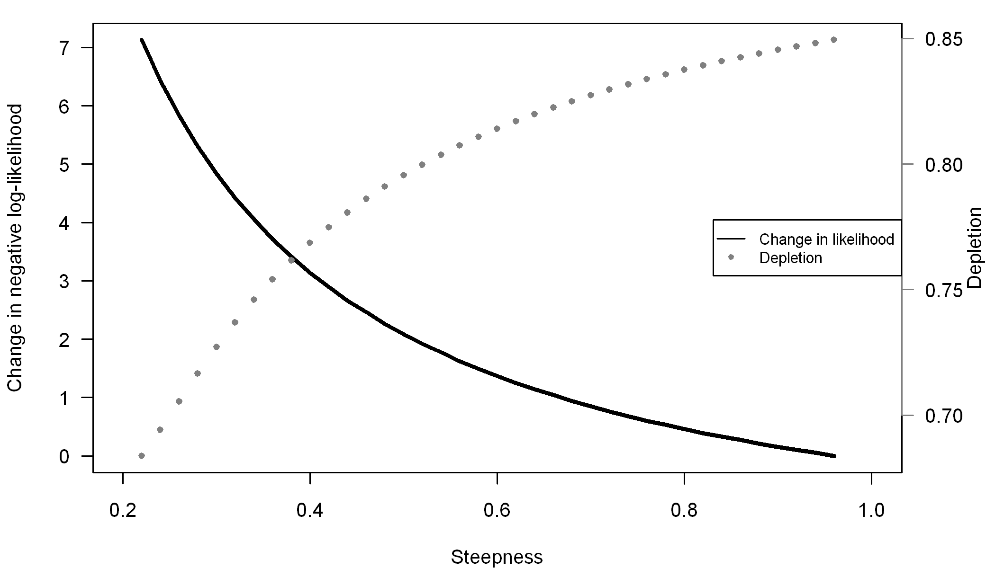

Figure . Likelihood profile on steepness (*h*). The change in negative log-likelihood from the likelihood when steepness was 0.98 is plotted. The estimates of depletion are also shown.

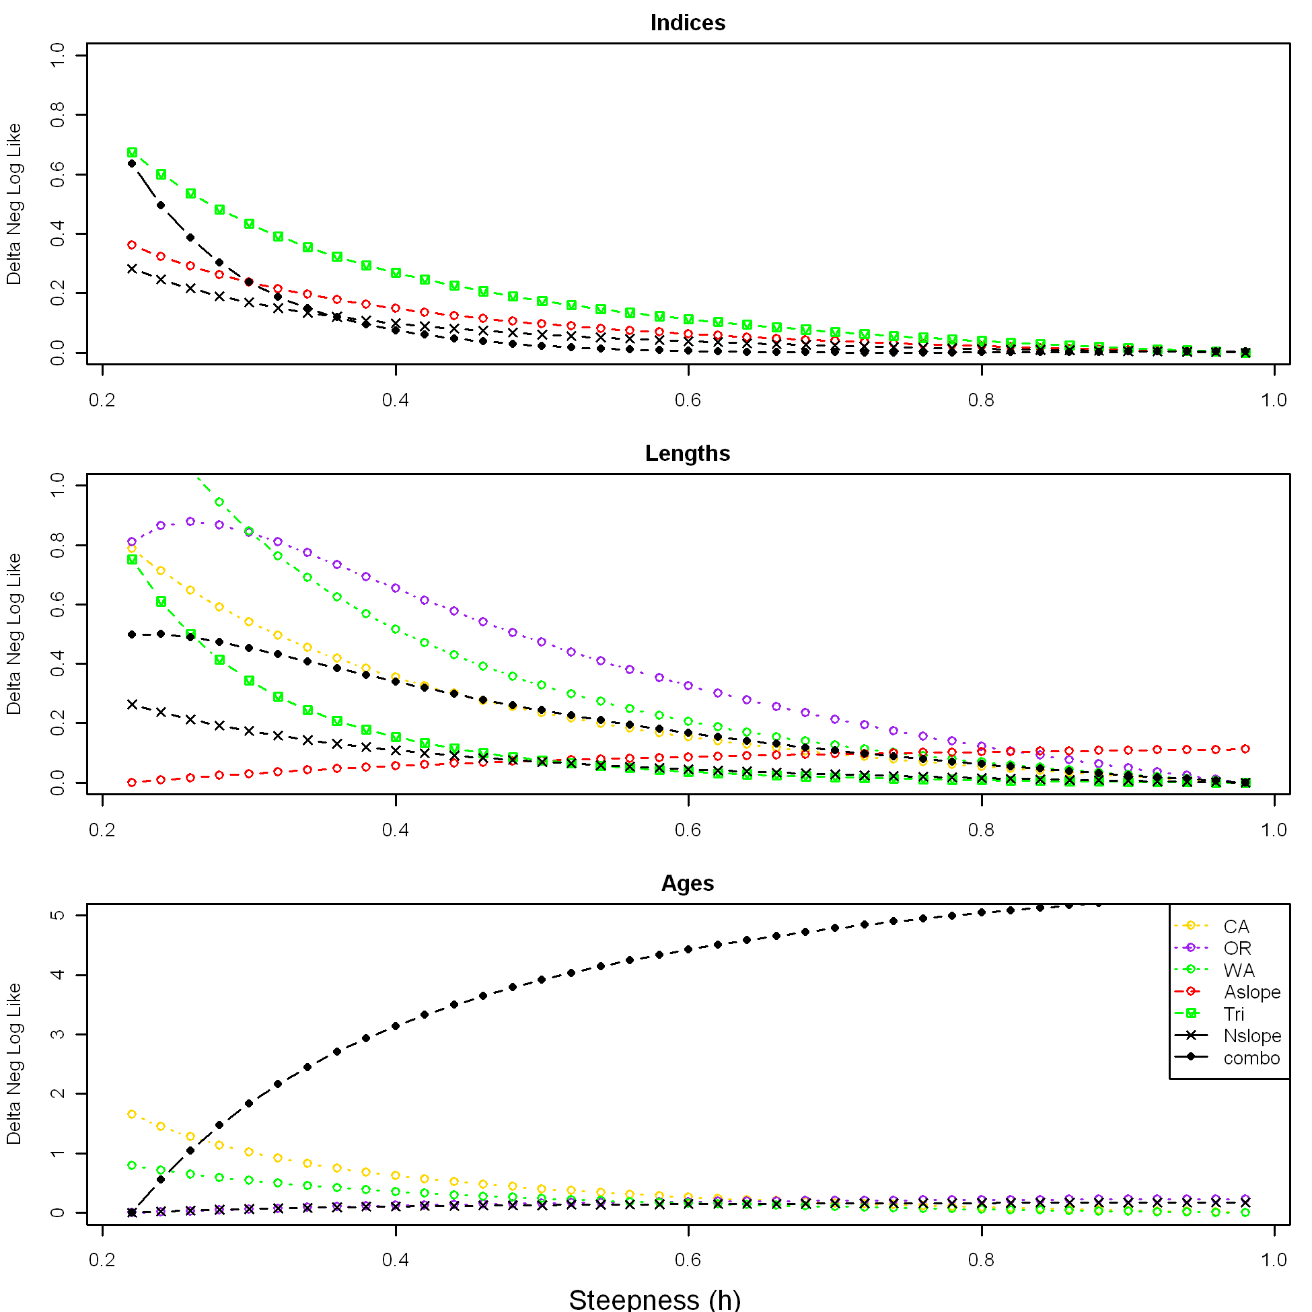

Figure : Likelihoods components for the profile over steepness relative to the minimum likelihood for that data source.

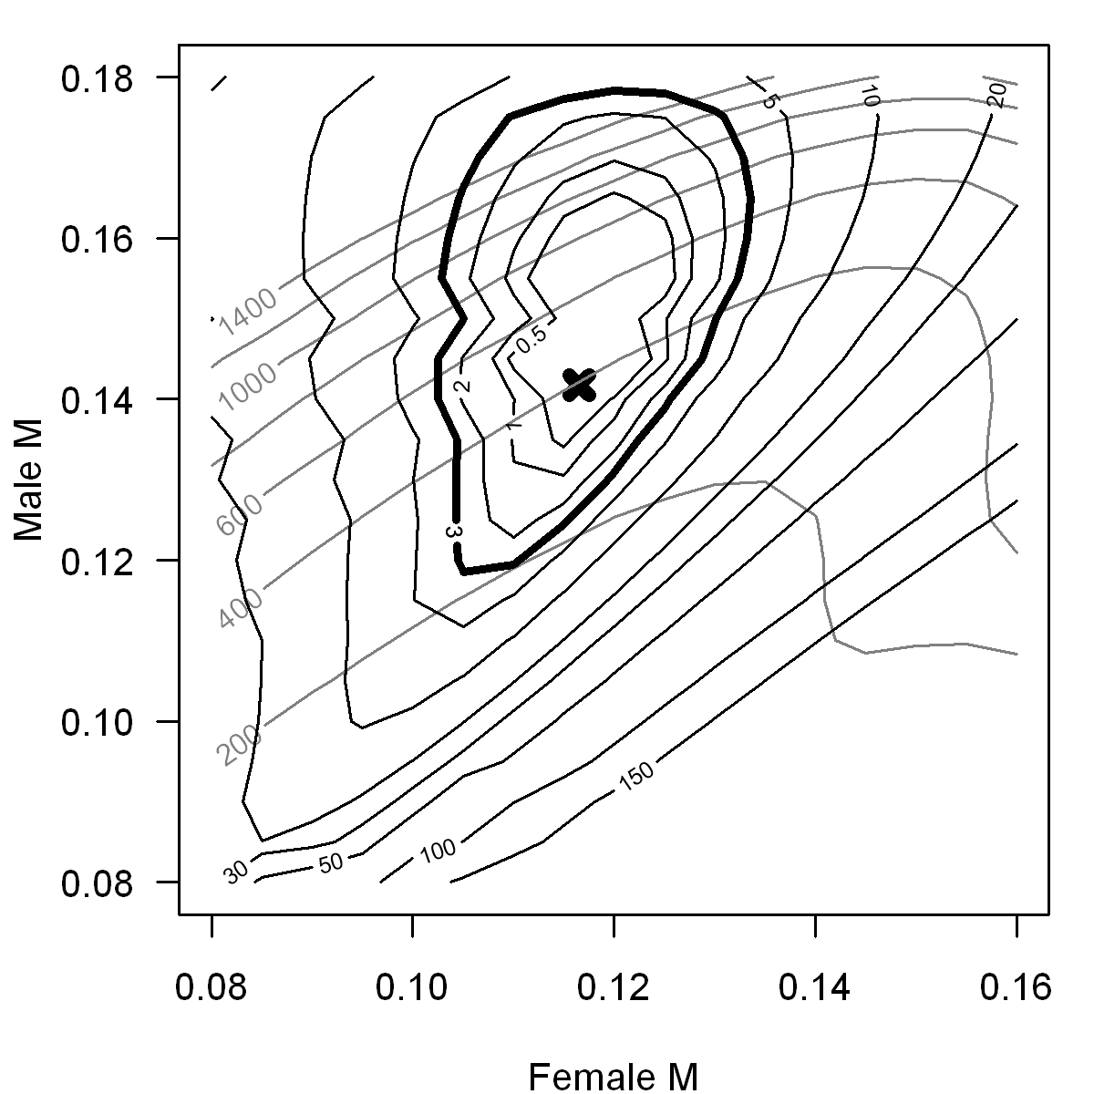

Figure . Joint likelihood profile on female and male natural mortality. The black circular lines are the difference in negative log-likelihood from the minimum negative log-likelihood in the profile. The X marks the location of the base case estimates of female and male natural mortality, showing the influence of the priors. The grey contour lines show the estimates of 2011 spawning biomass (200 to 1400 times 1,000mt).

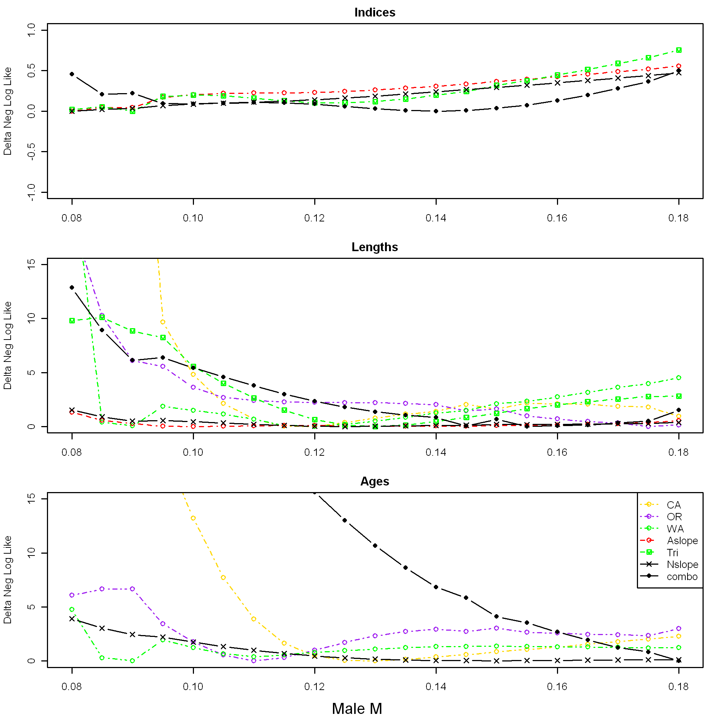

Figure : Likelihood components for a slice of the joint profile over natural mortality relative to the minimum likelihood for that data source. Female *M* was fixed at 0.115 and male *M* ranged from 0.08 to 0.18.

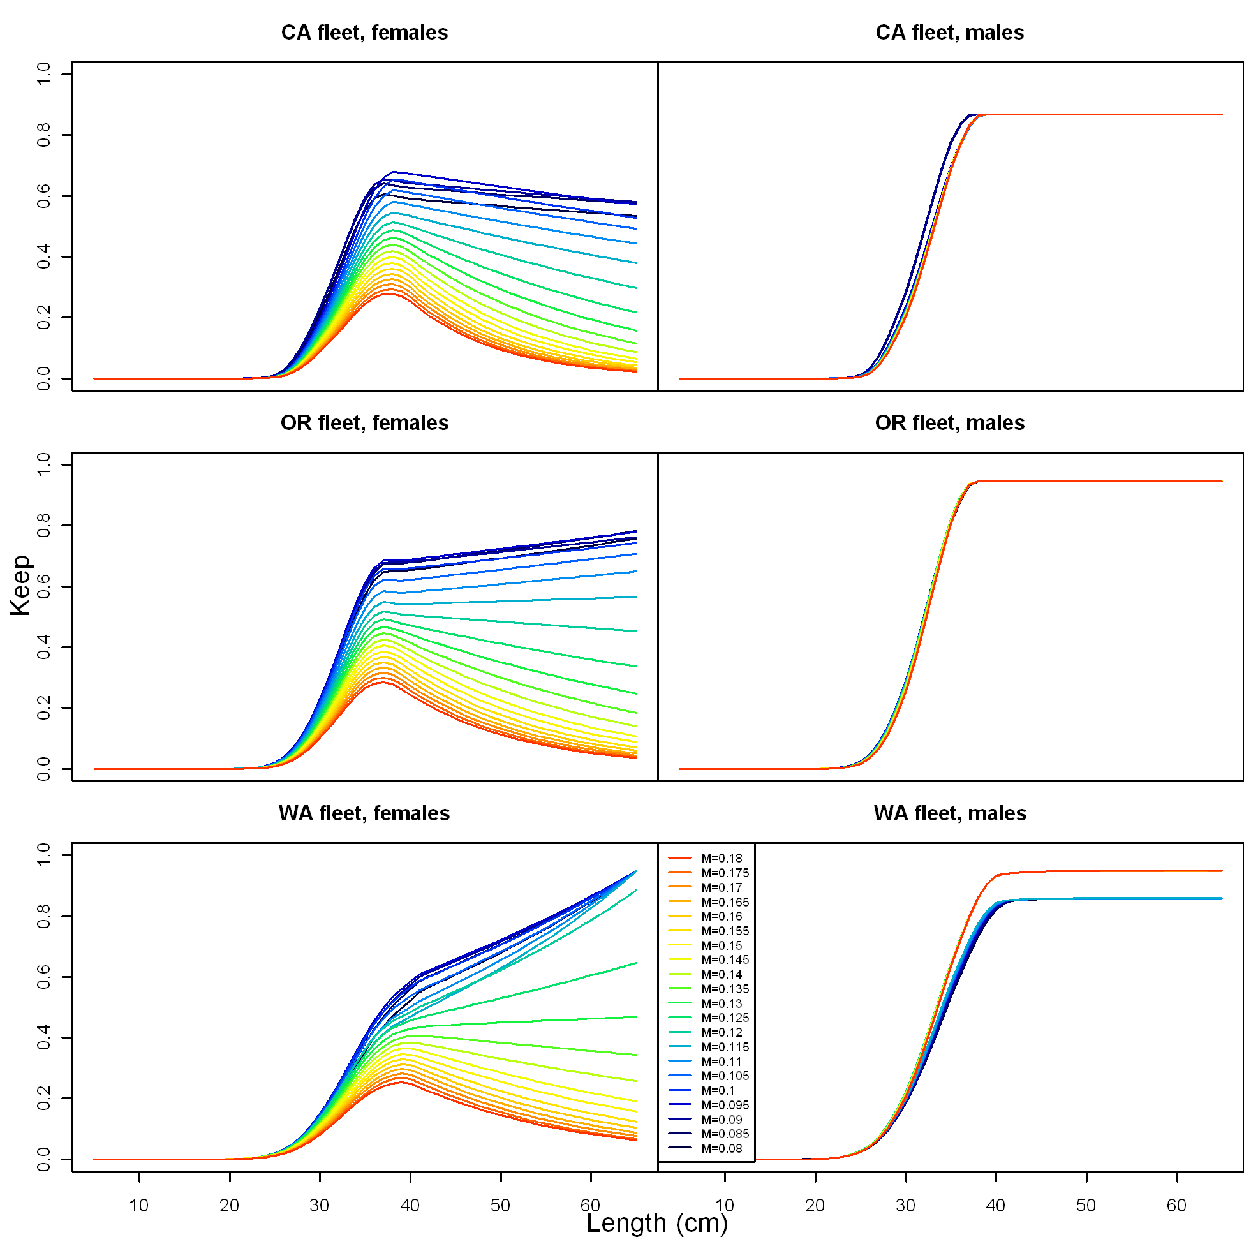

Figure : Estimated keep curves (selectivity times retention) for the commercial fleets with changing male natural mortality and female natural mortality fixed at 0.115. Blue colors indicate small values of male *M* and increasing values of male *M* proceed through oranges, yellow, greens and finally reds.

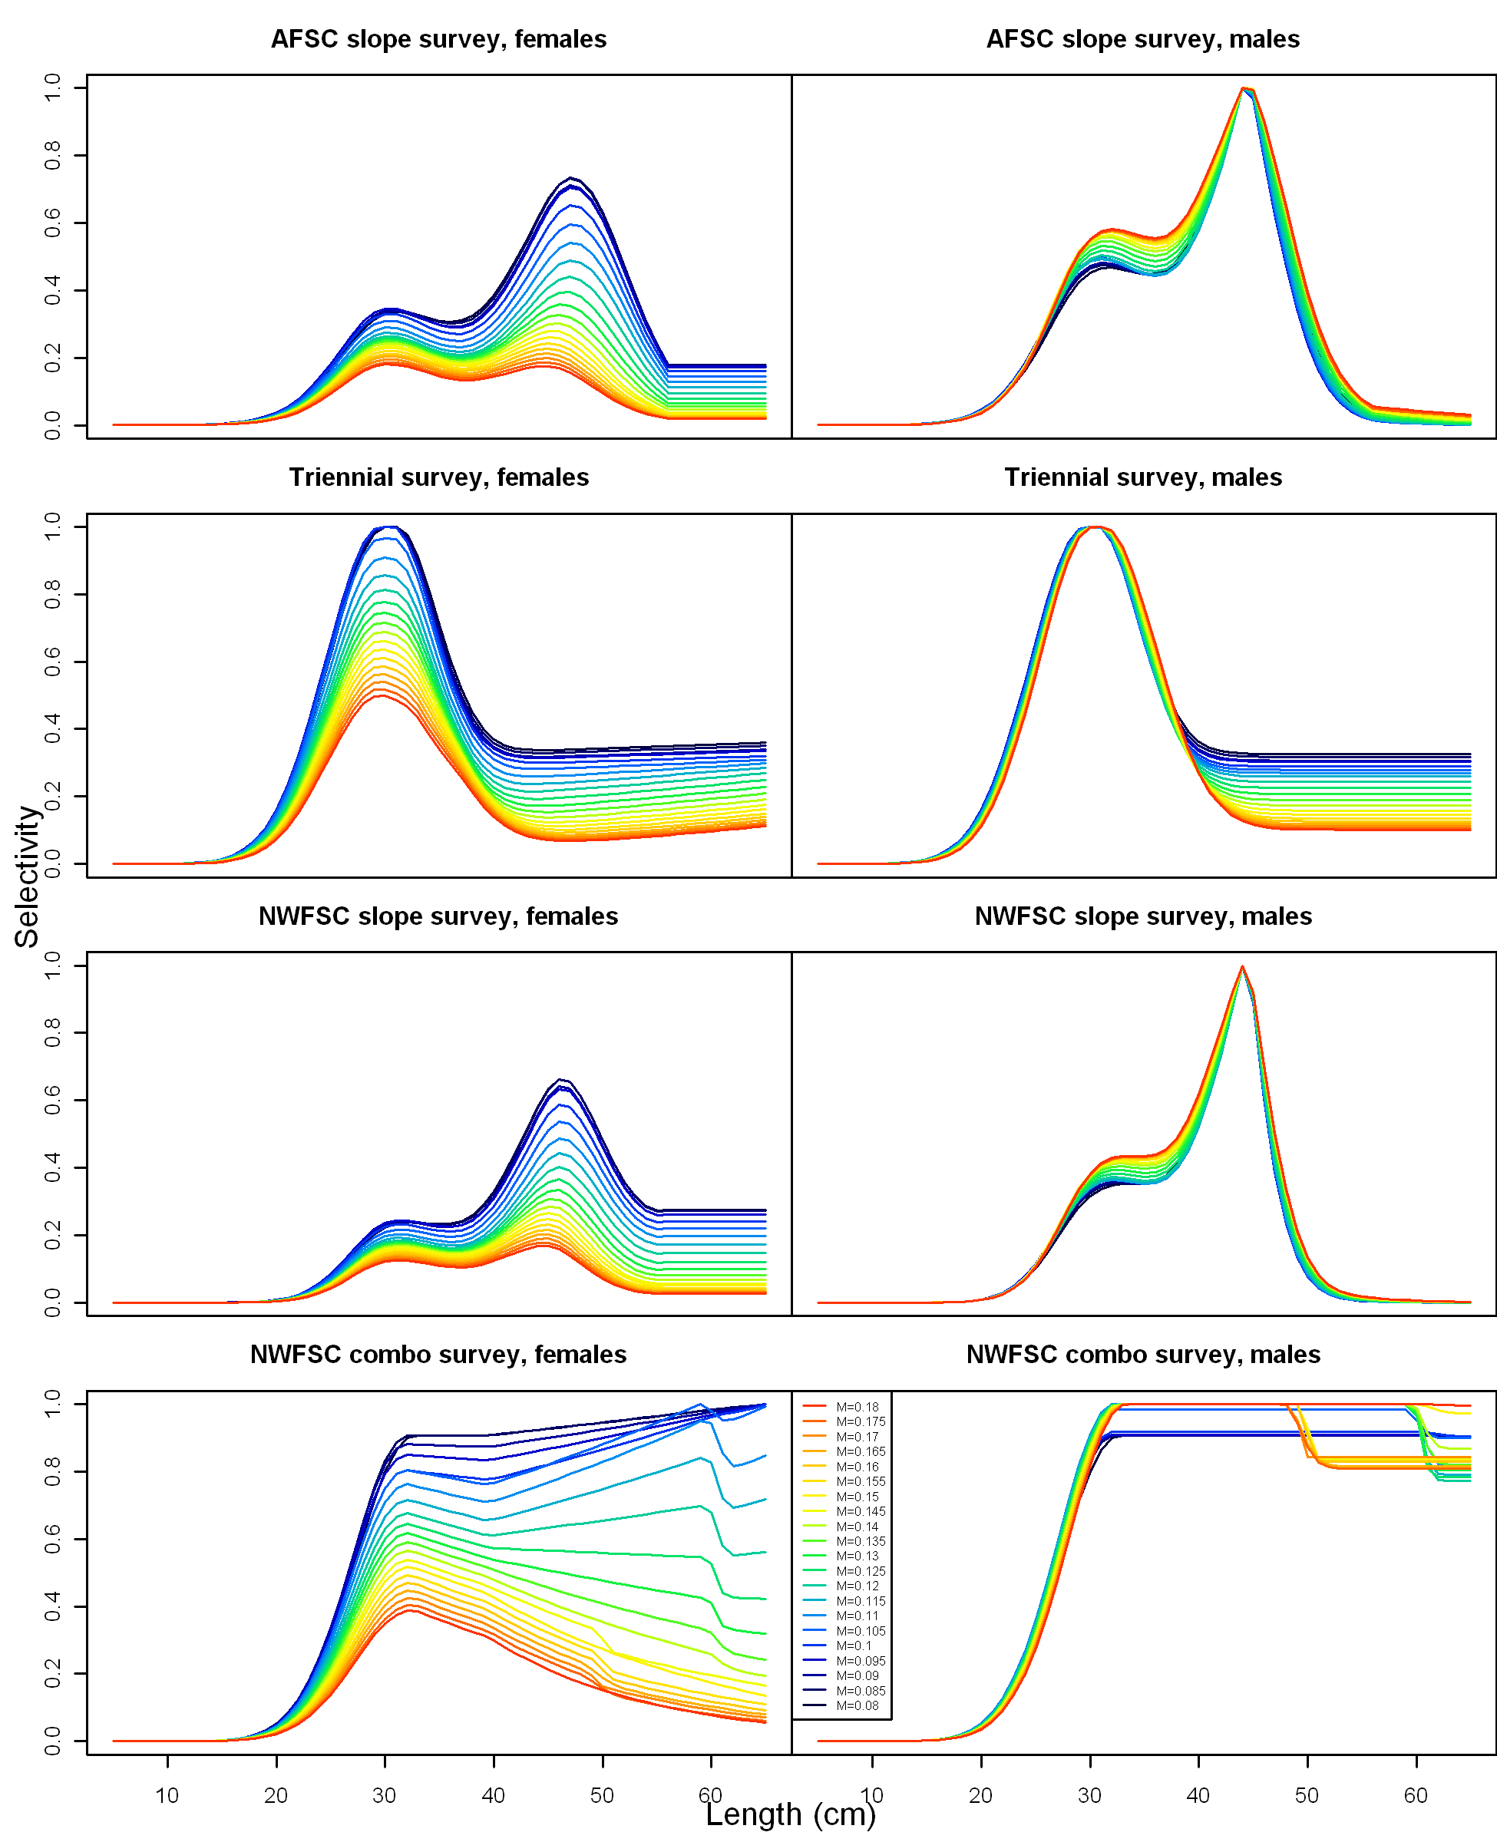

Figure : Estimated selectivity curves for surveys with changing male natural mortality and female natural mortality fixed at 0.115. Blue colors indicate small values of male *M* and increasing values of male *M* proceed through oranges, yellow, greens and finally reds.



Figure . Estimated spawning potential ratio (SPR) for the base case model with approximate 95% asymptotic confidence intervals. One minus SPR is plotted so that higher exploitation rates occur on the upper portion of the y-axis. The management target is plotted as red horizontal line and values above this reflect harvests in excess of the overfishing proxy based on the SPR30%..



Figure . Time-series of estimated summary harvest rate (total catch divided by age-5 and older biomass) for the base case model (round points) with approximate 95% asymptotic confidence intervals (grey lines). The red line is the harvest rate at the overfishing proxy using SPR30%.



Figure . Phase plot of estimated relative (1-SPR) vs. relative spawning biomass for the base case model. The relative (1-SPR) is (1-SPR) divided by 0.3 (the SPR target). Relative depletion is the annual spawning biomass divided by the spawning biomass corresponding to 25% of the unfished spawning biomass. The red point indicates the year 2010.



Figure . Equilibrium yield curve (derived from reference point values reported in Table i) for the base case model. Values are based on 2010 fishery selectivity and distribution with steepness fixed at 0.8. The depletion is relative to unfished spawning biomass.

# Appendix A. Fits to length and age composition data



Figure A.1. Model fits (red line) to observed discard length composition data (both sexes) for California.



Figure A.2. Model fits (red line) to observed female length composition data for California.



Figure A.3. Model fits (red line) to observed male length composition data for California.



Figure A.4. Model fits (red line) to observed whole catch length composition data (sexes combined) for Oregon.



Figure A.5. Model fits (red line) to observed retained length composition data (sexes combined) for Oregon.

**length comps, female, discard, OR length comps, male, discard, OR**

 

Length (cm)

Figure A.6. Model fits (red line) to the Pikitch study discard length composition data for female (left) and male (right) fish for Oregon.



Figure A.7. Model fits (red line) to WCGOP discard length composition data for female (left) and male (right) fish for Oregon.



Figure A.8. Model fits (red line) to commercial length composition data for females for Oregon.



Figure A.8. (cont). Model fits (red line) to commercial length composition data for females for Oregon.



Figure A.9. Model fits (red line) to commercial length composition data for males for Oregon.



Figure A.9. (cont). Model fits (red line) to commercial length composition data for females for Oregon.



Figure A.10. Model fits (red line) to WCGOP discard length composition data for both sexes for Washington.



Figure A.11. Model fits (red line) to commercial length composition data for sexes combined for Washington.



Figure A.12. Model fits (red line) to commercial length composition data for females for Washington.



Figure A.13. Model fits (red line) to commercial length composition data for males for Washington.



Figure A.14. Model fits (red line) to survey length composition data for females by the AFSC slope survey.



Figure A.15. Model fits (red line) to survey length composition data for males by the AFSC slope survey.



Figure A.16. Model fits (red line) to survey length composition data for females by the Triennial survey.



Figure A.17. Model fits (red line) to survey length composition data for males by the Triennial survey.

**Length comps, female, NWFSC Slope Length comps, male, NWFSC Slope**



Figure A.18. Model fits (red line) to survey length composition data for females (left) and males (right) by the NWFSC slope survey.

**Length comps, female, NWFSC Combo Length comps, male, NWFSC Combo**

 

Figure A.19. Model fits (red line) to survey length composition data for females (left) and males (right) by the NWFSC combo survey.



Figure A.20. Model fits (red line) to commercial age composition data for females from California.



Figure A.21. Model fits (red line) to commercial age composition data for males from California.



Figure A.22. Model fits (red line) to commercial age composition data for females from Oregon.



Figure A.23. Model fits (red line) to commercial age composition data for males from Oregon.



Figure A.24. Model fits (red line) to commercial age composition data for females from Washington.



Figure A.25. Model fits (red line) to commercial age composition data for males from Washington.

**ghost age comps, female, ghost age comps, male,**

**AFSC_slope AFSC_slope**



Age (yrs)

Figure A.26. Implied model fits (red line) to survey age composition data for females (left) and males (right) from the AFSC slope survey. These data were not actually fit to in the model.

**age comps, female, age comps, male,**

**NWFSC_slope NWFSC_slope**



Age (yr)

Figure A.27. Model fits (red line) to survey age composition data for females (left) and males (right) by the NWFSC slope survey.

**ghost age comps, female, ghost age comps, male,**

**NWFSC_combo NWFSC_combo**



Age (yr)

Figure A.28. Implied model fits (red line) to survey age composition data for females (left) and males (right) by the NWFSC combo survey. The conditional age-at-length distributions were fit to in the model.

# Appendix B. Predicted numbers at age by sex

Table B.1 Female numbers at age for the base case model.

|  |  |  |  |  |  |  |  |  |  |  |  |  |  |  |  |  |
| --- | --- | --- | --- | --- | --- | --- | --- | --- | --- | --- | --- | --- | --- | --- | --- | --- |
|  | Age |  |  |  |  |  |  |  |  |  |  |  |  |  |  |  |
| Year | 0 | 1 | 2 | 3 | 4 | 5 | 6 | 7 | 8 | 9 | 10-19 | 20-29 | 30-39 | 40-49 | 50-59 | 60+ |
| 1910 | 189,910 | 169,452 | 150,817 | 134,232 | 119,470 | 106,332 | 94,639 | 84,231 | 74,968 | 66,724 | 371,576 | 115,902 | 36,152 | 11,277 | 3,517 | 1,595 |
| 1911 | 189,860 | 169,025 | 150,817 | 134,232 | 119,470 | 106,332 | 94,639 | 84,231 | 74,968 | 66,724 | 371,576 | 115,902 | 36,152 | 11,277 | 3,517 | 1,595 |
| 1912 | 189,804 | 168,981 | 150,438 | 134,232 | 119,470 | 106,332 | 94,639 | 84,231 | 74,968 | 66,723 | 371,571 | 115,901 | 36,152 | 11,277 | 3,517 | 1,595 |
| 1913 | 189,742 | 168,931 | 150,398 | 133,894 | 119,470 | 106,332 | 94,638 | 84,231 | 74,967 | 66,723 | 371,562 | 115,898 | 36,151 | 11,276 | 3,517 | 1,594 |
| 1914 | 189,673 | 168,876 | 150,354 | 133,859 | 119,170 | 106,332 | 94,638 | 84,231 | 74,967 | 66,722 | 371,547 | 115,893 | 36,150 | 11,276 | 3,517 | 1,594 |
| 1915 | 189,597 | 168,815 | 150,305 | 133,820 | 119,138 | 106,064 | 94,638 | 84,230 | 74,966 | 66,721 | 371,530 | 115,886 | 36,148 | 11,275 | 3,517 | 1,594 |
| 1916 | 189,512 | 168,747 | 150,250 | 133,776 | 119,103 | 106,037 | 94,400 | 84,230 | 74,966 | 66,720 | 371,509 | 115,878 | 36,145 | 11,275 | 3,517 | 1,594 |
| 1917 | 189,417 | 168,671 | 150,190 | 133,727 | 119,064 | 106,005 | 94,375 | 84,018 | 74,965 | 66,719 | 371,488 | 115,869 | 36,143 | 11,274 | 3,517 | 1,594 |
| 1918 | 189,309 | 168,586 | 150,122 | 133,673 | 119,021 | 105,971 | 94,347 | 83,994 | 74,773 | 66,713 | 371,421 | 115,845 | 36,136 | 11,272 | 3,516 | 1,594 |
| 1919 | 189,187 | 168,490 | 150,047 | 133,613 | 118,973 | 105,932 | 94,316 | 83,969 | 74,751 | 66,541 | 371,344 | 115,815 | 36,127 | 11,269 | 3,515 | 1,593 |
| 1920 | 189,051 | 168,382 | 149,961 | 133,546 | 118,920 | 105,889 | 94,282 | 83,941 | 74,728 | 66,521 | 371,122 | 115,783 | 36,118 | 11,266 | 3,514 | 1,593 |
| 1921 | 188,900 | 168,261 | 149,865 | 133,470 | 118,860 | 105,842 | 94,244 | 83,911 | 74,704 | 66,501 | 370,926 | 115,756 | 36,110 | 11,264 | 3,513 | 1,593 |
| 1922 | 188,732 | 168,127 | 149,758 | 133,384 | 118,792 | 105,789 | 94,201 | 83,875 | 74,674 | 66,476 | 370,693 | 115,714 | 36,098 | 11,260 | 3,512 | 1,592 |
| 1923 | 188,542 | 167,977 | 149,638 | 133,289 | 118,716 | 105,728 | 94,153 | 83,834 | 74,637 | 66,440 | 370,380 | 115,644 | 36,077 | 11,254 | 3,510 | 1,591 |
| 1924 | 188,330 | 167,808 | 149,504 | 133,182 | 118,631 | 105,660 | 94,099 | 83,790 | 74,598 | 66,403 | 370,047 | 115,563 | 36,054 | 11,247 | 3,508 | 1,590 |
| 1925 | 188,088 | 167,619 | 149,354 | 133,063 | 118,536 | 105,584 | 94,037 | 83,739 | 74,552 | 66,358 | 369,629 | 115,451 | 36,021 | 11,237 | 3,505 | 1,589 |
| 1926 | 187,824 | 167,404 | 149,186 | 132,929 | 118,430 | 105,500 | 93,969 | 83,683 | 74,503 | 66,314 | 369,199 | 115,328 | 35,985 | 11,226 | 3,502 | 1,587 |
| 1927 | 187,522 | 167,169 | 148,995 | 132,780 | 118,311 | 105,406 | 93,894 | 83,622 | 74,454 | 66,271 | 368,800 | 115,206 | 35,949 | 11,215 | 3,498 | 1,586 |
| 1928 | 187,184 | 166,901 | 148,786 | 132,610 | 118,178 | 105,299 | 93,809 | 83,553 | 74,395 | 66,219 | 368,344 | 115,059 | 35,905 | 11,201 | 3,494 | 1,584 |
| 1929 | 186,801 | 166,599 | 148,546 | 132,424 | 118,026 | 105,181 | 93,715 | 83,478 | 74,333 | 66,167 | 367,923 | 114,916 | 35,861 | 11,188 | 3,490 | 1,582 |
| 1930 | 186,376 | 166,259 | 148,278 | 132,211 | 117,861 | 105,046 | 93,609 | 83,391 | 74,262 | 66,105 | 367,505 | 114,709 | 35,812 | 11,174 | 3,486 | 1,580 |
| 1931 | 185,896 | 165,880 | 147,975 | 131,972 | 117,671 | 104,899 | 93,489 | 83,298 | 74,188 | 66,046 | 367,141 | 114,515 | 35,765 | 11,160 | 3,481 | 1,578 |
| 1932 | 185,359 | 165,453 | 147,638 | 131,702 | 117,459 | 104,730 | 93,359 | 83,194 | 74,109 | 65,986 | 366,857 | 114,346 | 35,725 | 11,148 | 3,478 | 1,577 |
| 1933 | 184,754 | 164,975 | 147,258 | 131,402 | 117,219 | 104,541 | 93,209 | 83,079 | 74,018 | 65,918 | 366,592 | 114,187 | 35,686 | 11,136 | 3,474 | 1,575 |
| 1934 | 184,072 | 164,437 | 146,833 | 131,064 | 116,952 | 104,328 | 93,041 | 82,946 | 73,917 | 65,840 | 366,343 | 114,042 | 35,649 | 11,125 | 3,471 | 1,573 |
| 1935 | 183,299 | 163,830 | 146,354 | 130,685 | 116,651 | 104,090 | 92,851 | 82,796 | 73,798 | 65,748 | 366,044 | 113,898 | 35,610 | 11,114 | 3,467 | 1,572 |
| 1936 | 182,424 | 163,141 | 145,813 | 130,259 | 116,314 | 103,822 | 92,639 | 82,626 | 73,662 | 65,639 | 365,663 | 113,741 | 35,564 | 11,100 | 3,463 | 1,570 |
| 1937 | 181,433 | 162,363 | 145,201 | 129,778 | 115,934 | 103,522 | 92,400 | 82,437 | 73,510 | 65,517 | 365,211 | 113,572 | 35,511 | 11,085 | 3,458 | 1,568 |
| 1938 | 180,312 | 161,481 | 144,507 | 129,233 | 115,506 | 103,184 | 92,133 | 82,224 | 73,340 | 65,379 | 364,694 | 113,408 | 35,457 | 11,068 | 3,453 | 1,566 |
| 1939 | 179,046 | 160,483 | 143,723 | 128,616 | 115,021 | 102,803 | 91,833 | 81,987 | 73,154 | 65,233 | 364,173 | 113,264 | 35,406 | 11,053 | 3,449 | 1,564 |
| 1940 | 177,611 | 159,356 | 142,835 | 127,918 | 114,472 | 102,371 | 91,492 | 81,713 | 72,929 | 65,046 | 363,380 | 113,075 | 35,322 | 11,031 | 3,442 | 1,561 |
| 1941 | 175,997 | 158,079 | 141,832 | 127,127 | 113,850 | 101,882 | 91,107 | 81,410 | 72,685 | 64,846 | 362,518 | 112,881 | 35,235 | 11,008 | 3,435 | 1,557 |
| 1942 | 174,198 | 156,642 | 140,695 | 126,234 | 113,147 | 101,329 | 90,672 | 81,069 | 72,418 | 64,633 | 361,616 | 112,683 | 35,146 | 10,984 | 3,428 | 1,554 |
| 1943 | 172,206 | 155,041 | 139,416 | 125,223 | 112,352 | 100,703 | 90,179 | 80,679 | 72,107 | 64,383 | 360,533 | 112,442 | 35,045 | 10,955 | 3,419 | 1,550 |
| 1944 | 170,016 | 153,268 | 137,991 | 124,085 | 111,452 | 99,995 | 89,614 | 80,212 | 71,703 | 64,022 | 358,489 | 111,893 | 34,853 | 10,898 | 3,402 | 1,542 |
| 1945 | 167,711 | 151,319 | 136,413 | 122,816 | 110,439 | 99,194 | 88,992 | 79,739 | 71,350 | 63,755 | 357,425 | 111,672 | 34,764 | 10,872 | 3,394 | 1,539 |
| 1946 | 165,316 | 149,268 | 134,679 | 121,412 | 109,310 | 98,293 | 88,276 | 79,174 | 70,905 | 63,406 | 355,927 | 111,330 | 34,644 | 10,836 | 3,383 | 1,534 |
| 1947 | 162,933 | 147,136 | 132,853 | 119,868 | 108,060 | 97,287 | 87,471 | 78,529 | 70,386 | 62,985 | 354,087 | 110,894 | 34,501 | 10,791 | 3,369 | 1,528 |

Table B.1 (continued) Female numbers at age for the base case model.

|  |  |  |  |  |  |  |  |  |  |  |  |  |  |  |  |  |
| --- | --- | --- | --- | --- | --- | --- | --- | --- | --- | --- | --- | --- | --- | --- | --- | --- |
|  | Age |  |  |  |  |  |  |  |  |  |  |  |  |  |  |  |
| Year | 0 | 1 | 2 | 3 | 4 | 5 | 6 | 7 | 8 | 9 | 10-19 | 20-29 | 30-39 | 40-49 | 50-59 | 60+ |
| 1948 | 160,724 | 145,015 | 130,955 | 118,243 | 106,686 | 96,175 | 86,578 | 77,818 | 69,823 | 62,540 | 352,339 | 110,515 | 34,382 | 10,754 | 3,357 | 1,522 |
| 1949 | 158,913 | 143,049 | 129,068 | 116,554 | 105,240 | 94,951 | 85,584 | 77,008 | 69,160 | 61,993 | 349,959 | 109,949 | 34,213 | 10,700 | 3,341 | 1,515 |
| 1950 | 157,891 | 141,437 | 127,318 | 114,874 | 103,737 | 93,663 | 84,487 | 76,099 | 68,390 | 61,328 | 346,719 | 109,149 | 33,986 | 10,622 | 3,318 | 1,505 |
| 1951 | 158,276 | 140,528 | 125,883 | 113,317 | 102,241 | 92,324 | 83,332 | 75,093 | 67,518 | 60,548 | 342,422 | 108,023 | 33,668 | 10,516 | 3,286 | 1,490 |
| 1952 | 160,874 | 140,870 | 125,074 | 112,040 | 100,855 | 90,993 | 82,137 | 74,055 | 66,602 | 59,741 | 337,785 | 106,778 | 33,320 | 10,401 | 3,251 | 1,475 |
| 1953 | 166,167 | 143,183 | 125,379 | 111,320 | 99,718 | 89,758 | 80,947 | 72,976 | 65,647 | 58,879 | 332,661 | 105,349 | 32,922 | 10,271 | 3,212 | 1,457 |
| 1954 | 174,057 | 147,894 | 127,437 | 111,591 | 99,078 | 88,749 | 79,864 | 71,968 | 64,792 | 58,187 | 329,212 | 104,436 | 32,682 | 10,191 | 3,188 | 1,446 |
| 1955 | 184,842 | 154,916 | 131,630 | 113,423 | 99,319 | 88,178 | 78,962 | 70,994 | 63,875 | 57,395 | 325,320 | 103,361 | 32,396 | 10,098 | 3,159 | 1,433 |
| 1956 | 198,739 | 164,515 | 137,880 | 117,154 | 100,949 | 88,393 | 78,456 | 70,200 | 63,024 | 56,604 | 321,522 | 102,298 | 32,112 | 10,007 | 3,131 | 1,421 |
| 1957 | 213,652 | 176,884 | 146,423 | 122,717 | 104,271 | 89,844 | 78,647 | 69,747 | 62,313 | 55,841 | 317,588 | 101,215 | 31,826 | 9,918 | 3,104 | 1,408 |
| 1958 | 223,386 | 190,156 | 157,432 | 130,321 | 109,221 | 92,800 | 79,939 | 69,918 | 61,916 | 55,218 | 313,796 | 100,211 | 31,567 | 9,839 | 3,079 | 1,397 |
| 1959 | 222,858 | 198,820 | 169,245 | 140,119 | 115,989 | 97,206 | 82,568 | 71,064 | 62,062 | 54,857 | 309,932 | 99,130 | 31,285 | 9,755 | 3,053 | 1,386 |
| 1960 | 208,038 | 198,350 | 176,956 | 150,633 | 124,710 | 103,229 | 86,489 | 73,405 | 63,085 | 54,996 | 306,510 | 98,096 | 31,017 | 9,678 | 3,027 | 1,374 |
| 1961 | 209,173 | 185,160 | 176,538 | 157,496 | 134,067 | 110,989 | 91,840 | 76,866 | 65,114 | 55,832 | 302,986 | 96,759 | 30,652 | 9,573 | 2,992 | 1,359 |
| 1962 | 216,675 | 186,170 | 164,798 | 157,124 | 140,176 | 119,318 | 98,750 | 81,640 | 68,220 | 57,678 | 301,365 | 95,631 | 30,348 | 9,489 | 2,964 | 1,347 |
| 1963 | 230,529 | 192,848 | 165,697 | 146,675 | 139,844 | 124,754 | 106,156 | 87,768 | 72,430 | 60,392 | 301,408 | 94,405 | 30,008 | 9,395 | 2,933 | 1,333 |
| 1964 | 254,130 | 205,178 | 171,640 | 147,475 | 130,545 | 124,458 | 110,986 | 94,330 | 77,828 | 64,065 | 303,549 | 93,012 | 29,613 | 9,284 | 2,897 | 1,317 |
| 1965 | 274,932 | 226,183 | 182,615 | 152,765 | 131,257 | 116,182 | 110,724 | 98,626 | 83,656 | 68,853 | 309,078 | 91,701 | 29,245 | 9,183 | 2,864 | 1,303 |
| 1966 | 262,362 | 244,698 | 201,310 | 162,532 | 135,965 | 116,816 | 103,363 | 98,400 | 87,480 | 74,029 | 318,593 | 90,440 | 28,896 | 9,089 | 2,834 | 1,289 |
| 1967 | 231,637 | 233,510 | 217,789 | 179,172 | 144,658 | 121,006 | 103,928 | 91,863 | 87,289 | 77,428 | 331,910 | 89,208 | 28,560 | 8,999 | 2,806 | 1,277 |
| 1968 | 208,091 | 206,163 | 207,830 | 193,838 | 159,468 | 128,745 | 107,666 | 92,396 | 81,552 | 77,357 | 347,637 | 88,173 | 28,284 | 8,928 | 2,784 | 1,267 |
| 1969 | 193,689 | 185,207 | 183,492 | 184,975 | 172,521 | 141,924 | 114,546 | 95,703 | 81,993 | 72,224 | 361,143 | 87,031 | 27,963 | 8,844 | 2,759 | 1,256 |
| 1970 | 181,883 | 172,389 | 164,840 | 163,313 | 164,633 | 153,538 | 126,250 | 101,753 | 84,803 | 72,437 | 367,010 | 85,609 | 27,527 | 8,723 | 2,724 | 1,239 |
| 1971 | 166,759 | 161,881 | 153,431 | 146,712 | 145,353 | 146,516 | 136,573 | 112,125 | 90,119 | 74,856 | 371,785 | 84,259 | 27,051 | 8,589 | 2,685 | 1,220 |
| 1972 | 149,089 | 148,420 | 144,079 | 136,558 | 130,578 | 129,359 | 130,333 | 121,312 | 99,340 | 79,596 | 378,393 | 83,396 | 26,615 | 8,467 | 2,649 | 1,204 |
| 1973 | 136,322 | 132,693 | 132,098 | 128,235 | 121,540 | 116,206 | 115,045 | 115,676 | 107,282 | 87,471 | 385,889 | 82,645 | 26,052 | 8,303 | 2,602 | 1,182 |
| 1974 | 135,011 | 121,330 | 118,101 | 117,571 | 114,132 | 108,164 | 103,351 | 102,119 | 102,325 | 94,507 | 399,149 | 82,667 | 25,518 | 8,148 | 2,557 | 1,161 |
| 1975 | 152,454 | 120,164 | 107,988 | 105,113 | 104,642 | 101,572 | 96,206 | 91,764 | 90,390 | 90,236 | 416,912 | 83,682 | 25,031 | 8,006 | 2,516 | 1,142 |
| 1976 | 190,402 | 135,688 | 106,950 | 96,112 | 93,554 | 93,125 | 90,337 | 85,400 | 81,182 | 79,640 | 427,016 | 85,560 | 24,508 | 7,855 | 2,473 | 1,122 |
| 1977 | 181,483 | 169,463 | 120,767 | 95,188 | 85,542 | 83,257 | 82,821 | 80,182 | 75,534 | 71,498 | 425,027 | 88,235 | 23,950 | 7,693 | 2,426 | 1,101 |
| 1978 | 153,968 | 161,525 | 150,827 | 107,486 | 84,720 | 76,128 | 74,048 | 73,524 | 70,945 | 66,566 | 416,016 | 91,392 | 23,427 | 7,543 | 2,384 | 1,082 |
| 1979 | 166,681 | 137,036 | 143,762 | 134,241 | 95,665 | 75,395 | 67,704 | 65,720 | 65,019 | 62,464 | 403,193 | 93,807 | 22,863 | 7,376 | 2,335 | 1,061 |
| 1980 | 183,211 | 148,351 | 121,966 | 127,952 | 119,477 | 85,133 | 67,039 | 60,046 | 58,023 | 57,087 | 387,649 | 94,064 | 22,202 | 7,170 | 2,275 | 1,034 |
| 1981 | 159,375 | 163,064 | 132,037 | 108,553 | 113,881 | 106,327 | 75,711 | 59,496 | 53,094 | 51,075 | 371,366 | 94,632 | 21,706 | 7,000 | 2,226 | 1,012 |
| 1982 | 157,763 | 141,849 | 145,130 | 117,483 | 96,503 | 101,027 | 93,930 | 66,490 | 51,952 | 46,175 | 350,249 | 95,688 | 21,350 | 6,846 | 2,181 | 993 |
| 1983 | 162,461 | 140,414 | 126,248 | 129,113 | 104,374 | 85,466 | 88,943 | 82,041 | 57,649 | 44,821 | 324,160 | 96,840 | 21,003 | 6,652 | 2,123 | 968 |
| 1984 | 139,567 | 144,595 | 124,971 | 112,309 | 114,683 | 92,398 | 75,197 | 77,637 | 71,103 | 49,729 | 299,039 | 99,316 | 20,840 | 6,464 | 2,067 | 943 |
| 1985 | 154,405 | 124,219 | 128,693 | 111,162 | 99,724 | 101,475 | 81,271 | 65,636 | 67,287 | 61,323 | 280,092 | 102,578 | 20,878 | 6,276 | 2,010 | 919 |
| 1986 | 153,107 | 137,425 | 110,557 | 114,480 | 98,731 | 88,274 | 89,263 | 70,876 | 56,765 | 57,846 | 273,754 | 103,686 | 21,090 | 6,073 | 1,949 | 892 |
| 1987 | 189,142 | 136,270 | 122,312 | 98,372 | 101,772 | 87,565 | 77,887 | 78,154 | 61,576 | 49,038 | 269,040 | 102,347 | 21,603 | 5,896 | 1,897 | 870 |
| 1988 | 266,862 | 168,342 | 121,283 | 108,827 | 87,437 | 90,215 | 77,167 | 68,054 | 67,719 | 53,038 | 258,500 | 98,963 | 22,144 | 5,710 | 1,841 | 846 |

Table B.1 (continued) Female numbers at age for the base case model.

|  |  |  |  |  |  |  |  |  |  |  |  |  |  |  |  |  |
| --- | --- | --- | --- | --- | --- | --- | --- | --- | --- | --- | --- | --- | --- | --- | --- | --- |
|  | Age |  |  |  |  |  |  |  |  |  |  |  |  |  |  |  |
| Year | 0 | 1 | 2 | 3 | 4 | 5 | 6 | 7 | 8 | 9 | 10-19 | 20-29 | 30-39 | 40-49 | 50-59 | 60+ |
| 1989 | 189,234 | 237,515 | 149,828 | 107,896 | 96,676 | 77,413 | 79,357 | 67,297 | 58,884 | 58,286 | 254,171 | 94,921 | 22,550 | 5,531 | 1,787 | 823 |
| 1990 | 213,297 | 168,424 | 211,393 | 133,289 | 95,843 | 85,560 | 68,016 | 69,057 | 58,060 | 50,518 | 255,199 | 90,528 | 22,513 | 5,349 | 1,729 | 798 |
| 1991 | 256,781 | 189,840 | 149,901 | 188,069 | 118,429 | 84,887 | 75,307 | 59,374 | 59,842 | 50,075 | 252,082 | 85,917 | 22,539 | 5,206 | 1,681 | 778 |
| 1992 | 277,370 | 228,543 | 168,962 | 133,365 | 167,111 | 104,868 | 74,617 | 65,540 | 51,209 | 51,308 | 248,806 | 80,043 | 22,531 | 5,064 | 1,626 | 754 |
| 1993 | 201,311 | 246,867 | 203,409 | 150,336 | 118,543 | 148,124 | 92,382 | 65,155 | 56,748 | 44,080 | 248,941 | 73,931 | 22,752 | 4,971 | 1,577 | 733 |
| 1994 | 170,797 | 179,172 | 219,718 | 180,985 | 133,628 | 105,081 | 130,535 | 80,757 | 56,534 | 48,995 | 244,067 | 68,224 | 23,343 | 4,936 | 1,533 | 714 |
| 1995 | 142,203 | 152,015 | 159,468 | 195,512 | 160,931 | 118,607 | 92,923 | 114,846 | 70,716 | 49,347 | 245,950 | 64,514 | 24,352 | 4,994 | 1,504 | 702 |
| 1996 | 168,513 | 126,565 | 135,297 | 141,903 | 173,864 | 142,864 | 104,891 | 81,724 | 100,463 | 61,623 | 244,968 | 63,753 | 24,905 | 5,103 | 1,472 | 689 |
| 1997 | 248,392 | 149,982 | 112,646 | 120,418 | 126,288 | 154,628 | 126,721 | 92,544 | 71,634 | 87,565 | 254,530 | 62,873 | 24,689 | 5,249 | 1,435 | 673 |
| 1998 | 191,249 | 221,077 | 133,488 | 100,258 | 107,169 | 112,333 | 137,249 | 111,997 | 81,361 | 62,694 | 288,499 | 61,120 | 24,136 | 5,437 | 1,404 | 661 |
| 1999 | 159,016 | 170,218 | 196,765 | 118,808 | 89,229 | 95,341 | 99,774 | 121,512 | 98,766 | 71,509 | 297,029 | 61,057 | 23,503 | 5,619 | 1,380 | 651 |
| 2000 | 291,300 | 141,529 | 151,499 | 175,126 | 105,737 | 79,377 | 84,667 | 88,297 | 107,080 | 86,723 | 310,587 | 62,412 | 22,792 | 5,701 | 1,356 | 641 |
| 2001 | 201,850 | 259,266 | 125,965 | 134,838 | 155,860 | 94,067 | 70,502 | 74,960 | 77,870 | 94,123 | 337,612 | 62,557 | 21,918 | 5,781 | 1,337 | 632 |
| 2002 | 111,210 | 179,652 | 230,754 | 112,112 | 120,005 | 138,671 | 83,589 | 62,496 | 66,251 | 68,650 | 369,040 | 63,285 | 20,862 | 5,901 | 1,328 | 624 |
| 2003 | 103,704 | 98,980 | 159,896 | 205,378 | 99,780 | 106,776 | 123,250 | 74,131 | 55,276 | 58,462 | 374,118 | 64,794 | 19,657 | 6,074 | 1,329 | 617 |
| 2004 | 118,642 | 92,300 | 88,095 | 142,312 | 182,786 | 88,778 | 94,888 | 109,262 | 65,522 | 48,733 | 370,556 | 64,740 | 18,431 | 6,329 | 1,339 | 610 |
| 2005 | 149,873 | 105,595 | 82,150 | 78,407 | 126,658 | 162,638 | 78,911 | 84,168 | 96,677 | 57,853 | 358,200 | 65,843 | 17,567 | 6,655 | 1,366 | 603 |
| 2006 | 125,805 | 133,392 | 93,983 | 73,116 | 69,782 | 112,695 | 144,558 | 69,994 | 74,472 | 85,359 | 355,138 | 66,354 | 17,528 | 6,872 | 1,409 | 597 |
| 2007 | 144,405 | 111,970 | 118,722 | 83,647 | 65,073 | 62,092 | 100,187 | 128,289 | 61,986 | 65,835 | 374,183 | 70,100 | 17,544 | 6,911 | 1,470 | 591 |
| 2008 | 186,481 | 128,524 | 99,657 | 105,666 | 74,445 | 57,894 | 55,167 | 88,776 | 113,311 | 54,600 | 365,605 | 80,054 | 17,171 | 6,800 | 1,533 | 582 |
| 2009 | 164,196 | 165,974 | 114,391 | 88,697 | 94,042 | 66,228 | 51,420 | 48,840 | 78,289 | 99,599 | 353,154 | 82,477 | 17,155 | 6,622 | 1,584 | 573 |
| 2010 | 188,258 | 146,139 | 147,721 | 101,811 | 78,939 | 83,658 | 58,814 | 45,508 | 43,048 | 68,766 | 379,228 | 86,329 | 17,543 | 6,424 | 1,608 | 563 |
| 2011 | 188,107 | 167,555 | 130,068 | 131,476 | 90,610 | 70,227 | 74,310 | 52,081 | 40,150 | 37,861 | 371,929 | 93,939 | 17,597 | 6,181 | 1,631 | 556 |

Table B.2 Male numbers at age for the base case model.

|  |  |  |  |  |  |  |  |  |  |  |  |  |  |  |  |  |
| --- | --- | --- | --- | --- | --- | --- | --- | --- | --- | --- | --- | --- | --- | --- | --- | --- |
|  | Age |  |  |  |  |  |  |  |  |  |  |  |  |  |  |  |
| Year | 0 | 1 | 2 | 3 | 4 | 5 | 6 | 7 | 8 | 9 | 10-19 | 20-29 | 30-39 | 40-49 | 50-59 | 60+ |
| 1910 | 189,910 | 165,233 | 143,401 | 124,454 | 108,010 | 93,739 | 81,353 | 70,604 | 61,275 | 53,179 | 264,627 | 64,149 | 15,551 | 3,770 | 914 | 292 |
| 1911 | 189,860 | 164,817 | 143,401 | 124,454 | 108,010 | 93,739 | 81,353 | 70,604 | 61,275 | 53,179 | 264,627 | 64,149 | 15,551 | 3,770 | 914 | 292 |
| 1912 | 189,804 | 164,774 | 143,040 | 124,454 | 108,010 | 93,739 | 81,353 | 70,604 | 61,275 | 53,179 | 264,622 | 64,147 | 15,550 | 3,770 | 914 | 292 |
| 1913 | 189,742 | 164,726 | 143,003 | 124,141 | 108,010 | 93,739 | 81,353 | 70,604 | 61,275 | 53,178 | 264,612 | 64,143 | 15,549 | 3,769 | 914 | 292 |
| 1914 | 189,673 | 164,672 | 142,961 | 124,108 | 107,738 | 93,739 | 81,353 | 70,604 | 61,274 | 53,178 | 264,598 | 64,137 | 15,548 | 3,769 | 914 | 292 |
| 1915 | 189,597 | 164,612 | 142,914 | 124,072 | 107,710 | 93,503 | 81,353 | 70,604 | 61,274 | 53,177 | 264,581 | 64,129 | 15,546 | 3,768 | 914 | 292 |
| 1916 | 189,512 | 164,546 | 142,862 | 124,031 | 107,678 | 93,479 | 81,148 | 70,603 | 61,274 | 53,176 | 264,561 | 64,119 | 15,543 | 3,768 | 913 | 292 |
| 1917 | 189,417 | 164,472 | 142,805 | 123,986 | 107,643 | 93,451 | 81,127 | 70,426 | 61,273 | 53,176 | 264,542 | 64,108 | 15,540 | 3,767 | 913 | 292 |
| 1918 | 189,309 | 164,389 | 142,740 | 123,936 | 107,604 | 93,420 | 81,103 | 70,406 | 61,117 | 53,172 | 264,475 | 64,078 | 15,532 | 3,765 | 913 | 292 |
| 1919 | 189,187 | 164,296 | 142,669 | 123,880 | 107,561 | 93,386 | 81,076 | 70,385 | 61,099 | 53,035 | 264,401 | 64,041 | 15,523 | 3,763 | 912 | 292 |
| 1920 | 189,051 | 164,190 | 142,588 | 123,818 | 107,512 | 93,349 | 81,047 | 70,361 | 61,080 | 53,019 | 264,219 | 64,004 | 15,513 | 3,761 | 912 | 292 |
| 1921 | 188,900 | 164,072 | 142,496 | 123,748 | 107,458 | 93,307 | 81,014 | 70,336 | 61,060 | 53,003 | 264,067 | 63,973 | 15,505 | 3,759 | 911 | 292 |
| 1922 | 188,732 | 163,941 | 142,394 | 123,668 | 107,397 | 93,260 | 80,977 | 70,307 | 61,036 | 52,983 | 263,878 | 63,925 | 15,492 | 3,756 | 910 | 291 |
| 1923 | 188,542 | 163,795 | 142,280 | 123,580 | 107,328 | 93,207 | 80,936 | 70,272 | 61,006 | 52,955 | 263,610 | 63,842 | 15,470 | 3,750 | 909 | 291 |
| 1924 | 188,330 | 163,630 | 142,153 | 123,481 | 107,251 | 93,147 | 80,889 | 70,236 | 60,975 | 52,927 | 263,331 | 63,749 | 15,445 | 3,744 | 908 | 290 |
| 1925 | 188,088 | 163,446 | 142,010 | 123,371 | 107,165 | 93,080 | 80,836 | 70,193 | 60,938 | 52,892 | 262,972 | 63,618 | 15,410 | 3,736 | 906 | 290 |
| 1926 | 187,824 | 163,236 | 141,850 | 123,246 | 107,070 | 93,005 | 80,778 | 70,146 | 60,899 | 52,857 | 262,611 | 63,477 | 15,371 | 3,726 | 903 | 289 |
| 1927 | 187,522 | 163,008 | 141,668 | 123,108 | 106,962 | 92,922 | 80,713 | 70,095 | 60,859 | 52,824 | 262,294 | 63,342 | 15,333 | 3,717 | 901 | 288 |
| 1928 | 187,184 | 162,745 | 141,470 | 122,950 | 106,842 | 92,828 | 80,640 | 70,037 | 60,811 | 52,783 | 261,923 | 63,181 | 15,287 | 3,706 | 899 | 288 |
| 1929 | 186,801 | 162,452 | 141,242 | 122,778 | 106,705 | 92,724 | 80,559 | 69,974 | 60,761 | 52,742 | 261,596 | 63,029 | 15,242 | 3,695 | 896 | 287 |
| 1930 | 186,376 | 162,120 | 140,987 | 122,580 | 106,555 | 92,605 | 80,468 | 69,902 | 60,703 | 52,693 | 261,259 | 62,833 | 15,192 | 3,683 | 893 | 286 |
| 1931 | 185,896 | 161,750 | 140,699 | 122,359 | 106,384 | 92,475 | 80,365 | 69,824 | 60,642 | 52,646 | 260,985 | 62,660 | 15,145 | 3,671 | 890 | 285 |
| 1932 | 185,359 | 161,334 | 140,378 | 122,109 | 106,192 | 92,327 | 80,253 | 69,736 | 60,578 | 52,598 | 260,798 | 62,523 | 15,105 | 3,661 | 888 | 284 |
| 1933 | 184,754 | 160,868 | 140,017 | 121,830 | 105,975 | 92,160 | 80,124 | 69,639 | 60,503 | 52,543 | 260,628 | 62,405 | 15,068 | 3,651 | 886 | 283 |
| 1934 | 184,072 | 160,343 | 139,613 | 121,517 | 105,733 | 91,972 | 79,980 | 69,528 | 60,420 | 52,480 | 260,473 | 62,309 | 15,034 | 3,643 | 883 | 283 |
| 1935 | 183,299 | 159,751 | 139,157 | 121,166 | 105,461 | 91,762 | 79,816 | 69,403 | 60,323 | 52,407 | 260,269 | 62,216 | 14,999 | 3,633 | 881 | 282 |
| 1936 | 182,424 | 159,080 | 138,643 | 120,771 | 105,156 | 91,526 | 79,634 | 69,260 | 60,212 | 52,320 | 259,995 | 62,116 | 14,961 | 3,623 | 879 | 281 |
| 1937 | 181,433 | 158,320 | 138,061 | 120,325 | 104,813 | 91,261 | 79,429 | 69,101 | 60,087 | 52,223 | 259,675 | 62,016 | 14,920 | 3,612 | 876 | 280 |
| 1938 | 180,312 | 157,461 | 137,402 | 119,819 | 104,426 | 90,964 | 79,199 | 68,923 | 59,949 | 52,113 | 259,291 | 61,916 | 14,879 | 3,600 | 873 | 280 |
| 1939 | 179,046 | 156,488 | 136,656 | 119,247 | 103,988 | 90,628 | 78,941 | 68,724 | 59,796 | 51,997 | 258,928 | 61,844 | 14,844 | 3,590 | 871 | 279 |
| 1940 | 177,611 | 155,389 | 135,811 | 118,600 | 103,491 | 90,247 | 78,648 | 68,495 | 59,613 | 51,848 | 258,285 | 61,698 | 14,782 | 3,574 | 867 | 277 |
| 1941 | 175,997 | 154,143 | 134,858 | 117,867 | 102,929 | 89,816 | 78,317 | 68,241 | 59,414 | 51,689 | 257,604 | 61,549 | 14,721 | 3,558 | 863 | 276 |
| 1942 | 174,198 | 152,743 | 133,777 | 117,039 | 102,293 | 89,328 | 77,943 | 67,954 | 59,195 | 51,519 | 256,930 | 61,410 | 14,664 | 3,542 | 859 | 275 |
| 1943 | 172,206 | 151,181 | 132,561 | 116,101 | 101,575 | 88,776 | 77,519 | 67,627 | 58,941 | 51,319 | 256,084 | 61,220 | 14,596 | 3,524 | 854 | 274 |
| 1944 | 170,016 | 149,452 | 131,206 | 115,046 | 100,760 | 88,151 | 77,033 | 67,238 | 58,615 | 51,032 | 254,250 | 60,665 | 14,440 | 3,484 | 845 | 270 |
| 1945 | 167,711 | 147,552 | 129,706 | 113,870 | 99,845 | 87,446 | 76,498 | 66,839 | 58,324 | 50,822 | 253,562 | 60,516 | 14,387 | 3,468 | 841 | 269 |
| 1946 | 165,316 | 145,552 | 128,056 | 112,568 | 98,824 | 86,651 | 75,883 | 66,367 | 57,960 | 50,542 | 252,425 | 60,223 | 14,301 | 3,444 | 834 | 267 |
| 1947 | 162,933 | 143,473 | 126,320 | 111,137 | 97,694 | 85,765 | 75,191 | 65,827 | 57,538 | 50,208 | 250,972 | 59,827 | 14,193 | 3,414 | 827 | 265 |
| 1948 | 160,724 | 141,405 | 124,516 | 109,630 | 96,452 | 84,784 | 74,424 | 65,231 | 57,078 | 49,855 | 249,685 | 59,511 | 14,106 | 3,389 | 821 | 263 |
| 1949 | 158,913 | 139,488 | 122,721 | 108,064 | 95,144 | 83,705 | 73,569 | 64,553 | 56,538 | 49,421 | 247,808 | 59,002 | 13,973 | 3,353 | 812 | 260 |
| 1950 | 157,891 | 137,916 | 121,058 | 106,506 | 93,785 | 82,569 | 72,626 | 63,794 | 55,915 | 48,897 | 245,106 | 58,212 | 13,774 | 3,300 | 799 | 256 |

Table B.2 (continued) Male numbers at age for the base case model.

|  |  |  |  |  |  |  |  |  |  |  |  |  |  |  |  |  |
| --- | --- | --- | --- | --- | --- | --- | --- | --- | --- | --- | --- | --- | --- | --- | --- | --- |
|  | Age |  |  |  |  |  |  |  |  |  |  |  |  |  |  |  |
| Year | 0 | 1 | 2 | 3 | 4 | 5 | 6 | 7 | 8 | 9 | 10-19 | 20-29 | 30-39 | 40-49 | 50-59 | 60+ |
| 1951 | 158,276 | 137,030 | 119,693 | 105,062 | 92,433 | 81,388 | 71,632 | 62,953 | 55,209 | 48,283 | 241,405 | 57,050 | 13,484 | 3,225 | 780 | 250 |
| 1952 | 160,874 | 137,363 | 118,924 | 103,879 | 91,180 | 80,214 | 70,605 | 62,083 | 54,464 | 47,646 | 237,504 | 55,783 | 13,166 | 3,144 | 761 | 244 |
| 1953 | 166,167 | 139,618 | 119,214 | 103,211 | 90,153 | 79,126 | 69,582 | 61,180 | 53,687 | 46,965 | 233,301 | 54,366 | 12,808 | 3,054 | 739 | 237 |
| 1954 | 174,057 | 144,212 | 121,171 | 103,462 | 89,573 | 78,237 | 68,651 | 60,331 | 52,981 | 46,413 | 231,025 | 53,620 | 12,608 | 3,002 | 726 | 232 |
| 1955 | 184,842 | 151,059 | 125,157 | 105,161 | 89,791 | 77,733 | 67,876 | 59,515 | 52,229 | 45,776 | 228,328 | 52,758 | 12,375 | 2,943 | 711 | 228 |
| 1956 | 198,739 | 160,419 | 131,100 | 108,620 | 91,265 | 77,923 | 67,441 | 58,848 | 51,533 | 45,143 | 225,808 | 51,999 | 12,161 | 2,889 | 697 | 223 |
| 1957 | 213,652 | 172,480 | 139,223 | 113,778 | 94,268 | 79,202 | 67,605 | 58,469 | 50,951 | 44,533 | 223,117 | 51,249 | 11,946 | 2,834 | 684 | 219 |
| 1958 | 223,386 | 185,422 | 149,691 | 120,828 | 98,744 | 81,808 | 68,715 | 58,613 | 50,626 | 44,036 | 220,499 | 50,590 | 11,750 | 2,785 | 671 | 215 |
| 1959 | 222,858 | 193,871 | 160,923 | 129,912 | 104,862 | 85,692 | 70,976 | 59,573 | 50,746 | 43,748 | 217,806 | 49,919 | 11,547 | 2,733 | 658 | 210 |
| 1960 | 208,038 | 193,412 | 168,255 | 139,660 | 112,747 | 91,002 | 74,346 | 61,535 | 51,582 | 43,859 | 215,443 | 49,327 | 11,359 | 2,686 | 646 | 206 |
| 1961 | 209,173 | 180,550 | 167,857 | 146,024 | 121,206 | 97,842 | 78,946 | 64,438 | 53,245 | 44,528 | 212,847 | 48,482 | 11,108 | 2,624 | 630 | 201 |
| 1962 | 216,675 | 181,535 | 156,695 | 145,678 | 126,729 | 105,185 | 84,885 | 68,439 | 55,783 | 46,002 | 211,855 | 47,873 | 10,912 | 2,574 | 617 | 197 |
| 1963 | 230,529 | 188,046 | 157,549 | 135,991 | 126,429 | 109,977 | 91,252 | 73,578 | 59,227 | 48,166 | 212,028 | 47,165 | 10,694 | 2,518 | 602 | 193 |
| 1964 | 254,130 | 200,070 | 163,200 | 136,732 | 118,022 | 109,715 | 95,403 | 79,080 | 63,645 | 51,098 | 213,686 | 46,297 | 10,444 | 2,454 | 586 | 187 |
| 1965 | 274,932 | 220,552 | 173,635 | 141,637 | 118,665 | 102,420 | 95,178 | 82,682 | 68,412 | 54,920 | 217,928 | 45,499 | 10,217 | 2,395 | 571 | 182 |
| 1966 | 262,362 | 238,606 | 191,411 | 150,693 | 122,922 | 102,978 | 88,851 | 82,492 | 71,540 | 59,052 | 225,221 | 44,775 | 10,016 | 2,342 | 558 | 178 |
| 1967 | 231,637 | 227,696 | 207,080 | 166,120 | 130,781 | 106,673 | 89,337 | 77,012 | 71,383 | 61,762 | 235,281 | 44,088 | 9,833 | 2,292 | 545 | 174 |
| 1968 | 208,091 | 201,031 | 197,611 | 179,719 | 144,170 | 113,495 | 92,550 | 77,456 | 66,684 | 61,699 | 247,128 | 43,635 | 9,712 | 2,255 | 536 | 171 |
| 1969 | 193,689 | 180,596 | 174,469 | 171,501 | 155,972 | 125,113 | 98,464 | 80,229 | 67,045 | 57,602 | 256,867 | 43,070 | 9,568 | 2,212 | 525 | 167 |
| 1970 | 181,883 | 168,097 | 156,734 | 151,417 | 148,840 | 135,350 | 108,525 | 85,308 | 69,356 | 57,780 | 260,079 | 42,129 | 9,334 | 2,148 | 510 | 162 |
| 1971 | 166,759 | 157,851 | 145,887 | 136,025 | 131,409 | 129,160 | 117,397 | 94,006 | 73,714 | 59,724 | 262,404 | 41,177 | 9,077 | 2,079 | 493 | 156 |
| 1972 | 149,089 | 144,725 | 136,995 | 126,611 | 118,051 | 114,035 | 112,033 | 101,706 | 81,255 | 63,513 | 266,388 | 40,563 | 8,856 | 2,018 | 478 | 151 |
| 1973 | 136,322 | 129,390 | 125,603 | 118,894 | 109,881 | 102,439 | 98,892 | 96,990 | 87,770 | 69,810 | 270,714 | 39,765 | 8,534 | 1,935 | 458 | 145 |
| 1974 | 135,011 | 118,310 | 112,294 | 109,007 | 103,183 | 95,350 | 88,839 | 85,622 | 83,721 | 75,441 | 279,886 | 39,446 | 8,241 | 1,860 | 439 | 139 |
| 1975 | 152,454 | 117,172 | 102,678 | 97,457 | 94,603 | 89,539 | 82,697 | 76,937 | 73,949 | 72,031 | 292,874 | 39,747 | 7,993 | 1,796 | 423 | 133 |
| 1976 | 190,402 | 132,310 | 101,691 | 89,111 | 84,579 | 82,092 | 77,653 | 71,603 | 66,417 | 63,572 | 299,825 | 40,420 | 7,722 | 1,729 | 406 | 128 |
| 1977 | 181,483 | 165,244 | 114,828 | 88,255 | 77,336 | 73,393 | 71,192 | 67,229 | 61,799 | 57,075 | 297,569 | 41,459 | 7,440 | 1,661 | 389 | 122 |
| 1978 | 153,968 | 157,504 | 143,411 | 99,656 | 76,593 | 67,109 | 63,651 | 61,645 | 58,044 | 53,139 | 290,265 | 42,768 | 7,189 | 1,601 | 374 | 117 |
| 1979 | 166,681 | 133,624 | 136,693 | 124,462 | 86,488 | 66,463 | 58,197 | 55,102 | 53,195 | 49,863 | 279,992 | 43,568 | 6,916 | 1,537 | 358 | 112 |
| 1980 | 183,211 | 144,657 | 115,969 | 118,632 | 108,015 | 75,046 | 57,625 | 50,348 | 47,479 | 45,576 | 267,130 | 42,988 | 6,576 | 1,457 | 338 | 106 |
| 1981 | 159,375 | 159,004 | 125,544 | 100,646 | 102,956 | 93,729 | 65,079 | 49,883 | 43,441 | 40,777 | 254,596 | 42,865 | 6,341 | 1,398 | 322 | 101 |
| 1982 | 157,763 | 138,317 | 137,978 | 108,877 | 87,155 | 88,886 | 80,486 | 55,462 | 42,153 | 36,420 | 234,888 | 42,543 | 6,095 | 1,330 | 305 | 95 |
| 1983 | 162,461 | 136,918 | 120,019 | 119,612 | 94,168 | 75,040 | 75,940 | 68,046 | 46,360 | 34,872 | 210,899 | 41,839 | 5,792 | 1,243 | 284 | 89 |
| 1984 | 139,567 | 140,996 | 118,802 | 104,029 | 103,415 | 81,020 | 64,043 | 64,122 | 56,807 | 38,311 | 189,660 | 41,832 | 5,561 | 1,162 | 264 | 82 |
| 1985 | 154,405 | 121,126 | 122,335 | 102,950 | 89,890 | 88,906 | 69,107 | 54,069 | 53,544 | 46,962 | 174,866 | 42,161 | 5,395 | 1,085 | 245 | 76 |
| 1986 | 153,107 | 134,004 | 105,099 | 106,030 | 88,998 | 77,332 | 75,869 | 58,321 | 45,068 | 44,115 | 169,642 | 41,214 | 5,250 | 1,003 | 226 | 70 |
| 1987 | 189,142 | 132,877 | 116,285 | 91,147 | 91,816 | 76,808 | 66,310 | 64,435 | 48,986 | 37,456 | 166,359 | 39,479 | 5,223 | 938 | 211 | 65 |
| 1988 | 266,862 | 164,151 | 115,305 | 100,838 | 78,902 | 79,172 | 65,743 | 56,149 | 53,898 | 40,506 | 158,267 | 36,818 | 5,174 | 871 | 195 | 60 |
| 1989 | 189,234 | 231,602 | 142,435 | 99,952 | 87,202 | 67,900 | 67,560 | 55,462 | 46,786 | 44,413 | 154,723 | 34,048 | 5,086 | 809 | 181 | 55 |
| 1990 | 213,297 | 164,231 | 200,961 | 123,467 | 86,423 | 74,996 | 57,846 | 56,819 | 46,007 | 38,339 | 154,597 | 31,134 | 4,866 | 747 | 167 | 51 |
| 1991 | 256,781 | 185,114 | 142,506 | 174,226 | 106,807 | 74,416 | 64,052 | 48,860 | 47,432 | 38,007 | 151,978 | 28,571 | 4,713 | 701 | 156 | 47 |

Table B.2 (continued) Male numbers at age for the base case model.

|  |  |  |  |  |  |  |  |  |  |  |  |  |  |  |  |  |
| --- | --- | --- | --- | --- | --- | --- | --- | --- | --- | --- | --- | --- | --- | --- | --- | --- |
|  | Age |  |  |  |  |  |  |  |  |  |  |  |  |  |  |  |
| Year | 0 | 1 | 2 | 3 | 4 | 5 | 6 | 7 | 8 | 9 | 10-19 | 20-29 | 30-39 | 40-49 | 50-59 | 60+ |
| 1992 | 277,370 | 222,853 | 160,630 | 123,556 | 150,727 | 91,936 | 63,454 | 53,901 | 40,535 | 38,851 | 148,301 | 25,496 | 4,521 | 651 | 143 | 43 |
| 1993 | 201,311 | 240,721 | 193,383 | 139,297 | 106,961 | 129,956 | 78,652 | 53,677 | 45,022 | 33,464 | 147,784 | 22,735 | 4,416 | 615 | 133 | 40 |
| 1994 | 170,797 | 174,712 | 208,889 | 167,701 | 120,589 | 92,228 | 111,218 | 66,603 | 44,931 | 37,294 | 144,067 | 20,500 | 4,422 | 591 | 124 | 37 |
| 1995 | 142,203 | 148,230 | 151,613 | 181,185 | 145,283 | 104,195 | 79,310 | 95,006 | 56,481 | 37,851 | 147,280 | 19,512 | 4,591 | 590 | 120 | 36 |
| 1996 | 168,513 | 123,414 | 128,634 | 131,513 | 156,991 | 125,568 | 89,625 | 67,745 | 80,511 | 47,509 | 148,917 | 19,615 | 4,643 | 594 | 114 | 34 |
| 1997 | 248,392 | 146,248 | 107,107 | 111,636 | 114,116 | 136,094 | 108,532 | 77,018 | 57,749 | 68,031 | 158,212 | 19,531 | 4,513 | 600 | 109 | 32 |
| 1998 | 191,249 | 215,573 | 126,924 | 92,954 | 96,872 | 98,949 | 117,726 | 93,447 | 65,886 | 49,055 | 185,413 | 19,188 | 4,353 | 614 | 104 | 31 |
| 1999 | 159,016 | 165,980 | 187,089 | 110,153 | 80,664 | 84,015 | 85,662 | 101,559 | 80,221 | 56,260 | 193,514 | 19,649 | 4,214 | 632 | 101 | 30 |
| 2000 | 291,300 | 138,005 | 144,049 | 162,368 | 95,587 | 69,953 | 72,718 | 73,861 | 87,107 | 68,412 | 205,315 | 20,657 | 4,053 | 636 | 98 | 29 |
| 2001 | 201,850 | 252,811 | 119,771 | 125,015 | 140,899 | 82,900 | 60,559 | 62,729 | 63,405 | 74,380 | 226,499 | 21,159 | 3,873 | 641 | 96 | 28 |
| 2002 | 111,210 | 175,180 | 219,407 | 103,945 | 108,487 | 122,216 | 71,807 | 52,313 | 53,986 | 54,347 | 250,906 | 21,990 | 3,685 | 656 | 95 | 27 |
| 2003 | 103,704 | 96,516 | 152,034 | 190,416 | 90,205 | 94,110 | 105,891 | 62,067 | 45,068 | 46,341 | 254,698 | 23,204 | 3,486 | 679 | 95 | 27 |
| 2004 | 118,642 | 90,002 | 83,763 | 131,945 | 165,244 | 78,247 | 81,525 | 91,487 | 53,428 | 38,639 | 250,932 | 23,696 | 3,297 | 713 | 96 | 26 |
| 2005 | 149,873 | 102,966 | 78,110 | 72,695 | 114,503 | 143,348 | 67,799 | 70,479 | 78,844 | 45,888 | 241,136 | 24,903 | 3,218 | 759 | 98 | 26 |
| 2006 | 125,805 | 130,071 | 89,361 | 67,789 | 63,085 | 99,328 | 124,202 | 58,610 | 60,735 | 67,712 | 238,681 | 25,996 | 3,334 | 791 | 102 | 25 |
| 2007 | 144,405 | 109,182 | 112,885 | 77,554 | 58,828 | 54,728 | 86,082 | 107,430 | 50,560 | 52,242 | 254,315 | 28,709 | 3,461 | 801 | 107 | 25 |
| 2008 | 186,481 | 125,325 | 94,756 | 97,969 | 67,300 | 51,025 | 47,395 | 74,326 | 92,380 | 43,285 | 248,806 | 34,245 | 3,464 | 788 | 112 | 25 |
| 2009 | 164,196 | 161,842 | 108,766 | 82,236 | 85,014 | 58,367 | 44,170 | 40,881 | 63,793 | 78,865 | 238,216 | 35,674 | 3,548 | 763 | 115 | 24 |
| 2010 | 188,258 | 142,501 | 140,458 | 94,394 | 71,361 | 73,726 | 50,517 | 38,084 | 35,064 | 54,409 | 257,932 | 37,803 | 3,734 | 734 | 116 | 23 |
| 2011 | 188,107 | 163,384 | 123,672 | 121,898 | 81,913 | 61,891 | 63,828 | 43,585 | 32,703 | 29,957 | 252,750 | 41,711 | 3,831 | 703 | 117 | 23 |

# Appendix C. SS Data File

#C Dover Sole 2011 assessment (Allan Hicks, Chantel Wetzel)

1910 #_styr

2010 #_endyr

1 #_nseas

12 #_months/season

1 #_spawn_seas

3 #N fisheries

4 #N surveys

1 #N_areas

CA%OR%WA%AFSC_Slope%Triennial%NWFSC_Slope%NWFSC_combo

0.5 0.5 0.5 0.825 0.55 0.65 0.65 #timing_in_season

1 1 1 1 1 1 1 #_area_assignments_for_each_fishery_and_survey

1 1 1 #_units of catch: 1=bio; 2=num

0.01 0.01 0.01 #_se of log(catch) only used for init_eq_catch and for Fmethod 2 and 3

2 #_Ngenders

60 #_Nages

0 0 0 #_init_equil_catch_for_each_fishery

101 #_N_lines_of_catch_to_read

#CA OR WA Year Season

0.0 0.0 0.0 1910 1

10.0 0.0 0.0 1911 1

20.0 0.0 0.0 1912 1

30.0 0.0 0.0 1913 1

40.0 0.0 0.0 1914 1

50.0 0.0 0.0 1915 1

55.8 0.0 0.0 1916 1

152.1 0.0 0.0 1917 1

183.7 0.0 0.0 1918 1

192.7 0.0 0.0 1919 1

166.5 0.0 0.0 1920 1

254.6 0.0 0.0 1921 1

429.6 0.0 0.0 1922 1

493.9 0.0 0.0 1923 1

692.8 0.0 0.0 1924 1

763.5 0.0 0.0 1925 1

753.7 0.0 0.0 1926 1

913.1 0.0 0.0 1927 1

895.9 0.0 0.0 1928 1

1020.0 0.0 0.0 1929 1

951.8 0.0 0.0 1930 1

820.2 0.0 0.0 1931 1

774.7 9.4 0.0 1932 1

724.2 4.4 0.0 1933 1

767.7 1.6 0.0 1934 1

785.2 4.7 95.0 1935 1

719.3 18.3 244.0 1936 1

726.1 92.7 210.9 1937 1

680.0 1.9 260.3 1938 1

861.5 288.6 245.6 1939 1

655.5 518.5 296.9 1940 1

412.2 618.9 467.9 1941 1

273.9 1031.6 500.6 1942 1

408.8 2732.1 696.9 1943 1

417.7 676.5 498.8 1944 1

683.3 1170.7 500.9 1945 1

944.7 1427.2 526.7 1946 1

1104.0 905.4 434.5 1947 1

1554.9 1321.9 639.0 1948 1

2977.6 1431.9 512.9 1949 1

3731.9 2750.3 471.7 1950 1

3662.3 3601.8 379.0 1951 1

4796.8 3234.0 532.0 1952 1

3545.5 1111.0 420.6 1953 1

3638.1 1543.7 736.9 1954 1

3267.7 1214.3 1130.0 1955 1

3286.1 1447.2 932.5 1956 1

3159.1 1656.1 365.3 1957 1

3136.0 1690.7 642.3 1958 1

2784.0 1952.8 423.7 1959 1

3619.7 2127.3 1091.7 1960 1

3046.4 1867.6 708.5 1961 1

3406.5 2160.3 731.6 1962 1

3808.6 2578.8 969.2 1963 1

3898.0 2501.4 546.4 1964 1

4563.8 1439.3 497.4 1965 1

4383.1 1629.2 313.5 1966 1

3091.0 1718.8 226.9 1967 1

3647.1 1873.7 491.7 1968 1

5860.0 2621.0 460.9 1969 1

6876.9 2590.1 597.2 1970 1

6383.4 2632.7 394.4 1971 1

10016.1 2728.0 369.8 1972 1

10199.3 2075.5 383.5 1973 1

8657.9 2578.3 441.0 1974 1

10291.3 2068.3 428.5 1975 1

10322.3 2295.0 1072.7 1976 1

9944.5 1854.4 928.4 1977 1

9421.1 3383.8 1422.2 1978 1

10611.5 5064.9 2186.5 1979 1

8231.9 4024.7 1990.0 1980 1

9250.7 5228.1 1834.2 1981 1

10050.4 8083.4 2738.2 1982 1

8578.1 8449.4 2922.8 1983 1

9779.0 6099.4 3376.4 1984 1

12001.8 5695.2 2846.2 1985 1

10981.9 4771.9 1451.0 1986 1

10708.3 6016.8 1606.3 1987 1

8138.0 7647.4 2270.2 1988 1

7706.4 8886.0 2235.5 1989 1

6297.3 7489.6 1897.1 1990 1

7686.1 8793.9 1716.6 1991 1

8630.5 6055.0 1334.8 1992 1

6534.0 6462.7 1308.8 1993 1

4457.6 3842.9 979.8 1994 1

6060.9 3503.1 897.3 1995 1

6391.0 4629.4 1048.6 1996 1

5292.0 3937.7 833.6 1997 1

3561.9 3769.3 619.7 1998 1

3804.8 4430.6 788.3 1999 1

3323.4 4625.1 741.9 2000 1

2446.3 3714.5 703.6 2001 1

3099.7 2689.5 444.3 2002 1

3239.0 3312.9 464.7 2003 1

2384.4 3798.6 550.1 2004 1

2202.4 3968.7 721.2 2005 1

1739.7 3523.4 694.0 2006 1

2758.7 5550.2 955.2 2007 1

2992.1 7259.6 951.9 2008 1

3154.3 7452.4 1124.8 2009 1

2613.6 6878.9 882.1 2010 1

#Abundance indices

26

#_Units: 0=numbers; 1=biomass; 2=F

#_Errtype: -1=normal; 0=lognormal; >0=T

#_Fleet Units Errtype

1 1 0 # CA

2 1 0 # OR

3 1 0 # WA

4 1 0 # AFSC slope

5 1 0 # Triennial

6 1 0 # NWFSC slope

7 1 0 # NWFSC combo

#Year Seas Fleet Value SE(log(B))

#AFSC slope fleet=4 Median

1997 1 4 115287 0.09129261

1999 1 4 116304.8 0.09623537

2000 1 4 133776 0.09146446

2001 1 4 181507.3 0.09268572

#early Triennial fleet=5

1980 1 5 17879.62 0.07298857

1983 1 5 23398.54 0.06499434

1986 1 5 26575.62 0.07334597

1989 1 5 18716.04 0.05991776

1992 1 5 15544.73 0.08627467

#late Triennial fleet=5

1995 1 5 35859.58 0.06544357

1998 1 5 45343.85 0.05805078

2001 1 5 67084.99 0.05440894

2004 1 5 113326.52 0.0589862

#NWFSC_Slope fleet=6

1998 1 6 131311.2 0.0627629

1999 1 6 148025.2 0.07379278

2000 1 6 137961.7 0.06827921

2001 1 6 124823 0.06603929

2002 1 6 172913.7 0.06255329

#NWFSC_Combo fleet=7

2003 1 7 293434.6 0.07699773

2004 1 7 255788.7 0.06025355

2005 1 7 253880.2 0.05664991

2006 1 7 267902 0.05420957

2007 1 7 299382.6 0.04907333

2008 1 7 278502.9 0.05175503

2009 1 7 252247.9 0.05260745

2010 1 7 266347.5 0.05725072

#_Discards

3 #_N_fleets_with_discard

#Fleet Units Err_Type

#_discard_units (1=same_as_catchunits(bio/num);2=fraction; 3=numbers)

#_discard_error: >0 for DF of T-dist(read CV below); 0 for normal with CV; -1 for normal with se; -2 for lognormal with se in log space

#Fleet Units Error

1 2 -2

2 2 -2

3 2 -2

28 #nobs_disc

# Year Seas Fleet Value Error

1992 1 1 0.1271 0.2 # Humboldt State University study

1959 1 2 0.1465 0.2 # Hermann and Harry (1963)

1974 1 2 0.167 0.2 # Methot et al (1990) based on TenEyck and Demory (1975)

1986 1 2 0.07 0.2 # Pikitch study

2002 1 1 0.232125545 0.068944819

2002 1 2 0.157901557 0.119007613

2002 1 3 0.133399084 0.078908815

2003 1 1 0.203113758 0.059834439

2003 1 2 0.178569276 0.086140416

2003 1 3 0.228919933 0.111126444

2004 1 1 0.111893249 0.120534811

2004 1 2 0.062234531 0.152444324

2004 1 3 0.04404019 0.103040781

2005 1 1 0.12471805 0.063502045

2005 1 2 0.091372665 0.132519747

2005 1 3 0.131077363 0.082992192

2006 1 1 0.167871942 0.087901932

2006 1 2 0.109009151 0.181441127

2006 1 3 0.213451921 0.087873794

2007 1 1 0.162606146 0.080141759

2007 1 2 0.067312476 0.206500451

2007 1 3 0.111201871 0.142774737

2008 1 1 0.112377748 0.091753302

2008 1 2 0.03370918 0.216252586

2008 1 3 0.035152131 0.212366644

2009 1 1 0.144438259 0.089267311

2009 1 2 0.041777754 0.113055143

2009 1 3 0.057377194 0.129324783

#_Mean_BodyWt

24 #nobs meanwt

30 #degrees of freedom for meanwt t-distn

#Year Seas Type Partition Value CV

2002 1 1 1 0.490566942 0.176332583

2002 1 2 1 0.445147843 0.194378017

2002 1 3 1 0.35032816 0.283023071

2003 1 1 1 0.52339686 0.169887183

2003 1 2 1 0.384117905 0.252789016

2003 1 3 1 0.323329211 0.338282413

2004 1 1 1 0.429157794 0.204920027

2004 1 2 1 0.327226833 0.243105638

2004 1 3 1 0.300457571 0.279897793

2005 1 1 1 0.414446216 0.197262172

2005 1 2 1 0.445233464 0.206508047

2005 1 3 1 0.381844341 0.27779069

2006 1 1 1 0.435172012 0.262609593

2006 1 2 1 0.411322616 0.220213686

2006 1 3 1 0.379793576 0.380502945

2007 1 1 1 0.446243677 0.199786602

2007 1 2 1 0.355818132 0.241683037

2007 1 3 1 0.362023165 0.27167789

2008 1 1 1 0.437647043 0.226674874

2008 1 2 1 0.48875268 0.220375603

2008 1 3 1 0.429695212 0.238527025

2009 1 1 1 0.459920164 0.197406524

2009 1 2 1 0.469166492 0.274947503

2009 1 3 1 0.444393179 0.333852267

#Population length bins

2 # length bin method: 1=use databins; 2=generate from binwidth,min,max below; 3=read vector

1 # binwidth for population size comp

5 # minimum size in the population (lower edge of first bin and size at age 0.00)

65 # maximum size in the population (lower edge of last bin)

#Length bins

-1 #min_tail #min_proportion_for_compressing_tails_of_observed_composition

0.0001 #min_comp #constant_added_to_expected_frequencies

0 #_combine males into females at or below this bin number

#_Length_Composition_Data

27 #nlength #N_length_bins

#len_bins(1,nlength) #_lower_edge_of_length_bins

8 10 12 14 16 18 20 22 24 26 28 30 32 34 36 38 40 42 44 46 48 50 52 54 56 58 60

#LENGTH_COMPOSITIONS:Replicates_(by_state)_must_be_contigent_within_Year-Seas-Fleet-Sex

163 #nobs length nTows

#year Season Fleet gender partition nSamps F8 F10 F12 F14 F16 F18 F20 F22 F24 F26 F28 F30 F32 F34 F36 F38 F40 F42 F44 F46 F48 F50 F52 F54 F56 F58 F60 M8 M10 M12 M14 M16 M18 M20 M22 M24 M26 M28 M30 M32 M34 M36 M38 M40 M42 M44 M46 M48 M50 M52 M54 M56 M58 M60

#Commercial reatined LFs. WA years 1965, 1967, 1969:1972, and 2006 are unsexed (unsexed lengths greater than 25% of all lengths)

1978 1 1 3 2 64 0 0 0 0 0 0 0 0 0 0 0 0.339899734 1.741067788 2.100462231 4.572913046 7.865397341 7.629908084 8.167721043 6.312695052 4.384372247 2.093411046 1.028791241 0.26921715 0.147323333 0 0.051242495 0 0 0 0 0 0 0 0 0 0 0 0.09445667 0.603469681 2.969623255 6.751952849 11.23199383 13.33270554 10.45892873 5.454482543 1.678067189 0.361825328 0.358072557 0 0 0 0 0 0

1979 1 1 3 2 38 0 0 0 0 0 0 0 0 0.036952175 0 0 0.019693728 1.144775488 2.65004214 7.544125617 7.18141051 7.775731218 7.401851183 6.1515027 5.51564895 2.30756747 1.259539822 0.291823151 0.545535061 0.161770652 0.112659611 0 0 0 0 0 0 0 0 0 0.128082612 0 0.328214936 0.290009447 2.811172005 6.483739667 9.95166858 10.87540109 11.27626953 5.96576916 1.465352085 0.063015348 0.098905413 0 0 0 0 0 0.161770652

1980 1 1 3 2 115 0 0 0 0 0 0 0 0 0 0.015855856 0.159769026 0.650379342 2.184050956 5.191653215 7.97772675 8.053838505 7.785978238 6.206602276 4.699540021 3.340058421 1.730296325 0.886888207 0.400039688 0.107271452 0.151596356 0.000899878 0.052976783 0 0 0 0 0 0 0 0 0 0 0.169389296 1.387984057 4.510661255 10.4798072 13.58524365 9.306003515 6.548284788 2.913666831 1.02446173 0.38012736 0.074102908 0.024846113 0 0 0 0 0

1981 1 1 3 2 80 0 0 0 0 0 0 0 0 0 0.049370005 0.185407792 0.398696998 0.817023657 2.924025386 4.481144925 5.271151705 6.629899934 6.386384518 5.488125329 4.380157799 2.076942125 1.357771093 0.45889071 0.174988318 0.033374593 0 0 0 0 0 0 0 0 0 0.032340444 0 0 0.180639624 1.16645472 4.458667621 11.35599172 10.84572587 12.5846332 9.470805399 5.390678578 2.739865448 0.43899341 0.221849073 0 0 0 0 0 0

1982 1 1 3 2 68 0 0 0 0 0 0.013930254 0 0 0 0 0.032505772 0.547886711 2.820324654 2.460753545 4.23782979 5.635683077 5.223369543 6.549345662 5.507313917 4.250666234 1.601897548 0.870724826 0.30391759 0.115380468 0.041308027 0.002069265 0.013930254 0 0 0 0 0 0 0 0 0 0.101862743 0.161037605 1.564538338 6.246226941 8.271428614 12.31254836 12.19676697 10.58981447 5.983156429 1.956298569 0.289905767 0.097578057 0 0 0 0 0 0

1983 1 1 3 2 106 0 0 0 0 0 0 0 0.013292522 0 0.012725414 0.274886469 0.816634708 3.509230846 5.922819809 7.465411876 6.476915241 6.620585105 5.161995084 5.276427246 4.305118739 2.015597339 1.250189809 0.400559913 0.555284222 0.124672972 0.003745502 0 0 0 0 0 0 0 0 0.00740794 0 0.029285379 0.327671306 0.896710467 4.067009219 9.250525921 11.00184044 10.70600845 7.276125153 4.030574927 1.617959286 0.420745858 0.043916847 0 0.028228207 0.089897785 0 0 0

1984 1 1 3 2 88 0 0 0 0 0 0 0 0 0 0.002673493 0.066717546 0.951555223 4.221125252 6.56962829 8.589762033 7.526292884 6.625499666 8.323115136 7.203599533 3.743241082 1.704348436 1.139466344 0.392207783 0.226505647 0.057891804 0.046221591 0 0 0 0 0 0 0 0 0.099476639 0 0 0.401303894 1.459833566 4.127101422 7.820650499 8.683448309 8.3132269 5.911165934 3.977372563 1.442555017 0.374013515 0 0 0 0 0 0 0

1985 1 1 3 2 121 0 0 0 0 0 0 0 0 0 0.050941914 0.342874837 1.113221144 2.773541879 6.784854888 7.197891674 7.406136375 6.355382601 5.688807334 4.012544027 2.784863356 1.384712944 0.582485945 0.165509927 0.042396155 0.032935234 0.017333456 0 0 0 0 0 0 0 0 0.050867491 0.00584518 0.111179847 0.789377433 4.200767305 8.590832407 10.72262672 10.00597602 8.522371276 5.385567456 3.381687926 1.131426568 0.298767511 0.066273179 0 0 0 0 0 0

1986 1 1 3 2 100 0 0 0 0 0 0 0 0.027181653 0.009837564 0.081562261 0.346911007 2.05829918 4.112136273 7.361819373 7.127777186 7.738904644 5.626397441 5.1628103 4.263400104 2.320338561 1.492106857 0.353173846 0.393385795 0.041893179 0 0.004160647 0 0 0 0 0 0 0 0 0.027181653 0.044230913 0.202983837 1.28679851 5.186239511 9.379816614 9.039450419 8.486148202 7.845854023 5.45615782 2.917483833 1.019454596 0.401584626 0.17463236 0 0 0.009887212 0 0 0

1987 1 1 3 2 98 0 0 0 0 0 0 0 0 0.003841361 0.149855687 0.705391025 3.146437899 5.512632221 8.090889172 7.054243116 5.843734703 5.394760069 4.882939032 3.653283066 2.11913629 1.176165936 0.641514521 0.131454368 0.095141438 0.088312375 0.086545982 0 0 0 0 0 0 0 0 0 0 0.159189549 1.302337762 5.706431655 10.49505519 10.38771979 8.405165297 6.331717885 5.070848623 2.071201814 1.09235381 0.1615609 0.028787185 0.011352278 0 0 0 0 0

1988 1 1 3 2 94 0 0 0 0 0 0 0 0 0 0.095078635 0.936293569 2.560303948 5.546148272 8.11006299 8.376549054 7.59002559 7.155311805 5.18208491 4.122842316 2.567923713 1.523907715 0.317752803 0.217282176 0.034217898 0.045931111 0.010573891 0.07998647 0 0 0 0 0 0 0 0 0 0.215920811 1.104447817 6.335053995 9.811445094 10.02413574 7.938933892 5.052268018 2.50929485 1.446952238 0.642145301 0.244070249 0.162422243 0 0.010160606 0 0 0.030472281 0

1989 1 1 3 2 127 0 0 0 0 0 0 0 0 0.030317811 0.089382386 0.910850683 2.568437375 5.31777693 6.333651363 6.729319661 7.130569322 5.855118351 5.830269667 5.984769426 3.319422894 1.97352625 0.554873789 0.198396899 0.023273795 0.146795249 0.0676665 0.010871298 0 0 0 0 0 0 0 0.004839217 0 0.355124859 1.407073653 4.636152393 9.290772698 9.692065884 7.319939312 6.338299621 4.24971043 2.115777083 1.282303609 0.230020027 0.002631563 0 0 0 0 0 0

1990 1 1 3 2 101 0 0 0 0 0.046337742 0 0 0 0.086241791 0.358746455 1.184221296 2.906824644 5.135131071 5.982233881 6.067391117 6.771163671 5.342957633 4.671835857 4.133745926 2.65194517 1.289952387 0.587099106 0.269394094 0.164491676 0.007019854 0 0.06559899 0 0 0 0 0 0 0 0.034571376 0.164190689 0.793589035 3.132755819 7.474541969 12.30914854 11.05881432 7.0290716 4.428993994 3.116169236 1.490979068 0.916754406 0.176437017 0.140036146 0.011614424 0 0 0 0 0

1991 1 1 3 2 133 0 0 0 0 0 0 0 0 0.022493599 0.228014893 0.75934311 1.896042285 4.523434218 6.655659217 6.437120784 5.626823705 5.34436777 4.561464383 3.137030626 2.440725259 1.069406512 0.596954 0.344712023 0.116290603 0.024793287 0.045463447 0.022030641 0 0 0 0 0 0 0.00641592 0 0.159324995 0.401874361 2.345358256 6.578994028 12.85742398 12.6584202 8.595076882 5.392461871 3.709305355 2.234445796 0.936320352 0.224019648 0.047873614 0.000514382 0 0 0 0 0

1992 1 1 3 2 130 0 0 0 0 0 0 0 0 0.006087136 0.075916702 0.487352381 2.367477633 4.398152348 6.203128593 7.29735559 6.436657015 6.075029657 5.09671631 4.93917814 3.03038878 1.616724122 1.036080275 0.391938604 0.238205145 0.073574811 0.049582918 0.03926213 0 0 0 0 0 0 0.017664101 0.005035748 0.089003416 0.41433735 1.882785874 5.490592805 10.61422412 11.09901042 7.857119541 5.703186214 3.76652964 1.955119895 0.883374597 0.32059142 0.015199985 0.009752484 0.017664101 0 0 0 0

1993 1 1 3 2 85 0 0 0 0 0 0 0 0 0.053485298 0.160145711 0.913868078 2.638624372 4.422229867 5.822538649 6.928265075 5.673879103 5.691731302 4.523425633 4.259092023 2.865406146 1.388730332 0.598032901 0.330142216 0.186318733 0 0 0.043228478 0 0 0 0 0 0 0 0.041102444 0.033376514 0.477617042 1.845915137 5.448796109 8.32959401 9.408533337 8.338221826 7.527727305 6.585941883 3.969463168 1.209492692 0.265337221 0.019737396 0 0 0 0 0 0

1994 1 1 3 2 70 0 0 0 0 0 0 0 0 0 0 1.203911756 4.151298434 7.978101329 9.312839459 6.547988719 6.202519114 4.33878279 3.346397211 4.477054369 1.984624257 1.270191364 0.727539107 0.244555395 0.054400885 0 0 0 0 0 0 0 0 0 0 0 0.058686155 0.971551402 2.670447771 6.973382562 9.841197919 7.53988114 5.452581243 5.397661148 4.89714086 2.906711822 1.076041918 0.142580905 0.231930964 0 0 0 0 0 0

1995 1 1 3 2 97 0 0 0 0 0 0 0 0.072837107 0 0.194963139 0.96730597 2.288631808 3.833133614 6.340378753 5.548343588 6.303878582 5.345309214 5.57392902 5.508697488 3.254090621 1.520609075 0.465542275 0.147797167 0.187047583 0.058372696 0.01745735 0.029813515 0 0 0 0 0 0 0 0.097197113 0.039749354 0.464482586 1.545662127 3.909240235 7.098724308 10.0449625 9.800697502 7.319861276 6.230446781 4.375333834 0.975021054 0.299769032 0.098656815 0.028789145 0 0.013267774 0 0 0

1996 1 1 3 2 94 0 0 0 0 0 0 0 0.016573487 0.016573487 0.110661697 0.346082172 1.201910552 3.339048352 6.244622747 6.234759841 6.137093336 5.943147195 4.172882853 4.258831253 3.074735433 1.328606895 0.58752176 0.206717007 0.178319707 0.026213739 0.021298386 0.020623641 0 0 0 0 0 0 0 0.068250173 0.043583046 0.282356284 1.276939022 3.292541824 7.488965717 10.53994254 11.10407389 8.562276441 7.63441246 4.776177167 1.034853058 0.319698561 0.024858538 0.076267362 0 0.008580381 0 0 0

1997 1 1 3 2 88 0 0 0 0 0 0 0 0.038909947 0.006824634 0.039271993 0.488142549 1.599705741 4.656427781 6.747525095 7.075775374 6.147827139 5.266644337 4.43886243 3.909749194 2.637258174 1.414966369 0.443463054 0.267789625 0.154483459 0.038631871 0.010115429 0.024058902 0 0 0 0 0 0 0 0.023063587 0.057308309 0.211901001 1.244343655 3.869697949 7.927877822 10.16948893 10.13167454 9.297471051 6.509059371 3.927827422 0.842061513 0.361140421 0 0 0.020651334 0 0 0 0

1998 1 1 3 2 90 0 0 0 0 0 0 0 0.017677486 0 0.020225956 1.013131435 2.15492154 5.232187072 7.113800373 7.276541886 6.278236267 5.824402447 4.365518048 2.722390783 2.064841125 0.739014457 0.452007997 0.262327092 0.231909024 0.073894003 0.007697473 0 0 0 0 0 0 0 0 0.044467939 0.078669758 0.218859435 2.34989729 6.033003745 12.15675932 12.12301532 8.797741349 6.003467466 3.62880091 1.791970158 0.691349624 0.13979966 0.091473566 0 0 0 0 0 0

1999 1 1 3 2 83 0 0 0 0 0 0 0 0 0 0.088237933 0.373062307 1.700028275 4.256668214 7.348111635 6.938458554 5.868204251 5.947265903 3.668816507 3.431822327 1.949454401 1.195954142 0.458665077 0.314387213 0.251005664 0.147196296 0.086623855 0.029488988 0 0 0 0 0 0 0 0 0 0.578949284 1.966094924 6.149545592 11.44210892 11.65842671 8.351090287 6.1122468 5.535049692 2.561497529 1.04917674 0.299840736 0.208177333 0.034343915 0 0 0 0 0

2000 1 1 3 2 74 0 0 0 0 0 0 0.003065153 0.01904221 0.093238812 0.099752576 0.746799057 2.490246521 5.280468235 7.200890055 6.438773944 6.166826762 5.46114484 5.035655326 3.40114755 2.55784428 1.13051634 0.464157116 0.130122296 0.161301817 0.034456201 0.061895999 0 0 0 0 0 0 0 0 0.061895999 0.124970189 0.373945116 2.129252585 5.324389943 11.3195564 12.31992515 8.907158853 5.203933374 4.405613131 2.174024372 0.400683258 0.253169598 0 0.024136937 0 0 0 0 0

2001 1 1 3 2 80 0 0 0 0 0 0 0 0.032912645 0.104641359 0.017639896 0.280509239 1.480680767 4.26078769 6.257804292 7.639781871 7.259505125 5.510957367 4.473464029 3.525708249 2.091004848 1.535637557 0.791118286 0.450138393 0.018593413 0.126312594 0.005496791 0 0 0 0 0 0 0 0 0.109489484 0.090213749 0.1661825 1.192189145 4.408866696 8.831987099 13.08397301 10.77984081 7.708287904 4.004150055 2.593543126 0.702626101 0.373975395 0.059067871 0.032912645 0 0 0 0 0

2002 1 1 3 2 119 0 0 0 0 0 0 0 0 0 0.113335164 0.6191586 1.423852171 4.793718203 8.14120297 10.40972077 8.443704398 7.319537318 4.535630961 3.287415556 2.85715248 1.431567867 0.602060495 0.26797502 0.127819978 0.054115491 0.018088388 0.002051404 0 0 0 0 0 0 0.045365848 0 0 0.203806397 0.705482806 2.902543012 6.871357567 12.12412014 10.34177894 5.7188149 3.840728873 1.74368169 0.784473812 0.140682389 0.069119764 0.019970557 0.039966073 0 0 0 0

2003 1 1 3 2 114 0 0 0 0 0 0 0 0.064020289 0.081398374 0.063090023 0.392139724 1.29568579 4.319125514 6.966682046 8.100409507 7.691470077 4.745742572 4.514747335 2.909714451 2.536568743 1.175298664 0.442074483 0.06460181 0.044559594 0.101836764 0.028106142 0.012811642 0 0 0 0 0 0 0 0.071537144 0.081398374 0.227271484 1.243297139 4.135161957 9.965646863 15.0836346 11.1142057 6.683854439 3.283001448 1.680734487 0.684958432 0.1045504 0.081310443 0.004315841 0.005037702 0 0 0 0

2004 1 1 3 2 76 0 0 0 0 0 0 0 0.049815372 0.011487942 0.13874745 1.014173921 2.338923745 5.64302368 8.846989603 8.162239593 6.124739973 4.192230063 2.537545698 2.267796321 1.785483043 0.680274543 0.024923422 0.095803669 0.024923422 0 0 0 0 0 0 0 0 0 0 0 0.056168322 0.310982611 1.639739206 6.161264124 12.84561716 13.42757443 9.653469374 6.556709866 2.787749501 1.650547394 0.654045665 0.235719046 0.039215392 0.042076452 0 0 0 0 0

2005 1 1 3 2 97 0 0 0 0 0 0 0 0 0 0.054763536 0.198863878 1.244253536 4.217865849 7.61060478 9.815204419 9.132146136 7.772984369 4.81757776 3.859883972 2.590427917 1.24517466 0.6432039 0.261386398 0.126344947 0.027545042 0 0 0 0 0 0 0 0 0 0.027054941 0 0.277993453 1.030155345 3.610549741 9.016701229 12.2816918 8.85707638 5.915400989 3.06955779 1.524234877 0.615328915 0.097010232 0.036053326 0 0 0.022959881 0 0 0

2006 1 1 3 2 83 0 0 0 0 0 0 0 0.08112203 0.017099976 0.171063917 0.316928988 1.240520895 3.52527101 6.54153455 7.471679174 8.717151449 6.799170012 5.370116118 5.281802556 3.09149447 1.874743485 0.992120771 0.552776422 0.092264813 0.091423988 0.007495045 0.16224406 0 0 0 0 0 0 0 0 0.135710543 0.217409649 1.67454479 4.085491705 9.728176515 10.68430351 9.60330439 5.812919307 3.277997946 1.435559187 0.667324651 0.136314309 0.094764228 0 0 0.048155539 0 0 0

2007 1 1 3 2 85 0 0 0 0 0 0 0 0.091576685 0.173462569 0.192043064 0.448886393 1.942665319 5.975236886 6.938809252 8.983891517 7.641315189 4.679043076 4.742648234 3.378480873 1.724489068 1.25137141 0.4962646 0.227745933 0.020466812 0.01014703 0 0 0 0 0 0 0 0 0 0 0.062623228 0.24934721 1.203367801 4.41407455 12.40413917 13.46186207 9.892361656 4.743412996 3.042630227 1.0629932 0.367690559 0.102739984 0.064066415 0.01014703 0 0 0 0 0

2008 1 1 3 2 91 0 0 0 0 0 0 0 0 0.07525698 0.135284301 0.458927706 1.887301906 4.929321943 9.34710778 10.70608123 8.297251515 6.649338478 5.10515129 3.687987603 2.34795724 1.379833806 0.466480297 0.055875045 0.196126864 0 0 0.121656194 0 0 0 0 0 0 0 0 0.07525698 0.17976996 1.126668997 5.929275436 8.129740152 11.70052962 7.383249248 4.733120319 3.112449489 0.990559922 0.581211701 0.081467165 0.106079988 0.023680849 0 0 0 0 0

2009 1 1 3 2 71 0 0 0 0 0 0 0 0 0.027962971 0.12399483 0.602178166 2.114338366 4.407650729 7.188896979 6.865316633 8.857946205 6.980626262 5.272666861 5.213410801 3.484197634 1.462578535 0.570122023 0.27997267 0.192493376 0.064239048 0.025117137 0.050387718 0 0 0 0 0 0 0 0 0.044484907 0.525500435 1.451497745 4.912433062 9.826560497 9.875311327 7.116448167 5.624693042 4.245595271 1.567562192 0.59612263 0.361827295 0.007404562 0.027925314 0 0 0 0.032536605 0

1966 1 2 3 2 34 0 0 0 0 0 0 0 0 0 0.034881527 0.130882809 0.445818387 2.678379925 7.214089525 9.280625731 10.90135616 9.983948566 7.083648989 5.189290227 3.163707596 2.046721293 1.423548174 0.844715256 0.77808761 0.582591659 0.239732711 0.222158702 0 0 0 0 0 0 0 0 0 0 0.124897198 0.659587781 3.377682393 7.283804893 9.318429457 7.458941192 5.128857211 2.423252208 1.198961588 0.604412018 0.15030713 0 0 0.026682089 0 0 0

1967 1 2 3 2 26 0 0 0 0 0 0 0 0 0 0 0 0.266230938 0.897860785 5.836897806 11.07092365 12.46952482 10.31382714 8.001069 3.980635374 3.611516089 2.464301645 1.95403104 0.820575149 1.040502658 0.543296019 0.368449511 0.25154639 0 0 0 0 0 0 0 0 0 0 0 0.355325721 2.237736921 6.805382271 11.19937165 7.601210273 4.3854089 1.70656712 0.942004356 0.552359098 0.248223783 0.03131096 0 0.043910927 0 0 0

1968 1 2 3 2 27 0 0 0 0 0 0 0 0 0 0 0 0.083875798 1.032191928 4.643376675 10.52205803 14.16833869 13.92481961 10.54582135 7.081060961 3.945312773 2.332205779 1.618345777 0.929255732 0.497768506 0.363151362 0.068696159 0.178323949 0 0 0 0 0 0 0 0 0 0 0.042011307 0.260380831 1.545193113 4.769469212 7.341310675 6.453682286 4.459782267 2.025117454 0.629507147 0.3348667 0.138401443 0.0656745 0 0 0 0 0

1969 1 2 3 2 28 0 0 0 0 0 0 0 0 0 0 0.139813194 0.537079338 2.343586606 6.691031142 11.69857364 12.44291808 11.42985368 9.107237549 5.593868555 4.863325651 2.867407829 1.932577269 1.109980747 0.829900361 0.322970163 0.162153804 0.055682392 0 0 0 0 0 0 0 0 0 0 0.018981267 0.245172116 2.286726711 7.554553319 6.943824947 5.502933101 2.976070482 1.479622701 0.576775629 0.180864724 0.069611384 0.03690362 0 0 0 0 0

1970 1 2 3 2 27 0 0 0 0 0 0 0 0 0 0 0.035453054 0.286784593 2.843642281 5.322134661 9.942406151 11.92071881 11.44526243 9.790800716 6.467816011 3.877061902 2.491149509 1.349052284 0.900089225 0.419734312 0.134833844 0.196645858 0.262537355 0 0 0 0 0 0 0 0 0 0 0.198007804 0.550399151 3.347353388 5.874877475 8.472532331 6.819287714 3.728068922 2.368735381 0.580324614 0.374290222 0 0 0 0 0 0 0

1971 1 2 3 2 4 0 0 0 0 0 0 0 0 0 0 0 0.297387943 0.819679437 3.457532667 6.611184443 4.385088285 5.210517273 4.619281976 7.963697054 2.571412504 0.708556783 1.933500344 2.130462477 1.343516586 0 0.22490355 0.297387943 0 0 0 0 0 0 0 0 0 0 0.522291494 0.297387943 3.235287359 11.53671144 16.28763452 12.08939976 6.501992847 5.026477158 0.964354108 0.446854743 0.258749682 0.258749682 0 0 0 0 0

1972 1 2 3 2 20 0 0 0 0 0 0 0 0 0 0 0.178264988 0.278679807 1.646898474 6.04612541 8.885354603 10.77523605 11.06524783 7.362976351 4.920347004 2.884582 1.999081522 1.42522917 0.988419036 0.365888493 0.326320274 0.241781435 0.231427904 0 0 0 0 0 0 0 0 0 0.053006172 0 0.603899923 3.540316452 9.270377513 11.66196497 7.705254553 4.42996025 2.102854317 0.576428236 0.086218229 0.207526897 0.08856588 0.051766249 0 0 0 0

1973 1 2 3 2 24 0 0 0 0 0 0 0 0 0 0 0.242382701 1.259637237 4.747603902 9.822118555 11.92519187 11.22659576 9.252426996 6.607267818 4.860238278 3.322779344 2.176174393 1.476333032 0.866786243 0.612957975 0.370285745 0.170150029 0 0 0 0 0 0 0 0.037820064 0 0 0.054361106 0.106345355 1.107801742 3.234492609 6.558633896 8.421293968 5.478934333 3.15432663 1.445950673 0.953814098 0.354543874 0.152751776 0 0 0 0 0 0

1974 1 2 3 2 22 0 0 0 0 0 0 0 0 0 0.051147397 0.200539139 1.349707874 2.938333551 8.398746538 14.77340479 12.71221323 10.27498664 7.253023337 4.7694765 3.243723953 1.957662661 1.132920255 0.658471335 0.407714334 0.088758952 0.08353077 0.035163383 0 0 0 0 0 0 0 0 0.060566368 0 0.640824996 2.064053738 4.252948912 7.00991607 6.796094009 4.930914259 2.608220172 0.696631559 0.28808833 0.179729122 0.092995956 0 0.049491865 0 0 0 0

1975 1 2 3 2 16 0 0 0 0 0 0 0 0 0 0 0 0.274165987 1.873475717 4.141352901 8.663564873 13.41193009 10.9086557 8.694765334 5.203183686 2.93676801 1.677727296 0.746619804 0.775410518 0.494912248 0.180341389 0 0 0 0 0 0 0 0 0 0 0 0 0.065851091 1.145256145 2.911856831 6.643158716 11.1948255 8.492414908 5.14428372 3.209513291 0.848980583 0.116003554 0.115679044 0.070960057 0 0 0.058343003 0 0

1976 1 2 3 2 11 0 0 0 0 0 0 0 0 0 0 0.178335704 0.648953937 1.306137766 4.554157984 14.0035104 13.81179123 13.31639505 7.848024943 6.464018671 4.166713746 3.023115796 2.431815105 1.841534345 0.341821112 0.23424059 0 0 0 0 0 0 0 0 0 0 0 0 0.324476968 0.79805088 3.62273622 5.841285219 6.613987967 4.414218935 1.616664994 1.858098932 0.371025744 0.368887765 0 0 0 0 0 0 0

1977 1 2 3 2 12 0 0 0 0 0 0 0 0 0 0 0.079707384 0.316367045 3.395791718 5.943549259 10.0427129 11.18715222 11.27512285 7.702426894 4.504435156 3.579418677 3.309272936 1.449689753 0.659763047 0.200550074 0.30058767 0.331455943 0 0 0 0 0 0 0 0 0 0 0 0.09252944 0.969253703 4.130607397 7.10405114 8.221939401 6.236898975 5.161110637 2.459269985 0.843018862 0.32708636 0.176230577 0 0 0 0 0 0

1978 1 2 3 2 5 0 0 0 0 0 0 0 0 0.305241616 0.305241616 0.915724849 3.448343992 4.721228265 9.030765312 6.410220848 6.543840651 3.181372425 4.76927434 3.752521577 2.023180654 2.493544855 0.806102753 0.736552207 0.69141025 0.169090733 0 0.338181465 0 0 0 0 0 0 0 0 0 0 2.01558775 5.832207845 9.276777575 9.47530506 7.743328059 7.15373753 3.852061764 2.689990013 0.836197391 0.184138052 0.298830555 0 0 0 0 0 0

1979 1 2 3 2 21 0 0 0 0 0 0 0 0 0 0.155612627 0.056725375 0.303588397 1.483654796 4.61124876 7.464968374 9.264019391 7.639364962 6.246011569 3.681955471 3.444089337 2.573934716 1.025540738 0.579165008 0.323506079 0.435337329 0.028377554 0.098189717 0 0 0 0 0 0 0 0 0 0.189704284 0.135442962 1.307956552 5.627576066 10.6585589 12.26052783 9.691315427 4.498237645 3.503321288 1.744377976 0.772495532 0.038501244 0.08900445 0 0 0.039312086 0.028377554 0

1980 1 2 3 2 26 0 0 0 0 0 0 0 0 0 0 0 0.825975602 2.603675428 5.273061279 9.195199339 8.412849876 9.316747219 7.318608547 4.689866072 4.046388111 2.070381476 1.643618758 1.095478054 0.906997806 0.164131259 0.106233341 0 0 0 0 0 0 0 0 0 0 0.097963183 0.416533762 2.451799476 5.954489046 10.53744093 9.951885618 6.51153238 5.053210968 0.805931367 0.345287182 0.054885009 0.149828912 0 0 0 0 0 0

1981 1 2 3 2 37 0 0 0 0 0 0 0 0 0 0 0.011526394 0.220256788 1.593022362 4.557912582 6.417600912 6.871015857 6.379396078 5.06751388 4.535270142 3.15718236 1.675858585 1.365510274 0.768904323 0.405578714 0.316600207 0.037540929 0.034780166 0 0 0 0 0 0 0 0 0 0.022468916 0.306995023 0.997990769 5.269829232 9.796012196 12.43513982 10.99760656 8.24752411 5.356672796 2.151924199 0.745405351 0.151341452 0 0.037496554 0.068122463 0 0 0

1982 1 2 3 2 35 0 0 0 0 0 0 0 0 0 0.007855167 0.24905281 1.120209989 4.473928584 6.445667606 5.562656528 4.361995399 4.651044801 4.493286438 3.02608242 2.253427866 1.467070699 0.934587359 0.434773854 0.523029782 0.19223468 0.051521471 0 0 0 0 0 0 0 0 0 0.01388187 0.131190259 1.724512245 6.302004386 12.66766884 13.55060565 9.527790977 6.497364607 4.157439611 2.953688687 1.454124789 0.718136922 0.047173652 0.005992047 0 0 0 0 0

1983 1 2 3 2 30 0 0 0 0 0 0 0 0 0 0 0.064144077 0.559276786 4.17199311 7.591377736 9.275522672 8.155817741 6.290676273 4.02785236 2.475938128 2.313083023 1.713457379 0.961350407 0.788533856 0.282473229 0.079273354 0.079288643 0.054565346 0 0 0 0 0 0 0 0 0 0.406314207 1.611817355 5.887599571 11.59353443 14.50624289 8.478117547 4.221198959 2.159832299 1.268156194 0.444145023 0.292924058 0.190928002 0.054565346 0 0 0 0 0

1984 1 2 3 2 38 0 0 0 0 0 0 0 0 0 0.015963208 0.340184645 1.518216893 4.539177101 8.21230947 7.784318253 6.028115211 4.05620449 2.948548262 3.256611814 2.997570725 2.03039651 1.073772455 0.553383182 0.372946611 0.217018466 0.058230781 0.012174974 0 0 0 0 0 0 0 0 0.217181696 0.540597437 2.379381374 5.856268309 11.11632774 11.37239603 8.414649339 5.392482249 3.970607819 2.617274697 1.378160231 0.501783282 0.188852517 0.038894228 0 0 0 0 0

1985 1 2 3 2 50 0 0 0 0 0 0 0.029318315 0 0 0.011715504 0.368160742 1.679867684 5.329100219 9.397050568 8.366209891 5.43913667 3.329303566 2.782599119 2.914729539 1.995426843 1.306081364 0.640794097 0.40308141 0.22609182 0.109358079 0.038990372 0.050035308 0 0 0 0 0 0 0.044591785 0 0.086689934 0.756003091 2.10788755 6.373490281 11.75382723 10.08363542 7.892391434 5.680599079 4.630811072 3.953202958 1.52606542 0.49913242 0.13171102 0.062910194 0 0 0 0 0

1986 1 2 3 2 36 0 0 0 0 0 0 0 0 0 0.101846915 0.387500467 0.996791654 3.482234326 7.290501497 7.973236737 6.795815278 4.480911996 3.437143159 3.418224586 1.923228829 1.435002649 0.64885027 0.602119994 0.255299719 0.118076127 0.068420038 0.005729699 0 0 0 0 0 0 0 0 0.06806628 0.164458738 2.717815009 7.735102862 12.2237285 13.56357471 8.061360339 5.331386429 3.208637775 1.996333572 0.824607732 0.372851692 0.239606583 0.071535837 0 0 0 0 0

1987 1 2 3 2 39 0 0 0 0 0 0 0 0 0 0.326921161 0.565422687 2.689194228 5.992125965 8.965241257 7.00609871 5.142861611 3.118947802 1.74800775 1.228759852 1.21038826 0.840172705 0.490681805 0.229064846 0.203999532 0.047994372 0.045905633 0.018218856 0 0 0 0 0 0 0 0 0.325118832 1.49143222 7.189782548 11.55994838 15.81054636 12.3863154 5.765415085 2.779605777 1.369905618 0.893806013 0.38934166 0.110878836 0.057896241 0 0 0 0 0 0

1988 1 2 3 2 52 0 0 0 0 0 0 0 0 0.058742568 0.135344797 0.950687285 1.871837325 5.553439294 8.413929567 7.841102525 6.641492838 3.308336599 2.571114953 1.245049395 1.143527295 0.717629817 0.348409185 0.417881418 0.198579442 0.102987432 0.01893245 0.033702623 0 0 0 0 0 0 0 0 0.153903114 0.593275212 3.143549069 7.80866473 15.13675074 15.13007831 8.828822328 3.912789218 2.06309163 0.952565373 0.410424904 0.224338046 0.054305108 0.014715406 0 0 0 0 0

1989 1 2 3 2 64 0 0 0 0 0 0 0 0 0 0.086681318 0.396339916 1.90723573 4.341167238 8.381154976 7.538405588 5.628432309 3.812853393 2.774255273 2.323088443 1.657672942 1.146829055 0.765450292 0.366281431 0.179028928 0.160709969 0.06445294 0 0 0 0 0 0 0 0 0 0.067915879 0.409050898 1.476443513 7.65209914 14.95383328 15.32169967 9.186807216 4.536769952 2.60906426 0.92412443 0.900522608 0.301450883 0.070437201 0.05974133 0 0 0 0 0

1990 1 2 3 2 65 0 0 0 0 0 0 0 0 0.024732573 0.102278613 0.468272248 2.088957477 4.921969543 6.220233833 6.698282539 5.910145572 3.710513377 3.672793099 3.734975657 2.195119754 1.279793741 0.745513344 0.333635043 0.137618143 0.100598297 0.111482133 0.046688453 0 0 0 0 0 0 0 0 0.073449722 0.469061926 1.876151041 7.049724073 14.74311771 13.58759807 6.766850474 3.83968006 3.6730103 3.233904444 1.46136924 0.648056425 0.059419172 0 0 0.015003907 0 0 0

1991 1 2 3 2 91 0 0 0 0 0 0 0 0.038026355 0 0.185720725 0.371311517 2.350326468 5.576445205 8.838003625 7.621155968 5.914328913 4.141464251 3.134428277 2.499066714 1.510005968 1.085894359 0.989854415 0.437979648 0.339652653 0.07086883 0.059703713 0.021794985 0 0 0 0 0 0 0 0 0.055009322 0.503932302 2.926888051 9.330253291 15.11273798 13.20302477 5.992926739 3.333839898 1.891406451 1.134720936 0.756806894 0.427815782 0.125288148 0.019316842 0 0 0 0 0

1992 1 2 3 2 88 0 0 0 0 0 0 0 0 0.028467304 0.051209334 0.490388581 1.076093976 3.955912973 6.844516813 7.093540832 6.187616174 5.216678415 3.935203964 3.356472481 1.842359554 1.365286845 0.693317069 0.360101291 0.358190564 0.261743514 0.029520654 0.110562367 0 0 0 0 0 0 0 0.024633537 0.035579437 0.395012978 2.716903184 7.511533941 13.60879359 12.36218073 8.683286398 5.171426997 3.122523309 1.623956532 0.941657889 0.461199226 0.033560731 0.050568805 0 0 0 0 0

1993 1 2 3 2 33 0 0 0 0 0 0 0 0 0 0.188383662 0.955027893 1.837535383 3.438205195 7.053777534 7.17959468 5.686285039 5.08827503 4.250598595 3.404963825 2.967939715 1.147480602 1.195903821 0.640226281 0.900462501 0.284066331 0.118474247 0 0 0 0 0 0 0 0 0 0.111692691 0.934053635 3.182267456 8.79051634 11.58932145 9.586004865 7.664513883 5.074359928 3.354346913 1.755657188 0.868072179 0.502895363 0.249097781 0 0 0 0 0 0

1994 1 2 3 2 36 0 0 0 0 0 0 0 0 0.007972602 0.390154996 0.499144621 2.214390178 4.39223943 6.011536382 6.379243461 4.017292678 4.432969446 3.012679948 1.762453319 1.921735588 1.038658006 0.944775243 0.115192333 0.107013777 0.049955124 0.06983291 0.010915064 0 0 0 0 0 0 0 0 0.14501731 2.604139935 6.253578867 13.18702206 15.85443635 10.18753046 7.22938048 3.038376652 1.851541684 1.470782538 0.545059391 0.139569748 0.115409414 0 0 0 0 0 0

1995 1 2 3 2 31 0 0 0 0 0 0 0 0 0.248906706 0.177675051 2.477239178 3.555633573 5.910870614 5.247589212 7.690083196 4.933737021 2.634491504 1.931056073 1.266668583 0.911202439 1.207655674 0.385069504 0.034800669 0.23502669 0.064529997 0 0.071789232 0 0 0 0 0 0 0 0.012076833 0.149783062 2.705225264 5.997905871 12.47489903 13.56762864 14.71527109 5.71285511 2.680699186 1.371170784 0.811140846 0.508363668 0.282251147 0.026704542 0 0 0 0 0 0

1996 1 2 3 2 26 0 0 0 0 0 0 0 0 0 0.085841075 0.680491828 3.250252202 7.436317171 10.47678886 9.909347995 6.887630966 3.456266045 3.010245879 2.662614514 1.207447877 1.316140011 0.645759048 0.781670548 0.440063012 0.434328637 0 0.165902249 0 0 0 0 0 0 0 0 0.203628955 1.254465774 4.284055257 8.682761602 10.41655399 9.867210715 6.249654505 2.624997582 1.625397244 1.125647855 0.372072809 0.086691419 0.206492399 0 0.015482056 0 0 0.13777992 0

1997 1 2 3 2 37 0 0 0 0 0 0 0 0 0.080711221 0.193080719 0.436114337 1.653653204 4.660526574 8.613218743 9.799667339 6.9717639 6.585974498 3.469439771 3.586930404 1.351297608 1.335758074 0.779274277 0.541628707 0.324458343 0.080711221 0.146565103 0 0 0 0 0 0 0 0 0 0.05976034 0.351825589 2.535540998 5.337984562 12.4562708 12.03455153 8.840626974 4.021458194 1.838695665 0.990078093 0.488633288 0.187364202 0.128400732 0.118034995 0 0 0 0 0

1998 1 2 3 2 49 0 0 0 0 0 0 0 0.016606781 0 0.017330182 0.269262239 0.96743208 3.628486718 8.038675382 9.534186523 10.07639025 6.979383949 4.642044164 3.563387209 2.803443365 1.405782362 1.430701666 0.896032325 0.656699711 0.407958524 0.068813761 0.058412318 0 0 0 0 0 0 0 0 0 0.313103319 1.253184449 3.885762891 9.60505448 12.25197171 8.672047552 4.610152462 1.603039012 1.34248564 0.476976709 0.199971555 0.290095626 0 0.035125083 0 0 0 0

1999 1 2 3 2 46 0 0 0 0 0 0 0 0 0.023397397 0 0.181803427 1.31245743 4.317879435 7.293310143 10.83029039 9.145756821 6.456521117 5.078107815 2.946815601 1.660877167 1.388039671 0.576834805 0.577062379 0.250014523 0.422558113 0.032695757 0 0 0 0 0 0 0 0 0 0.059577158 0.200031893 2.066249603 5.104149194 12.42587999 12.99416191 8.258799532 2.922125356 2.009357433 0.686113111 0.468641541 0.093352308 0.19200858 0 0 0.025130401 0 0 0

2000 1 2 3 2 46 0 0 0 0 0 0 0 0 0 0.367908917 0.773705143 1.503286764 4.409108563 7.007860845 6.79744965 6.852927899 5.217810745 3.168568235 3.146405396 2.102563454 0.870871116 0.700172205 0.41846281 0.33409088 0.166883763 0.065980442 0.087445432 0 0 0 0 0 0 0 0 0.004674026 0.538519903 2.964168888 9.505476908 12.73736527 12.94581238 6.497345372 4.353447108 2.773548128 1.64004785 1.353805565 0.34068326 0.306613402 0.046989687 0 0 0 0 0

2001 1 2 3 2 42 0 0 0 0 0 0 0 0 0 0 0.295480015 0.422188572 1.837787696 5.821723514 9.145339582 7.67649881 5.927288462 6.045909981 4.199042519 2.910545399 1.476194734 2.507989493 0.638723933 0.355208517 0.300943455 0.286401259 0.114153005 0 0 0 0 0 0 0.008931184 0 0 0.426116846 1.236466618 4.441051282 10.250444 13.99547982 8.112983964 5.797907598 3.146423988 1.302614095 0.518450873 0.135414101 0.207257393 0.066319369 0.051972321 0.17829902 0.162448584 0 0

2002 1 2 3 2 49 0 0 0 0 0 0 0 0 0 0 0.195519352 0.621754189 2.507871753 4.288440068 6.860186425 7.090408381 5.924091239 4.104057982 2.961111618 2.555289949 1.297465343 0.675308986 1.013753525 0.185567171 0.15112136 0.062769042 0.075498114 0 0 0 0 0 0 0 0 0.116299971 0.144942872 1.767905356 5.798790617 13.99130693 15.15377503 11.32309426 5.391077689 3.303258675 1.687460514 0.436901002 0.206866768 0.033946042 0.074159779 0 0 0 0 0

2003 1 2 3 2 65 0 0 0 0 0 0 0 0 0 0.019588157 0.03253169 0.510163023 1.867133948 4.462084041 6.577051126 6.414034676 6.715233098 3.621450961 3.031193337 2.313005041 1.348520482 1.041565916 0.439952214 0.591523999 0.197402887 0.071405308 0.042661016 0 0 0 0 0 0 0 0.022903278 0 0.117931927 1.06339038 4.112450881 11.38958475 19.05841887 13.09977851 6.173072098 2.787750772 1.559901179 0.701336421 0.360092806 0.186944866 0.069942337 0 0 0 0 0

2004 1 2 3 2 63 0 0 0 0 0 0 0 0 0.104068842 0.152497586 0.168588223 0.374097851 1.786390637 4.038799423 6.318897127 6.899928064 6.361243653 3.783516256 3.295807703 1.956749139 1.121653497 0.669831003 0.593036191 0.157101283 0.229783709 0.066307049 0.066307049 0 0 0 0 0 0 0 0.032749728 0.170375891 0.462907639 1.548978106 4.49720949 12.54080058 18.18587405 14.72537848 6.369015688 2.295345546 0.497966716 0.317206182 0.133472082 0.061857418 0.01625812 0 0 0 0 0

2005 1 2 3 2 68 0 0 0 0 0 0 0 0 0 0.081586008 0.1764193 0.674791389 1.104112003 3.85968044 5.238118211 8.115978109 7.005789313 5.442307242 4.093021773 1.979984956 1.427942962 1.114460721 0.502653604 0.321126259 0.279629538 0.175678811 0.055415484 0 0 0 0 0 0 0 0 0.040919354 0.192139182 0.988355997 3.712483715 11.09263579 15.27627729 14.85240821 7.31276492 3.230592632 1.042559806 0.351993225 0.100660777 0.114546331 0 0 0.042966652 0 0 0

2006 1 2 3 2 86 0 0 0 0 0 0 0 0 0.054447222 0.022328201 0.185081845 1.159866637 2.263131676 4.416593932 6.946014275 7.396976506 6.356362626 4.876515036 3.538538512 2.0461802 0.932195021 0.546522604 0.604533195 0.199510378 0.15362005 0.034220333 0.100510191 0 0 0 0 0 0 0 0 0.034789771 0.428287484 1.733511808 4.847888733 10.96881827 16.0011606 13.42987827 6.858003839 2.309326771 1.070447652 0.270436552 0.042861364 0.081483073 0.07765551 0.012301857 0 0 0 0

2007 1 2 3 2 100 0 0 0 0 0 0 0 0 0 0.147391434 0.664127525 1.38464471 2.611585489 5.296796161 6.121886751 5.796012908 5.915121028 4.346967486 3.329263381 1.604736413 1.34603921 0.426891416 0.412337146 0.207072323 0.151393273 0.069216251 0 0 0 0 0 0 0 0 0 0.046189332 0.463234809 2.067226817 6.271577449 11.69375809 17.20169207 13.19909705 5.914350717 2.319280127 0.550297114 0.146078881 0.095692408 0.065458048 0.062282372 0.026112488 0 0 0.046189332 0

2008 1 2 3 2 134 0 0 0 0 0 0 0 0 0.006833835 0.062184833 0.382149007 1.221409446 2.557989039 4.548989284 6.873412875 5.973534856 6.584041557 4.08335329 2.828190494 1.855852326 1.45458224 0.750297736 0.555722631 0.133591219 0.086130815 0.075014973 0.04004153 0 0 0 0 0 0 0 0 0 0.641378846 1.76036527 5.735065068 10.80130197 16.44829678 12.89575716 7.020770722 2.628400687 1.388876355 0.385391332 0.130083327 0.079529322 0 0 0 0 0 0.011461169

2009 1 2 3 2 106 0 0 0 0 0 0 0 0 0.086694862 0.033407564 0.152459145 0.756173299 2.377616995 5.588637819 7.652641385 7.18412947 5.607680478 4.356181571 3.083292477 2.403564967 1.715710786 0.997771782 0.464086599 0.109437084 0.057236756 0.109471714 0.055900957 0 0 0 0 0 0.004956213 0 0.011146869 0.061697015 0.299135661 0.880376321 3.585241214 10.94996549 16.22127463 12.51961987 7.285678239 3.101908599 1.390319678 0.539939244 0.333324122 0.023321121 0 0 0 0 0 0

2010 1 2 3 2 30 0 0 0 0 0 0 0 0 0 0 0 0.610614463 2.449200234 7.684244486 9.420057646 7.693725513 9.916033726 5.437036081 5.333498559 3.010570933 1.558633708 1.146995494 0.805068868 0.570439259 0.183479478 0.154730776 0 0 0 0 0 0 0 0 0 0 0.095328669 0.973361147 3.791252157 8.47059156 12.31236574 10.21885081 5.342961026 1.510916446 1.164472585 0.021941829 0.123628802 0 0 0 0 0 0 0

-1965 1 3 0 2 1 0 0 0 0 0 0 0 0 0 0 0 0 0 1.869158879 3.738317757 9.345794393 19.1588785 13.08411215 15.88785047 10.74766355 10.74766355 6.542056075 4.205607477 2.803738318 1.869158879 0 0 0 0 0 0 0 0 0 0 0 0 0 0 0 1.869158879 3.738317757 9.345794393 19.1588785 13.08411215 15.88785047 10.74766355 10.74766355 6.542056075 4.205607477 2.803738318 1.869158879 0 0

-1966 1 3 3 2 1 0 0 0 0 0 0 0 0 0 0 0 0 0 2.5 0 6.25 5 11.25 16.25 15 7.5 7.5 2.5 2.5 2.5 1.25 0 0 0 0 0 0 0 0 0 0 0 0 0 1.25 0 2.5 5 5 2.5 2.5 1.25 0 0 0 0 0 0 0

1967 1 3 0 2 4 0 0 0 0 0 0 0 0 0 0 0 0 1.407877781 5.986939973 10.76307459 16.78762409 13.82136786 13.23129461 11.64489404 6.789146758 5.879305691 5.534803403 2.234340953 3.502680076 1.41230735 0.531241084 0.473101745 0 0 0 0 0 0 0 0 0 0 0 0 1.407877781 5.986939973 10.76307459 16.78762409 13.82136786 13.23129461 11.64489404 6.789146758 5.879305691 5.534803403 2.234340953 3.502680076 1.41230735 0.531241084 0.473101745

1968 1 3 3 2 7 0 0 0 0 0 0 0 0 0 0 0 0.232012177 0.348018265 1.856097415 3.559785468 6.544156436 3.63111847 6.464354248 9.20991108 8.831915687 8.052203514 4.866803638 3.769085512 2.574322613 1.463037169 0.764944599 0.312455218 0 0 0 0 0 0 0 0 0 0 0 0 0.038651829 0.072043688 1.474685966 2.864413399 8.364058155 11.00664957 7.82003497 3.679851915 1.837960039 0.284125304 0.077303657 0 0 0 0

1969 1 3 0 2 4 0 0 0 0 0 0 0 0 0 0 0.205596179 0.364335745 2.440888531 8.922689301 13.04468663 16.0567787 18.280393 14.32350379 9.283263934 5.634878873 4.488472554 2.601238511 1.942851982 1.03700675 1.162532211 0.177669195 0.033214105 0 0 0 0 0 0 0 0 0 0 0.205596179 0.364335745 2.440888531 8.922689301 13.04468663 16.0567787 18.280393 14.32350379 9.283263934 5.634878873 4.488472554 2.601238511 1.942851982 1.03700675 1.162532211 0.177669195 0.033214105

1970 1 3 0 2 32 0 0 0.001543583 0.010012949 0.022571338 0.018660544 0.008574727 0.018470649 0.028906236 0.038358542 0.01705345 0.229875492 1.532455337 6.159309344 11.98197825 20.60033563 19.72433625 15.63592762 8.602344851 5.956402488 3.477209368 2.859637706 1.382840819 0.797688115 0.591167364 0.273339727 0.030999617 0 0 0.001543583 0.010012949 0.022571338 0.018660544 0.008574727 0.018470649 0.028906236 0.038358542 0.01705345 0.229875492 1.532455337 6.159309344 11.98197825 20.60033563 19.72433625 15.63592762 8.602344851 5.956402488 3.477209368 2.859637706 1.382840819 0.797688115 0.591167364 0.273339727 0.030999617

1971 1 3 0 2 9 0 0 0 0 0 0 0 0 0 0 0 0.016660835 0.174496492 1.481120596 6.107680126 18.72228998 23.6445761 20.95055452 12.02558555 5.529617505 3.552259298 2.907538785 2.282413509 0.714283015 1.455298598 0.326374726 0.109250367 0 0 0 0 0 0 0 0 0 0 0 0.016660835 0.174496492 1.481120596 6.107680126 18.72228998 23.6445761 20.95055452 12.02558555 5.529617505 3.552259298 2.907538785 2.282413509 0.714283015 1.455298598 0.326374726 0.109250367

1972 1 3 0 2 7 0 0 0 0 0 0 0 0 0 0 0 0.155556267 0.525429763 4.254928962 8.464677435 13.22380879 17.85368244 16.20456738 12.66351026 9.497121579 6.733160137 3.49260272 3.072285224 1.873677237 0.951830453 0.875474664 0.157686698 0 0 0 0 0 0 0 0 0 0 0 0.155556267 0.525429763 4.254928962 8.464677435 13.22380879 17.85368244 16.20456738 12.66351026 9.497121579 6.733160137 3.49260272 3.072285224 1.873677237 0.951830453 0.875474664 0.157686698

1973 1 3 3 2 3 0 0 0 0 0 0 0 0 0 0 0 0 0.235417054 0.235417054 0.835435688 1.461057117 4.253103057 4.929046311 5.857029613 4.363157434 2.100507101 1.553604731 1.363064265 0.600018634 0.417717844 0 0.706251161 0 0 0 0 0 0 0 0 0 0 0 0 1.586563437 7.297189047 13.18541033 18.77848202 12.81242544 7.755078366 6.47529463 1.847583286 0.933428539 0.235417054 0.18230079 0 0 0 0

-1974 1 3 3 2 2 0 0 0 0 0 0 0 0 0 0 0 0 0.380589468 0.456302978 1.217481914 1.139746488 4.180418398 4.333867335 3.345547868 4.863861908 4.028991378 1.974617018 1.823189997 1.139746488 0.151427021 0 0 0 0 0 0 0 0 0 0 0 0 0 0.380589468 2.739839786 4.258153825 18.10675786 9.197729243 15.59608052 12.77850531 4.485294356 1.900925423 0.75915702 0.380589468 0 0.380589468 0 0 0

1975 1 3 3 2 3 0 0 0 0 0 0 0 0 0 0 0 0 0.368748131 0.515981393 4.02994142 4.331298577 5.70838138 8.38422726 5.353710818 4.617544511 1.431918769 2.250587275 0.695752462 0.401285939 0 0.147233261 0 0 0 0 0 0 0 0 0 0 0 0 0.245832088 1.384614289 7.22580681 16.83402663 15.29026493 11.53382182 6.529068945 1.810561997 0.909391294 0 0 0 0 0 0 0

1976 1 3 3 2 6 0 0 0 0 0 0 0 0 0 0 0.012245615 0.114108954 0.069300092 0.407426146 1.07196364 3.686803176 4.126273469 3.882742592 4.740746523 3.269395857 4.041188027 1.753245382 1.114691178 0.577209823 0.889508798 0.061242745 0 0 0 0 0 0 0 0 0 0 0 0.122946222 2.009928515 6.035445295 8.912442293 14.89149312 16.1483527 9.838488144 6.373251477 3.647566272 1.364818128 0.705392336 0.131783489 0 0 0 0 0

-1977 1 3 3 2 2 0 0 0 0 0 0 0 0 0 0 0 0 0 0.486933876 0.56828691 4.295130208 7.293349185 6.564724863 10.94002378 9.15617867 5.105107564 1.782660779 1.134205163 1.052852129 0.485749548 0 0 0 0 0 0 0 0 0 0 0 0 0 0.405580842 1.135389492 7.048105755 10.04632473 14.09858017 9.399053444 6.404387451 1.460801628 0.892514718 0.244059102 0 0 0 0 0 0

-1983 1 3 3 2 1 0 0 0 0 0 0 0 0 0 0 0 4 2 0 6.945669405 14 10 18.76824554 14 6 10 2 2 2 0 0 0 0 0 0 0 0 0 0 0 0 0 0 0 0 0 3.054330595 0 0 3.231754457 2 0 0 0 0 0 0 0 0

1985 1 3 3 2 11 0 0 0 0 0 0 0 0 0.129434992 0 0 0.251870457 1.782829205 2.297895014 4.417115231 6.076315191 6.393977247 4.943238806 4.533230092 2.714514066 2.54726862 2.46848845 1.29960407 0.594530754 0.636304845 0.258869983 0.24805692 0 0 0 0 0 0 0 0 0 0.100438196 1.07542061 3.405537326 9.097849464 13.34486991 9.674070808 9.609812898 7.002505341 2.993458713 0.91558441 1.040636517 0.146271865 0 0 0 0 0 0

1986 1 3 3 2 11 0 0 0 0 0 0 0 0 0 0 0.398311576 0.962890549 1.558705909 1.994905473 4.918219732 6.87658509 6.598798722 7.742956622 5.668158612 5.076311394 3.665186169 3.22042003 2.302783205 1.134207228 0.956470801 0.225537587 0.316741574 0 0 0 0 0 0 0 0 0.035334847 0 0.597467363 3.172663529 4.518177207 13.17353912 10.52222023 6.160330078 3.53252555 1.364765791 2.410096586 0.412937792 0.412583011 0.070168621 0 0 0 0 0

1987 1 3 3 2 18 0 0 0 0 0 0 0 0 0 0 0 0.72564423 2.75015906 4.759407131 7.549512787 6.899647852 8.1546904 6.780302971 5.527845044 2.854121387 3.695390818 1.828545086 1.613286612 1.726070213 0.571179812 0.537524078 0.14022836 0 0 0 0 0 0 0 0 0 0 0.204369099 2.090049246 7.894911564 9.606178584 9.277098313 6.450162389 3.465545048 1.878486012 1.97169955 0.859292809 0.015392788 0.173258759 0 0 0 0 0

1988 1 3 3 2 22 0 0 0 0 0 0 0 0 0 0 0 0.102846288 1.370464496 3.459744025 8.257335137 7.905894708 7.313626526 4.941547616 5.850583098 3.386328316 4.05821661 2.382803548 1.286132902 1.055192477 0.497796838 0.184326577 0.42293045 0 0 0 0 0 0 0 0 0 0.063379818 0.012954035 2.083228132 6.116105675 9.719973588 11.56346305 7.54444441 4.880553635 2.768531492 1.739940383 0.883190672 0.012954035 0.012954035 0.122557429 0 0 0 0

1989 1 3 3 2 20 0 0 0 0 0 0 0 0 0 0 0 0.8540743 1.891691323 4.910864619 6.158442055 10.25365461 6.565745035 6.526328393 3.645913452 2.420187745 2.355645712 0.473725474 1.078163587 0.761681892 0.424166661 0.022611766 0.139281831 0 0 0 0 0 0 0 0 0 0 0 2.625774437 8.973217697 9.311552142 8.20943757 8.075011956 5.194210175 4.76137877 2.336443046 0.869547653 0.618574556 0.076288749 0.466384795 0 0 0 0

1990 1 3 3 2 16 0 0 0 0 0 0 0 0 0 0 0.155844664 0.958300124 3.263525414 5.1040917 11.48003693 9.041375805 6.770729774 5.844836111 4.975397022 2.493915283 3.010796089 1.025160666 0.287493862 0.639285342 1.584749111 0.053063208 0.613315795 0 0 0 0 0 0 0 0 0 0 0 1.078756415 6.475517875 9.386794781 11.47624069 4.932087309 4.160132184 3.350700859 1.338926733 0.207988406 0.290937847 0 0 0 0 0 0

1991 1 3 3 2 18 0 0 0 0 0 0 0 0 0 0 0.038635357 0.171521231 1.109729335 3.540159673 4.686079836 6.828212178 8.906365448 7.393318846 4.984998537 4.858992207 3.077483875 1.958027797 1.806046251 1.168012411 0.534655224 0.333163292 0.455545808 0 0 0 0 0 0 0 0 0 0 0.058673137 3.401183333 6.432699702 12.75370176 10.93492314 6.000108046 3.642436834 3.437137264 1.040785829 0.44740365 0 0 0 0 0 0 0

1992 1 3 3 2 17 0 0 0 0 0 0 0 0 0 0 0 0.763493903 2.959374864 7.19773048 13.67426925 12.09940959 8.962145226 5.119309768 4.433058568 2.919584455 2.8545594 3.042022412 0.681413953 1.373090712 0.058760557 0.223049421 0.148410205 0 0 0 0 0 0 0 0 0 0 0.290457591 0.898317242 7.117803929 8.765737545 7.186830151 5.276530346 1.916412444 1.291265759 0.514917384 0.184548997 0.047495848 0 0 0 0 0 0

1993 1 3 3 2 17 0 0 0 0 0 0 0 0 0 0 0.180314003 0.370754897 2.240765097 7.005354915 8.210529048 7.378114822 8.041160353 5.56467027 5.390019793 2.42530194 1.741149824 1.477343195 1.138997079 0.895632415 0.654608452 0.076777995 0.056121759 0 0 0 0 0 0 0 0 0 0 0.650980249 3.317536161 7.931961907 12.01610592 9.964030956 6.646350908 2.535671188 2.081049359 1.348450955 0.552101885 0.108144656 0 0 0 0 0 0

1994 1 3 3 2 17 0 0 0 0 0 0 0 0 0 0 0.472979074 0.019861805 3.113797189 6.806543899 8.993488097 5.631537854 4.690889787 3.761402454 3.364577761 2.867095195 1.115545909 1.33544114 0.989969621 0.492915728 0.062070369 0.042576519 0.140226987 0 0 0 0 0 0 0 0 0 0 0.448746611 6.739098446 11.25066532 12.39566157 9.951456131 7.809385734 2.325483606 3.249293796 1.46169529 0.300402872 0.16719123 0 0 0 0 0 0

1995 1 3 3 2 21 0 0 0 0 0 0 0 0 0 0 0.072471151 1.559156475 1.947822731 6.1962463 7.648439319 7.202082983 5.234779825 5.114720552 2.906786125 2.025541757 1.231263685 0.794044167 0.255789846 0.960432855 0.268138039 0.017834437 0.064018708 0 0 0 0 0 0 0 0 0 0 1.414442685 4.457255175 14.19259274 17.11230263 10.54376628 3.169281244 3.245142966 1.427925671 0.692551368 0.209501418 0.017834437 0.017834437 0 0 0 0 0

1996 1 3 3 2 20 0 0 0 0 0 0 0 0 0 0 0 0.679787579 2.007111146 6.306436329 8.778285795 8.404183985 7.108783585 3.338336488 2.376396064 1.652426401 1.52906293 1.758320928 0.757937651 0.451273558 0.056483113 0.071769269 0.166352463 0 0 0 0 0 0 0 0 0 0.029998221 0.749028339 3.37988428 9.466452009 16.80311327 12.63341736 5.108015284 2.970458998 1.563601307 1.200516224 0.242542521 0.410024905 0 0 0 0 0 0

1997 1 3 3 2 20 0 0 0 0 0 0 0 0 0 0 0.21352529 0.045696215 2.701881951 6.504384013 7.581284576 6.986535101 7.520911623 6.407801857 1.790104894 1.457842597 1.171437325 1.059564603 0.488435041 0.806241659 0.147312899 0 0.250283941 0 0 0 0 0 0 0.401948644 0 0 0.5195735 0.883817468 3.623915184 12.03905255 15.0099666 9.308123787 6.877550481 2.509532741 1.997090588 0.485640947 0.926641554 0 0.196745467 0.087156905 0 0 0 0

1998 1 3 3 2 19 0 0 0 0 0 0 0 0 0 0 0.165198767 0.501949508 2.518245176 8.142948971 8.549136081 12.88867284 11.65912481 9.656078234 5.254042036 3.257205136 2.079978941 0.672404523 0.355653073 0.909607914 0.659468455 0.278791422 0.138972186 0 0 0 0 0 0 0 0.177098499 0 0 0.403184957 1.223653536 4.500729113 6.541151221 10.50485218 5.461403042 2.284049651 0.976425976 0.062875249 0 0.177098499 0 0 0 0 0 0

1999 1 3 3 2 24 0 0 0 0 0 0 0 0 0 0 0.278040779 0.330380754 1.971359264 5.760244624 8.498928422 8.160762534 8.361983351 6.127347976 4.428589489 2.790540678 1.845174206 1.860796326 0.595535033 0.392262103 0.334400916 0.117263777 0.060086872 0 0 0 0 0 0 0 0 0 0 0.351923736 2.146709105 7.386089987 14.76170108 12.68003865 4.832986168 3.391913345 1.258363772 0.557598218 0.289290806 0.390605825 0.039082209 0 0 0 0 0

2000 1 3 3 2 23 0 0 0 0 0 0 0 0 0 0 0.1453423 1.017550655 2.045548618 6.510267959 9.407281218 7.995149516 6.162106892 5.901649005 4.281084343 3.2673455 1.098412547 1.112678173 0.449043966 0.695873922 0.320895552 0.099420447 0 0 0 0 0 0 0 0 0 0 0 0.31347297 1.510890737 8.650858154 13.83305406 13.59965031 6.50362922 3.405669399 0.890775805 0.50692768 0.275421049 0 0 0 0 0 0 0

2001 1 3 3 2 19 0 0 0 0 0 0 0 0 0 0 0 0.329924595 1.762609439 4.714614511 6.969597499 7.668517037 6.579734516 6.787861848 3.940046919 2.691584989 1.413714049 0.884696477 0.621021559 1.267800233 0.909253697 0.021382865 0.20254255 0 0 0 0 0 0 0 0 0 0 0.116932233 2.153598923 8.356097823 14.70209321 14.66925764 8.806011038 3.173778903 0.266761941 0.212323542 0.312344467 0.13451236 0.331385138 0 0 0 0 0

2002 1 3 3 2 18 0 0 0 0 0 0 0 0 0 0 0 0.422864958 2.00596356 2.904758615 7.760182725 9.613351259 10.05489854 7.025633954 3.827260767 5.107799905 2.278506241 0.893012103 0.23975617 1.568828927 0.10468253 0.07909017 0.256839195 0 0 0 0 0 0 0 0 0 0 0.003315283 1.698928646 5.910194863 13.64449089 11.00520105 8.791889788 2.876762623 0.982160339 0.522277115 0 0.204658437 0.216691337 0 0 0 0 0

2003 1 3 3 2 23 0 0 0 0 0 0 0 0 0 0.000930907 0 0.071020692 0.814046065 2.445092037 2.811912685 7.158327313 7.440024322 5.580692615 2.711613504 3.054508707 0.968909786 0.967525721 0.887076586 0.362093875 0.321393751 0 0 0 0 0 0 0 0 0 0 0.000930907 0 0.322741416 1.11906321 5.180988174 15.24779109 19.45926534 12.77171706 6.909940369 1.709818607 0.734003858 0.242122358 0.457201357 0.095364354 0 0.153883334 0 0 0

2004 1 3 3 2 19 0 0 0 0 0 0 0 0 0 0 0.157661459 0.104071135 0.684929117 3.044917547 5.6687932 6.840334145 5.617167469 4.496579242 5.712734448 3.658501985 2.428978552 2.875190962 1.005113491 1.014123831 0.448420295 0.124731318 0.403971691 0 0 0 0 0 0 0 0 0 0 0.034500101 0.859196422 5.472500318 12.25675099 16.17889732 13.0108084 4.390434774 2.78698744 0.501581715 0.113002706 0.045270551 0 0.06384938 0 0 0 0

2005 1 3 3 2 17 0 0 0 0 0 0 0 0 0 0 0.418181745 0.759694999 1.963170507 2.008393064 5.684246125 9.363573782 10.44430678 5.731129468 6.149381872 4.804668111 1.948735798 0.8841876 0.517859194 0.040733223 0.459193773 0.120535879 0.442113965 0 0 0 0 0 0 0 0 0 0.268732197 0 2.042881699 4.529417516 9.686402598 16.23241356 9.416475359 3.805472832 0.939985788 0.725947325 0.43361687 0.139853986 0 0.03869438 0 0 0 0

2006 1 3 0 2 12 0 0 0 0 0 0 0 0 0 0 0.291677269 3.335683171 10.12696229 12.07542008 19.7682989 14.69662484 11.25282069 8.940815011 6.002725456 5.40199777 2.408649286 1.780882666 1.880329756 1.241170177 0.510043785 0.212260138 0.073638712 0 0 0 0 0 0 0 0 0 0 0.291677269 3.335683171 10.12696229 12.07542008 19.7682989 14.69662484 11.25282069 8.940815011 6.002725456 5.40199777 2.408649286 1.780882666 1.880329756 1.241170177 0.510043785 0.212260138 0.073638712

2007 1 3 3 2 22 0 0 0 0 0 0 0 0 0 0 0.332936207 0.435424798 1.27639088 2.451883435 4.460772241 5.637013465 4.659332319 5.897089497 3.410725539 2.160211546 1.961126524 1.35633517 0.903093337 0.305051818 0.407345656 0.15771959 0.140053122 0 0 0 0 0 0 0 0.146082916 0 0.145363547 0.562834848 3.252598431 6.501476718 14.40359048 17.94481434 11.46684134 6.123971856 1.859877139 0.86654267 0.502379147 0.177991386 0 0 0.09313004 0 0 0

2008 1 3 3 2 23 0 0 0 0 0 0 0 0 0 0 0 0.248295972 1.350331571 3.611366374 5.367075136 6.463855227 6.048744368 5.222189365 3.507459205 3.29297022 1.867209643 1.599077439 0.921482855 0.441634873 0.228331615 0.238821805 0.171142836 0 0 0 0 0 0 0 0 0 0.004424729 0.282711912 2.679204918 8.017291556 13.23549351 14.96188582 10.78776221 5.512000541 2.133060501 0.925319091 0.517898317 0.19605842 0.08666258 0.080237387 0 0 0 0

2009 1 3 3 2 10 0 0 0 0 0 0 0 0 0 0 0 0.232853738 1.077315122 3.246489685 6.045787311 9.956004829 9.473645719 7.994015086 5.489132042 3.978399751 2.07874761 2.165184861 1.048405738 0.295861983 0.126112649 0.196985523 0.645888683 0 0 0 0 0 0 0 0 0 0 0 1.177651825 4.066448489 10.21109492 12.24496375 8.351190508 5.905970093 2.023246268 1.302333292 0.356953534 0.079690731 0.055604421 0.174021832 0 0 0 0

2010 1 3 3 2 12 0 0 0 0 0 0 0 0 0 0 0 0.009313589 0.415109276 1.261706497 3.827027562 5.988462333 4.439213476 6.114432176 4.281226519 2.28205729 2.768490133 1.962385002 1.603507442 0.903385314 0.536735649 0.269573563 0.090031363 0 0 0 0 0 0 0 0 0.082391479 0 0.173632634 1.477374545 6.457226169 14.78038818 16.12756943 12.57521435 6.7241557 2.903344654 0.941454734 0.34294241 0.250035681 0.329221368 0 0 0 0 0.082391479

#WCGOP discards

2006 1 1 0 1 125 0 0 0.000926208 0.004785409 0.004139951 0.008574132 0.015188117 0.01984461 0.0326924 0.056434934 0.080241277 0.060501885 0.090695921 0.127727609 0.066846271 0.106952529 0.143199006 0.065719277 0.035547845 0.037144797 0.030941833 0.004245121 0.005248513 0.001360368 0.000574056 0 0.000467928 0 0 0.000926208 0.004785409 0.004139951 0.008574132 0.015188117 0.01984461 0.0326924 0.056434934 0.080241277 0.060501885 0.090695921 0.127727609 0.066846271 0.106952529 0.143199006 0.065719277 0.035547845 0.037144797 0.030941833 0.004245121 0.005248513 0.001360368 0.000574056 0 0.000467928

2007 1 1 0 1 121 0 0.000271355 0 0.000334101 0.000229962 0.0015797 0.004365384 0.01176795 0.027971933 0.037783097 0.041200884 0.107102431 0.081054379 0.086646158 0.119163724 0.099166337 0.086208396 0.075745016 0.076754622 0.032359232 0.050888676 0.022583657 0.012033136 0.014984304 0.004902783 0 0.004902783 0 0.000271355 0 0.000334101 0.000229962 0.0015797 0.004365384 0.01176795 0.027971933 0.037783097 0.041200884 0.107102431 0.081054379 0.086646158 0.119163724 0.099166337 0.086208396 0.075745016 0.076754622 0.032359232 0.050888676 0.022583657 0.012033136 0.014984304 0.004902783 0 0.004902783

2008 1 1 0 1 36 0 0 0 0 0 0 0.002273106 0.004649534 0.00449455 0.008332261 0.028199795 0.072422033 0.026528177 0.037871809 0.072012629 0.160571361 0.076725187 0.134592615 0.133618474 0.111559016 0.040089319 0.084226152 0.001833983 0 0 0 0 0 0 0 0 0 0 0.002273106 0.004649534 0.00449455 0.008332261 0.028199795 0.072422033 0.026528177 0.037871809 0.072012629 0.160571361 0.076725187 0.134592615 0.133618474 0.111559016 0.040089319 0.084226152 0.001833983 0 0 0 0

2009 1 1 0 1 112 0 0 0 0.000154 0.000277398 0 0.000128334 0.002738312 0.009564022 0.015821158 0.039482559 0.041581008 0.072154318 0.066198432 0.203552989 0.122171204 0.144958746 0.116523292 0.082398562 0.04126676 0.02364462 0.010572726 0.00681156 0 0 0 0 0 0 0 0.000154 0.000277398 0 0.000128334 0.002738312 0.009564022 0.015821158 0.039482559 0.041581008 0.072154318 0.066198432 0.203552989 0.122171204 0.144958746 0.116523292 0.082398562 0.04126676 0.02364462 0.010572726 0.00681156 0 0 0 0

2006 1 2 0 1 79 0 0 0 0.001510655 0.031620712 0.000637847 0.002939035 0.042179695 0.059920408 0.097427948 0.086205538 0.116919206 0.048768086 0.100064179 0.106554862 0.031175848 0.061972236 0.056952312 0.01821955 0.037593346 0.083516713 0.015821826 0 0 0 0 0 0 0 0 0.001510655 0.031620712 0.000637847 0.002939035 0.042179695 0.059920408 0.097427948 0.086205538 0.116919206 0.048768086 0.100064179 0.106554862 0.031175848 0.061972236 0.056952312 0.01821955 0.037593346 0.083516713 0.015821826 0 0 0 0 0

2007 1 2 0 1 78 0 0 0 0.003446779 0.004902973 0.008874751 0.011398128 0.013216374 0.030969272 0.039224227 0.069643642 0.157969993 0.082013321 0.098705454 0.163231792 0.076024963 0.035973919 0.068710282 0.000789626 0.025325212 0.009901813 0.019935496 0.019935496 0.059806487 0 0 0 0 0 0 0.003446779 0.004902973 0.008874751 0.011398128 0.013216374 0.030969272 0.039224227 0.069643642 0.157969993 0.082013321 0.098705454 0.163231792 0.076024963 0.035973919 0.068710282 0.000789626 0.025325212 0.009901813 0.019935496 0.019935496 0.059806487 0 0 0

2008 1 2 0 1 28 0 0 0 0 0 0 0.000525404 0 0.004728632 0.022066947 0.142579427 0.092579629 0.056598118 0.063311123 0.131651881 0.120107242 0.235275691 0.102729521 0.000525404 0.027320982 0 0 0 0 0 0 0 0 0 0 0 0 0 0.000525404 0 0.004728632 0.022066947 0.142579427 0.092579629 0.056598118 0.063311123 0.131651881 0.120107242 0.235275691 0.102729521 0.000525404 0.027320982 0 0 0 0 0 0 0

2009 1 2 0 1 145 0 0 0 0 0.000402053 0.006422435 0.005379327 0.024374788 0.011931455 0.023815225 0.045924604 0.112416105 0.168653119 0.178535325 0.10398685 0.088774504 0.057104794 0.044105282 0.043115932 0.037608404 0.021447291 0.008623123 0.000871116 0.01436008 0 0 0.002148188 0 0 0 0 0.000402053 0.006422435 0.005379327 0.024374788 0.011931455 0.023815225 0.045924604 0.112416105 0.168653119 0.178535325 0.10398685 0.088774504 0.057104794 0.044105282 0.043115932 0.037608404 0.021447291 0.008623123 0.000871116 0.01436008 0 0 0.002148188

2006 1 3 0 1 98 0 0 0 0 0.009113645 0.01633445 0.014600469 0.023272621 0.040545836 0.060254654 0.074222728 0.089264886 0.152698862 0.137956566 0.136897684 0.076007056 0.045149932 0.017596585 0.044832089 0.009409231 0.008835111 0.028140932 0.00833429 0 0 0.000959556 0.005572819 0 0 0 0 0.009113645 0.01633445 0.014600469 0.023272621 0.040545836 0.060254654 0.074222728 0.089264886 0.152698862 0.137956566 0.136897684 0.076007056 0.045149932 0.017596585 0.044832089 0.009409231 0.008835111 0.028140932 0.00833429 0 0 0.000959556 0.005572819

2007 1 3 0 1 71 0 0 0.000755784 0 7.56E-05 0.0041256 0.005083409 0.037890341 0.013794204 0.047895596 0.167642149 0.205051663 0.134401366 0.176661415 0.048330072 0.080262457 0.039026746 0.00339196 0.006823809 0.013898808 0.000314406 0.014124973 9.49E-05 4.03E-05 0.000314406 0 0 0 0 0.000755784 0 7.56E-05 0.0041256 0.005083409 0.037890341 0.013794204 0.047895596 0.167642149 0.205051663 0.134401366 0.176661415 0.048330072 0.080262457 0.039026746 0.00339196 0.006823809 0.013898808 0.000314406 0.014124973 9.49E-05 4.03E-05 0.000314406 0 0

2008 1 3 0 1 21 0 0 0 0 0 0 0 0 0 0.001785869 0.095914109 0.19888876 0.171928804 0.126666259 0.185777398 0.133755442 0.025887815 0.012778202 0 0.046001526 0 0 0 0.000615817 0 0 0 0 0 0 0 0 0 0 0 0 0.001785869 0.095914109 0.19888876 0.171928804 0.126666259 0.185777398 0.133755442 0.025887815 0.012778202 0 0.046001526 0 0 0 0.000615817 0 0 0

2009 1 3 0 1 90 0 0 0 0.003824324 0.001869526 0.003580741 0.021012856 0.163366024 0.143293187 0.01369326 0.132847238 0.089043518 0.143251997 0.125725991 0.035004102 0.030841685 0.037391624 0.007822289 0.004838358 0.030312588 0.001626908 0.003079947 0.004904971 0 0.0002787 0 0.002390166 0 0 0 0.003824324 0.001869526 0.003580741 0.021012856 0.163366024 0.143293187 0.01369326 0.132847238 0.089043518 0.143251997 0.125725991 0.035004102 0.030841685 0.037391624 0.007822289 0.004838358 0.030312588 0.001626908 0.003079947 0.004904971 0 0.0002787 0 0.002390166

#AFSC slope

1997 1 4 3 0 162 0.003528442 0 0 0.03673502 0.036630891 0.142271224 0.424232052 0.851926768 1.495698319 2.648490588 4.10372333 4.745275554 4.123784068 3.97339075 3.355485152 3.003994867 2.917691754 3.177001492 3.340176914 2.638323618 1.052115712 0.431501227 0.147478832 0.080146379 0.021279265 0.004101525 0 0 0 0.011303083 0.019969766 0.085340847 0.189775717 0.451935566 1.373125235 4.2758098 8.450393666 10.06940315 9.804180429 7.04224715 4.291888848 3.338767662 3.217675169 2.498302473 1.464026997 0.43540032 0.154101464 0.057141582 0.004450217 0.00651808 0.00325904 0 0 0

1999 1 4 3 0 166 0.002861942 0.02534599 0.036610875 0.014081106 0.095016865 0.245255371 0.51473855 1.082242469 1.518737005 1.814363829 2.988997384 4.291333051 5.036216354 4.14334059 3.166524921 2.45104609 2.719597663 2.710238386 3.092223314 2.711527787 1.498748685 0.546444465 0.184346392 0.074310316 0.034800493 0.027657393 0.082837998 0.006089615 0.011264885 0.016897327 0.014081106 0.127130903 0.255122923 0.564283628 1.303943128 2.287593005 5.074064499 8.713612815 10.65448429 9.679191496 6.861615717 4.805086114 3.293619591 2.52103839 1.701521148 0.675333419 0.238309516 0.052141144 0.018815363 0.009178791 0 0.006135906 0 0

2000 1 4 3 0 176 0 0.019227469 0 0 0.128124399 0.295600576 0.573623389 1.170521208 1.217773961 1.45951267 2.269833878 2.635478665 3.249617876 3.229651496 2.790633655 2.691979209 2.493193689 2.830582119 3.364478116 2.432002489 1.211502761 0.543675092 0.178038912 0.150319023 0.057382643 0.007883644 0.021207924 0 0 0.014964623 0 0.131021777 0.427818007 0.99157604 1.550740365 2.02171448 3.000607757 7.057818476 12.85131487 12.16450774 8.834363211 5.459001757 4.208575803 2.910708558 1.826156131 1.037552405 0.347630062 0.090363706 0 0.026388874 0.003785522 0 0.015571936 0.005973039

2001 1 4 3 0 179 0 0 0 0 0.040396478 0.376613281 1.240382419 2.103562592 1.917005841 2.195797785 3.394068346 3.646437888 3.587457651 3.616471741 2.993071784 2.450485425 2.616663486 2.022634362 2.316190211 2.000315149 1.252128451 0.482973594 0.117997359 0.058017727 0.026155679 0.001689307 0.015206678 0 0 0 0 0.006282132 0.224858464 1.171675248 2.086922602 2.640629365 4.121584281 6.221559445 10.43772821 12.13639111 9.219048536 5.003763733 3.161819261 2.561709129 1.354584876 0.764384993 0.303849443 0.062653615 0.033625642 0.00632186 0.008884818 0 0 0

#early Triennial

1980 1 5 3 0 27 0 0 0 0 0 0 0 0.146439979 0.598201848 0.939907418 2.198174324 1.9339223 4.032376743 4.890853341 6.306939204 3.437309884 3.529091266 2.389346984 1.805586928 1.789009947 1.486110371 1.249293371 0.738211138 0.149697433 0.03930921 0.270229318 0.045011699 0 0 0 0 0 0 0 0.077470036 1.13240989 2.413547754 5.027921618 8.031157468 11.17775617 11.5024629 8.743031118 6.677777482 2.700487016 2.334117871 1.450733097 0.277401546 0.381507698 0.048597813 0.048597813 0 0 0 0

1983 1 5 3 0 35 0 0 0 0.028573024 0.045582267 0.57611109 0.528717364 0.672225271 1.851864291 2.938358038 4.06123781 5.167809743 6.07706173 6.489954813 4.062346473 3.699189264 2.091286911 1.761092938 1.070113636 0.894453934 0.791013768 0.498494085 0.323904394 0.235700012 0.0772673 0.087498284 0.018053176 0 0 0 0 0.152573642 0.241952967 0.651977366 2.094689724 4.291921826 7.470098421 9.774219216 12.75306883 8.474185661 5.398789891 2.559493706 0.847012644 0.609607783 0.307406611 0.28252097 0 0.042571131 0 0 0 0 0 0

1986 1 5 3 0 125 0 0 0 0 0.024636945 0.023768132 0.273694941 0.623546346 0.924568642 1.572942716 2.659054114 4.959349181 5.273547567 5.686284329 3.966347401 2.713754233 1.627276966 0.79006811 0.669110931 0.375178952 0.335036897 0.305297734 0.102031029 0.071602238 0.112942874 0.006951067 0.014231352 0 0 0 0 0.014764172 0.012470709 0.314287481 0.826705018 1.741161249 4.463797588 10.59506278 19.01166825 17.26375834 8.253077204 2.821455096 0.866671603 0.405631605 0.146175017 0.078720385 0.030172993 0.036705438 0.006492381 0 0 0 0 0

1989 1 5 3 0 323 0 0 0 0.014206181 0.134247906 0.265367437 1.055880932 1.868512145 2.768101909 3.948373554 4.619467002 5.535754512 5.146542464 4.656984879 3.905479221 2.502772451 2.133595546 1.340767191 0.881521477 0.464978014 0.37614531 0.291741656 0.178628541 0.093855576 0.09765593 0.06446977 0.047215288 0 0 0 0.011509297 0.137777645 0.351524057 1.657758505 2.620868399 4.483961875 6.113949417 10.61289531 11.78498439 9.061787662 5.68383738 3.033821387 1.123058852 0.496942396 0.285276875 0.066449069 0.037023774 0.034651226 0.003797467 0 0.00586012 0 0 0

1992 1 5 3 0 243 0 0 0 0.006409271 0.056924404 0.122452325 0.729565043 2.041068353 3.949381586 4.177573208 4.541078542 6.117943153 5.631206962 6.349480742 4.274601654 3.031055252 2.019695167 1.350580697 1.036631736 0.845667558 0.560173096 0.375195578 0.339329609 0.118837665 0.118540517 0.012652639 0.039279615 0 0 0 0.022823017 0.07426007 0.371017468 0.925600482 3.075070042 5.836963667 7.296613857 8.507200697 9.338116434 7.256414703 4.87011211 2.684193342 1.074398199 0.409238904 0.257322652 0.108294068 0.047035915 0 0 0 0 0 0 0

#late Triennial

1995 1 5 3 0 296 0 0 0 0.011366385 0.054050229 0.342754958 1.028415775 1.687540506 3.041057391 4.751326195 5.815483457 6.239817976 5.730127974 5.008780009 3.411201673 2.022614101 1.079694279 0.568947465 0.395657309 0.33429604 0.277394447 0.203386422 0.115335769 0.045234491 0.072479061 0.007679807 0.008914544 0 0 0 0.011632955 0.053012553 0.400097059 1.46909094 3.052923629 5.768332853 9.105249622 10.62210848 11.01304493 7.985446167 5.144234265 2.03683626 0.596194404 0.243049595 0.108852014 0.056672303 0.050335911 0.014970605 0.004928149 0.004968396 0 0.001666457 0 0.002796192

1998 1 5 3 0 374 0 0 0 0.014218194 0.081391643 0.231473856 0.791969379 1.513255358 2.615749053 5.046207524 6.688764137 6.851569155 6.32991047 4.536452863 2.70923826 1.716745286 1.285699944 0.86609798 0.49234783 0.27000053 0.266753761 0.284151692 0.157839192 0.080054994 0.062068127 0.012351043 0.019569668 0 0 0 0.017079872 0.155872762 0.285707426 1.07422082 2.733113558 5.888712078 9.955463022 12.7536701 11.53900337 6.977366813 3.619000398 1.282963253 0.483502073 0.107396756 0.090976291 0.057508407 0.028366651 0.016960097 0 0.00292627 0 0 0 0.006310043

2001 1 5 3 0 454 0 0 0.004173168 0.021335553 0.119137712 0.736566674 1.670292836 2.814560671 4.162409316 4.900169987 2.819919945 5.30986934 4.581658111 3.841066421 3.769981292 2.367147373 1.692612666 1.098145706 0.721409381 0.61350707 0.405483743 0.179051495 0.153004953 0.158084292 0.041199253 0.027012885 0.025790342 0 0 0 0.010843876 0.163424342 1.162512026 2.428055017 4.408510274 6.142919596 7.430587427 5.981032853 11.71038421 8.862634129 5.953679079 2.073526736 0.829998201 0.268535473 0.203504275 0.038810492 0.055455236 0.022614835 0.007146905 0 0 0 0 0.012234831

2004 1 5 3 0 371 0 0 0.004852806 0.032421242 0.317633902 1.301036496 2.62040872 3.279387782 3.071695469 3.712036074 3.882339893 4.510756676 4.079136704 4.211490143 3.015108355 3.392138472 2.60262653 2.098971841 1.251695333 0.842527704 0.472564972 0.298739489 0.24113971 0.137216162 0.052465437 0.025141778 0.043445856 0 0 0.012784353 0.05078846 0.320007745 1.235271326 3.075970297 3.439875737 4.377762642 6.162893178 6.535200947 8.081667417 7.843733175 6.82481773 3.657025169 1.86254029 0.674579731 0.195743548 0.064475001 0.021720773 0.008639225 0.013940908 0.003977745 0 0.034885667 0 0.004721389

#NWFSC_Slope

1998 1 6 3 0 220 0 0.003084882 0 0 0 0.010785728 0.158953283 0.356214657 0.639242067 1.42894831 2.557262706 3.52276505 4.318362848 4.173012167 3.596027413 3.373955295 2.931701492 3.326305848 3.274169342 2.359258049 1.235404746 0.46247455 0.423055939 0.21008777 0.049390576 0.037084432 0.009902876 0 0 0 0 0 0.029500434 0.154273331 0.384247998 1.785461579 5.330932253 11.05223451 12.37539588 11.30978996 7.445411168 4.712916199 2.691707565 2.107487967 1.297763605 0.574234187 0.183878094 0.058818177 0.015670164 0.016755646 0 0.010032243 0 0.006039006

1999 1 6 3 0 279 0 0 0 0.003144058 0.010357983 0.016373901 0.150430866 0.61675183 1.352368267 2.181114477 3.739306961 4.380378864 4.988662977 4.06400721 3.429456974 3.176581778 3.041764674 3.262237862 3.420974471 2.676396663 1.444736894 0.501563917 0.202184826 0.090607068 0.023737367 0.021768467 0.011336553 0 0 0 0.008000612 0.00491301 0.045473238 0.183284522 0.835416412 2.314166661 5.209981659 9.00171669 10.65135804 9.719271261 6.840514692 3.966472529 2.99709795 2.57859348 1.599308197 0.880505547 0.294293688 0.033401077 0.02130741 0 0 0.008678419 0 0

2000 1 6 3 0 284 0 0.005846419 0 0.003527331 0.00232484 0.012626532 0.078941419 0.285106008 0.773687874 1.668439222 2.116796712 2.974382826 3.386380706 3.685173477 3.813482953 3.311354282 3.232823918 3.698889382 3.9393955 3.353046109 1.694098739 0.666035848 0.25608711 0.183914683 0.086912902 0.023643353 0.0296976 0 0 0 0 0 0.008220724 0.111664801 0.462258217 1.719855653 3.597949599 7.191277893 11.34982764 13.26142797 8.788351077 5.990742765 3.793419463 2.16665443 1.346052562 0.570357726 0.247293516 0.026460922 0.015507754 0.02542063 0.007558511 0.006742152 0.006742152 0.023598106

2001 1 6 3 0 291 0 0 0 0 0 0.070968619 0.207124402 0.589742596 1.321171944 1.824202378 2.018650122 2.552270238 3.105879494 2.654926576 2.826813228 2.950770968 3.973415675 4.685071321 5.172719591 3.35968581 1.436262912 0.50923944 0.16866174 0.083101094 0.06197192 0.010022519 0.017800622 0 0 0 0.01094893 0.059506629 0.00987839 0.250652108 0.58921896 1.573637291 2.847972013 4.400571079 7.448164353 9.111469799 8.01074553 6.542774354 5.519673692 7.494228659 4.649118367 1.63320707 0.174981637 0.04014537 0.01187806 0.009508853 0 0.00936684 0 0 #I removed a suspect 2cm fish

2002 1 6 3 0 365 0 0.010185893 0.005092947 0 0.010185893 0.035920584 0.31837323 0.64566824 1.102153063 2.338300812 2.616534312 3.405893947 4.236675024 4.123637334 3.843931883 3.719416751 3.81288683 3.438160405 3.519845815 1.972885444 1.078004985 0.407085803 0.180239377 0.099927047 0.039674875 0.041463373 0.005720603 0 0.010185635 0 0.009547107 0.029375357 0.059296322 0.118418711 0.415425998 1.527654953 3.745303114 5.425648373 7.344158322 9.851452201 8.963176758 7.590839209 5.873966675 4.189153019 2.500452812 0.879228907 0.332298402 0.087639216 0.026430677 0.004180839 0.003719609 0.001866922 0 0.002716394

#NWFSC_Combo

2003 1 7 3 0 438 0 0 0.006872914 0.016116601 0.021501054 0.070022989 0.248336255 0.665639697 1.435573092 2.323731436 2.808653454 3.388326347 4.359330173 4.767373682 5.463610767 5.011557473 4.133547938 3.4446529 2.82712639 1.718526615 1.334281914 0.816615716 0.218145974 0.243477876 0.113385603 0.083088335 0.032970132 0 0 0 0.036024177 0.015890321 0.095203271 0.355378955 0.796503849 2.108566979 3.550629014 5.058487078 7.483985061 9.648528916 9.348094382 7.121385813 3.628607748 2.39697617 1.706596281 0.643359707 0.214775563 0.161634328 0.041874481 0.025564417 0.00626496 0.003203203 0 0

2004 1 7 3 0 402 0 0 0.004593645 0.008553004 0.017357318 0.080920615 0.300937371 0.93638383 1.546361546 2.360960535 3.199216317 4.623298103 4.048783319 5.154701706 4.213832981 3.849670775 3.75055176 2.980599236 2.74085706 1.925135439 1.223028254 0.475208319 0.277556118 0.129536581 0.145290246 0.044972906 0.008031413 0 0.003627471 0 0.006473589 0.027739177 0.123751184 0.415944345 1.29717983 2.670647563 4.528021807 6.559862903 7.441147786 8.822871007 8.196018121 6.166799819 4.119250137 2.96624149 1.608218074 0.605506533 0.26294537 0.058773375 0.054079994 0.01034636 0.008215669 0 0 0

2005 1 7 3 0 544 0 0 0.008280477 0.01553034 0.029128912 0.094837379 0.379338139 1.017700955 2.00798828 2.699085171 3.488780784 3.964873986 4.507529144 4.37380272 4.254661968 4.399338569 3.792646171 3.149478942 2.631443312 1.723062309 1.001688711 0.468082116 0.27997332 0.073164705 0.079954512 0.021730451 0.022813787 0 0 0.001723046 0.001309933 0.03525337 0.227268314 0.455110434 1.44351149 3.085842355 4.81784381 6.573135719 7.882887743 8.812625627 7.62357508 5.882366175 4.000572789 2.398236332 1.35519489 0.591097779 0.218271752 0.069254766 0.007835768 0.025698349 0 0.003815689 0.002653631 0

2006 1 7 3 0 529 0 0 0 0.001668402 0.006850571 0.013041135 0.199512924 0.632991761 1.619785732 2.643973927 4.327831183 3.871491366 4.386499079 4.521225571 3.969417153 4.30364935 3.219963003 3.067307197 2.382515067 1.839964707 0.796225136 0.905980507 0.23220651 0.175135826 0.077027198 0.053751174 0.013675453 0 0 0 0.013340665 0.004506884 0.04353509 0.399060604 1.341481003 2.585233162 5.341177537 7.00466844 7.960693607 7.920672453 7.938153312 5.841591061 4.55938054 2.945013713 1.893770952 0.57383864 0.253795999 0.075146238 0.043250167 0 0 0 0 0

2007 1 7 3 0 577 0 0 0 0 0.00485549 0.072761606 0.265981419 0.599916742 1.005883493 2.291226916 2.782712407 4.877621321 4.912091713 5.943535535 4.135427478 4.241048681 3.538690037 3.781123401 2.397349891 2.187756162 0.963571975 0.662445948 0.37667473 0.090552492 0.033566669 0.055504402 0.023774576 0 0 0 0 0.016641622 0.091036657 0.154031165 0.790295384 1.57054103 3.755863631 5.842430119 9.603547576 8.191503981 8.445663585 6.410307987 4.649303743 2.768178006 1.588468206 0.522747815 0.251170824 0.0677758 0.025497608 0.009030161 0.001892019 0 0 0

2008 1 7 3 0 553 0 0 0 0 0.006591351 0.108314705 0.196093268 0.290396674 0.801232315 1.040768908 2.102884818 3.698722449 4.577580535 5.19875697 4.747847731 4.171079427 3.149698828 2.854366045 2.815364544 2.105611987 1.328010104 0.77530462 0.319259573 0.230536779 0.069402412 0.038249522 0.074054932 0 0 0 0 0.008052036 0.075173147 0.325093623 0.624379975 1.289653638 2.85593332 6.193250036 9.541706693 10.59737633 9.810677087 7.108755963 5.075034306 2.847634762 1.189623303 0.906344721 0.544411538 0.210876941 0.059724574 0.036169517 0 0 0 0

2009 1 7 3 0 543 0 0 0.002704664 0 0.004547152 0.046798166 0.141211457 0.22291839 1.129070569 2.187488366 2.073671802 3.832139942 4.373643545 3.99565232 4.095037406 3.621633336 3.975037269 3.757964777 2.254923903 2.066259903 1.687963522 0.514240123 0.369295395 0.112572461 0.084432954 0.031756372 0.018614405 0 0 0 0.001474222 0.008346803 0.083462646 0.094925671 0.595837962 1.924436015 3.036176496 6.618231734 7.684864343 9.090190801 9.303706459 6.969901119 6.136367341 4.159907581 2.008959592 0.830658257 0.644518059 0.138513913 0.038113881 0.027512838 0.004316071 0 0 0

2010 1 7 3 0 596 0.001669464 0.001726938 0 0.003481665 0.014927707 0.072750757 0.206169391 0.92414691 1.039254066 1.420608176 2.367556224 3.29835594 5.167965012 3.737008682 5.397925851 4.021773009 5.450572508 3.506801739 4.003503004 2.496242673 1.81814725 0.855844971 0.65730838 0.330820073 0.197006494 0.05510117 0.008516585 0 0 0 0.007424591 0.019023053 0.044335335 0.149509492 0.837747176 1.294494134 3.533836117 3.697454374 5.850606936 9.086954165 8.192113409 6.800279812 4.464271203 3.934203175 3.498994835 0.921438715 0.428428377 0.117733667 0.002411566 0.063555229 0 0 0 0

# Pikitch discard study

1986 1 2 3 1 10 0 0 0 0 0 0.005 0 0.02 0.035 0.075 0.14 0.065 0.03 0 0.005 0 0 0 0 0 0 0 0 0 0 0 0 0 0 0 0 0 0.005 0.015 0.105 0.17 0.195 0.115 0.02 0 0 0 0 0 0 0 0 0 0 0 0 0 0 0

1987 1 2 3 1 10 0 0 0 0 0 0.01124 0.01124 0.02247 0.03745 0.07678 0.11049 0.07865 0.02996 0.00375 0 0 0 0 0 0 0 0 0 0 0 0 0 0 0 0.00375 0 0.00936 0.02434 0.03745 0.06929 0.14981 0.20412 0.10112 0.01498 0.00375 0 0 0 0 0 0 0 0 0 0 0 0 0 0

# OR study of at-sea vs landed sizes

1959 1 2 0 0 3 0 0 0 0 0 0 0 0 0 0.00193 0.01349 0.02312 0.05299 0.10212 0.19075 0.16474 0.13295 0.08189 0.05588 0.04335 0.02987 0.02408 0.0289 0.01734 0.02216 0.00771 0.00578 0.00096 0 0 0 0 0 0 0 0 0 0 0 0 0 0 0 0 0 0 0 0 0 0 0 0 0 0

1959 1 2 0 2 2 0 0 0 0 0 0 0 0 0 0 0 0 0.017 0.073 0.163 0.2 0.174 0.1 0.082 0.071 0.034 0.027 0.023 0.015 0.012 0.006 0.003 0 0 0 0 0 0 0 0 0 0 0 0 0 0 0 0 0 0 0 0 0 0 0 0 0 0 0

1960 1 2 0 0 5 0 0 0 0 0 0 0 0.0007 0 0.00141 0.00986 0.01479 0.02606 0.05915 0.09437 0.17676 0.17535 0.12254 0.08803 0.06338 0.0493 0.03662 0.03521 0.01831 0.0169 0.00845 0.00211 0.0007 0 0 0 0 0 0 0 0 0 0 0 0 0 0 0 0 0 0 0 0 0 0 0 0 0 0

1960 1 2 0 2 4 0 0 0 0 0 0 0 0 0 0 0 0.00168 0.00712 0.03435 0.09929 0.16045 0.17051 0.13741 0.11395 0.0884 0.062 0.03854 0.03435 0.0176 0.02011 0.00838 0.00293 0.00209 0.00084 0 0 0 0 0 0 0 0 0 0 0 0 0 0 0 0 0 0 0 0 0 0 0 0 0

1961 1 2 0 0 7 0 0 0 0 0 0 0.00251 0.00335 0.00251 0.00587 0.01425 0.03437 0.04946 0.07293 0.12238 0.12741 0.14753 0.09556 0.09723 0.06873 0.04359 0.0394 0.0285 0.02012 0.0109 0.00838 0.00168 0.00335 0 0 0 0 0 0 0 0 0 0 0 0 0 0 0 0 0 0 0 0 0 0 0 0 0 0

1961 1 2 0 2 3 0 0 0 0 0 0 0 0 0 0 0 0.00472 0.029 0.08564 0.14902 0.16858 0.16521 0.11059 0.08833 0.06339 0.04248 0.03574 0.0236 0.01349 0.00742 0.00607 0.00405 0.00202 0.00067 0 0 0 0 0 0 0 0 0 0 0 0 0 0 0 0 0 0 0 0 0 0 0 0 0

#_AGE_DATA

60 #n_abins #_N_agebins #(<=_#_of_age,_the_model_always_start_at_age_0)

#age_bins1(1,n_abins) #_lower_age_of_agebins

#1 2 3 4 5 6 7 8 9 10 11 12 13 14 15 16 17 18 19 20 21 22 23 24 25 26 27 28 29 30 35 40 50

1 2 3 4 5 6 7 8 9 10 11 12 13 14 15 16 17 18 19 20 21 22 23 24 25 26 27 28 29 30 31 32 33 34 35 36 37 38 39 40 41 42 43 44 45 46 47 48 49 50 51 52 53 54 55 56 57 58 59 60

#_Age_error

3 #N_ageerr

#age_err(1,N_ageerr,1,2,0,nages) #_vector_with_stddev_of_ageing_precision_for_each_AGE_and_type

# Unbiased break & burn otolith ages

#_Vector_w_mean_mid-year_ages. # -1 means TRUE mid-year ages

#NWFSC CAP Break & Burn ageing error

-1 -1 -1 -1 -1 -1 -1 -1 -1 -1 -1 -1 -1 -1 -1 -1 -1 -1 -1 -1 -1 -1 -1 -1 -1 -1 -1 -1 -1 -1 -1 -1 -1 -1 -1 -1 -1 -1 -1 -1 -1 -1 -1 -1 -1 -1 -1 -1 -1 -1 -1 -1 -1 -1 -1 -1 -1 -1 -1 -1 -1

0.209737 0.209737 0.283800574 0.360932713 0.441260551 0.524916492 0.612038422 0.702769944 0.797260608 0.895666162 0.998148804 1.104877454 1.216028032 1.331783744 1.452335388 1.577881665 1.708629513 1.844794438 1.986600879 2.134282573 2.288082939 2.448255484 2.615064216 2.788784082 2.969701422 3.158114436 3.354333682 3.558682585 3.771497967 3.993130607 4.223945818 4.464324047 4.714661505 4.975370817 5.246881704 5.529641692 5.824116847 6.130792548 6.450174279 6.782788472 7.129183367 7.489929918 7.865622737 8.256881069 8.664349818 9.088700603 9.530632875 9.990875059 10.47018576 10.96935502 11.48920561 12.03059438 12.5944137 13.18159289 13.79309979 14.42994233 15.09317021 15.78387661 16.5032 17.25232603 18.03248948

#CA Break and Burn Ageing Error

-1 -1 -1 -1 -1 -1 -1 -1 -1 -1 -1 -1 -1 -1 -1 -1 -1 -1 -1 -1 -1 -1 -1 -1 -1 -1 -1 -1 -1 -1 -1 -1 -1 -1 -1 -1 -1 -1 -1 -1 -1 -1 -1 -1 -1 -1 -1 -1 -1 -1 -1 -1 -1 -1 -1 -1 -1 -1 -1 -1 -1

0.139903 0.139903 0.279806 0.419709 0.559612 0.699515 0.839418 0.979321 1.119224 1.259127 1.39903 1.538933 1.678836 1.818739 1.958642 2.098545 2.238448 2.378351 2.518254 2.658157 2.79806 2.937963 3.077866 3.217769 3.357672 3.497575 3.637478 3.777381 3.917284 4.057187 4.19709 4.336993 4.476896 4.616799 4.756702 4.896605 5.036508 5.176411 5.316314 5.456217 5.59612 5.736023 5.875926 6.015829 6.155732 6.295635 6.435538 6.575441 6.715344 6.855247 6.99515 7.135053 7.274956 7.414859 7.554762 7.694665 7.834568 7.974471 8.114374 8.254277 8.39418

# Biased scale ages Hockey-stick model BreakPoint = 9.685 Slope = 0.450

-1 1.5 2.5 3.5 4.5 5.5 6.5 7.5 8.5 9.5 10.33 10.78 11.23 11.68 12.13 12.58 13.03 13.48 13.93 14.38 14.83 15.28 15.73 16.18 16.63 17.08 17.53 17.98 18.43 18.88 19.33 19.78 20.23 20.68 21.13 21.58 22.03 22.48 22.93 23.38 23.83 24.28 24.73 25.18 25.63 26.08 26.53 26.98 27.43 27.88 28.33 28.78 29.23 29.68 30.13 30.58 31.04 31.49 31.94 32.39 32.84

0.142 0.214 0.356 0.499 0.641 0.784 0.926 1.069 1.211 1.354 1.471 1.536 1.600 1.664 1.728 1.792 1.856 1.920 1.985 2.049 2.113 2.177 2.241 2.305 2.369 2.434 2.498 2.562 2.626 2.690 2.754 2.818 2.882 2.947 3.011 3.075 3.139 3.203 3.267 3.331 3.396 3.460 3.524 3.588 3.652 3.716 3.780 3.845 3.909 3.973 4.037 4.101 4.165 4.229 4.294 4.358 4.422 4.486 4.550 4.614 4.678

#_AGE_COMPOSITIONS(duplicates_must_be_contigent_within_Year-Seas-Fleet-Sex_because_of_ageerr_and_states)

432 #nobsa

3 #_Lbin_method: 1=poplenbins; 2=datalenbins; 3=lengths

1 #_combine males into females at or below this bin number

#year Season Fleet gender partition ageErr LbinLo LbinHi nSamps F1 F2 F3 F4 F5 F6 F7 F8 F9 F10 F11 F12 F13 F14 F15 F16 F17 F18 F19 F20 F21 F22 F23 F24 F25 F26 F27 F28 F29 F30 F31 F32 F33 F34 F35 F36 F37 F38 F39 F40 F41 F42 F43 F44 F45 F46 F47 F48 F49 F50 F51 F52 F53 F54 F55 F56 F57 F58 F59 F60 F1.1 F2.1 F3.1 F4.1 F5.1 F6.1 F7.1 F8.1 F9.1 F10.1 F11.1 F12.1 F13.1 F14.1 F15.1 F16.1 F17.1 F18.1 F19.1 F20.1 F21.1 F22.1 F23.1 F24.1 F25.1 F26.1 F27.1 F28.1 F29.1 F30.1 F31.1 F32.1 F33.1 F34.1 F35.1 F36.1 F37.1 F38.1 F39.1 F40.1 F41.1 F42.1 F43.1 F44.1 F45.1 F46.1 F47.1 F48.1 F49.1 F50.1 F51.1 F52.1 F53.1 F54.1 F55.1 F56.1 F57.1 F58.1 F59.1 F60.1

#Commercial ages. OR 1966-1984 are scales. 1985 onward are break & burn. CA and WA are all break & burn

-1980 1 1 3 2 2 -1 -1 56 0 0 0 0 1.096841106 3.087793492 5.120854377 6.942898955 7.857390602 7.216049244 4.464904365 4.050300388 2.514823124 1.626101177 0.438522829 0.842697254 0.085955567 0.165728211 0 0.052646462 0.113081749 0.051755091 0 0 0 0 0 0 0 0 0 0 0 0 0 0 0 0 0 0 0 0 0 0 0 0 0 0 0 0 0 0 0 0 0 0 0 0 0 0 0 0 0 0 0.511282621 2.626055214 7.022545288 10.84168903 13.77069654 8.643611729 3.489987952 2.850845115 2.361001184 0.88679428 0.569030133 0.438444724 0.227172318 0.03249988 0 0 0 0 0 0 0 0 0 0 0 0 0 0 0 0 0 0 0 0 0 0 0 0 0 0 0 0 0 0 0 0 0 0 0 0 0 0 0 0 0 0

1981 1 1 3 2 2 -1 -1 48 0 0 0 0 0.44962536 0.531658181 0.871106778 1.54405267 1.80662979 2.441535252 3.598751719 2.685729771 3.139995958 2.438724208 2.196167968 1.920386034 3.055062145 2.70697066 1.834924159 1.889008694 1.451121057 0.738291039 1.408455973 0.531296149 1.200620922 0.640000965 0.288772739 0.339024533 0.574534931 0.642222814 0.290635588 0.033368749 0 0.078133097 0 0 0 0 0.033368749 0 0.029887046 0 0 0 0 0 0 0 0 0 0 0 0 0 0 0 0 0 0 0 0 0 0 0 0.327151848 0.517765666 0.634907543 0.604810336 2.32395901 3.228716421 4.009666273 2.824494901 5.328354955 4.965255917 3.969669144 5.020396588 3.656800706 4.094127339 3.058778263 1.985260537 2.392299761 1.389215463 1.904576145 1.483525745 0.76050624 1.616721865 0.607253609 0.385012336 0.314864621 0.415663227 0.388328539 0.165515868 0 0.236337435 0 0 0 0 0 0 0 0 0 0 0 0 0 0 0 0 0 0 0 0 0 0 0 0 0 0

1982 1 1 3 2 2 -1 -1 28 0 0 0 0.170780796 0 0.170780796 0.707844431 2.224341534 1.926625181 2.687022329 2.100671446 3.235090495 2.595026469 1.931575572 3.182105057 2.321230963 2.418778287 1.346888765 1.66250874 1.476662499 0.756553824 1.52583028 0.704561174 1.209221602 0.726384994 0.277802099 0 0.170780796 0 0 0.170780796 0.071073768 0 0 0 0 0 0 0 0.170780796 0 0 0 0 0 0 0 0 0 0 0 0 0 0 0 0 0 0 0 0 0 0 0 0 0.306229354 0.903676881 1.623291982 3.407071247 5.468938901 5.168079264 5.129895075 6.722450801 6.470995093 4.459092516 4.466714106 2.987009669 3.746572078 2.681217572 1.613551672 2.616283683 1.394620629 1.640114965 0.375068551 0.501145501 0.341561593 0.191228997 0.071073768 0.338633098 0.277802099 0.503500136 0.310915683 0 0 0 0.341561593 0 0 0 0 0 0 0 0 0 0 0 0 0 0 0 0 0 0 0 0 0 0 0 0 0

1983 1 1 3 2 2 -1 -1 38 0 0 0 0.619535573 2.127591225 9.223495917 5.440445811 6.052550074 3.199037632 2.972578272 3.432720242 3.922381113 2.641138769 2.821176266 2.624421623 1.676964607 1.070208982 0.609222102 0.353152251 0.168228917 0.890796803 0.171646572 0.233561354 0.213725515 0.178159361 0 0 0 0 0 0 0.178159361 0.084453733 0 0 0 0 0.084453733 0 0 0 0 0 0 0 0 0 0 0 0 0 0 0 0 0 0 0 0 0 0 0 0 0 0.043428955 0.134543207 2.554560161 3.367243793 2.513223855 3.608182658 5.33525992 4.857235438 6.245588314 4.413785052 4.626291368 4.134553304 2.144004848 1.628899337 1.059246451 0.903598359 0.072258799 0.534478082 0.261904736 0 0.178159361 0.178159361 0.037429472 0 0.178159361 0 0 0 0 0 0 0 0 0 0 0 0 0 0 0 0 0 0 0 0 0 0 0 0 0 0 0 0 0 0 0 0

1984 1 1 3 2 2 -1 -1 54 0 0 0 0 0.159444702 0.359309768 1.394794546 3.360897922 3.780414337 3.815482243 3.403768631 3.152690967 2.709635818 2.749124181 2.194672256 3.692993541 2.800073752 2.290089681 1.330305752 2.7270985 1.939952946 1.878204014 1.125646473 2.027216029 0.833588413 1.047894666 1.029879464 0.749850059 0.279864847 0.238472336 0.240610068 0.449697634 0.294827561 0.182969543 0.05149398 0.05149398 0 0 0.079066829 0.075175378 0 0.166708427 0 0 0 0 0 0 0 0.044875565 0 0 0 0 0 0 0 0 0 0.05149398 0 0 0 0 0 0 0.443059159 1.075943448 1.776150554 2.520526356 1.66813801 2.021216426 2.674253037 3.525185612 3.954728487 2.896954271 3.077691824 3.022747115 2.708017829 2.733337835 2.36747326 2.520352132 1.359159177 1.092598798 1.063125562 0.753641365 0.704472489 0.498995595 0.344345379 0.313347619 0.651765998 0.418579477 0.451740725 0.220244389 0.212937725 0.044455194 0 0.044455194 0 0 0 0 0 0 0 0.080581169 0 0 0 0 0 0 0 0 0 0 0 0 0 0

1985 1 1 3 2 2 -1 -1 80 0 0 0 0.027755656 0.105336482 0.964284581 2.663203343 3.558049577 5.264058247 4.647024747 4.459809337 2.063404722 2.62839745 1.941288136 1.601582812 1.822191499 1.800907536 2.359958833 1.567294969 1.85436489 1.616484117 1.392686895 1.52606286 1.000676468 0.925632645 0.570835789 0.548905111 0.578903468 0.445116021 0.228309926 0.300973717 0.159551944 0.29945494 0.160054823 0.030567335 0.087916919 0.088407651 0.11975922 0 0.053492216 0 0 0.066028031 0.078890882 0.034020775 0 0 0 0 0.035600126 0 0 0 0 0.048203391 0 0 0 0 0 0.046308645 0 0 0.013877828 0.012809553 1.336973932 1.571471093 2.884055061 3.806353105 3.685132183 4.056334476 3.506298236 4.06747538 3.020985594 2.149186531 2.935962021 2.987424589 2.252488857 1.883518941 2.57766393 0.91756401 1.623846332 0.887813119 0.610066338 0.463396817 0.822080842 0.389429988 0.349162046 0.202916934 0.343993465 0.214290557 0.07123898 0 0.085047462 0.06113467 0.114256781 0.112057964 0 0.066028031 0 0 0 0 0 0 0 0 0.072953812 0.072953812 0 0 0 0 0 0 0 0 0 0 0

1986 1 1 3 2 2 -1 -1 75 0 0 0 0.131981706 0.789026621 1.805643217 4.169893747 4.49422862 5.703443658 6.039345525 4.245383633 2.45086247 2.314883975 1.497401475 1.492032811 0.936988004 1.265267285 1.122667677 1.017693347 0.865229708 1.125073298 1.010561631 0.53259699 0.893549547 0.641489508 1.156590172 0.609447774 0.257251454 0.380562186 0.146535802 0.333330265 0.20118645 0.082123813 0.031061859 0.279320742 0.021955101 0.088865246 0.088865246 0.090508503 0 0 0 0 0 0 0 0 0 0 0 0 0 0 0 0 0 0 0 0 0.088504973 0.07889918 0 0 0.02938778 0.617187965 1.681744807 3.340416266 4.501211636 4.094623944 4.929310962 3.489521089 3.289636093 2.298923298 1.464492148 1.73892888 2.158355868 1.593445184 1.390477997 1.623245426 1.64344926 2.381463101 1.358839081 1.288240514 0.815797267 1.365654233 0.949662651 0.948414843 0.468448326 0.141718466 0.264294111 0.538941848 0.320581299 0.120339317 0.161939887 0.076929686 0.257986924 0 0.048907933 0 0 0 0.050299001 0.076929686 0 0 0 0 0 0 0 0 0 0 0 0 0 0 0 0 0

1987 1 1 3 2 2 -1 -1 72 0 0 0.06060422 0.28031996 1.17725798 3.911855374 4.994888457 4.301850909 4.409102144 3.606735897 3.156966703 3.434247737 2.026274499 0.902787207 1.699073068 1.24471477 1.618360196 1.19003491 1.56035058 1.125049499 0.552690383 0.641900234 0.602042691 1.191110894 0.386140341 0.933983832 0.751147165 0.2405504 0.461889413 0.382945755 0.282688099 0.183582891 0.16533626 0.390698866 0.156799488 0.284185084 0.087922746 0.144631969 0.200386261 0 0 0.029726667 0 0.040382652 0 0 0 0 0 0 0 0 0 0 0 0 0 0 0 0 0 0 0 0.320417146 1.410550892 3.1216704 4.043036152 4.910592854 4.438339487 4.656025975 4.189057153 2.859867022 2.544112911 2.807763673 2.081059128 1.918865524 1.323177684 1.186383219 1.177875095 1.436582153 1.464237598 0.965865525 0.675361126 0.989219398 0.094921742 0.42867056 0.504461709 0.381392551 0.308383139 0.104116605 0.184470282 0.104116605 0.109015208 0.029726667 0.078783686 0 0 0.062408567 0.215847792 0 0.062408567 0 0 0 0 0 0 0 0 0 0 0 0 0 0 0 0 0 0 0

1988 1 1 3 2 2 -1 -1 71 0 0 0 0.115663905 1.492983244 2.396842354 3.713088832 6.451920484 3.299940237 3.623808934 2.895113171 2.756708834 2.585722714 1.988834169 1.678361772 0.800317102 1.047864535 1.698954182 0.767997853 1.9214767 1.063528726 1.028000996 1.04104843 0.898827637 0.673838144 0.541003199 0.381817643 0.850750998 0.737120462 0.354928901 0.242327058 0.166490335 0.188540414 0.192644887 0.265998862 0.276971949 0.124117757 0.156491566 0.157185139 0.168712659 0.013081709 0 0.072372373 0.024752842 0.034754366 0 0 0.041394519 0 0 0 0 0 0 0 0 0 0 0 0 0 0 0 0.390699486 1.071869543 2.071012083 4.254260851 5.703742501 4.433490379 4.190804274 4.187382846 4.141574148 1.796259846 2.093601796 1.421269041 1.468910547 0.999192457 1.437126487 1.470763606 1.612868128 1.233376321 0.913137547 0.838447622 0.940844172 0.921579141 0.506946659 0.480334087 0.620358 0.241545575 0.157662076 0.42684683 0.106607966 0.216367705 0.105382674 0.092188844 0.105270553 0.082789039 0 0.035897139 0.060649981 0.041394519 0.043429104 0.06777233 0 0 0 0 0 0 0 0 0 0 0 0 0 0 0 0 0.084043505

1989 1 1 3 2 2 -1 -1 105 0 0 0 0 0.760591814 3.929355725 3.373699736 3.790875996 4.653757057 3.532708638 2.928886089 2.80558086 1.702637581 1.382766437 1.154418961 1.178659887 1.225611606 1.15287324 1.472728003 0.863283169 1.062746231 1.272358456 1.323146243 1.383699872 0.914630744 0.982924352 0.613983804 1.335783042 0.560572898 0.606395506 0.74116138 0.602278475 0.666102577 0.575073146 0.460035763 0.34403406 0.393465544 0.41729816 0.336381727 0.199588978 0.081516237 0.066824084 0.146614067 0.135491074 0.1479964 0.100690245 0.116706722 0.08180704 0.010166614 0 0.03675598 0 0 0 0 0 0 0 0 0.033297125 0 0.012736985 0 0 0.660918473 2.375361095 2.680015519 3.758716198 3.729239209 2.876351813 2.944470223 3.500108261 2.540383824 2.035626656 2.046954362 1.433950001 1.729087537 1.607358878 1.238229179 1.514156119 0.985599086 0.945996171 0.879426538 1.180880585 0.824254062 0.867524052 0.8993786 0.604894356 0.676275271 0.403823382 0.48850987 0.418049479 0.260829806 0.385114043 0.405904819 0.113397179 0.375274584 0.128705023 0.122374256 0.068489835 0.087975093 0.009469907 0.22742416 0.009469907 0.022885407 0.156433267 0.023089371 0 0 0 0.016194756 0.038460095 0 0 0 0 0 0 0 0.032271365

1990 1 1 3 2 2 -1 -1 26 0 0 0 0 0.725518396 2.645213168 4.336609718 4.444693268 4.299410885 5.488952329 2.451591617 2.475884315 2.23745796 1.612515945 1.906513525 1.240476581 0.465347722 1.162823297 0.227175123 0.789240582 1.275441595 0.47818264 0.777063886 0.459486547 0.767795659 1.114555667 1.169498143 0.844999821 0.439607981 0.799917075 0.619057531 0.318038071 0.597006152 0.266923891 0.176751954 0.346759292 0.299195657 0.16287805 0.234348862 0.200886776 0.281258492 0.14281064 0.097986804 0 0 0.132077031 0 0 0.097986804 0 0 0 0 0 0 0 0 0 0 0.092334491 0 0 0 0.402720995 1.296787087 2.882625848 4.410713289 4.329640374 3.737303442 3.586053178 3.817237888 3.466235922 2.896387535 4.249076363 1.750051127 1.525656361 0.880374417 1.421169695 1.591578715 0.830898198 0.6925067 0.311087392 1.269018871 1.181143074 0.3813398 0.525252323 0.180926924 0.756925619 0.612332724 0.11002926 0.135996517 0.31891098 0.245487064 0 0 0.298954248 0.214535798 0 0.374191926 0.180926924 0.234849755 0.046408737 0 0.132077031 0 0.020313957 0 0 0 0 0 0 0 0 0 0 0 0 0 0

1991 1 1 3 2 2 -1 -1 26 0 0 0 0 0 0.246596191 1.211636942 2.2746043 4.185983189 3.802879435 3.295886462 3.292857205 2.451457215 2.822717181 2.4048556 1.953590424 1.578201705 0.558218269 0.886485474 1.091544818 0.378972162 0.715485994 0.166279064 0.184833271 0.138073915 0.614686552 0.357885596 0.176516577 0.159273978 0.221509791 0.192764929 0.063444765 0 0 0.037418055 0.037418055 0.143260706 0.011911283 0.09190211 0.069292793 0.102834299 0 0.040426407 0.040426407 0 0 0.040426407 0 0 0 0 0 0 0 0 0 0 0 0 0 0 0 0 0 0 0.93174986 2.602304667 4.695742115 6.445704618 4.027068981 7.638223374 6.116459102 6.700227418 4.602648644 3.913297774 3.875458676 1.573860896 1.946300764 1.305150373 1.059162511 0.71009032 0.60195317 0.661945731 0.543856109 0.611849416 0.224434357 0.281719382 0.484346785 0.516999304 0.430391429 0.135109461 0.333949826 0.054256647 0 0.069292793 0 0.115464598 0 0 0.21545155 0 0 0.106710848 0 0.063444765 0.069292793 0.069292793 0 0 0.09190211 0.09190211 0 0 0 0 0 0 0 0 0.040426407

1992 1 1 3 2 2 -1 -1 43 0 0 0 0.082453411 0.879613789 2.083089272 4.768497145 5.697854177 4.355551094 6.857061383 3.189954149 4.006953413 3.087154226 2.733202726 2.930755728 1.641339574 1.432072863 1.709765555 0.838166435 1.238268378 0.358529761 0.74531195 0.466312557 0.594110077 0.748788687 0.230981144 0.378788678 0.231136476 0.232554154 0.133927114 0.022423822 0.161828983 0.061365534 0.05549595 0.022423822 0.06417158 0 0.026770268 0.022423822 0 0 0.135260804 0.022423822 0 0 0 0 0.022423822 0 0 0 0 0 0 0 0 0 0 0 0 0 0 0 0 0.625393321 1.055817233 2.812300197 3.696714291 2.736932312 4.821295445 3.789391875 4.13267363 3.922530487 2.751394847 2.320584114 2.596591645 1.748931355 2.281797147 1.960933595 0.883461057 1.144439238 0.833689475 0.640537103 0.381578051 0.493973148 0.398837765 0.301844257 0.126998514 0.071333985 0.401685608 0.133298523 0.308725996 0.090014937 0.041236367 0.106702195 0 0 0.05730159 0.020618183 0 0 0.020618183 0 0 0 0 0 0 0 0 0 0 0 0.020618183 0 0 0 0 0 0

1993 1 1 3 2 2 -1 -1 29 0 0 0 0 0.883408214 3.92155218 5.221350516 6.327690009 3.476318751 4.609987181 3.011575435 2.781464361 1.968277628 3.098625312 3.333265637 3.532709122 2.068589241 1.82046634 1.239127852 1.057239735 0.676638684 0.821512035 1.024656816 1.110830473 0.790458557 0.743959043 0.374037189 0.514887864 0.366089774 0.505090464 0.29314323 0.272979079 0.354835405 0.386678028 0.160005022 0.229267909 0.103191297 0.056905054 0.243292333 0 0.049110521 0 0 0 0 0 0 0 0 0.060368653 0 0 0 0 0 0 0 0 0 0 0 0 0 0 0.660295644 2.633487063 4.333076704 4.027477177 2.724323806 3.899170035 1.42319514 2.97098774 1.302879221 2.104194277 1.62187596 3.211936244 1.635344784 1.880432901 1.020420706 1.113815825 0.500857506 1.386036391 0.679598323 0.324560241 0.425668016 0.040707726 0.623294133 0.153233971 0.478417296 0.37168235 0.049110521 0.263526741 0.023124226 0.101247684 0 0.058757339 0 0.058757339 0.253042687 0.058757339 0 0.043999206 0 0 0 0 0.053122794 0 0 0 0 0 0 0 0 0 0 0 0 0

1994 1 1 3 2 2 -1 -1 25 0 0 0 0.269064154 1.377180526 2.682444774 5.234568399 6.399551266 3.579186624 4.115189725 2.822508558 3.17899593 2.861444396 2.113262899 0.860036714 1.29299116 0.75367284 1.492911776 0.230656665 0.516865345 1.163126276 0.716781144 0.293781267 0.522802146 0.284822391 0.96422613 0.381109449 0.301542252 0.295833975 0.333503233 0.151145347 0.09330412 0.175492846 0.05903362 0.05903362 0.034602256 0.034602256 0 0.034602256 0.051433633 0 0 0 0 0 0 0 0 0 0.086988521 0 0 0 0 0 0 0 0 0 0 0 0 0 1.00518588 2.335394526 3.896558611 5.05236157 7.184774423 4.920877099 4.568272756 3.662002738 2.351100313 2.474093988 2.31475363 1.846774286 2.677932851 0.859092017 1.837053353 0.870744914 1.30959851 1.190947535 0.492546045 0.737656161 0.05903362 0.46265643 0.336021241 0.515865603 0.39687767 0.173977041 0.170166237 0.058360699 0.111132617 0 0 0.11806724 0 0 0.086988521 0 0.05903362 0.045799769 0 0 0 0 0 0 0 0 0 0 0 0 0 0 0 0 0 0 0

1995 1 1 3 2 2 -1 -1 35 0 0 0 0 0.160185554 1.595217998 3.386805065 3.724917565 5.196629394 4.413937306 3.276610935 3.373967456 2.903064483 1.557009002 2.099297245 2.073115669 1.191673431 1.999115705 1.802224553 1.672396672 1.880780571 1.193108997 0.686309099 0.50236291 0.93245913 1.125105397 1.077479318 0.528482055 0.990321298 0.324825537 0.345294663 0.233963599 0.12769536 0.475417892 0.174991681 0.26847536 0.285493035 0.295868773 0.039589608 0.1052706 0 0.056729352 0.229164062 0.04628771 0 0 0.133653345 0 0 0 0 0 0 0 0 0.053960583 0 0 0.053960583 0 0 0 0 0 0.220199589 1.832496764 4.636454798 4.15185355 4.60852527 4.070447421 3.838497714 3.081657882 3.654317216 2.274811758 1.777776258 1.679064118 1.709691081 1.143956156 1.140183846 0.799155484 1.014830782 1.098894708 0.776869019 0.492263909 0.168898986 0.470588206 0.419479741 0.395062684 0.142339314 0.490073256 0.251909957 0.169128308 0.119584798 0.184600908 0.081022557 0 0.10484248 0 0.024896895 0 0.135446756 0.076679743 0 0 0 0 0 0 0 0 0.093599795 0 0 0 0.076679743 0 0 0 0 0

1996 1 1 3 2 2 -1 -1 40 0 0 0 0.084240192 0.232572833 0.556652904 2.383863203 4.940335486 5.941131229 5.28804796 4.797404344 3.03616545 2.144054637 1.944970133 0.995385097 1.36357386 0.561175315 0.658814488 0.659838633 2.064556745 0.571418715 0.904695304 0.516200727 0.637753893 0.449105356 0.681853884 0.810100107 0.31669187 0.660711221 0.375930473 0.372233946 0.147047231 0.115967061 0.17437704 0.110643785 0.187267012 0.232862033 0.335736981 0 0.049140429 0.01748573 0.048485493 0 0 0.036422077 0.042561842 0.01748573 0.022105279 0 0.036422077 0 0 0.01748573 0.048147195 0 0 0 0 0 0 0 0 0 0 0.3465169 1.271918952 2.977456531 5.794355845 5.712178194 4.449992267 4.403683053 5.28722388 2.904592462 2.201884442 1.703997723 1.762489979 1.066129907 0.924355257 1.932843396 1.69761442 1.619843123 0.637153818 1.263616694 0.894319193 0.666369183 0.622896909 0.615692395 0.372404714 0.756899034 0.704723818 0.86905499 0.339058323 0.092119827 0.14130141 0 0.070252474 0.07024334 0.014891871 0.022105279 0 0.021290089 0.051193284 0 0 0.042120096 0 0.01748573 0 0.048147195 0 0 0 0.020463272 0 0 0 0 0 0 0

1997 1 1 3 2 2 -1 -1 42 0 0 0 0.061521968 0.901104744 4.270001099 4.772492085 5.428874422 5.60927396 7.915376487 4.295443227 3.679508231 1.722379608 2.422191322 1.693997598 1.072168436 0.675588437 0.767834847 0.584055018 1.09195212 0.642550378 0.354837937 0.290393706 0.469433601 0.973529509 0.419483009 0.411952952 0.256682814 0.269113225 0.322855286 0.070860647 0.277357755 0.08872108 0.100037184 0.0494055 0.077766202 0.211040009 0 0 0.007942495 0 0.040452387 0 0 0.036074087 0 0 0.05972194 0 0.007942495 0 0 0 0 0 0 0 0 0 0 0 0 0 0 1.270289609 3.772187893 4.524174163 4.312181047 5.751270731 4.204922634 3.589967715 2.953506656 2.179084733 1.941337554 1.575911129 1.352957219 1.511029059 1.210841685 0.590643118 0.721642589 0.901095174 0.702098994 0.38900089 0.695717247 0.780216107 0.430328051 0.175036189 0.424533559 0.3667105 0.113182534 0.416788692 0.197017334 0 0.098508667 0.044524915 0.078751124 0.078813608 0.243811076 0 0 0 0 0 0 0 0 0 0 0 0 0 0 0 0 0 0 0 0 0 0

1998 1 1 3 2 2 -1 -1 48 0 0 0 0.110816376 1.185388443 3.813739165 5.074253842 5.58804365 6.004216014 4.32089668 5.061708855 3.424388334 1.962332625 1.843078022 1.436016653 0.968133734 0.940956307 0.983788016 1.029938549 0.701541863 0.309705523 0.381112198 0.388212632 0.094021793 0.263253219 0.060819842 0.153551389 0.153459496 0.064375927 0.161836093 0.041789308 0.183626943 0.041900583 0.079058103 0.022475344 0 0.137907298 0 0 0 0.065197632 0.046403691 0 0 0 0 0 0 0 0 0 0 0 0 0 0 0 0 0 0 0 0 0 0.212235884 1.380405045 2.637215458 3.770442719 6.158927669 6.553545552 5.933159602 5.375341246 5.281144178 3.22504861 2.395797945 2.064358025 1.770039739 0.804649386 0.882337715 0.521133747 0.625635283 0.28855069 0.486421686 0.269550684 0.155813791 0.357281099 0.455955395 0.187688336 0.188821889 0 0.263519349 0.083020912 0.201022429 0 0.048226889 0 0.067658724 0.079525886 0 0.052118502 0.079058103 0.046403691 0 0 0 0 0 0 0 0 0 0 0 0 0 0 0 0 0 0 0

1999 1 1 3 2 2 -1 -1 42 0 0 0 0 0.394484633 1.470665796 3.161517821 5.982301339 4.147056708 4.740129315 4.742666449 5.401896834 3.057155992 2.545563606 2.474493489 2.062830747 1.126591421 0.797424727 0.730453193 0.682869774 0.647479401 0.576618156 0.538245489 0.104032297 0.143097244 0.288107866 0.382865299 0.175969439 0.20099827 0.127467338 0.174458569 0.035664946 0.012991857 0.081616489 0.109553565 0.013084696 0 0 0 0 0.138121358 0 0 0 0 0 0 0 0 0 0.062892286 0 0 0 0 0 0 0 0 0 0 0 0 0.128615777 0.95076972 2.767826086 4.717013999 5.766990832 5.497989261 4.814460644 6.062114267 5.099139315 3.520120974 2.254754508 2.210820658 1.561643487 1.554334126 0.586765888 0.749227919 0.741964429 0.723481481 0.689224457 0.383705919 0.484905457 0.172235373 0.3133331 0.014206123 0.174090545 0.215338006 0 0 0.285770861 0 0 0 0.013084696 0 0 0.107352842 0.107352842 0 0 0 0 0 0 0 0 0 0 0 0 0 0 0 0 0 0 0 0

2000 1 1 3 2 2 -1 -1 65 0 0.031793913 0.003413111 0.115816934 0.731511917 2.087084997 2.821314065 4.427175973 4.981262057 3.781717532 3.82813253 4.559533444 2.664631322 2.573974762 1.874526465 1.8655465 1.352754446 0.601506107 0.714500422 0.930189566 1.055637516 0.813378669 0.754198277 0.879529345 0.885877318 0.404262432 0.48268497 0.166695406 0.376553282 0.597028911 0.41967329 0.228190645 0.158736337 0.124051446 0.278442587 0.133197459 0.022400788 0.151240248 0.007095358 0 0 0 0.035655778 0 0.026500025 0 0 0 0 0 0 0 0 0 0 0 0 0 0 0 0 0 0 0.227161473 0.658521142 2.496870826 3.043393422 3.577190665 4.346948341 5.617923563 5.033236518 4.598007529 3.473401022 2.995918427 3.081391565 1.72257389 1.28142167 1.162053869 0.974960236 0.999421269 0.731877596 1.076021681 0.676324842 0.715245098 0.520055086 0.573927052 0.411217275 0.600588259 0.170575915 0.312567606 0.17546194 0.035655778 0 0.182747778 0.277366629 0.007095358 0.086435314 0 0.081740279 0.007095358 0 0 0 0 0 0 0 0.088395667 0 0 0 0 0 0 0 0 0 0 0 0.031793913

2001 1 1 3 2 2 -1 -1 61 0 0 0 0.143186426 0.175354408 1.174181666 3.902378587 4.703775822 2.94347883 3.182500293 3.620297782 2.904952805 2.659889173 2.771624269 2.712358312 1.607981855 0.894200749 1.199341281 0.739582132 1.120623243 0.488428214 1.106627056 1.095145972 0.154500791 0.494586394 0.738505531 0.372026077 0.578121462 0.216825332 0.488131867 0.189321217 0.142539436 0.246539302 0.130250122 0.029121504 0.140796468 0.114641559 0.017250709 0.043560071 0.225032035 0 0.165540267 0 0 0.020549067 0 0.087638821 0 0 0 0 0 0 0 0 0 0 0 0 0 0 0 0 0 0.331043658 0.624617136 2.780320999 5.112549402 4.486323803 4.190571587 5.612199537 5.701962555 4.336040709 3.133884012 3.614007934 2.957525277 1.925551752 1.313671993 0.958831609 0.884171428 1.086933169 0.706976485 0.673100061 0.929987634 1.11437061 0.5768306 0.486631019 0.245922072 0.38847887 0.23383205 0.222039913 0.182429171 0.094310146 0.091933125 0.288740535 0.136376321 0.018061344 0.29066914 0.241344584 0 0 0.143186426 0 0.143186426 0 0 0 0 0 0 0 0 0 0 0 0 0 0 0 0

2002 1 1 3 2 2 -1 -1 67 0 0 0 0 0.297108396 1.614062536 3.743192726 5.195734706 6.629790876 6.043913898 4.823315699 4.716567424 3.853162992 3.258478669 2.431579992 1.412848399 1.68240343 1.421287503 0.880175483 1.418708046 0.64623309 0.541245352 0.51867563 0.412478424 0.613080604 0.679214667 0.686301049 0.354866107 0.438695613 0.43145129 0.270681519 0.056012616 0.332067649 0.140551204 0.184706462 0.154939273 0.147123386 0.008694085 0.033999367 0.008489329 0 0 0.033999367 0.05294029 0 0 0.005073266 0 0 0 0.005073266 0 0 0 0 0 0 0 0 0 0 0 0 0 0.562610502 1.215240061 2.625563172 3.250079068 5.643339971 4.434309626 4.400495964 4.216802367 4.569760146 3.294495286 1.635269571 1.227032548 1.306798527 0.890411206 0.723219514 0.453975309 0.226162993 0.428449175 0.095107826 0.119148591 0.344995887 0.250946989 0.346230113 0.314935992 0.140148156 0.026826016 0.101533382 0.197751705 0.251084188 0 0.288885111 0.170300127 0 0.010857755 0.048210886 0.010098589 0 0 0 0 0 0 0 0 0 0 0 0 0 0 0 0 0 0 0 0

2003 1 1 3 2 2 -1 -1 65 0 0 0 0 0.319160733 1.94585595 4.944052368 6.448254869 4.07849746 4.73726226 3.421891498 4.255840552 2.372036782 2.541338674 2.071658669 0.970607875 1.032415858 0.989930206 1.011111129 0.548888354 0.563223175 0.862713615 0.436087713 0.339392678 0.351370016 0.19762113 0.117777735 0.064973041 0.10422622 0.099044243 0.106330842 0.112106828 0.034175863 0.168167488 0.091941044 0.019531217 0.00805752 0.005278619 0.002737238 0.093984467 0 0.059288957 0 0.005278619 0.035899547 0 0.005278619 0 0 0 0.069130808 0 0 0 0.003390723 0 0 0 0 0 0 0 0 0.026794158 0.671380299 1.333126946 3.642032456 5.507734955 6.652337785 6.599691051 4.92891882 6.454981673 6.045167101 4.69243584 2.255132124 1.492457814 1.139761407 0.494621554 0.474251025 0.349394426 0.370778288 0.487407134 0.009037552 0.278183905 0.076161497 0.064398182 0.071884878 0.027507372 0 0 0.123888864 0 0 0 0.042463246 0.030483656 0 0 0 0 0.009037552 0 0 0 0 0 0 0 0 0 0 0 0 0 0.002737238 0 0 0 0 0

2004 1 1 3 2 2 -1 -1 8 0 0 0 0 0.256613114 0.873613759 2.436940298 3.936383412 8.328813931 7.797505284 10.60467309 6.086398768 4.895304203 4.437907053 1.313243817 1.459154648 0.566997741 0.701672001 1.114200023 0.635961082 0 0.617000645 0.288436925 0.342048112 0.321555104 0.112792652 0 0.112792652 0 0 0 0 0 0 0 0 0 0 0 0 0 0 0 0.342048112 0 0 0 0 0 0 0 0 0 0 0 0 0 0 0 0 0 0 0 0 0.513226227 1.017732913 0 1.717185512 5.247749602 9.6299764 6.010669115 4.896189436 2.551244933 4.979580064 2.139005531 2.735284272 0.321555104 0.342048112 0 0.203703695 0 0 0.112792652 0 0 0 0 0 0 0 0 0 0 0 0 0 0 0 0 0 0 0 0 0 0 0 0 0 0 0 0 0 0 0 0 0 0 0 0 0

2006 1 1 3 2 2 -1 -1 10 0 0 0 0 0 0 0.979807351 2.530503385 1.926455909 5.483398579 6.143571748 6.037600939 7.490448828 3.812997295 3.098884389 2.174248661 1.439156462 2.711928246 0.89408565 1.826133672 0.642506497 0.352677417 0.361989359 0 0.233128242 0.332297743 0.027255445 0.896767173 0.332297743 0 0 0.202589352 0 0.334733914 0 0 0 0 0 0 0 0.332297743 0 0 0 0 0 0.209355843 0 0 0.352677417 0 0 0 0 0 0 0 0 0 0 0 0 0 0 0 0 4.179259224 4.843088381 7.432861924 6.567714717 8.168638775 3.632161519 7.728826732 1.869883768 2.637338411 0.656365032 0.705354833 0 0.209355843 0 0 0 0 0 0 0 0 0 0 0 0 0 0 0 0 0 0 0 0 0 0 0 0 0 0 0 0 0.209355843 0 0 0 0 0 0 0 0 0 0 0

2007 1 1 3 2 2 -1 -1 22 0 0 0 0 0.12832674 0.591480937 3.740980612 6.383673616 7.300146168 6.356028928 3.924129766 3.982252304 2.87109126 2.243854375 2.025913903 1.222210406 1.865729458 0.825975915 0.325000185 0.338104632 0.377757172 0.257317873 0.474126508 0.251140441 0.113443103 0.582708773 0.273001811 0 0.002542446 0 0 0 0 0.090941043 0 0 0 0 0.090941043 0 0 0 0 0 0 0 0 0 0 0.000366484 0 0 0 0 0 0 0 0 0 0 0 0 0 0 0 0.531210341 3.623338327 4.545946838 5.463377447 5.038446763 8.81584619 5.871826329 7.201409262 5.470131254 1.898037944 1.886702354 0.074137101 0.861231434 0.870705077 0.173754489 0.338832634 0 0.240060632 0 0.108310702 0.347508979 0 0 0 0 0 0 0 0 0 0 0 0 0 0 0 0 0 0 0 0 0 0 0 0 0 0 0 0 0 0 0 0 0 0

2008 1 1 3 2 2 -1 -1 6 0 0 0 0 0 0 0.791044481 3.486046954 9.176215961 7.231134448 7.049864292 8.038229716 7.963979313 3.922078425 2.423174216 2.317358879 3.063645534 0.701724111 0 1.760939922 0.960706977 0 0 0 0.380371564 0 0 0 0 0.320235659 0 0 0 0 0 0 0 0 0 0 0 0 0 0 0.380371564 0 0 0 0 0 0 0 0 0 0 0 0 0 0 0 0 0 0 0 0 0 0.380371564 1.603851937 9.077265552 4.885975528 3.353583516 1.830130689 8.339086545 4.019394441 4.713087525 1.120468604 0 0 0.380371564 0 0 0 0.329290521 0 0 0 0 0 0 0 0 0 0 0 0 0 0 0 0 0 0 0 0 0 0 0 0 0 0 0 0 0 0 0 0 0 0 0 0 0

-1966 1 2 3 2 3 -1 -1 34 0 0 0 0 0.243964031 1.624076016 5.736353758 9.341373414 9.373220814 10.72936073 7.36110205 5.967066207 4.436605494 3.045313906 1.491338665 1.464317513 0.651299667 0.366431062 0.193435662 0.19313746 0.059609122 0.025816195 0.059347771 0 0 0 0 0 0 0 0 0 0 0 0 0 0 0 0 0 0 0 0 0 0 0 0 0 0 0 0 0 0 0 0 0 0 0 0 0 0 0 0 0 0.106942454 0.989641376 2.497829057 4.81434686 6.545111778 6.857500095 6.042639192 4.405852076 2.981903962 1.065814193 0.764589221 0.335511613 0.199845446 0.029303143 0 0 0 0 0 0 0 0 0 0 0 0 0 0 0 0 0 0 0 0 0 0 0 0 0 0 0 0 0 0 0 0 0 0 0 0 0 0 0 0 0 0

-1967 1 2 3 2 3 -1 -1 26 0 0 0 0.043796501 0.351850738 3.938669314 8.944222751 10.44404159 9.469215405 8.601570687 7.254631189 4.875608686 3.886916084 2.726017533 1.067536171 1.135049068 0.588444642 0.310838801 0.083694001 0.035604884 0.08891377 0 0 0.044566196 0 0 0 0 0 0 0 0 0 0 0 0 0 0 0 0 0 0 0 0 0 0 0 0 0 0 0 0 0 0 0 0 0 0 0 0 0 0 0 0 0.254885807 1.793680041 3.981823595 5.527597664 7.224941722 6.398065665 4.404256882 3.568110231 1.62865198 0.806480667 0.275802181 0 0.122706883 0.077461091 0.044347573 0 0 0 0 0 0 0 0 0 0 0 0 0 0 0 0 0 0 0 0 0 0 0 0 0 0 0 0 0 0 0 0 0 0 0 0 0 0 0 0 0

-1968 1 2 3 2 3 -1 -1 27 0 0 0 0 0.473902638 3.766000173 7.697059361 9.734914953 9.472669306 11.20890675 9.844875411 8.337755439 5.576074158 3.283188429 1.435523477 0.602735858 0.137698476 0.131464273 0.064275961 0.042021039 0.039593026 0.033978257 0 0 0 0 0 0 0 0 0 0 0 0 0 0 0 0 0 0 0 0 0 0 0 0 0 0 0 0 0 0 0 0 0 0 0 0 0 0 0 0 0 0.036430528 0.351928401 1.755252185 4.303026143 4.846586784 4.621189803 4.037003448 3.579637816 2.285183188 1.438073905 0.564302991 0.19418358 0.029751622 0.041504413 0 0 0.033308207 0 0 0 0 0 0 0 0 0 0 0 0 0 0 0 0 0 0 0 0 0 0 0 0 0 0 0 0 0 0 0 0 0 0 0 0 0 0 0 0

-1969 1 2 3 2 3 -1 -1 28 0 0.043237159 0 0.074524451 0.766919873 4.777151928 10.10625181 15.23503839 10.5246952 7.678034652 7.580966043 6.035134365 4.003805919 2.245843874 1.497224738 1.267393212 0.259755623 0.075981593 0.038268958 0.026891532 0.029628675 0 0 0 0 0 0 0 0 0 0 0 0 0 0 0 0 0 0 0 0 0 0 0 0 0 0 0 0 0 0 0 0 0 0 0 0 0 0 0 0 0 0 0 0.237872557 2.165589338 6.324597624 6.366691387 4.661376819 3.438907254 2.019687163 1.34476014 0.631928123 0.379445494 0.092391909 0.070004192 0 0 0 0 0 0 0 0 0 0 0 0 0 0 0 0 0 0 0 0 0 0 0 0 0 0 0 0 0 0 0 0 0 0 0 0 0 0 0 0 0 0 0 0

-1970 1 2 3 2 3 -1 -1 27 0 0 0 0.04319588 0.480052057 3.222269035 6.78238152 9.971849109 10.92902293 10.83007548 7.987859553 5.918466082 3.843871805 2.805887284 1.588547971 1.058728989 1.18365901 0.614372271 0.290277512 0.100626135 0 0 0.034980373 0 0 0 0 0 0 0 0 0 0 0 0 0 0 0 0 0 0 0 0 0 0 0 0 0 0 0 0 0 0 0 0 0 0 0 0 0 0 0 0 0.041207313 0.697133592 1.46380916 3.985615049 5.015578154 5.470882891 5.084236463 4.170413341 2.642053749 2.163702161 0.891729639 0.51025827 0.17725722 0 0 0 0 0 0 0 0 0 0 0 0 0 0 0 0 0 0 0 0 0 0 0 0 0 0 0 0 0 0 0 0 0 0 0 0 0 0 0 0 0 0 0 0

-1971 1 2 3 2 3 -1 -1 16 0 0 0 0 0 0 0 0 0 0 0 0 0 0 0 0 0 0 0 0 0 0 0 0 0 0 0 0 0 0 0 0 0 0 0 0 0 0 0 0 0 0 0 0 0 0 0 0 0 0 0 0 0 0 0 0 0 0 0 0 0 0 0 0 0 0 0 0 0 0 0 0 0 0 0 0 100 0 0 0 0 0 0 0 0 0 0 0 0 0 0 0 0 0 0 0 0 0 0 0 0 0 0 0 0 0 0 0 0 0 0 0 0 0 0 0 0 0 0 0

-1972 1 2 3 2 3 -1 -1 20 0 0 0 0 0.578087564 4.256798705 6.945617292 8.698806309 9.700419404 7.165898229 8.083416091 4.463285839 2.922407614 2.360781047 0.938042576 1.267904991 0.552661327 0.615368776 0.263917747 0.363617004 0.139454944 0.23693539 0 0.060312098 0 0.046587832 0 0 0 0 0 0 0 0 0 0 0 0 0 0 0 0 0 0 0 0 0 0 0 0 0 0 0 0 0 0 0 0 0 0 0 0 0 0 0 1.807771738 4.973164179 6.16361263 7.845369178 6.48219252 4.917883864 2.862016545 2.289014211 1.184956855 0.673594967 0.527347804 0.369804329 0.188941223 0 0 0 0 0 0.054009177 0 0 0 0 0 0 0 0 0 0 0 0 0 0 0 0 0 0 0 0 0 0 0 0 0 0 0 0 0 0 0 0 0 0 0 0

-1973 1 2 3 2 3 -1 -1 24 0 0 0 2.351097073 35.80773032 0 0 0 0 0 0 0 0 0 0 0 0 0 7.58114367 5.03627366 4.04688623 0 0 0 0 0 0 0 0 0 0 0 0 0 0 0 0 0 0 0 0 0 0 0 0 0 0 0 0 0 0 0 0 0 0 0 0 0 0 0 0 0 0 1.321167533 4.205024981 0 0 0 0 0 0 0 0 31.3124668 0 3.991395042 2.572569081 0 0.812725097 0.96152051 0 0 0 0 0 0 0 0 0 0 0 0 0 0 0 0 0 0 0 0 0 0 0 0 0 0 0 0 0 0 0 0 0 0 0 0 0 0 0 0

-1974 1 2 3 2 3 -1 -1 22 0 0 0 0 0.652808154 2.997623419 11.05775577 15.77738034 12.19787011 8.251650612 5.511019588 4.999003843 2.639102981 2.315665402 1.357026514 0.979906862 1.049880704 0.426852002 0.383851383 0.117526149 0.07265963 0.040016047 0.037770401 0 0 0 0 0 0 0 0 0 0 0 0 0 0 0 0 0 0 0 0 0 0 0 0 0 0 0 0 0 0 0 0 0 0 0 0 0 0 0 0 0.037154389 0.26836601 2.148290943 3.511720602 5.277026356 6.158824388 4.089288174 2.701975928 2.101002138 0.989498262 1.153095187 0.498743273 0.154818712 0.044825724 0 0 0 0 0 0 0 0 0 0 0 0 0 0 0 0 0 0 0 0 0 0 0 0 0 0 0 0 0 0 0 0 0 0 0 0 0 0 0 0 0 0 0

-1975 1 2 3 2 3 -1 -1 16 0 0 0 0.073811447 0.235199386 2.253268858 6.207420956 11.09142464 12.07330999 8.555117645 5.755946822 5.427007819 2.762567929 2.392238414 1.037593208 0.986179412 0.494331804 0.266689477 0.203905648 0.288586973 0.206691252 0.041390786 0 0 0 0 0 0 0 0 0 0 0 0 0 0 0 0 0 0 0 0 0 0 0 0 0 0 0 0 0 0 0 0 0 0 0 0 0 0 0 0 0 0 0.308699978 1.672824663 3.576058253 6.648968385 6.190186865 5.94378498 4.996062673 4.407444309 2.17929594 1.73088232 0.770537309 0.681848245 0.173664612 0.248886476 0 0.118172529 0 0 0 0 0 0 0 0 0 0 0 0 0 0 0 0 0 0 0 0 0 0 0 0 0 0 0 0 0 0 0 0 0 0 0 0 0 0 0 0

-1976 1 2 3 2 3 -1 -1 11 0 0 0 0 0.535126159 2.697497502 5.297538263 11.23161778 15.01880026 10.1579585 8.60160658 6.900470087 4.391798971 3.58735357 2.276983528 1.442190612 0.850466138 0.621173271 0.267039286 0.306597696 0.085105401 0 0 0 0 0 0 0 0 0 0 0 0 0 0 0 0 0 0 0 0 0 0 0 0 0 0 0 0 0 0 0 0 0 0 0 0 0 0 0 0 0 0 0 0.193665384 1.058198126 4.187428537 5.111328725 5.036679604 3.512464434 2.742621906 1.677035137 0.847214244 0.744595334 0.30956443 0 0.309880527 0 0 0 0 0 0 0 0 0 0 0 0 0 0 0 0 0 0 0 0 0 0 0 0 0 0 0 0 0 0 0 0 0 0 0 0 0 0 0 0 0 0 0

-1977 1 2 3 2 3 -1 -1 12 0 0 0 0 0.251133471 1.672570816 4.381920525 8.100797656 10.39593284 9.753712433 10.27360731 6.502596316 3.786092248 2.727782206 2.385859699 1.530557178 0.605539491 0.749800371 0.542912922 0.154756394 0.091932276 0.031077648 0.207242324 0 0.159137945 0 0 0 0 0 0 0 0 0 0 0 0 0 0 0 0 0 0 0 0 0 0 0 0 0 0 0 0 0 0 0 0 0 0 0 0 0 0 0 0.314906936 0.886832936 2.038422349 6.030246575 5.554875861 5.536177816 4.911907186 3.787204169 2.501415016 1.298586223 0.985750791 1.049516035 0.191040268 0.304224974 0.144792849 0.031077648 0.128060298 0 0 0 0 0 0 0 0 0 0 0 0 0 0 0 0 0 0 0 0 0 0 0 0 0 0 0 0 0 0 0 0 0 0 0 0 0 0 0

-1978 1 2 3 2 3 -1 -1 5 0 0 0 0.303959043 0.911877128 5.435517551 9.84029518 7.460955721 3.42732453 3.832873617 3.972271243 3.949915635 3.849892282 2.3384047 0.688505061 1.070217824 1.360058731 0.946410485 0.168380242 0.351744577 0.336760484 0.183364335 0 0 0 0 0 0 0 0 0 0 0 0 0 0 0 0 0 0 0 0 0 0 0 0 0 0 0 0 0 0 0 0 0 0 0 0 0 0 0 0 0 0 1.519795214 5.571129989 6.376695768 5.657659055 5.968701892 7.990596104 6.398147851 2.790258604 3.403442594 1.848248066 1.085201917 0.304825 0.656569577 0 0 0 0 0 0 0 0 0 0 0 0 0 0 0 0 0 0 0 0 0 0 0 0 0 0 0 0 0 0 0 0 0 0 0 0 0 0 0 0 0 0 0

-1979 1 2 3 2 3 -1 -1 21 0 0 0 0 0.312933282 3.92645449 9.319990868 14.07846111 17.56724263 15.02986113 11.34646043 7.725095391 6.475019956 6.196917254 2.494765855 1.818841527 0.992084928 1.647839249 0.408083187 0.150963607 0.074490939 0.211972305 0.094402257 0.009204308 0.094402257 0 0 0 0 0 0 0 0 0 0 0 0 0 0 0 0 0 0 0 0 0 0 0 0 0 0 0 0 0 0 0 0 0 0 0 0 0 0 0 0 0 0 0 0 0 0 0 0 0 0.024513036 0 0 0 0 0 0 0 0 0 0 0 0 0 0 0 0 0 0 0 0 0 0 0 0 0 0 0 0 0 0 0 0 0 0 0 0 0 0 0 0 0 0 0 0 0

-1980 1 2 3 2 3 -1 -1 25 0 0.32106469 0 0 0 0 0 0 0 0 0 0 0 31.43532754 31.69516495 21.97324777 0 6.271628676 3.827741831 3.588133093 0 0.88769145 0 0 0 0 0 0 0 0 0 0 0 0 0 0 0 0 0 0 0 0 0 0 0 0 0 0 0 0 0 0 0 0 0 0 0 0 0 0 0 0 0 0 0 0 0 0 0 0 0 0 0 0 0 0 0 0 0 0 0 0 0 0 0 0 0 0 0 0 0 0 0 0 0 0 0 0 0 0 0 0 0 0 0 0 0 0 0 0 0 0 0 0 0 0 0 0 0 0

-1981 1 2 3 2 3 -1 -1 36 0 0 0.009873126 0 0.12418077 2.169200583 6.526775438 11.4304362 17.12826316 15.4210001 12.99273537 10.90336322 7.427592564 6.38341514 3.7032104 2.330410342 1.751936944 0.49306365 0.43913947 0.237854318 0.144505772 0.347818315 0.035225124 0 0 0 0 0 0 0 0 0 0 0 0 0 0 0 0 0 0 0 0 0 0 0 0 0 0 0 0 0 0 0 0 0 0 0 0 0 0 0 0 0 0 0 0 0 0 0 0 0 0 0 0 0 0 0 0 0 0 0 0 0 0 0 0 0 0 0 0 0 0 0 0 0 0 0 0 0 0 0 0 0 0 0 0 0 0 0 0 0 0 0 0 0 0 0 0 0

-1982 1 2 3 2 3 -1 -1 35 0 0 0 0.105653559 1.025027551 4.033808389 9.066721066 14.71550935 13.47844708 14.26794401 8.738292569 10.8871515 6.072051548 5.887577762 4.441559027 3.031539423 1.279647101 1.534421506 0.70152812 0.539942567 0.193177875 0 0 0 0 0 0 0 0 0 0 0 0 0 0 0 0 0 0 0 0 0 0 0 0 0 0 0 0 0 0 0 0 0 0 0 0 0 0 0 0 0 0 0 0 0 0 0 0 0 0 0 0 0 0 0 0 0 0 0 0 0 0 0 0 0 0 0 0 0 0 0 0 0 0 0 0 0 0 0 0 0 0 0 0 0 0 0 0 0 0 0 0 0 0 0 0 0 0 0

-1983 1 2 3 2 3 -1 -1 30 0 0 0 0 0.287559218 1.973829639 6.263727723 12.97280713 19.55117956 17.03404628 14.03950221 10.47002506 5.871359122 4.530627963 2.439588401 1.690621718 1.120826351 0.690970677 0.302928634 0.55030748 0.164726943 0.016742218 0.028623664 0 0 0 0 0 0 0 0 0 0 0 0 0 0 0 0 0 0 0 0 0 0 0 0 0 0 0 0 0 0 0 0 0 0 0 0 0 0 0 0 0 0 0 0 0 0 0 0 0 0 0 0 0 0 0 0 0 0 0 0 0 0 0 0 0 0 0 0 0 0 0 0 0 0 0 0 0 0 0 0 0 0 0 0 0 0 0 0 0 0 0 0 0 0 0 0 0

-1984 1 2 3 2 3 -1 -1 37 0 0 0 0 0.137068027 1.857441882 6.810910389 11.95446478 14.69892415 11.7335985 11.85172706 7.544018417 6.287709078 5.967743155 5.024697675 3.217661999 2.7245582 1.836798512 1.459889565 1.344804866 0.517545123 0.309860541 0.252142982 0.063921078 0.095323958 0.206334797 0 0 0.011906264 0 0.063921078 0 0 0 0 0 0 0 0 0 0 0.063921078 0 0 0 0 0 0 0 0 0 0 0 0 0 0 0 0 0 0 0 0 0 0 0 0 0 0 0.063921078 0.063921078 0 0.255684312 0.255684312 0.191763234 0.255684312 0.319605391 0.319605391 0.191763234 0.255684312 0.191763234 0.255684312 0.127842156 0.191763234 0.191763234 0.383526469 0.191763234 0 0.127842156 0 0.063921078 0 0.063921078 0 0 0 0 0 0 0 0 0 0 0 0 0 0 0 0 0 0 0 0 0 0 0 0 0 0 0 0

1985 1 2 3 2 1 -1 -1 36 0 0 0 0 0.050184613 0.10266024 0.437296779 1.660065994 3.107792849 5.013783087 6.039268266 6.078999725 5.002950381 3.497085015 2.373829511 2.23585 1.866957224 1.308312426 0.951572681 0.919493001 1.087526671 1.060660562 0.835036762 0.451935798 0.398951667 0.544198487 0.230903051 0.138003131 0.133807313 0.294720925 0.216827062 0.179643916 0.053104542 0.085556278 0.025838533 0.055172383 0.027692997 0.002219913 0 0 0.017541305 0 0.011796399 0 0 0 0 0 0 0 0 0 0 0 0 0 0 0 0 0 0 0 0 0 0 0.112592905 0.350145673 0.983582046 1.799442158 2.763795762 5.296578786 5.071258843 5.067395896 3.609710173 3.81791945 3.378426518 3.50777336 3.242377462 2.333053637 1.501618388 1.414176287 1.16465488 1.350799314 1.106640415 0.958097784 0.715732598 0.552915879 0.319933128 0.765338268 0.436317654 0.276812051 0.410840232 0.191816209 0.245396198 0.190082543 0.122971846 0.168295134 0.127676067 0.108986557 0 0 0 0 0.039606412 0 0 0 0 0 0 0 0 0 0 0 0 0 0 0 0

1986 1 2 3 2 1 -1 -1 23 0 0 0 0 0.002948933 0.123953864 0.289701333 0.893478475 1.354921636 2.031411294 2.772657533 2.58741794 4.665964136 3.594273769 3.090597102 3.12315201 2.367049636 1.780455782 1.408532648 0.517862394 1.114677946 0.755927317 0.708424873 1.259831998 0.522910784 0.445565535 0.595385077 0.351270158 0.299499073 0.765274187 0.024757714 0.012000107 0.018767153 0 0.124439791 0.170836487 0.133730912 0 0 0.040120423 0.112439684 0 0 0 0 0.010645614 0 0 0 0 0 0 0 0 0 0 0 0 0 0 0 0 0 0 0 0.107996719 0.272530642 0.382145672 1.828670028 2.276022498 2.986714827 4.810063793 7.599637223 4.607232494 6.77158792 5.491344146 4.13033089 3.775614641 2.560513557 2.355039678 2.245041819 1.902218804 1.469546044 0.972825183 0.895680654 0.919429625 1.156684598 0.814086693 0.314171194 0.204323856 0.180323642 0.380050226 0.144824845 0.156488831 0.012757608 0.05602083 0.124439791 0.012000107 0.012757608 0 0 0 0 0 0 0 0 0 0 0 0 0 0 0 0 0 0 0 0 0

1987 1 2 3 2 1 -1 -1 39 0 0 0 0 0 0.055673021 0.648090876 1.275124866 2.337456576 4.111387288 5.459716962 4.609665571 4.798118679 4.073975738 3.443127431 2.099910245 1.233774584 1.291839709 0.673948728 0.663349915 0.392615958 0.411515151 0.259043253 0.281660033 0.215538994 0.14020606 0.15471229 0.112730524 0.102457205 0.114890154 0.046138511 0.076086201 0.22110004 0.056572127 0.001685416 0.079547158 0.02160992 0.062120568 0.030036417 0.017924289 0 0.004728908 0.033465009 0 0 0 0 0 0 0 0 0 0 0 0 0 0 0 0 0 0 0 0 0 0 0.031482197 0.187044798 0.924671086 1.945443769 3.29274106 5.808065545 7.485335089 8.562016401 8.322168744 6.038685874 4.931043021 3.821299337 2.619757314 1.783058634 1.173085527 0.834043041 0.563728476 0.378528239 0.301689878 0.252702998 0.264187458 0.170933881 0.18461398 0.181366606 0.082178994 0.003685631 0.105613926 0.07011251 0.001402892 0.038954633 0 0 0.027411198 0.001402892 0 0 0 0 0 0 0 0 0 0 0 0 0 0 0 0 0 0 0 0 0

1988 1 2 3 2 1 -1 -1 50 0 0 0 0 0 0.189367399 0.57455004 1.177129879 3.916040508 4.379793375 5.216632917 5.896945448 5.085600699 4.23181544 2.809668658 1.399838798 1.59742631 1.105220455 0.880915619 0.616636936 0.330518682 0.487849957 0.152377291 0.162653501 0.101095053 0.068861975 0.049901065 0.173140999 0.248024373 0.086024439 0.08623954 0 0.237893017 0.026508159 0.006749943 0.077991115 0.01502258 0 0.011492521 0 0.011904681 0 0 0 0 0 0 0 0 0 0 0 0 0 0 0 0 0 0 0 0 0 0 0 0.049556469 0.153171399 0.713800292 1.439500436 2.870382883 6.314324473 5.087620285 7.686168981 6.409055679 6.633860018 4.816164207 4.428675277 2.906751706 2.155219395 1.397277669 0.877230975 0.630710964 0.641811089 0.993289628 0.496795151 0.45106568 0.32134481 0.339037501 0.185684466 0.16452065 0.034139074 0.004193145 0.004193145 0.069535215 0.100375839 0.021128274 0.013832972 0.077991115 0 0.069065892 0 0.030693875 0 0 0 0 0 0 0 0 0 0 0 0 0 0 0 0 0 0 0

1989 1 2 3 2 1 -1 -1 62 0 0 0 0 0.105124453 0.685198047 0.966366023 2.969574254 5.095591868 5.194757115 4.789250565 4.390920169 3.07027929 2.712128971 2.297942944 1.768687349 1.710017893 1.104131061 0.625805851 0.554865292 0.490577745 0.322685656 0.458961126 0.255330059 0.17638447 0.293911944 0.226637046 0.081979142 0.060738206 0.132516015 0.112080138 0.050738029 0.112770389 0.117358274 0.092437678 0.023704156 0.193957648 0.027741802 0.088698607 0.043777144 0 0.032918739 0 0 0 0 0 0 0 0 0 0 0 0 0 0 0 0 0 0 0 0 0 0 0.296823517 0.553625421 1.283060041 3.120593903 4.711892356 6.095141888 5.344029555 6.520704952 6.072577535 5.186266201 4.288790648 3.260586342 2.322424146 1.417765781 1.432354167 0.933287956 1.2298676 1.016128165 0.508544837 0.430083724 0.403789956 0.333483983 0.261342347 0.228755977 0.24005213 0.268377873 0.189270911 0.136415887 0 0.059899944 0.132516015 0.069692586 0.071701971 0.051642713 0 0 0 0.020261843 0 0 0 0 0 0 0.071701971 0 0 0 0 0 0 0 0 0 0 0

1990 1 2 3 2 1 -1 -1 63 0 0 0 0 0.099617653 1.012653816 1.41624233 2.038374496 2.765604877 3.191487622 3.290919771 4.442035162 4.315504363 3.115234469 3.025313451 2.823298974 2.202441683 1.52758061 1.446918672 1.234158907 0.722595907 0.729068037 0.405502667 0.436282322 0.418229973 0.201521479 0.262163121 0.154562647 0.125962058 0.075617972 0.064015386 0.21093493 0.005838825 0.041862124 0.003864974 0.021521072 0.040895581 0.114594665 0.002369798 0.003469027 0.015335395 0.122067504 0.015362069 0 0.025055011 0 0 0 0.014785809 0 0 0 0 0 0 0 0 0 0 0 0 0 0 0 0.060848655 0.656914893 0.944956193 1.585312892 3.093199052 3.792057869 4.419723025 5.353745166 5.648002286 6.439951877 4.597583908 3.798831583 4.013724708 2.679155857 1.985970102 2.181917627 1.103487239 1.176433097 0.786752887 0.651607796 0.438406554 0.42765165 0.41877263 0.300815912 0.078865659 0.482545605 0.003469027 0.32154686 0.02817913 0 0.002369798 0.124498676 0.071589951 0.019662511 0.025644162 0 0 0.089604566 0 0 0.015335395 0 0 0 0 0 0 0 0 0 0 0 0 0 0 0

1991 1 2 3 2 1 -1 -1 91 0 0 0 0 0.045607277 0.318818423 1.172244196 4.201390006 5.338354255 6.05055724 6.355784255 5.365924535 3.317142157 2.667377755 1.849220356 1.585741958 1.361542951 0.799828529 0.695735718 0.673344287 0.478622104 0.601214107 0.452148076 0.28060144 0.211702641 0.126362348 0.261667472 0.121338115 0.055656518 0.210936162 0.056972692 0.055519009 0.077070154 0.083324535 0.156687707 0.070987215 0.010052968 0.010323701 0.040478759 0.002713181 0.0140695 0 0.013354506 0.003391855 0.021215706 0 0 0 0 0 0 0 0 0 0 0 0 0 0 0 0 0 0 0.010052968 0 0.39785674 1.007941886 3.725153303 4.978199568 6.500196157 8.182270887 6.86350386 5.026696681 3.959095906 3.728446629 3.221602509 1.925334041 1.180677887 0.834901774 0.656151503 0.501900405 0.360627315 0.215814593 0.374619041 0.173020546 0.455217471 0.09306931 0.085947876 0.093461317 0.177823887 0 0.010056501 0.020227148 0.010052968 0 0.002741448 0.002741448 0 0.009572062 0 0 0 0 0 0 0 0 0 0 0 0 0 0 0 0 0 0 0 0 0

1992 1 2 3 2 1 -1 -1 87 0 0 0 0.099992419 0.839374184 2.289792211 3.791116837 5.358234472 4.454119248 4.695341271 4.642641466 2.695809011 2.941746733 1.706523248 1.555015379 1.323838564 0.830291377 0.824280015 0.608473615 0.81633646 0.53028498 0.294065228 0.53730509 0.151763582 0.3254209 0.325184145 0.088687485 0.379218846 0.063889585 0.150825196 0.06156309 0.085684684 0.103442309 0.051267982 0.084944254 0.012902944 0.076615898 0.050214391 0.055428636 0.049589934 0.023930257 0.004376448 0 0.031657885 0 0 0 0 0 0 0 0 0 0 0 0 0 0 0 0 0 0 0.054860348 0.114366233 0.760364349 1.931499208 4.281977323 5.296781311 5.40798633 4.92466776 6.350319769 5.52574742 4.287765233 3.950359808 2.83516235 2.230043334 2.011539016 1.500008409 1.02475929 0.725333764 0.45798599 0.846274621 0.449736665 0.388819876 0.174669728 0.200832147 0.129857933 0.108798551 0.110551207 0.076334523 0.09328221 0.056916853 0.013736704 0 0.130522556 0.109255664 0.161841906 0.031657885 0.142775641 0.005092583 0.022849173 0.012616805 0 0.025072455 0 0 0 0 0 0 0 0 0 0 0 0 0 0 0 0.025786807

1993 1 2 3 2 1 -1 -1 33 0 0 0 0.075530092 0.261454329 1.411216536 1.707481022 4.957568871 4.50685826 4.433450282 4.794255136 4.636599414 3.985343577 2.643767914 2.31874953 1.578136061 0.962537877 1.21888601 0.820449185 1.036835511 0.790589868 0.45472837 0.52557289 0.421725665 0.453438277 0.613634586 0.139406048 0.202906038 0.168646905 0.111136466 0.180875074 0.055686382 0.085996752 0.111136466 0.185610485 0 0.055686382 0 0.185610485 0.138834138 0 0 0.185610485 0 0 0 0 0 0 0 0 0 0 0 0 0 0 0 0 0 0 0 0 0 0.176858233 1.418304554 4.175336669 6.487901596 7.03821254 5.593836084 4.763304156 4.403530334 2.436439978 2.367040215 2.695200722 2.012210669 1.490205866 1.715043313 1.184747368 0.506455692 0.86696591 1.069115775 0.069331828 0.482587284 0.470079616 0.387612574 0.238591055 0.225443213 0.067291039 0.203371895 0.067291039 0.111372764 0.127841804 0.172911307 0.127841804 0 0.060550764 0 0.37122097 0 0 0 0 0 0 0 0 0 0 0 0 0 0 0 0 0 0 0 0 0

1994 1 2 3 2 1 -1 -1 36 0 0 0 0.155418201 1.653752134 4.964928534 4.626138232 4.311971783 4.113854944 3.698004089 2.527051509 2.351527062 1.278565092 1.745670485 1.124051595 0.516343205 0.540189228 0.838914525 0.393665483 0.131936501 0.53036384 0.553901069 0.313026248 0.052763959 0.070224807 0 0.014706822 0.187770845 0.106719374 0.084461586 0.073998233 0.081540718 0 0.039019479 0.116099973 0 0.070224807 0 0 0 0 0 0 0 0 0 0 0 0 0 0 0 0 0 0 0 0 0 0 0 0 0 0 0.226146322 2.727469618 8.368754476 8.486863165 8.393014504 8.34503007 5.66611709 4.091404882 4.389031273 2.388444457 2.412843885 1.6995323 1.097080031 0.820669756 0.829240531 0.518473351 0.502567654 0.379123044 0.383169361 0.200978201 0.042616878 0.057089934 0 0.092247966 0.122756847 0.283120928 0.015619718 0.084899494 0 0.016105364 0 0.054563247 0 0.007985993 0.007985993 0 0 0.010933396 0.011315911 0 0 0 0 0 0 0 0 0 0 0 0 0 0 0 0 0 0

1995 1 2 3 2 1 -1 -1 30 0 0 0 0 0.316544223 2.623366299 5.163076902 5.381001307 4.123457544 5.377192906 3.590917646 3.062762998 2.177893474 1.779247979 1.359024893 0.449755988 0.697136568 0.895922243 0.468912997 0.523635227 0.406513073 0.342685222 0.271659694 0.220416415 0.306348121 0.170005281 0.125183779 0.005558651 0.194201675 0.11067403 0.103671859 0.009279879 0.044893184 0 0.117958425 0.113956264 0 0 0 0 0 0.07624325 0.00057699 0 0.00057699 0 0.00057699 0.037075235 0 0 0 0.028506987 0 0 0 0 0 0 0 0 0 0 0 0 0.129955994 1.78372682 6.281396271 7.462041483 7.093233987 7.310647768 7.413904313 4.749936525 3.917359011 4.053413619 1.53629481 1.456446451 1.49550875 0.706851167 0.571270117 0.738172565 0.291831139 0.294182181 0.300008809 0.110563802 0.221888864 0.210557441 0.083167474 0.123145196 0.13479738 0.12456959 0.14357272 0.052020217 0.100861498 0.028506987 0.032033987 0.094050259 0.07624325 0 0.021869246 0.004981661 0.099031919 0.004981661 0 0.028506987 0 0 0 0 0 0 0 0.004981661 0 0.037075235 0 0 0 0 0 0

1996 1 2 3 2 1 -1 -1 26 0 0 0 0 0.518865578 2.473447202 6.149231424 5.801395439 5.049478855 5.477796366 3.871115957 4.345627564 3.405582311 2.595173928 1.920497624 1.546175775 0.427081304 1.290955934 1.016554194 0.669963096 0.580924348 0.760520337 0.272917151 0.519063371 0.598447836 0.415402716 0.093678601 0.232434919 0.407836852 0.096649215 0.064929334 0.423178689 0.069309281 0.169055071 0.052782607 0.274895658 0.16301845 0.34406273 0.01990784 0 0.16236059 0.048636711 0.114532502 0.017784762 0 0.069390814 0 0.064929334 0 0.024318355 0 0 0 0 0 0 0 0 0 0 0 0 0 0.081181683 0.836850262 3.531812962 3.610626181 6.082533715 4.234163142 3.564185138 4.170692036 3.834768303 2.762850812 2.045798188 2.26179643 1.537356069 1.528188466 0.786832062 1.34797427 0.567982533 0.652577523 0.601510038 0.376581262 0.356023034 0 0.314217751 0.405225564 0.160022188 0.17894539 0.134440342 0.220958236 0.143312337 0.015446361 0.033231123 0.095497869 0.16835498 0.004461479 0.156989292 0.074499016 0 0.147763625 0.035018768 0 0.080933437 0.123955008 0 0 0 0 0.114532502 0 0 0 0 0 0 0 0 0 0

1997 1 2 3 2 1 -1 -1 34 0 0 0 0 2.704303643 6.892512682 0 0 0 0 0 0 0 11.17132063 9.330897611 11.88689498 6.082507835 3.671430204 1.860952975 6.534583203 3.244781339 0.559632658 0.651495041 2.02098505 0.810094319 0.387227255 0.938862821 0.411327086 0 2.429248891 0 0.987687452 0 0.052005012 0 0.739637269 0 0.137442183 0 0 0.136294771 0 0 0 0.298253009 0 0 0 0 0 0 0 0 0 0 0 0 0 0 0 0 0 0 0.687690128 4.234191332 0 0 0 0 0 0 0 0 0 0 0 6.886901584 3.217083227 0 0 0 1.342391994 0.147428105 2.687710179 0.411327086 0.39197397 0.549238295 1.597376658 0.070170433 0 0.070170433 0.618939702 1.547341166 0 0 1.120623596 0.356888754 0.052005012 0 0 0 0.035085216 0 0 0.035085216 0 0 0 0 0 0 0 0 0 0 0 0 0 0 0

1998 1 2 3 2 1 -1 -1 40 0 0 0 0 0.032450907 2.110778013 2.606205052 5.066253707 7.508775067 8.18436984 5.787966551 5.835166455 3.317058866 1.574870909 1.734363194 1.584936897 1.038415788 1.574654479 0.65526188 0.694231836 0.769387907 0.663831503 0.224881847 0.277883488 0.285459241 0.271104025 0.274212592 0.066843389 0.071439349 0.293924945 0.103982439 0.145632156 0.119502488 0.222860547 0.005403271 0.062469422 0.149509292 0.037659902 0.095890609 0.051533861 0.037659902 0 0 0 0 0.02819008 0 0 0.02819008 0.02819008 0 0 0 0 0 0 0 0 0 0 0 0 0 0 0.713294452 1.421792166 2.797993394 4.8078097 5.348243087 5.221942447 5.193975703 3.942231328 2.868177993 2.086434566 2.482637636 1.757644463 1.247048081 1.470895254 0.86530884 0.727241681 0.778370686 0.578842124 0.180680344 0.391070723 0.357802572 0.172602115 0.439144519 0.051533861 0.081808763 0.156230237 0.005403271 0.02819008 0.116670052 0.064693369 0 0 0 0 0 0.022884636 0 0 0 0 0 0 0 0 0 0 0 0 0 0 0 0 0 0 0 0

1999 1 2 3 2 1 -1 -1 41 0 0 0 0.049265859 0.601164935 2.701164769 4.126414817 6.609738676 6.157613625 7.452570954 6.202071557 4.496928646 3.313889891 2.162325846 1.839137659 1.432221468 1.225174756 1.244511768 0.283146862 0.594488827 0.506145471 0.767326455 0.259242769 0.193155543 0.141934524 0.212591377 0 0 0 0.031668799 0.185454321 0 0 0.030081549 0.027609658 0.047328436 0 0 0 0 0.101399156 0 0 0 0 0 0 0 0 0.039510643 0 0 0 0 0 0 0 0 0 0 0 0 0 0 0.603205557 0.962311639 3.367442135 5.147084681 6.477602909 7.776192395 4.460642603 4.525270526 3.074995848 1.629624026 1.189389669 1.255014207 0.94410932 1.345288927 0.986963903 0.701220411 0.281424882 0.410941388 0.151901138 0.577695389 0.244232611 0.098533711 0.095006398 0.227965753 0.10524599 0 0.129008814 0.063337598 0.031668799 0 0 0.101399156 0 0 0 0 0 0 0 0 0 0 0 0 0 0 0 0 0 0 0 0 0 0 0 0

2000 1 2 3 2 1 -1 -1 39 0 0 0 0 0.395703072 0.605614117 2.690359404 4.035811574 5.828296458 5.673887367 6.873345424 4.829590167 3.996207538 2.087942506 1.431137509 1.481721477 1.44589158 1.11795918 0.488287664 0.657250712 0.365143759 0.328253731 0.270610699 0.320041872 0.408667666 0.108339925 0.117299194 0.16437524 0.240779833 0.055961394 0.029280531 0.09573553 0.037868041 0.142366025 0 0 0 0 0 0.101238366 0.024186666 0 0 0 0.028761902 0 0 0 0 0 0 0 0 0 0 0 0 0 0 0 0 0 0 0 0.364878016 1.572800637 2.323732887 4.049013568 5.788129467 5.202589782 7.887919433 6.089502952 4.730219875 2.887036847 2.962456714 1.771047028 1.587854186 1.250852403 0.869765358 0.641279499 0.400569829 0.398841905 0.596461731 0.520921969 0.361909154 0.234796905 0.164788553 0.065069817 0.059410102 0.15447835 0 0.287339899 0.030129572 0.201103183 0.038422352 0 0 0 0.028761902 0 0 0 0 0 0 0 0 0 0 0 0 0 0 0 0 0 0 0 0 0

2001 1 2 3 2 1 -1 -1 40 0 0 0 0 0 0.280849118 3.319362398 4.55688772 3.667668453 5.672039261 4.414101132 5.642139437 5.751070001 3.030497167 2.466070557 1.56856648 3.3057439 0.857103286 0.656646064 1.333270474 1.090769229 0.233433745 0 0.641402643 0.406246739 0 0.10241751 0 0.10241751 0 0.406246739 0 0.130308506 0 0.10241751 0.406246739 0.406246739 0 0 0 0 0 0 0 0.406246739 0 0.22176104 0 0 0 0 0 0 0 0 0 0.406246739 0 0 0 0 0 0 0 0.406246739 0.406246739 0.406246739 2.437480434 2.0819039 5.198315094 3.549898669 7.881996712 7.317266463 5.999318389 1.643828561 2.434704377 1.787374509 1.13867611 0.406246739 0.812493478 1.3284985 0.406246739 0.641402643 0.406246739 0 0.189932439 0.767502857 0 0.406246739 0 0 0 0 0 0 0 0 0.361256118 0 0 0 0 0 0 0 0 0 0 0 0 0 0 0 0 0 0 0 0 0 0

2002 1 2 3 2 1 -1 -1 33 0 0 0 0.347213914 0 0.133680848 2.139665745 2.005984897 5.506374353 6.866979697 5.166662054 2.826094891 2.808115432 3.194274035 1.724040006 1.751283956 1.297878455 0.347213914 0.603450626 0.694427829 0 0.96021503 0.61712924 0.34308579 0.544244774 0.347213914 0.269915325 0 0.185025946 0 0.694427829 0 0.092512973 0 0.694427829 0.347213914 0 0 0 0 0.19703086 0 0 0 0 0 0.347213914 0 0 0 0 0 0 0 0 0 0 0 0 0 0 0 0 0 0.347213914 0.840482758 3.909779499 4.401887353 5.966493785 5.653024084 8.054426186 3.512019196 6.424829913 5.839298383 4.240558264 1.246397769 1.821031166 1.220579866 0.439726887 0.544244774 0.347213914 0.61712924 0.19703086 0.544244774 0.19703086 0 0 0.038113789 0 0 0 0.544244774 0 0 0 0 0 0 0 0 0 0 0 0 0 0 0 0 0 0 0 0 0 0 0 0 0 0 0 0

2003 1 2 3 2 1 -1 -1 52 0 0 0 0.019676644 0.480888381 1.747445701 2.276866187 3.147068668 3.979795408 5.920638217 3.753765747 4.341382045 2.904186017 2.735053576 2.463303049 1.401106929 0.958341275 0.915439081 0.489448464 0.50624625 0.446065367 0.229267434 0.180526642 0.388958019 0.19457347 0.115268522 0.248338319 0.161537577 0.119299074 0.161818526 0.066301116 0.10493888 0.039763357 0.090297074 0.105094413 0.017048701 0 0 0.09611205 0 0 0 0.065457703 0 0 0.019120744 0 0 0.025694347 0.065480577 0 0 0 0 0 0 0 0 0 0 0 0 0 0.079463499 0.79198785 2.990571289 3.740029751 4.372518 4.859067875 5.610688611 6.23107855 6.460455562 5.196108949 4.238709828 3.907220345 2.270637646 2.053530463 1.621663217 0.679292756 0.453189842 0.292675927 0.442770791 0.39327339 0.361405613 0.466633689 0.304810274 0.298475316 0.1552164 0.092279876 0.169334085 0 0.013405987 0.109403263 0 0.006702993 0.102295111 0.025694347 0.006702993 0 0 0 0 0 0 0 0.054708909 0.105813713 0 0 0.060569739 0 0 0 0 0 0 0 0 0 0

2004 1 2 3 2 1 -1 -1 53 0 0 0 0 0.441242704 1.363001983 3.207349813 2.978739557 2.995104556 3.997261626 4.813746456 3.078042681 4.35737676 2.900040754 1.683665986 1.741944038 0.663615922 0.31235896 0.457399182 0.197471046 0.226188244 0.094152506 0.249485725 0.29620657 0.171279474 0.248115265 0 0.153962759 0.080635682 0.273002954 0 0 0.098735523 0.098735523 0.127452721 0.098735523 0.098735523 0 0 0 0 0.179371205 0 0 0 0 0 0 0 0 0 0 0 0 0 0 0 0 0 0 0 0 0 0.145036134 1.445934416 2.639733899 6.005293286 5.917988592 3.597309246 6.433203401 5.751821978 6.823378576 5.036268647 4.389956697 4.876472895 2.762002628 2.306398533 0.569879757 0.851599555 0.686974597 0.4882106 0.29620657 0.314687572 0.29620657 0.151063814 0 0.17426743 0 0.075531907 0.055227236 0.098735523 0.028717198 0 0 0 0 0 0 0 0 0 0 0 0 0 0 0 0 0 0 0 0 0 0.098735523 0 0 0 0 0 0

2005 1 2 3 2 1 -1 -1 28 0 0 0 0 0.507409611 2.083873529 4.259404899 4.269320243 4.432549645 3.969847391 5.209924872 3.100176886 2.327931746 2.454654699 1.060351156 2.060754694 1.134177268 0 0.331525157 0.192057643 0.192057643 0.177143554 0.081883128 0 0 0.384115286 0.368868052 0.192057643 0.104418995 0.081883128 0 0 0 0 0 0 0 0.081883128 0 0 0 0 0 0 0 0 0 0 0 0 0 0 0 0 0 0 0 0 0 0 0 0 0 0.384115286 1.527734723 2.440389133 6.227636835 6.444639572 5.931461453 5.469215712 6.104947895 4.824428037 5.031305532 4.470787351 3.158530454 3.154805418 1.716961613 0.929793747 0.753316483 0.835199612 0.576172929 0.192057643 0.192057643 0.192057643 0 0 0 0 0.192057643 0 0 0.192057643 0 0 0 0 0 0 0 0 0 0 0 0 0 0 0 0 0 0 0 0 0 0 0 0 0 0 0 0

2006 1 2 3 2 1 -1 -1 52 0 0.054086472 0.157306952 0.108384672 0.189091862 0.4114433 2.73012082 5.446896013 6.225632275 6.107701358 2.270682008 2.509451089 4.954426373 1.844684306 1.226723184 1.131035087 1.562606618 0.594548595 0.212543233 0.261589518 0.798013314 0.261589518 0 0.314613903 0.252147591 0.274031788 0 0 0.297553039 0.157306952 0.157306952 0 0.055236281 0 0.157306952 0 0 0 0 0 0 0 0 0 0 0 0 0 0 0.157306952 0 0 0 0 0 0 0 0 0 0 0 0 0 0 1.155235134 1.650327435 4.781202327 6.222160991 5.724713025 5.27050615 4.570011531 6.215675744 6.06664433 4.422099545 3.285666649 3.215742388 1.817227327 0.788746654 1.258455613 0.786534758 0.314613903 0.157306952 0.471920855 0.314613903 0.157306952 0 0.157306952 0.157306952 0 0 0 0 0 0.157306952 0 0 0 0 0 0 0 0 0 0 0 0 0 0 0 0 0 0 0 0 0 0 0 0 0 0

2007 1 2 3 2 1 -1 -1 59 0 0 0 0.191153903 0.191153903 3.932441708 0 0 0 9.862942555 0 3.16193317 0 3.762134404 2.159527863 1.49318324 0 0.191153903 1.500308963 0.534650098 0.316127332 0.559693436 0.405309321 0.477767491 0.382307806 0 0 0 0 0 0 0 0.107664526 0 0 0 0 0 0 0 0 0 0 0 0 0 0 0 0 0 0 0 0 0 0 0 0 0 0 0 0 0 0 0 1.494687885 2.800839516 6.983050042 8.916037354 0 11.64913793 6.424264094 5.91291969 4.865861841 6.690041482 5.001820826 2.516875894 2.448952756 1.986696202 1.066974671 0.624243628 0.171395339 0.124973429 0.327158184 0.191153903 0.191153903 0.191153903 0 0 0 0 0 0 0 0 0 0 0 0 0 0 0 0.191153903 0 0 0 0 0 0 0 0 0 0 0 0 0 0 0 0 0 0

2008 1 2 3 2 1 -1 -1 52 0 0 0 0 0.138132729 0.547321428 3.137694927 5.563892194 7.782174487 7.704758318 5.418695572 2.614550932 1.882825197 1.181652006 1.515510849 1.928242586 0.817971268 0.306081339 0.460009427 0.782043685 0.183495399 0.138132729 0.220338521 0.050978287 0.045611241 0.1092335 0.18374397 0 0 0 0.138132729 0 0 0.138132729 0 0 0.138132729 0 0 0.138132729 0 0 0 0 0.138132729 0 0 0 0 0 0 0 0 0 0 0 0 0 0 0 0 0 0 0 0.138132729 0.552530915 3.09708499 5.301593034 7.180178248 7.542791029 6.814272513 4.456841875 2.537367407 4.133823729 1.872982619 2.573961958 2.025238245 1.89768205 2.025080686 1.41792184 0.828796373 0.465376474 0.690663644 0.036594552 0 0 0 0.321876699 0.138132729 0 0 0.276265458 0 0 0.132923241 0 0 0 0 0 0 0 0 0 0 0 0 0 0 0 0.138132729 0 0 0 0 0 0 0 0 0

2009 1 2 3 2 1 -1 -1 76 0.03612937 0 0 0 0 0 1.534280711 4.081219006 9.350682046 0 7.720772606 5.5433387 4.453699362 2.175319235 0.96760795 1.811947709 1.793463873 1.637282762 0.83830092 0.930864773 0.41915046 0.745587723 0.116862034 0.380345497 0.20957523 0.116862034 0 0.20957523 0 0.00041915 0.20957523 0 0 0 0 0 0 0 0 0 0.20957523 0 0 0 0 0 0 0 0 0 0 0 0 0 0 0 0 0 0 0 0 0 0 0 0 0.383347418 1.164738183 0 0 13.01641533 11.23828602 0 4.995424131 4.247263463 3.097955749 3.574570281 2.945141331 3.323659634 1.406776045 0.802497878 1.400396139 0 0.478399078 0.604278166 0.176259995 0.302139083 0 0.20957523 0 0 0 0.302139083 0 0 0 0.20957523 0.20957523 0.20957523 0 0 0 0.20957523 0 0 0 0 0 0 0 0 0 0 0 0 0 0 0 0 0 0

1985 1 3 3 2 1 -1 -1 6 0 0 0 0 0.321645762 0.793725237 1.601312317 0.611875213 1.170358665 1.439313365 4.617417031 3.791189792 3.148915156 4.444581734 2.810100194 6.129092789 2.339767494 2.530363501 0.948544978 1.043035273 1.957537124 0.649981933 0.286413189 1.11969589 1.628011507 0.374267911 0.286413189 0.087854722 0.748535822 0 0.087854722 0.474272489 0 0.286413189 0 0 0 0 0 0 0.087854722 0.008086263 0 0 0 0 0 0 0 0 0 0 0 0 0 0 0 0 0 0 0 0 0 0.145936318 0.772519399 1.693657704 2.948398953 2.697905662 4.310659416 2.914506297 4.727461055 6.580599741 6.812781501 4.053344137 3.476344275 2.927810647 3.516465426 1.193035184 0.177580023 0.93328728 0.157715039 0.726848958 1.006255439 0.286413189 0.072968159 0.455906949 0.157715039 0.286413189 0.286413189 0 0 0.286413189 0.008086263 0.474272489 0 0 0 0 0 0 0.087854722 0 0 0 0 0 0 0 0 0 0 0 0 0 0 0 0 0 0 0

1986 1 3 3 2 1 -1 -1 7 0 0 0.35648215 0.693533919 4.087315636 6.031023305 6.015529077 7.122884969 5.659225242 4.337600633 4.021551709 2.206110336 3.427164109 2.394966839 2.218904518 2.026749444 2.028800764 0.440465194 0.926914111 0.764225847 0.511280246 0.148699959 0.456277578 0.146821731 0.523036798 0.667609651 0.075289094 0.618612317 0.363420997 0.073410866 0 0.237716635 0 0.477589346 0.001878228 0.001878228 0 0 0 0 0 0 0 0 0 0 0 0 0 0 0 0 0 0 0 0 0 0 0 0 0 0.35648215 0 0.880742483 5.051294633 4.390927066 4.783733197 5.236168056 5.676379522 2.696859806 1.747671114 2.028484166 1.954041351 0.288131903 1.188304768 0.768440188 1.238905642 0.356574953 0.525755736 0 0.288131903 0 0.118858318 0 0.262130166 0 0.073410866 0.169273586 0.35648215 0 0 0 0 0 0.380988484 0.118858318 0 0 0 0 0 0 0 0 0 0 0 0 0 0 0 0 0 0 0 0 0 0 0 0

1987 1 3 3 2 1 -1 -1 13 0 0 0 0.829960242 5.896695237 8.992554341 7.000015718 5.056934967 5.542609179 4.826640486 4.47456067 2.420526055 2.328123835 1.629303561 2.079956739 1.453974935 1.761314793 1.430462285 0.371416775 0.158432365 0.319755064 0.410402212 1.025394218 0.06064778 0.130734347 0.020215927 0.161663213 0.299879651 0.021818248 0 0 0 0 0 0.056529118 0.020215927 0 0.118000512 0 0 0 0 0 0 0 0 0 0 0 0 0 0 0 0 0 0 0 0 0 0 0 0 0 0.402876299 5.917682176 9.517754257 6.07094989 4.608557361 3.292207872 1.817321617 2.827911743 1.018061968 0.492489347 1.076305205 1.023300077 0.223588781 0.375687201 0.732148049 0.515410132 0.020215927 0.382914676 0.172989754 0 0.113735188 0.020215927 0.040431853 0 0.36269875 0 0 0 0.07580755 0 0 0 0 0 0 0 0 0 0 0 0 0 0 0 0 0 0 0 0 0 0 0 0 0 0 0 0

1988 1 3 3 2 1 -1 -1 17 0 0 0 0.104950642 0.550599236 1.769991313 1.917243391 3.104086202 4.928457457 4.702074739 4.437781032 4.518551546 3.591485396 3.428530381 2.414181716 2.423879769 2.120540741 0.806793912 1.562992224 1.038485828 1.073160673 1.099137816 0.55695871 1.312250782 0.309797117 0.717700193 0.260928017 0.115074655 0.253369925 0.560697428 0.216311765 0 0 0.477239782 0.038932845 0.260928017 0 0.121685912 0.104950642 0 0 0 0.260928017 0 0 0 0 0 0 0 0 0 0 0 0 0 0 0 0 0 0 0 0.104950642 0.196820157 2.251922284 3.051016826 2.930317454 4.242648622 5.154218344 4.230750307 2.934231654 4.23793399 3.375404054 3.982219 2.221920982 2.41789198 1.282206292 0.953883923 0.882461994 1.217697761 0.658555442 0.104950642 0.314890369 0.243245913 0.259981182 0 0.354607036 0.337997677 0 0.216311765 0 0.321205708 0.194722463 0.13829527 0 0 0 0.026062442 0 0 0 0 0 0 0 0 0 0 0 0 0 0 0 0 0 0 0 0 0 0

1989 1 3 3 2 1 -1 -1 12 0 0.753061641 0.095872381 0.026922657 4.737990989 11.54323349 12.8048256 5.416895098 3.413817086 3.923788863 0.916428446 2.628854857 1.176484913 1.230175037 0.044837301 0.219189211 0.129050645 0.645883607 1.066657569 0.061544553 0.2761735 0 0.015837156 0.019012464 0.17076297 0.001997536 0 0.1295825 0.015837156 0 0 0 0.092203489 0 0 0 0 0 0 0.061544553 0 0 0 0 0 0 0 0 0 0 0 0 0 0 0 0 0 0 0 0 0 0 0 0.806906956 7.549591526 4.057545652 6.488211783 5.2018935 3.848342969 1.503901838 2.549687871 2.938400873 0.864771178 0.886847172 2.371220641 1.011042442 0.015837156 0.768898797 0.753061641 1.598326772 0.222125495 0 1.506123282 0 0.753061641 0 0.242143645 0 0.753061641 0 0.753061641 0 0 0 0 0 0.092203489 0.753061641 0 0 0 0 0 0 0 0 0 0.092203489 0 0 0 0 0 0 0 0 0 0 0 0

1990 1 3 3 2 1 -1 -1 12 0 0.201559462 0 0.900408392 6.69161478 9.64890644 10.27293637 9.605400115 7.009736869 5.16637826 1.898728821 1.908448568 1.656653688 0.040583575 0.094376499 1.595765052 0.301011193 0.3877912 0.643009899 0.495800395 1.222559762 0 1.257636079 0.986683115 0.057460953 0.016572354 0 0 0.175185185 0 0.2983072 0 0.240846247 0 0.050022086 0 0 0 0 0 0.175185185 0 0.050022086 0 0 0 0 0 0 0 0 0 0 0 0 0 0 0 0 0 0 0 0 0.175185185 4.862693416 8.481810607 6.540365897 4.200255553 5.013606576 2.667455992 0.734913473 0.417089312 1.74134069 0.738684312 0.007438867 0.007438867 0.296278602 0.079776976 0.27389757 0.536993085 0 0.175185185 0 0 0 0 0 0 0 0 0 0 0 0 0 0 0 0 0 0 0 0 0 0 0 0 0 0 0 0 0 0 0 0 0 0 0 0 0 0

1991 1 3 3 2 1 -1 -1 9 0 0 0 0.534332491 2.451474727 6.653730734 5.673153592 9.70568604 7.091061471 4.106929534 1.244826059 3.420204156 1.518447905 1.286332626 0.917136436 0.402851602 0.855530573 1.273457517 0.618789506 0.084559038 0.644094184 1.22669634 0 0.498043118 0 0.084559038 0 0.959557381 0 0 0 0 0.143072838 0 0 0 0.018150593 0 0 0.328630986 0 0 0 0 0 0 0 0 0 0 0 0 0 0 0 0 0 0 0 0 0 0 0 0.677939781 5.850089855 8.23752833 7.091230725 4.994697654 5.361932933 1.415179554 1.663045433 2.457267548 2.398178171 0.387144786 0.90266594 2.236954741 0.577505517 0.680497392 0.90266594 0 0.1170276 0.808409676 0.672055836 0 0.164315493 0 0 0.018264427 0 0 0 0.164315493 0 0.479778691 0 0 0 0 0 0 0 0 0 0 0 0 0 0 0 0 0 0 0 0 0 0 0 0 0 0

1992 1 3 3 2 1 -1 -1 17 0 0 0 0.074890496 2.565943492 6.572423225 9.294502273 8.350948707 10.79318067 6.879681073 3.838533929 4.538213097 2.913211663 1.066836017 2.104928282 1.883996316 0.568888139 0.477363446 0.484698663 0.146025592 1.306534924 0.914310692 0.265059599 0.072179725 0.114212418 0.240765213 0.107300644 0.047175209 0.219252064 0.059796976 0 0 0.02151315 0.222470796 0 0.02151315 0.018071566 0.231807436 0 0 0.047372636 0 0 0 0 0 0 0 0 0 0 0 0 0 0 0 0 0 0 0 0 0 0 0.630514931 2.739250626 4.502781482 4.483511738 5.478814675 4.141050898 3.224800665 2.743976717 1.456885263 1.180389151 0.451336569 0.281058496 0.081441158 0.886398463 0.060944238 0.094745272 0.232823665 0.126965217 0 0.013571602 0 0 0.236042398 0 0 0.047372636 0 0 0 0 0 0.222470796 0.219252064 0 0 0 0 0 0 0 0 0 0 0 0 0 0 0 0 0 0 0 0 0 0 0 0

1993 1 3 3 2 1 -1 -1 15 0 0 0 1.211864482 5.097996648 5.993811266 5.192007926 5.761161943 6.933227701 4.501890252 3.829033421 2.741190204 2.319364576 1.163007185 1.559683672 1.286201894 0.681663249 0.878967243 0.449879807 0.064349736 0.445156184 1.094805241 0.289515215 0.022973406 0.234110887 0.595029524 0.023192336 0.238328055 0.024216321 0.087323142 0.388701646 0.225047276 0 0.114639888 0 0 0.011596168 0 0 0 0 0 0 0 0 0 0 0 0 0 0 0 0 0 0 0 0 0 0 0 0 0 0 1.347721391 5.207851448 5.363855725 7.18758953 4.679837126 6.239709959 3.52125097 2.303390685 1.89178339 2.642597922 0.681406963 0.431139233 0.712097743 0.587843224 0.024216321 0.426902216 0.382706591 0.011596168 0.508942647 0.438498384 0.261883749 0.075375415 0.426902216 0.342706657 0 0.024216321 0.024216321 0 0.342706657 0 0 0.213451108 0 0.024216321 0 0 0 0 0 0 0 0 0 0.213451108 0 0 0 0 0 0 0 0 0 0 0 0 0

1994 1 3 3 2 1 -1 -1 17 0 0 0 0 1.871910241 8.509503333 4.875628793 6.498600732 3.93549834 4.56821426 1.775233008 1.625897958 1.201387051 1.996157313 0.829920989 0.500541796 0.393471053 0.460627058 1.244501097 0.406743794 0.848181094 0.415128479 0.262605518 0.218485206 0.044120311 0.1240831 0.099255208 0.145071606 0.077847693 0.113266332 0.0777219 0.031805274 0.03897497 0 0.196756849 0 0.140123683 0.316560861 0.031818496 0 0 0 0 0.021214527 0 0 0 0 0 0 0 0 0 0 0 0 0 0 0 0 0 0 0 0 3.577754487 11.27851653 8.608275526 6.37439061 6.431446735 3.91284939 3.665782504 3.368591665 2.085056882 0.347331244 0.586149939 0.740248488 2.056690393 0.270432747 0.520460929 0.044120311 0.16185204 0.577946833 0.064262577 0.16133821 0.164837998 0.275118373 0.072786193 0 0.16185204 0 0 0.051571666 0.051571666 0.16185204 0 0.051571666 0.053019801 0 0 0 0 0.063610548 0 0 0 0 0 0 0 0 0 0 0 0.16185204 0 0 0 0 0 0

1995 1 3 3 2 1 -1 -1 21 0 0 0 0.524317945 0.944492777 4.62908043 7.690768579 5.88109909 4.344797328 4.020696288 3.029974978 2.760636977 1.544070887 2.081903172 1.010365191 0.834423744 0.329812406 0.724771207 0.399007734 0.554534189 0.232080821 0.435605175 0.222918388 0.15729228 0.628817682 0.134046661 0.114771768 0.017840777 0 0.013944606 0.096930991 0 0.112401133 0 0 0 0 0 0 0 0 0 0 0 0.044891147 0 0 0 0 0 0 0 0 0.037928209 0 0 0 0 0 0 0 0 0 0.265385225 2.528584112 6.442669826 13.27317154 7.372249382 9.564675187 3.901489983 4.206694314 2.369014918 2.05120345 0.836845169 0.901352814 0.86037888 0.358318647 0.18741638 0.055768986 0.133363278 0.229964932 0.462769916 0.165142885 0.110346116 0.006962938 0.035681554 0.006962938 0 0 0 0.006962938 0.112401133 0 0 0 0 0 0 0 0 0 0 0 0 0 0 0 0 0 0 0 0 0 0 0 0 0 0 0 0

1996 1 3 3 2 1 -1 -1 20 0 0 0 0.151721844 0.557534332 3.498281315 2.886672786 7.01273642 6.161528578 6.554700699 4.925929232 2.836797138 1.527528481 0.878936109 0.65055374 0.948135057 0.5980723 0.686724782 0.339827968 0.266394597 0.559697355 0.582763687 0.425910255 0.434677296 0.450641348 0.565417358 0.112048324 0.349913737 0.291683792 0 0 0.41038814 0.013863301 0 0.098072296 0 0.098072296 0 0 0.250421143 0.084837957 0 0 0 0 0 0 0.04864048 0 0 0 0 0 0 0 0 0 0 0 0 0 0 0 0 1.593592321 2.79028005 6.829740483 10.76948001 7.490424291 7.042108669 3.652168796 4.417068824 1.695300924 0.592602547 0.633217047 1.449818709 0.885622656 0.444280627 0.220465904 0.598004764 0.146720987 0.376278517 0 0.140905866 0.242914499 0.351031304 0.151721844 0.097280961 0.084837957 0.322816096 0.390711828 0.154769168 0.200175197 0.266956874 0 0 0.04864048 0.264284445 0.04864048 0 0 0 0.04864048 0 0 0 0.04864048 0 0.04864048 0.202091285 0 0 0 0 0 0 0 0 0 0

1997 1 3 3 2 1 -1 -1 8 0 0 0 0 0.154641089 2.040777499 2.260292947 5.973423737 5.231140244 4.997790586 5.885308518 3.553943535 3.085271506 2.234981438 2.332002407 1.216551822 0.691860393 0.564070867 0.304386674 0.342989819 0.514074444 0.359487558 1.043465735 0.343835934 0.532184664 0.327601355 0.241573973 0 0.515950085 0 0 0 0 0 0 0 0 0 0 0 0 0 0 0 0 0 0 0 0 0 0 0 0 0 0 0 0 0 0 0 0 0 0 0 0.252121136 3.044573595 4.265374186 3.851843146 6.589667529 9.617054797 6.751938108 5.065250389 4.861248929 3.857001811 1.418228167 0.585409907 0.154641089 1.31681232 0.482242444 0.687671867 0.343835934 0 0.380826598 0.397061177 0.687671867 0 0.053225243 0 0 0.053225243 0 0 0.154641089 0 0 0 0 0.327601355 0 0 0.053225243 0 0 0 0 0 0 0 0 0 0 0 0 0 0 0 0 0 0 0

1998 1 3 3 2 1 -1 -1 18 0 0 0 0 0.140905632 4.476033678 9.872174746 8.061373153 15.02316981 11.87807224 8.119811556 1.967824768 1.081312756 2.977653366 1.111632864 0.270683315 0.324928301 0.764284273 0.603745365 0.054915056 0 0 0.548516014 0 0 0 0 0.25023693 0.548516014 0 0.952337649 0 0 0 0 0.548516014 0 0 0 0 0 0 0 0 0 0 0 0 0 0 0 0 0 0 0 0 0 0 0 0 0 0 0 0.112699902 0 1.874948734 1.376398863 4.917276096 3.945414909 9.363711599 3.693565771 2.325276415 1.57865423 0.254363614 0.816971271 0 0 0 0 0.109160042 0 0 0 0 0 0 0 0 0 0 0 0 0 0 0 0 0 0 0 0 0 0 0 0 0 0 0 0 0 0 0 0 0 0 0 0 0 0 0 0.054915056

1999 1 3 3 2 1 -1 -1 24 0 0 0 0 0 4.085985749 0 0.384503306 7.51302637 14.17093785 17.91940611 6.043688225 6.180765424 3.65271001 4.015368408 1.252218335 2.229857205 0.769006611 0.20493063 1.175021318 0 0.691843983 0 0 1.538013222 0.252257295 0 0.769006611 0 0 0 0 0 0 0 0 0 0 0 0 0 0 0 0 0 0 0 0 0 0 0 0 0 0 0 0 0 0 0 0 0 0 0 0 0 2.30832742 6.424117408 0.384503306 0 0 9.724854178 0 0.814055891 0 2.272424555 2.147144134 0 0.769006611 0 0 0 0.769006611 0 0 0 0 0 0 0 0 0 0 0 0 0.769006611 0.769006611 0 0 0 0 0 0 0 0 0 0 0 0 0 0 0 0 0 0 0 0 0 0 0 0

2000 1 3 3 2 1 -1 -1 23 0 0 0 0 0.453337332 1.629713825 5.491511106 5.242747698 7.723800203 6.302618506 4.490337402 7.282057641 4.109638582 0.946006529 0.453337332 0.517512961 0.409214252 1.312328035 0.710474733 0.453337332 0 0.453337332 0 0 0 0.263287301 0 0.453337332 0 0 0 0 0 0 0 0 0 0 0.453337332 0 0 0 0 0 0 0 0 0 0 0 0 0 0 0 0 0 0 0 0 0 0 0 0 0 1.360011997 0.453337332 4.543798627 6.124189581 4.962885986 3.935255991 11.46359578 6.152442811 3.328380945 2.20254206 1.823943205 1.559154696 0.409214252 1.623299298 0.453337332 0 0 0 0 0 0 0 0.453337332 0 0 0 0 0 0 0 0 0 0 0 0 0 0 0 0 0 0 0 0 0 0 0 0 0 0 0 0 0 0 0 0 0

2001 1 3 3 2 1 -1 -1 12 0 0 0 0 0.061779776 0.341219993 1.458444437 4.368122785 5.836529465 8.662711816 5.126877536 4.368946214 4.978473239 2.561038457 2.289530287 1.456619961 1.382855915 0.344628254 0.786041158 0.833451063 0.377409011 0.50616381 0 0.477466943 0.544166975 0 0.102059949 0 0 0 0 0 0.102059949 0 0 0 0 0 0 0 0 0 0 0 0 0 0 0 0 0 0 0 0 0 0 0 0 0 0 0 0 0 0 0 0.2774382 0.821993042 2.644828885 4.595930659 7.801567003 7.917197105 7.091635852 4.241338039 5.475485586 4.241562926 2.858333607 1.234553953 1.28150504 0.982352601 0.997226307 0 0.277577172 0 0 0 0 0 0.148625348 0.144251684 0 0 0 0 0 0 0 0 0 0 0 0 0 0 0 0 0 0 0 0 0 0 0 0 0 0 0 0 0 0 0 0

2002 1 3 3 2 1 -1 -1 18 0 0 0 0.01764873 2.277575467 3.27313345 0 0 0 0 0 17.01687815 0 6.771949105 6.213149945 3.233963457 1.288825787 1.642277738 1.12049606 0.264461397 1.699889508 1.229886338 1.013107841 1.467513738 0.168329727 0 1.264437683 0 0 0 1.229886338 0.034551346 0 0 0 0.034551346 0 0 0 0 0 0 0 0 0 0 0 0 0 0 0 0 0 0 0 0 0 0 0 0 0 0 0 0.127073734 0.708274971 0 8.607404567 14.18101371 0 0 0 4.126597519 6.35006988 4.20826342 3.398041584 4.693623681 0 0 1.12049606 0.09613167 1.12049606 0 0 0 0 0 0 0 0 0 0 0 0 0 0 0 0 0 0 0 0 0 0 0 0 0 0 0 0 0 0 0 0 0 0 0 0 0 0 0

2003 1 3 3 2 1 -1 -1 21 0 0.177010584 0 0.028508855 0.238167883 1.025327044 2.089445905 2.905297581 4.554573646 3.857483756 3.155969486 4.562492467 2.48766209 1.987809886 2.585699803 1.381598566 0.563333751 0.491146966 0 0.449198346 0.447538762 0.903147865 0.354762964 0.377574815 0.230515266 0 0 0 0.161773483 0.595197141 0 0 0 0 0 0 0 0 0 0 0 0 0 0 0 0 0 0 0 0 0 0 0 0 0 0 0 0 0 0 0 0 0 0.464316045 0.453337934 2.290352271 2.357082482 4.040436009 6.112516433 5.731547335 5.391339997 8.379812755 7.255536856 4.141259239 4.694907585 4.397922201 1.668903246 2.242851356 0.84163893 0.555974177 0.323546966 0.485628714 0.350675807 0 0.161773483 0.102303219 0.474616427 0.324236746 0 0 0.151592502 0 0.161773483 0.305473681 0.324236746 0 0 0.203170462 0 0 0 0 0 0 0 0 0 0 0 0 0 0 0 0 0 0 0 0 0 0

2004 1 3 3 2 1 -1 -1 19 0 0 0 0.046932589 0.226688969 1.113356342 4.329137379 3.331876869 3.499363265 3.702878159 5.110049761 2.703477843 5.371884669 3.457373398 3.213090878 2.922305314 1.505333537 0.866652994 0.419774655 0.762501651 0.034067222 0.014477794 0.443570678 0.488295763 0.039726712 0.214157188 0.089340225 0.02286864 0.077670166 0.066471585 0 0.02286864 0.037346434 0 0 0 0 0 0 0 0 0 0 0 0 0 0 0 0 0 0 0 0 0 0 0 0 0 0 0 0 0 0 0.276479194 1.358631708 2.936637161 4.331831918 4.660637349 5.160681954 8.068488717 6.01177503 5.997667587 5.687242145 2.721837573 1.470438197 1.85590574 2.633060438 1.234967064 0.011198582 0.691254369 0 0 0.410100477 0 0 0 0 0 0 0 0.066996704 0 0 0 0 0 0 0 0.214157188 0 0 0 0 0 0.066471585 0 0 0 0 0 0 0 0 0 0 0 0 0 0 0

2005 1 3 3 2 1 -1 -1 7 0 0 0 0 0.863945969 2.005344496 2.759547423 5.214335303 4.637082088 5.196293604 4.468812703 6.64544664 6.088514955 6.121272877 2.138020596 1.786077496 1.59712688 1.684203285 0.170506185 0.323052253 0.152546069 0 0 1.016492038 0.170506185 0 0.152546069 0 0 0 0 0 0 0 0 0 0 0 0 0 0 0 0 0 0 0 0 0 0 0 0 0 0 0 0 0 0 0 0 0 0 0 0 0 0.973287701 1.19165975 2.779944742 3.252737072 3.483613078 2.491244011 3.081933134 7.109979934 3.510990539 8.484776727 5.844761541 2.290566665 1.05671748 0 0.152546069 0.239622474 0 0.863945969 0 0 0 0 0 0 0 0 0 0 0 0 0 0 0 0 0 0 0 0 0 0 0 0 0 0 0 0 0 0 0 0 0 0 0 0 0 0

2006 1 3 3 2 1 -1 -1 12 0 0 0 0 0.007789345 1.285931079 2.546692655 4.304427343 4.767107953 4.492879816 5.35773207 4.216797642 3.298688452 3.733666954 2.817847019 1.514415089 2.273851487 3.881769431 0.964463325 0.7945817 0.698019907 0 0.334736776 0 0.278825065 0.194157216 0 0 0.026482917 0.087947332 0 0 0 0.155769449 0 0.026482917 0 0 0 0 0.472471199 0.026482917 0.026482917 0 0 0 0 0 0 0 0 0 0 0 0 0 0 0 0 0 0 0 0 0 0.483339501 2.112349853 4.882599823 6.774076791 5.257452027 6.42527254 4.093850373 5.649234835 2.157673486 3.607423458 4.122293178 1.79877695 1.853204181 0.529207815 0.512870354 0.697088964 0.040399155 0.010868302 0 0.034981497 0 0 0 0.335555447 0 0 0 0 0 0 0 0 0.034981497 0 0 0 0 0 0 0 0 0 0 0 0 0 0 0 0 0 0 0 0 0 0 0

2007 1 3 3 2 1 -1 -1 22 0 0 0 0 0.26355824 0.580667297 3.004943313 4.089383994 4.102880013 4.05264061 3.426829606 2.493426887 3.720601349 3.511978296 1.707908258 1.684978175 1.64302409 1.64015034 0.573578392 0.445965058 0.393218803 0.26355824 0.215224668 0 0.307797566 0 0.068459071 0 0 0 0.26355824 0.26355824 0 0 0.027576564 0 0 0 0 0 0 0 0 0 0 0 0 0 0 0 0 0 0 0 0 0 0 0 0 0 0 0 0 0 0.15510542 0.890040226 3.515282052 7.605304258 8.234233051 7.127137723 6.727713377 5.110182865 4.405367796 3.918111179 4.262310994 3.043797449 2.016223195 1.054232958 0.790674719 0.890006452 0.013689824 0 0 0.027576564 0.013689824 0.199810904 0.26355824 0.199810904 0 0.26355824 0 0 0.26355824 0 0 0.26355824 0 0 0 0 0 0 0 0 0 0 0 0 0 0 0 0 0 0 0 0 0 0 0 0

#AK slope marginal age comps

1997 1 4 3 0 1 -1 -1 -111 0.540758815 3.662393714 3.36082558 1.283232218 2.807273215 2.500025678 1.537947284 2.586998121 0.871713433 2.107522066 0.41040879 0.394955748 2.426046999 2.307241694 2.542609518 0.736377772 4.530555233 0.326250691 1.850327006 0.75878854 1.607908015 0.186198983 0.705965913 2.586117451 2.656792703 1.020002275 0.621198582 0.098275866 1.075696079 0.497639721 0.028735915 0.946813291 0.152768599 0.531689219 0.174562109 0 0.074811817 0.397376571 0.234870025 0 0 0.062634748 0 0.605251478 0 0.205619316 0 0.135405697 0 0 0 0 0 0 0 0.164311382 0 0 0 0 2.229646064 0.433923731 3.755678089 19.78926136 0.759880658 2.412368176 0.417722944 1.725332385 2.572139975 2.036515554 0.535231881 0.466796851 0.445652307 0.01992318 0.517278019 0.259576832 0.126767483 0.089969559 1.699717894 1.302684896 1.658887642 0.662499181 0.05508815 0.066745982 0.757950863 0.016353716 0.084488003 0.024091223 0.046445393 0.35386675 0 0 0.046445393 0.704364457 0.524460655 0.152699385 0.098072389 0.551665072 0 0 0.286910036 0 0 0 0 0 0 0 0 0 0 0 0 0 0 0 0 0 0 0

1999 1 4 3 0 1 -1 -1 -139 0.674541247 1.574786551 1.079452171 2.297113096 2.305869391 3.449331757 3.427825799 3.350551987 2.143803285 1.405808931 2.797684822 1.394257429 0.534371116 0.951326535 2.045155201 0.94103944 0.45881318 6.49705369 5.411994236 1.598710138 0.687838408 0.442299457 0.794634339 0.999546634 1.740209231 1.30247685 1.46269135 0.372126123 0.986189362 0.183991583 0.160656984 0.758187556 0.31295083 0.227606878 0.24644095 0.039736073 2.000776994 0.290281449 0.021827613 0.036574981 0.206654793 0.807288634 5.124288281 0.026632258 0.163412644 0.210908468 0 0.186457612 0 0 0 0 0 0 0 0 0 0 0 0 2.101245858 1.773864622 2.008866735 1.669575905 2.186337053 2.37502431 1.841046926 3.34818675 1.219042653 1.50419235 1.410650781 1.475517827 0.789532794 0.578378416 0.846626309 0.453438077 0.598775687 0.252046366 0.263817183 0.351165103 1.5445278 1.158624533 1.379720498 0.900795542 0.318244315 0.240431493 0.295195041 0.381087704 0.206055301 0.165384577 0.036124261 0.262349464 0.607467486 0.436423382 0.122098663 0.301373706 0.148474987 0.025479769 0.037714707 0 0.021827613 0.165608278 0 0.021827613 0 0.021827613 0 0 0 0 0 0 0 0.021827613 0 0 0 0 0 0

2000 1 4 3 0 1 -1 -1 -119 0 0.028771653 3.941545581 5.604203304 1.497047786 7.393738959 0.842567612 6.710767473 1.195925674 1.678794934 0.764194626 1.385425245 1.690135651 0.849303243 1.590999244 2.180414928 5.266024045 0.930664176 0.450423236 2.325803136 1.216242664 0.342801079 0.508336512 2.499710057 1.353169733 0.176775077 1.273446823 3.204056003 1.651413839 0.048189826 0.093029862 0.172746954 0.106106011 0.210936337 0.164724421 0.040689281 0.014219614 0.074784492 0 0.121252071 0.178877274 0 0 0.179821138 0.203368082 0 0 0 0 0 0 0 0 0 0 0 0 0 0 0 0 0 3.084716512 5.000800859 0.525295591 3.454918932 3.288376262 0.742733063 2.622956552 0.416479566 3.738672308 3.377864425 1.297112168 1.569863548 1.478028297 0.213970022 0.190417986 2.822287185 0.140967205 1.263871245 1.003630692 0.125027876 0.151874921 0.187661538 0 0.176686169 0 0.595433895 0.410544409 0.140967205 0 0.135576166 0 0.812469647 0 0.014219614 0 0.014219614 0 0 0 0 0 0 0.014219614 0.014219614 0 0 0 0 0 0 0 0 0 0 0 0 0 0.812469647

2001 1 4 3 0 1 -1 -1 -124 0 4.777594929 5.591695271 6.600307873 5.687954045 4.703078231 3.292800298 2.969320409 1.168759412 4.995094434 1.705239667 0.811448523 1.448452824 1.330193825 0.454899115 0.962382179 1.386741854 0.531926091 0.463273298 0.117346255 0.683999863 0.226787075 0.194558046 0.883534257 1.085184502 2.801527008 0.370424465 0.283145975 0.723937105 0.164061413 0.268633314 1.088122884 0.260184392 0.057925722 0.239742838 0.039800173 0.005689994 0.013876942 0.052020891 0.193915437 0 0.25387245 0.01463438 0.082822995 0 0.038649615 0.955273345 0.055375692 0 0 0 0 0.008587364 0 0 0 0 0 0 0 0 0 5.423285978 3.254393133 3.059117711 0.770773498 3.229707023 2.38561452 2.945851746 0.881506649 1.311627022 2.786381477 2.39706756 2.181288542 0.360160915 0.396538878 0.819044089 0.928596875 0.41019561 0.557955641 1.018501438 0.487545776 0.388216334 0.354769414 0 0 0.08179883 0.248876051 0.335933312 0.152097984 0.234488612 0.3509655 0.328768755 0.311247873 0.051122065 0.102439974 0.044005393 0.009338173 0.472998192 0.024433538 0.109898905 0 0 0 0.173776505 0.334591882 0 0 0.240281955 0 0 0 0 0 0 0 0 0 0 0

#NWFSC

2003 1 7 1 0 1 18 18 3 0 0 66.66666667 33.33333333 0 0 0 0 0 0 0 0 0 0 0 0 0 0 0 0 0 0 0 0 0 0 0 0 0 0 0 0 0 0 0 0 0 0 0 0 0 0 0 0 0 0 0 0 0 0 0 0 0 0 0 0 0 0 0 0 0 0 66.66666667 33.33333333 0 0 0 0 0 0 0 0 0 0 0 0 0 0 0 0 0 0 0 0 0 0 0 0 0 0 0 0 0 0 0 0 0 0 0 0 0 0 0 0 0 0 0 0 0 0 0 0 0 0 0 0 0 0 0 0

2003 1 7 1 0 1 20 20 6 0 0 83.33333333 0 0 16.66666667 0 0 0 0 0 0 0 0 0 0 0 0 0 0 0 0 0 0 0 0 0 0 0 0 0 0 0 0 0 0 0 0 0 0 0 0 0 0 0 0 0 0 0 0 0 0 0 0 0 0 0 0 0 0 0 0 83.33333333 0 0 16.66666667 0 0 0 0 0 0 0 0 0 0 0 0 0 0 0 0 0 0 0 0 0 0 0 0 0 0 0 0 0 0 0 0 0 0 0 0 0 0 0 0 0 0 0 0 0 0 0 0 0 0 0 0 0 0

2003 1 7 1 0 1 22 22 13 0 0 30.76923077 46.15384615 15.38461538 7.692307692 0 0 0 0 0 0 0 0 0 0 0 0 0 0 0 0 0 0 0 0 0 0 0 0 0 0 0 0 0 0 0 0 0 0 0 0 0 0 0 0 0 0 0 0 0 0 0 0 0 0 0 0 0 0 0 0 30.76923077 46.15384615 15.38461538 7.692307692 0 0 0 0 0 0 0 0 0 0 0 0 0 0 0 0 0 0 0 0 0 0 0 0 0 0 0 0 0 0 0 0 0 0 0 0 0 0 0 0 0 0 0 0 0 0 0 0 0 0 0 0 0 0

2003 1 7 1 0 1 24 24 28 0 0 32.14285714 39.28571429 17.85714286 7.142857143 3.571428571 0 0 0 0 0 0 0 0 0 0 0 0 0 0 0 0 0 0 0 0 0 0 0 0 0 0 0 0 0 0 0 0 0 0 0 0 0 0 0 0 0 0 0 0 0 0 0 0 0 0 0 0 0 0 0 32.14285714 39.28571429 17.85714286 7.142857143 3.571428571 0 0 0 0 0 0 0 0 0 0 0 0 0 0 0 0 0 0 0 0 0 0 0 0 0 0 0 0 0 0 0 0 0 0 0 0 0 0 0 0 0 0 0 0 0 0 0 0 0 0 0 0 0

2003 1 7 1 0 1 26 26 35 0 0 5.714285714 31.42857143 31.42857143 17.14285714 8.571428571 0 5.714285714 0 0 0 0 0 0 0 0 0 0 0 0 0 0 0 0 0 0 0 0 0 0 0 0 0 0 0 0 0 0 0 0 0 0 0 0 0 0 0 0 0 0 0 0 0 0 0 0 0 0 0 0 0 5.714285714 31.42857143 31.42857143 17.14285714 8.571428571 0 5.714285714 0 0 0 0 0 0 0 0 0 0 0 0 0 0 0 0 0 0 0 0 0 0 0 0 0 0 0 0 0 0 0 0 0 0 0 0 0 0 0 0 0 0 0 0 0 0 0 0 0 0 0

2003 1 7 1 0 1 28 28 32 0 0 3.125 18.75 37.5 21.875 6.25 9.375 3.125 0 0 0 0 0 0 0 0 0 0 0 0 0 0 0 0 0 0 0 0 0 0 0 0 0 0 0 0 0 0 0 0 0 0 0 0 0 0 0 0 0 0 0 0 0 0 0 0 0 0 0 0 0 3.125 18.75 37.5 21.875 6.25 9.375 3.125 0 0 0 0 0 0 0 0 0 0 0 0 0 0 0 0 0 0 0 0 0 0 0 0 0 0 0 0 0 0 0 0 0 0 0 0 0 0 0 0 0 0 0 0 0 0 0 0 0 0 0

2003 1 7 1 0 1 30 30 35 0 0 0 11.42857143 40 22.85714286 5.714285714 8.571428571 5.714285714 2.857142857 2.857142857 0 0 0 0 0 0 0 0 0 0 0 0 0 0 0 0 0 0 0 0 0 0 0 0 0 0 0 0 0 0 0 0 0 0 0 0 0 0 0 0 0 0 0 0 0 0 0 0 0 0 0 0 11.42857143 40 22.85714286 5.714285714 8.571428571 5.714285714 2.857142857 2.857142857 0 0 0 0 0 0 0 0 0 0 0 0 0 0 0 0 0 0 0 0 0 0 0 0 0 0 0 0 0 0 0 0 0 0 0 0 0 0 0 0 0 0 0 0 0 0 0 0 0

2003 1 7 1 0 1 32 32 37 0 0 0 10.81081081 18.91891892 18.91891892 24.32432432 8.108108108 8.108108108 0 0 8.108108108 0 0 0 0 0 2.702702703 0 0 0 0 0 0 0 0 0 0 0 0 0 0 0 0 0 0 0 0 0 0 0 0 0 0 0 0 0 0 0 0 0 0 0 0 0 0 0 0 0 0 0 0 0 10.81081081 18.91891892 18.91891892 24.32432432 8.108108108 8.108108108 0 0 8.108108108 0 0 0 0 0 2.702702703 0 0 0 0 0 0 0 0 0 0 0 0 0 0 0 0 0 0 0 0 0 0 0 0 0 0 0 0 0 0 0 0 0 0 0 0 0 0 0 0 0 0

2003 1 7 1 0 1 34 34 34 0 0 0 0 14.70588235 20.58823529 11.76470588 14.70588235 20.58823529 0 2.941176471 5.882352941 0 2.941176471 5.882352941 0 0 0 0 0 0 0 0 0 0 0 0 0 0 0 0 0 0 0 0 0 0 0 0 0 0 0 0 0 0 0 0 0 0 0 0 0 0 0 0 0 0 0 0 0 0 0 0 0 14.70588235 20.58823529 11.76470588 14.70588235 20.58823529 0 2.941176471 5.882352941 0 2.941176471 5.882352941 0 0 0 0 0 0 0 0 0 0 0 0 0 0 0 0 0 0 0 0 0 0 0 0 0 0 0 0 0 0 0 0 0 0 0 0 0 0 0 0 0 0 0 0 0

2003 1 7 1 0 1 36 36 33 0 0 0 0 3.03030303 12.12121212 12.12121212 27.27272727 9.090909091 15.15151515 3.03030303 6.060606061 9.090909091 0 0 3.03030303 0 0 0 0 0 0 0 0 0 0 0 0 0 0 0 0 0 0 0 0 0 0 0 0 0 0 0 0 0 0 0 0 0 0 0 0 0 0 0 0 0 0 0 0 0 0 0 0 3.03030303 12.12121212 12.12121212 27.27272727 9.090909091 15.15151515 3.03030303 6.060606061 9.090909091 0 0 3.03030303 0 0 0 0 0 0 0 0 0 0 0 0 0 0 0 0 0 0 0 0 0 0 0 0 0 0 0 0 0 0 0 0 0 0 0 0 0 0 0 0 0 0 0 0

2003 1 7 1 0 1 38 38 41 0 0 0 0 0 4.87804878 7.317073171 12.19512195 12.19512195 14.63414634 12.19512195 2.43902439 12.19512195 2.43902439 4.87804878 2.43902439 2.43902439 0 4.87804878 2.43902439 0 0 0 0 0 2.43902439 0 0 0 0 0 0 0 0 0 0 0 0 0 0 0 0 0 0 0 0 0 0 0 0 0 0 0 0 0 0 0 0 0 0 0 0 0 0 0 4.87804878 7.317073171 12.19512195 12.19512195 14.63414634 12.19512195 2.43902439 12.19512195 2.43902439 4.87804878 2.43902439 2.43902439 0 4.87804878 2.43902439 0 0 0 0 0 2.43902439 0 0 0 0 0 0 0 0 0 0 0 0 0 0 0 0 0 0 0 0 0 0 0 0 0 0 0 0 0 0 0 0 0 0

2003 1 7 1 0 1 40 40 39 0 0 0 0 0 0 7.692307692 10.25641026 5.128205128 7.692307692 10.25641026 5.128205128 12.82051282 5.128205128 7.692307692 2.564102564 5.128205128 5.128205128 2.564102564 5.128205128 0 2.564102564 0 0 2.564102564 0 2.564102564 0 0 0 0 0 0 0 0 0 0 0 0 0 0 0 0 0 0 0 0 0 0 0 0 0 0 0 0 0 0 0 0 0 0 0 0 0 0 0 7.692307692 10.25641026 5.128205128 7.692307692 10.25641026 5.128205128 12.82051282 5.128205128 7.692307692 2.564102564 5.128205128 5.128205128 2.564102564 5.128205128 0 2.564102564 0 0 2.564102564 0 2.564102564 0 0 0 0 0 0 0 0 0 0 0 0 0 0 0 0 0 0 0 0 0 0 0 0 0 0 0 0 0 0 0 0 0

2003 1 7 1 0 1 42 42 44 0 0 0 0 0 0 0 0 2.272727273 4.545454545 9.090909091 13.63636364 11.36363636 4.545454545 9.090909091 2.272727273 2.272727273 4.545454545 0 6.818181818 2.272727273 0 0 2.272727273 0 4.545454545 0 2.272727273 2.272727273 2.272727273 2.272727273 2.272727273 0 0 0 2.272727273 2.272727273 0 0 0 0 2.272727273 0 2.272727273 0 0 0 0 0 0 0 0 0 0 0 0 0 0 0 0 0 0 0 0 0 0 0 0 2.272727273 4.545454545 9.090909091 13.63636364 11.36363636 4.545454545 9.090909091 2.272727273 2.272727273 4.545454545 0 6.818181818 2.272727273 0 0 2.272727273 0 4.545454545 0 2.272727273 2.272727273 2.272727273 2.272727273 2.272727273 0 0 0 2.272727273 2.272727273 0 0 0 0 2.272727273 0 2.272727273 0 0 0 0 0 0 0 0 0 0 0 0 0 0 0 0

2003 1 7 1 0 1 44 44 44 0 0 0 0 0 0 0 0 2.272727273 2.272727273 0 2.272727273 2.272727273 9.090909091 4.545454545 9.090909091 6.818181818 6.818181818 0 6.818181818 2.272727273 2.272727273 2.272727273 2.272727273 2.272727273 2.272727273 2.272727273 4.545454545 0 4.545454545 2.272727273 2.272727273 6.818181818 0 4.545454545 2.272727273 0 0 0 0 0 2.272727273 2.272727273 0 0 0 0 0 0 0 0 0 0 0 0 0 0 0 0 0 0 0 0 0 0 0 0 0 2.272727273 2.272727273 0 2.272727273 2.272727273 9.090909091 4.545454545 9.090909091 6.818181818 6.818181818 0 6.818181818 2.272727273 2.272727273 2.272727273 2.272727273 2.272727273 2.272727273 2.272727273 4.545454545 0 4.545454545 2.272727273 2.272727273 6.818181818 0 4.545454545 2.272727273 0 0 0 0 0 2.272727273 2.272727273 0 0 0 0 0 0 0 0 0 0 0 0 0 0 0 0 0

2003 1 7 1 0 1 46 46 38 0 0 0 0 0 0 0 0 0 2.631578947 0 5.263157895 5.263157895 2.631578947 2.631578947 2.631578947 0 0 2.631578947 7.894736842 5.263157895 5.263157895 5.263157895 0 0 5.263157895 0 5.263157895 0 10.52631579 2.631578947 7.894736842 2.631578947 0 2.631578947 2.631578947 2.631578947 2.631578947 0 0 5.263157895 0 0 2.631578947 0 0 0 0 0 0 0 0 0 0 0 0 0 0 0 0 0 0 0 0 0 0 0 0 0 2.631578947 0 5.263157895 5.263157895 2.631578947 2.631578947 2.631578947 0 0 2.631578947 7.894736842 5.263157895 5.263157895 5.263157895 0 0 5.263157895 0 5.263157895 0 10.52631579 2.631578947 7.894736842 2.631578947 0 2.631578947 2.631578947 2.631578947 2.631578947 0 0 5.263157895 0 0 2.631578947 0 0 0 0 0 0 0 0 0 0 0 0 0 0 0 0

2003 1 7 1 0 1 48 48 29 0 0 0 0 0 0 0 0 0 0 3.448275862 0 3.448275862 3.448275862 3.448275862 3.448275862 0 3.448275862 3.448275862 3.448275862 3.448275862 6.896551724 0 3.448275862 0 10.34482759 0 3.448275862 6.896551724 6.896551724 10.34482759 0 6.896551724 0 3.448275862 6.896551724 0 3.448275862 0 0 0 0 0 0 0 0 0 0 0 0 0 0 0 0 0 0 0 0 0 0 0 0 0 0 0 0 0 0 0 0 3.448275862 0 3.448275862 3.448275862 3.448275862 3.448275862 0 3.448275862 3.448275862 3.448275862 3.448275862 6.896551724 0 3.448275862 0 10.34482759 0 3.448275862 6.896551724 6.896551724 10.34482759 0 6.896551724 0 3.448275862 6.896551724 0 3.448275862 0 0 0 0 0 0 0 0 0 0 0 0 0 0 0 0 0 0 0 0 0 0

2003 1 7 1 0 1 50 50 17 0 0 0 0 0 0 0 0 0 0 0 0 0 0 17.64705882 0 5.882352941 0 0 0 0 0 0 5.882352941 0 0 0 5.882352941 5.882352941 0 11.76470588 5.882352941 0 0 0 0 5.882352941 0 5.882352941 5.882352941 0 5.882352941 0 0 0 0 5.882352941 0 5.882352941 0 0 0 0 0 0 0 5.882352941 0 0 0 0 0 0 0 0 0 0 0 0 0 0 0 0 0 17.64705882 0 5.882352941 0 0 0 0 0 0 5.882352941 0 0 0 5.882352941 5.882352941 0 11.76470588 5.882352941 0 0 0 0 5.882352941 0 5.882352941 5.882352941 0 5.882352941 0 0 0 0 5.882352941 0 5.882352941 0 0 0 0 0 0 0 5.882352941 0 0 0

2003 1 7 1 0 1 52 52 6 0 0 0 0 0 0 0 0 0 0 0 0 0 0 0 0 0 0 0 16.66666667 33.33333333 0 0 0 0 0 0 0 0 0 0 0 0 16.66666667 16.66666667 0 16.66666667 0 0 0 0 0 0 0 0 0 0 0 0 0 0 0 0 0 0 0 0 0 0 0 0 0 0 0 0 0 0 0 0 0 0 0 0 0 0 0 0 0 0 16.66666667 33.33333333 0 0 0 0 0 0 0 0 0 0 0 0 16.66666667 16.66666667 0 16.66666667 0 0 0 0 0 0 0 0 0 0 0 0 0 0 0 0 0 0 0 0 0 0 0

2003 1 7 1 0 1 54 54 3 0 0 0 0 0 0 0 0 0 0 0 0 0 0 0 0 0 0 0 0 0 0 0 0 33.33333333 0 0 0 0 0 0 0 0 0 0 33.33333333 0 0 0 0 33.33333333 0 0 0 0 0 0 0 0 0 0 0 0 0 0 0 0 0 0 0 0 0 0 0 0 0 0 0 0 0 0 0 0 0 0 0 0 0 0 0 0 0 0 0 33.33333333 0 0 0 0 0 0 0 0 0 0 33.33333333 0 0 0 0 33.33333333 0 0 0 0 0 0 0 0 0 0 0 0 0 0 0 0 0 0 0

2003 1 7 1 0 1 60 60 2 0 0 0 0 0 0 0 0 0 0 0 0 0 0 0 0 0 0 0 0 0 50 0 0 0 0 0 0 0 0 50 0 0 0 0 0 0 0 0 0 0 0 0 0 0 0 0 0 0 0 0 0 0 0 0 0 0 0 0 0 0 0 0 0 0 0 0 0 0 0 0 0 0 0 0 0 0 0 0 0 0 50 0 0 0 0 0 0 0 0 50 0 0 0 0 0 0 0 0 0 0 0 0 0 0 0 0 0 0 0 0 0 0 0 0 0 0 0 0 0

2004 1 7 1 0 1 20 20 3 0 0 33.33333333 66.66666667 0 0 0 0 0 0 0 0 0 0 0 0 0 0 0 0 0 0 0 0 0 0 0 0 0 0 0 0 0 0 0 0 0 0 0 0 0 0 0 0 0 0 0 0 0 0 0 0 0 0 0 0 0 0 0 0 0 0 33.33333333 66.66666667 0 0 0 0 0 0 0 0 0 0 0 0 0 0 0 0 0 0 0 0 0 0 0 0 0 0 0 0 0 0 0 0 0 0 0 0 0 0 0 0 0 0 0 0 0 0 0 0 0 0 0 0 0 0 0 0

2004 1 7 1 0 1 22 22 5 0 0 40 0 40 0 20 0 0 0 0 0 0 0 0 0 0 0 0 0 0 0 0 0 0 0 0 0 0 0 0 0 0 0 0 0 0 0 0 0 0 0 0 0 0 0 0 0 0 0 0 0 0 0 0 0 0 0 0 0 0 0 40 0 40 0 20 0 0 0 0 0 0 0 0 0 0 0 0 0 0 0 0 0 0 0 0 0 0 0 0 0 0 0 0 0 0 0 0 0 0 0 0 0 0 0 0 0 0 0 0 0 0 0 0 0 0 0 0 0

2004 1 7 1 0 1 24 24 5 0 0 20 80 0 0 0 0 0 0 0 0 0 0 0 0 0 0 0 0 0 0 0 0 0 0 0 0 0 0 0 0 0 0 0 0 0 0 0 0 0 0 0 0 0 0 0 0 0 0 0 0 0 0 0 0 0 0 0 0 0 0 20 80 0 0 0 0 0 0 0 0 0 0 0 0 0 0 0 0 0 0 0 0 0 0 0 0 0 0 0 0 0 0 0 0 0 0 0 0 0 0 0 0 0 0 0 0 0 0 0 0 0 0 0 0 0 0 0 0

2004 1 7 1 0 1 26 26 19 0 0 5.263157895 47.36842105 10.52631579 26.31578947 0 5.263157895 5.263157895 0 0 0 0 0 0 0 0 0 0 0 0 0 0 0 0 0 0 0 0 0 0 0 0 0 0 0 0 0 0 0 0 0 0 0 0 0 0 0 0 0 0 0 0 0 0 0 0 0 0 0 0 0 5.263157895 47.36842105 10.52631579 26.31578947 0 5.263157895 5.263157895 0 0 0 0 0 0 0 0 0 0 0 0 0 0 0 0 0 0 0 0 0 0 0 0 0 0 0 0 0 0 0 0 0 0 0 0 0 0 0 0 0 0 0 0 0 0 0 0 0 0 0

2004 1 7 1 0 1 28 28 16 0 0 0 25 31.25 31.25 6.25 6.25 0 0 0 0 0 0 0 0 0 0 0 0 0 0 0 0 0 0 0 0 0 0 0 0 0 0 0 0 0 0 0 0 0 0 0 0 0 0 0 0 0 0 0 0 0 0 0 0 0 0 0 0 0 0 0 25 31.25 31.25 6.25 6.25 0 0 0 0 0 0 0 0 0 0 0 0 0 0 0 0 0 0 0 0 0 0 0 0 0 0 0 0 0 0 0 0 0 0 0 0 0 0 0 0 0 0 0 0 0 0 0 0 0 0 0 0

2004 1 7 1 0 1 30 30 32 0 0 0 6.25 18.75 28.125 21.875 9.375 3.125 3.125 9.375 0 0 0 0 0 0 0 0 0 0 0 0 0 0 0 0 0 0 0 0 0 0 0 0 0 0 0 0 0 0 0 0 0 0 0 0 0 0 0 0 0 0 0 0 0 0 0 0 0 0 0 0 6.25 18.75 28.125 21.875 9.375 3.125 3.125 9.375 0 0 0 0 0 0 0 0 0 0 0 0 0 0 0 0 0 0 0 0 0 0 0 0 0 0 0 0 0 0 0 0 0 0 0 0 0 0 0 0 0 0 0 0 0 0 0 0 0

2004 1 7 1 0 1 32 32 30 0 0 0 0 6.666666667 36.66666667 16.66666667 13.33333333 6.666666667 6.666666667 3.333333333 3.333333333 6.666666667 0 0 0 0 0 0 0 0 0 0 0 0 0 0 0 0 0 0 0 0 0 0 0 0 0 0 0 0 0 0 0 0 0 0 0 0 0 0 0 0 0 0 0 0 0 0 0 0 0 0 0 6.666666667 36.66666667 16.66666667 13.33333333 6.666666667 6.666666667 3.333333333 3.333333333 6.666666667 0 0 0 0 0 0 0 0 0 0 0 0 0 0 0 0 0 0 0 0 0 0 0 0 0 0 0 0 0 0 0 0 0 0 0 0 0 0 0 0 0 0 0 0 0 0 0

2004 1 7 1 0 1 34 34 29 0 0 0 0 3.448275862 17.24137931 31.03448276 10.34482759 3.448275862 6.896551724 20.68965517 6.896551724 0 0 0 0 0 0 0 0 0 0 0 0 0 0 0 0 0 0 0 0 0 0 0 0 0 0 0 0 0 0 0 0 0 0 0 0 0 0 0 0 0 0 0 0 0 0 0 0 0 0 0 0 3.448275862 17.24137931 31.03448276 10.34482759 3.448275862 6.896551724 20.68965517 6.896551724 0 0 0 0 0 0 0 0 0 0 0 0 0 0 0 0 0 0 0 0 0 0 0 0 0 0 0 0 0 0 0 0 0 0 0 0 0 0 0 0 0 0 0 0 0 0 0 0

2004 1 7 1 0 1 36 36 39 0 0 0 0 7.692307692 7.692307692 12.82051282 7.692307692 23.07692308 12.82051282 7.692307692 5.128205128 5.128205128 0 5.128205128 0 0 2.564102564 0 0 0 0 0 0 2.564102564 0 0 0 0 0 0 0 0 0 0 0 0 0 0 0 0 0 0 0 0 0 0 0 0 0 0 0 0 0 0 0 0 0 0 0 0 0 0 0 7.692307692 7.692307692 12.82051282 7.692307692 23.07692308 12.82051282 7.692307692 5.128205128 5.128205128 0 5.128205128 0 0 2.564102564 0 0 0 0 0 0 2.564102564 0 0 0 0 0 0 0 0 0 0 0 0 0 0 0 0 0 0 0 0 0 0 0 0 0 0 0 0 0 0 0 0 0 0 0

2004 1 7 1 0 1 38 38 38 0 0 0 0 0 5.263157895 7.894736842 5.263157895 7.894736842 18.42105263 18.42105263 2.631578947 13.15789474 10.52631579 2.631578947 2.631578947 0 0 0 2.631578947 0 0 0 2.631578947 0 0 0 0 0 0 0 0 0 0 0 0 0 0 0 0 0 0 0 0 0 0 0 0 0 0 0 0 0 0 0 0 0 0 0 0 0 0 0 0 0 5.263157895 7.894736842 5.263157895 7.894736842 18.42105263 18.42105263 2.631578947 13.15789474 10.52631579 2.631578947 2.631578947 0 0 0 2.631578947 0 0 0 2.631578947 0 0 0 0 0 0 0 0 0 0 0 0 0 0 0 0 0 0 0 0 0 0 0 0 0 0 0 0 0 0 0 0 0 0 0 0

2004 1 7 1 0 1 40 40 40 0 0 0 0 0 0 2.5 5 5 12.5 7.5 15 10 7.5 15 0 7.5 0 2.5 0 2.5 0 2.5 0 0 0 2.5 0 0 0 0 0 2.5 0 0 0 0 0 0 0 0 0 0 0 0 0 0 0 0 0 0 0 0 0 0 0 0 0 0 0 0 0 0 0 0 0 2.5 5 5 12.5 7.5 15 10 7.5 15 0 7.5 0 2.5 0 2.5 0 2.5 0 0 0 2.5 0 0 0 0 0 2.5 0 0 0 0 0 0 0 0 0 0 0 0 0 0 0 0 0 0 0 0 0 0 0 0 0 0 0

2004 1 7 1 0 1 42 42 49 0 0 0 0 0 0 0 0 6.12244898 6.12244898 12.24489796 2.040816327 12.24489796 6.12244898 8.163265306 4.081632653 6.12244898 6.12244898 2.040816327 0 2.040816327 2.040816327 2.040816327 2.040816327 4.081632653 2.040816327 4.081632653 0 0 2.040816327 0 2.040816327 0 0 2.040816327 0 0 2.040816327 0 2.040816327 0 0 0 0 0 0 0 0 0 0 0 0 0 0 0 0 0 0 0 0 0 0 0 0 0 0 0 0 6.12244898 6.12244898 12.24489796 2.040816327 12.24489796 6.12244898 8.163265306 4.081632653 6.12244898 6.12244898 2.040816327 0 2.040816327 2.040816327 2.040816327 2.040816327 4.081632653 2.040816327 4.081632653 0 0 2.040816327 0 2.040816327 0 0 2.040816327 0 0 2.040816327 0 2.040816327 0 0 0 0 0 0 0 0 0 0 0 0 0 0 0 0 0 0 0 0

2004 1 7 1 0 1 44 44 50 0 0 0 0 0 0 0 0 0 2 0 4 2 2 2 2 2 10 4 2 6 4 10 4 6 0 0 0 0 4 6 6 2 8 2 4 2 0 0 2 0 0 0 0 2 0 0 0 0 0 0 0 0 0 0 0 0 0 0 0 0 0 0 0 0 0 0 0 0 2 0 4 2 2 2 2 2 10 4 2 6 4 10 4 6 0 0 0 0 4 6 6 2 8 2 4 2 0 0 2 0 0 0 0 2 0 0 0 0 0 0 0 0 0 0 0 0 0 0 0

2004 1 7 1 0 1 46 46 51 0 0 0 0 0 0 0 0 0 0 0 0 7.843137255 1.960784314 5.882352941 3.921568627 1.960784314 1.960784314 1.960784314 1.960784314 3.921568627 3.921568627 1.960784314 3.921568627 0 3.921568627 1.960784314 3.921568627 5.882352941 9.803921569 9.803921569 3.921568627 1.960784314 5.882352941 1.960784314 0 1.960784314 1.960784314 0 1.960784314 1.960784314 0 0 0 0 0 0 0 0 1.960784314 0 0 0 0 0 0 0 0 0 0 0 0 0 0 0 0 0 0 0 0 0 0 7.843137255 1.960784314 5.882352941 3.921568627 1.960784314 1.960784314 1.960784314 1.960784314 3.921568627 3.921568627 1.960784314 3.921568627 0 3.921568627 1.960784314 3.921568627 5.882352941 9.803921569 9.803921569 3.921568627 1.960784314 5.882352941 1.960784314 0 1.960784314 1.960784314 0 1.960784314 1.960784314 0 0 0 0 0 0 0 0 1.960784314 0 0 0 0 0 0 0 0 0 0

2004 1 7 1 0 1 48 48 19 0 0 0 0 0 0 0 0 0 0 0 0 0 5.263157895 10.52631579 10.52631579 5.263157895 0 0 5.263157895 0 0 0 0 5.263157895 5.263157895 0 0 5.263157895 5.263157895 5.263157895 5.263157895 10.52631579 5.263157895 5.263157895 5.263157895 0 0 0 5.263157895 0 0 0 0 0 0 0 0 0 0 0 0 0 0 0 0 0 0 0 0 0 0 0 0 0 0 0 0 0 0 0 0 0 5.263157895 10.52631579 10.52631579 5.263157895 0 0 5.263157895 0 0 0 0 5.263157895 5.263157895 0 0 5.263157895 5.263157895 5.263157895 5.263157895 10.52631579 5.263157895 5.263157895 5.263157895 0 0 0 5.263157895 0 0 0 0 0 0 0 0 0 0 0 0 0 0 0 0 0 0 0 0

2004 1 7 1 0 1 50 50 16 0 0 0 0 0 0 0 0 0 0 0 0 0 0 0 0 0 6.25 6.25 12.5 0 6.25 0 0 6.25 0 18.75 0 0 0 6.25 0 0 0 6.25 6.25 0 6.25 0 0 6.25 6.25 0 0 6.25 0 0 0 0 0 0 0 0 0 0 0 0 0 0 0 0 0 0 0 0 0 0 0 0 0 0 0 0 0 0 0 0 6.25 6.25 12.5 0 6.25 0 0 6.25 0 18.75 0 0 0 6.25 0 0 0 6.25 6.25 0 6.25 0 0 6.25 6.25 0 0 6.25 0 0 0 0 0 0 0 0 0 0 0 0 0 0 0

2004 1 7 1 0 1 52 52 3 0 0 0 0 0 0 0 0 0 0 0 0 0 0 0 0 0 0 0 33.33333333 33.33333333 0 0 0 0 0 0 0 0 0 0 0 33.33333333 0 0 0 0 0 0 0 0 0 0 0 0 0 0 0 0 0 0 0 0 0 0 0 0 0 0 0 0 0 0 0 0 0 0 0 0 0 0 0 0 0 0 0 0 0 0 33.33333333 33.33333333 0 0 0 0 0 0 0 0 0 0 0 33.33333333 0 0 0 0 0 0 0 0 0 0 0 0 0 0 0 0 0 0 0 0 0 0 0 0 0 0 0

2004 1 7 1 0 1 56 56 1 0 0 0 0 0 0 0 0 0 0 0 0 0 0 0 0 0 0 0 0 0 0 0 0 100 0 0 0 0 0 0 0 0 0 0 0 0 0 0 0 0 0 0 0 0 0 0 0 0 0 0 0 0 0 0 0 0 0 0 0 0 0 0 0 0 0 0 0 0 0 0 0 0 0 0 0 0 0 0 0 0 0 0 0 100 0 0 0 0 0 0 0 0 0 0 0 0 0 0 0 0 0 0 0 0 0 0 0 0 0 0 0 0 0 0 0 0 0 0 0

2004 1 7 1 0 1 58 58 1 0 0 0 0 0 0 0 0 0 0 0 0 0 0 0 0 0 0 0 0 0 0 0 0 0 0 0 0 100 0 0 0 0 0 0 0 0 0 0 0 0 0 0 0 0 0 0 0 0 0 0 0 0 0 0 0 0 0 0 0 0 0 0 0 0 0 0 0 0 0 0 0 0 0 0 0 0 0 0 0 0 0 0 0 0 0 0 0 100 0 0 0 0 0 0 0 0 0 0 0 0 0 0 0 0 0 0 0 0 0 0 0 0 0 0 0 0 0 0 0

2005 1 7 1 0 1 14 14 1 0 100 0 0 0 0 0 0 0 0 0 0 0 0 0 0 0 0 0 0 0 0 0 0 0 0 0 0 0 0 0 0 0 0 0 0 0 0 0 0 0 0 0 0 0 0 0 0 0 0 0 0 0 0 0 0 0 0 0 0 0 100 0 0 0 0 0 0 0 0 0 0 0 0 0 0 0 0 0 0 0 0 0 0 0 0 0 0 0 0 0 0 0 0 0 0 0 0 0 0 0 0 0 0 0 0 0 0 0 0 0 0 0 0 0 0 0 0 0 0

2005 1 7 1 0 1 16 16 2 0 100 0 0 0 0 0 0 0 0 0 0 0 0 0 0 0 0 0 0 0 0 0 0 0 0 0 0 0 0 0 0 0 0 0 0 0 0 0 0 0 0 0 0 0 0 0 0 0 0 0 0 0 0 0 0 0 0 0 0 0 100 0 0 0 0 0 0 0 0 0 0 0 0 0 0 0 0 0 0 0 0 0 0 0 0 0 0 0 0 0 0 0 0 0 0 0 0 0 0 0 0 0 0 0 0 0 0 0 0 0 0 0 0 0 0 0 0 0 0

2005 1 7 1 0 1 18 18 3 0 33.33333333 66.66666667 0 0 0 0 0 0 0 0 0 0 0 0 0 0 0 0 0 0 0 0 0 0 0 0 0 0 0 0 0 0 0 0 0 0 0 0 0 0 0 0 0 0 0 0 0 0 0 0 0 0 0 0 0 0 0 0 0 0 33.33333333 66.66666667 0 0 0 0 0 0 0 0 0 0 0 0 0 0 0 0 0 0 0 0 0 0 0 0 0 0 0 0 0 0 0 0 0 0 0 0 0 0 0 0 0 0 0 0 0 0 0 0 0 0 0 0 0 0 0 0 0

2005 1 7 1 0 1 20 20 7 0 0 57.14285714 28.57142857 14.28571429 0 0 0 0 0 0 0 0 0 0 0 0 0 0 0 0 0 0 0 0 0 0 0 0 0 0 0 0 0 0 0 0 0 0 0 0 0 0 0 0 0 0 0 0 0 0 0 0 0 0 0 0 0 0 0 0 0 57.14285714 28.57142857 14.28571429 0 0 0 0 0 0 0 0 0 0 0 0 0 0 0 0 0 0 0 0 0 0 0 0 0 0 0 0 0 0 0 0 0 0 0 0 0 0 0 0 0 0 0 0 0 0 0 0 0 0 0 0 0 0 0

2005 1 7 1 0 1 22 22 15 0 0 20 53.33333333 26.66666667 0 0 0 0 0 0 0 0 0 0 0 0 0 0 0 0 0 0 0 0 0 0 0 0 0 0 0 0 0 0 0 0 0 0 0 0 0 0 0 0 0 0 0 0 0 0 0 0 0 0 0 0 0 0 0 0 0 20 53.33333333 26.66666667 0 0 0 0 0 0 0 0 0 0 0 0 0 0 0 0 0 0 0 0 0 0 0 0 0 0 0 0 0 0 0 0 0 0 0 0 0 0 0 0 0 0 0 0 0 0 0 0 0 0 0 0 0 0 0

2005 1 7 1 0 1 24 24 31 0 0 0 41.93548387 41.93548387 9.677419355 6.451612903 0 0 0 0 0 0 0 0 0 0 0 0 0 0 0 0 0 0 0 0 0 0 0 0 0 0 0 0 0 0 0 0 0 0 0 0 0 0 0 0 0 0 0 0 0 0 0 0 0 0 0 0 0 0 0 0 41.93548387 41.93548387 9.677419355 6.451612903 0 0 0 0 0 0 0 0 0 0 0 0 0 0 0 0 0 0 0 0 0 0 0 0 0 0 0 0 0 0 0 0 0 0 0 0 0 0 0 0 0 0 0 0 0 0 0 0 0 0 0 0 0

2005 1 7 1 0 1 26 26 45 0 0 0 26.66666667 42.22222222 20 8.888888889 2.222222222 0 0 0 0 0 0 0 0 0 0 0 0 0 0 0 0 0 0 0 0 0 0 0 0 0 0 0 0 0 0 0 0 0 0 0 0 0 0 0 0 0 0 0 0 0 0 0 0 0 0 0 0 0 0 0 26.66666667 42.22222222 20 8.888888889 2.222222222 0 0 0 0 0 0 0 0 0 0 0 0 0 0 0 0 0 0 0 0 0 0 0 0 0 0 0 0 0 0 0 0 0 0 0 0 0 0 0 0 0 0 0 0 0 0 0 0 0 0 0 0

2005 1 7 1 0 1 28 28 36 0 0 0 13.88888889 30.55555556 30.55555556 16.66666667 5.555555556 2.777777778 0 0 0 0 0 0 0 0 0 0 0 0 0 0 0 0 0 0 0 0 0 0 0 0 0 0 0 0 0 0 0 0 0 0 0 0 0 0 0 0 0 0 0 0 0 0 0 0 0 0 0 0 0 0 13.88888889 30.55555556 30.55555556 16.66666667 5.555555556 2.777777778 0 0 0 0 0 0 0 0 0 0 0 0 0 0 0 0 0 0 0 0 0 0 0 0 0 0 0 0 0 0 0 0 0 0 0 0 0 0 0 0 0 0 0 0 0 0 0 0 0 0 0

2005 1 7 1 0 1 30 30 51 0 0 0 7.843137255 21.56862745 29.41176471 21.56862745 15.68627451 3.921568627 0 0 0 0 0 0 0 0 0 0 0 0 0 0 0 0 0 0 0 0 0 0 0 0 0 0 0 0 0 0 0 0 0 0 0 0 0 0 0 0 0 0 0 0 0 0 0 0 0 0 0 0 0 0 7.843137255 21.56862745 29.41176471 21.56862745 15.68627451 3.921568627 0 0 0 0 0 0 0 0 0 0 0 0 0 0 0 0 0 0 0 0 0 0 0 0 0 0 0 0 0 0 0 0 0 0 0 0 0 0 0 0 0 0 0 0 0 0 0 0 0 0 0

2005 1 7 1 0 1 32 32 43 0 0 0 2.325581395 13.95348837 32.55813953 18.60465116 11.62790698 6.976744186 9.302325581 2.325581395 0 2.325581395 0 0 0 0 0 0 0 0 0 0 0 0 0 0 0 0 0 0 0 0 0 0 0 0 0 0 0 0 0 0 0 0 0 0 0 0 0 0 0 0 0 0 0 0 0 0 0 0 0 0 2.325581395 13.95348837 32.55813953 18.60465116 11.62790698 6.976744186 9.302325581 2.325581395 0 2.325581395 0 0 0 0 0 0 0 0 0 0 0 0 0 0 0 0 0 0 0 0 0 0 0 0 0 0 0 0 0 0 0 0 0 0 0 0 0 0 0 0 0 0 0 0 0 0 0

2005 1 7 1 0 1 34 34 44 0 0 0 2.272727273 6.818181818 15.90909091 22.72727273 18.18181818 11.36363636 6.818181818 11.36363636 2.272727273 2.272727273 0 0 0 0 0 0 0 0 0 0 0 0 0 0 0 0 0 0 0 0 0 0 0 0 0 0 0 0 0 0 0 0 0 0 0 0 0 0 0 0 0 0 0 0 0 0 0 0 0 0 2.272727273 6.818181818 15.90909091 22.72727273 18.18181818 11.36363636 6.818181818 11.36363636 2.272727273 2.272727273 0 0 0 0 0 0 0 0 0 0 0 0 0 0 0 0 0 0 0 0 0 0 0 0 0 0 0 0 0 0 0 0 0 0 0 0 0 0 0 0 0 0 0 0 0 0 0

2005 1 7 1 0 1 36 36 32 0 0 0 0 3.125 9.375 18.75 21.875 9.375 9.375 12.5 12.5 0 3.125 0 0 0 0 0 0 0 0 0 0 0 0 0 0 0 0 0 0 0 0 0 0 0 0 0 0 0 0 0 0 0 0 0 0 0 0 0 0 0 0 0 0 0 0 0 0 0 0 0 0 3.125 9.375 18.75 21.875 9.375 9.375 12.5 12.5 0 3.125 0 0 0 0 0 0 0 0 0 0 0 0 0 0 0 0 0 0 0 0 0 0 0 0 0 0 0 0 0 0 0 0 0 0 0 0 0 0 0 0 0 0 0 0 0 0

2005 1 7 1 0 1 38 38 39 0 0 0 0 2.564102564 2.564102564 15.38461538 7.692307692 7.692307692 7.692307692 17.94871795 12.82051282 7.692307692 7.692307692 2.564102564 0 2.564102564 2.564102564 0 0 0 0 0 2.564102564 0 0 0 0 0 0 0 0 0 0 0 0 0 0 0 0 0 0 0 0 0 0 0 0 0 0 0 0 0 0 0 0 0 0 0 0 0 0 0 0 2.564102564 2.564102564 15.38461538 7.692307692 7.692307692 7.692307692 17.94871795 12.82051282 7.692307692 7.692307692 2.564102564 0 2.564102564 2.564102564 0 0 0 0 0 2.564102564 0 0 0 0 0 0 0 0 0 0 0 0 0 0 0 0 0 0 0 0 0 0 0 0 0 0 0 0 0 0 0 0 0 0 0 0

2005 1 7 1 0 1 40 40 39 0 0 0 0 0 2.564102564 2.564102564 7.692307692 17.94871795 2.564102564 15.38461538 15.38461538 2.564102564 5.128205128 2.564102564 2.564102564 0 7.692307692 5.128205128 2.564102564 0 0 2.564102564 5.128205128 0 0 0 0 0 0 0 0 0 0 0 0 0 0 0 0 0 0 0 0 0 0 0 0 0 0 0 0 0 0 0 0 0 0 0 0 0 0 0 0 0 2.564102564 2.564102564 7.692307692 17.94871795 2.564102564 15.38461538 15.38461538 2.564102564 5.128205128 2.564102564 2.564102564 0 7.692307692 5.128205128 2.564102564 0 0 2.564102564 5.128205128 0 0 0 0 0 0 0 0 0 0 0 0 0 0 0 0 0 0 0 0 0 0 0 0 0 0 0 0 0 0 0 0 0 0 0 0

2005 1 7 1 0 1 42 42 36 0 0 0 0 0 0 0 2.777777778 5.555555556 0 11.11111111 11.11111111 0 2.777777778 8.333333333 11.11111111 2.777777778 8.333333333 5.555555556 11.11111111 2.777777778 2.777777778 2.777777778 0 2.777777778 0 0 0 5.555555556 0 0 0 0 0 0 0 0 0 2.777777778 0 0 0 0 0 0 0 0 0 0 0 0 0 0 0 0 0 0 0 0 0 0 0 0 0 0 0 0 2.777777778 5.555555556 0 11.11111111 11.11111111 0 2.777777778 8.333333333 11.11111111 2.777777778 8.333333333 5.555555556 11.11111111 2.777777778 2.777777778 2.777777778 0 2.777777778 0 0 0 5.555555556 0 0 0 0 0 0 0 0 0 2.777777778 0 0 0 0 0 0 0 0 0 0 0 0 0 0 0 0 0 0 0 0 0

2005 1 7 1 0 1 44 44 33 0 0 0 0 0 0 3.03030303 0 3.03030303 9.090909091 6.060606061 3.03030303 12.12121212 0 3.03030303 0 12.12121212 3.03030303 0 3.03030303 9.090909091 0 3.03030303 0 6.060606061 0 0 3.03030303 6.060606061 0 3.03030303 3.03030303 0 0 0 6.060606061 0 0 0 0 0 0 0 3.03030303 0 0 0 0 0 0 0 0 0 0 0 0 0 0 0 0 0 0 0 0 0 0 3.03030303 0 3.03030303 9.090909091 6.060606061 3.03030303 12.12121212 0 3.03030303 0 12.12121212 3.03030303 0 3.03030303 9.090909091 0 3.03030303 0 6.060606061 0 0 3.03030303 6.060606061 0 3.03030303 3.03030303 0 0 0 6.060606061 0 0 0 0 0 0 0 3.03030303 0 0 0 0 0 0 0 0 0 0 0 0 0 0 0 0

2005 1 7 1 0 1 46 46 15 0 0 0 0 0 0 0 0 0 0 0 0 0 6.666666667 0 0 6.666666667 6.666666667 0 0 13.33333333 0 0 13.33333333 13.33333333 6.666666667 0 0 0 0 0 0 13.33333333 0 6.666666667 0 0 0 0 6.666666667 0 0 0 0 0 6.666666667 0 0 0 0 0 0 0 0 0 0 0 0 0 0 0 0 0 0 0 0 0 0 0 0 0 0 0 6.666666667 0 0 6.666666667 6.666666667 0 0 13.33333333 0 0 13.33333333 13.33333333 6.666666667 0 0 0 0 0 0 13.33333333 0 6.666666667 0 0 0 0 6.666666667 0 0 0 0 0 6.666666667 0 0 0 0 0 0 0 0 0 0 0 0 0 0

2005 1 7 1 0 1 48 48 23 0 0 0 0 0 0 0 0 0 0 0 0 0 4.347826087 8.695652174 8.695652174 4.347826087 4.347826087 0 0 0 0 0 13.04347826 4.347826087 0 4.347826087 4.347826087 4.347826087 4.347826087 0 0 4.347826087 0 17.39130435 0 4.347826087 0 0 0 0 8.695652174 0 0 0 0 0 0 0 0 0 0 0 0 0 0 0 0 0 0 0 0 0 0 0 0 0 0 0 0 0 0 0 4.347826087 8.695652174 8.695652174 4.347826087 4.347826087 0 0 0 0 0 13.04347826 4.347826087 0 4.347826087 4.347826087 4.347826087 4.347826087 0 0 4.347826087 0 17.39130435 0 4.347826087 0 0 0 0 8.695652174 0 0 0 0 0 0 0 0 0 0 0 0 0 0 0 0 0 0

2005 1 7 1 0 1 50 50 5 0 0 0 0 0 0 0 0 0 0 20 0 0 0 0 0 20 0 20 0 0 0 0 0 0 0 0 0 0 20 0 0 0 20 0 0 0 0 0 0 0 0 0 0 0 0 0 0 0 0 0 0 0 0 0 0 0 0 0 0 0 0 0 0 0 0 0 0 0 0 20 0 0 0 0 0 20 0 20 0 0 0 0 0 0 0 0 0 0 20 0 0 0 20 0 0 0 0 0 0 0 0 0 0 0 0 0 0 0 0 0 0 0 0 0 0 0 0 0 0

2005 1 7 1 0 1 52 52 1 0 0 0 0 0 0 0 0 0 0 0 0 0 0 0 0 0 0 0 0 0 0 0 0 0 0 0 0 0 0 0 0 0 0 0 0 0 0 100 0 0 0 0 0 0 0 0 0 0 0 0 0 0 0 0 0 0 0 0 0 0 0 0 0 0 0 0 0 0 0 0 0 0 0 0 0 0 0 0 0 0 0 0 0 0 0 0 0 0 0 0 0 0 0 0 0 0 0 100 0 0 0 0 0 0 0 0 0 0 0 0 0 0 0 0 0 0 0 0 0

2005 1 7 1 0 1 54 54 1 0 0 0 0 0 0 0 0 0 0 0 0 0 0 0 0 0 0 0 0 0 0 0 0 0 0 0 0 0 0 0 0 0 0 0 0 0 0 0 0 0 0 100 0 0 0 0 0 0 0 0 0 0 0 0 0 0 0 0 0 0 0 0 0 0 0 0 0 0 0 0 0 0 0 0 0 0 0 0 0 0 0 0 0 0 0 0 0 0 0 0 0 0 0 0 0 0 0 0 0 0 0 100 0 0 0 0 0 0 0 0 0 0 0 0 0 0 0 0 0

2005 1 7 1 0 1 56 56 1 0 0 0 0 0 0 0 0 0 0 0 0 0 0 0 0 0 0 0 0 0 0 0 0 0 0 0 0 0 0 0 100 0 0 0 0 0 0 0 0 0 0 0 0 0 0 0 0 0 0 0 0 0 0 0 0 0 0 0 0 0 0 0 0 0 0 0 0 0 0 0 0 0 0 0 0 0 0 0 0 0 0 0 0 0 0 0 0 0 0 0 100 0 0 0 0 0 0 0 0 0 0 0 0 0 0 0 0 0 0 0 0 0 0 0 0 0 0 0 0

2005 1 7 1 0 1 60 60 1 0 0 0 0 0 0 0 0 0 0 0 0 0 0 0 0 0 0 0 0 0 0 0 0 0 0 100 0 0 0 0 0 0 0 0 0 0 0 0 0 0 0 0 0 0 0 0 0 0 0 0 0 0 0 0 0 0 0 0 0 0 0 0 0 0 0 0 0 0 0 0 0 0 0 0 0 0 0 0 0 0 0 0 0 0 0 100 0 0 0 0 0 0 0 0 0 0 0 0 0 0 0 0 0 0 0 0 0 0 0 0 0 0 0 0 0 0 0 0 0

2006 1 7 1 0 1 14 14 1 0 100 0 0 0 0 0 0 0 0 0 0 0 0 0 0 0 0 0 0 0 0 0 0 0 0 0 0 0 0 0 0 0 0 0 0 0 0 0 0 0 0 0 0 0 0 0 0 0 0 0 0 0 0 0 0 0 0 0 0 0 100 0 0 0 0 0 0 0 0 0 0 0 0 0 0 0 0 0 0 0 0 0 0 0 0 0 0 0 0 0 0 0 0 0 0 0 0 0 0 0 0 0 0 0 0 0 0 0 0 0 0 0 0 0 0 0 0 0 0

2006 1 7 1 0 1 16 16 1 0 100 0 0 0 0 0 0 0 0 0 0 0 0 0 0 0 0 0 0 0 0 0 0 0 0 0 0 0 0 0 0 0 0 0 0 0 0 0 0 0 0 0 0 0 0 0 0 0 0 0 0 0 0 0 0 0 0 0 0 0 100 0 0 0 0 0 0 0 0 0 0 0 0 0 0 0 0 0 0 0 0 0 0 0 0 0 0 0 0 0 0 0 0 0 0 0 0 0 0 0 0 0 0 0 0 0 0 0 0 0 0 0 0 0 0 0 0 0 0

2006 1 7 1 0 1 18 18 3 0 0 100 0 0 0 0 0 0 0 0 0 0 0 0 0 0 0 0 0 0 0 0 0 0 0 0 0 0 0 0 0 0 0 0 0 0 0 0 0 0 0 0 0 0 0 0 0 0 0 0 0 0 0 0 0 0 0 0 0 0 0 100 0 0 0 0 0 0 0 0 0 0 0 0 0 0 0 0 0 0 0 0 0 0 0 0 0 0 0 0 0 0 0 0 0 0 0 0 0 0 0 0 0 0 0 0 0 0 0 0 0 0 0 0 0 0 0 0 0

2006 1 7 1 0 1 20 20 5 0 20 40 20 20 0 0 0 0 0 0 0 0 0 0 0 0 0 0 0 0 0 0 0 0 0 0 0 0 0 0 0 0 0 0 0 0 0 0 0 0 0 0 0 0 0 0 0 0 0 0 0 0 0 0 0 0 0 0 0 0 20 40 20 20 0 0 0 0 0 0 0 0 0 0 0 0 0 0 0 0 0 0 0 0 0 0 0 0 0 0 0 0 0 0 0 0 0 0 0 0 0 0 0 0 0 0 0 0 0 0 0 0 0 0 0 0 0 0 0

2006 1 7 1 0 1 22 22 11 0 0 45.45454545 27.27272727 9.090909091 9.090909091 9.090909091 0 0 0 0 0 0 0 0 0 0 0 0 0 0 0 0 0 0 0 0 0 0 0 0 0 0 0 0 0 0 0 0 0 0 0 0 0 0 0 0 0 0 0 0 0 0 0 0 0 0 0 0 0 0 0 45.45454545 27.27272727 9.090909091 9.090909091 9.090909091 0 0 0 0 0 0 0 0 0 0 0 0 0 0 0 0 0 0 0 0 0 0 0 0 0 0 0 0 0 0 0 0 0 0 0 0 0 0 0 0 0 0 0 0 0 0 0 0 0 0 0 0 0

2006 1 7 1 0 1 24 24 23 0 0 4.347826087 30.43478261 39.13043478 8.695652174 8.695652174 8.695652174 0 0 0 0 0 0 0 0 0 0 0 0 0 0 0 0 0 0 0 0 0 0 0 0 0 0 0 0 0 0 0 0 0 0 0 0 0 0 0 0 0 0 0 0 0 0 0 0 0 0 0 0 0 0 4.347826087 30.43478261 39.13043478 8.695652174 8.695652174 8.695652174 0 0 0 0 0 0 0 0 0 0 0 0 0 0 0 0 0 0 0 0 0 0 0 0 0 0 0 0 0 0 0 0 0 0 0 0 0 0 0 0 0 0 0 0 0 0 0 0 0 0 0 0

2006 1 7 1 0 1 26 26 33 0 0 0 18.18181818 33.33333333 33.33333333 6.060606061 6.060606061 3.03030303 0 0 0 0 0 0 0 0 0 0 0 0 0 0 0 0 0 0 0 0 0 0 0 0 0 0 0 0 0 0 0 0 0 0 0 0 0 0 0 0 0 0 0 0 0 0 0 0 0 0 0 0 0 0 18.18181818 33.33333333 33.33333333 6.060606061 6.060606061 3.03030303 0 0 0 0 0 0 0 0 0 0 0 0 0 0 0 0 0 0 0 0 0 0 0 0 0 0 0 0 0 0 0 0 0 0 0 0 0 0 0 0 0 0 0 0 0 0 0 0 0 0 0

2006 1 7 1 0 1 28 28 47 0 0 0 6.382978723 23.40425532 40.42553191 12.76595745 10.63829787 4.255319149 0 0 2.127659574 0 0 0 0 0 0 0 0 0 0 0 0 0 0 0 0 0 0 0 0 0 0 0 0 0 0 0 0 0 0 0 0 0 0 0 0 0 0 0 0 0 0 0 0 0 0 0 0 0 0 0 6.382978723 23.40425532 40.42553191 12.76595745 10.63829787 4.255319149 0 0 2.127659574 0 0 0 0 0 0 0 0 0 0 0 0 0 0 0 0 0 0 0 0 0 0 0 0 0 0 0 0 0 0 0 0 0 0 0 0 0 0 0 0 0 0 0 0 0 0 0 0

2006 1 7 1 0 1 30 30 43 0 0 0 2.325581395 4.651162791 34.88372093 30.23255814 23.25581395 2.325581395 2.325581395 0 0 0 0 0 0 0 0 0 0 0 0 0 0 0 0 0 0 0 0 0 0 0 0 0 0 0 0 0 0 0 0 0 0 0 0 0 0 0 0 0 0 0 0 0 0 0 0 0 0 0 0 0 2.325581395 4.651162791 34.88372093 30.23255814 23.25581395 2.325581395 2.325581395 0 0 0 0 0 0 0 0 0 0 0 0 0 0 0 0 0 0 0 0 0 0 0 0 0 0 0 0 0 0 0 0 0 0 0 0 0 0 0 0 0 0 0 0 0 0 0 0 0 0

2006 1 7 1 0 1 32 32 30 0 0 0 0 20 13.33333333 13.33333333 26.66666667 13.33333333 0 13.33333333 0 0 0 0 0 0 0 0 0 0 0 0 0 0 0 0 0 0 0 0 0 0 0 0 0 0 0 0 0 0 0 0 0 0 0 0 0 0 0 0 0 0 0 0 0 0 0 0 0 0 0 0 0 20 13.33333333 13.33333333 26.66666667 13.33333333 0 13.33333333 0 0 0 0 0 0 0 0 0 0 0 0 0 0 0 0 0 0 0 0 0 0 0 0 0 0 0 0 0 0 0 0 0 0 0 0 0 0 0 0 0 0 0 0 0 0 0 0 0

2006 1 7 1 0 1 34 34 48 0 0 0 2.083333333 6.25 16.66666667 16.66666667 22.91666667 14.58333333 6.25 2.083333333 10.41666667 0 0 0 0 0 0 0 0 2.083333333 0 0 0 0 0 0 0 0 0 0 0 0 0 0 0 0 0 0 0 0 0 0 0 0 0 0 0 0 0 0 0 0 0 0 0 0 0 0 0 0 0 0 2.083333333 6.25 16.66666667 16.66666667 22.91666667 14.58333333 6.25 2.083333333 10.41666667 0 0 0 0 0 0 0 0 2.083333333 0 0 0 0 0 0 0 0 0 0 0 0 0 0 0 0 0 0 0 0 0 0 0 0 0 0 0 0 0 0 0 0 0 0 0 0 0 0 0

2006 1 7 1 0 1 36 36 42 0 0 0 0 2.380952381 4.761904762 19.04761905 11.9047619 21.42857143 14.28571429 7.142857143 4.761904762 4.761904762 4.761904762 0 0 2.380952381 0 0 2.380952381 0 0 0 0 0 0 0 0 0 0 0 0 0 0 0 0 0 0 0 0 0 0 0 0 0 0 0 0 0 0 0 0 0 0 0 0 0 0 0 0 0 0 0 0 2.380952381 4.761904762 19.04761905 11.9047619 21.42857143 14.28571429 7.142857143 4.761904762 4.761904762 4.761904762 0 0 2.380952381 0 0 2.380952381 0 0 0 0 0 0 0 0 0 0 0 0 0 0 0 0 0 0 0 0 0 0 0 0 0 0 0 0 0 0 0 0 0 0 0 0 0 0 0 0

2006 1 7 1 0 1 38 38 33 0 0 0 0 0 0 15.15151515 15.15151515 24.24242424 15.15151515 12.12121212 6.060606061 0 3.03030303 6.060606061 0 0 3.03030303 0 0 0 0 0 0 0 0 0 0 0 0 0 0 0 0 0 0 0 0 0 0 0 0 0 0 0 0 0 0 0 0 0 0 0 0 0 0 0 0 0 0 0 0 0 0 0 0 15.15151515 15.15151515 24.24242424 15.15151515 12.12121212 6.060606061 0 3.03030303 6.060606061 0 0 3.03030303 0 0 0 0 0 0 0 0 0 0 0 0 0 0 0 0 0 0 0 0 0 0 0 0 0 0 0 0 0 0 0 0 0 0 0 0 0 0 0 0 0 0

2006 1 7 1 0 1 40 40 39 0 0 0 0 0 0 5.128205128 5.128205128 12.82051282 10.25641026 20.51282051 10.25641026 2.564102564 0 7.692307692 2.564102564 12.82051282 2.564102564 0 0 5.128205128 0 0 0 0 2.564102564 0 0 0 0 0 0 0 0 0 0 0 0 0 0 0 0 0 0 0 0 0 0 0 0 0 0 0 0 0 0 0 0 0 0 0 0 0 0 0 0 5.128205128 5.128205128 12.82051282 10.25641026 20.51282051 10.25641026 2.564102564 0 7.692307692 2.564102564 12.82051282 2.564102564 0 0 5.128205128 0 0 0 0 2.564102564 0 0 0 0 0 0 0 0 0 0 0 0 0 0 0 0 0 0 0 0 0 0 0 0 0 0 0 0 0 0 0 0 0 0

2006 1 7 1 0 1 42 42 43 0 0 0 0 0 0 0 2.325581395 2.325581395 4.651162791 11.62790698 4.651162791 13.95348837 9.302325581 4.651162791 11.62790698 2.325581395 2.325581395 4.651162791 11.62790698 0 0 0 2.325581395 0 2.325581395 2.325581395 2.325581395 0 2.325581395 0 0 0 0 0 0 0 0 0 0 2.325581395 0 0 0 0 0 0 0 0 0 0 0 0 0 0 0 0 0 0 0 0 0 0 0 0 0 0 2.325581395 2.325581395 4.651162791 11.62790698 4.651162791 13.95348837 9.302325581 4.651162791 11.62790698 2.325581395 2.325581395 4.651162791 11.62790698 0 0 0 2.325581395 0 2.325581395 2.325581395 2.325581395 0 2.325581395 0 0 0 0 0 0 0 0 0 0 2.325581395 0 0 0 0 0 0 0 0 0 0 0 0 0 0 0 0 0 0 0

2006 1 7 1 0 1 44 44 33 0 0 0 0 0 0 0 0 0 3.03030303 6.060606061 9.090909091 6.060606061 6.060606061 9.090909091 3.03030303 9.090909091 3.03030303 9.090909091 6.060606061 3.03030303 3.03030303 0 0 0 0 0 6.060606061 3.03030303 3.03030303 0 3.03030303 3.03030303 0 0 0 3.03030303 3.03030303 0 0 0 0 0 0 0 0 0 0 0 0 0 0 0 0 0 0 0 0 0 0 0 0 0 0 0 0 0 0 0 3.03030303 6.060606061 9.090909091 6.060606061 6.060606061 9.090909091 3.03030303 9.090909091 3.03030303 9.090909091 6.060606061 3.03030303 3.03030303 0 0 0 0 0 6.060606061 3.03030303 3.03030303 0 3.03030303 3.03030303 0 0 0 3.03030303 3.03030303 0 0 0 0 0 0 0 0 0 0 0 0 0 0 0 0 0 0 0 0 0 0

2006 1 7 1 0 1 46 46 42 0 0 0 0 0 0 0 0 2.380952381 0 0 0 7.142857143 0 4.761904762 7.142857143 2.380952381 11.9047619 11.9047619 4.761904762 4.761904762 2.380952381 7.142857143 2.380952381 9.523809524 0 2.380952381 0 2.380952381 0 0 2.380952381 0 0 0 2.380952381 0 0 0 2.380952381 0 2.380952381 2.380952381 0 0 0 0 0 2.380952381 0 0 0 0 0 2.380952381 0 0 0 0 0 0 0 0 0 0 0 0 0 2.380952381 0 0 0 7.142857143 0 4.761904762 7.142857143 2.380952381 11.9047619 11.9047619 4.761904762 4.761904762 2.380952381 7.142857143 2.380952381 9.523809524 0 2.380952381 0 2.380952381 0 0 2.380952381 0 0 0 2.380952381 0 0 0 2.380952381 0 2.380952381 2.380952381 0 0 0 0 0 2.380952381 0 0 0 0 0 2.380952381 0 0 0 0 0

2006 1 7 1 0 1 48 48 19 0 0 0 0 0 0 0 0 5.263157895 0 0 0 10.52631579 0 0 0 5.263157895 10.52631579 5.263157895 5.263157895 0 10.52631579 0 5.263157895 0 0 5.263157895 5.263157895 5.263157895 5.263157895 0 0 5.263157895 5.263157895 0 0 0 0 0 0 0 5.263157895 0 0 0 0 0 0 5.263157895 0 0 0 0 0 0 0 0 0 0 0 0 0 0 0 0 0 0 0 5.263157895 0 0 0 10.52631579 0 0 0 5.263157895 10.52631579 5.263157895 5.263157895 0 10.52631579 0 5.263157895 0 0 5.263157895 5.263157895 5.263157895 5.263157895 0 0 5.263157895 5.263157895 0 0 0 0 0 0 0 5.263157895 0 0 0 0 0 0 5.263157895 0 0 0 0 0 0 0 0 0 0 0

2006 1 7 1 0 1 50 50 12 0 0 0 0 0 0 0 0 0 0 0 0 0 0 8.333333333 0 8.333333333 0 0 8.333333333 0 0 0 0 0 0 8.333333333 0 8.333333333 8.333333333 0 8.333333333 0 0 0 16.66666667 0 8.333333333 8.333333333 8.333333333 0 0 0 0 0 0 0 0 0 0 0 0 0 0 0 0 0 0 0 0 0 0 0 0 0 0 0 0 0 0 0 0 0 0 8.333333333 0 8.333333333 0 0 8.333333333 0 0 0 0 0 0 8.333333333 0 8.333333333 8.333333333 0 8.333333333 0 0 0 16.66666667 0 8.333333333 8.333333333 8.333333333 0 0 0 0 0 0 0 0 0 0 0 0 0 0 0 0 0 0 0 0

2006 1 7 1 0 1 52 52 4 0 0 0 0 0 0 0 0 0 0 0 0 0 25 0 0 0 0 0 0 0 0 0 0 0 0 25 0 0 0 0 0 0 0 0 0 0 0 25 0 0 0 25 0 0 0 0 0 0 0 0 0 0 0 0 0 0 0 0 0 0 0 0 0 0 0 0 0 0 0 0 0 0 25 0 0 0 0 0 0 0 0 0 0 0 0 25 0 0 0 0 0 0 0 0 0 0 0 25 0 0 0 25 0 0 0 0 0 0 0 0 0 0 0 0 0 0 0 0 0

2006 1 7 1 0 1 54 54 1 0 0 0 0 0 0 0 0 0 0 0 0 0 0 0 0 0 0 0 0 0 0 0 0 0 0 100 0 0 0 0 0 0 0 0 0 0 0 0 0 0 0 0 0 0 0 0 0 0 0 0 0 0 0 0 0 0 0 0 0 0 0 0 0 0 0 0 0 0 0 0 0 0 0 0 0 0 0 0 0 0 0 0 0 0 0 100 0 0 0 0 0 0 0 0 0 0 0 0 0 0 0 0 0 0 0 0 0 0 0 0 0 0 0 0 0 0 0 0 0

2006 1 7 1 0 1 56 56 3 0 0 0 0 0 0 0 0 0 0 0 0 0 0 0 0 0 33.33333333 0 0 0 33.33333333 0 0 0 33.33333333 0 0 0 0 0 0 0 0 0 0 0 0 0 0 0 0 0 0 0 0 0 0 0 0 0 0 0 0 0 0 0 0 0 0 0 0 0 0 0 0 0 0 0 0 0 0 0 0 0 0 0 33.33333333 0 0 0 33.33333333 0 0 0 33.33333333 0 0 0 0 0 0 0 0 0 0 0 0 0 0 0 0 0 0 0 0 0 0 0 0 0 0 0 0 0 0 0 0 0 0

2006 1 7 1 0 1 58 58 1 0 0 0 0 0 0 0 0 0 0 0 0 0 0 0 0 0 0 0 0 0 0 0 100 0 0 0 0 0 0 0 0 0 0 0 0 0 0 0 0 0 0 0 0 0 0 0 0 0 0 0 0 0 0 0 0 0 0 0 0 0 0 0 0 0 0 0 0 0 0 0 0 0 0 0 0 0 0 0 0 0 0 0 100 0 0 0 0 0 0 0 0 0 0 0 0 0 0 0 0 0 0 0 0 0 0 0 0 0 0 0 0 0 0 0 0 0 0 0 0

2007 1 7 1 0 1 16 16 1 0 0 0 100 0 0 0 0 0 0 0 0 0 0 0 0 0 0 0 0 0 0 0 0 0 0 0 0 0 0 0 0 0 0 0 0 0 0 0 0 0 0 0 0 0 0 0 0 0 0 0 0 0 0 0 0 0 0 0 0 0 0 0 100 0 0 0 0 0 0 0 0 0 0 0 0 0 0 0 0 0 0 0 0 0 0 0 0 0 0 0 0 0 0 0 0 0 0 0 0 0 0 0 0 0 0 0 0 0 0 0 0 0 0 0 0 0 0 0 0

2007 1 7 1 0 1 18 18 1 0 0 100 0 0 0 0 0 0 0 0 0 0 0 0 0 0 0 0 0 0 0 0 0 0 0 0 0 0 0 0 0 0 0 0 0 0 0 0 0 0 0 0 0 0 0 0 0 0 0 0 0 0 0 0 0 0 0 0 0 0 0 100 0 0 0 0 0 0 0 0 0 0 0 0 0 0 0 0 0 0 0 0 0 0 0 0 0 0 0 0 0 0 0 0 0 0 0 0 0 0 0 0 0 0 0 0 0 0 0 0 0 0 0 0 0 0 0 0 0

2007 1 7 1 0 1 20 20 10 0 0 50 40 0 10 0 0 0 0 0 0 0 0 0 0 0 0 0 0 0 0 0 0 0 0 0 0 0 0 0 0 0 0 0 0 0 0 0 0 0 0 0 0 0 0 0 0 0 0 0 0 0 0 0 0 0 0 0 0 0 0 50 40 0 10 0 0 0 0 0 0 0 0 0 0 0 0 0 0 0 0 0 0 0 0 0 0 0 0 0 0 0 0 0 0 0 0 0 0 0 0 0 0 0 0 0 0 0 0 0 0 0 0 0 0 0 0 0 0

2007 1 7 1 0 1 22 22 13 0 0 23.07692308 38.46153846 30.76923077 0 0 0 0 7.692307692 0 0 0 0 0 0 0 0 0 0 0 0 0 0 0 0 0 0 0 0 0 0 0 0 0 0 0 0 0 0 0 0 0 0 0 0 0 0 0 0 0 0 0 0 0 0 0 0 0 0 0 0 23.07692308 38.46153846 30.76923077 0 0 0 0 7.692307692 0 0 0 0 0 0 0 0 0 0 0 0 0 0 0 0 0 0 0 0 0 0 0 0 0 0 0 0 0 0 0 0 0 0 0 0 0 0 0 0 0 0 0 0 0 0 0 0 0 0

2007 1 7 1 0 1 24 24 21 0 0 19.04761905 23.80952381 42.85714286 14.28571429 0 0 0 0 0 0 0 0 0 0 0 0 0 0 0 0 0 0 0 0 0 0 0 0 0 0 0 0 0 0 0 0 0 0 0 0 0 0 0 0 0 0 0 0 0 0 0 0 0 0 0 0 0 0 0 0 19.04761905 23.80952381 42.85714286 14.28571429 0 0 0 0 0 0 0 0 0 0 0 0 0 0 0 0 0 0 0 0 0 0 0 0 0 0 0 0 0 0 0 0 0 0 0 0 0 0 0 0 0 0 0 0 0 0 0 0 0 0 0 0 0 0

2007 1 7 1 0 1 26 26 30 0 0 3.333333333 16.66666667 46.66666667 20 10 3.333333333 0 0 0 0 0 0 0 0 0 0 0 0 0 0 0 0 0 0 0 0 0 0 0 0 0 0 0 0 0 0 0 0 0 0 0 0 0 0 0 0 0 0 0 0 0 0 0 0 0 0 0 0 0 0 3.333333333 16.66666667 46.66666667 20 10 3.333333333 0 0 0 0 0 0 0 0 0 0 0 0 0 0 0 0 0 0 0 0 0 0 0 0 0 0 0 0 0 0 0 0 0 0 0 0 0 0 0 0 0 0 0 0 0 0 0 0 0 0 0 0

2007 1 7 1 0 1 28 28 35 0 0 2.857142857 14.28571429 20 14.28571429 37.14285714 5.714285714 0 5.714285714 0 0 0 0 0 0 0 0 0 0 0 0 0 0 0 0 0 0 0 0 0 0 0 0 0 0 0 0 0 0 0 0 0 0 0 0 0 0 0 0 0 0 0 0 0 0 0 0 0 0 0 0 2.857142857 14.28571429 20 14.28571429 37.14285714 5.714285714 0 5.714285714 0 0 0 0 0 0 0 0 0 0 0 0 0 0 0 0 0 0 0 0 0 0 0 0 0 0 0 0 0 0 0 0 0 0 0 0 0 0 0 0 0 0 0 0 0 0 0 0 0 0

2007 1 7 1 0 1 30 30 39 0 0 0 5.128205128 7.692307692 25.64102564 30.76923077 12.82051282 12.82051282 5.128205128 0 0 0 0 0 0 0 0 0 0 0 0 0 0 0 0 0 0 0 0 0 0 0 0 0 0 0 0 0 0 0 0 0 0 0 0 0 0 0 0 0 0 0 0 0 0 0 0 0 0 0 0 0 5.128205128 7.692307692 25.64102564 30.76923077 12.82051282 12.82051282 5.128205128 0 0 0 0 0 0 0 0 0 0 0 0 0 0 0 0 0 0 0 0 0 0 0 0 0 0 0 0 0 0 0 0 0 0 0 0 0 0 0 0 0 0 0 0 0 0 0 0 0 0

2007 1 7 1 0 1 32 32 50 0 0 0 0 10 20 26 20 10 4 4 4 0 0 2 0 0 0 0 0 0 0 0 0 0 0 0 0 0 0 0 0 0 0 0 0 0 0 0 0 0 0 0 0 0 0 0 0 0 0 0 0 0 0 0 0 0 0 0 0 0 0 0 0 10 20 26 20 10 4 4 4 0 0 2 0 0 0 0 0 0 0 0 0 0 0 0 0 0 0 0 0 0 0 0 0 0 0 0 0 0 0 0 0 0 0 0 0 0 0 0 0 0 0 0 0 0 0 0 0

2007 1 7 1 0 1 34 34 67 0 0 0 1.492537313 2.985074627 10.44776119 16.41791045 26.86567164 23.88059701 4.47761194 4.47761194 7.462686567 0 1.492537313 0 0 0 0 0 0 0 0 0 0 0 0 0 0 0 0 0 0 0 0 0 0 0 0 0 0 0 0 0 0 0 0 0 0 0 0 0 0 0 0 0 0 0 0 0 0 0 0 0 1.492537313 2.985074627 10.44776119 16.41791045 26.86567164 23.88059701 4.47761194 4.47761194 7.462686567 0 1.492537313 0 0 0 0 0 0 0 0 0 0 0 0 0 0 0 0 0 0 0 0 0 0 0 0 0 0 0 0 0 0 0 0 0 0 0 0 0 0 0 0 0 0 0 0 0 0

2007 1 7 1 0 1 36 36 42 0 0 0 2.380952381 0 2.380952381 11.9047619 19.04761905 21.42857143 9.523809524 14.28571429 4.761904762 2.380952381 4.761904762 4.761904762 2.380952381 0 0 0 0 0 0 0 0 0 0 0 0 0 0 0 0 0 0 0 0 0 0 0 0 0 0 0 0 0 0 0 0 0 0 0 0 0 0 0 0 0 0 0 0 0 0 0 2.380952381 0 2.380952381 11.9047619 19.04761905 21.42857143 9.523809524 14.28571429 4.761904762 2.380952381 4.761904762 4.761904762 2.380952381 0 0 0 0 0 0 0 0 0 0 0 0 0 0 0 0 0 0 0 0 0 0 0 0 0 0 0 0 0 0 0 0 0 0 0 0 0 0 0 0 0 0 0 0

2007 1 7 1 0 1 38 38 64 0 0 0 0 0 3.125 6.25 6.25 23.4375 23.4375 14.0625 7.8125 1.5625 6.25 1.5625 1.5625 0 1.5625 0 0 0 1.5625 0 0 0 0 0 0 1.5625 0 0 0 0 0 0 0 0 0 0 0 0 0 0 0 0 0 0 0 0 0 0 0 0 0 0 0 0 0 0 0 0 0 0 0 0 3.125 6.25 6.25 23.4375 23.4375 14.0625 7.8125 1.5625 6.25 1.5625 1.5625 0 1.5625 0 0 0 1.5625 0 0 0 0 0 0 1.5625 0 0 0 0 0 0 0 0 0 0 0 0 0 0 0 0 0 0 0 0 0 0 0 0 0 0 0 0 0 0 0

2007 1 7 1 0 1 40 40 36 0 0 0 0 0 0 0 8.333333333 19.44444444 16.66666667 0 11.11111111 5.555555556 2.777777778 5.555555556 13.88888889 0 2.777777778 2.777777778 0 0 0 2.777777778 2.777777778 0 0 0 0 2.777777778 0 2.777777778 0 0 0 0 0 0 0 0 0 0 0 0 0 0 0 0 0 0 0 0 0 0 0 0 0 0 0 0 0 0 0 0 0 0 0 0 8.333333333 19.44444444 16.66666667 0 11.11111111 5.555555556 2.777777778 5.555555556 13.88888889 0 2.777777778 2.777777778 0 0 0 2.777777778 2.777777778 0 0 0 0 2.777777778 0 2.777777778 0 0 0 0 0 0 0 0 0 0 0 0 0 0 0 0 0 0 0 0 0 0 0 0 0 0 0 0 0

2007 1 7 1 0 1 42 42 44 0 0 0 0 0 0 4.545454545 2.272727273 4.545454545 11.36363636 18.18181818 6.818181818 13.63636364 11.36363636 2.272727273 2.272727273 2.272727273 0 2.272727273 2.272727273 2.272727273 0 4.545454545 2.272727273 0 0 4.545454545 0 2.272727273 0 0 0 0 0 0 0 0 0 0 0 0 0 0 0 0 0 0 0 0 0 0 0 0 0 0 0 0 0 0 0 0 0 0 0 0 0 4.545454545 2.272727273 4.545454545 11.36363636 18.18181818 6.818181818 13.63636364 11.36363636 2.272727273 2.272727273 2.272727273 0 2.272727273 2.272727273 2.272727273 0 4.545454545 2.272727273 0 0 4.545454545 0 2.272727273 0 0 0 0 0 0 0 0 0 0 0 0 0 0 0 0 0 0 0 0 0 0 0 0 0 0 0 0 0 0 0

2007 1 7 1 0 1 44 44 35 0 0 0 0 0 0 0 0 2.857142857 11.42857143 2.857142857 2.857142857 5.714285714 14.28571429 2.857142857 14.28571429 5.714285714 2.857142857 2.857142857 5.714285714 2.857142857 5.714285714 8.571428571 2.857142857 2.857142857 0 0 0 0 0 0 0 2.857142857 0 0 0 0 0 0 0 0 0 0 0 0 0 0 0 0 0 0 0 0 0 0 0 0 0 0 0 0 0 0 0 0 0 0 0 2.857142857 11.42857143 2.857142857 2.857142857 5.714285714 14.28571429 2.857142857 14.28571429 5.714285714 2.857142857 2.857142857 5.714285714 2.857142857 5.714285714 8.571428571 2.857142857 2.857142857 0 0 0 0 0 0 0 2.857142857 0 0 0 0 0 0 0 0 0 0 0 0 0 0 0 0 0 0 0 0 0 0 0 0 0 0 0

2007 1 7 1 0 1 46 46 33 0 0 0 0 0 0 0 0 3.03030303 3.03030303 0 3.03030303 9.090909091 0 9.090909091 15.15151515 6.060606061 9.090909091 3.03030303 3.03030303 6.060606061 3.03030303 3.03030303 6.060606061 0 3.03030303 3.03030303 3.03030303 0 6.060606061 0 0 0 0 0 0 0 0 0 0 0 0 0 0 0 0 0 3.03030303 0 0 0 0 0 0 0 0 0 0 0 0 0 0 0 0 0 0 0 0 3.03030303 3.03030303 0 3.03030303 9.090909091 0 9.090909091 15.15151515 6.060606061 9.090909091 3.03030303 3.03030303 6.060606061 3.03030303 3.03030303 6.060606061 0 3.03030303 3.03030303 3.03030303 0 6.060606061 0 0 0 0 0 0 0 0 0 0 0 0 0 0 0 0 0 3.03030303 0 0 0 0 0 0 0 0 0 0 0 0

2007 1 7 1 0 1 48 48 17 0 0 0 0 0 0 0 0 0 0 0 0 0 11.76470588 0 0 5.882352941 11.76470588 0 17.64705882 0 5.882352941 0 0 0 0 11.76470588 0 0 11.76470588 5.882352941 11.76470588 0 0 0 0 0 0 0 0 0 0 0 0 0 5.882352941 0 0 0 0 0 0 0 0 0 0 0 0 0 0 0 0 0 0 0 0 0 0 0 0 0 0 0 11.76470588 0 0 5.882352941 11.76470588 0 17.64705882 0 5.882352941 0 0 0 0 11.76470588 0 0 11.76470588 5.882352941 11.76470588 0 0 0 0 0 0 0 0 0 0 0 0 0 5.882352941 0 0 0 0 0 0 0 0 0 0 0 0 0 0

2007 1 7 1 0 1 50 50 7 0 0 0 0 0 0 0 0 0 0 0 0 14.28571429 14.28571429 14.28571429 0 0 0 14.28571429 0 0 0 0 0 0 14.28571429 0 0 0 0 0 0 0 0 0 0 0 0 0 0 14.28571429 0 0 0 0 0 0 0 14.28571429 0 0 0 0 0 0 0 0 0 0 0 0 0 0 0 0 0 0 0 0 0 0 0 14.28571429 14.28571429 14.28571429 0 0 0 14.28571429 0 0 0 0 0 0 14.28571429 0 0 0 0 0 0 0 0 0 0 0 0 0 0 14.28571429 0 0 0 0 0 0 0 14.28571429 0 0 0 0 0 0 0 0 0 0 0

2007 1 7 1 0 1 52 52 10 0 0 0 0 0 0 0 0 0 0 0 0 0 0 10 20 0 10 10 10 0 0 10 0 0 10 10 0 0 0 0 0 10 0 0 0 0 0 0 0 0 0 0 0 0 0 0 0 0 0 0 0 0 0 0 0 0 0 0 0 0 0 0 0 0 0 0 0 0 0 0 0 0 0 10 20 0 10 10 10 0 0 10 0 0 10 10 0 0 0 0 0 10 0 0 0 0 0 0 0 0 0 0 0 0 0 0 0 0 0 0 0 0 0 0 0 0 0 0 0

2007 1 7 1 0 1 54 54 2 0 0 0 0 0 0 0 0 0 0 0 0 0 0 0 0 0 0 0 0 0 0 0 0 0 0 50 0 0 0 50 0 0 0 0 0 0 0 0 0 0 0 0 0 0 0 0 0 0 0 0 0 0 0 0 0 0 0 0 0 0 0 0 0 0 0 0 0 0 0 0 0 0 0 0 0 0 0 0 0 0 0 0 0 0 0 50 0 0 0 50 0 0 0 0 0 0 0 0 0 0 0 0 0 0 0 0 0 0 0 0 0 0 0 0 0 0 0 0 0

2007 1 7 1 0 1 56 56 2 0 0 0 0 0 0 0 0 0 0 0 0 0 0 0 0 0 50 0 0 0 0 0 0 0 0 0 0 0 0 0 0 0 0 0 0 50 0 0 0 0 0 0 0 0 0 0 0 0 0 0 0 0 0 0 0 0 0 0 0 0 0 0 0 0 0 0 0 0 0 0 0 0 0 0 0 0 50 0 0 0 0 0 0 0 0 0 0 0 0 0 0 0 0 0 0 50 0 0 0 0 0 0 0 0 0 0 0 0 0 0 0 0 0 0 0 0 0 0 0

2007 1 7 1 0 1 58 58 2 0 0 0 0 0 0 0 0 0 0 0 0 0 0 0 0 0 0 0 0 0 0 0 50 0 0 0 0 50 0 0 0 0 0 0 0 0 0 0 0 0 0 0 0 0 0 0 0 0 0 0 0 0 0 0 0 0 0 0 0 0 0 0 0 0 0 0 0 0 0 0 0 0 0 0 0 0 0 0 0 0 0 0 50 0 0 0 0 50 0 0 0 0 0 0 0 0 0 0 0 0 0 0 0 0 0 0 0 0 0 0 0 0 0 0 0 0 0 0 0

2007 1 7 1 0 1 60 60 1 0 0 0 0 0 0 0 0 0 0 0 0 0 0 0 0 0 0 0 0 0 100 0 0 0 0 0 0 0 0 0 0 0 0 0 0 0 0 0 0 0 0 0 0 0 0 0 0 0 0 0 0 0 0 0 0 0 0 0 0 0 0 0 0 0 0 0 0 0 0 0 0 0 0 0 0 0 0 0 0 0 100 0 0 0 0 0 0 0 0 0 0 0 0 0 0 0 0 0 0 0 0 0 0 0 0 0 0 0 0 0 0 0 0 0 0 0 0 0 0

2008 1 7 1 0 1 16 16 1 0 100 0 0 0 0 0 0 0 0 0 0 0 0 0 0 0 0 0 0 0 0 0 0 0 0 0 0 0 0 0 0 0 0 0 0 0 0 0 0 0 0 0 0 0 0 0 0 0 0 0 0 0 0 0 0 0 0 0 0 0 100 0 0 0 0 0 0 0 0 0 0 0 0 0 0 0 0 0 0 0 0 0 0 0 0 0 0 0 0 0 0 0 0 0 0 0 0 0 0 0 0 0 0 0 0 0 0 0 0 0 0 0 0 0 0 0 0 0 0

2008 1 7 1 0 1 18 18 6 0 50 50 0 0 0 0 0 0 0 0 0 0 0 0 0 0 0 0 0 0 0 0 0 0 0 0 0 0 0 0 0 0 0 0 0 0 0 0 0 0 0 0 0 0 0 0 0 0 0 0 0 0 0 0 0 0 0 0 0 0 50 50 0 0 0 0 0 0 0 0 0 0 0 0 0 0 0 0 0 0 0 0 0 0 0 0 0 0 0 0 0 0 0 0 0 0 0 0 0 0 0 0 0 0 0 0 0 0 0 0 0 0 0 0 0 0 0 0 0

2008 1 7 1 0 1 20 20 7 0 0 42.85714286 42.85714286 14.28571429 0 0 0 0 0 0 0 0 0 0 0 0 0 0 0 0 0 0 0 0 0 0 0 0 0 0 0 0 0 0 0 0 0 0 0 0 0 0 0 0 0 0 0 0 0 0 0 0 0 0 0 0 0 0 0 0 0 42.85714286 42.85714286 14.28571429 0 0 0 0 0 0 0 0 0 0 0 0 0 0 0 0 0 0 0 0 0 0 0 0 0 0 0 0 0 0 0 0 0 0 0 0 0 0 0 0 0 0 0 0 0 0 0 0 0 0 0 0 0 0 0

2008 1 7 1 0 1 22 22 19 0 0 26.31578947 36.84210526 31.57894737 5.263157895 0 0 0 0 0 0 0 0 0 0 0 0 0 0 0 0 0 0 0 0 0 0 0 0 0 0 0 0 0 0 0 0 0 0 0 0 0 0 0 0 0 0 0 0 0 0 0 0 0 0 0 0 0 0 0 0 26.31578947 36.84210526 31.57894737 5.263157895 0 0 0 0 0 0 0 0 0 0 0 0 0 0 0 0 0 0 0 0 0 0 0 0 0 0 0 0 0 0 0 0 0 0 0 0 0 0 0 0 0 0 0 0 0 0 0 0 0 0 0 0 0 0

2008 1 7 1 0 1 24 24 22 0 0 18.18181818 27.27272727 36.36363636 13.63636364 0 0 4.545454545 0 0 0 0 0 0 0 0 0 0 0 0 0 0 0 0 0 0 0 0 0 0 0 0 0 0 0 0 0 0 0 0 0 0 0 0 0 0 0 0 0 0 0 0 0 0 0 0 0 0 0 0 0 18.18181818 27.27272727 36.36363636 13.63636364 0 0 4.545454545 0 0 0 0 0 0 0 0 0 0 0 0 0 0 0 0 0 0 0 0 0 0 0 0 0 0 0 0 0 0 0 0 0 0 0 0 0 0 0 0 0 0 0 0 0 0 0 0 0 0 0

2008 1 7 1 0 1 26 26 24 0 0 4.166666667 16.66666667 25 25 4.166666667 20.83333333 4.166666667 0 0 0 0 0 0 0 0 0 0 0 0 0 0 0 0 0 0 0 0 0 0 0 0 0 0 0 0 0 0 0 0 0 0 0 0 0 0 0 0 0 0 0 0 0 0 0 0 0 0 0 0 0 4.166666667 16.66666667 25 25 4.166666667 20.83333333 4.166666667 0 0 0 0 0 0 0 0 0 0 0 0 0 0 0 0 0 0 0 0 0 0 0 0 0 0 0 0 0 0 0 0 0 0 0 0 0 0 0 0 0 0 0 0 0 0 0 0 0 0 0

2008 1 7 1 0 1 28 28 31 0 0 0 9.677419355 22.58064516 19.35483871 25.80645161 19.35483871 3.225806452 0 0 0 0 0 0 0 0 0 0 0 0 0 0 0 0 0 0 0 0 0 0 0 0 0 0 0 0 0 0 0 0 0 0 0 0 0 0 0 0 0 0 0 0 0 0 0 0 0 0 0 0 0 0 9.677419355 22.58064516 19.35483871 25.80645161 19.35483871 3.225806452 0 0 0 0 0 0 0 0 0 0 0 0 0 0 0 0 0 0 0 0 0 0 0 0 0 0 0 0 0 0 0 0 0 0 0 0 0 0 0 0 0 0 0 0 0 0 0 0 0 0 0

2008 1 7 1 0 1 30 30 47 0 0 0 0 4.255319149 14.89361702 34.04255319 31.91489362 10.63829787 0 4.255319149 0 0 0 0 0 0 0 0 0 0 0 0 0 0 0 0 0 0 0 0 0 0 0 0 0 0 0 0 0 0 0 0 0 0 0 0 0 0 0 0 0 0 0 0 0 0 0 0 0 0 0 0 0 4.255319149 14.89361702 34.04255319 31.91489362 10.63829787 0 4.255319149 0 0 0 0 0 0 0 0 0 0 0 0 0 0 0 0 0 0 0 0 0 0 0 0 0 0 0 0 0 0 0 0 0 0 0 0 0 0 0 0 0 0 0 0 0 0 0 0 0

2008 1 7 1 0 1 32 32 45 0 0 0 0 0 15.55555556 20 31.11111111 22.22222222 8.888888889 2.222222222 0 0 0 0 0 0 0 0 0 0 0 0 0 0 0 0 0 0 0 0 0 0 0 0 0 0 0 0 0 0 0 0 0 0 0 0 0 0 0 0 0 0 0 0 0 0 0 0 0 0 0 0 0 0 15.55555556 20 31.11111111 22.22222222 8.888888889 2.222222222 0 0 0 0 0 0 0 0 0 0 0 0 0 0 0 0 0 0 0 0 0 0 0 0 0 0 0 0 0 0 0 0 0 0 0 0 0 0 0 0 0 0 0 0 0 0 0 0 0

2008 1 7 1 0 1 34 34 45 0 0 0 0 0 8.888888889 6.666666667 35.55555556 20 13.33333333 15.55555556 0 0 0 0 0 0 0 0 0 0 0 0 0 0 0 0 0 0 0 0 0 0 0 0 0 0 0 0 0 0 0 0 0 0 0 0 0 0 0 0 0 0 0 0 0 0 0 0 0 0 0 0 0 0 8.888888889 6.666666667 35.55555556 20 13.33333333 15.55555556 0 0 0 0 0 0 0 0 0 0 0 0 0 0 0 0 0 0 0 0 0 0 0 0 0 0 0 0 0 0 0 0 0 0 0 0 0 0 0 0 0 0 0 0 0 0 0 0 0

2008 1 7 1 0 1 36 36 46 0 0 0 0 0 0 4.347826087 19.56521739 19.56521739 19.56521739 23.91304348 13.04347826 0 0 0 0 0 0 0 0 0 0 0 0 0 0 0 0 0 0 0 0 0 0 0 0 0 0 0 0 0 0 0 0 0 0 0 0 0 0 0 0 0 0 0 0 0 0 0 0 0 0 0 0 0 0 4.347826087 19.56521739 19.56521739 19.56521739 23.91304348 13.04347826 0 0 0 0 0 0 0 0 0 0 0 0 0 0 0 0 0 0 0 0 0 0 0 0 0 0 0 0 0 0 0 0 0 0 0 0 0 0 0 0 0 0 0 0 0 0 0 0

2008 1 7 1 0 1 38 38 40 0 0 0 0 0 0 5 7.5 17.5 20 17.5 10 7.5 7.5 2.5 2.5 0 2.5 0 0 0 0 0 0 0 0 0 0 0 0 0 0 0 0 0 0 0 0 0 0 0 0 0 0 0 0 0 0 0 0 0 0 0 0 0 0 0 0 0 0 0 0 0 0 0 0 5 7.5 17.5 20 17.5 10 7.5 7.5 2.5 2.5 0 2.5 0 0 0 0 0 0 0 0 0 0 0 0 0 0 0 0 0 0 0 0 0 0 0 0 0 0 0 0 0 0 0 0 0 0 0 0 0 0 0 0 0 0

2008 1 7 1 0 1 40 40 37 0 0 0 0 0 0 0 2.702702703 0 5.405405405 21.62162162 10.81081081 18.91891892 8.108108108 8.108108108 10.81081081 0 2.702702703 2.702702703 2.702702703 2.702702703 0 2.702702703 0 0 0 0 0 0 0 0 0 0 0 0 0 0 0 0 0 0 0 0 0 0 0 0 0 0 0 0 0 0 0 0 0 0 0 0 0 0 0 0 0 0 0 0 2.702702703 0 5.405405405 21.62162162 10.81081081 18.91891892 8.108108108 8.108108108 10.81081081 0 2.702702703 2.702702703 2.702702703 2.702702703 0 2.702702703 0 0 0 0 0 0 0 0 0 0 0 0 0 0 0 0 0 0 0 0 0 0 0 0 0 0 0 0 0 0 0 0 0 0 0 0 0

2008 1 7 1 0 1 42 42 49 0 0 0 0 0 0 0 2.040816327 10.20408163 8.163265306 6.12244898 4.081632653 2.040816327 10.20408163 8.163265306 6.12244898 12.24489796 14.28571429 0 0 2.040816327 4.081632653 4.081632653 0 0 0 0 2.040816327 2.040816327 2.040816327 0 0 0 0 0 0 0 0 0 0 0 0 0 0 0 0 0 0 0 0 0 0 0 0 0 0 0 0 0 0 0 0 0 0 0 0 0 2.040816327 10.20408163 8.163265306 6.12244898 4.081632653 2.040816327 10.20408163 8.163265306 6.12244898 12.24489796 14.28571429 0 0 2.040816327 4.081632653 4.081632653 0 0 0 0 2.040816327 2.040816327 2.040816327 0 0 0 0 0 0 0 0 0 0 0 0 0 0 0 0 0 0 0 0 0 0 0 0 0 0 0 0 0 0

2008 1 7 1 0 1 44 44 47 0 0 0 0 0 0 0 2.127659574 0 0 8.510638298 6.382978723 6.382978723 6.382978723 17.0212766 4.255319149 10.63829787 10.63829787 8.510638298 4.255319149 2.127659574 2.127659574 0 2.127659574 2.127659574 0 0 0 2.127659574 0 0 0 0 0 0 0 0 0 2.127659574 2.127659574 0 0 0 0 0 0 0 0 0 0 0 0 0 0 0 0 0 0 0 0 0 0 0 0 0 0 0 2.127659574 0 0 8.510638298 6.382978723 6.382978723 6.382978723 17.0212766 4.255319149 10.63829787 10.63829787 8.510638298 4.255319149 2.127659574 2.127659574 0 2.127659574 2.127659574 0 0 0 2.127659574 0 0 0 0 0 0 0 0 0 2.127659574 2.127659574 0 0 0 0 0 0 0 0 0 0 0 0 0 0 0 0 0 0 0 0

2008 1 7 1 0 1 46 46 33 0 0 0 0 0 0 0 0 0 0 0 6.060606061 3.03030303 6.060606061 6.060606061 6.060606061 6.060606061 9.090909091 12.12121212 3.03030303 3.03030303 3.03030303 0 6.060606061 3.03030303 3.03030303 3.03030303 0 3.03030303 0 0 3.03030303 3.03030303 0 0 0 6.060606061 0 0 6.060606061 0 0 0 0 0 0 0 0 0 0 0 0 0 0 0 0 0 0 0 0 0 0 0 0 0 0 0 0 0 0 0 6.060606061 3.03030303 6.060606061 6.060606061 6.060606061 6.060606061 9.090909091 12.12121212 3.03030303 3.03030303 3.03030303 0 6.060606061 3.03030303 3.03030303 3.03030303 0 3.03030303 0 0 3.03030303 3.03030303 0 0 0 6.060606061 0 0 6.060606061 0 0 0 0 0 0 0 0 0 0 0 0 0 0 0 0 0 0 0 0

2008 1 7 1 0 1 48 48 21 0 0 0 0 0 0 0 0 0 0 4.761904762 0 4.761904762 0 9.523809524 0 0 9.523809524 9.523809524 9.523809524 0 0 4.761904762 0 4.761904762 0 4.761904762 9.523809524 9.523809524 4.761904762 0 0 0 4.761904762 0 0 0 0 4.761904762 0 0 0 0 0 0 0 0 0 4.761904762 0 0 0 0 0 0 0 0 0 0 0 0 0 0 0 0 0 0 0 0 0 4.761904762 0 4.761904762 0 9.523809524 0 0 9.523809524 9.523809524 9.523809524 0 0 4.761904762 0 4.761904762 0 4.761904762 9.523809524 9.523809524 4.761904762 0 0 0 4.761904762 0 0 0 0 4.761904762 0 0 0 0 0 0 0 0 0 4.761904762 0 0 0 0 0 0 0 0 0 0 0

2008 1 7 1 0 1 50 50 12 0 0 0 0 0 0 0 0 0 0 0 0 0 0 0 0 0 8.333333333 8.333333333 8.333333333 8.333333333 8.333333333 0 0 16.66666667 0 0 8.333333333 8.333333333 0 0 0 0 8.333333333 0 0 8.333333333 0 8.333333333 0 0 0 0 0 0 0 0 0 0 0 0 0 0 0 0 0 0 0 0 0 0 0 0 0 0 0 0 0 0 0 0 0 0 0 0 0 0 8.333333333 8.333333333 8.333333333 8.333333333 8.333333333 0 0 16.66666667 0 0 8.333333333 8.333333333 0 0 0 0 8.333333333 0 0 8.333333333 0 8.333333333 0 0 0 0 0 0 0 0 0 0 0 0 0 0 0 0 0 0 0 0 0

2008 1 7 1 0 1 54 54 2 0 0 0 0 0 0 0 0 0 0 0 0 0 0 0 50 0 0 0 50 0 0 0 0 0 0 0 0 0 0 0 0 0 0 0 0 0 0 0 0 0 0 0 0 0 0 0 0 0 0 0 0 0 0 0 0 0 0 0 0 0 0 0 0 0 0 0 0 0 0 0 0 0 0 0 50 0 0 0 50 0 0 0 0 0 0 0 0 0 0 0 0 0 0 0 0 0 0 0 0 0 0 0 0 0 0 0 0 0 0 0 0 0 0 0 0 0 0 0 0

2008 1 7 1 0 1 56 56 3 0 0 0 0 0 0 0 0 0 0 0 0 0 0 0 0 0 0 33.33333333 0 0 33.33333333 33.33333333 0 0 0 0 0 0 0 0 0 0 0 0 0 0 0 0 0 0 0 0 0 0 0 0 0 0 0 0 0 0 0 0 0 0 0 0 0 0 0 0 0 0 0 0 0 0 0 0 0 0 0 0 0 0 0 33.33333333 0 0 33.33333333 33.33333333 0 0 0 0 0 0 0 0 0 0 0 0 0 0 0 0 0 0 0 0 0 0 0 0 0 0 0 0 0 0 0 0 0 0 0 0 0

2008 1 7 1 0 1 60 60 3 0 0 0 0 0 0 0 0 0 0 0 0 0 0 0 0 0 0 0 0 0 0 0 0 0 0 0 33.33333333 0 0 0 0 0 0 33.33333333 0 0 0 0 0 33.33333333 0 0 0 0 0 0 0 0 0 0 0 0 0 0 0 0 0 0 0 0 0 0 0 0 0 0 0 0 0 0 0 0 0 0 0 0 0 0 0 0 0 0 0 0 0 0 33.33333333 0 0 0 0 0 0 33.33333333 0 0 0 0 0 33.33333333 0 0 0 0 0 0 0 0 0 0 0 0 0 0 0 0 0 0 0

2009 1 7 1 0 1 12 12 1 0 100 0 0 0 0 0 0 0 0 0 0 0 0 0 0 0 0 0 0 0 0 0 0 0 0 0 0 0 0 0 0 0 0 0 0 0 0 0 0 0 0 0 0 0 0 0 0 0 0 0 0 0 0 0 0 0 0 0 0 0 100 0 0 0 0 0 0 0 0 0 0 0 0 0 0 0 0 0 0 0 0 0 0 0 0 0 0 0 0 0 0 0 0 0 0 0 0 0 0 0 0 0 0 0 0 0 0 0 0 0 0 0 0 0 0 0 0 0 0

2009 1 7 1 0 1 16 16 2 0 50 0 50 0 0 0 0 0 0 0 0 0 0 0 0 0 0 0 0 0 0 0 0 0 0 0 0 0 0 0 0 0 0 0 0 0 0 0 0 0 0 0 0 0 0 0 0 0 0 0 0 0 0 0 0 0 0 0 0 0 50 0 50 0 0 0 0 0 0 0 0 0 0 0 0 0 0 0 0 0 0 0 0 0 0 0 0 0 0 0 0 0 0 0 0 0 0 0 0 0 0 0 0 0 0 0 0 0 0 0 0 0 0 0 0 0 0 0 0

2009 1 7 1 0 1 18 18 3 0 33.33333333 66.66666667 0 0 0 0 0 0 0 0 0 0 0 0 0 0 0 0 0 0 0 0 0 0 0 0 0 0 0 0 0 0 0 0 0 0 0 0 0 0 0 0 0 0 0 0 0 0 0 0 0 0 0 0 0 0 0 0 0 0 33.33333333 66.66666667 0 0 0 0 0 0 0 0 0 0 0 0 0 0 0 0 0 0 0 0 0 0 0 0 0 0 0 0 0 0 0 0 0 0 0 0 0 0 0 0 0 0 0 0 0 0 0 0 0 0 0 0 0 0 0 0 0

2009 1 7 1 0 1 20 20 11 0 9.090909091 63.63636364 9.090909091 18.18181818 0 0 0 0 0 0 0 0 0 0 0 0 0 0 0 0 0 0 0 0 0 0 0 0 0 0 0 0 0 0 0 0 0 0 0 0 0 0 0 0 0 0 0 0 0 0 0 0 0 0 0 0 0 0 0 0 9.090909091 63.63636364 9.090909091 18.18181818 0 0 0 0 0 0 0 0 0 0 0 0 0 0 0 0 0 0 0 0 0 0 0 0 0 0 0 0 0 0 0 0 0 0 0 0 0 0 0 0 0 0 0 0 0 0 0 0 0 0 0 0 0 0 0

2009 1 7 1 0 1 22 22 13 0 0 46.15384615 46.15384615 7.692307692 0 0 0 0 0 0 0 0 0 0 0 0 0 0 0 0 0 0 0 0 0 0 0 0 0 0 0 0 0 0 0 0 0 0 0 0 0 0 0 0 0 0 0 0 0 0 0 0 0 0 0 0 0 0 0 0 0 46.15384615 46.15384615 7.692307692 0 0 0 0 0 0 0 0 0 0 0 0 0 0 0 0 0 0 0 0 0 0 0 0 0 0 0 0 0 0 0 0 0 0 0 0 0 0 0 0 0 0 0 0 0 0 0 0 0 0 0 0 0 0 0

2009 1 7 1 0 1 24 24 23 0 0 26.08695652 21.73913043 34.7826087 13.04347826 4.347826087 0 0 0 0 0 0 0 0 0 0 0 0 0 0 0 0 0 0 0 0 0 0 0 0 0 0 0 0 0 0 0 0 0 0 0 0 0 0 0 0 0 0 0 0 0 0 0 0 0 0 0 0 0 0 0 26.08695652 21.73913043 34.7826087 13.04347826 4.347826087 0 0 0 0 0 0 0 0 0 0 0 0 0 0 0 0 0 0 0 0 0 0 0 0 0 0 0 0 0 0 0 0 0 0 0 0 0 0 0 0 0 0 0 0 0 0 0 0 0 0 0 0 0

2009 1 7 1 0 1 26 26 26 0 0 3.846153846 3.846153846 34.61538462 23.07692308 23.07692308 7.692307692 3.846153846 0 0 0 0 0 0 0 0 0 0 0 0 0 0 0 0 0 0 0 0 0 0 0 0 0 0 0 0 0 0 0 0 0 0 0 0 0 0 0 0 0 0 0 0 0 0 0 0 0 0 0 0 0 3.846153846 3.846153846 34.61538462 23.07692308 23.07692308 7.692307692 3.846153846 0 0 0 0 0 0 0 0 0 0 0 0 0 0 0 0 0 0 0 0 0 0 0 0 0 0 0 0 0 0 0 0 0 0 0 0 0 0 0 0 0 0 0 0 0 0 0 0 0 0 0

2009 1 7 1 0 1 28 28 28 0 0 3.571428571 3.571428571 28.57142857 14.28571429 28.57142857 10.71428571 7.142857143 3.571428571 0 0 0 0 0 0 0 0 0 0 0 0 0 0 0 0 0 0 0 0 0 0 0 0 0 0 0 0 0 0 0 0 0 0 0 0 0 0 0 0 0 0 0 0 0 0 0 0 0 0 0 0 3.571428571 3.571428571 28.57142857 14.28571429 28.57142857 10.71428571 7.142857143 3.571428571 0 0 0 0 0 0 0 0 0 0 0 0 0 0 0 0 0 0 0 0 0 0 0 0 0 0 0 0 0 0 0 0 0 0 0 0 0 0 0 0 0 0 0 0 0 0 0 0 0 0

2009 1 7 1 0 1 30 30 41 0 0 0 4.87804878 14.63414634 7.317073171 39.02439024 12.19512195 9.756097561 2.43902439 7.317073171 2.43902439 0 0 0 0 0 0 0 0 0 0 0 0 0 0 0 0 0 0 0 0 0 0 0 0 0 0 0 0 0 0 0 0 0 0 0 0 0 0 0 0 0 0 0 0 0 0 0 0 0 0 0 4.87804878 14.63414634 7.317073171 39.02439024 12.19512195 9.756097561 2.43902439 7.317073171 2.43902439 0 0 0 0 0 0 0 0 0 0 0 0 0 0 0 0 0 0 0 0 0 0 0 0 0 0 0 0 0 0 0 0 0 0 0 0 0 0 0 0 0 0 0 0 0 0 0 0

2009 1 7 1 0 1 32 32 41 0 0 0 0 4.87804878 4.87804878 21.95121951 21.95121951 21.95121951 9.756097561 7.317073171 2.43902439 2.43902439 2.43902439 0 0 0 0 0 0 0 0 0 0 0 0 0 0 0 0 0 0 0 0 0 0 0 0 0 0 0 0 0 0 0 0 0 0 0 0 0 0 0 0 0 0 0 0 0 0 0 0 0 0 4.87804878 4.87804878 21.95121951 21.95121951 21.95121951 9.756097561 7.317073171 2.43902439 2.43902439 2.43902439 0 0 0 0 0 0 0 0 0 0 0 0 0 0 0 0 0 0 0 0 0 0 0 0 0 0 0 0 0 0 0 0 0 0 0 0 0 0 0 0 0 0 0 0 0 0

2009 1 7 1 0 1 34 34 63 0 0 0 0 1.587301587 1.587301587 11.11111111 11.11111111 20.63492063 26.98412698 15.87301587 6.349206349 3.174603175 0 1.587301587 0 0 0 0 0 0 0 0 0 0 0 0 0 0 0 0 0 0 0 0 0 0 0 0 0 0 0 0 0 0 0 0 0 0 0 0 0 0 0 0 0 0 0 0 0 0 0 0 0 1.587301587 1.587301587 11.11111111 11.11111111 20.63492063 26.98412698 15.87301587 6.349206349 3.174603175 0 1.587301587 0 0 0 0 0 0 0 0 0 0 0 0 0 0 0 0 0 0 0 0 0 0 0 0 0 0 0 0 0 0 0 0 0 0 0 0 0 0 0 0 0 0 0 0 0

2009 1 7 1 0 1 36 36 53 0 0 0 0 0 3.773584906 5.660377358 11.32075472 15.09433962 24.52830189 15.09433962 9.433962264 3.773584906 1.886792453 3.773584906 0 1.886792453 0 0 3.773584906 0 0 0 0 0 0 0 0 0 0 0 0 0 0 0 0 0 0 0 0 0 0 0 0 0 0 0 0 0 0 0 0 0 0 0 0 0 0 0 0 0 0 0 0 0 3.773584906 5.660377358 11.32075472 15.09433962 24.52830189 15.09433962 9.433962264 3.773584906 1.886792453 3.773584906 0 1.886792453 0 0 3.773584906 0 0 0 0 0 0 0 0 0 0 0 0 0 0 0 0 0 0 0 0 0 0 0 0 0 0 0 0 0 0 0 0 0 0 0 0 0 0 0 0

2009 1 7 1 0 1 38 38 40 0 0 0 0 0 2.5 0 17.5 17.5 17.5 15 7.5 0 2.5 12.5 0 5 0 0 2.5 0 0 0 0 0 0 0 0 0 0 0 0 0 0 0 0 0 0 0 0 0 0 0 0 0 0 0 0 0 0 0 0 0 0 0 0 0 0 0 0 0 0 0 0 0 2.5 0 17.5 17.5 17.5 15 7.5 0 2.5 12.5 0 5 0 0 2.5 0 0 0 0 0 0 0 0 0 0 0 0 0 0 0 0 0 0 0 0 0 0 0 0 0 0 0 0 0 0 0 0 0 0 0 0 0 0 0 0

2009 1 7 1 0 1 40 40 54 0 0 0 0 0 0 0 1.851851852 5.555555556 11.11111111 12.96296296 11.11111111 9.259259259 7.407407407 11.11111111 9.259259259 7.407407407 5.555555556 0 1.851851852 0 0 0 1.851851852 0 0 0 0 1.851851852 0 0 0 0 1.851851852 0 0 0 0 0 0 0 0 0 0 0 0 0 0 0 0 0 0 0 0 0 0 0 0 0 0 0 0 0 0 0 0 0 1.851851852 5.555555556 11.11111111 12.96296296 11.11111111 9.259259259 7.407407407 11.11111111 9.259259259 7.407407407 5.555555556 0 1.851851852 0 0 0 1.851851852 0 0 0 0 1.851851852 0 0 0 0 1.851851852 0 0 0 0 0 0 0 0 0 0 0 0 0 0 0 0 0 0 0 0 0 0 0 0 0 0

2009 1 7 1 0 1 42 42 49 0 0 0 0 0 0 0 0 2.040816327 12.24489796 4.081632653 14.28571429 8.163265306 2.040816327 4.081632653 14.28571429 6.12244898 4.081632653 2.040816327 8.163265306 2.040816327 0 6.12244898 2.040816327 2.040816327 4.081632653 0 2.040816327 0 0 0 0 0 0 0 0 0 0 0 0 0 0 0 0 0 0 0 0 0 0 0 0 0 0 0 0 0 0 0 0 0 0 0 0 0 0 0 0 2.040816327 12.24489796 4.081632653 14.28571429 8.163265306 2.040816327 4.081632653 14.28571429 6.12244898 4.081632653 2.040816327 8.163265306 2.040816327 0 6.12244898 2.040816327 2.040816327 4.081632653 0 2.040816327 0 0 0 0 0 0 0 0 0 0 0 0 0 0 0 0 0 0 0 0 0 0 0 0 0 0 0 0 0 0 0 0

2009 1 7 1 0 1 44 44 42 0 0 0 0 0 0 0 2.380952381 2.380952381 0 4.761904762 7.142857143 7.142857143 0 9.523809524 9.523809524 2.380952381 4.761904762 2.380952381 9.523809524 4.761904762 2.380952381 9.523809524 2.380952381 0 4.761904762 2.380952381 2.380952381 0 2.380952381 2.380952381 0 2.380952381 0 0 0 2.380952381 0 0 0 0 0 0 0 0 0 0 0 0 0 0 0 0 0 0 0 0 0 0 0 0 0 0 0 0 0 0 2.380952381 2.380952381 0 4.761904762 7.142857143 7.142857143 0 9.523809524 9.523809524 2.380952381 4.761904762 2.380952381 9.523809524 4.761904762 2.380952381 9.523809524 2.380952381 0 4.761904762 2.380952381 2.380952381 0 2.380952381 2.380952381 0 2.380952381 0 0 0 2.380952381 0 0 0 0 0 0 0 0 0 0 0 0 0 0 0 0 0 0 0 0 0 0 0

2009 1 7 1 0 1 46 46 47 0 0 0 0 0 0 0 0 0 0 4.255319149 6.382978723 4.255319149 0 4.255319149 6.382978723 6.382978723 6.382978723 4.255319149 10.63829787 6.382978723 4.255319149 2.127659574 2.127659574 4.255319149 2.127659574 2.127659574 2.127659574 2.127659574 0 0 4.255319149 4.255319149 2.127659574 0 0 0 0 2.127659574 4.255319149 0 0 0 2.127659574 0 0 0 0 0 0 0 0 0 0 0 0 0 0 0 0 0 0 0 0 0 0 0 0 0 0 4.255319149 6.382978723 4.255319149 0 4.255319149 6.382978723 6.382978723 6.382978723 4.255319149 10.63829787 6.382978723 4.255319149 2.127659574 2.127659574 4.255319149 2.127659574 2.127659574 2.127659574 2.127659574 0 0 4.255319149 4.255319149 2.127659574 0 0 0 0 2.127659574 4.255319149 0 0 0 2.127659574 0 0 0 0 0 0 0 0 0 0 0 0 0 0 0 0

2009 1 7 1 0 1 48 48 26 0 0 0 0 0 0 0 0 0 0 0 0 3.846153846 3.846153846 7.692307692 3.846153846 7.692307692 3.846153846 3.846153846 11.53846154 3.846153846 3.846153846 3.846153846 7.692307692 0 3.846153846 0 3.846153846 3.846153846 0 0 0 3.846153846 0 0 3.846153846 0 3.846153846 3.846153846 3.846153846 0 0 0 0 0 0 0 0 0 0 0 3.846153846 0 0 0 0 0 0 0 0 0 0 0 0 0 0 0 0 0 0 0 0 3.846153846 3.846153846 7.692307692 3.846153846 7.692307692 3.846153846 3.846153846 11.53846154 3.846153846 3.846153846 3.846153846 7.692307692 0 3.846153846 0 3.846153846 3.846153846 0 0 0 3.846153846 0 0 3.846153846 0 3.846153846 3.846153846 3.846153846 0 0 0 0 0 0 0 0 0 0 0 3.846153846 0 0 0 0 0 0 0 0

2009 1 7 1 0 1 50 50 13 0 0 0 0 0 0 0 0 0 0 0 0 0 0 15.38461538 7.692307692 0 0 7.692307692 15.38461538 0 0 0 0 0 0 0 23.07692308 0 0 0 0 0 0 0 0 7.692307692 0 0 0 0 0 0 0 0 0 0 0 0 0 0 15.38461538 0 0 0 7.692307692 0 0 0 0 0 0 0 0 0 0 0 0 0 0 0 0 0 0 15.38461538 7.692307692 0 0 7.692307692 15.38461538 0 0 0 0 0 0 0 23.07692308 0 0 0 0 0 0 0 0 7.692307692 0 0 0 0 0 0 0 0 0 0 0 0 0 0 15.38461538 0 0 0 7.692307692 0 0 0 0

2009 1 7 1 0 1 52 52 9 0 0 0 0 0 0 0 0 0 0 0 0 0 0 0 0 0 0 11.11111111 11.11111111 11.11111111 22.22222222 0 0 0 11.11111111 0 11.11111111 0 0 0 0 0 0 0 0 0 0 0 0 0 11.11111111 11.11111111 0 0 0 0 0 0 0 0 0 0 0 0 0 0 0 0 0 0 0 0 0 0 0 0 0 0 0 0 0 0 0 0 0 0 0 11.11111111 11.11111111 11.11111111 22.22222222 0 0 0 11.11111111 0 11.11111111 0 0 0 0 0 0 0 0 0 0 0 0 0 11.11111111 11.11111111 0 0 0 0 0 0 0 0 0 0 0 0 0 0 0 0 0

2009 1 7 1 0 1 54 54 2 0 0 0 0 0 0 0 0 0 0 0 0 0 0 0 0 0 0 0 0 0 0 0 0 0 0 50 50 0 0 0 0 0 0 0 0 0 0 0 0 0 0 0 0 0 0 0 0 0 0 0 0 0 0 0 0 0 0 0 0 0 0 0 0 0 0 0 0 0 0 0 0 0 0 0 0 0 0 0 0 0 0 0 0 0 0 50 50 0 0 0 0 0 0 0 0 0 0 0 0 0 0 0 0 0 0 0 0 0 0 0 0 0 0 0 0 0 0 0 0

2009 1 7 1 0 1 56 56 1 0 0 0 0 0 0 0 0 0 0 0 0 0 0 0 0 0 0 0 0 0 0 0 0 0 0 100 0 0 0 0 0 0 0 0 0 0 0 0 0 0 0 0 0 0 0 0 0 0 0 0 0 0 0 0 0 0 0 0 0 0 0 0 0 0 0 0 0 0 0 0 0 0 0 0 0 0 0 0 0 0 0 0 0 0 0 100 0 0 0 0 0 0 0 0 0 0 0 0 0 0 0 0 0 0 0 0 0 0 0 0 0 0 0 0 0 0 0 0 0

2009 1 7 1 0 1 58 58 1 0 0 0 0 0 0 0 0 0 0 0 0 0 0 0 0 0 0 0 0 0 0 0 0 0 0 0 0 0 0 0 0 0 0 0 0 0 0 0 100 0 0 0 0 0 0 0 0 0 0 0 0 0 0 0 0 0 0 0 0 0 0 0 0 0 0 0 0 0 0 0 0 0 0 0 0 0 0 0 0 0 0 0 0 0 0 0 0 0 0 0 0 0 0 0 0 0 0 0 100 0 0 0 0 0 0 0 0 0 0 0 0 0 0 0 0 0 0 0 0

2010 1 7 1 0 1 10 10 1 0 100 0 0 0 0 0 0 0 0 0 0 0 0 0 0 0 0 0 0 0 0 0 0 0 0 0 0 0 0 0 0 0 0 0 0 0 0 0 0 0 0 0 0 0 0 0 0 0 0 0 0 0 0 0 0 0 0 0 0 0 100 0 0 0 0 0 0 0 0 0 0 0 0 0 0 0 0 0 0 0 0 0 0 0 0 0 0 0 0 0 0 0 0 0 0 0 0 0 0 0 0 0 0 0 0 0 0 0 0 0 0 0 0 0 0 0 0 0 0

2010 1 7 1 0 1 14 14 2 0 100 0 0 0 0 0 0 0 0 0 0 0 0 0 0 0 0 0 0 0 0 0 0 0 0 0 0 0 0 0 0 0 0 0 0 0 0 0 0 0 0 0 0 0 0 0 0 0 0 0 0 0 0 0 0 0 0 0 0 0 100 0 0 0 0 0 0 0 0 0 0 0 0 0 0 0 0 0 0 0 0 0 0 0 0 0 0 0 0 0 0 0 0 0 0 0 0 0 0 0 0 0 0 0 0 0 0 0 0 0 0 0 0 0 0 0 0 0 0

2010 1 7 1 0 1 16 16 4 0 75 25 0 0 0 0 0 0 0 0 0 0 0 0 0 0 0 0 0 0 0 0 0 0 0 0 0 0 0 0 0 0 0 0 0 0 0 0 0 0 0 0 0 0 0 0 0 0 0 0 0 0 0 0 0 0 0 0 0 0 75 25 0 0 0 0 0 0 0 0 0 0 0 0 0 0 0 0 0 0 0 0 0 0 0 0 0 0 0 0 0 0 0 0 0 0 0 0 0 0 0 0 0 0 0 0 0 0 0 0 0 0 0 0 0 0 0 0 0

2010 1 7 1 0 1 18 18 4 0 25 75 0 0 0 0 0 0 0 0 0 0 0 0 0 0 0 0 0 0 0 0 0 0 0 0 0 0 0 0 0 0 0 0 0 0 0 0 0 0 0 0 0 0 0 0 0 0 0 0 0 0 0 0 0 0 0 0 0 0 25 75 0 0 0 0 0 0 0 0 0 0 0 0 0 0 0 0 0 0 0 0 0 0 0 0 0 0 0 0 0 0 0 0 0 0 0 0 0 0 0 0 0 0 0 0 0 0 0 0 0 0 0 0 0 0 0 0 0

2010 1 7 1 0 1 20 20 19 0 10.52631579 73.68421053 15.78947368 0 0 0 0 0 0 0 0 0 0 0 0 0 0 0 0 0 0 0 0 0 0 0 0 0 0 0 0 0 0 0 0 0 0 0 0 0 0 0 0 0 0 0 0 0 0 0 0 0 0 0 0 0 0 0 0 0 10.52631579 73.68421053 15.78947368 0 0 0 0 0 0 0 0 0 0 0 0 0 0 0 0 0 0 0 0 0 0 0 0 0 0 0 0 0 0 0 0 0 0 0 0 0 0 0 0 0 0 0 0 0 0 0 0 0 0 0 0 0 0 0 0

2010 1 7 1 0 1 22 22 23 0 0 60.86956522 26.08695652 4.347826087 4.347826087 4.347826087 0 0 0 0 0 0 0 0 0 0 0 0 0 0 0 0 0 0 0 0 0 0 0 0 0 0 0 0 0 0 0 0 0 0 0 0 0 0 0 0 0 0 0 0 0 0 0 0 0 0 0 0 0 0 0 60.86956522 26.08695652 4.347826087 4.347826087 4.347826087 0 0 0 0 0 0 0 0 0 0 0 0 0 0 0 0 0 0 0 0 0 0 0 0 0 0 0 0 0 0 0 0 0 0 0 0 0 0 0 0 0 0 0 0 0 0 0 0 0 0 0 0 0

2010 1 7 1 0 1 24 24 23 0 0 13.04347826 21.73913043 34.7826087 21.73913043 8.695652174 0 0 0 0 0 0 0 0 0 0 0 0 0 0 0 0 0 0 0 0 0 0 0 0 0 0 0 0 0 0 0 0 0 0 0 0 0 0 0 0 0 0 0 0 0 0 0 0 0 0 0 0 0 0 0 13.04347826 21.73913043 34.7826087 21.73913043 8.695652174 0 0 0 0 0 0 0 0 0 0 0 0 0 0 0 0 0 0 0 0 0 0 0 0 0 0 0 0 0 0 0 0 0 0 0 0 0 0 0 0 0 0 0 0 0 0 0 0 0 0 0 0 0

2010 1 7 1 0 1 26 26 32 0 0 12.5 12.5 43.75 9.375 15.625 3.125 3.125 0 0 0 0 0 0 0 0 0 0 0 0 0 0 0 0 0 0 0 0 0 0 0 0 0 0 0 0 0 0 0 0 0 0 0 0 0 0 0 0 0 0 0 0 0 0 0 0 0 0 0 0 0 12.5 12.5 43.75 9.375 15.625 3.125 3.125 0 0 0 0 0 0 0 0 0 0 0 0 0 0 0 0 0 0 0 0 0 0 0 0 0 0 0 0 0 0 0 0 0 0 0 0 0 0 0 0 0 0 0 0 0 0 0 0 0 0 0

2010 1 7 1 0 1 28 28 37 0 0 0 10.81081081 32.43243243 27.02702703 16.21621622 8.108108108 2.702702703 0 2.702702703 0 0 0 0 0 0 0 0 0 0 0 0 0 0 0 0 0 0 0 0 0 0 0 0 0 0 0 0 0 0 0 0 0 0 0 0 0 0 0 0 0 0 0 0 0 0 0 0 0 0 0 0 10.81081081 32.43243243 27.02702703 16.21621622 8.108108108 2.702702703 0 2.702702703 0 0 0 0 0 0 0 0 0 0 0 0 0 0 0 0 0 0 0 0 0 0 0 0 0 0 0 0 0 0 0 0 0 0 0 0 0 0 0 0 0 0 0 0 0 0 0 0 0

2010 1 7 1 0 1 30 30 45 0 0 0 6.666666667 8.888888889 24.44444444 13.33333333 15.55555556 11.11111111 13.33333333 4.444444444 0 2.222222222 0 0 0 0 0 0 0 0 0 0 0 0 0 0 0 0 0 0 0 0 0 0 0 0 0 0 0 0 0 0 0 0 0 0 0 0 0 0 0 0 0 0 0 0 0 0 0 0 0 0 6.666666667 8.888888889 24.44444444 13.33333333 15.55555556 11.11111111 13.33333333 4.444444444 0 2.222222222 0 0 0 0 0 0 0 0 0 0 0 0 0 0 0 0 0 0 0 0 0 0 0 0 0 0 0 0 0 0 0 0 0 0 0 0 0 0 0 0 0 0 0 0 0 0 0

2010 1 7 1 0 1 32 32 40 0 0 0 2.5 5 12.5 25 22.5 17.5 2.5 7.5 2.5 2.5 0 0 0 0 0 0 0 0 0 0 0 0 0 0 0 0 0 0 0 0 0 0 0 0 0 0 0 0 0 0 0 0 0 0 0 0 0 0 0 0 0 0 0 0 0 0 0 0 0 0 2.5 5 12.5 25 22.5 17.5 2.5 7.5 2.5 2.5 0 0 0 0 0 0 0 0 0 0 0 0 0 0 0 0 0 0 0 0 0 0 0 0 0 0 0 0 0 0 0 0 0 0 0 0 0 0 0 0 0 0 0 0 0 0 0

2010 1 7 1 0 1 34 34 55 0 0 0 0 3.636363636 5.454545455 14.54545455 21.81818182 21.81818182 10.90909091 14.54545455 5.454545455 1.818181818 0 0 0 0 0 0 0 0 0 0 0 0 0 0 0 0 0 0 0 0 0 0 0 0 0 0 0 0 0 0 0 0 0 0 0 0 0 0 0 0 0 0 0 0 0 0 0 0 0 0 0 3.636363636 5.454545455 14.54545455 21.81818182 21.81818182 10.90909091 14.54545455 5.454545455 1.818181818 0 0 0 0 0 0 0 0 0 0 0 0 0 0 0 0 0 0 0 0 0 0 0 0 0 0 0 0 0 0 0 0 0 0 0 0 0 0 0 0 0 0 0 0 0 0 0

2010 1 7 1 0 1 36 36 43 0 0 0 0 0 0 6.976744186 13.95348837 27.90697674 20.93023256 13.95348837 4.651162791 6.976744186 0 2.325581395 2.325581395 0 0 0 0 0 0 0 0 0 0 0 0 0 0 0 0 0 0 0 0 0 0 0 0 0 0 0 0 0 0 0 0 0 0 0 0 0 0 0 0 0 0 0 0 0 0 0 0 0 0 6.976744186 13.95348837 27.90697674 20.93023256 13.95348837 4.651162791 6.976744186 0 2.325581395 2.325581395 0 0 0 0 0 0 0 0 0 0 0 0 0 0 0 0 0 0 0 0 0 0 0 0 0 0 0 0 0 0 0 0 0 0 0 0 0 0 0 0 0 0 0 0

2010 1 7 1 0 1 38 38 51 0 0 0 0 0 0 11.76470588 9.803921569 11.76470588 23.52941176 21.56862745 3.921568627 5.882352941 3.921568627 3.921568627 0 1.960784314 0 0 1.960784314 0 0 0 0 0 0 0 0 0 0 0 0 0 0 0 0 0 0 0 0 0 0 0 0 0 0 0 0 0 0 0 0 0 0 0 0 0 0 0 0 0 0 0 0 0 0 11.76470588 9.803921569 11.76470588 23.52941176 21.56862745 3.921568627 5.882352941 3.921568627 3.921568627 0 1.960784314 0 0 1.960784314 0 0 0 0 0 0 0 0 0 0 0 0 0 0 0 0 0 0 0 0 0 0 0 0 0 0 0 0 0 0 0 0 0 0 0 0 0 0 0 0

2010 1 7 1 0 1 40 40 39 0 0 0 0 0 0 0 2.564102564 5.128205128 20.51282051 17.94871795 7.692307692 7.692307692 5.128205128 12.82051282 0 5.128205128 2.564102564 0 5.128205128 2.564102564 0 2.564102564 0 2.564102564 0 0 0 0 0 0 0 0 0 0 0 0 0 0 0 0 0 0 0 0 0 0 0 0 0 0 0 0 0 0 0 0 0 0 0 0 0 0 0 0 0 0 2.564102564 5.128205128 20.51282051 17.94871795 7.692307692 7.692307692 5.128205128 12.82051282 0 5.128205128 2.564102564 0 5.128205128 2.564102564 0 2.564102564 0 2.564102564 0 0 0 0 0 0 0 0 0 0 0 0 0 0 0 0 0 0 0 0 0 0 0 0 0 0 0 0 0 0 0 0 0 0 0

2010 1 7 1 0 1 42 42 32 0 0 0 0 0 0 0 0 3.125 6.25 12.5 6.25 9.375 3.125 6.25 3.125 9.375 9.375 3.125 3.125 6.25 3.125 3.125 6.25 3.125 0 0 0 0 3.125 0 0 0 0 0 0 0 0 0 0 0 0 0 0 0 0 0 0 0 0 0 0 0 0 0 0 0 0 0 0 0 0 0 0 0 0 0 0 3.125 6.25 12.5 6.25 9.375 3.125 6.25 3.125 9.375 9.375 3.125 3.125 6.25 3.125 3.125 6.25 3.125 0 0 0 0 3.125 0 0 0 0 0 0 0 0 0 0 0 0 0 0 0 0 0 0 0 0 0 0 0 0 0 0 0 0 0 0

2010 1 7 1 0 1 44 44 42 0 0 0 0 0 0 0 0 0 2.380952381 2.380952381 2.380952381 2.380952381 9.523809524 9.523809524 2.380952381 9.523809524 2.380952381 4.761904762 2.380952381 2.380952381 9.523809524 2.380952381 2.380952381 7.142857143 0 0 7.142857143 0 2.380952381 0 0 0 2.380952381 2.380952381 2.380952381 0 4.761904762 0 0 0 2.380952381 0 0 0 0 0 0 2.380952381 0 0 0 0 0 0 0 0 0 0 0 0 0 0 0 0 0 0 0 0 2.380952381 2.380952381 2.380952381 2.380952381 9.523809524 9.523809524 2.380952381 9.523809524 2.380952381 4.761904762 2.380952381 2.380952381 9.523809524 2.380952381 2.380952381 7.142857143 0 0 7.142857143 0 2.380952381 0 0 0 2.380952381 2.380952381 2.380952381 0 4.761904762 0 0 0 2.380952381 0 0 0 0 0 0 2.380952381 0 0 0 0 0 0 0 0 0 0 0

2010 1 7 1 0 1 46 46 38 0 0 0 0 0 0 0 0 0 0 0 2.631578947 2.631578947 2.631578947 5.263157895 7.894736842 7.894736842 13.15789474 7.894736842 5.263157895 7.894736842 2.631578947 5.263157895 5.263157895 2.631578947 7.894736842 0 0 2.631578947 0 5.263157895 0 0 2.631578947 2.631578947 0 0 0 0 0 0 0 0 0 0 0 0 0 0 0 0 0 0 0 0 0 0 0 0 0 0 0 0 0 0 0 0 0 0 0 0 2.631578947 2.631578947 2.631578947 5.263157895 7.894736842 7.894736842 13.15789474 7.894736842 5.263157895 7.894736842 2.631578947 5.263157895 5.263157895 2.631578947 7.894736842 0 0 2.631578947 0 5.263157895 0 0 2.631578947 2.631578947 0 0 0 0 0 0 0 0 0 0 0 0 0 0 0 0 0 0 0 0 0 0 0 0 0

2010 1 7 1 0 1 48 48 22 0 0 0 0 0 0 0 0 0 4.545454545 0 0 4.545454545 0 9.090909091 4.545454545 4.545454545 13.63636364 9.090909091 0 4.545454545 4.545454545 0 4.545454545 4.545454545 0 0 0 0 0 0 0 0 0 4.545454545 4.545454545 0 0 0 13.63636364 0 4.545454545 0 0 0 0 0 4.545454545 0 0 0 0 0 0 0 0 0 0 0 0 0 0 0 0 0 0 0 0 0 4.545454545 0 0 4.545454545 0 9.090909091 4.545454545 4.545454545 13.63636364 9.090909091 0 4.545454545 4.545454545 0 4.545454545 4.545454545 0 0 0 0 0 0 0 0 0 4.545454545 4.545454545 0 0 0 13.63636364 0 4.545454545 0 0 0 0 0 4.545454545 0 0 0 0 0 0 0 0 0 0 0 0

2010 1 7 1 0 1 50 50 18 0 0 0 0 0 0 0 0 0 0 0 0 0 5.555555556 5.555555556 5.555555556 16.66666667 5.555555556 0 5.555555556 0 5.555555556 5.555555556 5.555555556 0 11.11111111 0 0 0 0 0 5.555555556 5.555555556 5.555555556 0 0 0 0 0 0 0 11.11111111 0 0 0 0 0 0 0 0 0 0 0 0 0 0 0 0 0 0 0 0 0 0 0 0 0 0 0 0 0 0 0 5.555555556 5.555555556 5.555555556 16.66666667 5.555555556 0 5.555555556 0 5.555555556 5.555555556 5.555555556 0 11.11111111 0 0 0 0 0 5.555555556 5.555555556 5.555555556 0 0 0 0 0 0 0 11.11111111 0 0 0 0 0 0 0 0 0 0 0 0 0 0 0 0 0 0

2010 1 7 1 0 1 52 52 7 0 0 0 0 0 0 0 0 0 0 0 0 0 0 0 14.28571429 0 0 14.28571429 14.28571429 0 42.85714286 0 0 0 0 0 0 0 0 0 0 0 0 0 0 0 0 14.28571429 0 0 0 0 0 0 0 0 0 0 0 0 0 0 0 0 0 0 0 0 0 0 0 0 0 0 0 0 0 0 0 0 0 0 0 0 14.28571429 0 0 14.28571429 14.28571429 0 42.85714286 0 0 0 0 0 0 0 0 0 0 0 0 0 0 0 0 14.28571429 0 0 0 0 0 0 0 0 0 0 0 0 0 0 0 0 0 0 0 0 0

2010 1 7 1 0 1 54 54 6 0 0 0 0 0 0 0 16.66666667 0 0 0 0 0 0 0 0 0 0 16.66666667 16.66666667 0 0 0 0 16.66666667 0 0 0 16.66666667 0 16.66666667 0 0 0 0 0 0 0 0 0 0 0 0 0 0 0 0 0 0 0 0 0 0 0 0 0 0 0 0 0 0 0 0 0 0 0 0 16.66666667 0 0 0 0 0 0 0 0 0 0 16.66666667 16.66666667 0 0 0 0 16.66666667 0 0 0 16.66666667 0 16.66666667 0 0 0 0 0 0 0 0 0 0 0 0 0 0 0 0 0 0 0 0 0 0 0 0 0 0 0 0 0

2010 1 7 1 0 1 56 56 4 0 0 0 0 0 0 0 0 0 0 0 0 0 0 0 0 25 0 0 25 0 0 0 25 25 0 0 0 0 0 0 0 0 0 0 0 0 0 0 0 0 0 0 0 0 0 0 0 0 0 0 0 0 0 0 0 0 0 0 0 0 0 0 0 0 0 0 0 0 0 0 0 0 0 0 0 25 0 0 25 0 0 0 25 25 0 0 0 0 0 0 0 0 0 0 0 0 0 0 0 0 0 0 0 0 0 0 0 0 0 0 0 0 0 0 0 0 0 0 0

2010 1 7 1 0 1 58 58 1 0 0 0 0 0 0 0 0 0 0 0 0 0 0 0 0 0 0 0 0 0 0 0 0 100 0 0 0 0 0 0 0 0 0 0 0 0 0 0 0 0 0 0 0 0 0 0 0 0 0 0 0 0 0 0 0 0 0 0 0 0 0 0 0 0 0 0 0 0 0 0 0 0 0 0 0 0 0 0 0 0 0 0 0 100 0 0 0 0 0 0 0 0 0 0 0 0 0 0 0 0 0 0 0 0 0 0 0 0 0 0 0 0 0 0 0 0 0 0 0

2010 1 7 1 0 1 8 8 1 100 0 0 0 0 0 0 0 0 0 0 0 0 0 0 0 0 0 0 0 0 0 0 0 0 0 0 0 0 0 0 0 0 0 0 0 0 0 0 0 0 0 0 0 0 0 0 0 0 0 0 0 0 0 0 0 0 0 0 0 100 0 0 0 0 0 0 0 0 0 0 0 0 0 0 0 0 0 0 0 0 0 0 0 0 0 0 0 0 0 0 0 0 0 0 0 0 0 0 0 0 0 0 0 0 0 0 0 0 0 0 0 0 0 0 0 0 0 0 0

2003 1 7 2 0 1 16 16 1 0 0 100 0 0 0 0 0 0 0 0 0 0 0 0 0 0 0 0 0 0 0 0 0 0 0 0 0 0 0 0 0 0 0 0 0 0 0 0 0 0 0 0 0 0 0 0 0 0 0 0 0 0 0 0 0 0 0 0 0 0 0 100 0 0 0 0 0 0 0 0 0 0 0 0 0 0 0 0 0 0 0 0 0 0 0 0 0 0 0 0 0 0 0 0 0 0 0 0 0 0 0 0 0 0 0 0 0 0 0 0 0 0 0 0 0 0 0 0 0

2003 1 7 2 0 1 18 18 2 0 0 100 0 0 0 0 0 0 0 0 0 0 0 0 0 0 0 0 0 0 0 0 0 0 0 0 0 0 0 0 0 0 0 0 0 0 0 0 0 0 0 0 0 0 0 0 0 0 0 0 0 0 0 0 0 0 0 0 0 0 0 100 0 0 0 0 0 0 0 0 0 0 0 0 0 0 0 0 0 0 0 0 0 0 0 0 0 0 0 0 0 0 0 0 0 0 0 0 0 0 0 0 0 0 0 0 0 0 0 0 0 0 0 0 0 0 0 0 0

2003 1 7 2 0 1 20 20 4 0 0 100 0 0 0 0 0 0 0 0 0 0 0 0 0 0 0 0 0 0 0 0 0 0 0 0 0 0 0 0 0 0 0 0 0 0 0 0 0 0 0 0 0 0 0 0 0 0 0 0 0 0 0 0 0 0 0 0 0 0 0 100 0 0 0 0 0 0 0 0 0 0 0 0 0 0 0 0 0 0 0 0 0 0 0 0 0 0 0 0 0 0 0 0 0 0 0 0 0 0 0 0 0 0 0 0 0 0 0 0 0 0 0 0 0 0 0 0 0

2003 1 7 2 0 1 22 22 11 0 0 72.72727273 9.090909091 9.090909091 0 9.090909091 0 0 0 0 0 0 0 0 0 0 0 0 0 0 0 0 0 0 0 0 0 0 0 0 0 0 0 0 0 0 0 0 0 0 0 0 0 0 0 0 0 0 0 0 0 0 0 0 0 0 0 0 0 0 0 72.72727273 9.090909091 9.090909091 0 9.090909091 0 0 0 0 0 0 0 0 0 0 0 0 0 0 0 0 0 0 0 0 0 0 0 0 0 0 0 0 0 0 0 0 0 0 0 0 0 0 0 0 0 0 0 0 0 0 0 0 0 0 0 0 0

2003 1 7 2 0 1 24 24 16 0 0 25 50 25 0 0 0 0 0 0 0 0 0 0 0 0 0 0 0 0 0 0 0 0 0 0 0 0 0 0 0 0 0 0 0 0 0 0 0 0 0 0 0 0 0 0 0 0 0 0 0 0 0 0 0 0 0 0 0 0 0 25 50 25 0 0 0 0 0 0 0 0 0 0 0 0 0 0 0 0 0 0 0 0 0 0 0 0 0 0 0 0 0 0 0 0 0 0 0 0 0 0 0 0 0 0 0 0 0 0 0 0 0 0 0 0 0 0 0

2003 1 7 2 0 1 26 26 27 0 0 0 25.92592593 37.03703704 22.22222222 0 11.11111111 3.703703704 0 0 0 0 0 0 0 0 0 0 0 0 0 0 0 0 0 0 0 0 0 0 0 0 0 0 0 0 0 0 0 0 0 0 0 0 0 0 0 0 0 0 0 0 0 0 0 0 0 0 0 0 0 0 25.92592593 37.03703704 22.22222222 0 11.11111111 3.703703704 0 0 0 0 0 0 0 0 0 0 0 0 0 0 0 0 0 0 0 0 0 0 0 0 0 0 0 0 0 0 0 0 0 0 0 0 0 0 0 0 0 0 0 0 0 0 0 0 0 0 0

2003 1 7 2 0 1 28 28 32 0 0 0 15.625 28.125 34.375 9.375 3.125 3.125 6.25 0 0 0 0 0 0 0 0 0 0 0 0 0 0 0 0 0 0 0 0 0 0 0 0 0 0 0 0 0 0 0 0 0 0 0 0 0 0 0 0 0 0 0 0 0 0 0 0 0 0 0 0 0 15.625 28.125 34.375 9.375 3.125 3.125 6.25 0 0 0 0 0 0 0 0 0 0 0 0 0 0 0 0 0 0 0 0 0 0 0 0 0 0 0 0 0 0 0 0 0 0 0 0 0 0 0 0 0 0 0 0 0 0 0 0 0 0

2003 1 7 2 0 1 30 30 54 0 0 0 12.96296296 18.51851852 27.77777778 12.96296296 7.407407407 7.407407407 9.259259259 0 0 1.851851852 0 0 0 0 0 0 0 1.851851852 0 0 0 0 0 0 0 0 0 0 0 0 0 0 0 0 0 0 0 0 0 0 0 0 0 0 0 0 0 0 0 0 0 0 0 0 0 0 0 0 0 0 12.96296296 18.51851852 27.77777778 12.96296296 7.407407407 7.407407407 9.259259259 0 0 1.851851852 0 0 0 0 0 0 0 1.851851852 0 0 0 0 0 0 0 0 0 0 0 0 0 0 0 0 0 0 0 0 0 0 0 0 0 0 0 0 0 0 0 0 0 0 0 0 0 0 0

2003 1 7 2 0 1 32 32 60 0 0 0 0 5 10 18.33333333 11.66666667 13.33333333 15 6.666666667 6.666666667 5 1.666666667 3.333333333 0 3.333333333 0 0 0 0 0 0 0 0 0 0 0 0 0 0 0 0 0 0 0 0 0 0 0 0 0 0 0 0 0 0 0 0 0 0 0 0 0 0 0 0 0 0 0 0 0 0 0 5 10 18.33333333 11.66666667 13.33333333 15 6.666666667 6.666666667 5 1.666666667 3.333333333 0 3.333333333 0 0 0 0 0 0 0 0 0 0 0 0 0 0 0 0 0 0 0 0 0 0 0 0 0 0 0 0 0 0 0 0 0 0 0 0 0 0 0 0 0 0 0

2003 1 7 2 0 1 34 34 63 0 0 0 0 4.761904762 1.587301587 6.349206349 12.6984127 11.11111111 9.523809524 11.11111111 12.6984127 11.11111111 4.761904762 7.936507937 3.174603175 0 0 0 1.587301587 0 0 1.587301587 0 0 0 0 0 0 0 0 0 0 0 0 0 0 0 0 0 0 0 0 0 0 0 0 0 0 0 0 0 0 0 0 0 0 0 0 0 0 0 0 0 4.761904762 1.587301587 6.349206349 12.6984127 11.11111111 9.523809524 11.11111111 12.6984127 11.11111111 4.761904762 7.936507937 3.174603175 0 0 0 1.587301587 0 0 1.587301587 0 0 0 0 0 0 0 0 0 0 0 0 0 0 0 0 0 0 0 0 0 0 0 0 0 0 0 0 0 0 0 0 0 0 0 0 0

2003 1 7 2 0 1 36 36 54 0 0 0 0 0 1.851851852 0 5.555555556 5.555555556 11.11111111 11.11111111 9.259259259 7.407407407 5.555555556 20.37037037 7.407407407 5.555555556 1.851851852 1.851851852 0 1.851851852 1.851851852 1.851851852 0 0 0 0 0 0 0 0 0 0 0 0 0 0 0 0 0 0 0 0 0 0 0 0 0 0 0 0 0 0 0 0 0 0 0 0 0 0 0 0 0 0 1.851851852 0 5.555555556 5.555555556 11.11111111 11.11111111 9.259259259 7.407407407 5.555555556 20.37037037 7.407407407 5.555555556 1.851851852 1.851851852 0 1.851851852 1.851851852 1.851851852 0 0 0 0 0 0 0 0 0 0 0 0 0 0 0 0 0 0 0 0 0 0 0 0 0 0 0 0 0 0 0 0 0 0 0 0 0

2003 1 7 2 0 1 38 38 47 0 0 0 0 0 0 0 0 0 10.63829787 4.255319149 12.76595745 8.510638298 6.382978723 17.0212766 12.76595745 6.382978723 2.127659574 2.127659574 2.127659574 2.127659574 0 0 0 0 0 2.127659574 2.127659574 0 2.127659574 2.127659574 0 0 0 0 0 0 4.255319149 0 0 0 0 0 0 0 0 0 0 0 0 0 0 0 0 0 0 0 0 0 0 0 0 0 0 0 0 0 0 0 10.63829787 4.255319149 12.76595745 8.510638298 6.382978723 17.0212766 12.76595745 6.382978723 2.127659574 2.127659574 2.127659574 2.127659574 0 0 0 0 0 2.127659574 2.127659574 0 2.127659574 2.127659574 0 0 0 0 0 0 4.255319149 0 0 0 0 0 0 0 0 0 0 0 0 0 0 0 0 0 0 0 0 0 0

2003 1 7 2 0 1 40 40 23 0 0 0 0 0 0 0 0 0 0 0 0 13.04347826 0 13.04347826 17.39130435 13.04347826 0 0 0 0 4.347826087 4.347826087 0 4.347826087 8.695652174 4.347826087 0 0 0 0 0 0 4.347826087 4.347826087 4.347826087 0 0 0 0 0 0 0 0 0 4.347826087 0 0 0 0 0 0 0 0 0 0 0 0 0 0 0 0 0 0 0 0 0 0 0 0 0 0 13.04347826 0 13.04347826 17.39130435 13.04347826 0 0 0 0 4.347826087 4.347826087 0 4.347826087 8.695652174 4.347826087 0 0 0 0 0 0 4.347826087 4.347826087 4.347826087 0 0 0 0 0 0 0 0 0 4.347826087 0 0 0 0 0 0 0 0 0 0 0 0 0 0

2003 1 7 2 0 1 42 42 16 0 0 0 0 0 0 0 0 0 0 0 0 12.5 6.25 0 12.5 0 12.5 0 0 12.5 0 0 0 0 6.25 6.25 0 6.25 0 0 6.25 12.5 0 0 0 0 0 0 6.25 0 0 0 0 0 0 0 0 0 0 0 0 0 0 0 0 0 0 0 0 0 0 0 0 0 0 0 0 0 0 0 0 12.5 6.25 0 12.5 0 12.5 0 0 12.5 0 0 0 0 6.25 6.25 0 6.25 0 0 6.25 12.5 0 0 0 0 0 0 6.25 0 0 0 0 0 0 0 0 0 0 0 0 0 0 0 0 0 0 0 0

2003 1 7 2 0 1 44 44 11 0 0 0 0 0 0 0 0 0 0 0 0 0 0 0 0 0 0 0 0 0 0 9.090909091 9.090909091 9.090909091 0 0 9.090909091 0 0 0 0 0 0 18.18181818 0 18.18181818 0 0 18.18181818 9.090909091 0 0 0 0 0 0 0 0 0 0 0 0 0 0 0 0 0 0 0 0 0 0 0 0 0 0 0 0 0 0 0 0 0 0 0 0 0 0 0 0 0 9.090909091 9.090909091 9.090909091 0 0 9.090909091 0 0 0 0 0 0 18.18181818 0 18.18181818 0 0 18.18181818 9.090909091 0 0 0 0 0 0 0 0 0 0 0 0 0 0 0 0 0 0 0

2003 1 7 2 0 1 46 46 8 0 0 0 0 0 0 0 0 0 0 0 0 0 0 0 0 0 0 0 0 0 0 0 0 25 0 0 12.5 0 0 0 0 12.5 0 0 0 0 0 0 0 25 0 0 12.5 0 0 0 0 12.5 0 0 0 0 0 0 0 0 0 0 0 0 0 0 0 0 0 0 0 0 0 0 0 0 0 0 0 0 0 0 0 0 0 0 0 25 0 0 12.5 0 0 0 0 12.5 0 0 0 0 0 0 0 25 0 0 12.5 0 0 0 0 12.5 0 0 0 0 0 0 0 0 0 0 0

2003 1 7 2 0 1 48 48 3 0 0 0 0 0 0 0 0 0 0 0 0 0 0 0 0 0 0 0 0 0 0 0 0 0 0 0 0 0 0 0 0 0 0 0 33.33333333 0 0 0 33.33333333 0 0 0 0 0 33.33333333 0 0 0 0 0 0 0 0 0 0 0 0 0 0 0 0 0 0 0 0 0 0 0 0 0 0 0 0 0 0 0 0 0 0 0 0 0 0 0 0 0 0 0 0 0 0 0 0 0 33.33333333 0 0 0 33.33333333 0 0 0 0 0 33.33333333 0 0 0 0 0 0 0 0 0 0 0 0 0 0

2003 1 7 2 0 1 50 50 1 0 0 0 0 0 0 0 0 0 0 0 0 0 100 0 0 0 0 0 0 0 0 0 0 0 0 0 0 0 0 0 0 0 0 0 0 0 0 0 0 0 0 0 0 0 0 0 0 0 0 0 0 0 0 0 0 0 0 0 0 0 0 0 0 0 0 0 0 0 0 0 0 0 100 0 0 0 0 0 0 0 0 0 0 0 0 0 0 0 0 0 0 0 0 0 0 0 0 0 0 0 0 0 0 0 0 0 0 0 0 0 0 0 0 0 0 0 0 0 0

2004 1 7 2 0 1 18 18 1 0 0 100 0 0 0 0 0 0 0 0 0 0 0 0 0 0 0 0 0 0 0 0 0 0 0 0 0 0 0 0 0 0 0 0 0 0 0 0 0 0 0 0 0 0 0 0 0 0 0 0 0 0 0 0 0 0 0 0 0 0 0 100 0 0 0 0 0 0 0 0 0 0 0 0 0 0 0 0 0 0 0 0 0 0 0 0 0 0 0 0 0 0 0 0 0 0 0 0 0 0 0 0 0 0 0 0 0 0 0 0 0 0 0 0 0 0 0 0 0

2004 1 7 2 0 1 20 20 3 0 0 0 33.33333333 33.33333333 33.33333333 0 0 0 0 0 0 0 0 0 0 0 0 0 0 0 0 0 0 0 0 0 0 0 0 0 0 0 0 0 0 0 0 0 0 0 0 0 0 0 0 0 0 0 0 0 0 0 0 0 0 0 0 0 0 0 0 0 33.33333333 33.33333333 33.33333333 0 0 0 0 0 0 0 0 0 0 0 0 0 0 0 0 0 0 0 0 0 0 0 0 0 0 0 0 0 0 0 0 0 0 0 0 0 0 0 0 0 0 0 0 0 0 0 0 0 0 0 0 0 0

2004 1 7 2 0 1 22 22 9 0 0 33.33333333 33.33333333 22.22222222 11.11111111 0 0 0 0 0 0 0 0 0 0 0 0 0 0 0 0 0 0 0 0 0 0 0 0 0 0 0 0 0 0 0 0 0 0 0 0 0 0 0 0 0 0 0 0 0 0 0 0 0 0 0 0 0 0 0 0 33.33333333 33.33333333 22.22222222 11.11111111 0 0 0 0 0 0 0 0 0 0 0 0 0 0 0 0 0 0 0 0 0 0 0 0 0 0 0 0 0 0 0 0 0 0 0 0 0 0 0 0 0 0 0 0 0 0 0 0 0 0 0 0 0 0

2004 1 7 2 0 1 24 24 7 0 0 0 28.57142857 28.57142857 14.28571429 28.57142857 0 0 0 0 0 0 0 0 0 0 0 0 0 0 0 0 0 0 0 0 0 0 0 0 0 0 0 0 0 0 0 0 0 0 0 0 0 0 0 0 0 0 0 0 0 0 0 0 0 0 0 0 0 0 0 0 28.57142857 28.57142857 14.28571429 28.57142857 0 0 0 0 0 0 0 0 0 0 0 0 0 0 0 0 0 0 0 0 0 0 0 0 0 0 0 0 0 0 0 0 0 0 0 0 0 0 0 0 0 0 0 0 0 0 0 0 0 0 0 0 0

2004 1 7 2 0 1 26 26 29 0 0 6.896551724 20.68965517 10.34482759 24.13793103 24.13793103 0 0 6.896551724 3.448275862 3.448275862 0 0 0 0 0 0 0 0 0 0 0 0 0 0 0 0 0 0 0 0 0 0 0 0 0 0 0 0 0 0 0 0 0 0 0 0 0 0 0 0 0 0 0 0 0 0 0 0 0 0 6.896551724 20.68965517 10.34482759 24.13793103 24.13793103 0 0 6.896551724 3.448275862 3.448275862 0 0 0 0 0 0 0 0 0 0 0 0 0 0 0 0 0 0 0 0 0 0 0 0 0 0 0 0 0 0 0 0 0 0 0 0 0 0 0 0 0 0 0 0 0 0 0 0

2004 1 7 2 0 1 28 28 33 0 0 0 9.090909091 24.24242424 12.12121212 18.18181818 21.21212121 6.060606061 3.03030303 0 6.060606061 0 0 0 0 0 0 0 0 0 0 0 0 0 0 0 0 0 0 0 0 0 0 0 0 0 0 0 0 0 0 0 0 0 0 0 0 0 0 0 0 0 0 0 0 0 0 0 0 0 0 0 9.090909091 24.24242424 12.12121212 18.18181818 21.21212121 6.060606061 3.03030303 0 6.060606061 0 0 0 0 0 0 0 0 0 0 0 0 0 0 0 0 0 0 0 0 0 0 0 0 0 0 0 0 0 0 0 0 0 0 0 0 0 0 0 0 0 0 0 0 0 0 0 0

2004 1 7 2 0 1 30 30 62 0 0 0 1.612903226 16.12903226 14.51612903 19.35483871 11.29032258 14.51612903 6.451612903 6.451612903 1.612903226 3.225806452 0 1.612903226 0 1.612903226 0 1.612903226 0 0 0 0 0 0 0 0 0 0 0 0 0 0 0 0 0 0 0 0 0 0 0 0 0 0 0 0 0 0 0 0 0 0 0 0 0 0 0 0 0 0 0 0 1.612903226 16.12903226 14.51612903 19.35483871 11.29032258 14.51612903 6.451612903 6.451612903 1.612903226 3.225806452 0 1.612903226 0 1.612903226 0 1.612903226 0 0 0 0 0 0 0 0 0 0 0 0 0 0 0 0 0 0 0 0 0 0 0 0 0 0 0 0 0 0 0 0 0 0 0 0 0 0 0 0 0

2004 1 7 2 0 1 32 32 78 0 0 0 1.282051282 3.846153846 14.1025641 15.38461538 8.974358974 11.53846154 11.53846154 12.82051282 3.846153846 5.128205128 5.128205128 2.564102564 0 1.282051282 1.282051282 0 1.282051282 0 0 0 0 0 0 0 0 0 0 0 0 0 0 0 0 0 0 0 0 0 0 0 0 0 0 0 0 0 0 0 0 0 0 0 0 0 0 0 0 0 0 0 1.282051282 3.846153846 14.1025641 15.38461538 8.974358974 11.53846154 11.53846154 12.82051282 3.846153846 5.128205128 5.128205128 2.564102564 0 1.282051282 1.282051282 0 1.282051282 0 0 0 0 0 0 0 0 0 0 0 0 0 0 0 0 0 0 0 0 0 0 0 0 0 0 0 0 0 0 0 0 0 0 0 0 0 0 0 0

2004 1 7 2 0 1 34 34 73 0 0 0 0 1.369863014 5.479452055 5.479452055 9.589041096 15.06849315 13.69863014 10.95890411 6.849315068 9.589041096 5.479452055 8.219178082 1.369863014 2.739726027 0 2.739726027 0 0 0 0 0 1.369863014 0 0 0 0 0 0 0 0 0 0 0 0 0 0 0 0 0 0 0 0 0 0 0 0 0 0 0 0 0 0 0 0 0 0 0 0 0 0 0 1.369863014 5.479452055 5.479452055 9.589041096 15.06849315 13.69863014 10.95890411 6.849315068 9.589041096 5.479452055 8.219178082 1.369863014 2.739726027 0 2.739726027 0 0 0 0 0 1.369863014 0 0 0 0 0 0 0 0 0 0 0 0 0 0 0 0 0 0 0 0 0 0 0 0 0 0 0 0 0 0 0 0 0 0 0

2004 1 7 2 0 1 36 36 68 0 0 0 0 1.470588235 2.941176471 1.470588235 2.941176471 11.76470588 7.352941176 10.29411765 14.70588235 8.823529412 4.411764706 11.76470588 8.823529412 2.941176471 4.411764706 0 0 0 1.470588235 2.941176471 0 0 0 0 0 0 0 0 0 0 0 0 0 0 0 0 0 0 0 1.470588235 0 0 0 0 0 0 0 0 0 0 0 0 0 0 0 0 0 0 0 0 0 1.470588235 2.941176471 1.470588235 2.941176471 11.76470588 7.352941176 10.29411765 14.70588235 8.823529412 4.411764706 11.76470588 8.823529412 2.941176471 4.411764706 0 0 0 1.470588235 2.941176471 0 0 0 0 0 0 0 0 0 0 0 0 0 0 0 0 0 0 0 1.470588235 0 0 0 0 0 0 0 0 0 0 0 0 0 0 0 0 0

2004 1 7 2 0 1 38 38 52 0 0 0 0 1.923076923 0 1.923076923 0 9.615384615 9.615384615 9.615384615 3.846153846 3.846153846 1.923076923 3.846153846 13.46153846 1.923076923 9.615384615 3.846153846 5.769230769 0 5.769230769 1.923076923 0 1.923076923 1.923076923 3.846153846 0 0 0 1.923076923 0 1.923076923 0 0 0 0 0 0 0 0 0 0 0 0 0 0 0 0 0 0 0 0 0 0 0 0 0 0 0 0 0 0 0 1.923076923 0 1.923076923 0 9.615384615 9.615384615 9.615384615 3.846153846 3.846153846 1.923076923 3.846153846 13.46153846 1.923076923 9.615384615 3.846153846 5.769230769 0 5.769230769 1.923076923 0 1.923076923 1.923076923 3.846153846 0 0 0 1.923076923 0 1.923076923 0 0 0 0 0 0 0 0 0 0 0 0 0 0 0 0 0 0 0 0 0 0 0 0 0 0 0

2004 1 7 2 0 1 40 40 47 0 0 0 0 0 0 0 0 6.382978723 4.255319149 4.255319149 4.255319149 10.63829787 4.255319149 0 8.510638298 12.76595745 2.127659574 6.382978723 4.255319149 2.127659574 0 0 2.127659574 2.127659574 4.255319149 2.127659574 0 2.127659574 2.127659574 0 2.127659574 2.127659574 2.127659574 2.127659574 0 2.127659574 0 2.127659574 0 0 0 0 0 2.127659574 0 0 0 0 0 0 0 0 0 0 0 0 0 0 0 0 0 0 0 0 0 0 0 6.382978723 4.255319149 4.255319149 4.255319149 10.63829787 4.255319149 0 8.510638298 12.76595745 2.127659574 6.382978723 4.255319149 2.127659574 0 0 2.127659574 2.127659574 4.255319149 2.127659574 0 2.127659574 2.127659574 0 2.127659574 2.127659574 2.127659574 2.127659574 0 2.127659574 0 2.127659574 0 0 0 0 0 2.127659574 0 0 0 0 0 0 0 0 0 0 0 0 0 0 0

2004 1 7 2 0 1 42 42 22 0 0 0 0 0 0 0 4.545454545 0 0 0 4.545454545 4.545454545 0 9.090909091 4.545454545 0 0 0 0 0 9.090909091 4.545454545 0 4.545454545 9.090909091 4.545454545 0 4.545454545 0 0 0 4.545454545 9.090909091 0 4.545454545 4.545454545 9.090909091 4.545454545 0 0 0 0 0 0 0 0 0 0 0 0 0 0 0 0 0 0 0 0 0 0 0 0 0 0 0 0 4.545454545 0 0 0 4.545454545 4.545454545 0 9.090909091 4.545454545 0 0 0 0 0 9.090909091 4.545454545 0 4.545454545 9.090909091 4.545454545 0 4.545454545 0 0 0 4.545454545 9.090909091 0 4.545454545 4.545454545 9.090909091 4.545454545 0 0 0 0 0 0 0 0 0 0 0 0 0 0 0 0 0 0 0 0 0

2004 1 7 2 0 1 44 44 13 0 0 0 0 0 0 0 0 0 0 0 0 0 0 0 0 23.07692308 0 0 7.692307692 0 15.38461538 0 7.692307692 7.692307692 0 7.692307692 7.692307692 0 0 7.692307692 7.692307692 0 0 0 0 0 0 0 0 0 0 0 0 0 7.692307692 0 0 0 0 0 0 0 0 0 0 0 0 0 0 0 0 0 0 0 0 0 0 0 0 0 0 0 0 0 0 23.07692308 0 0 7.692307692 0 15.38461538 0 7.692307692 7.692307692 0 7.692307692 7.692307692 0 0 7.692307692 7.692307692 0 0 0 0 0 0 0 0 0 0 0 0 0 7.692307692 0 0 0 0 0 0 0 0 0 0 0 0 0 0

2004 1 7 2 0 1 46 46 3 0 0 0 0 0 0 0 0 0 0 0 0 0 0 0 0 0 33.33333333 0 0 0 0 0 0 33.33333333 0 0 0 0 0 0 33.33333333 0 0 0 0 0 0 0 0 0 0 0 0 0 0 0 0 0 0 0 0 0 0 0 0 0 0 0 0 0 0 0 0 0 0 0 0 0 0 0 0 0 0 0 0 0 33.33333333 0 0 0 0 0 0 33.33333333 0 0 0 0 0 0 33.33333333 0 0 0 0 0 0 0 0 0 0 0 0 0 0 0 0 0 0 0 0 0 0 0 0 0 0 0 0

2004 1 7 2 0 1 48 48 1 0 0 0 0 0 0 0 0 0 0 0 0 0 0 0 0 0 0 0 0 0 0 0 0 0 0 0 0 0 0 100 0 0 0 0 0 0 0 0 0 0 0 0 0 0 0 0 0 0 0 0 0 0 0 0 0 0 0 0 0 0 0 0 0 0 0 0 0 0 0 0 0 0 0 0 0 0 0 0 0 0 0 0 0 0 0 0 0 0 0 100 0 0 0 0 0 0 0 0 0 0 0 0 0 0 0 0 0 0 0 0 0 0 0 0 0 0 0 0 0

2004 1 7 2 0 1 50 50 3 0 0 0 0 0 0 0 0 0 0 0 33.33333333 0 0 0 0 0 0 0 0 0 0 33.33333333 33.33333333 0 0 0 0 0 0 0 0 0 0 0 0 0 0 0 0 0 0 0 0 0 0 0 0 0 0 0 0 0 0 0 0 0 0 0 0 0 0 0 0 0 0 0 0 0 0 0 33.33333333 0 0 0 0 0 0 0 0 0 0 33.33333333 33.33333333 0 0 0 0 0 0 0 0 0 0 0 0 0 0 0 0 0 0 0 0 0 0 0 0 0 0 0 0 0 0 0 0 0 0 0 0

2005 1 7 2 0 1 16 16 2 0 50 50 0 0 0 0 0 0 0 0 0 0 0 0 0 0 0 0 0 0 0 0 0 0 0 0 0 0 0 0 0 0 0 0 0 0 0 0 0 0 0 0 0 0 0 0 0 0 0 0 0 0 0 0 0 0 0 0 0 0 50 50 0 0 0 0 0 0 0 0 0 0 0 0 0 0 0 0 0 0 0 0 0 0 0 0 0 0 0 0 0 0 0 0 0 0 0 0 0 0 0 0 0 0 0 0 0 0 0 0 0 0 0 0 0 0 0 0 0

2005 1 7 2 0 1 18 18 1 0 100 0 0 0 0 0 0 0 0 0 0 0 0 0 0 0 0 0 0 0 0 0 0 0 0 0 0 0 0 0 0 0 0 0 0 0 0 0 0 0 0 0 0 0 0 0 0 0 0 0 0 0 0 0 0 0 0 0 0 0 100 0 0 0 0 0 0 0 0 0 0 0 0 0 0 0 0 0 0 0 0 0 0 0 0 0 0 0 0 0 0 0 0 0 0 0 0 0 0 0 0 0 0 0 0 0 0 0 0 0 0 0 0 0 0 0 0 0 0

2005 1 7 2 0 1 20 20 9 0 0 22.22222222 66.66666667 11.11111111 0 0 0 0 0 0 0 0 0 0 0 0 0 0 0 0 0 0 0 0 0 0 0 0 0 0 0 0 0 0 0 0 0 0 0 0 0 0 0 0 0 0 0 0 0 0 0 0 0 0 0 0 0 0 0 0 0 22.22222222 66.66666667 11.11111111 0 0 0 0 0 0 0 0 0 0 0 0 0 0 0 0 0 0 0 0 0 0 0 0 0 0 0 0 0 0 0 0 0 0 0 0 0 0 0 0 0 0 0 0 0 0 0 0 0 0 0 0 0 0 0

2005 1 7 2 0 1 22 22 15 0 6.666666667 26.66666667 33.33333333 20 13.33333333 0 0 0 0 0 0 0 0 0 0 0 0 0 0 0 0 0 0 0 0 0 0 0 0 0 0 0 0 0 0 0 0 0 0 0 0 0 0 0 0 0 0 0 0 0 0 0 0 0 0 0 0 0 0 0 6.666666667 26.66666667 33.33333333 20 13.33333333 0 0 0 0 0 0 0 0 0 0 0 0 0 0 0 0 0 0 0 0 0 0 0 0 0 0 0 0 0 0 0 0 0 0 0 0 0 0 0 0 0 0 0 0 0 0 0 0 0 0 0 0 0 0

2005 1 7 2 0 1 24 24 39 0 0 5.128205128 30.76923077 38.46153846 20.51282051 5.128205128 0 0 0 0 0 0 0 0 0 0 0 0 0 0 0 0 0 0 0 0 0 0 0 0 0 0 0 0 0 0 0 0 0 0 0 0 0 0 0 0 0 0 0 0 0 0 0 0 0 0 0 0 0 0 0 5.128205128 30.76923077 38.46153846 20.51282051 5.128205128 0 0 0 0 0 0 0 0 0 0 0 0 0 0 0 0 0 0 0 0 0 0 0 0 0 0 0 0 0 0 0 0 0 0 0 0 0 0 0 0 0 0 0 0 0 0 0 0 0 0 0 0 0

2005 1 7 2 0 1 26 26 45 0 0 6.666666667 31.11111111 28.88888889 11.11111111 17.77777778 0 4.444444444 0 0 0 0 0 0 0 0 0 0 0 0 0 0 0 0 0 0 0 0 0 0 0 0 0 0 0 0 0 0 0 0 0 0 0 0 0 0 0 0 0 0 0 0 0 0 0 0 0 0 0 0 0 6.666666667 31.11111111 28.88888889 11.11111111 17.77777778 0 4.444444444 0 0 0 0 0 0 0 0 0 0 0 0 0 0 0 0 0 0 0 0 0 0 0 0 0 0 0 0 0 0 0 0 0 0 0 0 0 0 0 0 0 0 0 0 0 0 0 0 0 0 0

2005 1 7 2 0 1 28 28 50 0 0 0 10 26 22 26 8 0 4 2 0 2 0 0 0 0 0 0 0 0 0 0 0 0 0 0 0 0 0 0 0 0 0 0 0 0 0 0 0 0 0 0 0 0 0 0 0 0 0 0 0 0 0 0 0 0 0 0 0 0 0 0 10 26 22 26 8 0 4 2 0 2 0 0 0 0 0 0 0 0 0 0 0 0 0 0 0 0 0 0 0 0 0 0 0 0 0 0 0 0 0 0 0 0 0 0 0 0 0 0 0 0 0 0 0 0 0 0 0

2005 1 7 2 0 1 30 30 55 0 0 0 0 9.090909091 20 27.27272727 21.81818182 9.090909091 7.272727273 1.818181818 3.636363636 0 0 0 0 0 0 0 0 0 0 0 0 0 0 0 0 0 0 0 0 0 0 0 0 0 0 0 0 0 0 0 0 0 0 0 0 0 0 0 0 0 0 0 0 0 0 0 0 0 0 0 0 9.090909091 20 27.27272727 21.81818182 9.090909091 7.272727273 1.818181818 3.636363636 0 0 0 0 0 0 0 0 0 0 0 0 0 0 0 0 0 0 0 0 0 0 0 0 0 0 0 0 0 0 0 0 0 0 0 0 0 0 0 0 0 0 0 0 0 0 0 0

2005 1 7 2 0 1 32 32 64 0 0 0 1.5625 6.25 4.6875 20.3125 25 12.5 10.9375 10.9375 3.125 3.125 1.5625 0 0 0 0 0 0 0 0 0 0 0 0 0 0 0 0 0 0 0 0 0 0 0 0 0 0 0 0 0 0 0 0 0 0 0 0 0 0 0 0 0 0 0 0 0 0 0 0 0 1.5625 6.25 4.6875 20.3125 25 12.5 10.9375 10.9375 3.125 3.125 1.5625 0 0 0 0 0 0 0 0 0 0 0 0 0 0 0 0 0 0 0 0 0 0 0 0 0 0 0 0 0 0 0 0 0 0 0 0 0 0 0 0 0 0 0 0 0 0

2005 1 7 2 0 1 34 34 67 0 0 0 0 4.47761194 8.955223881 7.462686567 5.970149254 5.970149254 13.43283582 11.94029851 8.955223881 1.492537313 8.955223881 11.94029851 2.985074627 4.47761194 0 0 0 0 1.492537313 1.492537313 0 0 0 0 0 0 0 0 0 0 0 0 0 0 0 0 0 0 0 0 0 0 0 0 0 0 0 0 0 0 0 0 0 0 0 0 0 0 0 0 0 4.47761194 8.955223881 7.462686567 5.970149254 5.970149254 13.43283582 11.94029851 8.955223881 1.492537313 8.955223881 11.94029851 2.985074627 4.47761194 0 0 0 0 1.492537313 1.492537313 0 0 0 0 0 0 0 0 0 0 0 0 0 0 0 0 0 0 0 0 0 0 0 0 0 0 0 0 0 0 0 0 0 0 0 0 0

2005 1 7 2 0 1 36 36 49 0 0 0 0 0 6.12244898 2.040816327 6.12244898 12.24489796 6.12244898 14.28571429 2.040816327 12.24489796 14.28571429 4.081632653 6.12244898 2.040816327 4.081632653 0 0 4.081632653 0 0 2.040816327 2.040816327 0 0 0 0 0 0 0 0 0 0 0 0 0 0 0 0 0 0 0 0 0 0 0 0 0 0 0 0 0 0 0 0 0 0 0 0 0 0 0 0 6.12244898 2.040816327 6.12244898 12.24489796 6.12244898 14.28571429 2.040816327 12.24489796 14.28571429 4.081632653 6.12244898 2.040816327 4.081632653 0 0 4.081632653 0 0 2.040816327 2.040816327 0 0 0 0 0 0 0 0 0 0 0 0 0 0 0 0 0 0 0 0 0 0 0 0 0 0 0 0 0 0 0 0 0 0 0

2005 1 7 2 0 1 38 38 42 0 0 0 0 0 0 2.380952381 7.142857143 2.380952381 7.142857143 9.523809524 4.761904762 7.142857143 11.9047619 7.142857143 2.380952381 7.142857143 11.9047619 2.380952381 7.142857143 2.380952381 0 2.380952381 0 0 2.380952381 0 2.380952381 0 0 0 0 0 0 0 0 0 0 0 0 0 0 0 0 0 0 0 0 0 0 0 0 0 0 0 0 0 0 0 0 0 0 0 0 0 0 2.380952381 7.142857143 2.380952381 7.142857143 9.523809524 4.761904762 7.142857143 11.9047619 7.142857143 2.380952381 7.142857143 11.9047619 2.380952381 7.142857143 2.380952381 0 2.380952381 0 0 2.380952381 0 2.380952381 0 0 0 0 0 0 0 0 0 0 0 0 0 0 0 0 0 0 0 0 0 0 0 0 0 0 0 0 0 0 0 0

2005 1 7 2 0 1 40 40 20 0 0 0 0 0 0 0 10 0 0 5 5 0 5 15 0 5 10 15 0 5 0 0 5 5 5 0 0 0 0 5 0 0 0 0 0 0 0 0 0 0 5 0 0 0 0 0 0 0 0 0 0 0 0 0 0 0 0 0 0 0 0 0 0 0 0 0 10 0 0 5 5 0 5 15 0 5 10 15 0 5 0 0 5 5 5 0 0 0 0 5 0 0 0 0 0 0 0 0 0 0 5 0 0 0 0 0 0 0 0 0 0 0 0 0 0 0 0 0 0

2005 1 7 2 0 1 42 42 15 0 0 0 0 0 0 0 13.33333333 0 0 6.666666667 0 0 6.666666667 6.666666667 6.666666667 6.666666667 13.33333333 0 0 13.33333333 0 0 6.666666667 0 13.33333333 0 0 0 0 0 0 0 0 0 0 0 0 0 0 0 0 0 0 0 0 0 0 0 0 0 0 6.666666667 0 0 0 0 0 0 0 0 0 0 0 0 0 0 13.33333333 0 0 6.666666667 0 0 6.666666667 6.666666667 6.666666667 6.666666667 13.33333333 0 0 13.33333333 0 0 6.666666667 0 13.33333333 0 0 0 0 0 0 0 0 0 0 0 0 0 0 0 0 0 0 0 0 0 0 0 0 0 0 6.666666667 0 0 0 0 0 0 0

2005 1 7 2 0 1 44 44 6 0 0 0 0 0 0 0 0 0 0 0 0 0 0 16.66666667 0 0 16.66666667 0 0 0 0 0 0 0 0 0 16.66666667 0 0 0 0 0 16.66666667 0 0 0 0 0 0 0 0 0 0 0 0 0 16.66666667 16.66666667 0 0 0 0 0 0 0 0 0 0 0 0 0 0 0 0 0 0 0 0 0 0 0 0 0 16.66666667 0 0 16.66666667 0 0 0 0 0 0 0 0 0 16.66666667 0 0 0 0 0 16.66666667 0 0 0 0 0 0 0 0 0 0 0 0 0 16.66666667 16.66666667 0 0 0 0 0 0 0 0 0 0 0

2005 1 7 2 0 1 46 46 2 0 0 0 0 0 0 0 0 0 0 0 0 0 0 0 0 0 0 0 0 0 0 0 0 0 0 0 0 0 0 50 0 0 0 0 0 0 0 0 0 0 0 0 0 0 0 0 0 0 50 0 0 0 0 0 0 0 0 0 0 0 0 0 0 0 0 0 0 0 0 0 0 0 0 0 0 0 0 0 0 0 0 0 0 0 0 0 0 0 0 50 0 0 0 0 0 0 0 0 0 0 0 0 0 0 0 0 0 0 50 0 0 0 0 0 0 0 0 0 0

2006 1 7 2 0 1 14 14 2 0 50 50 0 0 0 0 0 0 0 0 0 0 0 0 0 0 0 0 0 0 0 0 0 0 0 0 0 0 0 0 0 0 0 0 0 0 0 0 0 0 0 0 0 0 0 0 0 0 0 0 0 0 0 0 0 0 0 0 0 0 50 50 0 0 0 0 0 0 0 0 0 0 0 0 0 0 0 0 0 0 0 0 0 0 0 0 0 0 0 0 0 0 0 0 0 0 0 0 0 0 0 0 0 0 0 0 0 0 0 0 0 0 0 0 0 0 0 0 0

2006 1 7 2 0 1 16 16 1 0 100 0 0 0 0 0 0 0 0 0 0 0 0 0 0 0 0 0 0 0 0 0 0 0 0 0 0 0 0 0 0 0 0 0 0 0 0 0 0 0 0 0 0 0 0 0 0 0 0 0 0 0 0 0 0 0 0 0 0 0 100 0 0 0 0 0 0 0 0 0 0 0 0 0 0 0 0 0 0 0 0 0 0 0 0 0 0 0 0 0 0 0 0 0 0 0 0 0 0 0 0 0 0 0 0 0 0 0 0 0 0 0 0 0 0 0 0 0 0

2006 1 7 2 0 1 18 18 1 0 0 100 0 0 0 0 0 0 0 0 0 0 0 0 0 0 0 0 0 0 0 0 0 0 0 0 0 0 0 0 0 0 0 0 0 0 0 0 0 0 0 0 0 0 0 0 0 0 0 0 0 0 0 0 0 0 0 0 0 0 0 100 0 0 0 0 0 0 0 0 0 0 0 0 0 0 0 0 0 0 0 0 0 0 0 0 0 0 0 0 0 0 0 0 0 0 0 0 0 0 0 0 0 0 0 0 0 0 0 0 0 0 0 0 0 0 0 0 0

2006 1 7 2 0 1 20 20 6 0 16.66666667 50 0 33.33333333 0 0 0 0 0 0 0 0 0 0 0 0 0 0 0 0 0 0 0 0 0 0 0 0 0 0 0 0 0 0 0 0 0 0 0 0 0 0 0 0 0 0 0 0 0 0 0 0 0 0 0 0 0 0 0 0 16.66666667 50 0 33.33333333 0 0 0 0 0 0 0 0 0 0 0 0 0 0 0 0 0 0 0 0 0 0 0 0 0 0 0 0 0 0 0 0 0 0 0 0 0 0 0 0 0 0 0 0 0 0 0 0 0 0 0 0 0 0 0

2006 1 7 2 0 1 22 22 12 0 0 16.66666667 33.33333333 16.66666667 25 8.333333333 0 0 0 0 0 0 0 0 0 0 0 0 0 0 0 0 0 0 0 0 0 0 0 0 0 0 0 0 0 0 0 0 0 0 0 0 0 0 0 0 0 0 0 0 0 0 0 0 0 0 0 0 0 0 0 16.66666667 33.33333333 16.66666667 25 8.333333333 0 0 0 0 0 0 0 0 0 0 0 0 0 0 0 0 0 0 0 0 0 0 0 0 0 0 0 0 0 0 0 0 0 0 0 0 0 0 0 0 0 0 0 0 0 0 0 0 0 0 0 0 0

2006 1 7 2 0 1 24 24 19 0 0 5.263157895 21.05263158 31.57894737 36.84210526 5.263157895 0 0 0 0 0 0 0 0 0 0 0 0 0 0 0 0 0 0 0 0 0 0 0 0 0 0 0 0 0 0 0 0 0 0 0 0 0 0 0 0 0 0 0 0 0 0 0 0 0 0 0 0 0 0 0 5.263157895 21.05263158 31.57894737 36.84210526 5.263157895 0 0 0 0 0 0 0 0 0 0 0 0 0 0 0 0 0 0 0 0 0 0 0 0 0 0 0 0 0 0 0 0 0 0 0 0 0 0 0 0 0 0 0 0 0 0 0 0 0 0 0 0 0

2006 1 7 2 0 1 26 26 39 0 0 2.564102564 10.25641026 30.76923077 33.33333333 12.82051282 10.25641026 0 0 0 0 0 0 0 0 0 0 0 0 0 0 0 0 0 0 0 0 0 0 0 0 0 0 0 0 0 0 0 0 0 0 0 0 0 0 0 0 0 0 0 0 0 0 0 0 0 0 0 0 0 0 2.564102564 10.25641026 30.76923077 33.33333333 12.82051282 10.25641026 0 0 0 0 0 0 0 0 0 0 0 0 0 0 0 0 0 0 0 0 0 0 0 0 0 0 0 0 0 0 0 0 0 0 0 0 0 0 0 0 0 0 0 0 0 0 0 0 0 0 0 0

2006 1 7 2 0 1 28 28 50 0 0 0 2 16 34 18 14 6 8 2 0 0 0 0 0 0 0 0 0 0 0 0 0 0 0 0 0 0 0 0 0 0 0 0 0 0 0 0 0 0 0 0 0 0 0 0 0 0 0 0 0 0 0 0 0 0 0 0 0 0 0 0 2 16 34 18 14 6 8 2 0 0 0 0 0 0 0 0 0 0 0 0 0 0 0 0 0 0 0 0 0 0 0 0 0 0 0 0 0 0 0 0 0 0 0 0 0 0 0 0 0 0 0 0 0 0 0 0 0

2006 1 7 2 0 1 30 30 62 0 0 0 1.612903226 6.451612903 20.96774194 32.25806452 22.58064516 6.451612903 3.225806452 1.612903226 3.225806452 1.612903226 0 0 0 0 0 0 0 0 0 0 0 0 0 0 0 0 0 0 0 0 0 0 0 0 0 0 0 0 0 0 0 0 0 0 0 0 0 0 0 0 0 0 0 0 0 0 0 0 0 0 1.612903226 6.451612903 20.96774194 32.25806452 22.58064516 6.451612903 3.225806452 1.612903226 3.225806452 1.612903226 0 0 0 0 0 0 0 0 0 0 0 0 0 0 0 0 0 0 0 0 0 0 0 0 0 0 0 0 0 0 0 0 0 0 0 0 0 0 0 0 0 0 0 0 0 0 0

2006 1 7 2 0 1 32 32 60 0 0 0 0 1.666666667 5 18.33333333 23.33333333 16.66666667 15 6.666666667 10 1.666666667 0 0 0 1.666666667 0 0 0 0 0 0 0 0 0 0 0 0 0 0 0 0 0 0 0 0 0 0 0 0 0 0 0 0 0 0 0 0 0 0 0 0 0 0 0 0 0 0 0 0 0 0 0 1.666666667 5 18.33333333 23.33333333 16.66666667 15 6.666666667 10 1.666666667 0 0 0 1.666666667 0 0 0 0 0 0 0 0 0 0 0 0 0 0 0 0 0 0 0 0 0 0 0 0 0 0 0 0 0 0 0 0 0 0 0 0 0 0 0 0 0 0 0

2006 1 7 2 0 1 34 34 65 0 0 0 0 0 3.076923077 4.615384615 15.38461538 15.38461538 18.46153846 7.692307692 7.692307692 7.692307692 9.230769231 7.692307692 1.538461538 0 1.538461538 0 0 0 0 0 0 0 0 0 0 0 0 0 0 0 0 0 0 0 0 0 0 0 0 0 0 0 0 0 0 0 0 0 0 0 0 0 0 0 0 0 0 0 0 0 0 0 3.076923077 4.615384615 15.38461538 15.38461538 18.46153846 7.692307692 7.692307692 7.692307692 9.230769231 7.692307692 1.538461538 0 1.538461538 0 0 0 0 0 0 0 0 0 0 0 0 0 0 0 0 0 0 0 0 0 0 0 0 0 0 0 0 0 0 0 0 0 0 0 0 0 0 0 0 0 0

2006 1 7 2 0 1 36 36 40 0 0 0 0 0 0 2.5 2.5 12.5 10 12.5 2.5 10 7.5 10 5 7.5 10 0 2.5 2.5 0 0 0 2.5 0 0 0 0 0 0 0 0 0 0 0 0 0 0 0 0 0 0 0 0 0 0 0 0 0 0 0 0 0 0 0 0 0 0 0 0 0 0 0 0 0 2.5 2.5 12.5 10 12.5 2.5 10 7.5 10 5 7.5 10 0 2.5 2.5 0 0 0 2.5 0 0 0 0 0 0 0 0 0 0 0 0 0 0 0 0 0 0 0 0 0 0 0 0 0 0 0 0 0 0 0 0 0 0 0

2006 1 7 2 0 1 38 38 38 0 0 0 0 0 0 5.263157895 5.263157895 13.15789474 5.263157895 10.52631579 10.52631579 10.52631579 10.52631579 2.631578947 5.263157895 0 5.263157895 0 2.631578947 2.631578947 2.631578947 0 0 2.631578947 0 2.631578947 0 0 0 0 0 0 0 0 0 2.631578947 0 0 0 0 0 0 0 0 0 0 0 0 0 0 0 0 0 0 0 0 0 0 0 0 0 0 0 0 0 5.263157895 5.263157895 13.15789474 5.263157895 10.52631579 10.52631579 10.52631579 10.52631579 2.631578947 5.263157895 0 5.263157895 0 2.631578947 2.631578947 2.631578947 0 0 2.631578947 0 2.631578947 0 0 0 0 0 0 0 0 0 2.631578947 0 0 0 0 0 0 0 0 0 0 0 0 0 0 0 0 0 0 0 0 0 0 0

2006 1 7 2 0 1 40 40 20 0 0 0 0 0 0 0 0 0 5 5 5 5 10 15 0 5 0 5 10 5 0 10 0 5 0 5 0 0 5 0 5 0 0 0 0 0 0 0 0 0 0 0 0 0 0 0 0 0 0 0 0 0 0 0 0 0 0 0 0 0 0 0 0 0 0 0 0 0 5 5 5 5 10 15 0 5 0 5 10 5 0 10 0 5 0 5 0 0 5 0 5 0 0 0 0 0 0 0 0 0 0 0 0 0 0 0 0 0 0 0 0 0 0 0 0 0 0 0 0

2006 1 7 2 0 1 42 42 13 0 0 0 0 0 0 0 0 0 0 0 7.692307692 0 7.692307692 0 15.38461538 7.692307692 0 0 7.692307692 0 0 0 0 0 7.692307692 0 15.38461538 0 7.692307692 7.692307692 0 0 0 0 7.692307692 0 0 0 0 7.692307692 0 0 0 0 0 0 0 0 0 0 0 0 0 0 0 0 0 0 0 0 0 0 0 0 0 0 0 0 0 0 7.692307692 0 7.692307692 0 15.38461538 7.692307692 0 0 7.692307692 0 0 0 0 0 7.692307692 0 15.38461538 0 7.692307692 7.692307692 0 0 0 0 7.692307692 0 0 0 0 7.692307692 0 0 0 0 0 0 0 0 0 0 0 0 0 0 0 0 0 0 0

2006 1 7 2 0 1 44 44 14 0 0 0 0 0 7.142857143 0 0 0 0 7.142857143 0 0 7.142857143 7.142857143 0 7.142857143 0 0 0 7.142857143 7.142857143 0 7.142857143 7.142857143 7.142857143 7.142857143 0 0 0 0 7.142857143 0 0 0 7.142857143 0 7.142857143 0 0 0 0 0 0 0 0 0 0 0 0 0 0 0 0 0 0 0 0 0 0 0 0 0 0 0 7.142857143 0 0 0 0 7.142857143 0 0 7.142857143 7.142857143 0 7.142857143 0 0 0 7.142857143 7.142857143 0 7.142857143 7.142857143 7.142857143 7.142857143 0 0 0 0 7.142857143 0 0 0 7.142857143 0 7.142857143 0 0 0 0 0 0 0 0 0 0 0 0 0 0 0 0 0 0 0 0 0 0

2006 1 7 2 0 1 46 46 4 0 0 0 0 0 0 0 0 0 0 0 0 0 0 0 0 25 0 0 25 0 0 0 0 0 0 50 0 0 0 0 0 0 0 0 0 0 0 0 0 0 0 0 0 0 0 0 0 0 0 0 0 0 0 0 0 0 0 0 0 0 0 0 0 0 0 0 0 0 0 0 0 0 0 0 0 25 0 0 25 0 0 0 0 0 0 50 0 0 0 0 0 0 0 0 0 0 0 0 0 0 0 0 0 0 0 0 0 0 0 0 0 0 0 0 0 0 0 0 0

2006 1 7 2 0 1 48 48 2 0 0 0 0 0 0 0 0 0 0 0 0 0 0 0 0 0 0 0 0 0 0 0 0 0 0 0 50 0 0 0 0 0 0 0 0 0 0 0 0 0 0 0 0 0 0 0 0 0 0 0 50 0 0 0 0 0 0 0 0 0 0 0 0 0 0 0 0 0 0 0 0 0 0 0 0 0 0 0 0 0 0 0 0 0 0 0 50 0 0 0 0 0 0 0 0 0 0 0 0 0 0 0 0 0 0 0 0 0 0 0 50 0 0 0 0 0 0 0 0

2006 1 7 2 0 1 50 50 2 0 0 0 0 0 0 0 0 0 0 0 0 0 0 0 0 0 0 0 0 50 0 0 50 0 0 0 0 0 0 0 0 0 0 0 0 0 0 0 0 0 0 0 0 0 0 0 0 0 0 0 0 0 0 0 0 0 0 0 0 0 0 0 0 0 0 0 0 0 0 0 0 0 0 0 0 0 0 0 0 50 0 0 50 0 0 0 0 0 0 0 0 0 0 0 0 0 0 0 0 0 0 0 0 0 0 0 0 0 0 0 0 0 0 0 0 0 0 0 0

2007 1 7 2 0 1 18 18 4 0 0 25 75 0 0 0 0 0 0 0 0 0 0 0 0 0 0 0 0 0 0 0 0 0 0 0 0 0 0 0 0 0 0 0 0 0 0 0 0 0 0 0 0 0 0 0 0 0 0 0 0 0 0 0 0 0 0 0 0 0 0 25 75 0 0 0 0 0 0 0 0 0 0 0 0 0 0 0 0 0 0 0 0 0 0 0 0 0 0 0 0 0 0 0 0 0 0 0 0 0 0 0 0 0 0 0 0 0 0 0 0 0 0 0 0 0 0 0 0

2007 1 7 2 0 1 20 20 4 0 25 25 50 0 0 0 0 0 0 0 0 0 0 0 0 0 0 0 0 0 0 0 0 0 0 0 0 0 0 0 0 0 0 0 0 0 0 0 0 0 0 0 0 0 0 0 0 0 0 0 0 0 0 0 0 0 0 0 0 0 25 25 50 0 0 0 0 0 0 0 0 0 0 0 0 0 0 0 0 0 0 0 0 0 0 0 0 0 0 0 0 0 0 0 0 0 0 0 0 0 0 0 0 0 0 0 0 0 0 0 0 0 0 0 0 0 0 0 0

2007 1 7 2 0 1 22 22 12 0 0 41.66666667 50 0 0 8.333333333 0 0 0 0 0 0 0 0 0 0 0 0 0 0 0 0 0 0 0 0 0 0 0 0 0 0 0 0 0 0 0 0 0 0 0 0 0 0 0 0 0 0 0 0 0 0 0 0 0 0 0 0 0 0 0 41.66666667 50 0 0 8.333333333 0 0 0 0 0 0 0 0 0 0 0 0 0 0 0 0 0 0 0 0 0 0 0 0 0 0 0 0 0 0 0 0 0 0 0 0 0 0 0 0 0 0 0 0 0 0 0 0 0 0 0 0 0

2007 1 7 2 0 1 24 24 19 0 5.263157895 5.263157895 31.57894737 31.57894737 15.78947368 5.263157895 5.263157895 0 0 0 0 0 0 0 0 0 0 0 0 0 0 0 0 0 0 0 0 0 0 0 0 0 0 0 0 0 0 0 0 0 0 0 0 0 0 0 0 0 0 0 0 0 0 0 0 0 0 0 0 0 5.263157895 5.263157895 31.57894737 31.57894737 15.78947368 5.263157895 5.263157895 0 0 0 0 0 0 0 0 0 0 0 0 0 0 0 0 0 0 0 0 0 0 0 0 0 0 0 0 0 0 0 0 0 0 0 0 0 0 0 0 0 0 0 0 0 0 0 0 0 0 0 0

2007 1 7 2 0 1 26 26 42 0 0 7.142857143 4.761904762 19.04761905 42.85714286 16.66666667 2.380952381 2.380952381 2.380952381 2.380952381 0 0 0 0 0 0 0 0 0 0 0 0 0 0 0 0 0 0 0 0 0 0 0 0 0 0 0 0 0 0 0 0 0 0 0 0 0 0 0 0 0 0 0 0 0 0 0 0 0 0 0 7.142857143 4.761904762 19.04761905 42.85714286 16.66666667 2.380952381 2.380952381 2.380952381 2.380952381 0 0 0 0 0 0 0 0 0 0 0 0 0 0 0 0 0 0 0 0 0 0 0 0 0 0 0 0 0 0 0 0 0 0 0 0 0 0 0 0 0 0 0 0 0 0 0 0 0

2007 1 7 2 0 1 28 28 32 0 0 0 0 6.25 12.5 46.875 25 3.125 0 3.125 0 0 3.125 0 0 0 0 0 0 0 0 0 0 0 0 0 0 0 0 0 0 0 0 0 0 0 0 0 0 0 0 0 0 0 0 0 0 0 0 0 0 0 0 0 0 0 0 0 0 0 0 0 0 6.25 12.5 46.875 25 3.125 0 3.125 0 0 3.125 0 0 0 0 0 0 0 0 0 0 0 0 0 0 0 0 0 0 0 0 0 0 0 0 0 0 0 0 0 0 0 0 0 0 0 0 0 0 0 0 0 0 0 0 0 0

2007 1 7 2 0 1 30 30 61 0 0 0 1.639344262 3.278688525 9.836065574 24.59016393 27.86885246 18.03278689 9.836065574 1.639344262 1.639344262 0 1.639344262 0 0 0 0 0 0 0 0 0 0 0 0 0 0 0 0 0 0 0 0 0 0 0 0 0 0 0 0 0 0 0 0 0 0 0 0 0 0 0 0 0 0 0 0 0 0 0 0 0 1.639344262 3.278688525 9.836065574 24.59016393 27.86885246 18.03278689 9.836065574 1.639344262 1.639344262 0 1.639344262 0 0 0 0 0 0 0 0 0 0 0 0 0 0 0 0 0 0 0 0 0 0 0 0 0 0 0 0 0 0 0 0 0 0 0 0 0 0 0 0 0 0 0 0 0 0

2007 1 7 2 0 1 32 32 47 0 0 0 0 2.127659574 4.255319149 23.40425532 17.0212766 21.27659574 12.76595745 10.63829787 0 6.382978723 2.127659574 0 0 0 0 0 0 0 0 0 0 0 0 0 0 0 0 0 0 0 0 0 0 0 0 0 0 0 0 0 0 0 0 0 0 0 0 0 0 0 0 0 0 0 0 0 0 0 0 0 0 2.127659574 4.255319149 23.40425532 17.0212766 21.27659574 12.76595745 10.63829787 0 6.382978723 2.127659574 0 0 0 0 0 0 0 0 0 0 0 0 0 0 0 0 0 0 0 0 0 0 0 0 0 0 0 0 0 0 0 0 0 0 0 0 0 0 0 0 0 0 0 0 0 0

2007 1 7 2 0 1 34 34 58 0 0 0 0 0 5.172413793 13.79310345 10.34482759 8.620689655 12.06896552 17.24137931 12.06896552 8.620689655 5.172413793 1.724137931 1.724137931 1.724137931 0 0 1.724137931 0 0 0 0 0 0 0 0 0 0 0 0 0 0 0 0 0 0 0 0 0 0 0 0 0 0 0 0 0 0 0 0 0 0 0 0 0 0 0 0 0 0 0 0 0 5.172413793 13.79310345 10.34482759 8.620689655 12.06896552 17.24137931 12.06896552 8.620689655 5.172413793 1.724137931 1.724137931 1.724137931 0 0 1.724137931 0 0 0 0 0 0 0 0 0 0 0 0 0 0 0 0 0 0 0 0 0 0 0 0 0 0 0 0 0 0 0 0 0 0 0 0 0 0 0 0

2007 1 7 2 0 1 36 36 51 0 0 0 0 0 0 1.960784314 11.76470588 3.921568627 11.76470588 13.7254902 7.843137255 5.882352941 9.803921569 7.843137255 7.843137255 7.843137255 1.960784314 3.921568627 3.921568627 0 0 0 0 0 0 0 0 0 0 0 0 0 0 0 0 0 0 0 0 0 0 0 0 0 0 0 0 0 0 0 0 0 0 0 0 0 0 0 0 0 0 0 0 0 0 1.960784314 11.76470588 3.921568627 11.76470588 13.7254902 7.843137255 5.882352941 9.803921569 7.843137255 7.843137255 7.843137255 1.960784314 3.921568627 3.921568627 0 0 0 0 0 0 0 0 0 0 0 0 0 0 0 0 0 0 0 0 0 0 0 0 0 0 0 0 0 0 0 0 0 0 0 0 0 0 0 0

2007 1 7 2 0 1 38 38 37 0 0 0 0 0 0 0 8.108108108 5.405405405 10.81081081 2.702702703 8.108108108 8.108108108 5.405405405 13.51351351 8.108108108 2.702702703 5.405405405 8.108108108 2.702702703 2.702702703 0 0 0 2.702702703 0 0 0 0 0 2.702702703 2.702702703 0 0 0 0 0 0 0 0 0 0 0 0 0 0 0 0 0 0 0 0 0 0 0 0 0 0 0 0 0 0 0 0 0 0 0 8.108108108 5.405405405 10.81081081 2.702702703 8.108108108 8.108108108 5.405405405 13.51351351 8.108108108 2.702702703 5.405405405 8.108108108 2.702702703 2.702702703 0 0 0 2.702702703 0 0 0 0 0 2.702702703 2.702702703 0 0 0 0 0 0 0 0 0 0 0 0 0 0 0 0 0 0 0 0 0 0 0 0 0 0 0 0

2007 1 7 2 0 1 40 40 16 0 0 0 0 0 0 0 0 0 6.25 0 12.5 12.5 25 6.25 6.25 0 6.25 0 0 12.5 0 0 0 6.25 0 0 0 0 6.25 0 0 0 0 0 0 0 0 0 0 0 0 0 0 0 0 0 0 0 0 0 0 0 0 0 0 0 0 0 0 0 0 0 0 0 0 0 0 0 6.25 0 12.5 12.5 25 6.25 6.25 0 6.25 0 0 12.5 0 0 0 6.25 0 0 0 0 6.25 0 0 0 0 0 0 0 0 0 0 0 0 0 0 0 0 0 0 0 0 0 0 0 0 0 0 0 0 0 0

2007 1 7 2 0 1 42 42 21 0 0 0 0 0 0 0 0 0 4.761904762 0 9.523809524 14.28571429 9.523809524 9.523809524 0 0 4.761904762 4.761904762 0 0 9.523809524 4.761904762 0 0 0 0 0 0 0 0 4.761904762 9.523809524 4.761904762 4.761904762 0 0 0 0 0 4.761904762 0 0 0 0 0 0 0 0 0 0 0 0 0 0 0 0 0 0 0 0 0 0 0 0 0 0 0 0 4.761904762 0 9.523809524 14.28571429 9.523809524 9.523809524 0 0 4.761904762 4.761904762 0 0 9.523809524 4.761904762 0 0 0 0 0 0 0 0 4.761904762 9.523809524 4.761904762 4.761904762 0 0 0 0 0 4.761904762 0 0 0 0 0 0 0 0 0 0 0 0 0 0 0 0 0 0 0

2007 1 7 2 0 1 44 44 5 0 0 0 0 0 0 0 0 0 0 0 0 0 0 0 0 0 0 20 0 0 0 0 0 20 0 0 0 0 0 0 0 40 0 0 0 0 0 0 0 0 0 20 0 0 0 0 0 0 0 0 0 0 0 0 0 0 0 0 0 0 0 0 0 0 0 0 0 0 0 0 0 0 0 0 0 0 0 20 0 0 0 0 0 20 0 0 0 0 0 0 0 40 0 0 0 0 0 0 0 0 0 20 0 0 0 0 0 0 0 0 0 0 0 0 0 0 0 0 0

2007 1 7 2 0 1 46 46 5 0 0 0 0 0 0 0 0 0 0 0 0 0 0 0 40 0 0 0 0 0 20 0 0 0 20 0 0 0 0 0 20 0 0 0 0 0 0 0 0 0 0 0 0 0 0 0 0 0 0 0 0 0 0 0 0 0 0 0 0 0 0 0 0 0 0 0 0 0 0 0 0 0 0 0 40 0 0 0 0 0 20 0 0 0 20 0 0 0 0 0 20 0 0 0 0 0 0 0 0 0 0 0 0 0 0 0 0 0 0 0 0 0 0 0 0 0 0 0 0

2007 1 7 2 0 1 48 48 3 0 0 0 0 0 0 0 0 0 0 0 0 0 0 0 0 33.33333333 33.33333333 0 0 0 0 0 0 0 0 0 0 33.33333333 0 0 0 0 0 0 0 0 0 0 0 0 0 0 0 0 0 0 0 0 0 0 0 0 0 0 0 0 0 0 0 0 0 0 0 0 0 0 0 0 0 0 0 0 0 0 0 33.33333333 33.33333333 0 0 0 0 0 0 0 0 0 0 33.33333333 0 0 0 0 0 0 0 0 0 0 0 0 0 0 0 0 0 0 0 0 0 0 0 0 0 0 0 0 0 0 0

2007 1 7 2 0 1 50 50 2 0 0 0 0 0 0 0 0 0 0 0 0 0 0 0 0 0 0 0 0 0 0 0 0 50 0 0 0 50 0 0 0 0 0 0 0 0 0 0 0 0 0 0 0 0 0 0 0 0 0 0 0 0 0 0 0 0 0 0 0 0 0 0 0 0 0 0 0 0 0 0 0 0 0 0 0 0 0 0 0 0 0 0 0 50 0 0 0 50 0 0 0 0 0 0 0 0 0 0 0 0 0 0 0 0 0 0 0 0 0 0 0 0 0 0 0 0 0 0 0

2008 1 7 2 0 1 16 16 2 0 50 0 50 0 0 0 0 0 0 0 0 0 0 0 0 0 0 0 0 0 0 0 0 0 0 0 0 0 0 0 0 0 0 0 0 0 0 0 0 0 0 0 0 0 0 0 0 0 0 0 0 0 0 0 0 0 0 0 0 0 50 0 50 0 0 0 0 0 0 0 0 0 0 0 0 0 0 0 0 0 0 0 0 0 0 0 0 0 0 0 0 0 0 0 0 0 0 0 0 0 0 0 0 0 0 0 0 0 0 0 0 0 0 0 0 0 0 0 0

2008 1 7 2 0 1 20 20 9 0 11.11111111 66.66666667 22.22222222 0 0 0 0 0 0 0 0 0 0 0 0 0 0 0 0 0 0 0 0 0 0 0 0 0 0 0 0 0 0 0 0 0 0 0 0 0 0 0 0 0 0 0 0 0 0 0 0 0 0 0 0 0 0 0 0 0 11.11111111 66.66666667 22.22222222 0 0 0 0 0 0 0 0 0 0 0 0 0 0 0 0 0 0 0 0 0 0 0 0 0 0 0 0 0 0 0 0 0 0 0 0 0 0 0 0 0 0 0 0 0 0 0 0 0 0 0 0 0 0 0 0

2008 1 7 2 0 1 22 22 11 0 0 63.63636364 36.36363636 0 0 0 0 0 0 0 0 0 0 0 0 0 0 0 0 0 0 0 0 0 0 0 0 0 0 0 0 0 0 0 0 0 0 0 0 0 0 0 0 0 0 0 0 0 0 0 0 0 0 0 0 0 0 0 0 0 0 63.63636364 36.36363636 0 0 0 0 0 0 0 0 0 0 0 0 0 0 0 0 0 0 0 0 0 0 0 0 0 0 0 0 0 0 0 0 0 0 0 0 0 0 0 0 0 0 0 0 0 0 0 0 0 0 0 0 0 0 0 0

2008 1 7 2 0 1 24 24 21 0 0 4.761904762 38.0952381 4.761904762 28.57142857 19.04761905 4.761904762 0 0 0 0 0 0 0 0 0 0 0 0 0 0 0 0 0 0 0 0 0 0 0 0 0 0 0 0 0 0 0 0 0 0 0 0 0 0 0 0 0 0 0 0 0 0 0 0 0 0 0 0 0 0 4.761904762 38.0952381 4.761904762 28.57142857 19.04761905 4.761904762 0 0 0 0 0 0 0 0 0 0 0 0 0 0 0 0 0 0 0 0 0 0 0 0 0 0 0 0 0 0 0 0 0 0 0 0 0 0 0 0 0 0 0 0 0 0 0 0 0 0 0 0

2008 1 7 2 0 1 26 26 26 0 0 3.846153846 23.07692308 23.07692308 19.23076923 19.23076923 11.53846154 0 0 0 0 0 0 0 0 0 0 0 0 0 0 0 0 0 0 0 0 0 0 0 0 0 0 0 0 0 0 0 0 0 0 0 0 0 0 0 0 0 0 0 0 0 0 0 0 0 0 0 0 0 0 3.846153846 23.07692308 23.07692308 19.23076923 19.23076923 11.53846154 0 0 0 0 0 0 0 0 0 0 0 0 0 0 0 0 0 0 0 0 0 0 0 0 0 0 0 0 0 0 0 0 0 0 0 0 0 0 0 0 0 0 0 0 0 0 0 0 0 0 0 0

2008 1 7 2 0 1 28 28 33 0 0 0 0 6.060606061 15.15151515 39.39393939 18.18181818 15.15151515 6.060606061 0 0 0 0 0 0 0 0 0 0 0 0 0 0 0 0 0 0 0 0 0 0 0 0 0 0 0 0 0 0 0 0 0 0 0 0 0 0 0 0 0 0 0 0 0 0 0 0 0 0 0 0 0 0 6.060606061 15.15151515 39.39393939 18.18181818 15.15151515 6.060606061 0 0 0 0 0 0 0 0 0 0 0 0 0 0 0 0 0 0 0 0 0 0 0 0 0 0 0 0 0 0 0 0 0 0 0 0 0 0 0 0 0 0 0 0 0 0 0 0 0 0

2008 1 7 2 0 1 30 30 44 0 0 0 2.272727273 9.090909091 4.545454545 18.18181818 27.27272727 20.45454545 13.63636364 4.545454545 0 0 0 0 0 0 0 0 0 0 0 0 0 0 0 0 0 0 0 0 0 0 0 0 0 0 0 0 0 0 0 0 0 0 0 0 0 0 0 0 0 0 0 0 0 0 0 0 0 0 0 0 2.272727273 9.090909091 4.545454545 18.18181818 27.27272727 20.45454545 13.63636364 4.545454545 0 0 0 0 0 0 0 0 0 0 0 0 0 0 0 0 0 0 0 0 0 0 0 0 0 0 0 0 0 0 0 0 0 0 0 0 0 0 0 0 0 0 0 0 0 0 0 0 0

2008 1 7 2 0 1 32 32 52 0 0 0 0 3.846153846 7.692307692 5.769230769 19.23076923 17.30769231 15.38461538 9.615384615 9.615384615 1.923076923 1.923076923 3.846153846 0 3.846153846 0 0 0 0 0 0 0 0 0 0 0 0 0 0 0 0 0 0 0 0 0 0 0 0 0 0 0 0 0 0 0 0 0 0 0 0 0 0 0 0 0 0 0 0 0 0 0 3.846153846 7.692307692 5.769230769 19.23076923 17.30769231 15.38461538 9.615384615 9.615384615 1.923076923 1.923076923 3.846153846 0 3.846153846 0 0 0 0 0 0 0 0 0 0 0 0 0 0 0 0 0 0 0 0 0 0 0 0 0 0 0 0 0 0 0 0 0 0 0 0 0 0 0 0 0 0 0

2008 1 7 2 0 1 34 34 66 0 0 0 0 0 3.03030303 4.545454545 4.545454545 12.12121212 28.78787879 15.15151515 9.090909091 10.60606061 4.545454545 1.515151515 1.515151515 0 0 3.03030303 0 0 0 0 1.515151515 0 0 0 0 0 0 0 0 0 0 0 0 0 0 0 0 0 0 0 0 0 0 0 0 0 0 0 0 0 0 0 0 0 0 0 0 0 0 0 0 0 3.03030303 4.545454545 4.545454545 12.12121212 28.78787879 15.15151515 9.090909091 10.60606061 4.545454545 1.515151515 1.515151515 0 0 3.03030303 0 0 0 0 1.515151515 0 0 0 0 0 0 0 0 0 0 0 0 0 0 0 0 0 0 0 0 0 0 0 0 0 0 0 0 0 0 0 0 0 0 0 0

2008 1 7 2 0 1 36 36 38 0 0 0 0 0 0 5.263157895 5.263157895 7.894736842 13.15789474 10.52631579 5.263157895 10.52631579 7.894736842 5.263157895 7.894736842 7.894736842 5.263157895 7.894736842 0 0 0 0 0 0 0 0 0 0 0 0 0 0 0 0 0 0 0 0 0 0 0 0 0 0 0 0 0 0 0 0 0 0 0 0 0 0 0 0 0 0 0 0 0 0 0 5.263157895 5.263157895 7.894736842 13.15789474 10.52631579 5.263157895 10.52631579 7.894736842 5.263157895 7.894736842 7.894736842 5.263157895 7.894736842 0 0 0 0 0 0 0 0 0 0 0 0 0 0 0 0 0 0 0 0 0 0 0 0 0 0 0 0 0 0 0 0 0 0 0 0 0 0 0 0 0

2008 1 7 2 0 1 38 38 42 0 0 0 0 0 0 0 2.380952381 4.761904762 9.523809524 7.142857143 2.380952381 9.523809524 11.9047619 14.28571429 9.523809524 7.142857143 2.380952381 2.380952381 4.761904762 4.761904762 2.380952381 0 0 2.380952381 0 0 0 0 0 0 0 2.380952381 0 0 0 0 0 0 0 0 0 0 0 0 0 0 0 0 0 0 0 0 0 0 0 0 0 0 0 0 0 0 0 0 0 0 2.380952381 4.761904762 9.523809524 7.142857143 2.380952381 9.523809524 11.9047619 14.28571429 9.523809524 7.142857143 2.380952381 2.380952381 4.761904762 4.761904762 2.380952381 0 0 2.380952381 0 0 0 0 0 0 0 2.380952381 0 0 0 0 0 0 0 0 0 0 0 0 0 0 0 0 0 0 0 0 0 0 0 0 0 0 0

2008 1 7 2 0 1 40 40 21 0 0 0 0 0 0 0 0 0 4.761904762 0 9.523809524 0 14.28571429 9.523809524 9.523809524 9.523809524 14.28571429 0 4.761904762 0 4.761904762 0 4.761904762 0 0 9.523809524 4.761904762 0 0 0 0 0 0 0 0 0 0 0 0 0 0 0 0 0 0 0 0 0 0 0 0 0 0 0 0 0 0 0 0 0 0 0 0 0 0 0 0 0 4.761904762 0 9.523809524 0 14.28571429 9.523809524 9.523809524 9.523809524 14.28571429 0 4.761904762 0 4.761904762 0 4.761904762 0 0 9.523809524 4.761904762 0 0 0 0 0 0 0 0 0 0 0 0 0 0 0 0 0 0 0 0 0 0 0 0 0 0 0 0 0 0 0 0

2008 1 7 2 0 1 42 42 21 0 0 0 0 0 0 0 0 0 0 0 19.04761905 0 0 19.04761905 9.523809524 4.761904762 9.523809524 0 4.761904762 9.523809524 0 0 0 0 0 0 0 0 4.761904762 4.761904762 4.761904762 0 0 0 0 0 0 4.761904762 0 0 0 0 0 0 0 0 0 0 0 0 0 4.761904762 0 0 0 0 0 0 0 0 0 0 0 0 0 0 0 0 0 0 19.04761905 0 0 19.04761905 9.523809524 4.761904762 9.523809524 0 4.761904762 9.523809524 0 0 0 0 0 0 0 0 4.761904762 4.761904762 4.761904762 0 0 0 0 0 0 4.761904762 0 0 0 0 0 0 0 0 0 0 0 0 0 4.761904762 0 0 0 0 0 0 0

2008 1 7 2 0 1 44 44 9 0 0 0 0 0 0 0 0 0 0 0 11.11111111 0 11.11111111 0 0 0 11.11111111 11.11111111 22.22222222 0 0 0 0 0 11.11111111 0 0 0 0 0 11.11111111 0 0 0 0 0 0 0 0 0 0 0 0 11.11111111 0 0 0 0 0 0 0 0 0 0 0 0 0 0 0 0 0 0 0 0 0 0 0 0 0 0 11.11111111 0 11.11111111 0 0 0 11.11111111 11.11111111 22.22222222 0 0 0 0 0 11.11111111 0 0 0 0 0 11.11111111 0 0 0 0 0 0 0 0 0 0 0 0 11.11111111 0 0 0 0 0 0 0 0 0 0 0 0 0 0 0

2008 1 7 2 0 1 46 46 4 0 0 0 0 0 0 0 0 0 0 0 0 0 0 0 0 0 0 0 0 25 0 0 0 0 0 0 0 0 0 0 25 0 0 0 0 0 0 25 25 0 0 0 0 0 0 0 0 0 0 0 0 0 0 0 0 0 0 0 0 0 0 0 0 0 0 0 0 0 0 0 0 0 0 0 0 0 0 0 0 25 0 0 0 0 0 0 0 0 0 0 25 0 0 0 0 0 0 25 25 0 0 0 0 0 0 0 0 0 0 0 0 0 0 0 0 0 0 0 0

2008 1 7 2 0 1 48 48 3 0 0 0 0 0 0 0 0 0 0 0 0 0 0 0 0 0 0 0 0 0 33.33333333 0 0 33.33333333 0 0 0 0 0 0 0 0 0 0 0 0 0 0 0 0 0 0 0 0 0 0 0 0 0 33.33333333 0 0 0 0 0 0 0 0 0 0 0 0 0 0 0 0 0 0 0 0 0 0 0 0 0 0 0 0 0 0 33.33333333 0 0 33.33333333 0 0 0 0 0 0 0 0 0 0 0 0 0 0 0 0 0 0 0 0 0 0 0 0 0 33.33333333 0 0 0 0 0 0 0 0 0

2008 1 7 2 0 1 50 50 1 0 0 0 0 0 0 0 0 0 0 0 0 0 0 0 0 0 0 0 0 0 0 0 0 0 0 0 0 0 0 0 0 0 0 0 0 0 0 0 0 0 0 0 100 0 0 0 0 0 0 0 0 0 0 0 0 0 0 0 0 0 0 0 0 0 0 0 0 0 0 0 0 0 0 0 0 0 0 0 0 0 0 0 0 0 0 0 0 0 0 0 0 0 0 0 0 0 0 0 0 0 0 0 100 0 0 0 0 0 0 0 0 0 0 0 0 0 0 0 0

2008 1 7 2 0 1 52 52 1 0 0 0 0 0 0 0 0 0 0 0 0 0 0 0 0 0 0 0 0 100 0 0 0 0 0 0 0 0 0 0 0 0 0 0 0 0 0 0 0 0 0 0 0 0 0 0 0 0 0 0 0 0 0 0 0 0 0 0 0 0 0 0 0 0 0 0 0 0 0 0 0 0 0 0 0 0 0 0 0 100 0 0 0 0 0 0 0 0 0 0 0 0 0 0 0 0 0 0 0 0 0 0 0 0 0 0 0 0 0 0 0 0 0 0 0 0 0 0 0

2009 1 7 2 0 1 16 16 3 0 100 0 0 0 0 0 0 0 0 0 0 0 0 0 0 0 0 0 0 0 0 0 0 0 0 0 0 0 0 0 0 0 0 0 0 0 0 0 0 0 0 0 0 0 0 0 0 0 0 0 0 0 0 0 0 0 0 0 0 0 100 0 0 0 0 0 0 0 0 0 0 0 0 0 0 0 0 0 0 0 0 0 0 0 0 0 0 0 0 0 0 0 0 0 0 0 0 0 0 0 0 0 0 0 0 0 0 0 0 0 0 0 0 0 0 0 0 0 0

2009 1 7 2 0 1 18 18 3 0 33.33333333 66.66666667 0 0 0 0 0 0 0 0 0 0 0 0 0 0 0 0 0 0 0 0 0 0 0 0 0 0 0 0 0 0 0 0 0 0 0 0 0 0 0 0 0 0 0 0 0 0 0 0 0 0 0 0 0 0 0 0 0 0 33.33333333 66.66666667 0 0 0 0 0 0 0 0 0 0 0 0 0 0 0 0 0 0 0 0 0 0 0 0 0 0 0 0 0 0 0 0 0 0 0 0 0 0 0 0 0 0 0 0 0 0 0 0 0 0 0 0 0 0 0 0 0

2009 1 7 2 0 1 20 20 3 0 0 33.33333333 33.33333333 0 33.33333333 0 0 0 0 0 0 0 0 0 0 0 0 0 0 0 0 0 0 0 0 0 0 0 0 0 0 0 0 0 0 0 0 0 0 0 0 0 0 0 0 0 0 0 0 0 0 0 0 0 0 0 0 0 0 0 0 33.33333333 33.33333333 0 33.33333333 0 0 0 0 0 0 0 0 0 0 0 0 0 0 0 0 0 0 0 0 0 0 0 0 0 0 0 0 0 0 0 0 0 0 0 0 0 0 0 0 0 0 0 0 0 0 0 0 0 0 0 0 0 0

2009 1 7 2 0 1 22 22 14 0 0 28.57142857 42.85714286 14.28571429 14.28571429 0 0 0 0 0 0 0 0 0 0 0 0 0 0 0 0 0 0 0 0 0 0 0 0 0 0 0 0 0 0 0 0 0 0 0 0 0 0 0 0 0 0 0 0 0 0 0 0 0 0 0 0 0 0 0 0 28.57142857 42.85714286 14.28571429 14.28571429 0 0 0 0 0 0 0 0 0 0 0 0 0 0 0 0 0 0 0 0 0 0 0 0 0 0 0 0 0 0 0 0 0 0 0 0 0 0 0 0 0 0 0 0 0 0 0 0 0 0 0 0 0 0

2009 1 7 2 0 1 24 24 17 0 0 5.882352941 23.52941176 29.41176471 23.52941176 11.76470588 0 0 5.882352941 0 0 0 0 0 0 0 0 0 0 0 0 0 0 0 0 0 0 0 0 0 0 0 0 0 0 0 0 0 0 0 0 0 0 0 0 0 0 0 0 0 0 0 0 0 0 0 0 0 0 0 0 5.882352941 23.52941176 29.41176471 23.52941176 11.76470588 0 0 5.882352941 0 0 0 0 0 0 0 0 0 0 0 0 0 0 0 0 0 0 0 0 0 0 0 0 0 0 0 0 0 0 0 0 0 0 0 0 0 0 0 0 0 0 0 0 0 0 0 0 0 0

2009 1 7 2 0 1 26 26 29 0 0 0 3.448275862 34.48275862 24.13793103 10.34482759 20.68965517 6.896551724 0 0 0 0 0 0 0 0 0 0 0 0 0 0 0 0 0 0 0 0 0 0 0 0 0 0 0 0 0 0 0 0 0 0 0 0 0 0 0 0 0 0 0 0 0 0 0 0 0 0 0 0 0 0 3.448275862 34.48275862 24.13793103 10.34482759 20.68965517 6.896551724 0 0 0 0 0 0 0 0 0 0 0 0 0 0 0 0 0 0 0 0 0 0 0 0 0 0 0 0 0 0 0 0 0 0 0 0 0 0 0 0 0 0 0 0 0 0 0 0 0 0 0

2009 1 7 2 0 1 28 28 38 0 0 0 7.894736842 15.78947368 15.78947368 23.68421053 13.15789474 21.05263158 2.631578947 0 0 0 0 0 0 0 0 0 0 0 0 0 0 0 0 0 0 0 0 0 0 0 0 0 0 0 0 0 0 0 0 0 0 0 0 0 0 0 0 0 0 0 0 0 0 0 0 0 0 0 0 0 7.894736842 15.78947368 15.78947368 23.68421053 13.15789474 21.05263158 2.631578947 0 0 0 0 0 0 0 0 0 0 0 0 0 0 0 0 0 0 0 0 0 0 0 0 0 0 0 0 0 0 0 0 0 0 0 0 0 0 0 0 0 0 0 0 0 0 0 0 0 0

2009 1 7 2 0 1 30 30 46 0 0 0 0 0 10.86956522 19.56521739 32.60869565 8.695652174 21.73913043 4.347826087 0 2.173913043 0 0 0 0 0 0 0 0 0 0 0 0 0 0 0 0 0 0 0 0 0 0 0 0 0 0 0 0 0 0 0 0 0 0 0 0 0 0 0 0 0 0 0 0 0 0 0 0 0 0 0 0 10.86956522 19.56521739 32.60869565 8.695652174 21.73913043 4.347826087 0 2.173913043 0 0 0 0 0 0 0 0 0 0 0 0 0 0 0 0 0 0 0 0 0 0 0 0 0 0 0 0 0 0 0 0 0 0 0 0 0 0 0 0 0 0 0 0 0 0 0

2009 1 7 2 0 1 32 32 56 0 0 0 0 0 3.571428571 7.142857143 8.928571429 32.14285714 21.42857143 14.28571429 5.357142857 1.785714286 3.571428571 0 0 0 0 1.785714286 0 0 0 0 0 0 0 0 0 0 0 0 0 0 0 0 0 0 0 0 0 0 0 0 0 0 0 0 0 0 0 0 0 0 0 0 0 0 0 0 0 0 0 0 0 0 3.571428571 7.142857143 8.928571429 32.14285714 21.42857143 14.28571429 5.357142857 1.785714286 3.571428571 0 0 0 0 1.785714286 0 0 0 0 0 0 0 0 0 0 0 0 0 0 0 0 0 0 0 0 0 0 0 0 0 0 0 0 0 0 0 0 0 0 0 0 0 0 0 0 0

2009 1 7 2 0 1 34 34 59 0 0 0 0 1.694915254 1.694915254 6.779661017 8.474576271 15.25423729 13.55932203 10.16949153 18.6440678 10.16949153 5.084745763 3.389830508 0 0 5.084745763 0 0 0 0 0 0 0 0 0 0 0 0 0 0 0 0 0 0 0 0 0 0 0 0 0 0 0 0 0 0 0 0 0 0 0 0 0 0 0 0 0 0 0 0 0 0 1.694915254 1.694915254 6.779661017 8.474576271 15.25423729 13.55932203 10.16949153 18.6440678 10.16949153 5.084745763 3.389830508 0 0 5.084745763 0 0 0 0 0 0 0 0 0 0 0 0 0 0 0 0 0 0 0 0 0 0 0 0 0 0 0 0 0 0 0 0 0 0 0 0 0 0 0 0 0 0

2009 1 7 2 0 1 36 36 39 0 0 0 0 0 0 0 2.564102564 5.128205128 7.692307692 15.38461538 12.82051282 25.64102564 2.564102564 2.564102564 5.128205128 10.25641026 2.564102564 0 5.128205128 0 0 0 0 0 0 2.564102564 0 0 0 0 0 0 0 0 0 0 0 0 0 0 0 0 0 0 0 0 0 0 0 0 0 0 0 0 0 0 0 0 0 0 0 0 0 0 0 0 2.564102564 5.128205128 7.692307692 15.38461538 12.82051282 25.64102564 2.564102564 2.564102564 5.128205128 10.25641026 2.564102564 0 5.128205128 0 0 0 0 0 0 2.564102564 0 0 0 0 0 0 0 0 0 0 0 0 0 0 0 0 0 0 0 0 0 0 0 0 0 0 0 0 0 0 0 0 0

2009 1 7 2 0 1 38 38 42 0 0 0 0 0 0 0 2.380952381 2.380952381 7.142857143 7.142857143 9.523809524 11.9047619 7.142857143 4.761904762 9.523809524 9.523809524 14.28571429 2.380952381 7.142857143 0 2.380952381 0 0 0 0 0 2.380952381 0 0 0 0 0 0 0 0 0 0 0 0 0 0 0 0 0 0 0 0 0 0 0 0 0 0 0 0 0 0 0 0 0 0 0 0 0 0 0 2.380952381 2.380952381 7.142857143 7.142857143 9.523809524 11.9047619 7.142857143 4.761904762 9.523809524 9.523809524 14.28571429 2.380952381 7.142857143 0 2.380952381 0 0 0 0 0 2.380952381 0 0 0 0 0 0 0 0 0 0 0 0 0 0 0 0 0 0 0 0 0 0 0 0 0 0 0 0 0 0 0 0

2009 1 7 2 0 1 40 40 36 0 0 0 0 0 0 0 0 0 0 8.333333333 5.555555556 5.555555556 2.777777778 13.88888889 8.333333333 11.11111111 2.777777778 2.777777778 5.555555556 5.555555556 0 2.777777778 0 0 2.777777778 0 2.777777778 0 2.777777778 0 2.777777778 2.777777778 2.777777778 0 0 2.777777778 0 0 0 2.777777778 0 0 0 0 0 0 0 2.777777778 0 0 0 0 0 0 0 0 0 0 0 0 0 0 0 0 0 0 0 0 0 8.333333333 5.555555556 5.555555556 2.777777778 13.88888889 8.333333333 11.11111111 2.777777778 2.777777778 5.555555556 5.555555556 0 2.777777778 0 0 2.777777778 0 2.777777778 0 2.777777778 0 2.777777778 2.777777778 2.777777778 0 0 2.777777778 0 0 0 2.777777778 0 0 0 0 0 0 0 2.777777778 0 0 0 0 0 0 0 0 0 0 0

2009 1 7 2 0 1 42 42 27 0 0 0 0 0 0 0 0 0 3.703703704 0 7.407407407 3.703703704 7.407407407 14.81481481 7.407407407 3.703703704 7.407407407 3.703703704 0 0 3.703703704 3.703703704 3.703703704 3.703703704 3.703703704 3.703703704 3.703703704 3.703703704 0 0 0 3.703703704 0 0 3.703703704 0 0 0 0 0 0 0 0 0 0 0 0 0 0 0 0 0 0 0 0 0 3.703703704 0 0 0 0 0 0 0 0 0 0 0 3.703703704 0 7.407407407 3.703703704 7.407407407 14.81481481 7.407407407 3.703703704 7.407407407 3.703703704 0 0 3.703703704 3.703703704 3.703703704 3.703703704 3.703703704 3.703703704 3.703703704 3.703703704 0 0 0 3.703703704 0 0 3.703703704 0 0 0 0 0 0 0 0 0 0 0 0 0 0 0 0 0 0 0 0 0 3.703703704 0 0

2009 1 7 2 0 1 44 44 13 0 0 0 0 0 0 0 0 7.692307692 0 0 7.692307692 15.38461538 0 0 7.692307692 0 0 0 0 0 7.692307692 15.38461538 0 0 7.692307692 0 0 7.692307692 0 7.692307692 0 0 0 7.692307692 0 0 0 7.692307692 0 0 0 0 0 0 0 0 0 0 0 0 0 0 0 0 0 0 0 0 0 0 0 0 0 0 0 0 0 7.692307692 0 0 7.692307692 15.38461538 0 0 7.692307692 0 0 0 0 0 7.692307692 15.38461538 0 0 7.692307692 0 0 7.692307692 0 7.692307692 0 0 0 7.692307692 0 0 0 7.692307692 0 0 0 0 0 0 0 0 0 0 0 0 0 0 0 0 0 0 0 0 0

2009 1 7 2 0 1 46 46 9 0 0 0 0 0 0 0 0 0 0 0 0 11.11111111 0 0 0 0 0 11.11111111 0 11.11111111 0 22.22222222 0 0 11.11111111 0 0 0 0 0 0 11.11111111 11.11111111 0 0 0 0 0 11.11111111 0 0 0 0 0 0 0 0 0 0 0 0 0 0 0 0 0 0 0 0 0 0 0 0 0 0 0 0 0 0 0 0 11.11111111 0 0 0 0 0 11.11111111 0 11.11111111 0 22.22222222 0 0 11.11111111 0 0 0 0 0 0 11.11111111 11.11111111 0 0 0 0 0 11.11111111 0 0 0 0 0 0 0 0 0 0 0 0 0 0 0 0 0 0 0 0

2009 1 7 2 0 1 48 48 4 0 0 0 0 0 0 0 0 0 0 0 0 0 0 0 0 0 0 0 0 0 0 0 50 0 0 0 0 25 0 0 0 0 0 0 0 0 0 0 25 0 0 0 0 0 0 0 0 0 0 0 0 0 0 0 0 0 0 0 0 0 0 0 0 0 0 0 0 0 0 0 0 0 0 0 0 0 0 0 0 0 0 0 50 0 0 0 0 25 0 0 0 0 0 0 0 0 0 0 25 0 0 0 0 0 0 0 0 0 0 0 0 0 0 0 0 0 0 0 0

2009 1 7 2 0 1 50 50 2 0 0 0 0 0 0 0 0 0 0 0 0 0 0 0 0 0 50 0 0 0 50 0 0 0 0 0 0 0 0 0 0 0 0 0 0 0 0 0 0 0 0 0 0 0 0 0 0 0 0 0 0 0 0 0 0 0 0 0 0 0 0 0 0 0 0 0 0 0 0 0 0 0 0 0 0 0 50 0 0 0 50 0 0 0 0 0 0 0 0 0 0 0 0 0 0 0 0 0 0 0 0 0 0 0 0 0 0 0 0 0 0 0 0 0 0 0 0 0 0

2009 1 7 2 0 1 52 52 1 0 0 0 0 0 0 0 0 0 0 0 0 0 0 0 0 0 100 0 0 0 0 0 0 0 0 0 0 0 0 0 0 0 0 0 0 0 0 0 0 0 0 0 0 0 0 0 0 0 0 0 0 0 0 0 0 0 0 0 0 0 0 0 0 0 0 0 0 0 0 0 0 0 0 0 0 0 100 0 0 0 0 0 0 0 0 0 0 0 0 0 0 0 0 0 0 0 0 0 0 0 0 0 0 0 0 0 0 0 0 0 0 0 0 0 0 0 0 0 0

2009 1 7 2 0 1 54 54 1 0 0 0 0 0 0 0 0 0 0 0 0 0 0 0 0 0 0 0 0 0 0 0 0 0 0 0 0 0 0 100 0 0 0 0 0 0 0 0 0 0 0 0 0 0 0 0 0 0 0 0 0 0 0 0 0 0 0 0 0 0 0 0 0 0 0 0 0 0 0 0 0 0 0 0 0 0 0 0 0 0 0 0 0 0 0 0 0 0 0 100 0 0 0 0 0 0 0 0 0 0 0 0 0 0 0 0 0 0 0 0 0 0 0 0 0 0 0 0 0

2010 1 7 2 0 1 16 16 3 0 100 0 0 0 0 0 0 0 0 0 0 0 0 0 0 0 0 0 0 0 0 0 0 0 0 0 0 0 0 0 0 0 0 0 0 0 0 0 0 0 0 0 0 0 0 0 0 0 0 0 0 0 0 0 0 0 0 0 0 0 100 0 0 0 0 0 0 0 0 0 0 0 0 0 0 0 0 0 0 0 0 0 0 0 0 0 0 0 0 0 0 0 0 0 0 0 0 0 0 0 0 0 0 0 0 0 0 0 0 0 0 0 0 0 0 0 0 0 0

2010 1 7 2 0 1 18 18 5 0 20 80 0 0 0 0 0 0 0 0 0 0 0 0 0 0 0 0 0 0 0 0 0 0 0 0 0 0 0 0 0 0 0 0 0 0 0 0 0 0 0 0 0 0 0 0 0 0 0 0 0 0 0 0 0 0 0 0 0 0 20 80 0 0 0 0 0 0 0 0 0 0 0 0 0 0 0 0 0 0 0 0 0 0 0 0 0 0 0 0 0 0 0 0 0 0 0 0 0 0 0 0 0 0 0 0 0 0 0 0 0 0 0 0 0 0 0 0 0

2010 1 7 2 0 1 20 20 12 0 8.333333333 75 16.66666667 0 0 0 0 0 0 0 0 0 0 0 0 0 0 0 0 0 0 0 0 0 0 0 0 0 0 0 0 0 0 0 0 0 0 0 0 0 0 0 0 0 0 0 0 0 0 0 0 0 0 0 0 0 0 0 0 0 8.333333333 75 16.66666667 0 0 0 0 0 0 0 0 0 0 0 0 0 0 0 0 0 0 0 0 0 0 0 0 0 0 0 0 0 0 0 0 0 0 0 0 0 0 0 0 0 0 0 0 0 0 0 0 0 0 0 0 0 0 0 0

2010 1 7 2 0 1 22 22 26 0 0 53.84615385 26.92307692 15.38461538 3.846153846 0 0 0 0 0 0 0 0 0 0 0 0 0 0 0 0 0 0 0 0 0 0 0 0 0 0 0 0 0 0 0 0 0 0 0 0 0 0 0 0 0 0 0 0 0 0 0 0 0 0 0 0 0 0 0 0 53.84615385 26.92307692 15.38461538 3.846153846 0 0 0 0 0 0 0 0 0 0 0 0 0 0 0 0 0 0 0 0 0 0 0 0 0 0 0 0 0 0 0 0 0 0 0 0 0 0 0 0 0 0 0 0 0 0 0 0 0 0 0 0 0 0

2010 1 7 2 0 1 24 24 28 0 0 32.14285714 46.42857143 17.85714286 0 3.571428571 0 0 0 0 0 0 0 0 0 0 0 0 0 0 0 0 0 0 0 0 0 0 0 0 0 0 0 0 0 0 0 0 0 0 0 0 0 0 0 0 0 0 0 0 0 0 0 0 0 0 0 0 0 0 0 32.14285714 46.42857143 17.85714286 0 3.571428571 0 0 0 0 0 0 0 0 0 0 0 0 0 0 0 0 0 0 0 0 0 0 0 0 0 0 0 0 0 0 0 0 0 0 0 0 0 0 0 0 0 0 0 0 0 0 0 0 0 0 0 0 0

2010 1 7 2 0 1 26 26 24 0 0 8.333333333 16.66666667 33.33333333 20.83333333 20.83333333 0 0 0 0 0 0 0 0 0 0 0 0 0 0 0 0 0 0 0 0 0 0 0 0 0 0 0 0 0 0 0 0 0 0 0 0 0 0 0 0 0 0 0 0 0 0 0 0 0 0 0 0 0 0 0 8.333333333 16.66666667 33.33333333 20.83333333 20.83333333 0 0 0 0 0 0 0 0 0 0 0 0 0 0 0 0 0 0 0 0 0 0 0 0 0 0 0 0 0 0 0 0 0 0 0 0 0 0 0 0 0 0 0 0 0 0 0 0 0 0 0 0 0

2010 1 7 2 0 1 28 28 29 0 0 0 3.448275862 17.24137931 37.93103448 17.24137931 13.79310345 3.448275862 3.448275862 0 3.448275862 0 0 0 0 0 0 0 0 0 0 0 0 0 0 0 0 0 0 0 0 0 0 0 0 0 0 0 0 0 0 0 0 0 0 0 0 0 0 0 0 0 0 0 0 0 0 0 0 0 0 0 3.448275862 17.24137931 37.93103448 17.24137931 13.79310345 3.448275862 3.448275862 0 3.448275862 0 0 0 0 0 0 0 0 0 0 0 0 0 0 0 0 0 0 0 0 0 0 0 0 0 0 0 0 0 0 0 0 0 0 0 0 0 0 0 0 0 0 0 0 0 0 0 0

2010 1 7 2 0 1 30 30 30 0 0 0 3.333333333 16.66666667 26.66666667 13.33333333 16.66666667 10 10 0 3.333333333 0 0 0 0 0 0 0 0 0 0 0 0 0 0 0 0 0 0 0 0 0 0 0 0 0 0 0 0 0 0 0 0 0 0 0 0 0 0 0 0 0 0 0 0 0 0 0 0 0 0 0 3.333333333 16.66666667 26.66666667 13.33333333 16.66666667 10 10 0 3.333333333 0 0 0 0 0 0 0 0 0 0 0 0 0 0 0 0 0 0 0 0 0 0 0 0 0 0 0 0 0 0 0 0 0 0 0 0 0 0 0 0 0 0 0 0 0 0 0 0

2010 1 7 2 0 1 32 32 43 0 0 0 2.325581395 2.325581395 4.651162791 4.651162791 9.302325581 20.93023256 20.93023256 13.95348837 16.27906977 0 2.325581395 0 0 0 0 2.325581395 0 0 0 0 0 0 0 0 0 0 0 0 0 0 0 0 0 0 0 0 0 0 0 0 0 0 0 0 0 0 0 0 0 0 0 0 0 0 0 0 0 0 0 0 2.325581395 2.325581395 4.651162791 4.651162791 9.302325581 20.93023256 20.93023256 13.95348837 16.27906977 0 2.325581395 0 0 0 0 2.325581395 0 0 0 0 0 0 0 0 0 0 0 0 0 0 0 0 0 0 0 0 0 0 0 0 0 0 0 0 0 0 0 0 0 0 0 0 0 0 0 0 0

2010 1 7 2 0 1 34 34 45 0 0 0 0 0 0 6.666666667 8.888888889 24.44444444 13.33333333 8.888888889 15.55555556 8.888888889 6.666666667 0 2.222222222 0 2.222222222 2.222222222 0 0 0 0 0 0 0 0 0 0 0 0 0 0 0 0 0 0 0 0 0 0 0 0 0 0 0 0 0 0 0 0 0 0 0 0 0 0 0 0 0 0 0 0 0 0 0 6.666666667 8.888888889 24.44444444 13.33333333 8.888888889 15.55555556 8.888888889 6.666666667 0 2.222222222 0 2.222222222 2.222222222 0 0 0 0 0 0 0 0 0 0 0 0 0 0 0 0 0 0 0 0 0 0 0 0 0 0 0 0 0 0 0 0 0 0 0 0 0 0 0 0 0

2010 1 7 2 0 1 36 36 46 0 0 0 0 0 4.347826087 10.86956522 6.52173913 10.86956522 10.86956522 10.86956522 6.52173913 13.04347826 8.695652174 8.695652174 0 2.173913043 2.173913043 2.173913043 0 0 0 0 0 2.173913043 0 0 0 0 0 0 0 0 0 0 0 0 0 0 0 0 0 0 0 0 0 0 0 0 0 0 0 0 0 0 0 0 0 0 0 0 0 0 0 0 4.347826087 10.86956522 6.52173913 10.86956522 10.86956522 10.86956522 6.52173913 13.04347826 8.695652174 8.695652174 0 2.173913043 2.173913043 2.173913043 0 0 0 0 0 2.173913043 0 0 0 0 0 0 0 0 0 0 0 0 0 0 0 0 0 0 0 0 0 0 0 0 0 0 0 0 0 0 0 0 0 0 0

2010 1 7 2 0 1 38 38 38 0 0 0 0 0 0 0 2.631578947 7.894736842 7.894736842 5.263157895 15.78947368 18.42105263 7.894736842 7.894736842 2.631578947 5.263157895 7.894736842 5.263157895 2.631578947 0 2.631578947 0 0 0 0 0 0 0 0 0 0 0 0 0 0 0 0 0 0 0 0 0 0 0 0 0 0 0 0 0 0 0 0 0 0 0 0 0 0 0 0 0 0 0 0 0 2.631578947 7.894736842 7.894736842 5.263157895 15.78947368 18.42105263 7.894736842 7.894736842 2.631578947 5.263157895 7.894736842 5.263157895 2.631578947 0 2.631578947 0 0 0 0 0 0 0 0 0 0 0 0 0 0 0 0 0 0 0 0 0 0 0 0 0 0 0 0 0 0 0 0 0 0 0 0 0 0

2010 1 7 2 0 1 40 40 24 0 0 0 0 0 0 0 0 4.166666667 4.166666667 0 4.166666667 0 0 8.333333333 25 8.333333333 12.5 0 12.5 4.166666667 0 4.166666667 4.166666667 0 4.166666667 0 4.166666667 0 0 0 0 0 0 0 0 0 0 0 0 0 0 0 0 0 0 0 0 0 0 0 0 0 0 0 0 0 0 0 0 0 0 0 0 0 0 0 0 4.166666667 4.166666667 0 4.166666667 0 0 8.333333333 25 8.333333333 12.5 0 12.5 4.166666667 0 4.166666667 4.166666667 0 4.166666667 0 4.166666667 0 0 0 0 0 0 0 0 0 0 0 0 0 0 0 0 0 0 0 0 0 0 0 0 0 0 0 0 0 0 0 0

2010 1 7 2 0 1 42 42 23 0 0 0 0 0 0 0 0 0 0 0 8.695652174 13.04347826 13.04347826 4.347826087 8.695652174 4.347826087 8.695652174 0 4.347826087 4.347826087 4.347826087 4.347826087 0 0 0 4.347826087 4.347826087 0 0 4.347826087 4.347826087 0 0 0 0 0 0 0 0 0 0 0 4.347826087 0 0 0 0 0 0 0 0 0 0 0 0 0 0 0 0 0 0 0 0 0 0 0 0 0 0 0 8.695652174 13.04347826 13.04347826 4.347826087 8.695652174 4.347826087 8.695652174 0 4.347826087 4.347826087 4.347826087 4.347826087 0 0 0 4.347826087 4.347826087 0 0 4.347826087 4.347826087 0 0 0 0 0 0 0 0 0 0 0 4.347826087 0 0 0 0 0 0 0 0 0 0 0 0 0 0 0 0

2010 1 7 2 0 1 44 44 9 0 0 0 0 0 0 0 0 0 0 0 0 0 0 0 0 0 0 0 0 11.11111111 11.11111111 11.11111111 0 22.22222222 11.11111111 0 0 0 0 0 0 0 0 11.11111111 11.11111111 0 11.11111111 0 0 0 0 0 0 0 0 0 0 0 0 0 0 0 0 0 0 0 0 0 0 0 0 0 0 0 0 0 0 0 0 0 0 0 0 0 0 0 0 0 0 11.11111111 11.11111111 11.11111111 0 22.22222222 11.11111111 0 0 0 0 0 0 0 0 11.11111111 11.11111111 0 11.11111111 0 0 0 0 0 0 0 0 0 0 0 0 0 0 0 0 0 0 0 0 0 0

2010 1 7 2 0 1 46 46 7 0 0 0 0 0 0 0 0 0 0 0 0 14.28571429 0 14.28571429 0 0 14.28571429 0 0 0 0 0 0 0 0 0 0 0 0 14.28571429 0 14.28571429 0 0 0 0 14.28571429 0 0 0 14.28571429 0 0 0 0 0 0 0 0 0 0 0 0 0 0 0 0 0 0 0 0 0 0 0 0 0 0 0 0 0 0 14.28571429 0 14.28571429 0 0 14.28571429 0 0 0 0 0 0 0 0 0 0 0 0 14.28571429 0 14.28571429 0 0 0 0 14.28571429 0 0 0 14.28571429 0 0 0 0 0 0 0 0 0 0 0 0 0 0 0 0 0 0

2010 1 7 2 0 1 48 48 1 0 0 0 0 0 0 0 0 0 0 0 0 0 0 0 0 0 0 0 0 0 0 0 0 0 0 0 0 0 0 0 0 0 0 0 0 0 0 100 0 0 0 0 0 0 0 0 0 0 0 0 0 0 0 0 0 0 0 0 0 0 0 0 0 0 0 0 0 0 0 0 0 0 0 0 0 0 0 0 0 0 0 0 0 0 0 0 0 0 0 0 0 0 0 0 0 0 0 100 0 0 0 0 0 0 0 0 0 0 0 0 0 0 0 0 0 0 0 0 0

2010 1 7 2 0 1 52 52 2 0 0 0 0 0 0 0 0 0 0 0 0 0 0 0 0 0 0 50 0 0 0 0 0 0 0 0 0 0 0 0 0 0 50 0 0 0 0 0 0 0 0 0 0 0 0 0 0 0 0 0 0 0 0 0 0 0 0 0 0 0 0 0 0 0 0 0 0 0 0 0 0 0 0 0 0 0 0 50 0 0 0 0 0 0 0 0 0 0 0 0 0 0 50 0 0 0 0 0 0 0 0 0 0 0 0 0 0 0 0 0 0 0 0 0 0 0 0 0 0

#NWFSC marginalAgeCompsToSeeFit

#negative sample size means it predict values, but doesn't include them in likelihood

1998 1 6 3 0 1 -1 -1 139 0 0 0.529032062 0.701600317 2.381007632 2.863121637 2.649359607 1.771051005 4.355771714 3.014459075 2.359543394 2.120034401 1.820432747 1.188764329 1.622825541 1.521395497 0.347415556 0.989649917 0.603891331 0.565282055 0.542778365 1.309472113 0.541198671 0.417815208 0.636121195 0.431028108 0.497982523 0.489350053 0.165561069 0.138720857 0.533774792 0.16463468 0.019607812 0 0.082867156 0 0.049540395 0 0.049540395 0.012687703 0 0 0 0 0.177481948 0 0 0 0 0 0 0 0 0 0 0 0 0 0 0 0 0.016349037 1.123093729 3.78762843 3.832881539 8.297956238 8.395300048 5.990137456 8.273104662 4.389237068 2.555894139 3.677098618 3.803629615 1.922908626 1.298355898 0.914640657 0.866890126 0.711195193 0.182416611 0.590414921 0.310217747 0.240625493 0.010899662 0.034609664 0.305432618 0.094256454 0.211789349 0.234641803 0 0 0.253313195 0 0.010280549 0 0 0 0 0 0 0 0 0 0 0 0 0 0 0 0 0 0 0 0 0 0 0 0 0 0 0

1999 1 6 3 0 1 -1 -1 131 0 0 2.69024466 2.391663412 4.788084434 3.012877957 7.202628485 1.239934371 2.999628286 3.343039521 0.828709696 1.65777758 1.661372735 1.130688099 0.339567007 0.88976398 0.376690959 1.091345034 2.666989249 0.724209758 2.040927546 0.399012094 0.527480835 0.578100547 1.580798486 0.005228562 0.128372229 0.036683844 0.019870195 0.586404559 1.14121255 0 0.14986754 0 0.010184503 0 0 0 0.419036177 0.113094148 0 0.101529292 0 0 0 0 0 0 0 0 0 0 0 0 0 0 0 0 0 0 0 0 0.39239157 3.574191387 5.961942913 12.39319746 9.481741333 6.372782867 2.942902118 1.963205873 0.180959327 3.530319223 0.600886996 0.358258495 1.117738246 0.023336667 0.123436188 1.169324405 0.271123419 0.251489032 0.266666953 0.271124746 0.520029181 0.08113508 1.164095843 0 0 0 0 0 0 0 0 0.11470235 0 0 0 0 0 0 0 0 0 0 0 0 0 0 0 0 0 0 0 0 0 0 0 0 0 0

2000 1 6 3 0 1 -1 -1 126 0 0 0.686970255 1.070831819 1.134407235 2.406004111 1.474442073 0.982423904 4.039206651 2.754276707 0.955120614 1.609813028 2.334047175 1.761501935 1.589099791 1.839820054 0.66048315 0.806270145 0.273967163 0.884234418 3.593158987 1.382468859 0.779829044 0.464918446 0.25807398 0.544357143 0.134795523 0.333789431 0.319798124 0.230936304 0.692371108 0 0.453235383 0.185218052 0.160320764 1.063171027 0.177599047 0.413792058 0.0196678 0 0.432746415 0 0 0 0.018046164 0 0 0 0 0.064608586 0 0 0.064608586 0 0 0 0 0 0 0 0 0 0.219962083 2.294994116 2.816076757 2.419648855 3.641709926 3.917978049 9.09245374 5.169164929 4.941069364 6.672423053 4.103568732 4.509961453 3.375367136 0.430483791 1.199315613 3.568857832 0.005988169 0.446432563 0 0 0.147337708 0.238745075 0.388131489 0.005988169 0.537011093 0.200221444 0.056230133 0 0.257843577 0.031321727 0 0 0.068206471 0.056230133 0.080615629 0 0.056230133 0 0 0 0 0 0 0 0 0 0 0 0 0 0 0 0 0 0 0 0 0

2001 1 6 3 0 1 -1 -1 132 0 0 0.093244379 3.520595673 3.985955684 1.683393458 0.991878418 2.167543375 2.468828129 0.805151087 1.65748652 1.963562368 1.063338042 0.502881539 0.466754004 0.318657112 0.201180942 0.660788621 0.217607463 0.212123299 2.015651357 0.632983064 1.241444727 0.151890206 0.62065366 3.996090214 0.82024341 0.82106694 0.047144182 0.245649178 0.343791254 0.206219669 4.055144333 0.016736968 0.104869236 0.516584097 0.012808664 0 0.007155385 0.129595689 0.063089026 0.192016409 0 0 0.053982777 0 0 0.104869236 0 0 0 0 0 0 0 0 0 0 0 0 0 0 0.234760576 2.919734228 1.995650466 2.907174405 3.923926345 1.229610891 7.727181452 4.03154612 2.29582359 3.697197534 4.894914507 2.980764276 2.630763475 0.86933906 1.534927231 0.190751971 0.202094164 0.23416988 1.221899842 0.820725388 0.288342308 0.069882323 0.588370476 0.059259775 0.032935788 0 0.013166524 3.986653284 0.037428212 0 0.013166524 0.057661939 0.112392749 0 0 0 3.887221403 0 0.117511201 4.238849636 0.499196639 0 0.053982777 0 0 0 0 0.020373247 0 0 0 0 0 0 0 0 0 0

2002 1 6 3 0 1 -1 -1 140 0 0 0.574583872 1.993170539 3.470596341 3.82742409 4.531236296 3.360269292 3.042123223 2.574497556 2.5223392 2.01924478 1.305046171 2.306736809 0.872342768 1.313160346 1.622283764 1.29294728 0.689248529 0.920548632 0.480326137 0.537956397 0.609085161 0.238457208 0.200983364 0.495656665 0.273315286 0.264996341 0.214951178 0.111290875 0.389015751 0.339972874 0.312674945 0.350412809 0.143246301 0.146079831 0.139619414 0.057890901 0.18361942 0.043758334 0.195244323 0.092645554 0.033693899 0.012899264 0.018629469 0.184001416 2.128718184 0.056264428 0.023672081 0.041087998 0.055812529 0 0 0 0.012208292 0 0 0 0 0 0 0.180825649 0.17802824 2.072358647 4.629813188 3.622561514 4.112148855 4.27561056 3.754383525 6.127790395 4.480626714 4.271954309 2.407633745 2.583419121 1.542216285 1.114861871 1.326287768 0.519139307 0.879743883 0.17176246 0.688248062 0.672120539 0.277806992 0.145525806 0.23905255 0.299106798 0.144225979 0.33765335 0.358448765 0.074412114 0.115870934 0.18440602 0.086278168 0.036122824 0.224124028 0.079436016 0.119852791 0 0.078633304 0 0.192161586 0 0.262831435 0 0.017077317 0.025823994 0.01558987 0 0.18440602 0.119852791 0 0 0 0 0 0.023927005 0 0 0 0.119852791

2003 1 7 3 0 1 -1 -1 -381 0 0 1.668654031 2.780321731 4.787296042 4.185107741 4.895796829 5.125537327 4.360934313 3.036282665 1.489220873 1.509730034 3.478273043 1.249529239 1.231660199 0.792709344 0.907019249 0.347119426 0.250559085 0.301443484 0.161925006 0.25269606 0.031235011 0.294574647 0.056454728 0.391351652 0.060695901 0.172151479 0.159133942 0.145129616 0.525299474 0.842007442 0.097399136 0.02464823 0.090658133 0.106319889 0.275996122 0.043186601 0.0413956 0.038534554 0.028548017 0.170650729 0.003364355 1.430862878 0 0 0.027506325 0 0.006485988 0 0 0 0 0 0 0 0.052238467 0 0 0 0 0 0.616102323 1.968892425 3.739251501 7.506541482 3.182972687 2.457067299 2.344581337 5.18991045 2.410724484 3.980288024 2.368383725 1.733862672 9.309528151 1.23425443 0.634839166 0.179956299 0.13004787 0.036857457 0.191891828 0.280126504 0.343777688 0.00944078 0.044812564 0.034176363 0.600269464 0.097231147 0.041327585 0.131750534 0.001751504 0.026715551 0.133244073 0.026438903 0.174111616 0.332503295 0.017994253 0.027272781 0 0.1796826 0.093680284 0 0 0.115813605 0 0.028467055 0 0 0.115813605 0 0 0 0 0 0 0 0 0 0 0

2004 1 7 3 0 1 -1 -1 -207 0 0 0.109858686 1.218890475 2.061330343 3.829129103 3.877901418 1.343320423 2.228582244 2.097187657 2.162512433 1.638590798 6.03853683 4.838985032 1.31007592 0.229299331 0.622995796 0.703752999 0.368820081 0.300344464 0.709513494 0.530520069 1.080113182 0.275958081 0.30213512 0.362597096 0.083494261 0.167535798 0.174027349 0.260124724 1.058035417 0.240002226 0.253048465 0.197879985 0.577296978 0.094692794 0.142267054 0.092549689 0 0.313873262 0.040330458 0.17561303 0 0 0.076165448 0 0 0 0 0.02409369 0 0 0 0 0 0 0 0 0 0 0 0 0.176719534 1.529455726 8.429926017 4.457397198 3.054981074 3.503683888 4.312531315 3.522893131 6.460959104 3.734735541 1.654260446 0.665037085 6.076165858 1.618485213 1.207720806 0.980172894 0.560320812 0.679874431 0.341099529 0.84308997 0.458862041 0.223532071 0.680741685 0.4677267 0.465593292 0.024554828 0.045393272 0.028331869 0.180418328 0.174696843 0.447783246 0.39552771 0.024128868 0.049250139 0.135195756 0.05181334 0.03355501 0 0 0 0.034472323 0 0.007681262 0.049250139 0 0 0 0 0 0 0 0 0 0 0 0 0 0

2005 1 7 3 0 1 -1 -1 -518 0 0.362613992 0.160472912 2.407294604 4.947139283 6.304887698 6.572179959 5.20880838 2.30644954 2.412778583 3.365108977 1.698198126 1.000175033 1.371584188 1.027871312 1.158004703 0.426043689 0.372426412 0.255108108 0.491639141 0.353118213 0.062664634 0.275459739 0.637315528 0.857699169 0.01722025 0.124653203 0.739697038 0.387762345 0.023818067 0.062657954 0.202106058 0.110236862 0.024060512 0.141766041 0.122218647 0.02816456 0 0.008037862 0.052748051 0 0.224527225 0.08785866 0.113387379 0 0.017631305 0 0 0 0 0 0 0 0 0 0 0 0 0 0 0 0.494970183 0.305925267 3.089000432 5.190900692 6.071042691 6.455978741 6.959048345 3.647371248 2.200480462 3.732748415 1.546778708 2.491954005 2.688538716 2.137865834 1.539997118 0.619382927 1.244515204 0.254207831 0.494719254 0.348311382 0.108824075 0.097807737 0.623210772 0.088224222 0.279921588 0 0.132797033 0 0 0.161279857 0 0 0.060737172 0.004513659 0 0 0 0 0 0 0.067204469 0 0 0 0 0 0.076679668 0.044616858 0.043288196 0 0 0.173563299 0 0 0 0 0 0 0

2006 1 7 3 0 1 -1 -1 -505 0 0.007184414 0.073997189 0.534098835 2.630400912 6.956329477 4.976487072 7.734440832 5.173040429 2.19441897 2.143719849 1.651368273 1.495870915 0.395789474 0.796099371 0.426093318 1.311934859 0.750303925 0.407390748 0.912208972 0.194784904 0.148602184 0.284101258 0.253977225 0.489647198 0.138594411 0.219002306 1.08117895 0.087526283 0.092730928 0 0.255612789 0.015083885 0.021407953 0 0.407123964 0.00291871 0.124694802 0.038692475 0.05263951 0.014835031 0.135122525 0.048098474 0 0 0 0 0 0.050705657 0 0 0 0 0 0.017646659 0 0 0 0 0 0 0.019545991 1.005822032 0.597217012 2.982814602 6.502717969 7.977246119 7.643926629 4.03215 4.278088329 2.55249781 2.108955575 1.836925481 3.420008805 1.598477229 1.202532745 0.407905046 0.741310671 0.058749077 0.637611076 0.724059329 0.238311676 0.10015079 0.094199919 0.140571332 0.145192469 1.182546358 0.268784606 0 0.338847561 0.132062882 0.504020216 0 0 0 0.165228124 1.015400469 0.110188894 0 0 0.47884544 0 0 0 0 0 0 0 0 0 0 0.011181826 0 0 0 0 0 0 0 0

2007 1 7 3 0 1 -1 -1 -550 0 0 0.440770511 0.856037541 3.305846791 3.051820477 5.746038181 3.685288679 6.910601456 4.513013027 2.604955209 1.900032198 1.295888032 1.876569574 0.740625904 4.11505588 0.74964084 0.744567453 0.209234004 0.304316899 0.262906114 0.612976669 0.559874326 0.381725989 0.347491043 2.099807205 0.763532901 0.101414139 0.160669378 0.200677585 0.184023893 0.065975075 0.052576729 0 0 0 0.011983669 0 0 0 0.237747543 0 0 0 0 0.018700363 0 0.101414139 0.019963092 0 0 0 0 0 0 0 0 0 0 0 0 0.012045108 0.057638016 0.846267262 1.764813503 3.68886065 9.528138544 7.226951207 4.396376844 3.616813916 4.495884005 1.969652468 1.425730859 2.414673925 2.517247399 1.083336615 0.56412433 0.537830623 0.658558576 1.142330697 0.62169525 0.010325434 0.052422266 0 0.272359454 0.053971922 0 0 0.033523915 0.172405247 0.017786943 0.277181897 0.60306874 0.315863421 0.017059412 0 0 0 0 0 0.007147398 0 0.364151648 0 0 0 0 0 0 0 0 0 0 0 0 0 0 0 0 0

2008 1 7 3 0 1 -1 -1 -541 0 0.010499526 0.052729861 0.584471102 1.404272742 2.140552724 4.39523149 7.362954104 4.071699829 3.492509932 5.65375083 2.758442586 1.771772997 1.814990347 1.65341742 1.538574321 1.150288465 1.903161535 0.893400357 0.398347143 0.250263307 0.276972418 0.523294395 0.082695484 0.09557646 0.00503144 0.03697322 0.154912345 0.162216825 0.03073405 0 0.009194193 0.04446405 0.101535751 0.019895303 0 0.088013003 0 0.306754349 0.477725001 0.313143378 0 0 0 0 0 0 0 0.101280141 0 0 0 0 0 0 0 0 0 0 0 0 0.003056347 0.064434992 0.575278149 1.714474559 2.183978743 5.595536586 6.024410704 7.817679627 9.353086536 2.803616607 2.268167681 2.2674113 1.457750836 2.520294662 1.139405788 0.993670454 0.790904515 1.166553316 0.625010296 0.190980564 1.46540729 0 0.272402778 0.159888518 0.130535262 0.352879957 0.011760398 0 0.338620313 0.120457679 0.575666791 0.258464108 0 0 0 0 0 0.146174283 0.110183295 0 0 0 0.047702141 0.051620089 0 0 0 0 0 0.19116532 0 0.079627092 0 0 0 0 0 0 0

2009 1 7 3 0 1 -1 -1 -536 0.002536722 0.010037149 0.727048396 0.343854942 1.120497136 1.026373952 3.866814236 5.095318781 6.059713796 4.182752739 6.213005707 2.533853002 1.555824377 0.58707471 1.848130944 1.58395261 0.966548125 0.887098686 0.287364004 1.56735081 0.376361274 0.315838948 0.443827059 0.237204974 0.204357696 1.070302166 0.168845888 1.127381015 0.706566462 0.079785964 0.009766929 0.138848411 0.249565514 0.189954363 0 0.015310856 0.054430848 0.059843701 0.09314993 0.437884336 0 0.08909817 0.044263971 0.002077579 0 0 0 0 0 0 0 0.033268176 0 0 0 0.053486616 0 0 0 0 0.002536722 0.007697998 0.067070448 0.172640113 0.572594693 2.49361792 3.343666122 6.25323829 6.74214536 6.597119754 3.78069252 4.350636522 4.119561848 1.533765136 3.33407082 0.85189669 1.318008814 1.733953259 0.850236164 0.353356071 0.216717083 0.311356105 0.433084571 0.23454179 0.122288509 0.465825567 0.350473983 0.289847297 0.226961605 0.077209843 0.0619897 0.206604787 0.816397567 0.540664356 0.015310856 0.00625138 0.172283984 0 0.029212764 0.034104204 0.071101836 0 0 0 0 0 0 0 0.1419569 0 0 0 0 0 0 0 0 0.030738372 0 0

2010 1 7 3 0 1 -1 -1 -573 0.002507081 0.038510338 0.263806413 0.543104326 1.949153243 2.710626604 4.650388589 5.374787532 6.288930198 5.980776689 6.871055649 1.211726387 1.588008965 1.190287398 2.442663084 1.380376549 3.10044431 0.912972541 0.967110323 1.58578995 0.91112837 1.794114481 0.429195394 0.448647335 0.796016745 0.256626605 0 0.349962218 0.270279397 0.253903106 0.046431638 0.001882412 0.053000855 0.050920095 0.184940306 0.068050905 0 0.050337869 0.02114609 0.207684314 0 0.259755203 0 0 0 0 0 0.008275973 0.031000861 0 0 0 0 0 0 0 0 0 0 0 0 0.023384646 0.448093684 0.500404104 2.789629285 2.137776218 3.569332563 2.765282737 4.788905871 4.906407544 3.802714879 4.802906612 2.779939875 1.492315872 1.803878692 1.142955841 0.585881871 1.444137766 0.239675022 0.637088771 1.312369347 0.496324949 0.152726877 0.151779683 0.231209946 0.687125337 0.026858672 0.159567981 0 0 0.134145649 0.044821954 0.001618088 0.125910438 0.001882412 0.022167875 0 0.042443253 0.101377519 0 0 0.052754181 0 0.047877643 0 0 0 0 0 0 0 0 0 0 0 0 0 0 0 0

0 #_N_size@age_observations;_values_on_row1;_N_on_row2

# Year Season Fleet Gender Mkt ageerr Nsamp Fem_1 2 3 4 5 6 7 8 9 10 11 12 13 14 15 16 17 18 19 20 21 22 23 24 25 26 27 28 29 30 35 40 50 Mal_1 2 3 4 5 6 7 8 9 10 11 12 13 14 15 16 17 18 19 20 21 22 23 24 25 26 27 28 29 30 35 40 50

#_environmental_data

0 #N_envvar

0 #N_observations

0 # N sizefreq methods to read

#25 #Sizefreq N bins per method

#2 #Sizetfreq units(bio/num) per method

#3 #Sizefreq scale(kg/lbs/cm/inches) per method

#1e-005 #Sizefreq mincomp per method

#0 #Sizefreq N obs per method

#_Sizefreq bins

#26 28 30 32 34 36 38 40 42 44 46 48 50 52 54 56 58 60 62 64 68 72 76 80 90

#_Year season Fleet Partition Gender SampleSize <data>

#1 1971 1 1 3 0 125 0 0 0 0 0 0 0 0 0 4 1 1 2 4 1 5 6 2 3 11 8 4 5 0 0 0 0 0 0 0 0 0 0 1 0 1 3 0 3 4 2 4 5 9 17 8 3 8 0 0

0 # no tag data

0 # no morphcomp (stock) data

999

ENDDATA

# Appendix D. SS Control File

#C 2011 dover sole 2011 assessment in SS3

# Initial parameter values from Run 248.MC.A05, the final base model.

# Uses environment variables for trends in retention parameters and female maturity L50.

1 #_N_Growth_Patterns

1 #_N_Morphs_Within_GrowthPattern

#_Cond 1 #_Morph_between/within_stdev_ratio (no read if N_morphs=1)

#_Cond 1 #vector_Morphdist_(-1_in_first_val_gives_normal_approx)

#_Cond 0 # N_movement_definitions goes here if N_areas > 1

#_Cond 1.0 # first age that moves (real age at begin of season, not integer) also cond on do_migration>0

#_Cond 1 1 1 2 4 10 # example move definition for seas=1, morph=1, source=1 dest=2, age1=4, age2=10

3 #_Nblock_Patterns

2 1 2 #_blocks_per_pattern

# begin and end years of blocks

1910 1980 1981 1995 #Blocks for changes in fishery selection

1910 2003 #Blocks for changes in fishery retention for CA/WA

1910 1988 1989 2003 #Blocks for changes in fishery retention for OR

0.5 #_fracfemale

0 #_natM_type:_0=1Parm; 1=N_breakpoints;_2=Lorenzen;_3=agespecific;_4=agespec_withseasinterpolate

#2 #_N_breakpoints

#4 15 # age(real) at M breakpoints

1 # GrowthModel: 1=vonBert with L1&L2; 2=Richards with L1&L2; 3=not implemented; 4=not implemented

1.0 #_Growth_Age_for_L1 (minimum age for growth calcs)

50 #_Growth_Age_for_L2 (999 to use as Linf) (maximum age for growth calcs)

0.0 #_SD_add_to_LAA (set to 0.1 for SS2 V1.x compatibility)

4 #_CV_Growth_Pattern: 0 CV=f(LAA); 1 CV=F(A); 2 SD=F(LAA); 3 SD=F(A); 4 Lognormal

1 #_maturity_option: 1=length logistic; 2=age logistic; 3=read age-maturity matrix by growth_pattern; 4=read age-fecundity

#_placeholder for empirical age-maturity by growth pattern

2 #_First_Mature_Age

1 #_fecundity option:(1)eggs=Wt*(a+b*Wt);(2)eggs=a*L^b;(3)eggs=a*Wt^b

0 #hermaphrodite

1 #_parameter_offset_approach (1=none, 2= M, G, CV_G as offset from female-GP1, 3=like SS2 V1.x)

2 #_env/block/dev_adjust_method (1=standard; 2=with logistic trans to keep within base parm bounds)

#_growth_parms

#GP_1_Female

#LO HI INIT PRIOR PR_type SD PHASE env-var use_dev dev_minyr dev_maxyr dev_stddev Block Block_Fxn

0.05 0.20 0.101 -2.289 3 0.337 6 0 0 0 0 0 0 0 #_natM with prior LN(median=0.101,sd_log=0.337)

3 25 15 15 -1 10 2 0 0 0 0 0 0 0 #_Lmin from data but reduced slightly

35 60 47.5 47.5 -1 1 3 0 0 0 0 0 0 0 #_Lmax from prediction of NWFSC data

0.03 0.2 0.096 0.096 -1 1 2 0 0 0 0 0 0 0 #_VBK

0.01 1.0 0.13 0.13 -1 1 3 0 0 0 0 0 0 0 #_CV_at_Amin

0.01 1.0 0.05 0.0 -1 1 4 0 0 0 0 0 0 0 #_CV_at_Amax_as_exponential_offset_(rel_young)

#GP_1:::Male (Direct Estimation)

0.05 0.20 0.103 -2.276 3 0.337 7 0 0 0 0 0 0 0 #_natM with prior LN(median=0.103,sd_log=0.337)

3 25 15 15 -1 10 2 0 0 0 0 0 0 0 #_Lmin from data but reduced slightly

35 60 43.7 43.7 -1 10 3 0 0 0 0 0 0 0 #_Lmax from prediction of NWFSC data

0.03 0.2 0.097 0.097 -1 0.05 2 0 0 0 0 0 0 0 #_VBK

0.01 1.0 0.13 0 -1 1 3 0 0 0 0 0 0 0 #_CV-at_Amin

0.01 1.0 0.05 0.0 -1 1 4 0 0 0 0 0 0 0 #_CV_at_Amax

#LW_female

0 0.1 2.805E-06 2.805E-06 -1 0.2 -9 0 0 0 0 0 0 0 #_a

2 4 3.345 3.345 -1 2 -9 0 0 0 0 0 0 0 #_b

#Female_maturity

20 40 35.0 33.4 -1 5 -9 0 0 0 0 0 0 0 #_L50

-1 0 -0.775 -0.2988 -1 0.4 -9 0 0 0 0 0 0 0 #_slope

#Fecundity

-3 3 1 1 -1 0.8 -9 0 0 0 0 0 0 0 #_eggs / gm intercept

-3 3 0 0 -1 0.8 -9 0 0 0 0 0 0 0 #_eggs / gm slope

#LW_Male

0 0.1 2.231E-06 2.231E-06 -1 0.2 -9 0 0 0 0 0 0 0 #_a

2 4 3.412 3.412 -1 2 -9 0 0 0 0 0 0 0 #_b

#Allocate_R_by_areas_x_gmorphs

0 1 1 0.2 -1 9.8 -3 0 0 0 0 0 0 0 #frac to GP 1 in area 1

#Allocate_R_by_areas_(1_areain_this_case)

0 1 1 1 -1 9.8 -3 0 0 0 0 0 0 0 #frac R in area 1

#Allocate_R_by_season

-4 4 0 1 -1 9.8 -3 0 0 0 0 0 0 0 #frac R in season 1 (in log space)

#CohortGrowDev

#SS3 manual says it must be given a value of 1 and a negative phase

0 1 1 1 -1 0 -4 0 0 0 0 0 0 0

#0 #custom_MG-env_setup (0/1)

#-2 2 0 0 -1 99 -2 #_placeholder when no MG-environ parameters

#0 #custom_MG-block_setup (0/1)

#-2 2 0 0 -1 99 -2 #_placeholder when no MG-block parameters

#_seasonal_effects_on_biology_parms

0 0 0 0 0 0 0 0 0 0 #_femwtlen1,femwtlen2,L1,K,Malewtlen1,malewtlen2,L1,K

#_Cond -2 2 0 0 -1 99 -2 #enter parameter line when seasonal MG parameters

#_Cond -4 #_MGparm_Dev_Phase

#_Spawner-Recruitment

3 #_SR_function

#_LO HI INIT PRIOR PR_type SD PHASE

6 17 12.5 11 -1 5 1 #_Ln(R0)

0.22 1 0.8 0.8 0 0.09 -7 #_steepness

0.15 0.55 0.35 0.35 -1 0.2 -99 #_SD_recruitments

-2 2 0 0 -1 2 -99 #_Env_link

-2 2 0 0 -1 2 -99 #_ln(init_eq_R_multiplier)

0 0 0 0 -1 0 -99 # SR_autocorr

0 #_SR_env_link

0 #_SR_env_target_0=none;1=devs;_2=R0;_3=steepness

1 #do_recdev: 0=none; 1=devvector; 2=simple deviations

1960 # first year of main recr_devs; early devs can preceed this era

2009 # last year of main recr_devs; forecast devs start in following year

5 #_recdev phase

1 # (0/1) to read 11 advanced options

1910 #_recdev_early_start (0=none; neg value makes relative to recdev_start)

6 #_recdev_early_phase

6 #_forecast_recruitment phase (incl. late recr) (0 value resets to maxphase+1)

1 #_lambda for prior_fore_recr occurring before endyr+1

1960 #_last_early_yr_nobias_adj_in_MPD

1985 #_first_yr_fullbias_adj_in_MPD

2006 #_last_yr_fullbias_adj_in_MPD

2009 #_first_recent_yr_nobias_adj_in_MPD

0.9 #_max_bias_adj_in_MPD

0.0 # placeholder for future use

-5 #min rec_dev

5 #max rec_dev

0 #_read_recdevs

#_end of advanced SR options

#Fishing Mortality info

0.04 # F ballpark for tuning early phases

-2001 # F ballpark year (neg value to disable)

3 # F_Method: 1=Pope; 2=instan. F; 3=hybrid (hybrid is recommended)

3.5 # max F or harvest rate, depends on F_Method

# no additional F input needed for Fmethod 1

# read overall start F value; overall phase; N detailed inputs to read for Fmethod 2

# NUM ITERATIONS, FOR CONDITION 3

5 # read N iterations for tuning for Fmethod 3 (recommend 3 to 7)

#Fleet Year Seas F_value se phase (for detailed setup of F_Method=2)

#_initial_F_parms

#_LO HI INIT PRIOR PR_type SD PHASE

0 1 0 0.0001 0 99 -1 #Fleet1

0 1 0 0.0001 0 99 -1 #Fleet2

0 1 0 0.0001 0 99 -1 #Fleet2

#_Q_setup

# A=do power: 0=skip, survey is prop. to abundance, 1= add par for non-linearity

# B=env. link: 0=skip, 1= add par for env. effect on Q

# C=extra SD: 0=skip, 1= add par. for additive constant to input SE (in ln space)

# D=type: <0=mirror lower abs(#) fleet, 0=no par Q is median unbiased, 1=no par Q is mean unbiased, 2=estimate par for ln(Q)

# 3=ln(Q) + set of devs about ln(Q) for all years. 4=ln(Q) + set of devs about Q for indexyr-1

#D=devtype(<0=mirror, 0/1=none, 2=cons, 3=rand, 4=randwalk)

# A B C D

0 0 0 0 #Fleet1_(CA_TWL)

0 0 0 0 #Fleet2_(OR_TWL)

0 0 0 0 #Fleet3_(WA_TWL)

0 0 1 0 #AFSC_Slope

0 0 1 4 #Trienial

0 0 1 0 #NWFSC_slope

0 0 1 0 #NWFSC_combo

# Q parameters

1 # Par setup: 0=read one parm for each fleet with random q; 1=read a parm for each year of index

#Extra SD parameters for surveys

#Lo Hi Init Prior Prior Prior Phase

0 2 0.01 0 -1 99 3 #AFSC slope

0 2 0.01 0 -1 99 3 #Triennial

0 2 0.01 0 -1 99 3 #NWFSC_slope

0 2 0.01 0 -1 99 3 #NWFSC_combo

# Lo Hi Init Prior Prior Prior Param

# bnd bnd value mean type SD phase

# Early period

-10 2 -2 0 -1 99 1 # Triennial (log) base parameter (1980)

-4 4 0 0 -1 99 -50 # Triennial 1983 deviation

-4 4 0 0 -1 99 -50 # Triennial 1986 deviation

-4 4 0 0 -1 99 -50 # Triennial 1989 deviation

-4 4 0 0 -1 99 -50 # Triennial 1992 deviation

# Late period

-4 4 0 0 -1 99 1 # Triennial 1995 deviation

-4 4 0 0 -1 99 -50 # Triennial 1998 deviation

-4 4 0 0 -1 99 -50 # Triennial 2001 deviation

-4 4 0 0 -1 99 -50 # Triennial 2004 deviation

#Seltype(1,2*Ntypes,1,4) #SELEX_&_RETENTION_PARAMETERS

# Size-based setup

# A=Selex option: 1-24

# B=Do_retention: 0=no, 1=yes

# C=Male offset to female: 0=no, 1=yes

# D=Mirror selex (#)

# A B C D

#Size_Slectivity,_enter_4_cols #27 is cubic spline

#Pattern Retention Male Special

24 1 2 0 #Fleet1_(CA_TWL)

24 1 2 0 #Fleet2_(OR_TWL)

24 1 2 0 #Fleet3_(WA_TWL)

27 0 1 5 #AFSC_Slope

24 0 2 0 #Triennial

27 0 1 5 #NWFSC_slope

24 0 2 0 #NWFSC_combo

#Age_selectivity

10 0 0 0 # CA_TWL

10 0 0 0 # OR_TWL

10 0 0 0 # WA_TWL

10 0 0 0 # #AFSC_Slope

10 0 0 0 # #Trienial

10 0 0 0 # #NWFSC_slope

10 0 0 0 # #NWFSC_combo

#Selectivity parameters

#LO HI INIT PRIOR PR_TYPE SD PHASE env-var use_dev dev_yr1 dev_yr2 dev_sd nblks blk_pat

#1 CA Length selection

15 55 36 36 -1 5 2 0 0 0 0 0 1 2 #Peak

-7 7 -0.5 -0.5 -1 2 3 0 0 0 0 0 0 0 #Top (width)

-10 10 2 1.75 -1 5 3 0 0 0 0 0 0 0 #ASC_WIDTH

-10 10 6 0.1 -1 2 -4 0 0 0 0 0 0 0 #DESC_WIDTH

-20 30 -20 -1 -1 5 -9 0 0 0 0 0 0 0 #INIT (first bin)

-10 10 10 1 -1 5 -4 0 0 0 0 0 0 0 #Final (last bin)

#RETENTION

15 40 34 34 -1 99 2 0 0 0 0 0 2 2 #inflection

0.1 5 1.0 1.0 -1 99 3 0 0 0 0 0 2 2 #slope

0.5 1 1 1 -1 99 3 0 0 0 0 0 2 2 #asymptote

-10 10 0.0 0.0 -1 99 -9 0 0 0 0 0 0 0 # male offset to inflection (arithmetic)

#Females as offset

-10 60 40 0 -1 5 -4 0 0 0 0 0 0 0 # Dogleg_location

-10 10 0 0 -1 5 -5 0 0 0 0 0 0 0 # OffsetAtZero

-10 0 0 0 -1 5 5 0 0 0 0 0 0 0 # OffsetAtDogleg (can fix this at 0 to match male selex at peak)

-10 0.1 0 0 -1 5 5 0 0 0 0 0 0 0 # OffsetAtMaxage

#2 OR Length selection

15 55 36 36 -1 5 2 0 0 0 0 0 1 2 #Peak

-5 5 -0.5 -0.5 -1 2 3 0 0 0 0 0 0 0 #Top (width)

-10 10 2 1.75 -1 5 3 0 0 0 0 0 0 0 #ASC_WIDTH

-10 10 6 0.1 -1 2 -4 0 0 0 0 0 0 0 #DESC_WIDTH

-20 30 -20 -1 -1 5 -9 0 0 0 0 0 0 0 #INIT (first bin)

-10 10 10 1 -1 5 -4 0 0 0 0 0 0 0 #Final (last bin)

#RETENTION

15 40 34 34 -1 99 2 0 0 0 0 0 3 2 #inflection

0.1 5 1.0 1.0 -1 99 3 0 0 0 0 0 3 2 #slope

0.5 1 1 1 -1 99 3 0 0 0 0 0 3 2 #asymptote

-10 10 0.0 0.0 -1 99 -9 0 0 0 0 0 0 0 # male offset to inflection (arithmetic)

#Females as offset

-10 60 39 0 -1 5 -4 0 0 0 0 0 0 0 # Dogleg_location

-10 10 0 0 -1 5 -5 0 0 0 0 0 0 0 # OffsetAtZero

-10 0 0 0 -1 5 5 0 0 0 0 0 0 0 # OffsetAtDogleg (can fix this at 0 to match male selex at peak)

-10 0.1 0 0 -1 5 5 0 0 0 0 0 0 0 # OffsetAtMaxage

#3 WA Length selection

15 55 36 36 -1 5 2 0 0 0 0 0 1 2 #Peak

-5 5 -0.5 -0.5 -1 2 3 0 0 0 0 0 0 0 #Top (width)

-10 10 2 1.75 -1 5 3 0 0 0 0 0 0 0 #ASC_WIDTH

-10 10 6 0.1 -1 2 -4 0 0 0 0 0 0 0 #DESC_WIDTH

-20 30 -20 -1 -1 5 -9 0 0 0 0 0 0 0 #INIT (first bin)

-10 10 10 1 -1 5 -4 0 0 0 0 0 0 0 #Final (last bin)

#RETENTION

15 40 34 34 -1 99 2 0 0 0 0 0 2 2 #inflection

0.1 5 1.0 1.0 -1 99 3 0 0 0 0 0 2 2 #slope

0.5 1 1 1 -1 99 3 0 0 0 0 0 2 2 #asymptote

-10 10 0.0 0.0 -1 99 -9 0 0 0 0 0 0 0 # male offset to inflection (arithmetic)

#Females as offset

-10 60 40 0 -1 5 -4 0 0 0 0 0 0 0 # Dogleg_location

-10 10 0 0 -1 5 -5 0 0 0 0 0 0 0 # OffsetAtZero

-10 0 0 0 -1 5 5 0 0 0 0 0 0 0 # OffsetAtDogleg (can fix this at 0 to match male selex at peak)

-10 0.1 0 0 -1 5 5 0 0 0 0 0 0 0 # OffsetAtMaxage

#4 AFSC slope

0 2 0 0 -1 0 -9 0 0 0 0 0 0 0 #spline setup

-0.001 10 1 0 -1 0.1 3 0 0 0 0 0 0 0 # AgeSpline_GradLo

-10 0.01 -0.001 0 -1 0.1 3 0 0 0 0 0 0 0 # AgeSpline_GradHi

1 60 20 0 -1 0 -99 0 0 0 0 0 0 0 # AgeSpline_Knot_1

1 60 29 0 -1 0 -99 0 0 0 0 0 0 0 # AgeSpline_Knot_2

1 60 38 0 -1 0 -99 0 0 0 0 0 0 0 # AgeSpline_Knot_3

1 60 47 0 -1 0 -99 0 0 0 0 0 0 0 # AgeSpline_Knot_4

1 60 56 0 -1 0 -99 0 0 0 0 0 0 0 # AgeSpline_Knot_5

-9 7 -7 0 -1 0 2 0 0 0 0 0 0 0 # AgeSpline_Val_1

-9 7 -1 0 -1 0 2 0 0 0 0 0 0 0 # AgeSpline_Val_2

-9 7 0 0 -1 0 -99 0 0 0 0 0 0 0 # AgeSpline_Val_3

-9 7 0 0 -1 0 2 0 0 0 0 0 0 0 # AgeSpline_Val_4

-9 7 0 0 -1 0 2 0 0 0 0 0 0 0 # AgeSpline_Val_5

#Males as offset

-10 60 45 0 -1 5 -4 0 0 0 0 0 0 0 # Dogleg_location

-10 10 0 0 -1 5 -5 0 0 0 0 0 0 0 # MaleOffsetAtZero

-10 10 0 0 -1 5 5 0 0 0 0 0 0 0 # MaleOffsetAtDogleg (can fix this at 0 to match female selex at peak)

-10 10 0 0 -1 5 5 0 0 0 0 0 0 0 # MaleOffsetAtMaxage

#5 Triennial

15 55 36 36 -1 5 2 0 0 0 0 0 0 0 #Peak

-10 5 -0.5 -0.5 -1 2 3 0 0 0 0 0 0 0 #Top (width)

-10 10 2 1.75 -1 5 3 0 0 0 0 0 0 0 #ASC_WIDTH

-10 10 2 0.1 -1 2 4 0 0 0 0 0 0 0 #DESC_WIDTH

-20 30 -20 -1 -1 5 -9 0 0 0 0 0 0 0 #INIT (first bin)

-10 10 1 1 -1 5 4 0 0 0 0 0 0 0 #Final (last bin)

#Females as offset

-10 60 35 0 -1 5 -4 0 0 0 0 0 0 0 # Dogleg_location

-10 10 0 0 -1 5 -5 0 0 0 0 0 0 0 # OffsetAtZero

-10 0 0 0 -1 5 5 0 0 0 0 0 0 0 # OffsetAtDogleg (can fix this at 0 to match male selex at peak)

-10 0.1 0 0 -1 5 5 0 0 0 0 0 0 0 # OffsetAtMaxage

#6 NWFSC slope

0 2 0 0 -1 0 -9 0 0 0 0 0 0 0 #spline setup

-0.001 10 1 0 -1 0.1 3 0 0 0 0 0 0 0 # AgeSpline_GradLo

-10 0.01 -0.001 0 -1 0.1 3 0 0 0 0 0 0 0 # AgeSpline_GradHi

1 60 20 0 -1 0 -99 0 0 0 0 0 0 0 # AgeSpline_Knot_1

1 60 29 0 -1 0 -99 0 0 0 0 0 0 0 # AgeSpline_Knot_2

1 60 38 0 -1 0 -99 0 0 0 0 0 0 0 # AgeSpline_Knot_3

1 60 47 0 -1 0 -99 0 0 0 0 0 0 0 # AgeSpline_Knot_4

1 60 56 0 -1 0 -99 0 0 0 0 0 0 0 # AgeSpline_Knot_5

-9 7 -7 0 -1 0 2 0 0 0 0 0 0 0 # AgeSpline_Val_1

-9 7 -1 0 -1 0 2 0 0 0 0 0 0 0 # AgeSpline_Val_2

-9 7 0 0 -1 0 -99 0 0 0 0 0 0 0 # AgeSpline_Val_3

-9 7 0 0 -1 0 2 0 0 0 0 0 0 0 # AgeSpline_Val_4

-9 7 0 0 -1 0 2 0 0 0 0 0 0 0 # AgeSpline_Val_5

#Males as offset

-10 60 45 0 -1 5 -4 0 0 0 0 0 0 0 # Dogleg_location

-10 10 0 0 -1 5 -5 0 0 0 0 0 0 0 # MaleOffsetAtZero

-10 10 0 0 -1 5 5 0 0 0 0 0 0 0 # MaleOffsetAtDogleg (can fix this at 0 to match female selex at peak)

-10 10 0 0 -1 5 5 0 0 0 0 0 0 0 # MaleOffsetAtMaxage

#7 NWFSC_combo

15 55 36 36 -1 5 2 0 0 0 0 0 0 0 #Peak

-5 5 -0.5 -0.5 -1 2 3 0 0 0 0 0 0 0 #Top (width)

-10 10 2 1.75 -1 5 3 0 0 0 0 0 0 0 #ASC_WIDTH

-10 10 2 0.1 -1 2 4 0 0 0 0 0 0 0 #DESC_WIDTH

-20 30 -20 -1 -1 5 -9 0 0 0 0 0 0 0 #INIT (first bin)

-10 10 1 1 -1 5 4 0 0 0 0 0 0 0 #Final (last bin)

#Females as offset

-10 60 40 0 -1 5 -4 0 0 0 0 0 0 0 # Dogleg_location

-10 10 0 0 -1 5 -5 0 0 0 0 0 0 0 # OffsetAtZero

-10 0 0 0 -1 5 5 0 0 0 0 0 0 0 # OffsetAtDogleg (can fix this at 0 to match male selex at peak)

-10 0.1 0 0 -1 5 5 0 0 0 0 0 0 0 # OffsetAtMaxage

1 #_custom block setup (0/1)

#LO HI INIT PRIOR PR_TYPE SD PHASE

#CA blocks

15 55 36 0 -1 99 4 #peak selex, 1910-1980

15 55 36 0 -1 99 4 #peak selex, 1981-1995

15 40 34 0 -1 99 4 #retention inflection 1910-2003

0.1 5 1 0 -1 99 4 #retention slope 1910-2003

0.7 1 1 0 -1 99 4 #retention asymptote 1910-2003

#OR blocks

15 55 36 0 -1 99 4 #peak selex, 1910-1980

15 55 36 0 -1 99 4 #peak selex, 1981-1995

15 40 34 0 -1 99 4 #retention inflection 1910-1988

15 40 34 0 -1 99 4 #retention inflection 1989-2003

0.1 5 1 0 -1 99 4 #retention slope 1910-1988

0.1 5 1 0 -1 99 4 #retention slope 1989-2003

0.5 1 1 0 -1 99 4 #retention asymptote 1910-1988

0.5 1 1 0 -1 99 4 #retention asymptote 1989-2003

#WA blocks

15 55 36 0 -1 99 4 #peak selex, 1910-1980

15 55 36 0 -1 99 4 #peak selex, 1981-1995

15 40 34 0 -1 99 4 #retention inflection 1910-2003

0.1 5 1 0 -1 99 4 #retention slope 1910-2003

0.7 1 1 0 -1 99 4 #retention asymptote 1910-2003

1 #selparm_adjust_method: 1=standard; 2=logistic trans to keep in base parm bounds

# Tag loss and Tag reporting parameters go next

0 # TG_custom: 0=no read; 1=read if tags exist

#_Cond -6 6 1 1 2 0.01 -4 0 0 0 0 0 0 0 #_placeholder if no parameters

1 #_Variance_adjustments_to_input_values

#CA OR WA AFSCslope Triennial NWFSCslope NWFSCcombo

0 0 0 0 0 0 0 #Survey SE(log)

0 0 0 0 0 0 0 #Discard stddev

0 0 0 0 0 0 0 #Mean bodywt CV

2 2.5 3 2 1 2 2.5 #Length Comp

3 2 2 1 1 0.3 0.1 #Age Comp

1 1 1 1 1 1 1 #Size at age

1 #_maxlambdaphase

1 #_sd_offset

14 # number of changes to make to default Lambdas (default value is 1.0)

# Like_comp codes: 1=surv; 2=disc; 3=mnwt; 4=length; 5=age; 6=SizeFreq; 7=sizeage; 8=catch;

# 9=init_equ_catch; 10=recrdev; 11=parm_prior; 12=parm_dev; 13=CrashPen; 14=Morphcomp; 15=Tag-comp; 16=Tag-negbin

#like_comp fleet/survey phase value sizefreq_method

4 1 1 0.5 1 #commercial lgth comps

4 2 1 0.5 1 #commercial lgth comps

4 3 1 0.5 1 #commercial lgth comps

4 4 1 1 1 # lgth comps AKslope

4 5 1 1 1 # lgth comps Triennial

4 6 1 0.5 1 # lgth comps NWslope

4 7 1 1 1 # lgth comps NWcombo

5 1 1 0.5 1 #commercial age comps

5 2 1 0.5 1 #commercial age comps

5 3 1 0.5 1 #commercial age comps

5 4 1 0.5 1 #commercial age comps AKslope

5 5 1 1 1 #commercial age comps Triennial

5 6 1 0.5 1 #commercial age comps NWslope

5 7 1 1 1 #commercial age comps NWcombo

0 # (0/1) read specs for more stddev reporting

# 1 1 -1 5 1 5 # selex type, len/age, year, N selex bins, Growth pattern, N growth ages

# -5 16 27 38 46 # vector with selex std bin picks (-1 in first bin to self-generate)

# 1 2 14 26 40 # vector with growth std bin picks (-1 in first bin to self-generate)

999

# Appendix E. SS Starter File

#C Dover Sole 2011 assessment: recreate 2005 assessment in SS3 (Allan Hicks, Chantel Wetzel)

dover2011.dat

dover2011.ctl

1 # 0=use init values in control file; 1=use ss3.par

1 # run display detail (0,1,2)

1 # detailed age-structured reports in REPORT.SSO (0,1)

0 # write detailed checkup.sso file (0,1)

0 # write parm values to ParmTrace.sso (0=no,1=good,active; 2=good,all; 3=every_iter,all_parms; 4=every,active)

1 # Cumulative Report

0 # Include prior_like for non-estimated parameters (0,1)

1 # Use Soft Boundaries to aid convergence (0,1) (recommended)

0 # Number of bootstrap datafiles to produce (N-2), 1 means reporduce data, 2 means add expected values

10 # Turn off estimation for parameters entering after this phase

1 # MCMC burn interval

1 # MCMC thin interval

0.0001 # jitter initial parm value by this fraction

-1 # min yr for sdreport outputs (-1 for styr)

-2 # max yr for sdreport outputs (-1 for endyr; -2 for endyr+Nforecastyrs

0 # N individual STD years

#vector of year values

# 1973 1976

0.00001 # final convergence criteria (e.g. 1.0e-04)

0 # retrospective year relative to end year (e.g. -4)

5 # min age for calc of summary biomass

1 # Depletion basis: denom is: 0=skip; 1=rel X*B0; 2=rel X*Bmsy; 3=rel X*B_styr

1 # Fraction (X) for Depletion denominator (e.g. 0.4)

4 # (1-SPR)_reporting: 0=skip; 1=rel(1-SPR); 2=rel(1-SPR_MSY); 3=rel(1-SPR_Btarget); 4=notrel

1 # F_std reporting: 0=skip; 1=exploit(Bio); 2=exploit(Num); 3=sum(frates)

0 # F_report_basis: 0=raw; 1=rel Fspr; 2=rel Fmsy ; 3=rel Fbtgt

999 # check value for end of file

# Appendix F. SS Forecast File

#Dover sole 2011 V3.21f

# for all year entries except rebuilder; enter either: actual year, -999 for styr, 0 for endyr, neg number for rel. endyr

1 # Benchmarks: 0=skip; 1=calc F_spr,F_btgt,F_msy

2 # MSY: 1= set to F(SPR); 2=calc F(MSY); 3=set to F(Btgt); 4=set to F(endyr)

0.3 # SPR target (e.g. 0.40)

0.25 # Biomass target (e.g. 0.40)

#_Bmark_years: beg_bio, end_bio, beg_selex, end_selex, beg_relF, end_relF (enter actual year, or values of 0 or -integer to be rel. endyr)

0 0 0 0 0 0

0 #Bmark_relF_Basis: 1 = use year range; 2 = set relF same as forecast below

1 # Forecast: 0=none; 1=F(SPR); 2=F(MSY) 3=F(Btgt); 4=Ave F (uses first-last relF yrs); 5=input annual F scalar

12 # N forecast years

1 # F scalar (only used for Do_Forecast==5)

#_Fcast_years: beg_selex, end_selex, beg_relF, end_relF (enter actual year, or values of 0 or -integer to be rel. endyr)

0 0 0 0

# 0 0 0 0 # after processing

1 # Control rule method (1=catch=f(SSB) west coast; 2=F=f(SSB) )

0.25 # Control rule Biomass level for constant F (as frac of Bzero, e.g. 0.40)

0.05 # Control rule Biomass level for no F (as frac of Bzero, e.g. 0.10)

1 # Control rule target as fraction of Flimit (e.g. 0.75)

3 #_N forecast loops (1-3) (fixed at 3 for now)

3 #_First forecast loop with stochastic recruitment

0 #_Forecast loop control #3 (reserved for future bells&whistles)

0 #_Forecast loop control #4 (reserved for future bells&whistles)

0 #_Forecast loop control #5 (reserved for future bells&whistles)

2013 #FirstYear for caps and allocations (should be after years with fixed inputs)

0 # stddev of log(realized catch/target catch) in forecast (set value>0.0 to cause active impl_error)

0 # Do West Coast gfish rebuilder output (0/1)

-1 # Rebuilder: first year catch could have been set to zero (Ydecl)(-1 to set to 1999)

1 # Rebuilder: year for current age structure (Yinit) (-1 to set to endyear+1)

1 # fleet relative F: 1=use first-last alloc year; 2=read seas(row) x fleet(col) below

# Note that fleet allocation is used directly as average F if Do_Forecast=4

2 # basis for fcast catch tuning and for fcast catch caps and allocation (2=deadbio; 3=retainbio; 5=deadnum; 6=retainnum)

# Conditional input if relative F choice = 2

# Fleet relative F: rows are seasons, columns are fleets

#_Fleet: CA OR WA

# 0 0 0

# max totalcatch by fleet (-1 to have no max) must enter value for each fleet

-1 -1 -1

# max totalcatch by area (-1 to have no max); must enter value for each fleet

-1

# fleet assignment to allocation group (enter group ID# for each fleet, 0 for not included in an alloc group)

0 0 0

#_Conditional on >1 allocation group

# allocation fraction for each of: 1 allocation groups

#

6 # Number of forecast catch levels to input (else calc catch from forecast F)

3 # basis for input Fcast catch: 2=dead catch; 3=retained catch; 99=input Hrate(F) (units are from fleetunits; note new codes in SSV3.20)

# Input fixed catch values

#average of last 3 years

#Year Seas Fleet Catch(or_F)

2011 1 1 2900

2011 1 2 7200

2011 1 3 1000

2012 1 1 2900

2012 1 2 7200

2012 1 3 1000

#

999 # verify end of input